**Outcome :**

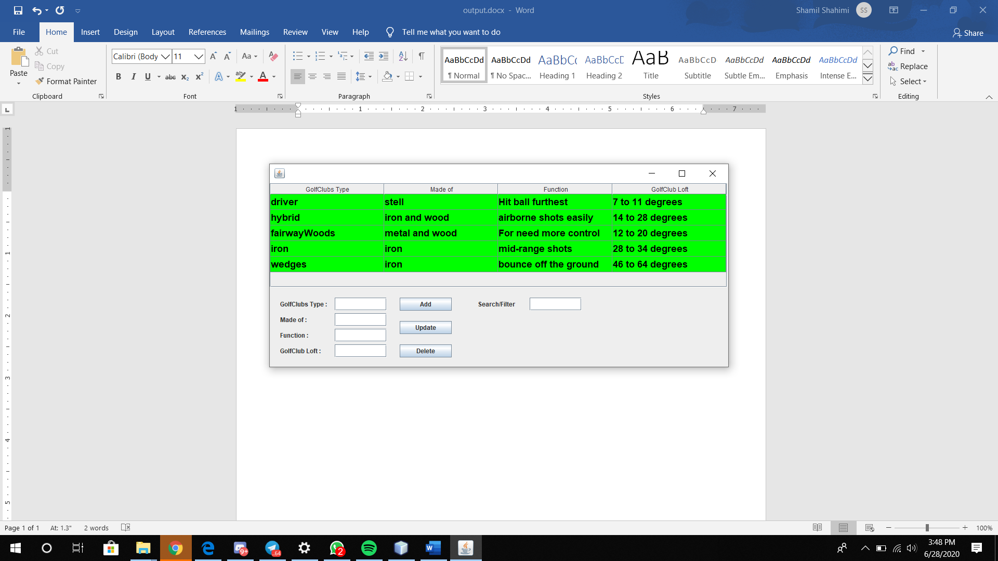

**Add info :**

Step 1 : Insert the information you want.

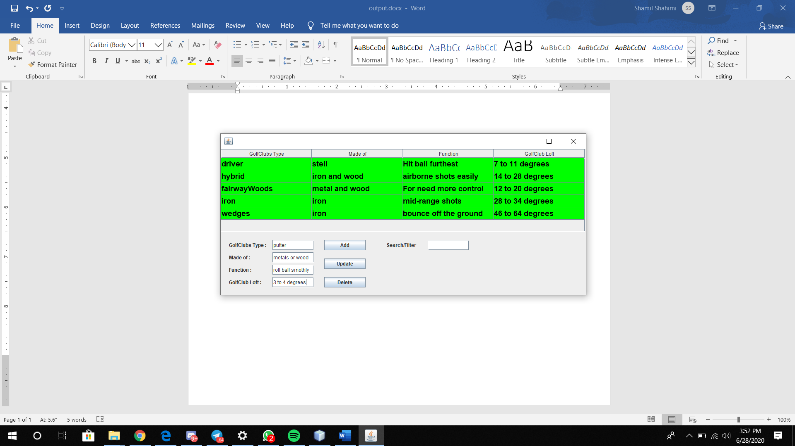

Step 2 : Click on “Add” button.

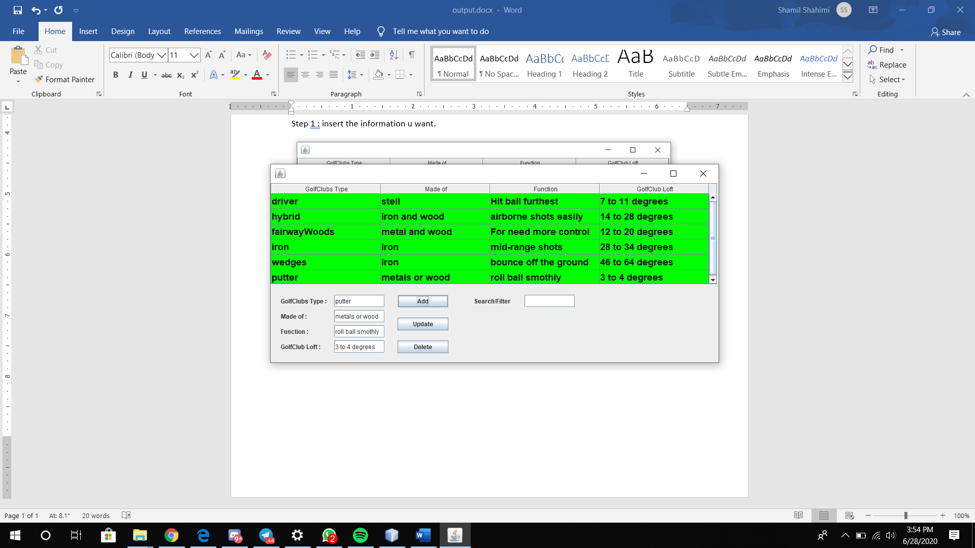

Update information :

Step 1 : Click on which bar you want to edit.

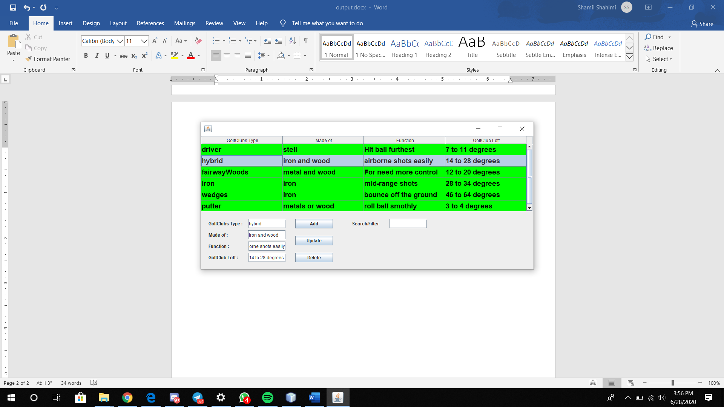

Step 2 : Write the update information you want and click “Update”.

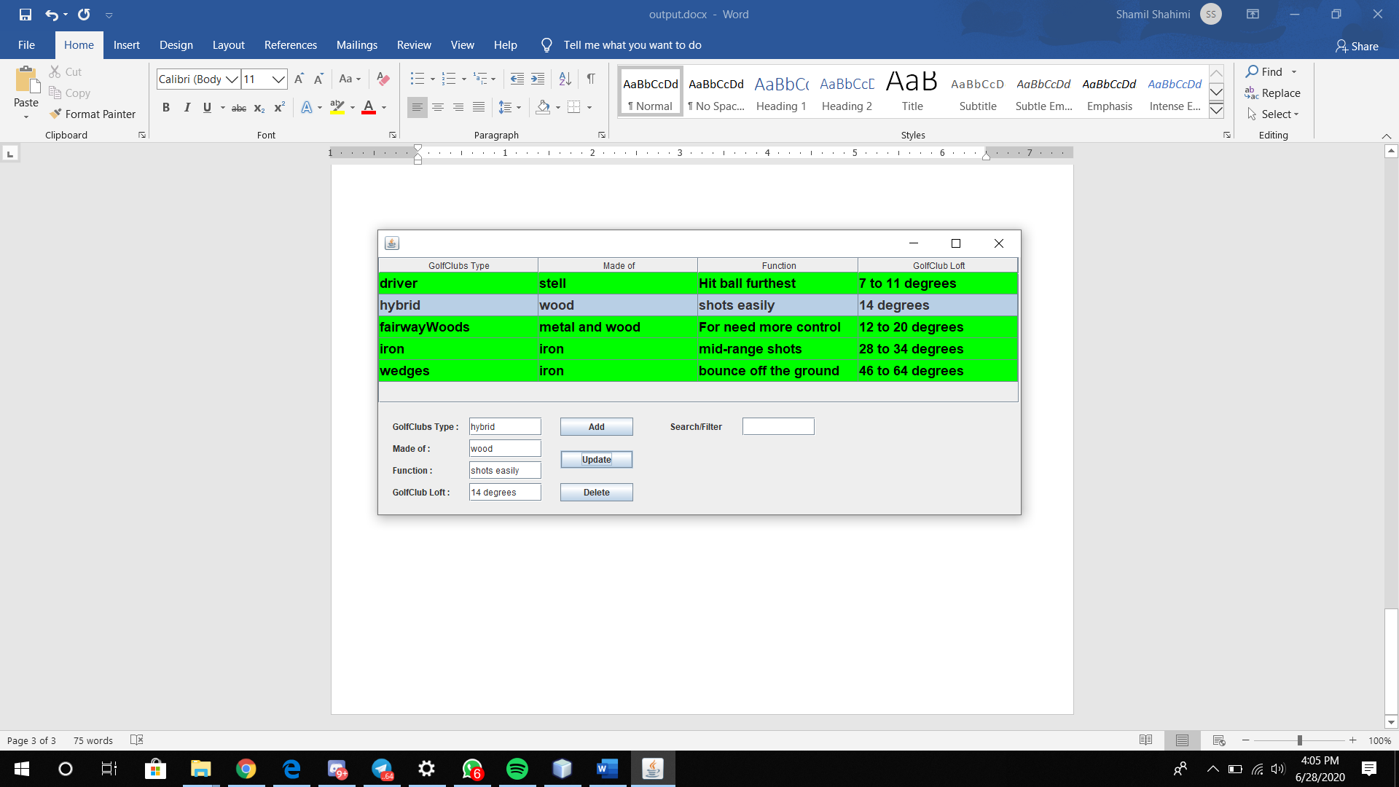

Or

**you also can edit it through specific bar you want to edit.**

Step 1 : Double click to edit it through specific bar you want to edit.

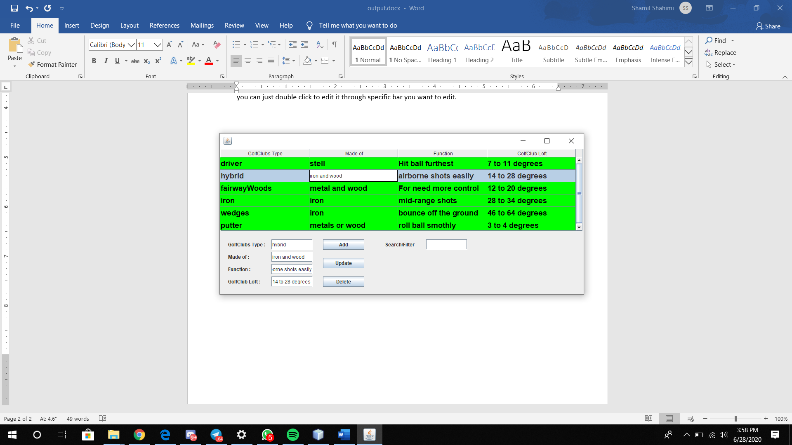

Step 2 : Click “enter” to update the edited information.

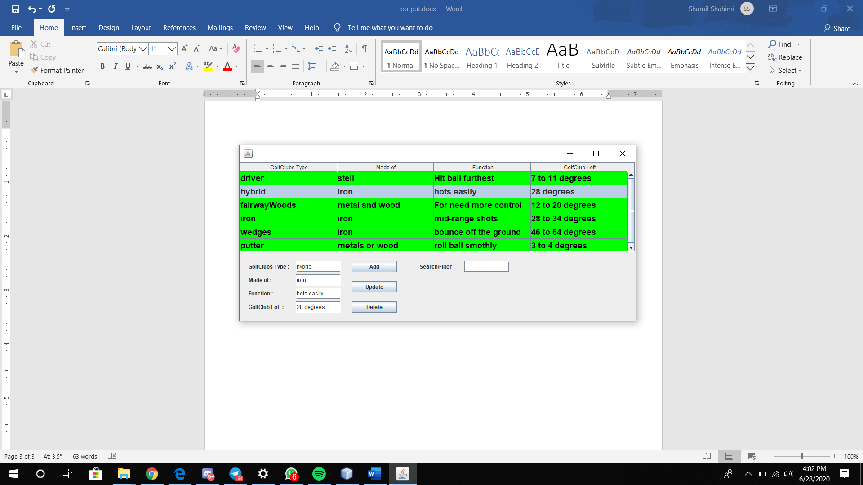

**Delete information :**

Step 1 : Click on any information you want to delete.

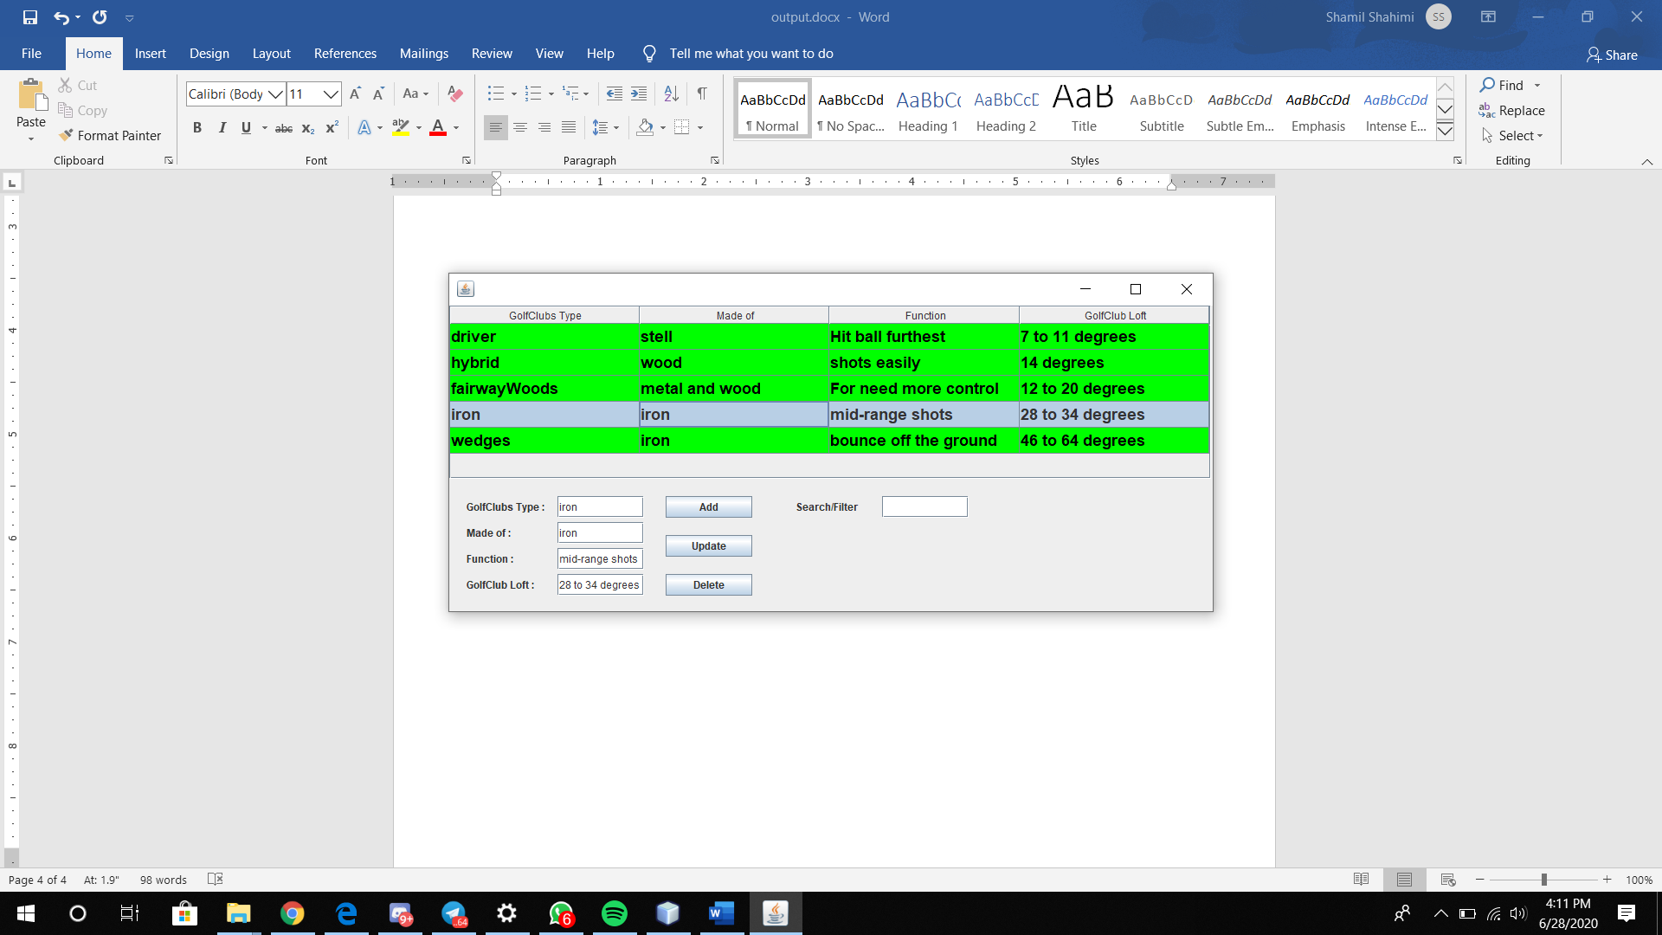

Step 2 : Click on “Delete” button.

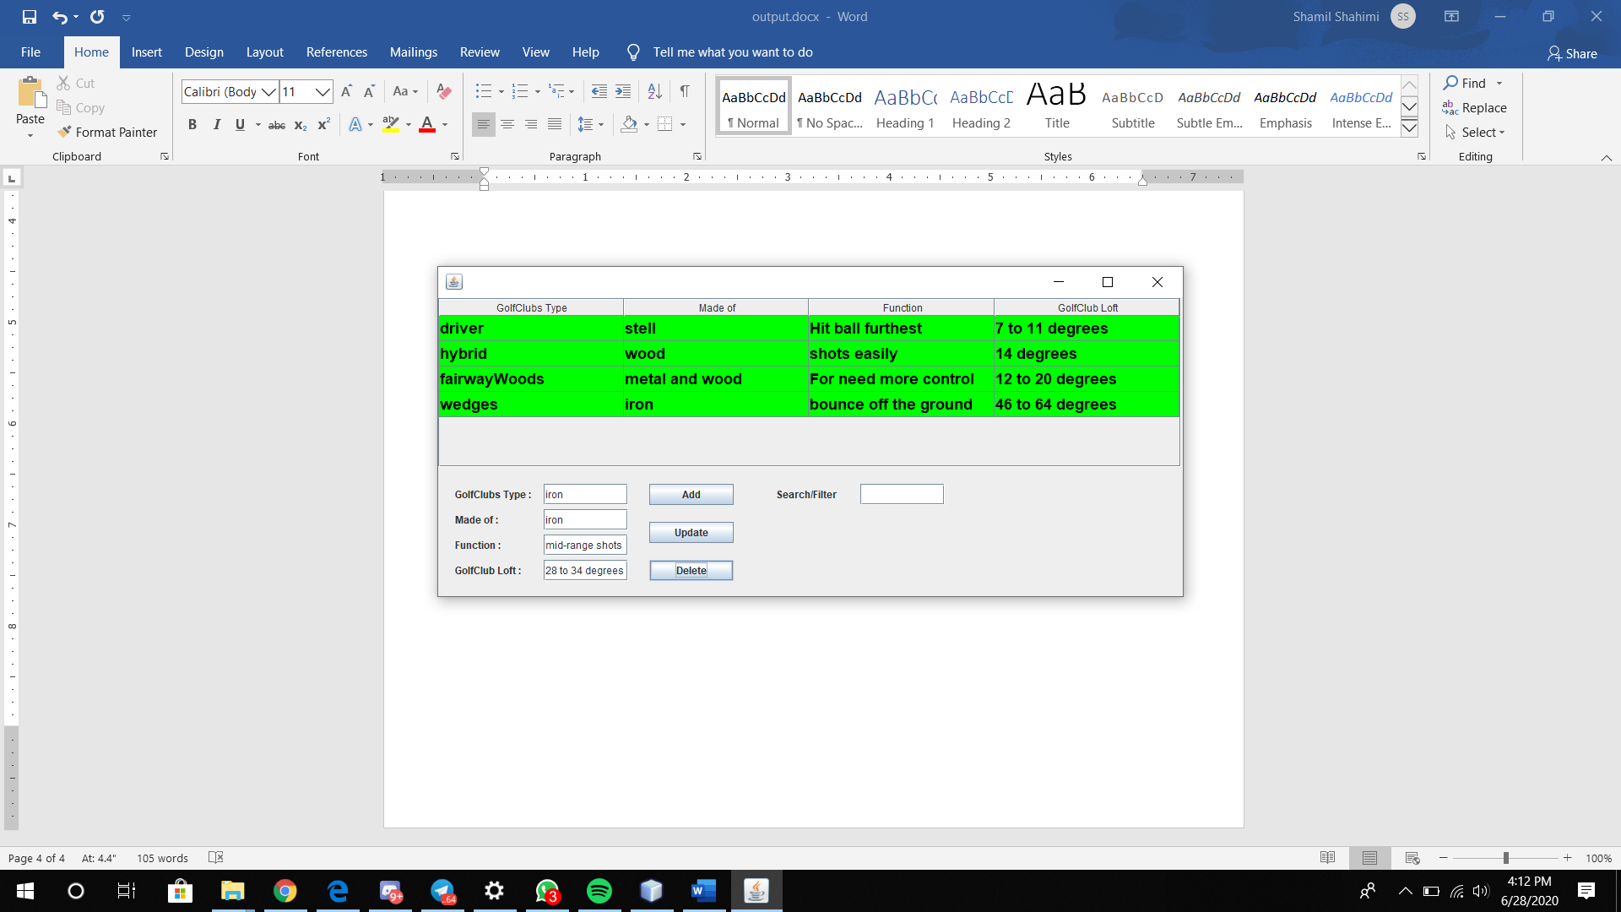

**Search :**

Step 1 : Click on the search/filter text bar.

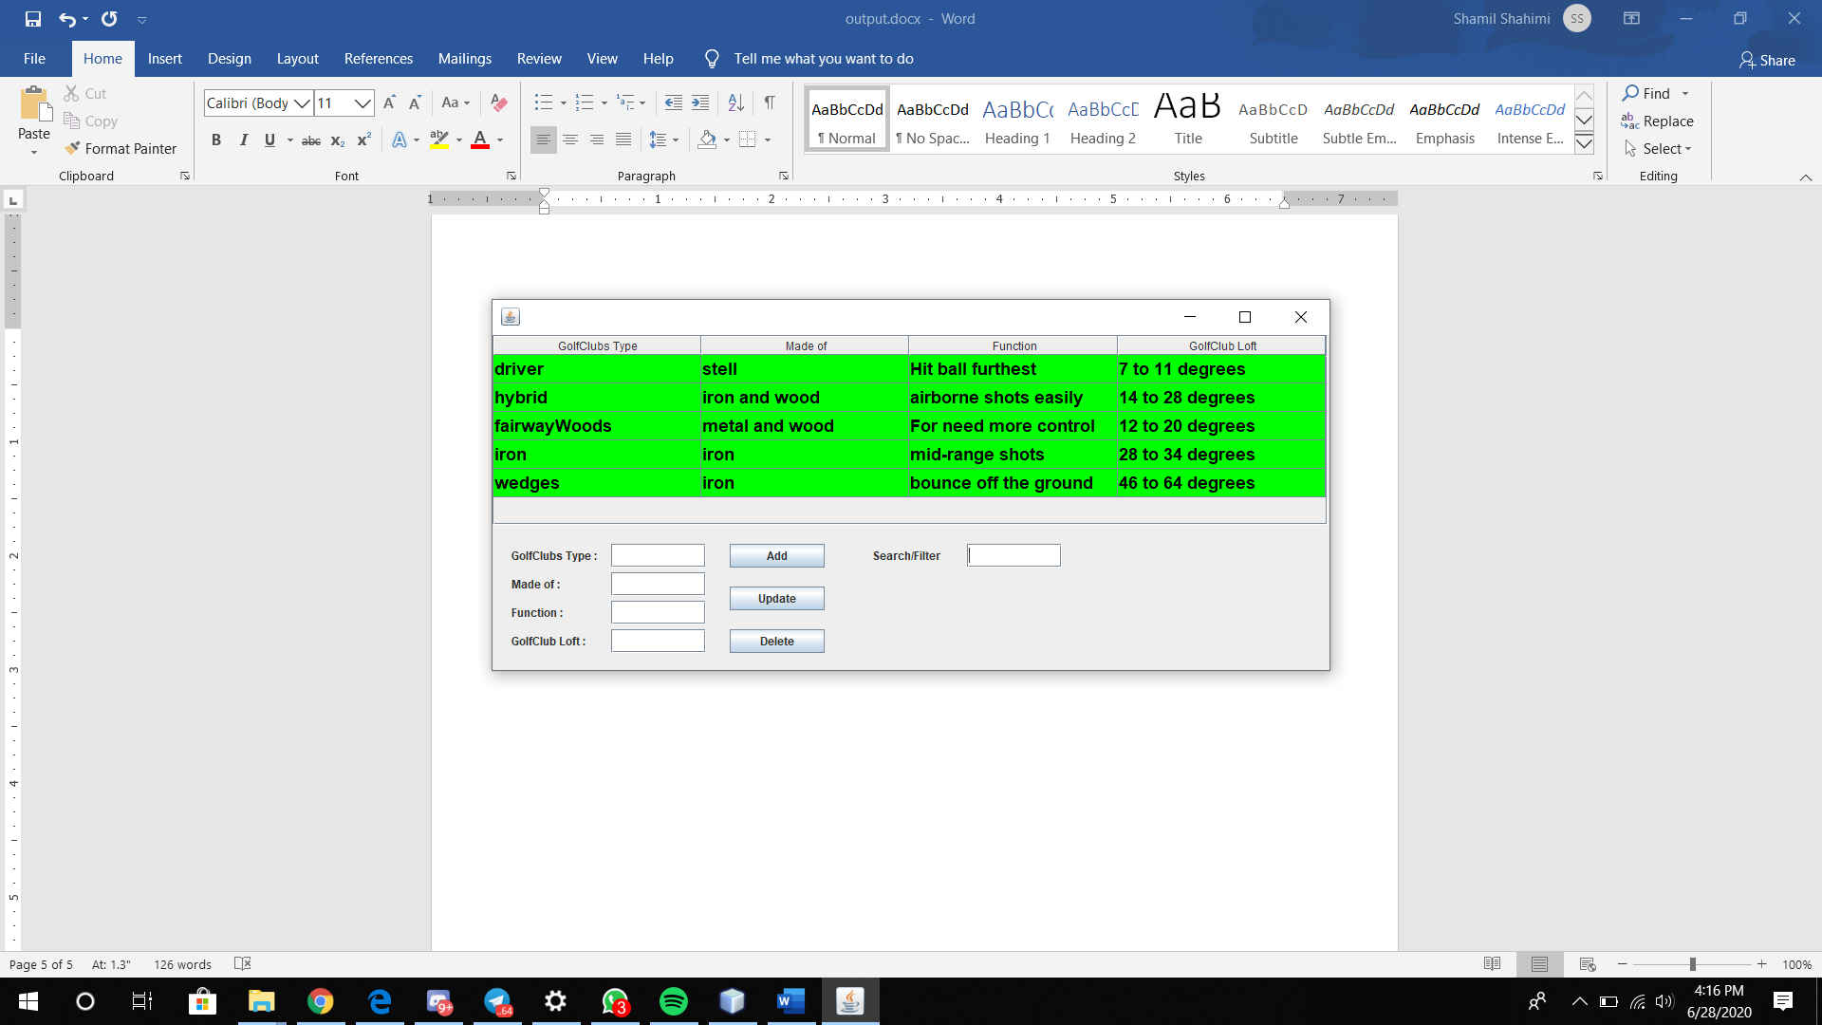

Step 2 : Write any information you want to search for.

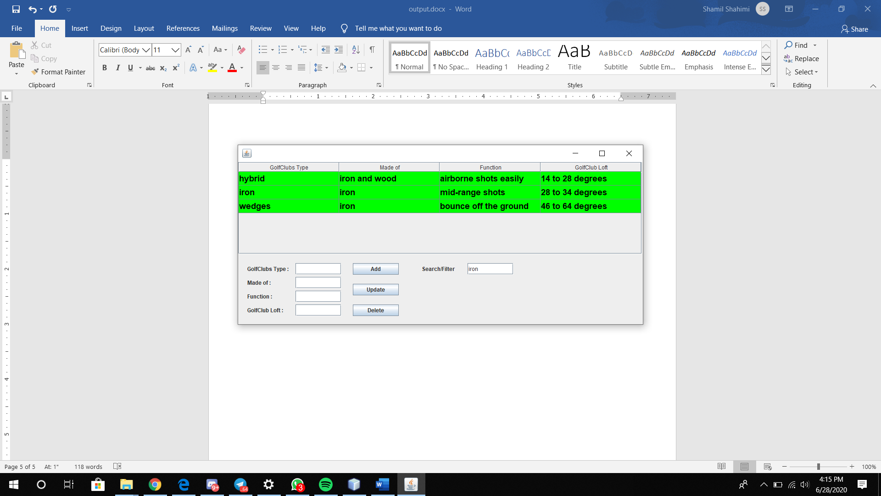

**Exit :**

Step 1 : Click on the “ X ” figure and you will exit .

