Final Project – Integrated Dependability Engineering Capstone
Fault-Tolerant University Records Service: Gateway, Observability, Security and Fault Injection, Baseline versus Improved
Astana IT University | Fault Tolerance and Dependable Computing | Academic Year 2026–2027
Student: Shamil Yakupov, ID 255193 | Instructor: Azamat Serek | Individual work
Experiments run on 6 November 2026 | Report date: 6 November 2026
Context note: all data in this project are synthetic. The system under test is a local Kubernetes lab; no real users, production systems or real university infrastructure were involved. The application is the hoWallet Go API, used (as in the midterm and endterm) only as a stand-in for a synthetic university service.
Contribution: this is individual work with no other team members. Shamil Yakupov is responsible for all of it: requirements, design, configuration, scripts, experiments, analysis and this report.

1. Abstract and Keywords
This project evaluates a dependable records service on a one-node Kubernetes lab, by comparing an improved configuration (nginx gateway with bounded retries, two API replicas, probes, drain on shutdown, three Prometheus alerts) with a retained baseline (one replica, no gateway). Both share one PostgreSQL and the same application code. Eight experiments from the assignment matrix were run with 2–4 repetitions per scenario under a test plan written beforehand. Losing one API instance cost the baseline a 25.0–25.6 s outage after a graceful delete and 2.0 s after a forced one, and cost the improved configuration no failed request in 418. Under a 2 s delay on one replica's database link, the improved configuration kept all 247 requests successful, each bounded near 5 s, while the baseline lost 30 % with a maximum of 34 s. No acknowledged write was lost or duplicated in any run of either configuration; that result belongs to the application, so it does not separate the two. The comparison is not uniformly favourable: during a database outage the baseline answered more requests successfully (37 % vs 8 %); the gain there is bounded response time, not availability. The load result is partly an artefact of a per-process rate limiter, one access-control case is recorded as failed because its expected value was wrong, the rollback experiment shows no gain from the improved configuration, and PostgreSQL remains a single point of failure. Ranges describe behaviour on one machine and are not statistical estimates.
Keywords: dependability, fault injection, availability, MTTR, bounded retries, idempotency, transaction rollback, Kubernetes, nginx, Prometheus, observability, access control.

2. Introduction, Motivation and System Context
A records service for a university has a simple promise: a student's payment or registration entry is recorded exactly once, can be read back, and is visible only to the people allowed to see it. A short outage near a deadline is a nuisance; a fee charged twice or a payment lost is worse. The work therefore asks a narrow question: which failures does the improved configuration actually tolerate, at what cost, and what can the evidence not show? The assignment's dependability vocabulary and means follow Avizienis et al. [1].
System. Option A of the assignment: the project continues the university information system from the midterm and endterm. The hoWallet Go API, written by the author as a personal-finance tracker, keeps the role of the university Registration/Records service, and PostgreSQL its data store. All accounts, households and transactions are synthetic lab records. The domain words in logs and tables come from the code: a household is the tenant (one student's record space), an account is a ledger, and a transaction is a record write (for example a fee payment). The system has more than three independently identifiable services: gateway, API, database, Prometheus, Grafana and a migration job, plus API modules (authentication, transactions, background jobs). The critical multi-step workflow is posting a record, which inserts a row and moves a ledger balance in one database transaction.
Relation to the endterm. The manifests and scripts continue the endterm lab. Three things changed. The configuration label endterm is now improved. The gateway log also records $upstream_status, so retries can be counted; no timeout or retry value changed. The PostgreSQL memory limit went from 256 Mi to 1 Gi after an OOM kill (Section 9.5). Three experiments are new (Exp 3 network delay, Exp 4 interrupted transaction, Exp 8 rollback), and all eight were run again, so endterm figures are used only where stated.
Correction to the endterm. The endterm reported a 23 s baseline outage after a replica loss. That figure was understated: its probe stopped while requests were still timing out, so it was a lower bound. Exp 1 now waits for 14.5 s of clean answers and measures 25.0–25.6 s. Section 10.3 gives the detail.

3. Requirements, Assumptions and Dependability Objectives

3.1 Users, workflow, data and consequences of failure
Table 1. Users, workflow, data and consequences of failure (notes/requirements.md).
Item | Description
Users | Students (own record space), staff/members invited into a record space, operators (cluster admin)
Main workflow | Sign in → choose record space (X-Household-ID) → read ledgers and records → post a record (fee payment) that moves a ledger balance
Data handled | Synthetic users (e-mail, bcrypt hash), record spaces, ledgers with balances, records (amount, currency, date, client_id), request/audit logs
Consequence of failure | Unavailable: students cannot see or pay fees (deadline risk). Wrong or duplicated record: a fee charged twice or a payment lost – worse than an outage (repo rule: "a wrong number is worse than an honest error"). Disclosure: one student sees another's records

3.2 Critical functions
Table 2. Critical functions.
ID | Critical function | Components on the path | Multi-step?
CF1 | Authenticate (log in, refresh, verify token on every call) | gateway → api (auth service, session check in Postgres) → postgres | yes: credential check + session row + token issue
CF2 | Post a record and update the ledger balance | gateway → api (membership check, money resolution, DB transaction: insert row + update balance, then audit) → postgres | yes – insert and balance update in one DB transaction (internal/service/transaction.go:501-536), idempotent by client_id
CF3 | Read records and balances | gateway → api (JWT, live session, membership) → postgres | no (read-only, safe to retry)
CF4 | Tenant isolation (only members see/change a record space) | api → postgres | – (cross-cutting)
CF5 (supporting) | Observe and alert | prometheus → api pods; grafana → prometheus | –

3.3 Service-level objectives
A request fails if it gets a 5xx, a timeout or a connection error. A 429 is the rate limiter working as designed and is counted separately. The structure of the objectives follows [2]. Table 39 in Section 10.11 gives the measured outcome per objective.
Table 3. Service-level objectives with the improved configuration as the target.
ID | Objective | Metric | Target (improved config) | Window | Checked in
SLO-1 | Availability of CF3 in steady state | request-success ratio ok/(ok+failed) | ≥ 99.5 % | 120 s quiet window at 5 req/s | Exp 5 (warm phase), Exp 6 (quiet window)
SLO-2 | Availability of CF3 during a single API-instance failure | request-success ratio | ≥ 99 % (target 100 %) | injection −5 s … +20 s | Exp 1
SLO-3 | Latency of CF3 | p95 latency | ≤ 500 ms at 30 req/s | 60 s load step | Exp 5
SLO-4 | Bounded failure latency under any dependency fault | max latency of any answer | GET ≤ 10.5 s (2 tries × proxy_read_timeout 5s + margin; endterm E2 measured a 10.0 s maximum), POST ≤ 5.5 s (one try); no hung connection | fault window | Exp 2, Exp 3
SLO-5 | Recovery time (RTO) | Exp 1: injection to replacement ready and no failures. Exp 2: restore command to end of the last failed request. Exp 8: undo to bad pod gone | ≤ 10 s instance; ≤ 30 s database | per injection | Exp 1, Exp 2, Exp 8
SLO-6 | Write integrity of CF2 | lost acknowledged writes; duplicate (household_id, client_id); balance = −Σ amounts | 0 lost, 0 duplicates, balance check passes | whole run | Exp 2, Exp 4, Exp 8
SLO-7 | Detection time | fault onset → alert firing | ≤ 30 s; 0 alerts in a quiet window (no false positive) | per injection | Exp 6
SLO-8 | Access control | share of unauthenticated / foreign-tenant requests denied; data changed by them | 100 % denied (401/404), 0 rows changed, each denial logged with request_id | per test case | Exp 7
SLO-9 | Backup recoverability (RPO) | records missing after restore vs. records at dump time | 0 records lost since the last pg_dump; RPO = time since that dump | restore drill | Not tested in the final project. Exp 8 as run is a release rollback. The only drill is the earlier one in ftr-a3

3.4 Assumptions
- Single-node kind cluster on Docker Desktop/WSL2; node, zone and host failures are out of scope.
- One PostgreSQL instance (StatefulSet, 1 replica, PVC 1 Gi). No streaming replica: database failover is not claimed; protection is restart-in-place plus logical backup (pg_dump).
- Fault model is one fault at a time (single-fault assumption); faults are injected deliberately by kubectl, docker exec, SQL locks or config changes.
- Clients reach the cluster through NodePorts; kind SNATs them to one address, so per-IP limits are shared by all test clients.
- Clients retry writes with the same client_id (as the real web client's outbox does); the gateway never replays POST.
- The exchange-rate provider is a non-critical external dependency; records in the base currency must not depend on it.
- All data and secrets are synthetic lab placeholders; tests run only in this authorised local environment.
- Clocks of client and cluster are the same host clock (timestamps comparable to ~1 ms).

4. Fault Model, Threat Model and Failure Analysis

4.1 Terminology and fault model
Table 4. Fault, error and failure as used here, after Avizienis et al. [1].
Term | Definition (2004 taxonomy) | Example in this system
Fault | The adjudged or hypothesised cause of an error. Active when it produces an error, dormant otherwise | API pod killed; Postgres stopped; 3 s injected delay; a client sending a forged token; code path that writes a rate of 1 when a rate is missing (design fault)
Error | The part of the system state that may lead to a failure | gateway upstream list still contains a dead pod; pgx pool connections broken; a transaction row inserted but balance not yet updated; a duplicate row from a replayed POST
Failure | The delivered service deviates from correct service (observable at the service interface) | client gets 5xx/timeout; a fee shown twice; a balance that differs from the sum of records; another tenant's data returned

Table 5. Fault model.
Class (2004) | Fault | Persistence | Injected in
Physical / operational, crash | API process or pod lost (delete, SIGKILL) | transient (replaced) | Exp 1, Exp 4
Operational, hang | API process frozen (SIGSTOP) – stops answering but keeps TCP | transient (liveness restart) | Exp 6
Dependency, crash/hang | PostgreSQL stopped (scale 0) or frozen | transient (restored) | Exp 2
Interaction, timing | 2000 ms delay on the API → Postgres link, beyond the gateway read timeout; table locks | transient | Exp 3, Exp 6
Interaction, overload | traffic step 5 → 30 → 5 req/s | transient | Exp 5
Interaction, malicious / invalid input | missing/forged token, foreign X-Household-ID, malformed body, brute force | permanent while attacker acts | Exp 7
Development / configuration | bad release rolled out (API_PORT=9999) | permanent until rolled back | Exp 8
Physical, storage | lost database volume | permanent until restored | not injected in the final project

4.2 Failure scenarios and impact
Severity: H = data integrity or confidentiality at risk, M = critical function unavailable, L = degraded but correct.
Table 6. Failure scenarios and failure-impact analysis.
# | Scenario (Exp) | Fault | Error | Failure (if not tolerated) | Impact (sev.) | Detection | Mitigation (improved config)
FS1 | Instance failure (Exp 1) | one API pod deleted or crashes | gateway/kube-proxy still route to the dead endpoint for ≤ 2 s; in-flight requests cut | 5xx / connection reset; baseline: 25.0–25.6 s outage after a graceful delete, 2.0 s after a forced one (Exp 1; the endterm's 23 s was understated) | CF1–CF3 unavailable (M) | readiness probe (2 s), endpoint drop, ApiReplicaDown (counts healthy replicas), error-rate alert | 2 replicas, maxUnavailable 0, preStop drain 5 s, gateway bounded retry on the other pod (proxy_next_upstream … tries 2), passive ejection max_fails=1 fail_timeout=2s
FS2 | Database unavailable (Exp 2) | Postgres scaled to 0 or frozen | pool connections fail; membership/session queries fail | baseline: requests hang until client timeout (12 s); risk of half-applied write | CF1–CF3 down (M); integrity risk (H) | ApiHighErrorRate, ApiHighLatencyP95, ERROR log "failed to check household membership" | fail fast: gateway 5 s read timeout → JSON 503 + Retry-After; membership check fails closed (500); write is one DB transaction → nothing half-applied; client retries with same client_id
FS3 | Network delay / timeout (Exp 3) | tc netem delay 2000ms on egress to Postgres in one API pod (the only pod for baseline) | requests exceed their deadline; upstream slots held | unbounded waits; retry storm amplifying load | latency SLO broken (M) | ApiHighLatencyP95, gateway log upstream_response_time | proxy_connect_timeout 1s, proxy_read_timeout 5s; retries bounded to 2 tries and only for idempotent methods; API server timeouts (read 15 s, write 15 s, header 5 s, cmd/api/main.go:81-88)
FS4 | Interrupted multi-step transaction (Exp 4) | API process SIGKILLed between "insert record" and "update balance". A loss after commit but before the client saw the answer is a further risk, handled by the same key, and not injected here | uncommitted DB transaction; client does not know whether the write happened | lost record (client gives up) or duplicate record (client retries a committed write); balance ≠ Σ records | fee lost or charged twice (H) | integrity check: rows vs. acknowledged writes, duplicate client_id, balance = −Σ | RunInTx (insert + balance in one transaction, rollback on any error), idempotency key client_id + unique index → retry returns the first row (200)
FS5 | Load step (Exp 5) | offered load 5 → 30 → 5 req/s | queueing in pool (40 conns/replica), CPU throttling, limiter counters fill | p95 above SLO; 429 for everyone behind one IP; 5xx | slow/denied service (M/L) | p95 alert, http_requests_in_flight, db_pool_acquired_conns | 2 replicas share load; per-user/per-IP rate limits answer JSON 429 + Retry-After instead of collapsing
FS6 | Monitoring / alert (Exp 6) | a replica hangs (SIGSTOP), the database stops for 25 s, or lock bursts slow it for about 40 s | the system degrades without users reporting it | incident unnoticed (false negative) or alert noise (false positive) | prolonged outage (M) | 3 Prometheus rules (for 6–10 s), Grafana dashboard, correlated request_id in gateway + API logs | rule ApiReplicaDown fixed to count healthy replicas (endterm finding); alerts scoped to job="api", route!="/health"
FS7 | Unauthorized / invalid operation (Exp 7) | request without token, forged JWT, user B targets A's record space, malformed or huge body, password brute force | request reaches business logic with wrong identity or bad input | disclosure or tampering of another student's records; crash on bad input | confidentiality/integrity (H) | 401/403/404/400/413/429 in logs with request_id, user_id; app_logs rows | JWT (HMAC, iss, exp), live-session check, verified-email gate, membership check → 404, input validation, 1 MB decode / 2 MB gateway cap, login lockout, rate limits (see security-controls.md)
FS8 | Recovery / rollback (Exp 8) | release listening on the wrong port (API_PORT=9999) | bad pod never ready; rollout stalls | service down after a deploy, if old pods were removed | M | readiness failure (2.1–2.4 s); no alert watches rollouts, measured as a monitoring gap | rolling update keeps old pods until new ones are ready; kubectl rollout undo. A default RollingUpdate with 1 replica does the same. Database loss is not part of Exp 8: pg_dump + pg_restore was drilled only in ftr-a3 (19.2 s)

4.3 Threat model
The STRIDE analysis [16] with code references is in notes/threat-model.md. Assets: records and balances, credentials, the JWT signing secret, tenant membership and the audit trail. Actors: A1 anonymous attacker, A2 authenticated user of another tenant, A3 compromised pod, A4 abusive or buggy client.
Table 7. Threats per entry point, controls and residual risk (condensed from notes/threat-model.md).
Entry point / actor | Threat (STRIDE) | Control | Residual risk
/auth/* (A1) | S: brute force, credential stuffing | 10 req/min per IP on /auth; lockout after 5 failures per (e-mail, IP) for 15 min; bcrypt | counters live in each replica's memory (Exp 7: first 429 at attempt 11, not 6)
/auth/* (A1) | S/T: forged JWT | HMAC only, issuer and expiry required; same 401 for all failures | whoever holds JWT_SECRET can mint tokens (A3)
Household API (A2) | I/T: reading or changing another tenant through X-Household-ID or foreign ids | membership check → 404; queries scoped by household_id | tested in Exp 7
Household API (A4) | T: duplicate writes on retry | client_id idempotency key + unique index | only POST /api/transactions has it
Household API (A4) | D: flooding, huge bodies | 600/min per user, 1200/min per IP, 60/min creates; 2 MB at the gateway, 1 MB decode | per-replica limits; no statement_timeout
Gateway (A1) | S: spoofed X-Real-IP to dodge limits | gateway overwrites X-Real-IP, clears True-Client-IP | the baseline, with no gateway, honours the header (Exp 7)
Any pod (A3) | E/I: lateral movement | NetworkPolicies, non-root, read-only root filesystem | API database user owns all tables; logs in the same database; not tested in Exp 7
All (A1–A4) | R: denying actions | JSON request log with request_id and user_id; audit_logs; app_logs | no dedicated failed-login event; audit queue drops under load

Table 8. Misuse scenarios tested in Exp 7.
ID | Misuse scenario | Actor | Threat (STRIDE) | Expected control | Evidence
MU1 | Request with no token, a garbage token or a forged token | A1 | Spoofing | 401, nothing changed | status, log line with request_id
MU2 | User B targets A's record space (read, create, delete) with X-Household-ID: A | A2 | Information disclosure, tampering | 404 household not found, A's data unchanged | before/after row snapshot, log lines
MU3 | Malformed, negative or oversized input | A4 | Tampering, denial of service | 400, JSON 413 from the gateway, service stays healthy | status, parallel probe
MU4 | Password brute force | A1 | Spoofing | 401 then 429 with Retry-After | status sequence, request log

5. Reliability Engineering Calculations
All values in Sections 5.1–5.3 are measured-final: computed by python analysis/reliability.py from evidence/results/reliability-inputs.json and read from analysis/reliability-computed.json when this report is built. Section 5.4 is illustrative and is not a measurement.

5.1 Formulas, units and windows
Table 9. Symbols.
Symbol | Meaning | Unit
T_obs | observation window length | s
N_f | failure episodes observed in the window | count
D | total downtime: sum of the lengths of the failure intervals | s
U = T_obs − D | total up time | s
ok, failed | requests answered correctly / failed in the window | count

Table 10. Quantities.
Quantity | Formula | Unit | Meaning
MTTR | D / N_f | s | mean time to restore client-visible service
MTTF | U / N_f | s | mean up time before a failure
MTBF | MTTF + MTTR = T_obs / N_f | s | mean time between the starts of successive failures
Availability | A = MTTF / (MTTF + MTTR) = U / T_obs | dimensionless, % | share of the window in which service was up
Observed failure rate | λ = N_f / T_obs | 1/s (printed as 1/h) | failure episodes per unit time, under the conditions of the window
Request-success ratio | R_req = ok / (ok + failed) | dimensionless, % | share of requests served correctly

Repetitions are pooled: T_obs, N_f, D, ok and failed are summed, then the formulas are applied. With N_f = 0 the window is right-censored: MTTF is reported as > T_obs, MTTR and MTBF as undefined, A = 1. Zero failures in a short window does not show that λ is zero; the rule of three gives a rough 95 % upper bound of λ < 3 / T_obs for a constant-rate process [4].
- Window: from the first client request to the end of the last one in the run, including the time before the fault. Each window encloses one injected fault.
- Failure interval: from the start of the first failed request to the end of the last failed request of an episode (client-visible downtime). Failed requests within 2.0 s are merged. Resolution is limited by the probe rate, and the length of a failed request, including the client's timeout, counts towards D.
- Observed failure rate basis: λ = N_f / T_obs, under the conditions of the window.
- MTTF, MTBF and λ here mostly reflect injection timing, not system reliability. The experimenter chooses when the fault happens, so MTTF is largely the lead time before the injection and λ is close to 1 / T_obs. They are computed because the assignment asks for them, and must not be extrapolated to a field value (notes/reliability.md §3). The comparable quantities are MTTR, D, R_req, and A between runs with equal windows and fault duration.

5.2 Measured results
Table 11. Measured-final reliability quantities, pooled per experiment and configuration. λ is per hour of window and conditional on injected faults.
Exp | Scenario | Config | Reps | T_obs (s) | N_f | D (s) | MTTR (s) | MTTF (s) | MTBF (s) | A | λ (1/h) | ok / failed | R_req
1 | Instance failure | baseline | 3 | 119.5 | 3 | 52.6 | 17.6 | 22.3 | 39.8 | 55.95 % | 90 | 657 / 302 | 68.51 %
1 | Instance failure | improved | 3 | 66.7 | 0 | 0.0 | undefined | > 66.7, censored | undefined | 100.00 % | 0 | 536 / 0 | 100.00 %
2 | Database unavailable | baseline | 4 | 207.0 | 4 | 102.7 | 25.7 | 26.1 | 51.8 | 50.42 % | 70 | 938 / 308 | 75.28 %
2 | Database unavailable | improved | 4 | 207.7 | 4 | 114.4 | 28.6 | 23.3 | 51.9 | 44.95 % | 69 | 632 / 618 | 50.56 %
3 | Network delay | baseline | 3 | 268.0 | 3 | 101.5 | 33.8 | 55.5 | 89.3 | 62.13 % | 40 | 465 / 74 | 86.27 %
3 | Network delay | improved | 3 | 247.5 | 0 | 0.0 | undefined | > 247.5, censored | undefined | 100.00 % | 0 | 498 / 0 | 100.00 %
4 | Interrupted transaction | baseline | 3 | 121.5 | 3 | 54.8 | 18.3 | 22.3 | 40.5 | 54.94 % | 89 | 366 / 123 | 74.85 %
4 | Interrupted transaction | improved | 3 | 115.6 | 0 | 0.0 | undefined | > 115.6, censored | undefined | 100.00 % | 0 | 465 / 0 | 100.00 %
5 | Load step | baseline | 2 | 240.4 | 6 | 6.2 | 1.0 | 39.0 | 40.1 | 97.42 % | 90 | 3077 / 41 | 98.69 %
5 | Load step | improved | 2 | 240.4 | 0 | 0.0 | undefined | > 240.4, censored | undefined | 100.00 % | 0 | 4204 / 0 | 100.00 %
6 | Monitoring, pooled | improved | 9 | 720.2 | 5 | 81.2 | 16.2 | 127.8 | 144.1 | 88.72 % | 25 | 3736 / 352 | 91.39 %
8 | Rollback | baseline | 2 | 146.8 | 0 | 0.0 | undefined | > 146.8, censored | undefined | 100.00 % | 0 | 736 / 0 | 100.00 %
8 | Rollback | improved | 2 | 156.0 | 0 | 0.0 | undefined | > 156.0, censored | undefined | 100.00 % | 0 | 782 / 0 | 100.00 %
7 | Unauthorized operation | – | – | n/a | n/a | n/a | n/a | n/a | n/a | n/a | n/a | n/a | reported in 10.9

5.3 Worked calculation and interpretation
Exp 1 baseline, repetition 1 (exp1-baseline-rep1-graceful): T_obs = 46.13 s, N_f = 1, D = 25.63 s, ok = 221, failed = 149.
U = 46.13 - 25.63 = 20.50 s
MTTR = 25.63 / 1 = 25.63 s
MTTF = 20.50 / 1 = 20.50 s (time around the outage, not a lifetime)
MTBF = 20.50 + 25.63 = 46.13 s
A = 20.50 / 46.13 = 44.44 %
lambda = 1 / 46.13 s = 78 per hour (one injected fault in this window)
R_req = 221 / (221 + 149) = 59.73 %
- Exp 1. The pooled MTTR of 17.6 s describes neither behaviour: graceful delete 25.6 s and 25.0 s, forced delete 2.0 s. Improved has no failure episode, so only a lower bound of 66.7 s on MTTF can be stated (rule of three: λ < 162 per hour, about this short window).
- Exp 2 favours the baseline on A (50.42 % vs 44.95 %) and R_req (75.28 % vs 50.56 %). Section 10.4 explains why this is not an availability gain for the baseline and not one for the improved configuration either.
- Exp 3. Slow successful requests are not downtime in this calculation. Improved has D = 0, yet its p95 is about 5 s, so read this row with its latency.
- Exp 5. 429 is excluded from R_req, so the baseline's 98.69 % does not show that 1086 requests were refused in the whole window.
- Exp 6 pools four different scenarios and has no baseline; the scenario rows of Table 27 are the useful ones.

5.4 Theoretical estimate (illustrative, not measured)
Every value in this table is illustrative. The per-instance availability of 0.999 is an assumption chosen to show the shape of the calculation. It was not measured and must not be cited as a result. Assuming independent failures, A_series = A1 × A2 × … and A_parallel = 1 − (1 − A)^n.
Table 12. ILLUSTRATIVE series and parallel availability, not measured.
Structure | Calculation (illustrative, each instance A = 0.999) | A
Gateway ×2 | 1 − 0.001² | 0.999999
API ×2 | 1 − 0.001² | 0.999999
PostgreSQL ×1 | – | 0.999
Path, improved | 0.999999 × 0.999999 × 0.999 | ≈ 0.998998
Path, baseline (API ×1, PostgreSQL ×1, no gateway) | 0.999 × 0.999 | ≈ 0.998001

Redundancy halves the illustrative unavailability from 0.2 % to 0.1 %, and what remains is almost entirely the single database, which agrees with the SPOF analysis of Section 6.5. Section 10.12 explains why measured results differ from this calculation.

6. System Architecture and Resilience Design

6.1 Service boundaries and data flows
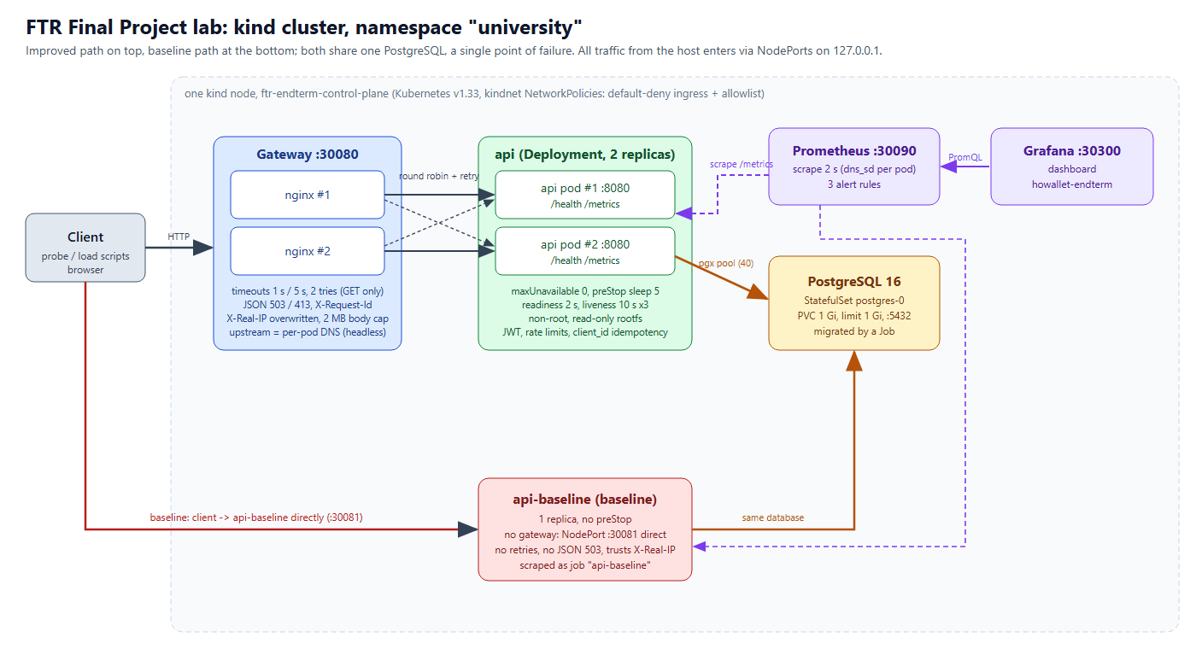
Figure 1. Lab architecture: improved path (gateway → API × 2 → PostgreSQL) with monitoring, and the baseline path at the bottom sharing the same database. Source: scripts/architecture.html.
AI-generated figure. The diagram was generated with the help of AI (Claude Code, as an HTML/SVG page rendered to PNG). It was carried over from the endterm, its labels were updated for this report, and it was checked by the author against the manifests in k8s/. The generation prompt is given in Appendix 14.6.
Table 13. Services (notes/architecture.md).
Service | Kind / replicas | Responsibility | Health check | Depends on | Recovery
gateway (nginx 1.27) | Deployment ×2, NodePort 30080 | Single entry; timeouts, retries, JSON 503/413, correlation id, IP header overwrite | readiness and liveness /healthz | api, kube-dns | kubelet restart; other pod serves
api (hoWallet Go) | Deployment ×2, maxUnavailable 0, maxSurge 1 | Business logic, auth, jobs, /metrics | readiness /health 2 s; liveness 10 s × 3 | postgres; Frankfurter (optional) | ReplicaSet replacement; liveness restart; preStop sleep 5
postgres 16 | StatefulSet ×1, PVC 1 Gi | Persistent store | readiness probe, period 5 s | volume | restart in place; pg_restore from a dump
university-migrate | Job (backoffLimit 10) | Applies schema migrations | – | postgres | Job retry
prometheus 2.54.1 | Deployment ×1, NodePort 30090 | Scrape every 2 s, 3 alert rules, 1 h retention | – | api pods | restart; history lost
grafana 11.2.0 | Deployment ×1, NodePort 30300 | Dashboard howallet-endterm | – | prometheus | dashboard provisioned from a ConfigMap
api-baseline | Deployment ×1, NodePort 30081 | Comparison path | readiness only | postgres | replacement pod only

Table 14. Dependencies and failure containment.
From → to | Protocol | Required? | If it fails
client → gateway | HTTP | yes | no service
gateway → api | HTTP, per-pod DNS (api-headless) | yes | retry on the other pod, then JSON 503
gateway → kube-dns | DNS, valid=2s | for pod changes | keeps last resolved addresses; new pods not discovered
api → postgres | pgx | yes | critical functions fail; no rows half-written
api → Frankfurter | HTTPS, background job only | no | same-currency writes unaffected; foreign currency uses the archive, else 422 no_rate
prometheus → api | HTTP /metrics | no | no metrics or alerts; service unaffected
grafana → prometheus | HTTP | no | no dashboard

Critical workflow, post a record. (1) The client sends POST /api/transactions with a bearer token, X-Household-ID and client_id. (2) The gateway sets X-Request-Id, overwrites X-Real-IP and proxies to one pod; it does not replay the POST once sent [10]. (3) API middleware runs: request id, logger, rate limit, JWT, live session, per-user limit, verified e-mail, membership. (4) CreateOnce looks up client_id; on a miss it runs one database transaction with the insert and the balance update [13]. (5) Audit, budget notification and cashback run after the commit, not atomically with it. (6) The API answers 201, or 200 for a replay.

6.2 Redundancy and backup strategy
Table 15. Redundancy and backup.
Layer | Strategy | Protects against | Does not protect against
Gateway, API | Active-active ×2, preferred anti-affinity | Loss or hang of one pod | Node loss (one node); shared DB failure
PostgreSQL | No replica. Restart in place, data on a PVC | Process crash | Volume loss, logical corruption
Data | Logical backup: pg_dump -Fc, restore with pg_restore --clean --if-exists | Volume loss, bad write | Writes after the last dump (RPO = time since the dump)
Backup immutability | Object-lock copy with a sha256 check was shown on the earlier lab (ftr-a4/scripts/ransomware-drill.sh) | Deletion of the backup | Not deployed in this lab
Release | Rolling update, maxUnavailable 0, kubectl rollout undo | Bad release | Bad migration (no automatic down-migration)

Backup is by the earlier drill only: pg_dump and pg_restore [14] were exercised in the ftr-a3 lab (restore in 19.2 s on a very small database). No restore was run in the final project, and SLO-9 is therefore not tested.

6.3 Baseline versus improved
Both configurations run side by side, use one image and share one PostgreSQL. The application mechanisms (rollback, idempotency, rate limits, validation) exist in both, so the comparison measures infrastructure mechanisms, not the application's.
Table 16. Exactly which mechanisms differ.
Mechanism | Baseline (api-baseline) | Improved (gateway + api)
API replicas | 1 | 2, maxUnavailable 0, maxSurge 1
Entry | Direct NodePort 30081 | Gateway ×2, NodePort 30080
Timeouts at the edge | None; the client's timeout applies | Connect 1 s, read 5 s
Bounded retries | None | 2 tries; not for a POST already sent
Passive ejection | None | max_fails=1 fail_timeout=2s
Failure answer | Hang, connection reset or API 500 | JSON 503 with Retry-After
Liveness probe | None | /health, 10 s × 3
Readiness probe | /health, 2 s, default threshold 3 | /health, 2 s, threshold 1, timeout 1 s
Graceful drain | None (default grace period) | preStop sleep 5, grace period 20 s
Pod hardening | No security context in the manifest | Non-root, read-only root filesystem
Anti-affinity | None | Preferred
Client IP | Trusts client-supplied X-Real-IP (Exp 7) | Overwritten at the gateway
Correlation id | API id only; adopts the client's header | Gateway id, same in both logs
Body cap at the edge | None (API 1 MB decode, 16 MB ceiling) | 2 MB, JSON 413
Alerts | None of its own (scraped as api-baseline) | 3 rules on job="api"
Network policy | Own ingress policy, same DB access | Gateway and Prometheus to API only

6.4 Deployment, restart and resource assumptions
Table 17. Resource and load assumptions.
Item | Value
API | requests 50m / 64 Mi; limits 500m / 256 Mi
Gateway | requests 50m / 32 Mi; limits 300m / 128 Mi
PostgreSQL | requests 50m / 128 Mi; limits 500m / 1 Gi. At 256 Mi it was OOM-killed in the endterm and in the first run of Exp 8 (evidence/anomalies.txt)
DB connections | pool maximum 40 per replica; up to 80 + baseline 40 against the PostgreSQL default of 100
Reference load | 30 req/s (Exp 5, one sample per run, see results/exp5-*.json)
Scaling | Manual; no metrics-server, so no HorizontalPodAutoscaler

6.5 Single points of failure
Table 18. Single points of failure.
Component | SPOF? | Effect when it fails | Accepted because / mitigation
PostgreSQL (1 instance, 1 PVC) | yes | every critical function fails (FS2); data loss if the volume is lost | lab scope; restart in place, fail-fast + JSON 503, pg_dump backup and restore drill (RPO = time since last dump)
kind node / host | yes | everything down | out of scope (assumption 1)
kube-dns | partly | gateway cannot re-resolve api-headless (cached valid=2s), new pods not discovered | kube-system replicas; nginx keeps last resolved addresses
Prometheus (1 replica) | yes, for monitoring only | no alerts, service itself unaffected | documented; would be a pair + Alertmanager in production
Grafana (1 replica) | yes, for dashboards only | no dashboard; alerts unaffected | –
Migration Job | start-up only | new schema not applied; the API has no schema-version check, so affected queries fail at run time | applied before the API starts; migrate up applies only versions above the stored one
JWT secret (one HMAC key) | yes (security) | if leaked, any token can be minted | Secret in K8s, no rotation in lab (threat-model.md A3)
Login lockout / rate-limit counters | not a SPOF, but not shared | each replica counts separately (2× limits), reset on restart | documented limitation; Exp 7: first 429 at attempt 11 instead of 6
API, gateway | no (2 replicas each) | – | redundancy + retries

7. Infrastructure and Software Fault-Tolerance Implementation

7.1 Infrastructure-level mechanisms
Table 19. Infrastructure mechanisms demonstrated.
Mechanism | Configuration | Demonstrated by
Instance redundancy with load balancing | API × 2 and gateway × 2 (k8s/30-api.yaml, k8s/40-gateway.yaml); per-pod upstream through the headless Service [11] | Exp 1: 418/418 with one pod deleted; 25.0–25.6 s or 2.0 s outage without it
Self-healing: restart and replacement | ReplicaSet replaces a deleted pod; liveness 10 s × 3 restarts a hung one [5] | Exp 1 recovery 1.3–1.7 s; Exp 6 hung replica back at 43.2–45.8 s
Rolling update and rollback | maxUnavailable 0, maxSurge 1, kubectl rollout undo [6] | Exp 8: old pods kept serving. A default RollingUpdate with one replica did the same, so this adds nothing measured over the default
Drain on shutdown | preStop sleep 5, grace period 20 s [7] | Exp 1 graceful runs: no failed request. Cost: bad pod takes 6.1–6.5 s to go in Exp 8, against 0.8–1.9 s
Database restart in place | StatefulSet, PVC; readiness pg_isready | Exp 2: recovers without intervention. No failover: PostgreSQL stays a SPOF

7.2 Software-level mechanisms
Six mechanisms already in the code or lab configuration are counted; none was added for this project. Go references are to the hoWallet repository at commit 06aea177; the test output is in analysis/ft-unit-tests.txt (20 unit tests: 20 passed, 0 failed).
Table 20. Software fault-tolerance mechanisms, references and tests (notes/software-ft.md).
# | Mechanism | Fault handled | Code / config | Unit test run | Exp
M1 | Gateway timeouts and bounded retries | Dead, hung or slow API replica | k8s/40-gateway.yaml:59-60,66-67 | none (nginx config) | 3, 1
M2 | Idempotent create via client_id | Client retry of a write whose answer was lost; concurrent duplicates | internal/service/transaction.go:278-316 | 16 passed | 4, 2
M3 | Database transaction rollback | Interruption between record insert and balance update | internal/repository/postgres/postgres.go:130-174 | error propagation only; real rollback needs integration | 4, 2
M4 | Health and readiness checks | Crashed or hung instance receiving traffic | k8s/30-api.yaml:64-74, internal/router/router.go:129-131 | none | 1, 6
M5 | Graceful degradation | Upstream or database down; exchange rate missing | k8s/40-gateway.yaml:73,79-83, internal/service/rates.go:265-271 | 2 passed | 2
M6 | Rate limiting with Retry-After | Overload, abusive client, brute force | internal/router/router.go:115,182,209,397-398,778-788 | 1 passed | 5, 7

- M1 gateway timeouts and bounded retries. Connect 1 s, read 5 s, at most 2 tries, idempotent methods only [10]. This is the outer layer in Nygard's sense [3]; there is no circuit breaker inside the API. max_fails=1 fail_timeout=2s is passive ejection, and is treated as part of M1. M1 has no Go test: it is nginx configuration, and Exp 1, 2 and 3 are its evidence.
- M2 idempotent create via client_id. The lookup comes first, so a retry returns the first row with no side effects; a concurrent loser hits the unique index, rolls back and reads the winner's row. 16 unit tests ran and passed. Integration tests against PostgreSQL were cited, not run. Limit: only POST /api/transactions has a key.
- M3 database transaction rollback. RunInTx commits only if the function returns no error. Its unit test TestRegister_TxError proves only that the error propagates; the integration tests were cited, not run. Exp 4 is the evidence. Limit: audit, budget notification and cashback run after the commit.
- M4 health and readiness checks. No Go test of the probe behaviour: Exp 1 and Exp 6 are the evidence. Limit: /health does not touch the database, so readiness stays green during a database outage or a slow database link (Exp 2, Exp 3).
- M5 graceful degradation. JSON 503 with Retry-After instead of an HTML page or a hang. Limit: during a database outage the API's own JSON 500 passes through the gateway unchanged. The no_rate path was shown in the endterm and was not repeated here.
- M6 rate limiting with Retry-After (httprate [18]). Limit: counters live in each replica's memory (Exp 5, Exp 7).
upstream api_upstream {
zone api_upstream 64k;
server api-headless.university.svc.cluster.local:8080 resolve max_fails=1 fail_timeout=2s; # line 35
}
location / {
proxy_set_header X-Real-IP $remote_addr; proxy_set_header True-Client-IP "";
proxy_set_header X-Request-Id $req_id; # adopted or minted correlation id
proxy_connect_timeout 1s; proxy_read_timeout 5s; # lines 59-60
proxy_next_upstream error timeout http_502 http_503 http_504; proxy_next_upstream_tries 2; # lines 66-67
error_page 502 503 504 = @degraded; error_page 413 = @too_large; # JSON bodies
}
Listing 1. Gateway excerpt (k8s/40-gateway.yaml).

7.3 Dependency-failure behaviour
If an API pod dies, the gateway retries GET on the other replica and answers JSON 503 if neither answers. If PostgreSQL stops, the membership check fails closed with a JSON 500, and requests that wait past 5 s get a JSON 503 from the gateway. Session liveness fails open on a database error, a deliberate choice to avoid mass sign-out, and a stated limitation. If the exchange-rate provider is down, base-currency writes are unaffected.

8. Monitoring, Observability and Security Implementation

8.1 Metrics and dashboard
Table 21. Metrics (metrics patch on feat/metrics, enabled by METRICS_ENABLED=true; hoWallet main has no metrics endpoint).
Metric | Type / labels | Used for
http_requests_total | counter {method, route, status} | request rate, error-rate alert
http_request_duration_seconds | histogram {method, route} | p50, p95, p99; latency alert
http_requests_in_flight | gauge | saturation
db_pool_acquired_conns, db_pool_total_conns | gauges from pgxpool | pool starvation
up (Prometheus) | per scraped pod | ApiReplicaDown alert

Prometheus scrapes every 2 s and evaluates rules every 2 s, discovering API pods per replica through DNS on the headless Service. The Grafana dashboard howallet-endterm (dashboard name kept from the endterm) shows only job="api", so baseline numbers come from the result files.
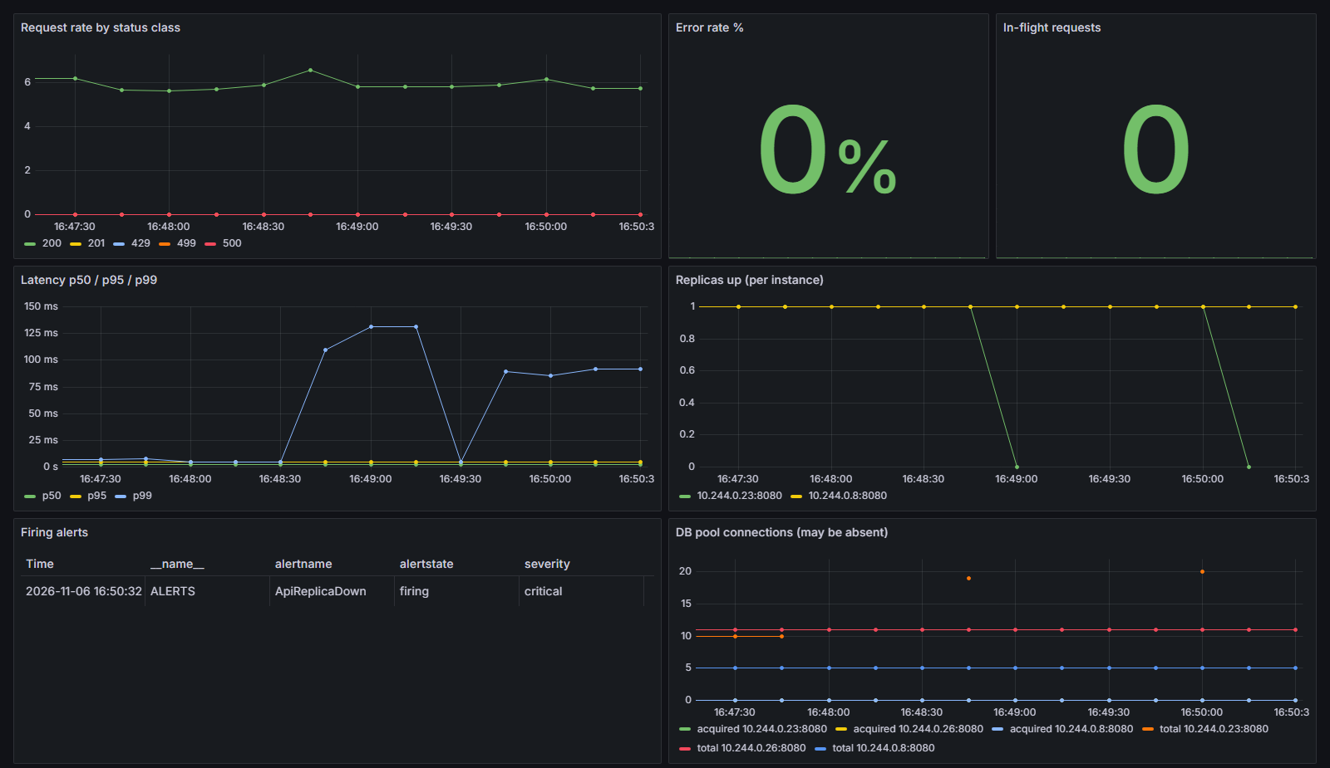
Figure 2. Grafana during the Exp 6 hung-replica series: one instance's up falls to 0, the firing table shows ApiReplicaDown, the error rate panel stays at 0 %.
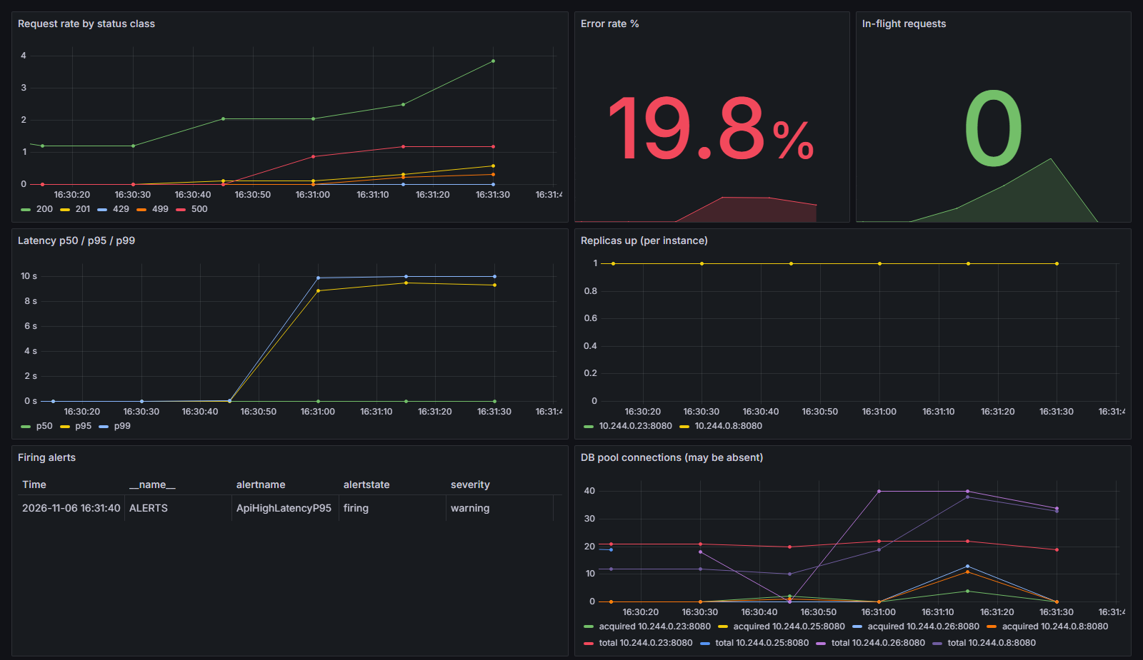
Figure 3. Grafana during Exp 2 rep 1 (database stopped): p95 and p99 reach the 5–10 s bound, 500 and 499 responses appear, ApiHighLatencyP95 fires. Replicas stay up, since /health does not touch the database.

8.2 Structured logs and request correlation
Both tiers log one JSON object per request. nginx adopts an incoming X-Request-Id or mints one and forwards it; the API adopts it, writes it to its log line with user_id and household_id, and persists the same lines to the app_logs table. Samples below are from evidence/log-samples.txt, shortened; identifiers are synthetic.
# Exp 3 improved: slow replica cut at 5 s, retried on the healthy one; client sees 200
gateway {"request_id":"exp3-improved-rep3-25","method":"GET","uri":"/api/accounts","status":200,
"upstream_addr":"10.244.0.7:8080, 10.244.0.8:8080","request_time":5.005,"upstream_status":"504, 200"}
api {"level":"ERROR","msg":"request","status":500,"duration":5000730056,"request_id":"exp3-improved-rep3-25"}
api {"level":"INFO","msg":"request","status":200,"duration":2626313,"request_id":"exp3-improved-rep3-25"}
# Exp 4 improved: interrupted POST is not replayed; the client's retry with the same client_id succeeds
gateway {"request_id":"exp4-improved-rep3-try1","method":"POST","status":503,"upstream_status":"502"}
gateway {"request_id":"exp4-improved-rep3-try2","method":"POST","status":201,"upstream_status":"201"}
# Exp 7: denied request, one id in both logs
gateway {"request_id":"exp7a-r2-05","method":"GET","uri":"/api/accounts","status":404,"upstream_status":"404"}
api {"level":"INFO","msg":"request","status":404,"request_id":"exp7a-r2-05","user_id":"9fe8558a-…"}
Listing 2. Correlated log lines, shortened from evidence/log-samples.txt.

8.3 Alert rules and incident indicators
Table 22. Alert rules (k8s/50-prometheus.yaml) [15] and observed firing delay from the injection (Exp 6).
Alert / severity | Expression (summary) | for | Indicates | Firing delay measured
ApiHighErrorRate / critical | 5xx rate / all rate > 0.05 over 30 s, job=api, route≠/health | 10 s | server-side failures | 14.2–16.2 s (database stopped)
ApiHighLatencyP95 / warning | histogram p95 over 30 s > 0.5 s | 10 s | slow responses, locks, saturation | 16.2 s (lock bursts)
ApiReplicaDown / critical | (count(up{job=api} == 1) < 2) or absent(up{job=api} == 1) | 6 s | fewer than 2 healthy replicas | 11.2–12.2 s (hung replica)

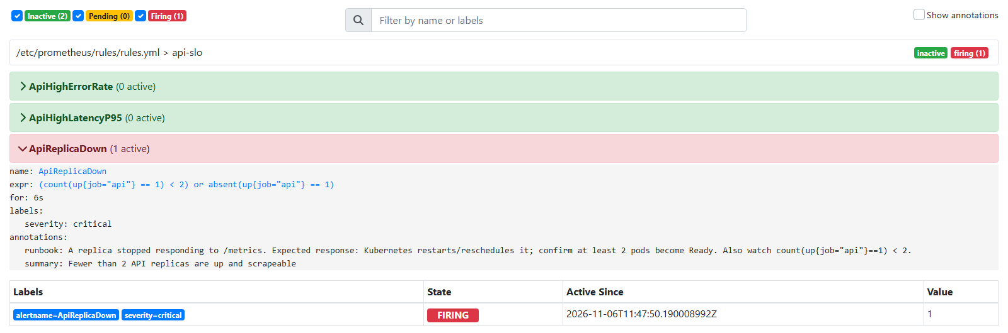
Figure 4. Prometheus alert page: ApiReplicaDown firing in Exp 6 rep 1 (screenshot taken by AlertWatcher during the run).
How an incident is diagnosed. An alert goes pending, then firing. The dashboard separates the cases: error rate up with replicas up points to a dependency; replicas below 2 points to a pod; latency up with no errors points to contention. The request_id from the client or the gateway log then finds the API line, and upstream_status shows the retries. Gap measured in Exp 8: no alert watches rollouts, so a stuck rollout is invisible to monitoring.

8.4 Security controls
Table 23. Security controls (notes/security-controls.md).
# | Control | Type | Where | Section | Tested in
C1 | JWT authentication (HMAC only, issuer and expiry required, live-session check) | Authentication | internal/middleware/auth.go:90-160, internal/middleware/session.go:125-140 | (a) | Exp 7 MU1
C2 | Household membership check, 404 for non-members | Access control | internal/middleware/auth.go:180-217 | (b) | Exp 7 MU2
C3 | Rate limits and login lockout | Abuse containment | internal/router/router.go:115,182,209, internal/service/auth.go:40-109 | (c), (d) | Exp 7 MU4, Exp 5
C4 | Input validation and body limits | Input safety | internal/handler/helpers.go:129-131, k8s/40-gateway.yaml (2 MB cap) | (e) | Exp 7 MU3
C5 | Request and audit logging with request_id | Detection, audit | internal/middleware/logger.go:42-101, internal/service/audit.go | (g) | Exp 7
C6 | NetworkPolicies, non-root, read-only root filesystem | Containment | k8s/70-network-policy.yaml, k8s/30-api.yaml | threat model, A3 | not tested in Exp 7

Controls map to OWASP API Security Top 10 2023 risks [17], mainly API1 (object level authorisation), API2 (authentication) and API4 (resource consumption). Secrets in the manifests are synthetic lab placeholders. Known weaknesses are stated: limits and lockout are per replica, session liveness fails open on a database error, there is no dedicated failed-login event, and the API's database user owns every table. NetworkPolicies [8] and pod hardening were deployed but not tested in Exp 7.

9. Verification, Validation and Experimental Methodology

9.1 Environment and configurations
One-node kind cluster [9] ftr-endterm (name kept from the endterm) on Docker Desktop, Windows 11 laptop, WSL2, namespace university. All traffic comes from one Python client on the same machine, through 127.0.0.1 NodePorts. Valid runs are from 6 November 2026, about 16:08–17:08 local time. The hypotheses, workloads, durations and criteria in evidence/test-plan.md were written before the runs. The configurations differ as in Table 16.

9.2 Tooling and repetitions
- scripts/run_exp.py <1..8> runs all repetitions of one experiment and appends the record to evidence/expN.txt; raw data lands in evidence/results/expN-*.json. bash run_all.sh runs all eight.
- scripts/ftlab.py: an open-loop probe (a hanging request does not slow it), an endpoint watcher and an alert watcher polling Prometheus every second. Each run first waits for all workloads ready and no alert active.
- scripts/faults.py (Exp 1, 2), scripts/final.py (Exp 3, 4, 8), scripts/exps.py (Exp 5, 6, 7), scripts/build_summary.py (consolidated table and reliability inputs). tc netem [12] injects the delay.

9.3 Test plan
Table 24. Experiment matrix as run (evidence/test-plan.md). B = baseline, I = improved.
Exp | Question | Fault | Workload | Reps | Hypothesis written before the run | Success criteria
1 | Does another instance keep the workflow available? | Delete one API pod: graceful, graceful, forced | GET /api/accounts, open loop, 8 req/s | 3 per config | I: at most a few failed requests per pod loss. B: outage until the replacement is ready | I availability ≥ 99 % after injection, ≥ 99.9 % for graceful. B: no target
2 | Fail safely, recover, no corruption? | Postgres scaled to 0 (2 runs) or SIGSTOP (2 runs), 20 s | GET at 6 req/s per config, timeout 12 s, plus one create per 1.5 s retried with same client_id | 4, both configs at once | Both fail and recover with no lost or duplicate write. I within about 10 s, B waits to the 12 s client timeout. An alert fires (I) | One row per acknowledged write, balance = −Σ, recovery ≤ 30 s, I errors JSON, alert fires
3 | Are timeouts and retries bounded and effective? | tc netem delay 2000ms to port 5432 in one API pod, 40 s | GET at 2 req/s, client timeout 60 s, plus one create per 1.5 s | 3 per config | I: cut at 5 s and retried once, ≥ 99 %, max ≤ 12 s; readiness will not remove the replica. B: every request about 8–10 s | I: delayed packets seen, ≥ 99 %, max ≤ 12 s, ≤ 2 tries, writes intact, latency normal ≤ 30 s after removal. B: no target
4 | Recover without losing or duplicating a record? | SIGKILL the API process while its create waits between insert and balance update (row lock held by a test session) | 2 creates, the interrupted create retried every 0.5 s; GET at 4 req/s; background creates | 3 per config | Rollback leaves nothing, retry gives one row in both. I retry in about 1–2 s; B only after the restart | 1 row for the id, 3 rows on the account, balance = −Σ, no duplicate anywhere, retry ≤ 60 s (I ≤ 10 s)
5 | How do throughput, latency and errors change? | None: load 5 → 30 → 5 req/s, 30 + 60 + 30 s | GET, 5 users, timeout 6 s; 429 counted apart | 2 per config | I serves all with p95 < 500 ms. B also holds this rate, so the difference may be small | ≥ 99 % excluding 429, p95 < 500 ms in the step, no alert
6 | Detected and diagnosed from telemetry? | Hung replica (SIGSTOP); database stopped 25 s; 22 lock bursts over about 40 s; quiet window | GET at 6 req/s (quiet 5 req/s); Prometheus polled every 1 s | 3, 2, 2, 2 (I only) | Each fault fires its alert within about 45 s; none in the quiet window; other alerts may also fire | Expected alert firing ≤ 45 s, clears after recovery, zero in quiet
7 | Access control and validation enforced and logged? | None: 11 access-control cases, input cases, 12 wrong passwords | Sequential requests; 5 req/s probe during input cases | 2 per set | 401, 404, 400/413, 429; data unchanged; each request has both log lines; X-Real-IP spoof not honoured through the gateway | Each case returns its expected status; md5 snapshot unchanged; all logged
8 | Return to an acceptable state? | set env API_PORT=9999, 45 s, then rollout undo | GET at 5 req/s, timeout 12 s, plus one create per 1.5 s | 2 per config | I: no failed request. B: probably the same. Monitoring will not notice the stuck rollout | ≥ 99 %, bad pod never ready, template restored, recovery ≤ 60 s, writes intact

Recorded per run: fault, start and end, detection time, recovery time, successful and failed requests, latency p50, p95 and max, retries and failovers, data-integrity result. Each run records whether the fault was really in place. Client retries reuse the same client_id. Integrity is checked in SQL: rows against acknowledged writes, distinct client_id, balance = −Σ amounts, and no duplicate (household_id, client_id) anywhere.

9.4 Automated tests
Table 25. Tests relevant to this project.
Level | Count | Status in this project
Unit tests of the fault-tolerance mechanisms | 20 | Run on 6 Nov 2026 at 06aea177: 20 passed (analysis/ft-unit-tests.txt)
All Go unit tests | 2095 top-level | Run on 4 Nov 2026 at 06aea177: 0 failed (notes/test-inventory.md)
Integration tests on real PostgreSQL | 278 (static count) | Cited, not run: Docker was busy with the lab
API tests over a real app and database | 538 (static count) | Cited, not run

9.5 Invalid runs and amendments
Negative findings about the lab are kept in the record. evidence/anomalies.txt and the two dated amendments in evidence/test-plan.md are the sources.
Table 26. Runs set aside, why, and what was done.
Run | Why | Action
exp4-*-rep1-INVALID-kill-not-effective (2) | SIGKILL had no effect: restart count unchanged, first POST answered 201 | Kept, excluded, rerun
exp8-improved-rep1-INVALID-confounded-postgres-oom | Postgres OOM-killed at its 256 Mi limit (exit 137, peak 268 MB, 68 connections); availability 3.61 % in the fault window. It measured the memory limit, not the rollout | Kept, excluded. Dated environment change to 1 Gi, for both configs. All later runs share one environment
results/pre-pg-memory-fix/ (Exp 3, Exp 4 rep 1) | Valid measurements of a different environment (256 Mi) | Set aside, not used; rerun
results/superseded/ (Exp 1 × 6, Exp 6 latency × 2) | Script defects: Exp 1 stopped too early; the alert watcher could stop just before a clear | Set aside; stop conditions fixed before the repeats. No hypothesis or criterion changed

Finding: PostgreSQL at 256 Mi. After the limit went to 1 Gi, the same broken release ran at 100 % availability. That supports memory pressure as the cause but does not prove it: it rests on one run pair. Two further readings limit the claim. At 1 Gi, the Exp 5 improved runs show a Postgres working set of 247.7–252.6 MiB, close to the old limit, and working set includes reclaimable cache. A memory.peak of 210 MB recorded at 17:01 covers only the time since Postgres last restarted (Exp 6 stopped it), so it says nothing about the Exp 8 runs. The endterm also saw a Postgres OOM kill, under normal lab load.

10. Results and Baseline-versus-Improved Comparison
Every value here is measured, on 6 November 2026, unless labelled otherwise. Ranges are min–max across valid repetitions. With 2–4 repetitions they describe behaviour and are not statistical estimates.

10.1 Consolidated results table
Table 27 on the next page is evidence/results/summary.md, reproduced by script when this report is built. Experiment 6 has no baseline row because the baseline has no alert rules of its own.

Table 27. Consolidated results, baseline versus improved (evidence/results/summary.md, every value measured).
Exp | Config | Valid reps | Fault injected | Detection (s) | Recovery (s) | OK / total | p50 ms | p95 ms | max ms | Retries / failovers | Data integrity | Result
1 | improved | 3 | pod delete: 2 graceful, 1 forced | 0.2-0.3 endpoint drop | 1.3-1.7; outage 0.0 | 418/418 (100.0 %) | 9.4-9.8 | 47.4-151.2 | 329.5-926.0 | 1 retried, 1 failovers OK, 0 degraded 503, max 2 tries | n/a (read-only probe) | PASS
1 | baseline | 3 | pod delete: 2 graceful, 1 forced | 0.2 endpoint drop | 2.3-25.9; outage 2.0-25.6 | 538/840 (64.048 %) | 9.0-4056.7 | 1244.9-6016.2 | 2145.5-6039.6 | 0 (no gateway) | n/a (read-only probe) | comparison, no target
2 | improved | 4 | postgres: 2 stop, 2 SIGSTOP freeze, 20 s | 0.3-2.8 first failure; alerts firing 15.2-21.2 | 4.0-12.3 after restore | 40/522 (7.663 %) during outage | 8.1-5005.9 | 5012.1-9179.7 | 10010.5-10015.8 | 188 retried, 12 failovers OK, 569 degraded 503, max 2 tries | 146 acked, 146 rows, 0 dup; balances OK | PASS
2 | baseline | 4 | postgres: 2 stop, 2 SIGSTOP freeze, 20 s | 0.3-2.8 first failure | 3.2-8.0 after restore | 182/489 (37.219 %) during outage | 11677.0-12002.8 | 12013.4-12014.4 | 12020.2-12031.8 | 0 (no gateway) | 143 acked, 143 rows, 0 dup; balances OK | PASS
3 | improved | 3 | netem 2000 ms api->postgres, 40 s | 1.0-1.5 first slow | 1.42-9.84 after removal | 247/247 (100.0 %) during fault | 10.0-10.7 | 5010.1-5013.4 | 5028.9-5083.2 | 31 retried, 31 failovers OK, 0 degraded 503, max 2 tries; client write retries 18 | 165 acked, 165 rows, 0 dup; balances OK | PASS
3 | baseline | 3 | netem 2000 ms api->postgres, 40 s | 1.0 first slow | 4.28-4.48 after removal | 173/247 (70.04 %) during fault | 10011.0-18035.5 | 18641.6-32048.1 | 22371.9-34030.4 | 0 (no gateway); client write retries 1001 | 165 acked, 165 rows, 0 dup; balances OK | comparison, no target; writes OK
4 | improved | 3 | SIGKILL between insert and balance move | 0.2 client error | 1.2-1.7 to successful retry | 376/376 (100.0 %) probe after kill | 9.2-9.6 | 26.5-138.8 | 117.0-1024.8 | 3 retried, 3 failovers OK, 3 degraded 503, max 2 tries; client tries 2 | interrupted id rows 1; balance == -sum all; DB dup 0 | PASS
4 | baseline | 3 | SIGKILL between insert and balance move | 0.2 client error | 3.6-34.1 to successful retry | 277/400 (69.25 %) probe after kill | 8.4-10355.6 | 26.8-12018.6 | 929.8-12028.5 | 0 (no gateway); client tries 5-7 | interrupted id rows 1; balance == -sum all; DB dup 0 | PASS
5 | improved | 2 | load step 5->30->5 req/s | n/a | n/a | 3600/3600 (100.0 %) in step phase | 9.2-9.6 | 25.7-28.5 | 88.7-165.7 | 0 retried, 0 failovers OK, 0 degraded 503, max 1 tries | n/a (read-only) | PASS
5 | baseline | 2 | load step 5->30->5 req/s | n/a | n/a | 2479/2520 (98.373 %), 1080 429 in step phase | 8.4 | 769.7-1094.8 | 2034.2-2292.1 | 0 (no gateway) | n/a (read-only) | FAIL
6 | improved | 3 | hung replica (SIGSTOP) | ApiReplicaDown firing 11.2-12.2 | alert cleared 52.6-55.5 | 1042/1076 (96.84 %) | 9.6-9.8 | 31.9-89.3 | 5009.2-5028.3 | 0 retried, 0 failovers OK, 34 degraded 503, max 1 tries | also fired: none | PASS
6 | improved | 2 | database stopped 25 s | ApiHighErrorRate firing 14.2-16.2 | alert cleared 53.4-54.5 | 9/303 (2.97 %) | 6.5-9.2 | 5009.2-5018.7 | 10007.7-10024.7 | 89 retried, 2 failovers OK, 276 degraded 503, max 2 tries | also fired: ApiHighLatencyP95 | PASS
6 | improved | 2 | lock bursts about 40 s | ApiHighLatencyP95 firing 16.2 | alert cleared 69.8-70.7 | 480/480 (100.0 %) | 599.9-610.1 | 1411.6-1421.0 | 1510.7-1519.3 | 0 retried, 0 failovers OK, 0 degraded 503, max 1 tries | also fired: none | PASS
6 | improved | 2 | none: quiet 120 s | n/a | n/a | 1200/1200 (100.0 %) | 9.4-9.5 | 23.3-27.4 | 78.9-94.0 | - | alerts seen: 0 | PASS
7 | gateway | 2 | access control | 22/22 logged in gateway+API | n/a | 20/22 cases as expected | - | - | - | - | victim snapshot unchanged: yes | FAIL
7 | gateway | 2 | input and limits | 38/38 gateway, 36/38 API; first 429 at attempt 11 | n/a | 38/38 cases as expected | - | - | - | - | accounts before/after: ['1', '1'], ['1', '1'] | PASS
8 | improved | 2 | broken release API_PORT=9999, then rollout undo | 2.2-2.4 readiness failure; alerts: none | 6.11-6.49 after undo | 530/530 (100.0 %) | 9.4-9.9 | 51.5-101.6 | 196.2-1019.5 | 0 retried, 0 failovers OK, 0 degraded 503, max 1 tries | 104 acked, 104 rows; config restored: yes | PASS
8 | baseline | 2 | broken release API_PORT=9999, then rollout undo | 2.1-2.4 readiness failure; alerts: none | 0.76-1.94 after undo | 479/479 (100.0 %) | 8.5-8.7 | 26.1-26.4 | 139.0-213.9 | 0 (no gateway) | 98 acked, 98 rows; config restored: yes | PASS

"comparison, no target" means the plan set no target for that row. Baseline has no alert rules of its own, so Exp 6 has no baseline row. Exp 7 FAIL: see Section 10.9. Exp 5 baseline FAIL: see Section 10.7.

10.2 Required metrics by experiment
Table 28. Availability, failure rate, recovery and detection. R_req and A are over the whole window; the consolidated table gives the fault window.
Exp | Config | R_req | A | Observed failure rate, basis | MTTR | Detection (s) | Recovery (s)
1 | baseline | 68.51 % | 55.95 % | 90 per hour, 3 in 119.5 s | 17.6 s | 0.2 endpoint drop | 2.3-25.9; outage 2.0-25.6
1 | improved | 100.00 % | 100.00 % | 0 per hour, 0 in 66.7 s | undefined | 0.2-0.3 endpoint drop | 1.3-1.7; outage 0.0
2 | baseline | 75.28 % | 50.42 % | 70 per hour, 4 in 207.0 s | 25.7 s | 0.3-2.8 first failure | 3.2-8.0 after restore
2 | improved | 50.56 % | 44.95 % | 69 per hour, 4 in 207.7 s | 28.6 s | 0.3-2.8 first failure; alerts firing 15.2-21.2 | 4.0-12.3 after restore
3 | baseline | 86.27 % | 62.13 % | 40 per hour, 3 in 268.0 s | 33.8 s | 1.0 first slow | 4.28-4.48 after removal
3 | improved | 100.00 % | 100.00 % | 0 per hour, 0 in 247.5 s | undefined | 1.0-1.5 first slow | 1.42-9.84 after removal
4 | baseline | 74.85 % | 54.94 % | 89 per hour, 3 in 121.5 s | 18.3 s | 0.2 client error | 3.6-34.1 to successful retry
4 | improved | 100.00 % | 100.00 % | 0 per hour, 0 in 115.6 s | undefined | 0.2 client error | 1.2-1.7 to successful retry
5 | baseline | 98.69 % | 97.42 % | 90 per hour, 6 in 240.4 s | 1.0 s | n/a | n/a
5 | improved | 100.00 % | 100.00 % | 0 per hour, 0 in 240.4 s | undefined | n/a | n/a
6 | improved | 91.39 % | 88.72 % | 25 per hour, 5 in 720.2 s | 16.2 s | ApiReplicaDown firing 11.2-12.2 | alert cleared 52.6-55.5
8 | baseline | 100.00 % | 100.00 % | 0 per hour, 0 in 146.8 s | undefined | 2.1-2.4 readiness failure; alerts: none | 0.76-1.94 after undo
8 | improved | 100.00 % | 100.00 % | 0 per hour, 0 in 156.0 s | undefined | 2.2-2.4 readiness failure; alerts: none | 6.11-6.49 after undo

10.3 Exp 1: application instance failure
Table 29. Exp 1 per run, after injection, probe 8 req/s. Latency in ms, times in s.
Config | Rep | OK / total | p50 | p95 | max | Endpoint drop | Endpoints back | Recovery | Outage
baseline | 1 graceful | 181/330 | 4056.7 | 6015.3 | 6030.6 | 0.2 | 0.9 | 25.9 | 25.6
baseline | 2 graceful | 187/331 | 3581.7 | 6016.2 | 6039.6 | 0.2 | 1.1 | 25.3 | 25.0
baseline | 3 forced | 170/179 | 9.0 | 1244.9 | 2145.5 | 0.2 | 1.3 | 2.3 | 2.0
improved | 1 graceful | 140/140 | 9.8 | 47.4 | 349.8 | 0.3 | 1.3 | 1.3 | 0.0
improved | 2 graceful | 138/138 | 9.4 | 151.2 | 926.0 | 0.2 | 1.4 | 1.4 | 0.0
improved | 3 forced | 140/140 | 9.7 | 54.2 | 329.5 | 0.2 | 1.7 | 1.7 | 0.0

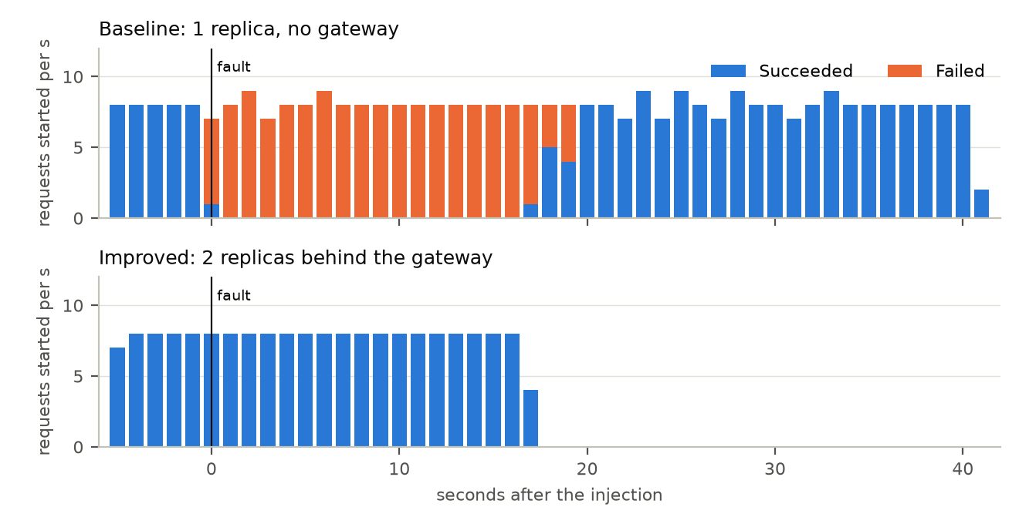
Figure 5. Exp 1 rep 1 (graceful delete): requests per second by outcome, from the raw records. The baseline fails for about 25 s although its endpoint returned at 0.9 s; the improved configuration shows no failed request.
Hypothesis held for improved; baseline worse than the plan expected. The improved configuration failed no request in 3 runs; one request failed over in the gateway log (502, 200). The baseline's graceful delete caused a 25.0–25.6 s outage although endpoints returned in 0.9–1.1 s; the forced delete caused 2.0 s. Why a graceful delete takes longer than a forced one is not established. The plan expected an outage until the replacement was ready; the replacement was ready far sooner than the outage ended, and readiness on /health does not show that the pod can serve database requests. The endterm's explanation, pool starvation during start-up, was not tested here.
Correction. The endterm's 23 s was a lower bound, because that probe stopped while requests were still timing out. The run now records clients_settled_before_stop, true in all six runs, and measures 25.0–25.6 s.

10.4 Exp 2: database unavailable
Table 30. Exp 2 per run, during the outage. Latency in ms; recovery in s after the restore command; writes = acknowledged / rows; alert firing in s.
Run | Config | OK / total | p50 | p95 | max | Codes | Recovery | Writes | Alerts firing
rep1-stop | baseline | 24/130 | 12002.8 | 12014.2 | 12031.8 | 200:24, 500:15, timeout:91 | 8.0 | 34/34 | no rule
rep1-stop | improved | 5/138 | 20.0 | 5012.1 | 10015.8 | 200:5, 500:19, 503:114 | 4.0 | 34/34 | HighErrorRate 15.2, HighLatencyP95 15.2
rep2-stop | baseline | 45/114 | 11677.0 | 12013.4 | 12029.9 | 200:45, 500:16, timeout:53 | 3.2 | 38/38 | no rule
rep2-stop | improved | 1/123 | 8.8 | 5025.8 | 10012.7 | 200:1, 500:21, 503:101 | 12.3 | 39/39 | HighErrorRate 15.2, HighLatencyP95 15.2
rep3-freeze | baseline | 62/130 | 11999.7 | 12013.8 | 12020.2 | 200:62, timeout:66, 500:2 | 4.3 | 37/37 | no rule
rep3-freeze | improved | 17/138 | 8.1 | 5021.8 | 10010.5 | 200:17, 503:116, 500:5 | 7.4 | 38/38 | HighErrorRate 21.2, HighLatencyP95 21.2
rep4-freeze | baseline | 51/115 | 12001.8 | 12014.4 | 12028.6 | 200:51, timeout:64 | 3.9 | 34/34 | no rule
rep4-freeze | improved | 17/123 | 5005.9 | 9179.7 | 10011.0 | 200:17, 503:102, 500:4 | 7.3 | 35/35 | HighErrorRate 20.2, HighLatencyP95 20.2

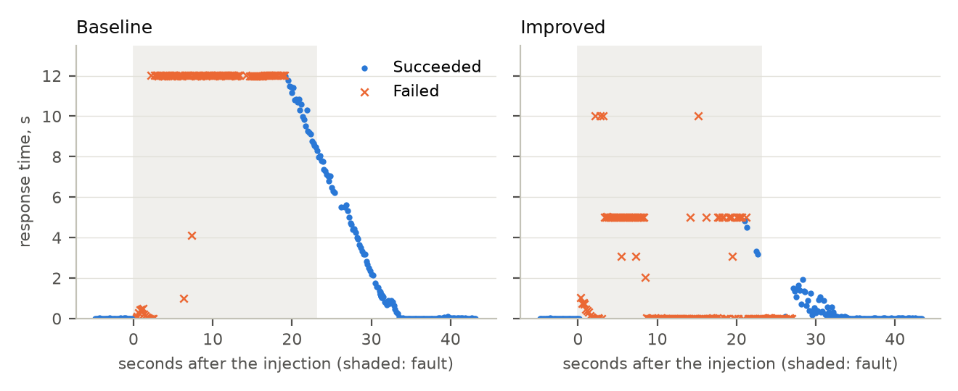
Figure 6. Exp 2 rep 1 (stop): response time of every GET, from the raw records. The improved configuration's failures end within 5–10 s or at once; the baseline's wait up to the 12 s client timeout.
The success ratio favours the baseline: 37 % vs 8 % during the outage, 75.28 % vs 50.56 % over the whole window. This must not be read as an availability gain for improved, and it is not a real gain for the baseline. No configuration can serve these reads with its only database down. The baseline's requests wait up to the 12 s client timeout, so some finish after the restore and count as successes. The gateway gives up within 10 s, and after one timeout max_fails=1 marks both replicas down, so later requests get a fast 503 (502 from no live upstreams). The improved gain is bounded response time: maximum 10.0 s and a machine-readable reply with Retry-After, against 12.0 s at the client's own limit. The price is fewer late successes and slower recovery after the restore (4.0–12.3 s vs 3.2–8.0 s). 188 requests were retried, only 12 of those succeeded on the other replica, and 569 got JSON 503. Both configurations recovered without intervention within the 30 s criterion, and all 146 and 143 acknowledged writes have exactly one row. Both alerts fired at 15.2–21.2 s, and correctly: requests really were slow and failing.

10.5 Exp 3: network delay or timeout (new)
Table 31. Exp 3 per run, during the fault. Latency in ms. Gateway retries all succeeded (504, 200). Client write retries are the writer's. Last slow = end of the last request over 200 ms after removal, s.
Config | Rep | Delayed packets | OK / total | p50 | p95 | max | Gateway retries | Client write retries | Last slow | Alerts firing (s)
baseline | 1 | 988 | 31/82 | 18035.5 | 32048.1 | 34030.4 | – | 287 | 1.1 | no rule
baseline | 2 | 1075 | 75/83 | 10011.0 | 18641.6 | 22371.9 | – | 393 | 0.5 | no rule
baseline | 3 | 1066 | 67/82 | 10011.3 | 19686.4 | 25528.4 | – | 321 | 0.7 | no rule
improved | 1 | 308 | 82/82 | 10.0 | 5013.4 | 5028.9 | 11 | 5 | 0.0 | HighErrorRate 22.2, HighLatencyP95 22.2
improved | 2 | 285 | 82/82 | 10.1 | 5010.1 | 5083.2 | 8 | 8 | 9.8 | HighErrorRate 36.5, HighLatencyP95 24.4
improved | 3 | 319 | 83/83 | 10.7 | 5011.2 | 5037.8 | 12 | 5 | 0.0 | HighErrorRate 32.3, HighLatencyP95 23.2

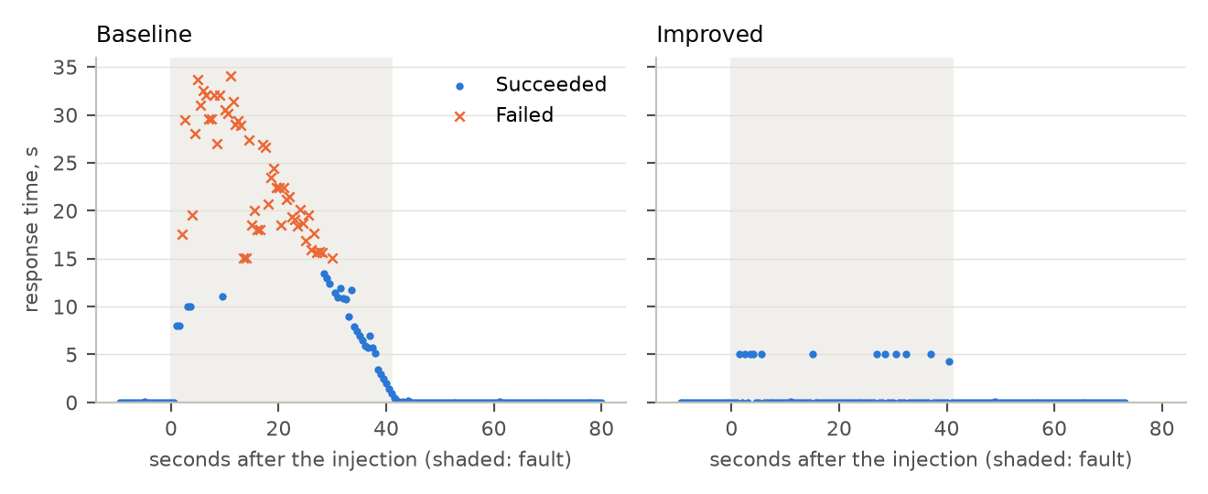
Figure 7. Exp 3 rep 1: response time of every GET. Improved: requests on the slow replica are cut at 5 s and retried, the rest stay near 10 ms. Baseline: nothing bounds the wait until connections are closed.
Baseline hypothesis failed. The plan predicted 8–10 s per request. Measured p50 was 10.0–18.0 s, maximum 34 s, and 30 % failed (74 of 247), as connections closed by the server without a response. A likely reason is the API's 15 s WriteTimeout, but this is a hypothesis, not tested. A confounder is the client's 1001 write retries, mostly 429 from the 60 creates/min route limit, which add load on the baseline (18 on improved). Improved passed: 247/247, maximum 5.08 s against the 12 s bound, at most 2 tries, 31 retries all 504, 200. Readiness did not remove the slow replica, as predicted, because /health does not touch the database. The 9.84 s recovery in one run comes from one 235 ms request after the removal, just over the 200 ms threshold; the others give 3.78 s and 1.42 s.
False-positive trade-off. ApiHighErrorRate fired in all three improved runs, though clients saw no failure: the API records a request the gateway timed out as a 500 (Listing 2 shows one, with the client's 200 beside it). ApiHighLatencyP95 fired too, correctly. In two runs the error alert was pending, cleared and returned before firing.

10.6 Exp 4: interrupted multi-step transaction (new)
Table 32. Exp 4 per run. Insert done and Committed are read from pg_locks and the table at the moment of the kill.
Config | Rep | Insert done | Committed | Container restarts | Client tries | Retry OK (s) | Probe OK / total | Rows for id | Rows on account | Balance / expected | DB dup | Alerts firing (s)
baseline | 1 | True | 0 | 5 -> 6 | 5 | 3.6 | 119/127 | 1 | 3/3 | -306 / -306 | 0 | no rule
baseline | 2 | True | 0 | 6 -> 7 | 6 | 22.2 | 93/127 | 1 | 3/3 | -306 / -306 | 0 | no rule
baseline | 3 | True | 0 | 7 -> 8 | 7 | 34.1 | 65/146 | 1 | 3/3 | -306 / -306 | 0 | no rule
improved | 1 | True | 0 | 2 -> 3 | 2 | 1.7 | 127/127 | 1 | 3/3 | -306 / -306 | 0 | none
improved | 2 | True | 0 | 3 -> 4 | 2 | 1.3 | 122/122 | 1 | 3/3 | -306 / -306 | 0 | ReplicaDown 10.6
improved | 3 | True | 0 | 4 -> 5 | 2 | 1.2 | 127/127 | 1 | 3/3 | -306 / -306 | 0 | ReplicaDown 9.6

Hypothesis held on integrity, and it does not separate the configurations. Idempotency and the transaction live in the application, so both have them. Each process was killed with the insert done and nothing committed; Postgres logged unexpected EOF on client connection with an open transaction; each retry was answered 201, so the first attempt really was rolled back. The difference is retry time and probes: improved retries succeed in 1.2–1.7 s through the other replica, and its probe stays at 376/376. The gateway does not replay the POST; the client's retry does the recovery. Baseline retry time grew 3.6 → 22.2 → 34.1 s with restart count. Kills were about 44 s apart, which likely puts the container into kubelet's restart back-off [7], so 3.6 s is the fair figure for a first crash. The back-off also shows on improved (endpoints back at 1.5, 19.0 and 31.3 s), where the other replica hides it; ApiReplicaDown fired in two of those runs, correctly.

10.7 Exp 5: high load
Table 33. Exp 5, 60 s step at 30 req/s (1800 requests per run). Latency in ms. CPU in millicores per API pod, one sample per run.
Config | Rep | 200 | 429 | Conn. errors | OK req/s | p50 | p95 | max | API CPU | Alerts
baseline | 1 | 1264 | 516 | 20 | 21.07 | 8.4 | 769.7 | 2034.2 | 61.2 | none
baseline | 2 | 1215 | 564 | 21 | 20.25 | 8.4 | 1094.8 | 2292.1 | 61.6 | none
improved | 1 | 1800 | 0 | 0 | 30.0 | 9.2 | 25.7 | 88.7 | 34.3, 29.2 | none
improved | 2 | 1800 | 0 | 0 | 30.0 | 9.6 | 28.5 | 165.7 | 38.1, 37.3 | none

The plan's hypothesis that the baseline also holds this rate failed, and the failure is the limiter, not capacity. API CPU stayed near 61.2–61.6 millicores. 1080 of 3600 requests got 429 once the 1200/min per-process limit ran out, 36–39 s into the step, which is why the baseline row fails (98.37 % excluding 429, p95 769.7–1094.8 ms). The improved configuration avoids this only because each replica counts separately (900/min each): its limit is effectively doubled, not shared. The improvement is therefore partly an artefact of the limiter, and this experiment does not show that two replicas add capacity that was needed. The cause of the 41 connection errors is not established; they appear only while the limiter is active. At low load the gateway costs little: warm-phase p50 is 9.9 ms against 9.1–9.3 ms.

10.8 Exp 6: monitoring and alert trigger
Table 34. Exp 6 per run. Latency in ms; alert times in s after the injection.
Run | Expected alert | OK / total | p95 | max | Alerts
quiet-window-rep1 | none | 600/600 | 27.4 | 94.0 | none seen
quiet-window-rep2 | none | 600/600 | 23.3 | 78.9 | none seen
replica-down-rep1 | ApiReplicaDown | 339/350 | 89.3 | 5028.3 | ReplicaDown: firing 11.2, clear 53.0
replica-down-rep2 | ApiReplicaDown | 356/369 | 71.4 | 5009.2 | ReplicaDown: firing 11.2, clear 55.5
replica-down-rep3 | ApiReplicaDown | 347/357 | 31.9 | 5027.8 | ReplicaDown: firing 12.2, clear 52.6
error-rate-rep1 | ApiHighErrorRate | 6/152 | 5009.2 | 10007.7 | HighErrorRate: firing 16.2, clear 53.4; HighLatencyP95: firing 22.2, clear 57.5
error-rate-rep2 | ApiHighErrorRate | 3/151 | 5018.7 | 10024.7 | HighErrorRate: firing 14.2, clear 54.5; HighLatencyP95: firing 20.2, clear not recorded
latency-rep1 | ApiHighLatencyP95 | 240/240 | 1421.0 | 1510.7 | HighLatencyP95: firing 16.2, clear 69.8
latency-rep2 | ApiHighLatencyP95 | 240/240 | 1411.6 | 1519.3 | HighLatencyP95: firing 16.2, clear 70.7

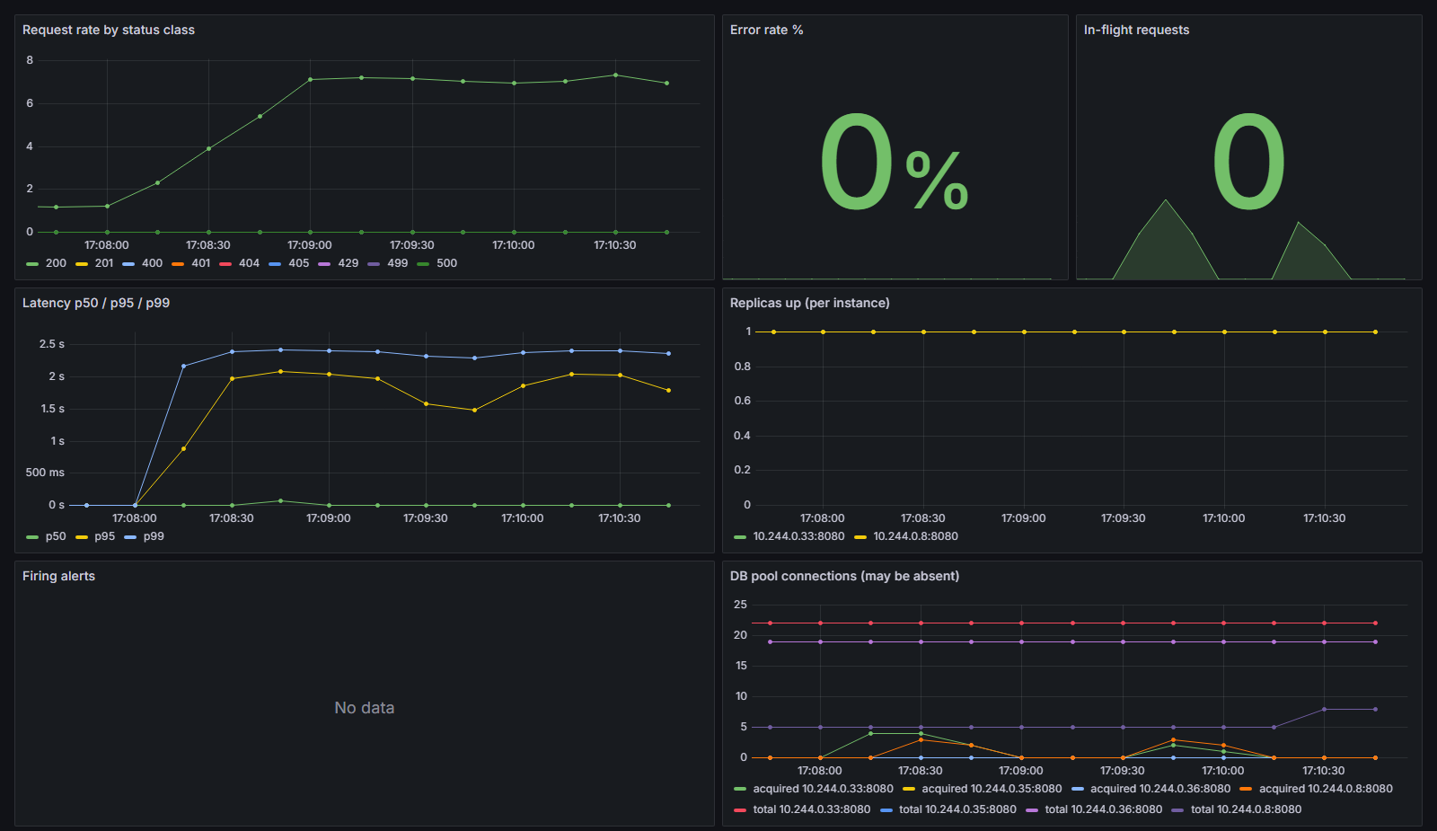
Figure 8. Grafana during the Exp 6 lock bursts: latency rises with no failed request, ApiHighLatencyP95 fires.
Hypothesis held. Each fault fired its alert within 45 s (11.2–16.2 s) and cleared after recovery; no alert fired in either quiet window. A database outage also fires ApiHighLatencyP95, which is correct: requests really were slow. In error-rate rep 2 that secondary alert's clear time was not recorded; the primary's was.
Hung replica: not all requests failed over. 34 of 1076 requests got a 503 after 5 s, with a single try (504) and no failover, all within about 5 s of the fault. Exp 3's slow replica did fail over. A hypothesis, not tested, is that readiness removed the hung replica from DNS while those requests were in flight, leaving nginx no other peer for them. The replica left endpoints at 2.4–2.7 s and returned at 43.2–45.8 s after the liveness restart.

10.9 Exp 7: unauthorized or invalid operation
Table 35. Exp 7 access control, rep 1. Rep 2 gave the same statuses.
Case | Status | Expected | As expected
no token GET /api/accounts | 401 | 401 | yes
no token POST /api/transactions | 401 | 401 | yes
garbage token GET /api/households | 401 | 401 | yes
token signed with wrong secret | 401 | 401 | yes
B reads A's accounts (X-Household-ID=A) | 404 | 404 | yes
B reads A's transactions | 404 | 404 | yes
B creates expense on A's account | 404 | 404 | yes
B deletes A's account | 404 | 404 | yes
B uses own household but A's account id | 400 | 4xx refusal | yes
B GET /api/households/{A} | 405 | 404 | no
A reads own accounts (control) | 200 | 200 | yes

Recorded result: FAIL, 20 of 22 cases as expected. The 2 failed cases are one case in both repetitions: B GET /api/households/{A} expected 404 and got 405, because that route has no GET. Nothing was disclosed: the body is empty. The case tests routing, not tenant isolation. The expected value was wrong, but it stays as written before the run, and the result is not re-scored. The other cases show tenant isolation enforced: 401 for missing, garbage or forged tokens, 404 for all of user B's attempts on A's record space, and a 400 refusal for A's account id used from B's own household. The md5 snapshot of the victim's data is unchanged, and 22/22 requests are in both logs.
Table 36. Exp 7 input and limit cases, rep 1 (rep 2 the same). 38/38 cases as expected over both reps.
Case | Status | Retry-After
malformed JSON POST /api/accounts | 400 | –
malformed JSON POST /api/transactions | 400 | –
negative amount | 400 | –
invalid UUID in path | 400 | –
3 MB body via gateway | 413 | –
1.5 MB body via gateway (API's own 1 MB decode limit) | 400 | –
correct password after the burst | 429 | 900

Twelve wrong passwords gave [401, 401, 401, 401, 401, 401, 401, 401, 401, 401, 429, 429]: first 429 at attempt 11, not 6, because each replica counts its own 5 failures (a weakness the threat model predicted). The correct password afterwards still got 429 with Retry-After: 900. Background probes stayed OK (39/39 and 40/40). The 3 MB bodies stop at the gateway with JSON 413, which is why those 2 requests are missing from the API log (36/38 in the API log, 38/38 at the gateway). Finding: on the baseline the API logged remote=203.0.113.77, an address chosen by the client, and therefore a fresh limiter and lockout key per request; through the gateway it logged 10.244.0.1. Failed logins have no dedicated audit event, only the request line.

10.10 Exp 8: recovery and rollback (new)
Table 37. Exp 8 per run. Latency in ms; readiness failure in s after the release; bad pod gone in s after the undo.
Config | Rep | OK / total | p50 | p95 | max | Readiness failure | Bad pod gone | Writes | DB dup | Restored | Alerts
baseline | 1 | 237/237 | 8.5 | 26.1 | 213.9 | 2.4 | 0.76 | 49/49 | 0 | yes | none
baseline | 2 | 242/242 | 8.7 | 26.4 | 139.0 | 2.1 | 1.94 | 49/49 | 0 | yes | none
improved | 1 | 265/265 | 9.9 | 51.5 | 196.2 | 2.4 | 6.11 | 52/52 | 0 | yes | none
improved | 2 | 265/265 | 9.4 | 101.6 | 1019.5 | 2.2 | 6.49 | 52/52 | 0 | yes | none

Both pass, and this experiment shows no gain from the improved configuration, as the plan predicted: a default RollingUpdate with 1 replica rounds maxUnavailable down to 0 and maxSurge up to 1 [6], so it keeps the old pod. The improved bad pod takes longer to go (6.11–6.49 s vs 0.76–1.94 s) because of the preStop sleep 5. No alert noticed the stuck rollout in any run: a monitoring gap. Separately, the first run of the same broken release at the 256 Mi Postgres limit was a real outage (3.61 % availability), kept as evidence that the database is a single point of failure (Section 9.5).

10.11 Data consistency, retries and objectives
Table 38. Data consistency across all write runs: no acknowledged write lost or duplicated in any valid run of either config.
Exp | Config | Runs | Acknowledged | Rows | Duplicates in database | Balance = −Σ
2 | baseline | 4 | 143 | 143 | 0 | yes
2 | improved | 4 | 146 | 146 | 0 | yes
3 | baseline | 3 | 165 | 165 | 0 | yes
3 | improved | 3 | 165 | 165 | 0 | yes
4 | baseline | 3 | 90 | 90 | 0 | yes
4 | improved | 3 | 86 | 86 | 0 | yes
8 | baseline | 2 | 98 | 98 | 0 | yes
8 | improved | 2 | 104 | 104 | 0 | yes

Table 39. Measured outcome per service-level objective (improved configuration).
SLO | Target | Measured | Outcome
SLO-1 steady availability | ≥ 99.5 % | 1200/1200 in quiet windows (Exp 6) | Met
SLO-2 during instance loss | ≥ 99 % | 418/418 (Exp 1) | Met
SLO-3 latency at 30 req/s | p95 ≤ 500 ms | 25.7–28.5 ms (Exp 5) | Met, with the limiter caveat
SLO-4 bounded failure latency | GET ≤ 10.5 s; POST ≤ 5.5 s | GET max 10.016 s (Exp 2), 5.08 s (Exp 3). POST was not separated in the results | GET met; POST not measured separately
SLO-5 recovery | ≤ 10 s instance; ≤ 30 s database | 1.3–1.7 s (Exp 1); 4.0–12.3 s (Exp 2); 6.11–6.49 s (Exp 8) | Met
SLO-6 write integrity | 0 lost, 0 duplicates, balance check | All runs (table above) | Met; application mechanism, present in both configs
SLO-7 detection | ≤ 30 s, no false positive in quiet | 11.2–16.2 s (Exp 6); 0 alerts in quiet | Met; but a false positive under fault in Exp 3, and a rollout gap in Exp 8
SLO-8 access control | 100 % denied, 0 rows changed, logged | Isolation enforced, snapshot unchanged, 22/22 logged. Exp 7 recorded FAIL on one mis-specified case | Recorded FAIL; see 10.9
SLO-9 backup recoverability | 0 records lost since dump | No restore run in this project | Not tested

Table 40. Hypotheses against results.
Exp | Hypothesis | Result
1 | Improved: at most a few failures. Baseline: outage until the replacement is ready | Improved held. Baseline outage outlasted readiness by far; cause not established
2 | Both fail and recover with no lost write; improved bounded, baseline waits; alert fires | Held. Success ratio favours the baseline; explained in 10.4
3 | Improved bounded and retried; baseline 8–10 s per request | Improved held. Baseline failed: p50 10–18 s, 30 % failed
4 | One row after retry in both; improved retry 1–2 s; baseline after restart | Held; integrity does not separate the configs
5 | Improved p95 < 500 ms; baseline also holds the rate | Improved held. Baseline part failed, by the limiter
6 | Each fault fires its alert ≤ 45 s; none in quiet | Held; 34 of 1076 got 503 with no failover
7 | Expected statuses; data unchanged; logged; spoof not honoured through the gateway | Held except the expected value of one case: recorded FAIL
8 | No failed request; baseline probably the same; monitoring will not notice | Held in all three parts: no gain from improved

10.12 Measured results against theory
Section 5.4 is illustrative; everything else is measured. The formula assumes independent failures and instant failover, and the measurements show otherwise. Both API replicas fail together when the shared database is lost (Exp 2), so redundancy gives nothing there. A replacement pod can be Ready before it can serve (Exp 1 baseline). Passive ejection likely delays recovery after a database restore (4.0–12.3 s vs 3.2–8.0 s). A request in flight on a hung replica may get no failover (Exp 6). The measured A values, such as 55.95 % or 44.95 %, cannot be compared with the illustrative 0.999: they describe short windows built around a deliberate fault, and the illustrative figure describes a long-run process that was not observed.

10.13 Trade-offs
Table 41. Trade-offs of the improved configuration, measured unless marked.
Trade-off | Evidence
Fewer late successes during a dependency outage | Exp 2: 8 % vs 37 % during the outage; response bounded at 10.0 s
Slower recovery after a database restore | Exp 2: 4.0–12.3 s vs 3.2–8.0 s
False-positive alert | Exp 3: ApiHighErrorRate fired in 3 of 3 runs while clients saw no failure
Slower shutdown | Exp 8: bad pod gone in 6.11–6.49 s vs 0.76–1.94 s (preStop)
Added latency | Exp 5 warm phase p50: 9.9 ms vs 9.1–9.3 ms. Retried requests cost about 5 s (Exp 3)
Resources | Configured limits: 2 API + 2 gateways, 1600 m CPU and 768 Mi, against 500 m and 256 Mi (from the manifests). Sampled in the Exp 5 step: API 29.2–38.1 m per pod, gateway 10.9–13.9 m per pod, baseline API 61.2–61.6 m
Complexity | Gateway config with timeouts, retries, per-pod DNS; rules can be wrong, as the endterm's ApiReplicaDown was
Limiter behaviour changes with replica count | Exp 5, Exp 7: effective limits double, lockout needs more attempts

11. Discussion, Limitations and Future Work

11.1 What the evidence supports
Redundancy with a retrying gateway turns the loss of one instance from an outage into no visible failure (Exp 1), and gateway timeouts bound the damage of one slow replica (Exp 3). Alerts detect a hung replica, a lost database and contention in 11–16 s, and stay silent in quiet windows (Exp 6). Correct records survived every injected fault in both configurations, thanks to the application's transaction and idempotency key, which are not improvements of this project's configuration. The clearest mechanism-level value is in Exp 1, Exp 3 and the retry time of Exp 4.

11.2 What the evidence does not support
- Availability during a database outage. Improved is lower on success ratio; the gain is bounded response time.
- Capacity from two replicas. Exp 5 is confounded by a per-process limiter.
- Rollback safety from the improved configuration. Exp 8 shows no gain over the Kubernetes default.
- Failure rates. MTTF, MTBF and λ reflect injection timing.
- Causes marked as hypotheses or not established: the graceful-delete outage in Exp 1, the WriteTimeout in Exp 3, the 41 connection errors in Exp 5, the DNS explanation in Exp 6, kubelet back-off in Exp 4, and memory pressure as the cause of the Postgres OOM run.

11.3 Limitations
- One node, one laptop. All replicas share one host, and the load generator runs on it. Pod-level faults cannot show node failure, and replicas on one node do not protect against node failure.
- PostgreSQL remains a single point of failure. There is no replica; only restart in place and an earlier manual backup drill. SLO-9 was not tested.
- Small repetition counts (2–4 per scenario): ranges describe behaviour, not statistics, and no confidence intervals are claimed. Exp 3 runs differ widely even within a config, and Exp 4 baseline runs affect each other through restart back-off.
- Shared environment. Both configurations share one database, and baseline and improved pods stay deployed during each other's runs. Exp 2 probes both at once, which is fair for the fault but puts both loads on one recovering database.
- Test defects kept as they are: one wrong expected value (Exp 7) and a bad kill in the first Exp 4 runs.
- Tests cited, not run: integration and API tests. M1 and M4 have no Go test.
- Reproduction needs the images. The API image is built from hoWallet at 06aea177 plus the metrics patch; the application source and the patch are private, available on request (Appendix 14.4).

11.4 Future work
- A database replica with failover, or at least scheduled backups with a timed restore drill, to address the SPOF and SLO-9.
- A separate startup gate or database-aware readiness, and an experiment that finds the cause of the graceful-delete outage.
- Shared rate-limit and lockout counters, then a repeat of Exp 5 with the limiter removed from the comparison.
- A statement_timeout and a pool-acquire timeout, so a blocked database fails inside the API.
- An alert on stuck rollouts, and an error-rate alert computed at the gateway, to remove the Exp 3 false positive.
- More repetitions on several nodes, with a load generator on another machine.

12. Conclusion
The dependability objectives were met for instance failure, bounded response under delay, write integrity, detection and recovery time, with the caveats given per objective. SLO-9 was not tested, and Exp 7 stands as a recorded FAIL for a wrong expected value. The improved configuration clearly helps when one instance fails or slows down. It does not make a database outage more available; it changes how that outage looks to the client. It gains nothing measurable in the rollback experiment, its load result is partly a limiter artefact, and it adds a false-positive alert. The main residual risk is the single PostgreSQL instance, and the lab's single node limits every availability claim to pod-level faults.

13. References
[1] A. Avizienis, J.-C. Laprie, B. Randell, C. Landwehr, "Basic Concepts and Taxonomy of Dependable and Secure Computing," IEEE Transactions on Dependable and Secure Computing, vol. 1, no. 1, pp. 11–33, 2004. doi:10.1109/TDSC.2004.2
[2] B. Beyer, C. Jones, J. Petoff, N. R. Murphy (eds.), Site Reliability Engineering: How Google Runs Production Systems, O'Reilly, 2016. Ch. 4 "Service Level Objectives", ch. 6 "Monitoring Distributed Systems", ch. 21 "Handling Overload". https://sre.google/sre-book/table-of-contents/
[3] M. T. Nygard, Release It! Design and Deploy Production-Ready Software, 2nd ed., Pragmatic Bookshelf, 2018. Stability patterns: timeouts, circuit breakers, bulkheads.
[4] J. A. Hanley, A. Lippman-Hand, "If Nothing Goes Wrong, Is Everything All Right? Interpreting Zero Numerators," JAMA, vol. 249, no. 13, pp. 1743–1745, 1983. doi:10.1001/jama.1983.03330370053031 (rule of three).
[5] Kubernetes documentation, "Liveness, Readiness, and Startup Probes." https://kubernetes.io/docs/concepts/configuration/liveness-readiness-startup-probes/
[6] Kubernetes documentation, "Deployments" (rolling update, maxSurge rounded up, maxUnavailable rounded down, rollback). https://kubernetes.io/docs/concepts/workloads/controllers/deployment/
[7] Kubernetes documentation, "Pod Lifecycle" (termination, preStop hooks, container restart back-off of 10 s, 20 s, 40 s, capped at 300 s). https://kubernetes.io/docs/concepts/workloads/pods/pod-lifecycle/
[8] Kubernetes documentation, "Network Policies." https://kubernetes.io/docs/concepts/services-networking/network-policies/
[9] kind documentation, "Quick Start." https://kind.sigs.k8s.io/docs/user/quick-start/
[10] nginx documentation, "Module ngx_http_proxy_module" (proxy_next_upstream, proxy_next_upstream_tries, proxy_connect_timeout, proxy_read_timeout). https://nginx.org/en/docs/http/ngx_http_proxy_module.html
[11] nginx documentation, "Module ngx_http_upstream_module" (server … resolve, open source since 1.27.3, max_fails, fail_timeout). https://nginx.org/en/docs/http/ngx_http_upstream_module.html
[12] Linux manual page, "tc-netem(8)." https://man7.org/linux/man-pages/man8/tc-netem.8.html
[13] PostgreSQL 16 documentation, "3.4. Transactions." https://www.postgresql.org/docs/16/tutorial-transactions.html
[14] PostgreSQL 16 documentation, "pg_dump." https://www.postgresql.org/docs/16/app-pgdump.html
[15] Prometheus documentation, "Alerting rules." https://prometheus.io/docs/prometheus/latest/configuration/alerting_rules/
[16] A. Shostack, Threat Modeling: Designing for Security, Wiley, 2014. STRIDE.
[17] OWASP, "OWASP Top 10 API Security Risks – 2023." https://api-security.owasp.org/editions/2023/en/0x11-t10/
[18] go-chi/chi v5.3.0 and go-chi/httprate v0.15.0 (HTTP router, rate limiter), jackc/pgx v5.9.2 (PostgreSQL driver), shopspring/decimal v1.4.0 (money arithmetic). https://github.com/go-chi/chi, https://github.com/go-chi/httprate, https://github.com/jackc/pgx, https://github.com/shopspring/decimal. Versions: go.mod at commit 06aea177.

14. Appendix: Code Repository, Configuration, Test Scripts, Logs and Supplementary Tables

14.1 Repository layout
ftr-final/
README.md reproduction steps, ports, gateway behaviour
run_all.sh one command: all eight experiments, then the summary
kind-config.yaml, Dockerfile.migrate
k8s/ 00-namespace, 10-postgres, 20-migrate-job, 30-api, 40-gateway, 50-prometheus, 60-grafana,
70-network-policy; baseline/api-baseline.yaml; optional/block-egress.yaml
scripts/ run_exp.py, faults.py, final.py, exps.py, ftlab.py, build_summary.py, log_samples.py, demo.py,
setup_users.py, up.sh, down.sh, architecture.html, grafana_shot.py
analysis/ reliability.py, reliability-computed.json, ft-unit-tests.txt
notes/ requirements, reliability, architecture, software-ft, threat-model, security-controls,
graceful-degradation, test-inventory, references
evidence/ test-plan.md, anomalies.txt, log-samples.txt, exp1..8.txt, results/, screenshots/, endterm-results/
report/ this report, slides, demo-runbook.md, build_report.py, build_deck.js, fig/
The repository is a local git repository. evidence/token.txt and evidence/lab-users.json are git-ignored. Secrets in k8s/00-namespace.yaml and the password in scripts/ftlab.py are synthetic lab placeholders, and the JWT in scripts/exps.py is the deliberately forged test token of Exp 7 (subject all zeros, signed with a wrong secret). No real credential is included.

14.2 One-command reproduction
bash scripts/up.sh --baseline # create the cluster, load images, apply manifests, wait for Ready
python scripts/setup_users.py # synthetic users; tokens go to the git-ignored evidence/lab-users.json (valid 24 h)
bash run_all.sh # all eight experiments, about 1 hour, then evidence/results/summary.md
python analysis/reliability.py --json-out analysis/reliability-computed.json # reliability table
python report/build_report.py # this report (needs Word for the PDF; --no-pdf for DOCX only)
bash scripts/down.sh # delete the cluster
A single experiment: python scripts/run_exp.py <1..8> [rep ...]. Rerunning a repetition overwrites its JSON.

14.3 Raw data locations
Table 42. Where each kind of evidence lives.
What | Where
Hypotheses, criteria, amendments | evidence/test-plan.md
Readable record per experiment | evidence/exp1.txt … exp8.txt
Raw per-request records and per-run results | evidence/results/exp*.json
Consolidated table and reading notes | evidence/results/summary.md
Inputs and computed reliability values | evidence/results/reliability-inputs.json, analysis/reliability-computed.json
Excluded and set-aside runs | *-INVALID-*.json, results/pre-pg-memory-fix/, results/superseded/, evidence/anomalies.txt
Log samples with correlation ids | evidence/log-samples.txt
Dashboards and firing alerts | evidence/screenshots/
Unit test output for the mechanisms | analysis/ft-unit-tests.txt
Endterm data, for reference only | evidence/endterm-results/

14.4 Building the images
scripts/up.sh needs local images howallet-api:endterm and ftr-migrate:endterm. The API image is built from the hoWallet repository at commit 06aea177 with the opt-in /metrics patch applied (commit 60cd5791 on feat/metrics), using its deployments/Dockerfile.api. The application source and the patch are private and not in this repository; they are available to the instructor on request. Without them, the instructor can inspect the configuration, scripts and raw data, and the demonstration runs on the author's machine.

14.5 Supplementary: reliability per run
Table 43. Reliability quantities per repetition (python analysis/reliability.py --per-run).
Exp | Config | Run | T_obs (s) | N_f | D (s) | MTTR (s) | A | ok / failed | R_req
1 | baseline | exp1-baseline-rep1-graceful | 46.1 | 1 | 25.6 | 25.6 | 44.44 % | 221 / 149 | 59.73 %
1 | baseline | exp1-baseline-rep2-graceful | 46.1 | 1 | 25.0 | 25.0 | 45.78 % | 226 / 144 | 61.08 %
1 | baseline | exp1-baseline-rep3-crash | 27.3 | 1 | 2.0 | 2.0 | 92.63 % | 210 / 9 | 95.89 %
1 | improved | exp1-improved-rep1-graceful | 22.3 | 0 | 0.0 | – | 100.00 % | 179 / 0 | 100.00 %
1 | improved | exp1-improved-rep2-graceful | 22.1 | 0 | 0.0 | – | 100.00 % | 178 / 0 | 100.00 %
1 | improved | exp1-improved-rep3-crash | 22.3 | 0 | 0.0 | – | 100.00 % | 179 / 0 | 100.00 %
2 | baseline | exp2-rep1-stop | 48.0 | 1 | 30.7 | 30.7 | 36.10 % | 183 / 106 | 63.32 %
2 | baseline | exp2-rep2-stop | 55.5 | 1 | 23.4 | 23.4 | 57.90 % | 265 / 69 | 79.34 %
2 | baseline | exp2-rep3-freeze | 54.0 | 1 | 24.5 | 24.5 | 54.58 % | 257 / 68 | 79.08 %
2 | baseline | exp2-rep4-freeze | 49.5 | 1 | 24.1 | 24.1 | 51.38 % | 233 / 65 | 78.19 %
2 | improved | exp2-rep1-stop | 48.2 | 1 | 26.7 | 26.7 | 44.65 % | 136 / 154 | 46.90 %
2 | improved | exp2-rep2-stop | 55.7 | 1 | 32.5 | 32.5 | 41.61 % | 171 / 164 | 51.04 %
2 | improved | exp2-rep3-freeze | 54.2 | 1 | 27.7 | 27.7 | 48.93 % | 164 / 162 | 50.31 %
2 | improved | exp2-rep4-freeze | 49.7 | 1 | 27.5 | 27.5 | 44.65 % | 161 / 138 | 53.85 %
3 | baseline | exp3-baseline-rep1 | 89.5 | 1 | 43.1 | 43.1 | 51.88 % | 129 / 51 | 71.67 %
3 | baseline | exp3-baseline-rep2 | 93.0 | 1 | 22.9 | 22.9 | 75.39 % | 179 / 8 | 95.72 %
3 | baseline | exp3-baseline-rep3 | 85.5 | 1 | 35.5 | 35.5 | 58.44 % | 157 / 15 | 91.28 %
3 | improved | exp3-improved-rep1 | 82.5 | 0 | 0.0 | – | 100.00 % | 166 / 0 | 100.00 %
3 | improved | exp3-improved-rep2 | 82.5 | 0 | 0.0 | – | 100.00 % | 166 / 0 | 100.00 %
3 | improved | exp3-improved-rep3 | 82.5 | 0 | 0.0 | – | 100.00 % | 166 / 0 | 100.00 %
4 | baseline | exp4-baseline-rep1 | 39.0 | 1 | 1.8 | 1.8 | 95.49 % | 149 / 8 | 94.90 %
4 | baseline | exp4-baseline-rep2 | 39.0 | 1 | 20.2 | 20.2 | 48.09 % | 123 / 34 | 78.34 %
4 | baseline | exp4-baseline-rep3 | 43.5 | 1 | 32.8 | 32.8 | 24.73 % | 94 / 81 | 53.71 %
4 | improved | exp4-improved-rep1 | 39.0 | 0 | 0.0 | – | 100.00 % | 157 / 0 | 100.00 %
4 | improved | exp4-improved-rep2 | 37.5 | 0 | 0.0 | – | 100.00 % | 151 / 0 | 100.00 %
4 | improved | exp4-improved-rep3 | 39.1 | 0 | 0.0 | – | 100.00 % | 157 / 0 | 100.00 %
5 | baseline | exp5-baseline-rep1 | 120.2 | 3 | 2.6 | 0.9 | 97.83 % | 1560 / 20 | 98.73 %
5 | baseline | exp5-baseline-rep2 | 120.2 | 3 | 3.6 | 1.2 | 97.01 % | 1517 / 21 | 98.63 %
5 | improved | exp5-improved-rep1 | 120.2 | 0 | 0.0 | – | 100.00 % | 2102 / 0 | 100.00 %
5 | improved | exp5-improved-rep2 | 120.2 | 0 | 0.0 | – | 100.00 % | 2102 / 0 | 100.00 %
6 | improved | exp6-error-rate-rep1 | 66.2 | 1 | 27.5 | 27.5 | 58.43 % | 240 / 158 | 60.30 %
6 | improved | exp6-error-rate-rep2 | 64.2 | 1 | 27.2 | 27.2 | 57.65 % | 226 / 160 | 58.55 %
6 | improved | exp6-latency-rep1 | 78.2 | 0 | 0.0 | – | 100.00 % | 470 / 0 | 100.00 %
6 | improved | exp6-latency-rep2 | 78.2 | 0 | 0.0 | – | 100.00 % | 470 / 0 | 100.00 %
6 | improved | exp6-quiet-window-rep1 | 120.0 | 0 | 0.0 | – | 100.00 % | 600 / 0 | 100.00 %
6 | improved | exp6-quiet-window-rep2 | 120.0 | 0 | 0.0 | – | 100.00 % | 600 / 0 | 100.00 %
6 | improved | exp6-replica-down-rep1 | 63.2 | 1 | 9.7 | 9.7 | 84.69 % | 369 / 11 | 97.11 %
6 | improved | exp6-replica-down-rep2 | 66.2 | 1 | 8.8 | 8.8 | 86.64 % | 385 / 13 | 96.73 %
6 | improved | exp6-replica-down-rep3 | 64.2 | 1 | 8.0 | 8.0 | 87.52 % | 376 / 10 | 97.41 %
8 | baseline | exp8-baseline-rep1 | 73.4 | 0 | 0.0 | – | 100.00 % | 368 / 0 | 100.00 %
8 | baseline | exp8-baseline-rep2 | 73.4 | 0 | 0.0 | – | 100.00 % | 368 / 0 | 100.00 %
8 | improved | exp8-improved-rep1 | 78.0 | 0 | 0.0 | – | 100.00 % | 391 / 0 | 100.00 %
8 | improved | exp8-improved-rep2 | 78.0 | 0 | 0.0 | – | 100.00 % | 391 / 0 | 100.00 %

14.6 AI-generated architecture diagram: prompt
The architecture diagram (Section 6.1) was generated by an AI coding assistant (Claude Code) inside a longer working session, so the exact wording of the original request was not preserved. The prompt below reproduces it: given to the assistant together with the k8s/ manifests, it yields scripts/architecture.html, which is then rendered to report/fig/architecture.png. All facts on the diagram were checked by the author against the manifests.
Read the Kubernetes manifests in k8s/ (namespace, postgres, migrate job, api, gateway, prometheus,
grafana, network policies) and k8s/baseline/api-baseline.yaml. Draw the architecture of this lab as a
single self-contained HTML page with an inline SVG (1400 x 760, white background, Segoe UI), so it can
be rendered to PNG for a report. Use only facts from the manifests.
Show:
- a dashed frame for the single kind node and the namespace "university", noting the default-deny
ingress NetworkPolicy with an allowlist;
- the Client on the left (probe/load scripts, browser);
- the improved path on top: Gateway (NodePort 30080) with two nginx pods, then the api Deployment with
two pods (:8080, /health, /metrics), then PostgreSQL 16 (StatefulSet postgres-0, PVC, :5432,
migrated by a Job);
- under each box, its resilience settings in small text: gateway timeouts and retries (GET only),
JSON 503/413, X-Request-Id, X-Real-IP overwritten, body cap, per-pod DNS upstream; api replicas,
maxUnavailable 0, preStop, readiness and liveness probes, non-root and read-only rootfs, JWT, rate
limits, client_id idempotency;
- monitoring on the right: Prometheus (NodePort 30090, scrape interval, dns_sd per pod, 3 alert
rules) and Grafana (NodePort 30300, dashboard), with arrows "scrape /metrics" and "PromQL";
- the baseline path at the bottom: api-baseline, 1 replica, no preStop, no gateway, NodePort 30081
direct, no retries, no JSON 503, trusts X-Real-IP, scraped as job "api-baseline";
- that both paths share the same PostgreSQL, which is a single point of failure.
Label the arrows (HTTP, round robin + retry, pgx pool, "same database"). Use one colour per tier
(client grey, gateway blue, api green, database amber, monitoring violet, baseline red), a title on top and a
one-line subtitle explaining the two paths. Keep the text readable when the image is 17 cm wide.

