Endterm Project — Resilient University Information System
Fault-Tolerant University Registration/Records Service: Gateway, Observability, Security and Fault Injection
Astana IT University | Fault Tolerance and Dependable Computing | Academic Year 2026–2027
Student: Shamil Yakupov, ID 255193 | Instructor: Azamat Serek
Project period: 28 October – 4 November 2026 | Report date: 4 November 2026
Context note: all data in this project are synthetic. The system under test is a local Kubernetes lab; no real users, production systems or real university infrastructure were involved. The application is the hoWallet Go API, used (as in the midterm) only as a stand-in for a synthetic university service.
Abstract. The endterm extends the midterm Registration Service lab into a monitored, hardened deployment: an nginx API gateway with bounded retries and JSON degradation, two API replicas with probes and drain-on-shutdown, a Prometheus metrics endpoint added to the service, three alert rules, a Grafana dashboard, request correlation across the gateway and the API, and network segmentation. Eight experiments (six with fault injection or abnormal conditions, two security/misuse tests) were run on 4 November 2026 against both the endterm configuration and a retained single-replica baseline. A replica loss cost the baseline 137–138 of 139 requests (23 s outage) and the endterm none; a 20 s database outage was answered with a JSON 503 within the 5 s gateway cap instead of 12 s hangs; every acknowledged write was stored exactly once in all integrity checks. One alert rule was found to be unable to fire, was fixed and re-verified; other limitations are reported in Section 9.

1. Introduction and Relationship to the Midterm
The midterm lab (Assignment 3) deployed a synthetic AITU Registration Service on a local kind cluster and measured replica loss, total service loss and database unavailability. The service was the hoWallet Go API (a personal-finance tracker written by the author) running unchanged as a stand-in application. The endterm continues exactly that system: the hoWallet API keeps the role of the university Registration/Records service, PostgreSQL remains its data store, and all accounts, households and transactions are synthetic lab records. The domain words in logs and tables come from the code: a household is the tenant (one student's record space), an account is a ledger, and a transaction is a record write (for example a fee payment or a registration entry).
What changed since the midterm (all changes are in the lab manifests, except one opt-in metrics patch to the service):
Table 1. Midterm (A3) versus endterm configuration.
Aspect | Midterm (A3 lab) | Endterm (this report)
Entry point | Kubernetes Service / NodePort straight to the API | nginx gateway x2 (NodePort 30080): timeouts, bounded retries, JSON 503/413, correlation id, client-IP sanitising
API replicas | 2, readiness/liveness on /health, preStop added at the end of A3 | 2, maxUnavailable 0, preStop sleep 5, anti-affinity, hardened pod (non-root, read-only rootfs)
Observability | kubectl and client-side probe only | GET /metrics in the API (feat/metrics), Prometheus (2 s scrape), Grafana dashboard, 3 alert rules, JSON logs joined by request id
Security | application controls only | + NetworkPolicies (default-deny ingress, API egress allow-list), gateway body limit, X-Real-IP overwrite, threat model
Testing | 3 manual failure simulations | 8 scripted experiments with acceptance criteria, 2–6 repetitions, integrity checks in SQL
Baseline kept | – | api-baseline: 1 replica, no preStop, no gateway, direct NodePort 30081, same image and database

The baseline deliberately keeps the midterm's direct exposure and drops the A3 hardening (one replica, no preStop), so that it represents the system before the resilience work and the comparison isolates the endterm mechanisms. Both configurations run side by side in one cluster, use the same image (howallet-api:endterm) and the same database, and are probed at the same time where possible.

1.1 Rubric and requirement traceability
Table 2. Traceability: requirement → report section → evidence (paths relative to the repository root).
Requirement (assignment section) | Section | Evidence file(s)
Containerised services, replicas, health checks, restart strategy (5) | 3.1, 3.5 | k8s/30-api.yaml, evidence/02-get-all.txt
API gateway, load balancing, timeouts, bounded retries (3, 5) | 3.3 | k8s/40-gateway.yaml
Service discovery / configuration (3) | 3.1 | k8s/30-api.yaml (headless Service), k8s/50-prometheus.yaml
Graceful degradation of a non-critical feature (5) | 3.4, 8.7 | evidence/e8-graceful-degradation.txt
Instance failure demonstrated (3) | 8.2 | evidence/e1-replica-failure.txt, results/e1-*.json
≥ 3 metrics (5) | 4.1 | patch/feat-metrics.diff, evidence/03-targets.txt
Structured logs, correlation ids (5) | 4.2 | evidence/04-correlation.txt, e5-access-control.txt
Dashboard (3) | 4.3 | k8s/60-grafana.yaml, screenshots/grafana-*.png
≥ 3 alerts with threshold and response (5) | 4.4 | k8s/50-prometheus.yaml, evidence/05-alert-rules.txt
Threat model (3) | 2.3 | notes/threat-model.md
≥ 3 security controls (5) | 5 | notes/security-controls.md, k8s/70-network-policy.yaml
≥ 2 security / misuse tests (6) | 8.6 | evidence/e5-.txt, e6-.txt
Automated tests (5) | 6.1 | notes/test-inventory.md, patch/feat-metrics.diff
Repeatable fault-injection scripts (5) | 7, App. A | scripts/faults.py, scripts/exps.py, scripts/ftlab.py
≥ 6 experiments, ≥ 4 fault, ≥ 2 security (6) | 7.4 | evidence/results/*.json
Required measurements (7) | 8.1–8.9 | evidence/results/summary.md, summary-data.md
Alerts triggered and correctness (7) | 8.5 | evidence/e4-alerts.txt, results/e4-*.json
Data integrity (7) | 8.3, 8.7, 8.8 | results/e2-.json, e7-.json, evidence/99-final-integrity.txt
Baseline vs endterm (7) | 8 | k8s/baseline/api-baseline.yaml, all e1/e2/e3/e7 results
Demonstration of ≥ 3 scenarios (9) | App. A | scripted: E1 (failure), E5/E6 (security), E4 (alert)

2. Updated Requirements, Assumptions and Threat Model

2.1 Requirements and acceptance criteria
Table 3. Dependability requirements and their measurable acceptance criteria.
ID | Requirement | Acceptance criterion (checked in)
R1 | Loss of one API instance is invisible to clients | 0 failed probe requests, replica replaced < 10 s (E1)
R2 | A database outage fails fast and honestly | JSON error, latency bounded (≤ 5 s gateway cap), alert fires, service recovers (E2)
R3 | Capacity for a documented load step | ≥ 99 % success at 30 req/s, p95 < 500 ms, no alert (E3)
R4 | Incidents are detected by alerts, not by users | each rule fires on its scenario, none fires in a quiet window (E4)
R5 | No access to another tenant's records | 401 without token, 404 for a foreign household, data unchanged, audit trail per request (E5)
R6 | Malformed or abusive input does not destabilise the service | 400/413 for bad input, lockout 429 with Retry-After, probe unaffected (E6)
R7 | No lost or duplicate records when a write is interrupted | rows = 200, 0 duplicates, balance = −sum after a pod kill (E7)
R8 | A failing non-critical dependency degrades one feature only | same-currency writes 201, foreign-currency 422 no_rate, nothing wrong written (E8)

2.2 Assumptions
- Single-node kind cluster (Kubernetes v1.33.1) on Docker Desktop/WSL2; node-level and zone failures are out of scope. One PostgreSQL instance (no replica) — database failover is not claimed.
- Clients reach the cluster through NodePorts on 127.0.0.1; the kind node SNATs them, so the API sees one client address (10.244.0.1). Per-IP limits are therefore shared by every test client.
- The exchange-rate provider (Frankfurter) is a non-critical external dependency; transactions in the base currency must not depend on it.
- Secrets in the repository are synthetic lab placeholders (Kubernetes Secret university-secrets).

2.3 Threat model (summary)
The full STRIDE analysis with code references is in notes/threat-model.md. Assets: financial/academic records and balances, credentials (bcrypt cost 12, refresh tokens stored as SHA-256), the JWT signing secret, tenant membership, the audit trail. Actors: A1 anonymous attacker, A2 authenticated user of another tenant, A3 compromised pod, A4 abusive or buggy client.
Table 4. Threats per entry point, implemented controls and residual risk (condensed).
Entry point / actor | Threat (STRIDE) | Control | Residual risk
/auth/* (A1) | S: brute force, credential stuffing | 10 req/min per IP on /auth; lockout after 5 failures per (e-mail, IP) for 15 min; bcrypt | counters live in each replica's memory (E6: 10 attempts with 2 replicas)
/auth/* (A1) | S/T: forged JWT | HMAC only, issuer and exp required; same 401 for all failures | whoever holds JWT_SECRET can mint tokens (A3)
Household API (A2) | I/T: IDOR via X-Household-ID or foreign ids | membership check → 404; queries scoped by household_id | – (tested in E5)
Household API (A4) | T: duplicate writes on retry | client_id idempotency key + unique index | only POST /api/transactions has it
Household API (A4) | D: flooding, huge bodies | 600/min per user, 1200/min per IP, 60/min creates; 2 MB gateway, 1 MB decode | per-replica limits; no statement_timeout
Gateway (A1) | S: spoofed X-Real-IP to dodge limits | gateway overwrites X-Real-IP, clears True-Client-IP | baseline (no gateway) trusts the header (E6 finding)
Any pod (A3) | E/I: lateral movement | NetworkPolicies, non-root, read-only rootfs, caps dropped | API DB user owns all tables; logs in the same DB
All (A1–A4) | R: deny actions | JSON request log with request_id/user_id; audit_logs; app_logs | no dedicated failed-login event; audit queue drops under load

3. Cloud/Microservices Architecture and Resilience Design

3.1 Components
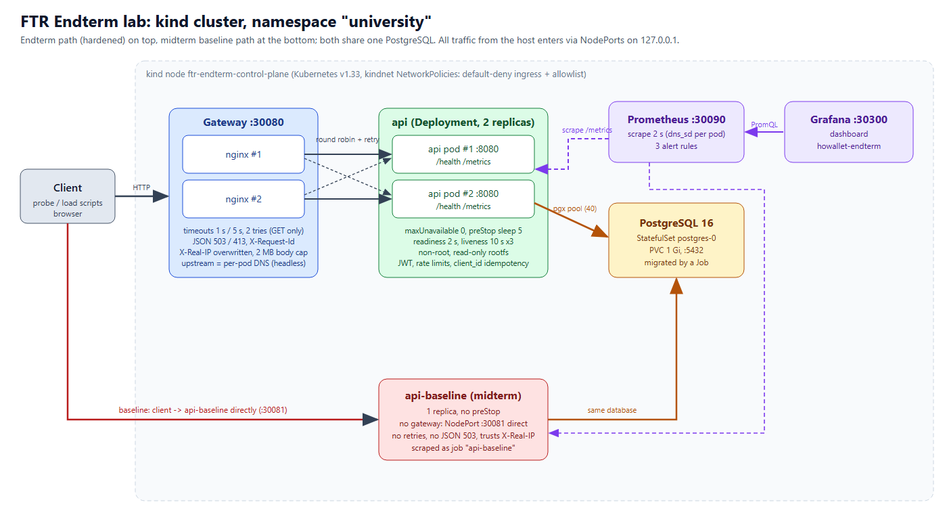
Figure 1. Endterm lab architecture: hardened path (gateway → api x2 → PostgreSQL) with monitoring, and the retained midterm baseline path (bottom) sharing the same database.
The system has six independently deployed components in namespace university (Table 5). Service discovery is DNS-based: the gateway and Prometheus resolve the headless Service api-headless, which returns one A record per ready API pod; configuration comes from ConfigMaps (gateway, Prometheus, Grafana) and one Secret.
Table 5. Components, replication and recovery strategy.
Component | Kind / replicas | Health checking | Recovery strategy
gateway (nginx 1.27) | Deployment x2, NodePort 30080 | readiness/liveness GET /healthz | restart by kubelet; the other gateway pod keeps serving
api (hoWallet Go API) | Deployment x2, RollingUpdate maxUnavailable 0 / maxSurge 1 | readiness /health every 2 s (1 failure); liveness every 10 s (3 failures) | ReplicaSet replaces a deleted pod; liveness restarts a hung one; preStop sleep 5 drains
postgres 16 | StatefulSet x1, PVC 1 Gi | readiness pg_isready | restart in place; data on PVC
university-migrate | Job | – | runs migrations once before the API
prometheus 2.54.1 | Deployment x1 | /-/ready | stateless (1 h retention), restart
grafana 11.2.0 | Deployment x1 | – | dashboard provisioned from ConfigMap
api-baseline | Deployment x1, NodePort 30081 | readiness /health only | replacement pod only

3.2 Resilience mechanisms
Table 6. Resilience mechanisms, their configuration and where they were exercised.
Mechanism | Configuration | Purpose | Exercised in
Redundancy | 2 API and 2 gateway replicas, anti-affinity (preferred) | survive an instance loss | E1, E4b, E7
Drain on shutdown | preStop sleep 5, terminationGracePeriodSeconds 20, server Shutdown 10 s | finish in-flight requests while endpoints update | E1 graceful
Fast removal | readiness period 2 s, failureThreshold 1 | stop routing to a sick pod | E1, E4b
Timeouts | gateway connect 1 s, read 5 s; API server read/write 15 s, header 5 s | bound latency, Slowloris | E2, E4b
Bounded retries | proxy_next_upstream error timeout http_502/503/504, tries 2, idempotent methods only | hide one bad replica from GETs | E1, E4b
Passive circuit breaking | max_fails=1 fail_timeout=2s per upstream server | skip a failed replica for 2 s | E1, E2
Graceful degradation | JSON 503 + Retry-After 2 (gateway); rates archive with 422 no_rate | honest, machine-readable failure | E2, E8
Idempotent writes | client_id + unique index (household_id, client_id) | safe client retries | E2, E7
Segmentation | NetworkPolicies: default-deny ingress, API egress allow-list | contain a compromised pod | deployment (A4 method)

3.3 Timeout, retry and circuit-breaker policy
The policy follows the stability patterns of Nygard [10]: every remote call has a timeout, retries are bounded and only for idempotent requests, and a failing instance is taken out of rotation. nginx resolves api-headless every 2 s (server … resolve, nginx ≥ 1.27.3) so that each API pod is a separate upstream server; with the single ClusterIP there would be no "next upstream" to retry on [8, 9]. POST is never replayed by the gateway (non_idempotent is deliberately absent); clients retry writes themselves with the same client_id. Inside the API there is no generic retry library and no circuit breaker; the database pool (pgx, 40 connections per replica) has no acquire timeout and PostgreSQL has no statement_timeout, so a blocked database shows up as requests waiting until the gateway's 5 s read timeout (Section 9).
upstream api_upstream {
zone api_upstream 64k;
server api-headless.university.svc.cluster.local:8080 resolve max_fails=1 fail_timeout=2s;
}
location / {
proxy_set_header X-Real-IP $remote_addr; proxy_set_header True-Client-IP "";
proxy_set_header X-Request-Id $req_id; # adopted or minted correlation id
proxy_connect_timeout 1s; proxy_read_timeout 5s;
proxy_next_upstream error timeout http_502 http_503 http_504; proxy_next_upstream_tries 2;
error_page 502 503 504 = @degraded; error_page 413 = @too_large; # JSON bodies
}
Listing 1. Gateway excerpt (k8s/40-gateway.yaml).

3.4 Graceful degradation
Two degradations are designed in. (1) Gateway: when no upstream answers in time, the client gets 503 {"error":"service_unavailable",…,"request_id":…} with Retry-After: 2 instead of an HTML page or a hung connection. (2) Exchange rates (non-critical feature): the write path never calls the external provider; a background job fills an archive table. When the provider is unreachable, writes in the base currency are unaffected, while a foreign-currency write with no archived rate is refused with 422 no_rate and nothing is written — the service never invents a rate of 1 or a zero (E8).

3.5 Deployment and scaling strategy
Rolling updates keep two ready API pods (maxUnavailable: 0, maxSurge: 1). Resource requests/limits: API 50m/500m CPU and 64/256 Mi; PostgreSQL 50m/500m and 128/256 Mi. Scaling is manual (kubectl scale); there is no metrics-server in the lab, so no HorizontalPodAutoscaler was used — E3 shows the two replicas used about 28–34 millicores each at 30 req/s, far from their limits. enableServiceLinks: false is set because the Service named api would otherwise inject API_PORT=tcp://…, which the API reads as its listen address.

4. Monitoring, Logging, Metrics and Alerting Design

4.1 Metrics in the service (feat/metrics patch)
The hoWallet API had no metrics endpoint. Commit 60cd5791 on branch feat/metrics (base 06aea177; shipped as patch/feat-metrics.diff) adds an opt-in Prometheus endpoint: with METRICS_ENABLED=true a middleware is installed first in the chi router and serves GET /metrics ahead of the logger and the rate limits; with the default false neither the route nor the middleware exists, so production behaviour is unchanged. A dedicated registry is used (no global state), and an optional METRICS_TOKEN requires a bearer token for scraping. The route label is the chi pattern (e.g. /api/accounts/{id}), not the raw path, and unmatched requests are labelled unmatched, which keeps cardinality bounded. Ten tests cover it (7 middleware, 3 router); all 10 pass (evidence/06-metrics-tests.txt).
Table 7. Metrics exposed by the API (names fixed in the patch).
Metric | Type / labels | Used for
http_requests_total | counter {method, route, status} | request rate, error-rate alert, dashboard
http_request_duration_seconds | histogram {method, route}, buckets 5 ms … 10 s | p50/p95/p99, latency alert [6]
http_requests_in_flight | gauge | saturation (dashboard)
db_pool_acquired_conns / total / max | gauges from pgxpool.Stat | pool starvation (E1 diagnosis)
process_*, go_* | standard collectors | CPU per pod in E3
up (Prometheus) | per scraped pod | ApiReplicaDown alert

4.2 Structured logs and request correlation
Both tiers log one JSON object per request. nginx adopts an incoming X-Request-Id or mints $request_id and forwards it; the API's chi RequestID middleware adopts the header, echoes it as X-Request-ID and writes it into its request log line together with user_id and household_id; the same lines are also persisted to the app_logs table every 2 s. One identifier therefore joins the gateway line, the API line and the database copy (E5 found all 11 test requests in all three places).
# client-supplied id, evidence/04-correlation.txt
gateway {"time":"2026-11-04T11:22:28+00:00","request_id":"endterm-corr-A-001","method":"GET","uri":"/api/households",
"status":200,"upstream_addr":"10.244.0.23:8080","request_time":0.015,"upstream_response_time":"0.014"}
api {"time":"2026-11-04T11:22:28.606293453Z","level":"INFO","msg":"request","method":"GET","path":"/api/households",
"status":200,"duration":14014531,"remote":"10.244.0.1","request_id":"endterm-corr-A-001","user_id":"e078777c-…"}
# no incoming id: nginx minted 715b152b146a75d71299d05c96c92b72 and the API logged the same id
Listing 2. One request seen in the gateway and API logs under the same correlation id.

4.3 Collection and dashboard
Prometheus scrapes every 2 s and evaluates rules every 2 s. It discovers API pods through dns_sd_configs on the headless Services, so up exists per replica, and scrapes the baseline under its own job api-baseline (Figure 2). The Grafana dashboard hoWallet API — Endterm (refresh 5 s) has seven panels: request rate by status, error rate %, in-flight requests, latency p50/p95/p99, replicas up per instance, firing alerts and DB pool connections (Figure 4, Figure 9, Figure 11, Figure 16).
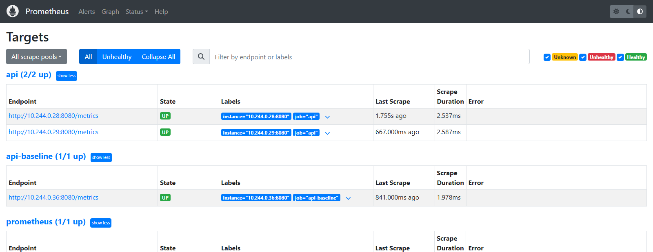
Figure 2. Prometheus targets: two api replicas discovered per pod, the baseline under its own job, all up (evidence/03-targets.txt).

4.4 Alert definitions
The three rules are in k8s/50-prometheus.yaml (evidence 05-alert-rules.txt). Before the experiments the error and latency rules were scoped to job="api" and route!="/health": unscoped, they mixed in baseline traffic and the cheap kubelet /health probes that dilute the error ratio. ApiReplicaDown was rewritten during the experiments after it was shown unable to fire (Section 8.5).
Table 8. Alert definitions, expected response and observed detection delay (from fault injection to state firing, AlertWatcher polling every 1 s).
Alert / severity | Detects | Threshold (expr, for) | Expected response | Observed delay
ApiHighErrorRate / critical | server-side failures (5xx) across the API | 5xx / all > 0.05 over rate[30s], job=api, route≠/health; for 10 s | check DB and pod logs by request_id, recent deploys; gateway already returns JSON 503 | 15.2–20.2 s (E2, 4 runs); 16.3 / 17.3 s (E4c)
ApiHighLatencyP95 / warning | slow responses (DB locks, saturation) | histogram_quantile(0.95, rate[30s]) > 0.5 s; for 10 s | inspect DB locks, pool saturation, in-flight; scale replicas | 18.2 / 19.3 s (E4d); 20.2–23.3 s as true positive in E2/E4c
ApiReplicaDown / critical (fixed rule) | fewer than 2 healthy, scrapeable API replicas | (count(up{job=api}==1) < 2) or absent(up{job=api}==1); for 6 s | Kubernetes restarts/reschedules; on-call confirms 2 Ready pods, reads pod events | 10.2 / 11.2 s (E4b reps 2–3)
ApiReplicaDown (original) | same intent | up{job=api} == 0; for 6 s | – | never fired: pending 4.1 s, cleared 8.1 s (E4b rep 1); pending 5.1 s (E1 crash)

The delay has a floor set by the design: a 2 s scrape, a 30 s rate window that must accumulate enough bad samples to cross the threshold, the for duration (6–10 s) and a 2 s evaluation interval. The observed 10–23 s is consistent with that budget; shortening it would trade detection speed for false positives (Google SRE book, ch. 6 [11]).

4.5 How an incident is detected and diagnosed
- Detect: an alert goes pending, then firing (Prometheus /alerts, Grafana Firing alerts).
- Localise: the dashboard separates the cases — error rate up and replicas 2/2 points to a dependency (E2: 5xx with failed to check household membership); replicas < 2 points to a pod (E4b); latency up with 0 % errors points to contention (E4d: table locks).
- Explain one request: take the request_id from the client response or the gateway log and grep the API log / app_logs for it (Listing 2); the line carries status, duration, user and household.
- Confirm the cause: kubectl get events / pod lastState (E4b showed Liveness probe failed … Killing, the final check found postgres OOMKilled), DB pool gauges (E1 diagnosis).

5. Security Controls and Intrusion-Tolerance Strategy
The strategy is defence in depth with fail-safe defaults: an attacker who passes one layer meets the next, and a failing check refuses rather than allows. Controls map to OWASP API Security Top 10 (2023) risks [12]. Exact expected behaviour per control is in notes/security-controls.md.
Table 9. Implemented security controls and their verification.
Control | Implementation | OWASP API | Verified by
Authentication | JWT HS256, issuer + exp required, live-session check; 401 JSON | API2 | E5 (4 x 401), middleware spec tests
Object/tenant authorisation | membership check per request → 404 (existence not revealed); queries scoped by household_id | API1 | E5 (4 x 404, 1 x 400), API test over every route
Input validation | typed JSON decode, 1 MB decode limit, positive decimal amounts, UUID path ids | API8 | E6 (4 x 400)
Body-size limit at the edge | nginx client_max_body_size 2m → JSON 413 | API4 | E6 (3 MB → 413)
Rate limiting | 1200/min per IP, 10/min on /auth, 600/min per user, 60/min creates; 429 JSON + Retry-After | API4 | E3 (baseline 429s), E6
Brute-force lockout | 5 failures per (e-mail, IP) / 15 min → 429 Retry-After 900, even for the right password | API2 | E6
Client-IP integrity | gateway overwrites X-Real-IP, clears True-Client-IP | API8 | E6 (baseline spoofable, gateway not)
Duplicate/abuse protection | client_id idempotency, unique index | API6 | E2, E7
Secrets handling | Kubernetes Secret via envFrom; API refuses to start with a short JWT_SECRET; refresh tokens hashed | API8 | deployment
Audit logging | per-request JSON log with request_id/user_id; app_logs; audit_logs for writes | API9 | E5 (11 app_logs rows)
Least privilege | non-root uid 65532, read-only rootfs, caps dropped, no SA token; NetworkPolicies | API8 | manifests, 02-get-all.txt
Safe failure | membership check fails closed (500) when the DB is down | – | E2 error bodies

Intrusion tolerance. The design aims to keep the service correct while partly compromised or abused: brute force is slowed by limits and lockout but cannot exhaust capacity (E6 probe stayed 43/43 OK); a stolen token for one tenant gives no access to another (E5); a retried or replayed write cannot double a balance (E7); a compromised pod is network-confined. Known weaknesses are stated, not hidden: limits and lockout are per replica, session liveness fails open on a DB error (to avoid mass sign-out), there is no dedicated failed-login security event, and the API's database user owns every table.

6. Verification and Validation Plan

6.1 Automated tests
Verification uses the project's existing test suites; validation uses the lab experiments against the acceptance criteria R1–R8 (Table 3).
Table 10. Automated test inventory (notes/test-inventory.md).
Level | Scope | Count | Status in this project
Unit (Go) | services, handlers, middleware on gomock mocks | 2095 top-level tests (3048 incl. subtests) | run on 4 Nov 2026 at 06aea177: exit 0, 0 failed, 51 s
Integration (Go, tag integration) | repositories on real PostgreSQL (testcontainers) | 278 (static count) | not re-run (Docker busy with the lab)
API/system (tags integration api) | real app over a fresh DB per test | 538 (static count) | not re-run
Metrics patch | label = route pattern, status, in-flight, scrape not counted, token, disabled = no route | 10 (7 + 3) | run on 4 Nov 2026 at 60cd5791: 10 passed (evidence/06-metrics-tests.txt)
Web | pure logic, components (MSW), Playwright journeys | ~901 / ~273 / 21 files | not re-run

Tests most relevant to fault tolerance include TestTransactionService_ClientIDConcurrentBurstWritesOnce (idempotency under a concurrent burst), TestAuthzHousehold_EveryRouteRefusesWithoutAValidMembership (tenant isolation on every route), TestLogin_AfterFiveFailures_EvenTheRightPasswordIs429WithRetryAfter and TestCreate_ForeignCurrencyWithNoRate_Is422AndWritesNothing (the E8 behaviour).

6.2 Validation: acceptance criteria and integrity checks
Each experiment has a pre-declared criterion (Table 20 repeats them with the verdict). Data integrity is checked in SQL, not through the API: for every test account, row count = acknowledged writes, count(DISTINCT client_id) = row count, balance = −sum(amount), and globally no duplicate (household_id, client_id) pair. Tenant isolation is checked with a before/after snapshot of counts and MD5 of the victim's rows.

7. Fault-Injection and Security-Test Methodology

7.1 Environment and dates
All measured runs were executed on 4 November 2026, between about 16:20 and 17:30 local time (UTC+05:00; log timestamps are partly UTC, e.g. 11:22Z cluster up, 12:22Z E8). The preceding days of the project period (28 October – 3 November) were used for design, the metrics patch, manifests and scripts; no measurement from those days is reported. Environment: one kind node ftr-endterm-control-plane (Kubernetes v1.33.1, containerd 2.1.1, WSL2 kernel 6.6.87.2) on a Windows 11 laptop; images howallet-api:endterm (both configurations), nginx:1.27-alpine, postgres:16-alpine, prom/prometheus:v2.54.1, grafana/grafana:11.2.0.

7.2 Tooling
- scripts/ftlab.py — Probe: open-loop load generator with a fixed offered rate and a thread pool, so a hanging request does not slow the probe (closed-loop probes under-report outages); EndpointWatcher: kubectl get endpoints -w, time-stamped on arrival; AlertWatcher: polls Prometheus /api/v1/alerts every second; known_state() waits for all workloads Ready and no alert active before each run.
- scripts/faults.py — E1 (pod delete, graceful or --grace-period=0 --force) and E2 (scale postgres 0, or SIGSTOP/SIGCONT of all postgres processes on the node).
- scripts/exps.py — E3–E8; scripts/final_check.py — final SQL integrity; scripts/build_summary.py — tables from JSON; scripts/render_evidence.py — terminal renders of the text logs.
- Workload: GET /api/accounts with a token and X-Household-ID (membership check + accounts query, so it needs the database). Client timeout 6 s (E1, E3) or 12 s (E2). Synthetic users created by scripts/setup_users.py (register → mark e-mail verified in SQL → log in).

7.3 Measurement definitions
Table 11. Definitions of the reported measurements.
Measurement | Definition
Success / failure | 2xx = success; anything else, connection error or client timeout = failure. 429 in E3 is reported separately as the limiter working.
Error rate, availability | failed / all and 2xx / all requests in the stated window
Latency | client-side, through the host NodePort; average and p95 of all requests in the window
Detection time | injection → first signal: endpoint removal (Kubernetes), first failed request, or alert state firing
Recovery time | E1: injection → replacement pod back in endpoints (or end of last failure if later); E2: restore command → end of the last failed request
User-visible outage | first failed request → end of the last failed request
E1 window | injection → recovery + 15 s; E2 window: injection → restore ("during outage") and the whole run ("interval")

7.4 Experiment catalogue
Table 12. Experiments: type, injection, hypothesis and repetitions (6 fault/abnormal, 2 security/misuse; E6 also includes abuse).
ID | Type | Injection / steps | Hypothesis | Reps
E1 | fault | delete one API pod under an 8 req/s probe (graceful and forced) | endterm: 0 failures; baseline: outage until the replacement is ready | 3 + 3
E2 | fault | PostgreSQL stopped (scale 0) or frozen (SIGSTOP) for 20 s; both configs probed 6 req/s each + a writer retrying with the same client_id | fast JSON errors, alert fires, no lost or duplicate data | 2 stop + 2 freeze per config
E3 | abnormal load | 5 → 30 → 5 req/s (30 s / 60 s / 30 s), 5 users | ≥ 99 % success, p95 < 500 ms | 2 + 2
E4 | monitoring | a) 120 s quiet; b) SIGSTOP one API process; c) DB scaled 0 for 25 s; d) 22 x LOCK TABLE accounts held 1.5 s | each rule fires on its scenario only | 1 + 3 + 2 + 2
E5 | security | 11 requests: no/garbage/forged token, user B against tenant A | 401/404, data unchanged, audit trail | 1
E6 | misuse | malformed JSON, negative amount, bad UUID, 3 MB / 1.5 MB bodies, 12 wrong passwords, spoofed X-Real-IP | 400/413/429, probe unaffected | 1
E7 | fault + integrity | 200 creates with unique client_id, one API pod deleted at t+16.7 s, client retries with the same id | 200 rows, 0 duplicates | 2 + 2
E8 | dependency failure | RATES_BASE_URL → unresolvable host (rolling update) | KZT 201, USD/EUR 422 no_rate, nothing wrong written | 1 (4 requests)

Restoring a known state. Every run starts with known_state(); E2 waits until both probes have been all-200 for 15 s; E8 restores the environment variable with a second rolling update.
Invalid runs. E2 freeze reps 3 and 4 did not inject a fault: the command went through Windows cmd.exe, which passed the quotes in pkill -f '^postgres' literally, so no process matched (0 failures, no alerts — a correct negative for the monitoring, but not an experiment). Both JSON files were renamed *-INVALID-not-injected.json, kept in the log with a note, excluded from all results, and the freeze variant was re-run as reps 5 and 6 with pkill -STOP -x postgres.

8. Results and Baseline-versus-Endterm Comparison
Per-run numbers below are read from evidence/results/*.json when this report is built; the readable logs are evidence/*.txt. Latencies are in milliseconds, times in seconds after the injection.

8.1 Summary of measurements
Table 13. Required measurements, endterm versus baseline (ranges over the valid repetitions).
Experiment | Config | Requests: failed / total | Error rate | Avg / p95 latency | Detection | Recovery | Availability
E1 replica loss (graceful, 2 reps) | endterm | 0 / 139, 0 / 140 | 0 % | 24 / 44; 133 / 1138 | endpoint drop 0.2 s; no alert | 1.9 / 1.6 s | 100 %
 | baseline | 137 / 139, 138 / 139 | 98.6–99.3 % | 5839–5880 / 6017–6028 | endpoint drop 0.2 s; no alert | 23.3 / 23.4 s | 1.4 / 0.7 %
E1 forced kill (1 rep) | endterm | 0 / 131 | 0 % | 20.5 / 38.5 | 0.2 s; ApiReplicaDown pending only | 0.8 s | 100 %
 | baseline | 9 / 140 | 6.4 % | 179 / 1573 | 0.2 s | 2.3 s | 93.6 %
E2 DB outage 20 s (4 valid reps), during outage | endterm | 118–121 / 121–122 | 97.5–99.2 % | 1553–2128 / 5010–5022 | ApiHighErrorRate firing 15.2–20.2 s | 6.2 / 7.2 s (stop), 16.7 / 13.1 s (freeze) | whole run 45.5–65.3 %
 | baseline | 62–72 / 113–114 | 54.4–63.7 % | 8277–10756 / 12015–12018 (client timeout) | no alert (not covered) | 2.3 / 2.4 s (stop), 13.4 / 7.5 s (freeze) | whole run 78.2–84.3 %
E3 30 req/s step (2 reps) | endterm | 0 / 1800 (x2) | 0 % | 10.6–11.1 / 26.2–27.9 | no alert (correct) | – | 100 %
 | baseline | 321 / 1800, 248 / 1800 (incl. 307 / 248 x 429) | 17.8 / 13.8 % | 111.8 / 995.1; 10.0 / 26.5 | no alert (not covered) | – | 82.2 / 86.2 %
E4b hung replica (fixed rule, 2 reps) | endterm | 13 / 404, 9 / 363 | 3.2 / 2.5 % | 176 / 63; 137 / 32 (max 5.0 s) | ApiReplicaDown firing 10.2 / 11.2 s | back in endpoints 51.9 / 45.1 s (liveness restart) | 96.8 / 97.5 %
E7 pod kill during 200 writes (2 reps) | endterm | 0 / 200 (x2) | 0 % | 62 / 206; 48 / 150 | endpoint drop 0.2 s | 1.1 / 1.1 s (endpoints back) | 100 %; 200 rows, 0 dup
 | baseline | 7 / 207 (x2), all retried | 3.4 % | 82 / 166; 80 / 187 | endpoint drop 0.2 s | 1.6 / 1.7 s (endpoints back) | 96.6 % of attempts; 200 rows, 0 dup

E3 baseline "failed" counts include the 429 refusals (307 and 248) plus 14 connection errors in rep 1; E7 recovery is the endpoint drop/return pair from Table 19.

8.2 E1 — Replica failure
Table 14. E1 per run (window: injection → recovery + 15 s; probe 8 req/s).
Config | Rep | Req | Failed | Err % | Avg | p95 | Ep. drop | Recovery | Outage | Avail % | Alerts
endterm | 1 graceful | 139 | 0 | 0.0 | 24.0 | 44.3 | 0.2 | 1.9 | 0.0 | 100.0 | none
endterm | 2 graceful | 140 | 0 | 0.0 | 133.0 | 1137.8 | 0.2 | 1.6 | 0.0 | 100.0 | none
endterm | 3 crash | 131 | 0 | 0.0 | 20.5 | 38.5 | 0.2 | 0.8 | 0.0 | 100.0 | ApiReplicaDown pending 5.1 s, not fired
baseline | 1 graceful | 139 | 137 | 98.6 | 5838.6 | 6027.9 | 0.2 | 23.3 | 23.0 | 1.4 | none
baseline | 2 graceful | 139 | 138 | 99.3 | 5880.0 | 6016.7 | 0.2 | 23.4 | 23.1 | 0.7 | none
baseline | 3 crash | 140 | 9 | 6.4 | 179.2 | 1573.1 | 0.2 | 2.3 | 2.0 | 93.6 | none

Endterm. No request failed in any of the three runs. The deleted pod left the endpoints after 0.2 s and the replacement was in rotation after 1.9, 1.6 and 0.8 s. Rep 2 shows the cost of hiding the failure: p95 rose to 1138 ms (max 1836 ms) because some requests reached the terminating pod and were retried on the other replica by the gateway. Baseline. A graceful delete caused a 23.0 / 23.1 s user-visible outage (137 and 138 of 139 requests failed, mostly 6 s client timeouts), while the forced kill caused only 2.0 s (9 failures).
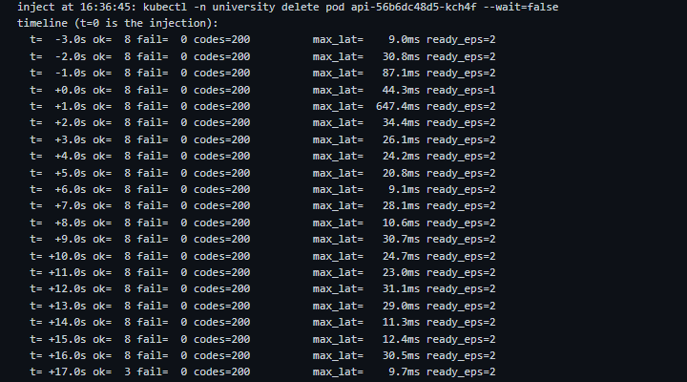
Figure 3. E1 endterm rep 1 (graceful delete): ready endpoints drop to 1 and return to 2, every 1-s bucket 8/8 OK (evidence/e1-replica-failure.txt).
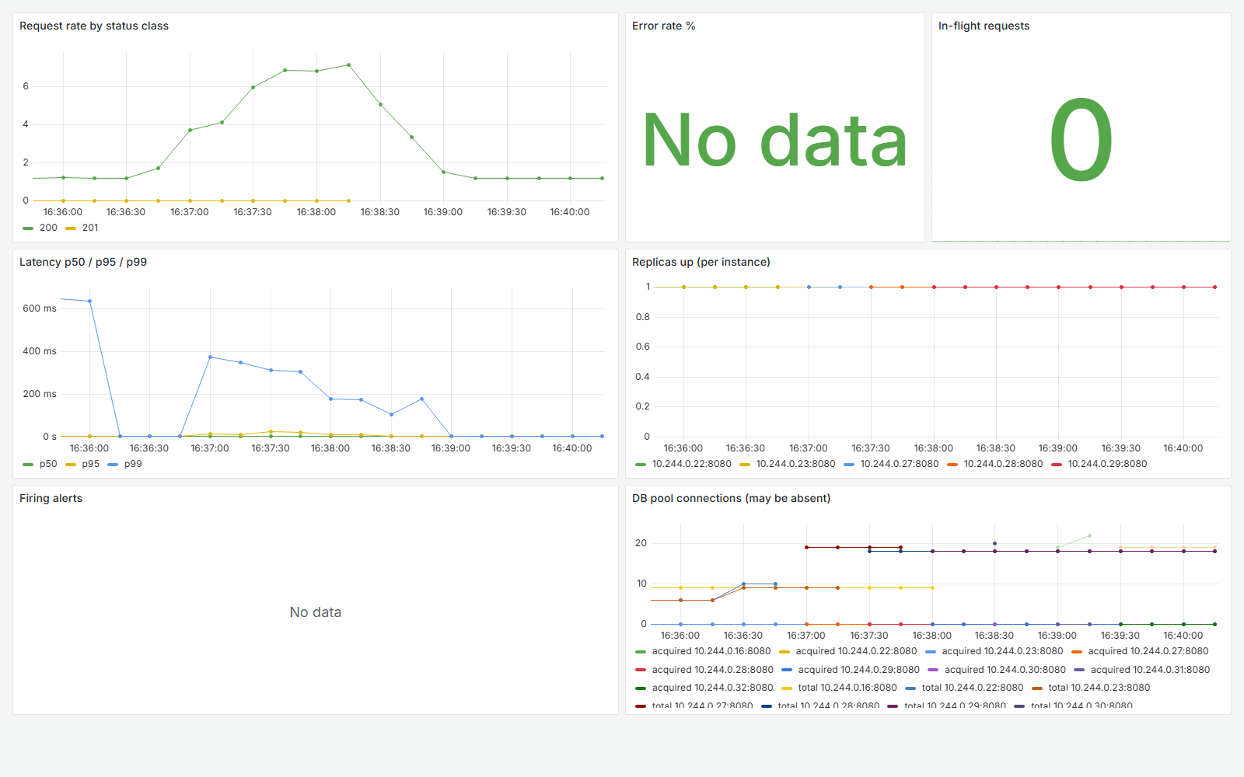
Figure 4. Grafana during the E1 endterm runs: only 200/201 responses, error rate has no 5xx data, new replica IPs appear in Replicas up as pods are replaced; p99 rises to about 370 ms.
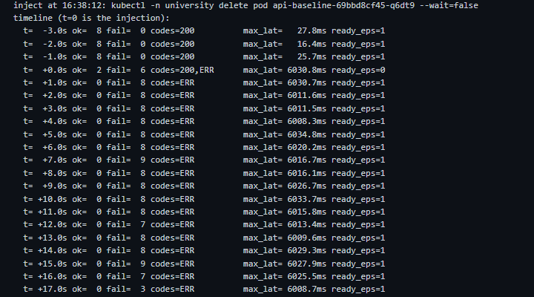
Figure 5. E1 baseline rep 1: every request fails for 23 s although the replacement is Ready (ready_eps=1) after about 1.7 s.
Root-cause hypothesis for the 23 s baseline outage (not proven). /health does not touch the database, so the new pod is Ready as soon as the process listens. In the diagnostic runs (e1-baseline-diagnostic.txt, Figure 6) the replacement answered a 1 req/s probe within 2.3 s, but under the queued 8 req/s burst its pool showed total=40=max, acquired=33, in_flight=34, and DB-backed requests hung until about t+20–25 s — the moment the startup exchange_rates job gave up on the external provider (522 after ~20 s). Pool starvation during startup jobs is the likely mechanism; why the forced kill did not show it was not established. The endterm masked it: retries to the healthy replica and the 5 s gateway cap.
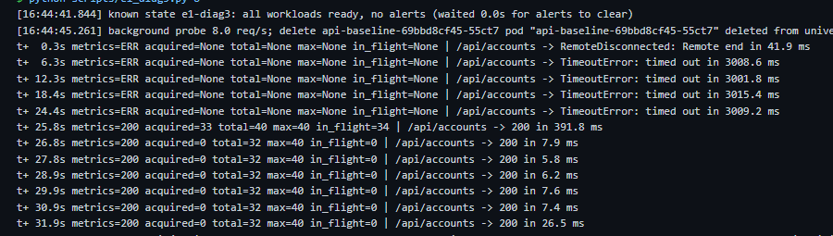
Figure 6. E1 baseline diagnostic at 8 req/s: metrics unreachable/timeouts until t+24.4 s, then the pool is full (total=40=max, in_flight=34); in the log the rates job fails at about the same moment.

8.3 E2 — Database outage (dependency failure)
Table 15. E2 per run, both configurations probed at the same time (during-outage window; "interval" = whole run; writes = acknowledged / rows / distinct client_id / balance; replays answered 200).
Run | Config | Req | Fail | Err % | Avg | p95 | Codes | Alert firing | Recov. | Interval avail % | Writes; replays
rep1-stop | endterm | 122 | 119 | 97.5 | 1553.4 | 5010.4 | 200:3, 500:19, 503:100 | 16.2 s | 6.2 | 49.8 | 35/35/35/ok; 1
rep1-stop | baseline | 114 | 62 | 54.4 | 8277.2 | 12015.1 | 200:52, 500:13, timeout:49 | no rule | 2.3 | 79.2 | 34/34/34/ok; 1
rep2-stop | endterm | 121 | 118 | 97.5 | 1558.2 | 5017.7 | 200:3, 500:17, 503:101 | 15.2 s | 7.2 | 45.5 | 34/34/34/ok; 0
rep2-stop | baseline | 113 | 63 | 55.8 | 8638.8 | 12016.1 | 200:50, 500:12, timeout:51 | no rule | 2.4 | 78.2 | 34/34/34/ok; 1
rep5-freeze | endterm | 122 | 121 | 99.2 | 2127.9 | 5021.9 | 200:1, 503:115, 500:6 | 20.2 s | 16.7 | 65.3 | 55/55/55/ok; 1
rep5-freeze | baseline | 113 | 72 | 63.7 | 10756.1 | 12017.7 | 200:41, timeout:70, 500:2 | no rule | 13.4 | 84.3 | 41/41/41/ok; 2
rep6-freeze | endterm | 121 | 120 | 99.2 | 2033.0 | 5012.1 | 200:1, 503:119, 500:1 | 20.2 s | 13.1 | 49.9 | 39/39/39/ok; 2
rep6-freeze | baseline | 113 | 68 | 60.2 | 10549.0 | 12016.6 | 200:45, timeout:68 | no rule | 7.5 | 79.6 | 38/38/38/ok; 2

Endterm. Clients received a JSON 503 from the gateway (service_unavailable, Retry-After: 2) or the API's JSON 500 (failed to check household membership); p95 during the outage was capped at 5.0 s by the gateway. ApiHighErrorRate fired at 15.2–20.2 s; ApiHighLatencyP95 also fired (21.3–22.3 s stop, 20.2 s freeze), correctly, since p95 really was 5 s. Baseline. Requests hung until the 12 s client timeout (49–70 timeouts per run, p95 12.0 s); no alert covers it. Integrity: in all 8 configuration-runs every acknowledged write was stored exactly once and balance = −sum; 0–2 retries per run were answered 200, i.e. the server recognised the client_id and replayed the stored row instead of writing a second one.
The honest trade-off. The endterm did not improve availability here; it made failure fast and visible. Over the whole run the baseline served more requests successfully (78.2–84.3 % vs 45.5–65.3 %) and recovered sooner after the restore (2.3–13.4 s vs 6.2–16.7 s): its hung requests simply completed once the database returned, whereas the gateway had already answered 503 and, with max_fails=1, kept marking upstreams failed while 5 s requests were still timing out.
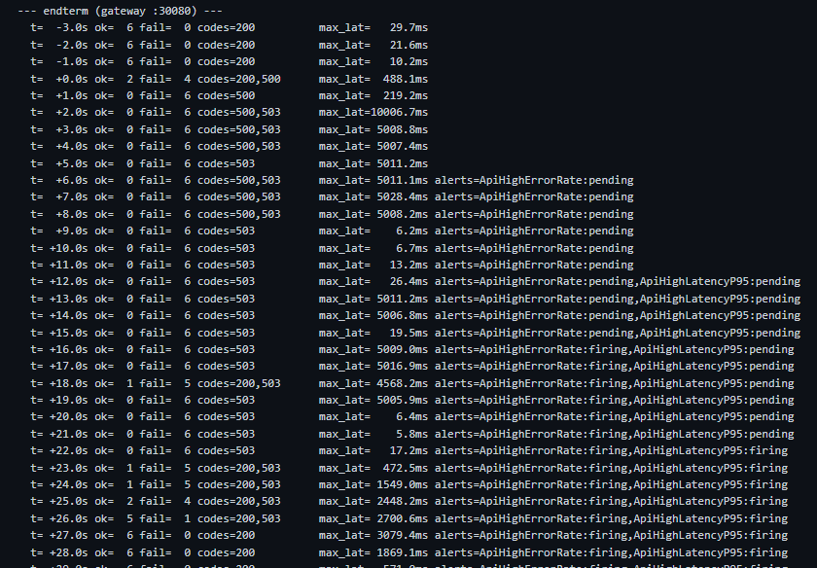
Figure 7. E2 rep 1 (stop), endterm: 500/503 with the latency capped near 5 s, ApiHighErrorRate pending at +6 s and firing at +16 s, successes return from +23 s.
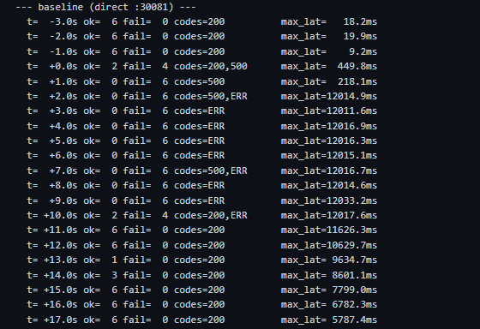
Figure 8. E2 rep 1 (stop), baseline at the same time: requests hang until the 12 s client timeout (codes=ERR), then all requests complete once the DB is back.
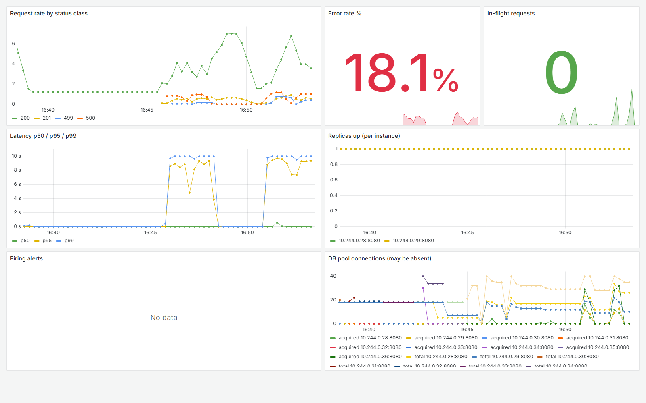
Figure 9. Grafana after the E2 series: latency p95/p99 at the 5–10 s ceiling during each outage, 500 responses, DB pool connections dropping and returning.

8.4 E3 — Load increase
Table 16. E3, 60 s step at 30 req/s ("failed" = connection errors; 429 counted separately; CPU in millicores from process_cpu_seconds_total).
Config | Rep | Req | OK | Failed | 429 | OK % | OK req/s | Avg | p95 | API CPU (per pod) | PG CPU | Alerts
endterm | 1 | 1800 | 1800 | 0 | 0 | 100.0 | 30.0 | 10.6 | 26.2 | 33.6, 27.9 | 61.3 | none
endterm | 2 | 1800 | 1800 | 0 | 0 | 100.0 | 30.0 | 11.1 | 27.9 | 31.7, 32.7 | 43.4 | none
baseline | 1 | 1800 | 1479 | 14 | 307 | 82.2 | 24.65 | 111.8 | 995.1 | 50.6 | 64.7 | none
baseline | 2 | 1800 | 1552 | 0 | 248 | 86.2 | 25.87 | 10.0 | 26.5 | 64.3 | 54.5 | none

The endterm served 1800/1800 requests at the full 30 req/s with p95 26–28 ms; each API pod used about 28–34 m CPU and each gateway pod 10–12 m. The baseline was throttled by its own limiter: one replica counts all traffic against the 1200/min per-IP limit (all clients share one SNAT address), so 307 and 248 requests were refused with 429 (rate_limited). The endterm passed only because the limit is counted per replica — this is the per-replica-limit limitation of Section 9, not extra capacity.
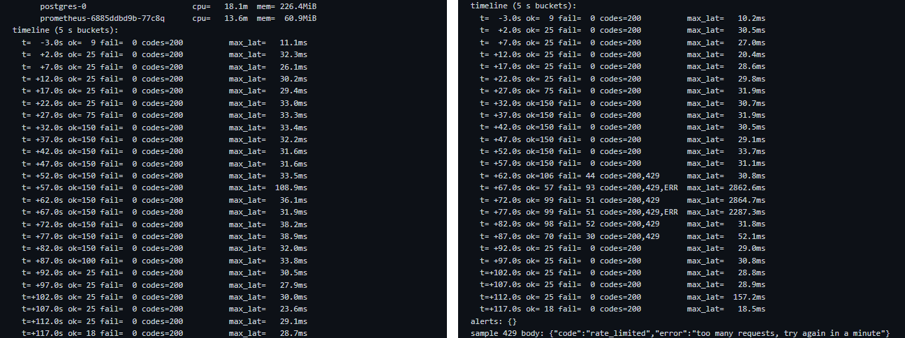
Figure 10. E3 timelines in 5-s buckets: endterm rep 1 (left) all 150/150 at 30 req/s; baseline rep 1 (right) refuses requests with 429 from t+62 s.
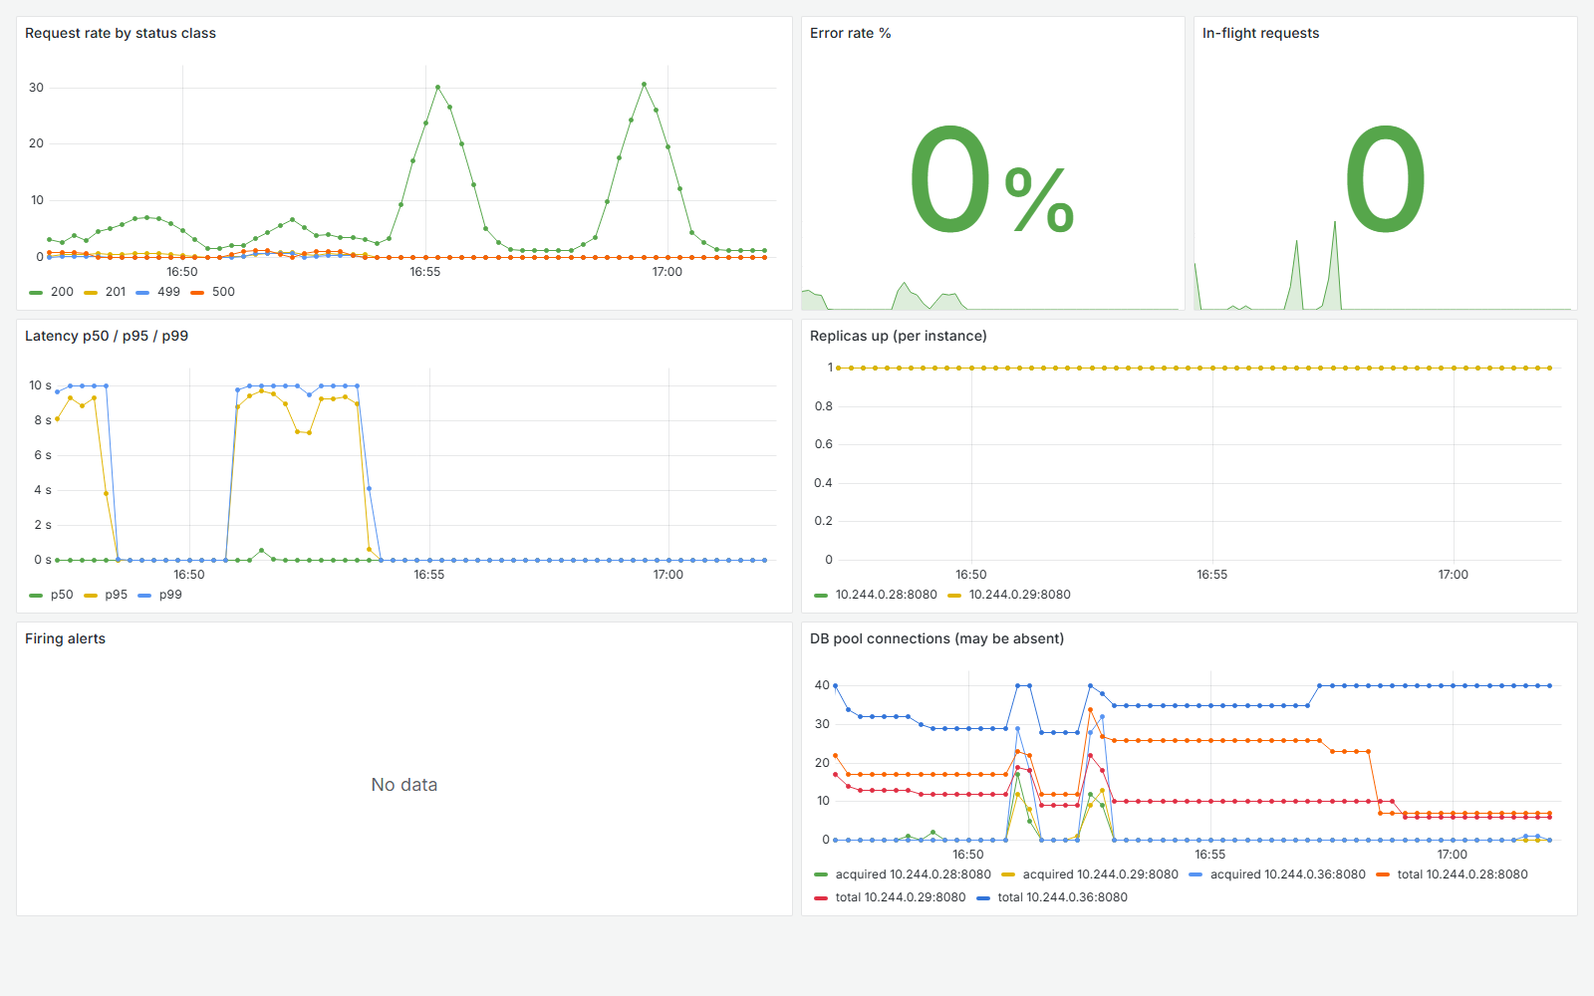
Figure 11. Grafana after E3: the request rate peaks at about 30 req/s during the E3 steps; the earlier 10 s latency plateaus belong to the preceding E2 outages; no firing alert.

8.5 E4 — Monitoring and alert tests
Table 17. E4 per run: probe during the fault window and alert timings (s after injection).
Run | Expected alert | Req | Fail | Err % | Avg | p95 | Max | Alert timings | Fired
quiet-window | none | 601 | 0 | 0.0 | 11.4 | 25.2 | 182.3 | 120 polls, nothing pending | none
replica-down-rep1 | ApiReplicaDown (original rule) | 392 | 13 | 3.3 | 178.0 | 31.4 | 5026.7 | ApiReplicaDown: pend 4.1, fire None, clear 8.1 | none
replica-down-rep2 | ApiReplicaDown | 404 | 13 | 3.2 | 175.8 | 63.0 | 5030.2 | ApiReplicaDown: pend 4.1, fire 10.2, clear 60.7 | ApiReplicaDown
replica-down-rep3 | ApiReplicaDown | 363 | 9 | 2.5 | 136.6 | 31.8 | 5032.5 | ApiReplicaDown: pend 6.1, fire 11.2, clear 53.6 | ApiReplicaDown
error-rate-rep1 | ApiHighErrorRate | 152 | 148 | 97.4 | 1721.5 | 5010.6 | 10030.7 | ApiHighErrorRate: pend 7.2, fire 17.3, clear 55.6; ApiHighLatencyP95: pend 13.2, fire 23.3, clear None | ApiHighErrorRate, ApiHighLatencyP95
error-rate-rep2 | ApiHighErrorRate | 152 | 146 | 96.0 | 2145.8 | 5028.1 | 10013.7 | ApiHighErrorRate: pend 6.2, fire 16.3, clear 58.6; ApiHighLatencyP95: pend 12.2, fire 22.3, clear 58.6 | ApiHighErrorRate, ApiHighLatencyP95
latency-rep1 | ApiHighLatencyP95 | 240 | 0 | 0.0 | 643.2 | 1420.8 | 1586.6 | ApiHighLatencyP95: pend 9.2, fire 19.3, clear 70.7 | ApiHighLatencyP95
latency-rep2 | ApiHighLatencyP95 | 240 | 0 | 0.0 | 640.1 | 1423.0 | 1537.6 | ApiHighLatencyP95: pend 8.1, fire 18.2, clear 71.6 | ApiHighLatencyP95

False negative found and fixed (E4b). The original rule up{job="api"} == 0 could not fire in this deployment: a dead or hung pod leaves the headless-Service DNS within about 2 s, so its scrape target disappears and the series goes stale instead of staying at 0 for the 6 s for. In rep 1 it went pending at 4.1 s and cleared at 8.1 s while a replica stayed hung for about 47 s until the liveness probe restarted it (Figure 12). The rule was changed to count healthy replicas ((count(up{job="api"}==1) < 2) or absent(up{job="api"}==1)), reloaded, and re-tested: firing at 10.2 and 11.2 s, cleared after the restart. During the hung-replica window the gateway answered 13 / 13 / 9 JSON 503s (max 5.0 s) out of 363–404 requests. Because of for: 6s, a pod replaced within 2 s (E1) still does not page — intended.
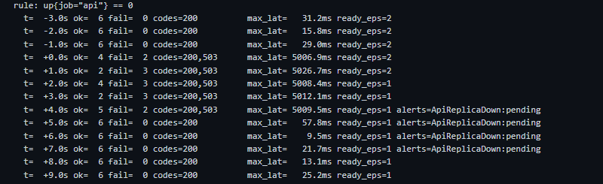
Figure 12. E4b rep 1 with the original rule: ApiReplicaDown only pending (t+4…7 s) and clears while ready_eps stays 1 (the hung pod is restarted by liveness about 47 s later).
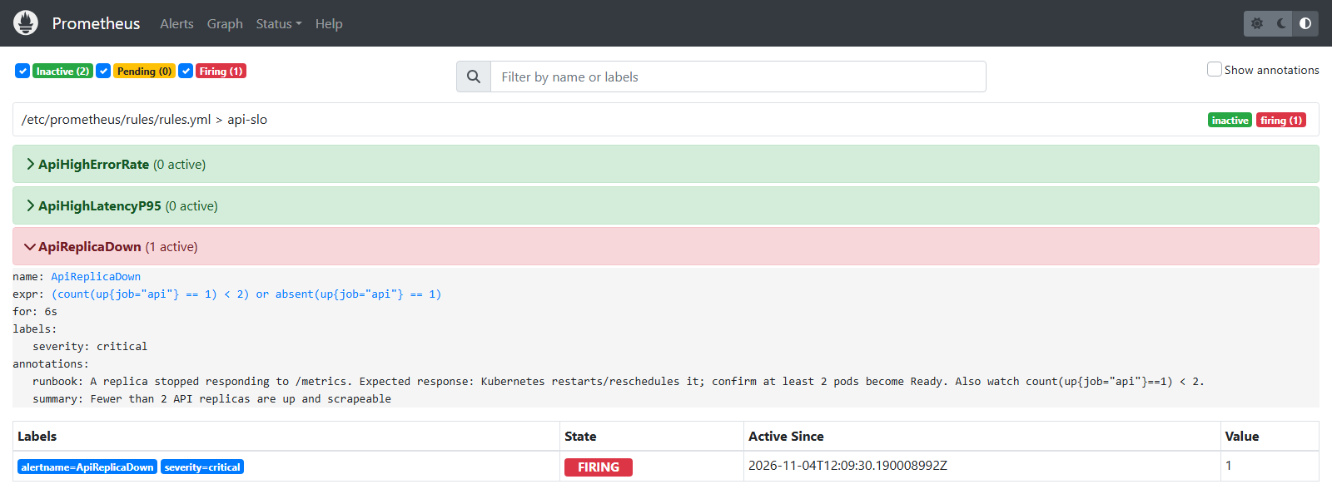
Figure 13. Prometheus: the fixed ApiReplicaDown rule firing in E4b rep 2.
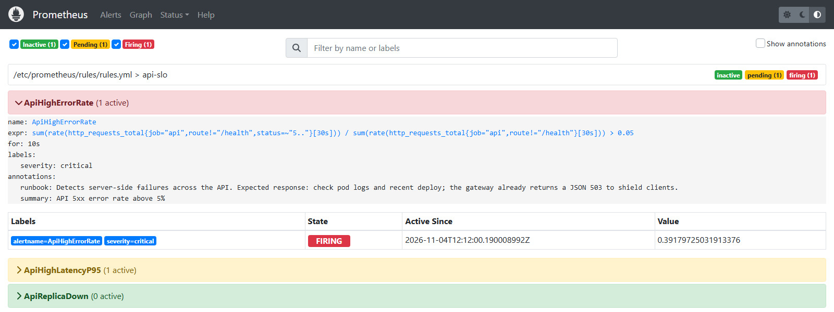
Figure 14. Prometheus: ApiHighErrorRate firing during the E4c database outage.
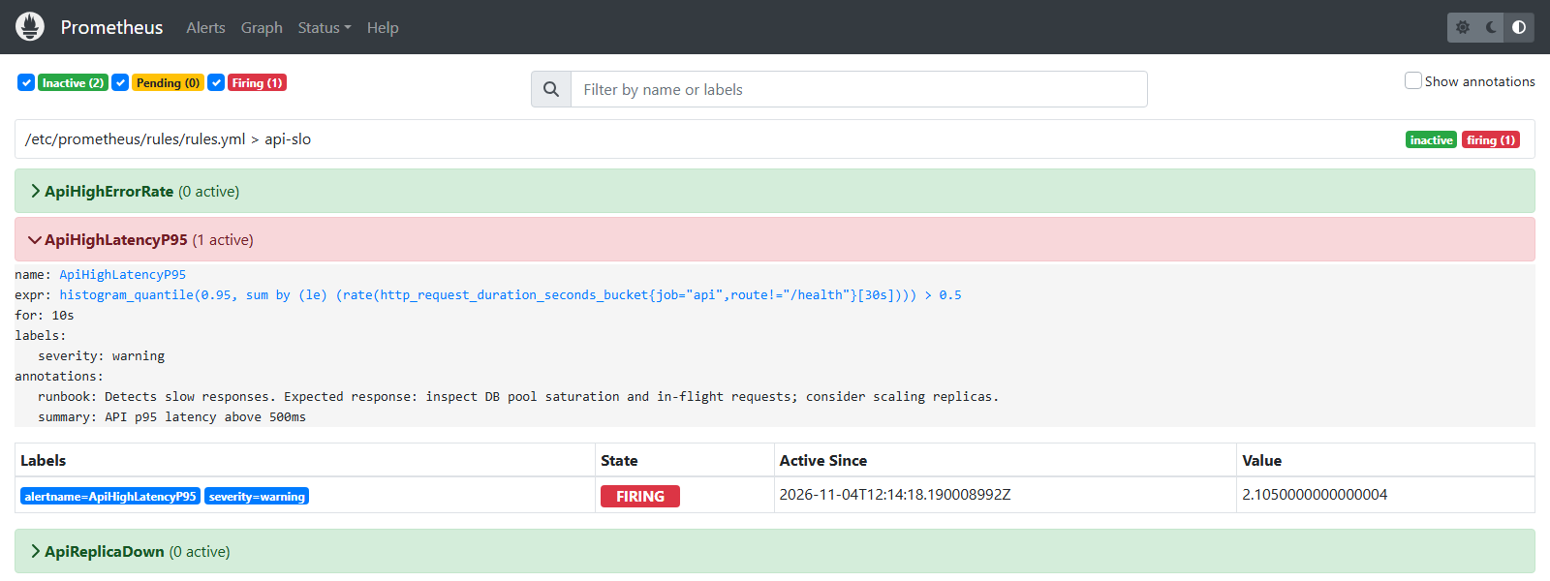
Figure 15. Prometheus: ApiHighLatencyP95 firing under the E4d table-lock bursts (0 failed requests, p95 1.42 s).
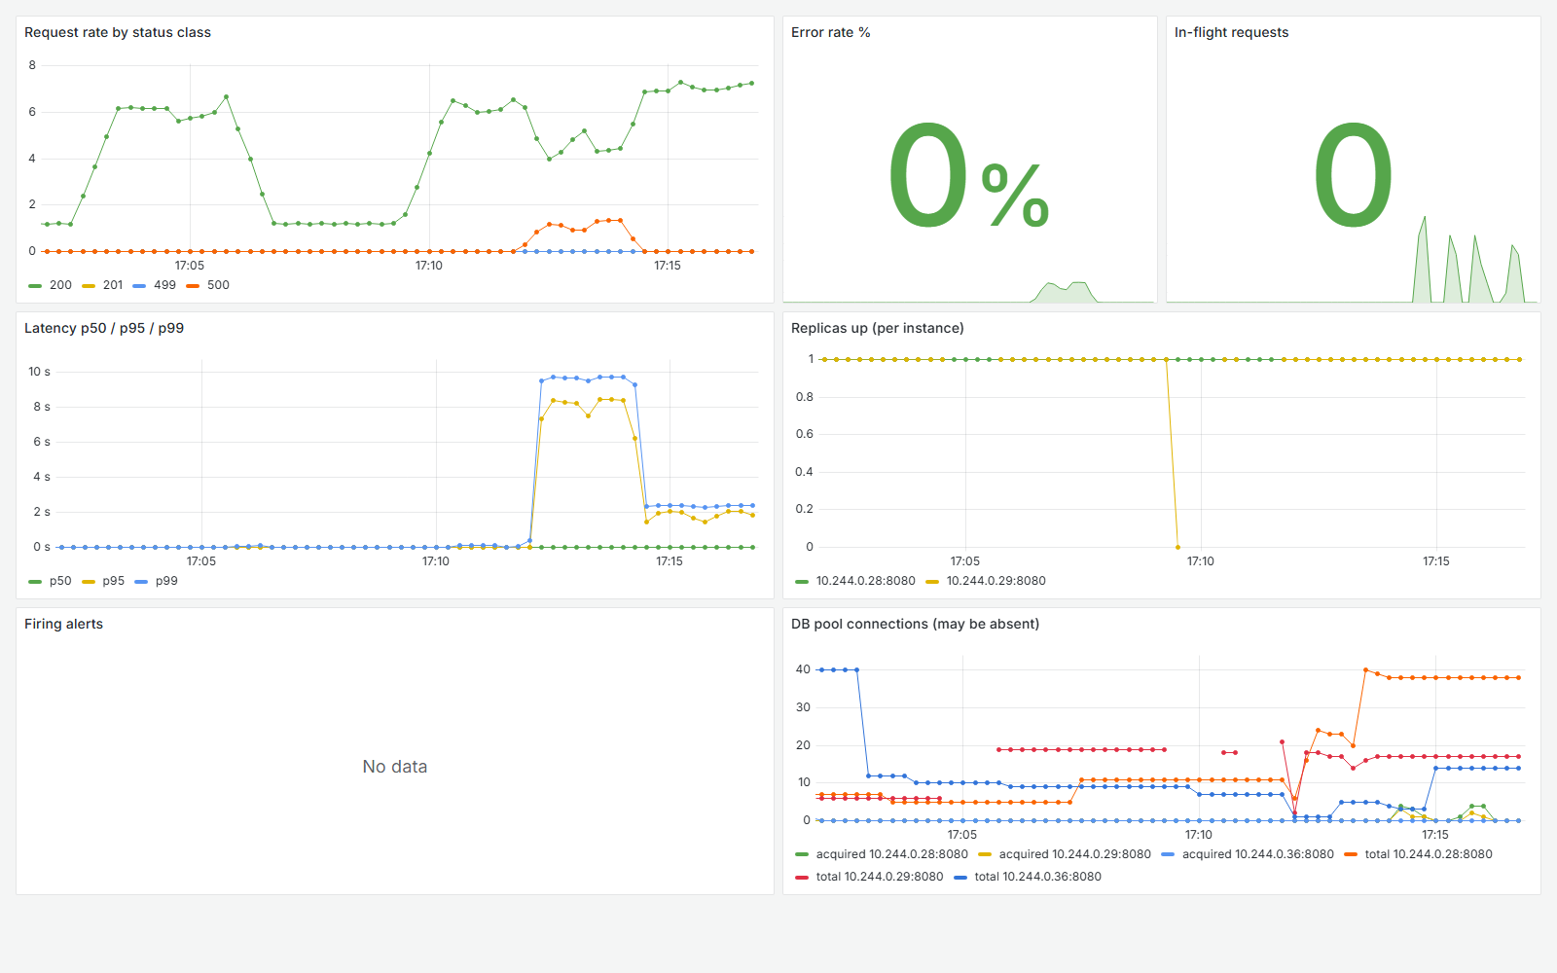
Figure 16. Grafana over the E4 series: one replica's up drops to 0 (E4b), 500s during E4c, p95/p99 near 8–10 s then about 2 s during E4d.
Table 18. Alerts triggered and their correctness across the measured runs.
Scenario (runs) | Alerts firing | Correct? | Comment
E4a quiet window (1) | 0 | yes (true negative) | 120 polls, 601/601 OK
E3 load step, endterm (2) | 0 | yes | p95 < 30 ms, no 5xx
E2 DB outage (4 valid) | 8 (4 x ErrorRate, 4 x LatencyP95) | yes | p95 really 5 s → latency alert is a true positive
E2 invalid reps 3–4 (2) | 0 | yes (nothing injected) | excluded from results
E4b original rule (1) / E1 (6) | 0 (pending only) | no — false negative | rule replaced
E4b fixed rule (2) | 2 x ApiReplicaDown | yes | cleared after liveness restart
E4c DB scaled 0 (2) | 4 (2 x ErrorRate, 2 x LatencyP95) | yes | the script's strict flag says "correct=False" because it expected one alert only; both alerts reflected real symptoms
E4d table locks (2) | 2 x LatencyP95 | yes | error-rate alert correctly silent

In total 16 alert firings were recorded, none of them false positives; the only false negative was the original ApiReplicaDown rule. The baseline has no alert coverage at all (scraped, but not alerted on).

8.6 E5 and E6 — Security and misuse tests
E5 access control. Four requests without a valid token (missing, garbage, signed with a wrong secret) got 401. User B, holding a valid token, sent tenant A's household id to read accounts, read transactions, create an expense and delete an account: all four got 404 household not found, so A's existence is not even confirmed. Using B's own household with A's account id gave 400 account not found. The SQL snapshot of A (1 account, 3 transactions, MD5 of rows) was identical before and after (data_unchanged = True), and each request was found in the gateway log, the API log and app_logs (11 rows) under its request id. One case was mis-specified: GET /api/households/{id} returned 405 because that route does not exist — it is not an authorisation case, which is why the script's automatic pass flag is false.
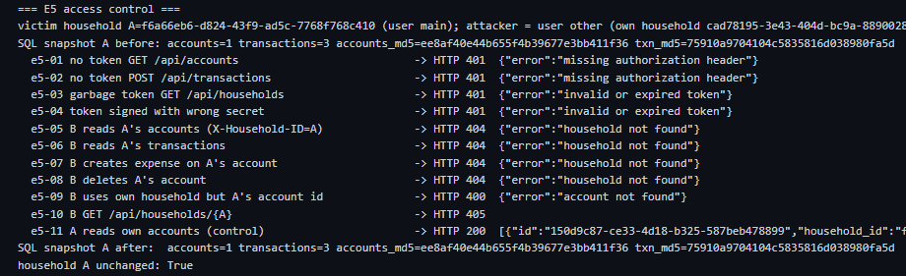
Figure 17. E5: 401 for missing/invalid tokens, 404 for a foreign tenant, identical SQL snapshots before and after.
E6 input and limits. Malformed JSON (x2), a negative amount and a bad UUID → 400; a 3 MB body → JSON 413 from the gateway; 1.5 MB → 400 from the API's own 1 MB decode limit; no account was created. Twelve wrong passwords: 401 for attempts 1–9, 429 at attempt 10 (Retry-After: 900), 401 at 11 (the other replica, which had not yet seen 5 failures), 429 at 12, and the correct password afterwards was still 429 — the lockout works, but with two in-memory counters it needed 10 attempts instead of 5. A background probe stayed 43/43 OK (avg 13.2 ms, p95 37.9 ms). Finding: the baseline trusts a client-supplied X-Real-IP — the API logged remote=203.0.113.77, an address chosen by the client and therefore a fresh rate-limit and lockout key per request; through the gateway it logged 10.244.0.1.
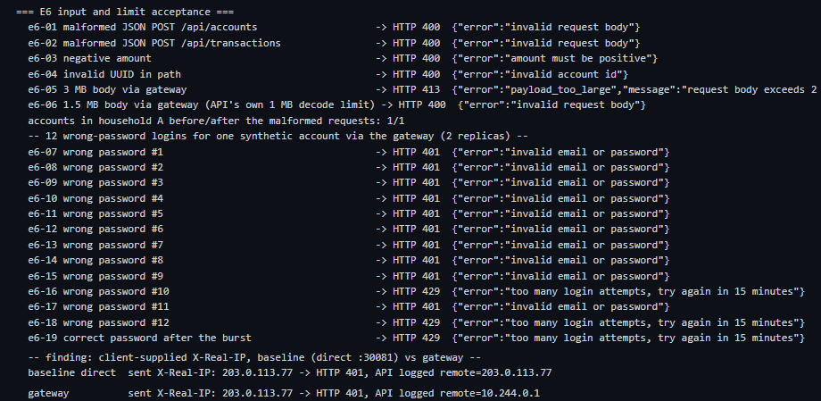
Figure 18. E6: validation, JSON 413, lockout sequence across two replicas, and the X-Real-IP comparison (baseline vs gateway).

8.7 E7 and E8 — Recovery, consistency and graceful degradation
Table 19. E7: 200 logical creates with unique client_id, one API pod deleted at t+16.7 s.
Config | Rep | HTTP attempts | Failed attempts | First attempt failed | Rows | Duplicates | Balances ok | Avg | p95 | Endpoint drop / back (s)
endterm | 1 | 200 | 0 | 0 | 200 | 0 | yes | 62.1 | 206.4 | 0.25 / 1.14
endterm | 2 | 200 | 0 | 0 | 200 | 0 | yes | 48.3 | 149.5 | 0.23 / 1.12
baseline | 1 | 207 | 7 | 5 | 200 | 0 | yes | 82.2 | 166.1 | 0.23 / 1.55
baseline | 2 | 207 | 7 | 5 | 200 | 0 | yes | 79.5 | 187.2 | 0.22 / 1.69

Both configurations ended with exactly 200 rows, 0 duplicates and correct balances. The endterm needed no retry at all (the gateway and preStop hid the kill); the baseline lost 7 HTTP attempts per run to connection errors and 5 creates needed a client retry, which the client_id key made safe. E7 therefore did not exercise the server-side replay path on the endterm; that path was exercised in E2.
E8. With RATES_BASE_URL pointing at an unresolvable host and an empty rates archive, KZT expenses returned 201 (twice), USD and EUR returned 422 no_rate, the household gained exactly 2 rows and 0 non-KZT rows, and the exchange_rates job logged ERROR. The environment was restored afterwards. Because the archive was already empty (the provider had answered 522 from inside the lab), E8 shows the no-rate path, not the stale-rate path.
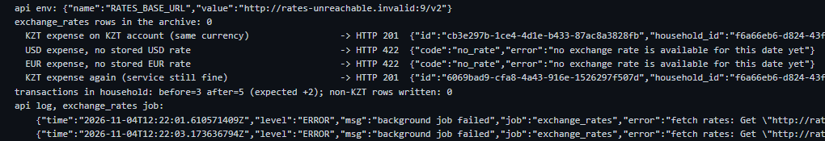
Figure 19. E8: base-currency writes succeed, foreign-currency writes are refused with 422 no_rate, nothing wrong is written, and the failing job is visible in the log.

8.8 Final integrity check
After all runs, scripts/final_check.py re-checked 35 accounts: balance = −sum(amount) everywhere and 0 duplicate (household_id, client_id) pairs in the whole database. The same check revealed that PostgreSQL had been OOM-killed once (exit 137, limit 256 Mi) at 12:22:04Z during the E8 rolling update, when up to four API pools plus the baseline were connected; it restarted by itself and no data was lost.
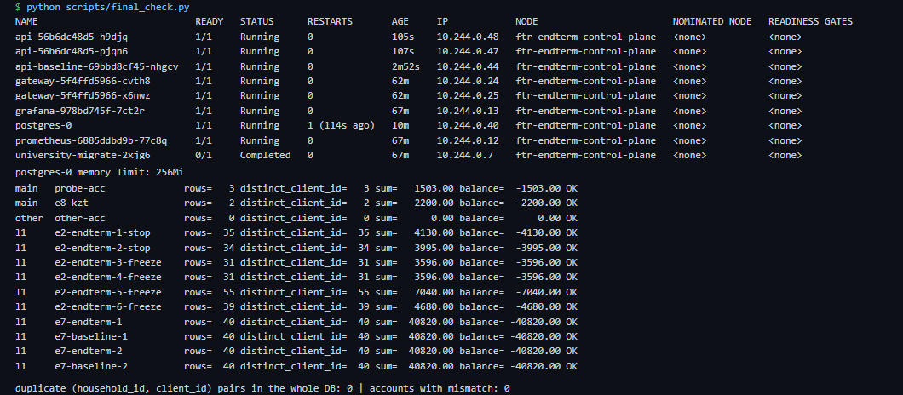
Figure 20. Final integrity (excerpt): pod states (postgres-0 restarted once; its lastState OOMKilled line is in the log), the first accounts checked, and the global duplicate check.

8.9 Pass/fail summary
Table 20. Pass/fail outcomes against the acceptance criteria.
Exp. | Acceptance criterion | Endterm result | Endterm | Baseline result | Baseline
E1 | 0 failed requests, recovery < 10 s | 0 failed (3 runs), 0.8–1.9 s | PASS | 137–138 / 139 failed, 23 s | FAIL
E2 | fast JSON error, alert, recovery, no lost/duplicate data | JSON 503/500 ≤ 5 s, alert 15–20 s, integrity 4/4 | PASS | 12 s hangs, no alert; integrity 4/4 | partial (integrity only)
E3 | ≥ 99 % at 30 req/s, p95 < 500 ms, no alert | 100 %, p95 ≤ 28 ms | PASS | 82–86 % (429) | FAIL
E4a | no alert in quiet window | 0 alerts | PASS | – | –
E4b | ApiReplicaDown fires on a lost replica | original: never; fixed: 10–11 s | FAIL → PASS | no rule | –
E4c | ApiHighErrorRate fires | 16–17 s | PASS | no rule | –
E4d | only ApiHighLatencyP95 fires | 18–19 s, nothing else | PASS | no rule | –
E5 | 401 / 404, data unchanged, audited | as expected, 11 app_logs rows | PASS | – | –
E6 | 400 / 413 / 429, service stable | as expected, probe 43/43 | PASS | X-Real-IP spoofable | FAIL (finding)
E7 | 200 rows, 0 duplicates, balances ok | yes, 0 client errors | PASS | yes, after 7 retries | PASS
E8 | KZT 201, foreign 422, nothing wrong written | as expected | PASS | – | –
Final | all accounts consistent | 35/35, 0 duplicates | PASS | (shared DB) | PASS

9. Discussion, Limitations and Lessons Learned

9.1 Discussion
The measurements support three claims. First, redundancy plus a retrying gateway turns an instance failure from a 23 s outage into no visible failure (E1, E7). Second, monitoring with explicit thresholds detects dependency failures, pod hangs and contention within 10–23 s and stays silent when nothing is wrong (E4). Third, correctness held under every injected fault: no lost or duplicated record in any of the integrity checks. The database outage shows that resilience mechanisms have costs: bounded latency and explicit errors were bought with lower success during and right after the outage (E2). Which is better depends on the client: for a mobile client with its own retry queue, a quick 503 is preferable to a 12 s hang; for a single request that can wait, the baseline's behaviour delivered more answers.

9.2 Limitations
- The /health endpoint does not check the database. Liveness is correct, but readiness stays green while PostgreSQL is down (E2) and, likely, while a fresh pod's pool is starved (E1 baseline). A readiness check with a DB ping was rejected in A3 because it would take every replica out at once during a DB outage; a better option is a separate startup gate.
- No statement timeout and no pool-acquire timeout. Requests wait on a blocked database until the gateway gives up at 5 s or the server's 15 s write timeout.
- 500 instead of 503 during a DB outage. The membership check fails closed with 500; the gateway only converts timeouts and 502/503/504 into its JSON 503, so 1–19 responses per outage window were 500s, and gateway retries cover GET only (POST is never replayed, by design).
- Slower recovery after a DB outage than the baseline (6–17 s vs 2–13 s): the price of the 5 s cap and max_fails=1.
- Rate limits and login lockout live in each replica's memory: 10 attempts instead of 5 with two replicas; a restart clears them. All host traffic shares one SNAT IP, so per-IP limits are shared by every test client — this is also why the baseline was throttled in E3.
- PostgreSQL was OOM-killed once (256 Mi limit with up to five connection pools). It recovered automatically, but the limit is too tight; there is no database replica.
- Measurement scope: one node, latencies include host port forwarding, 2–3 repetitions per scenario (behaviour, not tight distributions); the root cause of the baseline's 23 s outage is a hypothesis; E2 reps 3–4 were invalid and re-run; E8 covered only the empty-archive path; no metrics-server (CPU from kubelet/Prometheus).

9.3 Lessons learned
- An alert must be tested by injecting the failure it is meant to catch: up == 0 looked right in review and could never fire with DNS-based discovery.
- Verify that a fault was actually injected before reading the result: two "freeze" runs measured nothing because of shell quoting; the alert silence was the clue.
- A load balancer needs more than one upstream to retry on: behind a single ClusterIP the gateway's retry settings were inert until per-pod upstreams were used.
- Proxy headers are part of the security boundary: without the gateway, the client chose its own IP for rate limiting and logs.
- Idempotency keys are cheap and decisive: they made every client retry safe in E2 and E7.

10. Conclusion
The endterm system extends the midterm Registration Service with a gateway, replica-aware routing, an opt-in metrics endpoint, three tested alert rules, a dashboard, request correlation and network segmentation, and it was evaluated in eight experiments against a retained baseline. It meets its acceptance criteria for instance failure, load, monitoring, tenant isolation, input abuse, write consistency and dependency degradation. The comparison is not uniformly in its favour: during a database outage it trades availability and recovery speed for bounded latency and explicit errors. The main open items are a database-aware startup/readiness gate, a statement timeout, shared rate-limit state, a larger database memory limit and a database replica.

References
[1] Kubernetes Documentation, "Configure Liveness, Readiness and Startup Probes." https://kubernetes.io/docs/tasks/configure-pod-container/configure-liveness-readiness-startup-probes/
[2] Kubernetes Documentation, "Deployments" (rolling update strategy). https://kubernetes.io/docs/concepts/workloads/controllers/deployment/
[3] Kubernetes Documentation, "Pod Lifecycle" (termination, preStop hooks). https://kubernetes.io/docs/concepts/workloads/pods/pod-lifecycle/
[4] Kubernetes Documentation, "Network Policies." https://kubernetes.io/docs/concepts/services-networking/network-policies/
[5] Prometheus Documentation, "Alerting rules." https://prometheus.io/docs/prometheus/latest/configuration/alerting_rules/
[6] Prometheus Documentation, "Histograms and summaries." https://prometheus.io/docs/practices/histograms/
[7] Prometheus Documentation, "Configuration" (dns_sd_config). https://prometheus.io/docs/prometheus/latest/configuration/configuration/
[8] nginx Documentation, "Module ngx_http_upstream_module." https://nginx.org/en/docs/http/ngx_http_upstream_module.html
[9] nginx Documentation, "Module ngx_http_proxy_module." https://nginx.org/en/docs/http/ngx_http_proxy_module.html
[10] M. T. Nygard, Release It! Design and Deploy Production-Ready Software, 2nd ed. Pragmatic Bookshelf, 2018.
[11] B. Beyer, C. Jones, J. Petoff and N. R. Murphy (eds.), Site Reliability Engineering: How Google Runs Production Systems. O'Reilly, 2016 (ch. 6 "Monitoring Distributed Systems", ch. 22 "Addressing Cascading Failures").
[12] OWASP Foundation, "OWASP API Security Top 10 – 2023." https://owasp.org/API-Security/editions/2023/en/0x11-t10/

11. Appendix — Source, Configuration, Scripts, Logs

A. Repository and run instructions
Repository: https://github.com/shamilstud/howallet-ftr-endterm. It contains the lab (manifests, scripts, notes, evidence) and the service patch patch/feat-metrics.diff (hoWallet commit 60cd5791, branch feat/metrics, base 06aea177; metrics are off unless METRICS_ENABLED=true). The hoWallet application source itself is not modified by the lab.
bash scripts/up.sh --baseline # kind cluster, images, manifests in order, wait for readiness
python scripts/setup_users.py # synthetic users: register -> verify in SQL -> login (tokens git-ignored)
python scripts/faults.py e1 # E1 replica failure, 3 reps per config
python scripts/faults.py e2 # E2 database outage (stop / freeze), both configs at once
python scripts/exps.py e3 endterm 1 # E3 load step (also: e3 baseline N)
python scripts/exps.py e4quiet | e4replica N | e4errors N | e4latency N
python scripts/exps.py e5 | e6 | e7 <endterm|baseline> N | e8
python scripts/final_check.py # final SQL integrity
python scripts/build_summary.py # evidence/results/summary-data.md from the JSON
bash scripts/down.sh # delete the cluster
Demonstration plan for the defence (scripted, about 2 minutes each): E1 replica failure with the Grafana dashboard open, E4b hung replica with the alert page, E5/E6 security and misuse requests.

B. Configuration files
Table 21. Manifests.
File | Content
k8s/00-namespace.yaml | namespace university, synthetic Secret university-secrets
k8s/10-postgres.yaml | PostgreSQL 16 StatefulSet, PVC, Service
k8s/20-migrate-job.yaml | migration Job (image ftr-migrate:endterm, Dockerfile.migrate)
k8s/30-api.yaml | api Deployment x2, Service api, headless Service api-headless
k8s/40-gateway.yaml | nginx ConfigMap (Listing 1), gateway Deployment x2, NodePort 30080
k8s/50-prometheus.yaml | scrape config (dns_sd, 2 s) and the three alert rules
k8s/60-grafana.yaml | datasource and dashboard howallet-endterm (7 panels)
k8s/70-network-policy.yaml | default-deny ingress, per-tier allow rules, API egress allow-list
k8s/baseline/api-baseline.yaml | midterm baseline: 1 replica, NodePort 30081, own headless Service
k8s/optional/block-egress.yaml | replacement egress policy without external HTTPS
kind-config.yaml | single-node cluster with NodePort mappings 30080/30081/30090/30300

C. Scripts
Table 22. Scripts.
File | Purpose
scripts/up.sh, down.sh, switch-api-image.sh, get-token.sh, rec.sh | cluster lifecycle, token, recording $ command + output to evidence/*.txt
scripts/ftlab.py | Probe, EndpointWatcher, AlertWatcher, summarize, known_state
scripts/faults.py | E1, E2
scripts/exps.py | E3–E8
scripts/e1_diag.sh, e1_diag2.py, e1_diag3.py | E1 baseline diagnostics
scripts/setup_users.py, final_check.py, build_summary.py | users, final integrity, summary tables
scripts/render_evidence.py, shoot.mjs, architecture.html | terminal renders, browser screenshots, architecture diagram
report/build_report.py | this report (DOCX + PDF) from the evidence

D. Logs and additional results
Text logs: evidence/01-cluster-up.txt, 02-get-all.txt, 03-targets.txt, 04-correlation.txt, 05-alert-rules.txt, e1-replica-failure.txt, e1-baseline-diagnostic.txt, e2-database-outage.txt, e3-load-increase.txt, e4-alerts.txt, e5-access-control.txt, e6-input-limits.txt, e7-recovery-consistency.txt, e8-graceful-degradation.txt, 99-final-integrity.txt. Raw data: evidence/results/*.json (31 files incl. the two *-INVALID-not-injected.json), summary.md, summary-data.md. Note: the terminal logs also print a stats_interval that includes the 5 s before the injection; the tables in this report use stats_after_injection (E1) and the windows of Table 11.
Screenshots in evidence/screenshots/ not reproduced (or reproduced only as a crop) in the body, besides the terminal-*--main.png renders of each command header:
prom-alerts-e4-error-rate-rep1-ApiHighErrorRate-firing.png, prom-alerts-e4-error-rate-rep1-ApiHighLatencyP95-firing.png, prom-alerts-e4-error-rate-rep2-ApiHighErrorRate-firing.png, prom-alerts-e4-error-rate-rep2-ApiHighLatencyP95-firing.png, prom-alerts-e4-latency-rep1-ApiHighLatencyP95-firing.png, prom-alerts-e4-latency-rep2-ApiHighLatencyP95-firing.png, prom-alerts-e4-replica-down-rep2-ApiReplicaDown-firing.png, prom-alerts-e4-replica-down-rep3-ApiReplicaDown-firing.png, prometheus-targets.png, terminal-01-cluster-up.png, terminal-02-get-all.png, terminal-03-targets.png, terminal-04-correlation.png, terminal-05-alert-rules.png, terminal-e1-baseline-diagnostic.png, terminal-e1-replica-failure--e1-baseline-rep1-graceful.png, terminal-e1-replica-failure--e1-baseline-rep2-graceful.png, terminal-e1-replica-failure--e1-baseline-rep3-crash.png, terminal-e1-replica-failure--e1-endterm-rep1-graceful.png, terminal-e1-replica-failure--e1-endterm-rep2-graceful.png, terminal-e1-replica-failure--e1-endterm-rep3-crash.png, terminal-e2-database-outage--e2-rep1-stop-part1.png, terminal-e2-database-outage--e2-rep1-stop-part2.png, terminal-e2-database-outage--e2-rep2-stop-part1.png, terminal-e2-database-outage--e2-rep2-stop-part2.png, terminal-e2-database-outage--e2-rep3-freeze.png, terminal-e2-database-outage--e2-rep4-freeze.png, terminal-e2-database-outage--e2-rep5-freeze-part1.png, terminal-e2-database-outage--e2-rep5-freeze-part2.png, terminal-e2-database-outage--e2-rep6-freeze-part1.png, terminal-e2-database-outage--e2-rep6-freeze-part2.png, terminal-e3-load-increase--e3-baseline-rep1.png, terminal-e3-load-increase--e3-baseline-rep2.png, terminal-e3-load-increase--e3-endterm-rep1.png, terminal-e3-load-increase--e3-endterm-rep2.png, terminal-e4-alerts--e4-error-rate-rep1.png, terminal-e4-alerts--e4-error-rate-rep2.png, terminal-e4-alerts--e4-latency-rep1.png, terminal-e4-alerts--e4-latency-rep2.png, terminal-e4-alerts--e4-quiet-window.png, terminal-e4-alerts--e4-replica-down-rep1.png, terminal-e4-alerts--e4-replica-down-rep2.png, terminal-e4-alerts--e4-replica-down-rep3.png, terminal-e5-access-control--E5-access-control.png, terminal-e7-recovery-consistency--e7-baseline-rep1.png, terminal-e7-recovery-consistency--e7-baseline-rep2.png, terminal-e7-recovery-consistency--e7-endterm-rep1.png, terminal-e7-recovery-consistency--e7-endterm-rep2.png, terminal-e8-graceful-degradation--E8-graceful-degradation-exchange-rate-provider-unreachable.png

