Python To-Do by Samantha Hamilton

This is my to do app, written in Python. These screenshots were taken from VS Code.

Upon starting:

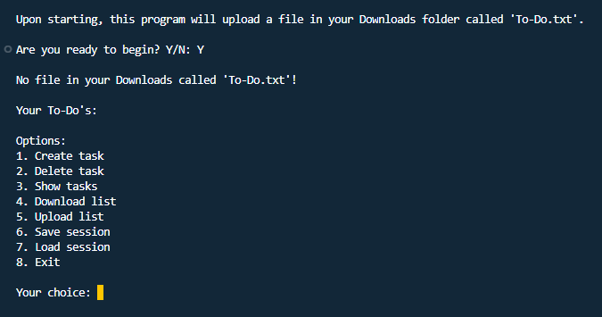

If you have a file called “To-Do.txt” in your Downloads folder, the app will load it upon starting:

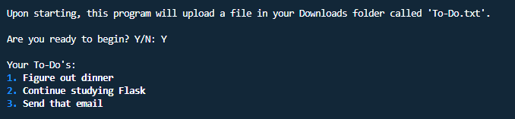

Add a task:

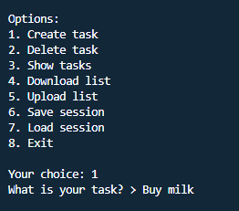

Show tasks:  
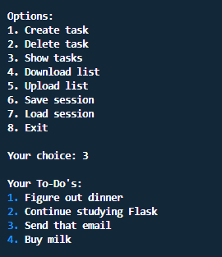

Delete tasks:

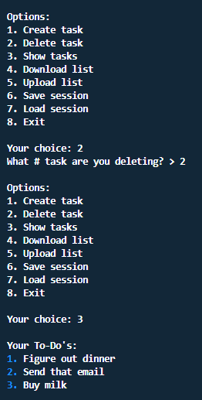

Download your list:

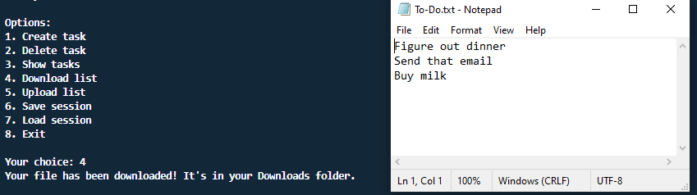

Upload a list:

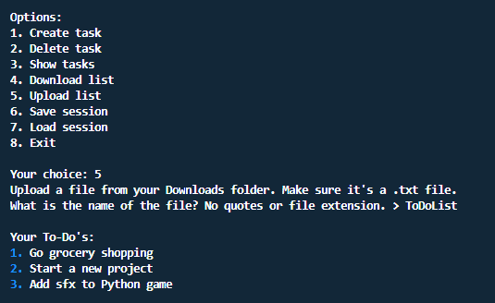

Save session:

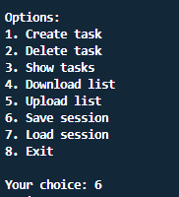

Load session (after restarting the application):

