**Software Requirements Specification (SRS)**

**Project topic:** Social networking site for IT professionals

**Description:**

It is expected to create a dynamic website where industry owners can post their requirements for a particular software ( with details ) and suppliers will be able to submit their quotations in reference to that post. The main goal is, the industry owners can get their desired software within their desired quotations, and also the suppliers will get software projects to work on which will improve their business.

**Users:**

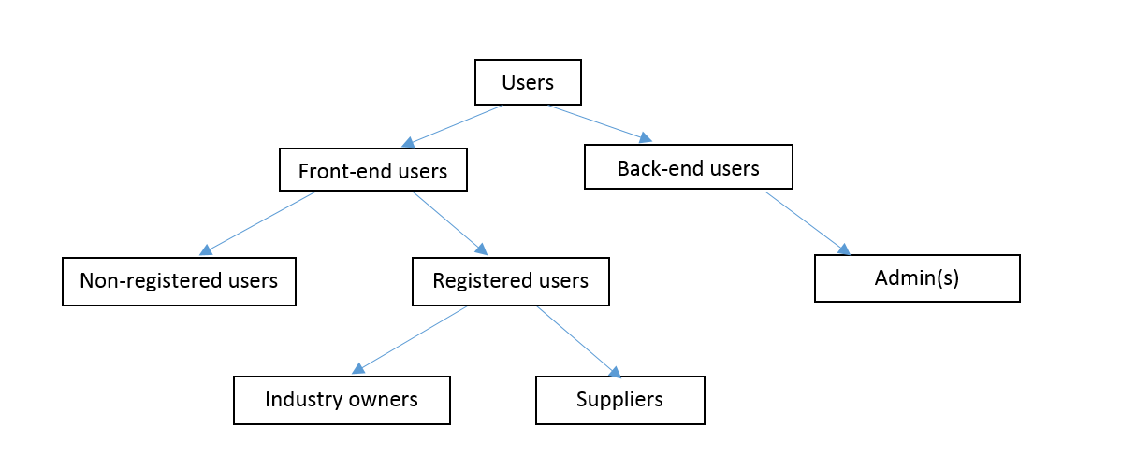

**Main success scenario (basic flow):**

1. Non-registered users will be able to view the site contents except the restricted ones. But to participate in any action (like submitting posts, quotations, comments, ratings etc.) they must create account and sign in.
2. To be a registered user, one must provide a valid email address, password, category (owner or supplier) and some additional information. Then a confirmation link will be mailed to that user, by clicking on which the user will complete the registration process.
3. The users will be able to edit their profiles or permanently deactivate their accounts. The profiles can be viewed by other users as well.
4. Industry owners can post their queries about any software along with relevant info like price range, deadline, category, product details etc.
5. Users can navigate to the posts based on the category of software. For example:



1. The suppliers can comment or submit their quotations in response to that query within the validation date. The price mentioned in quotations will be visible to only the owners. The responses can be edited or deleted by the respondents. In addition, each response will send a notification to the owner.
2. The owners will go through the quotations and can contact with the supplier by
   1. Sending message to the supplier (through the website)
   2. Viewing contact details (personally)
3. Each post will appear in news feed in form of the subject line, the users will have to click on that to view the detailed version of that post.
4. The owners can edit, delete or close their posts if they wish. Closing a post refers that the post will be visible in news feed but none will be able to comment or submit quotations under that post anymore.
5. The admin(s) will have the authority to delete any inappropriate or irrelevant content from the site.

**Extensions (alternative flow):**

1. If any supplier complete and deliver a particular software to an owner, then he can request the owner for rating/review and that rating will be visible in his (supplier’s) profile. It will help the other owners to take decision about which supplier they should contact.
2. If any user forgets his password, then he can reset the password through verification.
3. Users can request the admin to change their user role. For example, suppliers who deals with ERP based software, may need any software of different category like mobile app. In this case, they should be allowed to submit their queries as owner.
4. The admin(s) will have the right to change the policy, they can also cancel one’s membership if it is necessary.