**Setting up an Agent:**

1) Go to https://app.datadoghq.com/signup > enter your details > click Sign Up

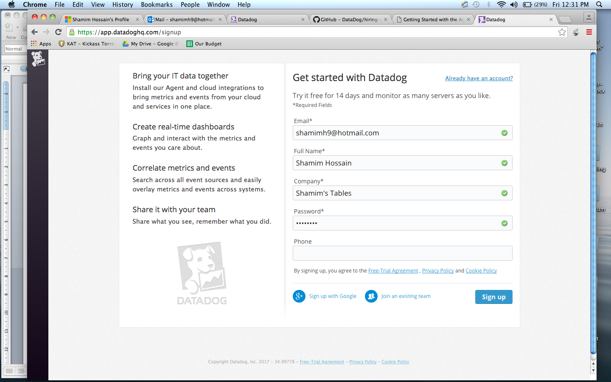

2) Click on Integrations and select Mac OS X

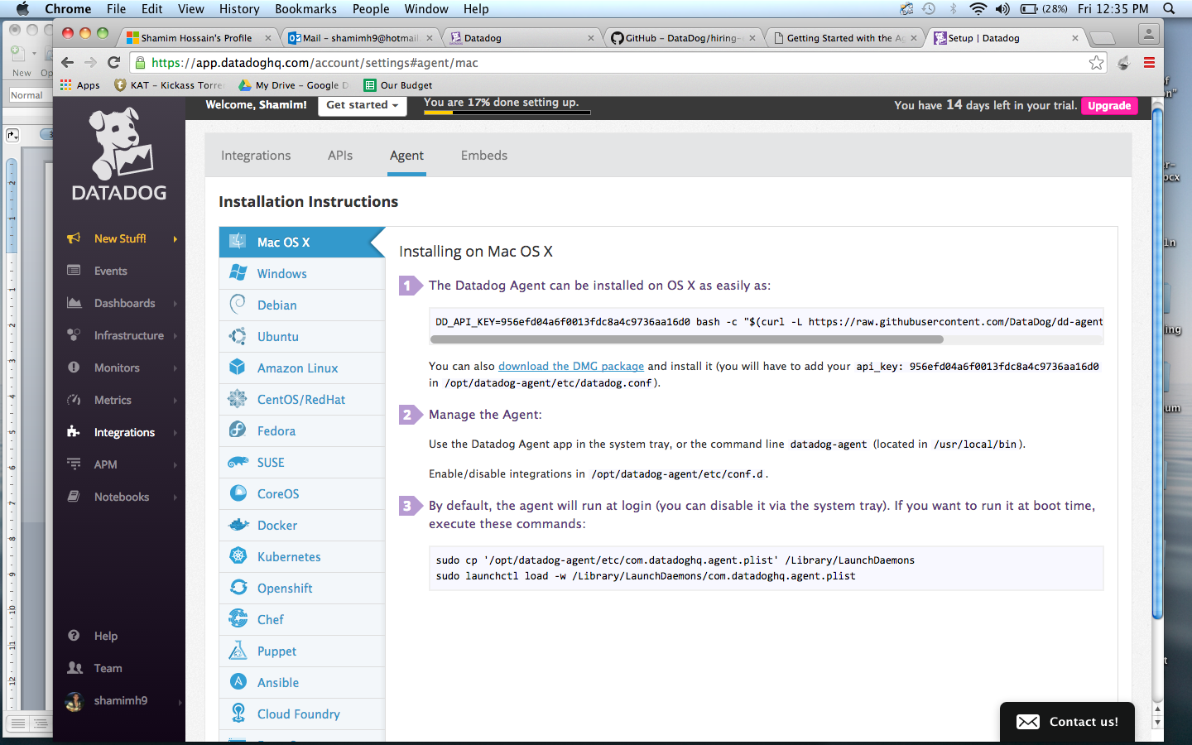

3) Click on “Download the DMG Package”.

4) Open the downloaded file and install it.

5) Open /opt/datadog-agent/etc/datadog.conf and copy paste the API key from the Datadog agent.

***Note:*** You must enable read and write access to this directory if not done so already. Here is how: https://support.apple.com/kb/PH18894?locale=en_US.

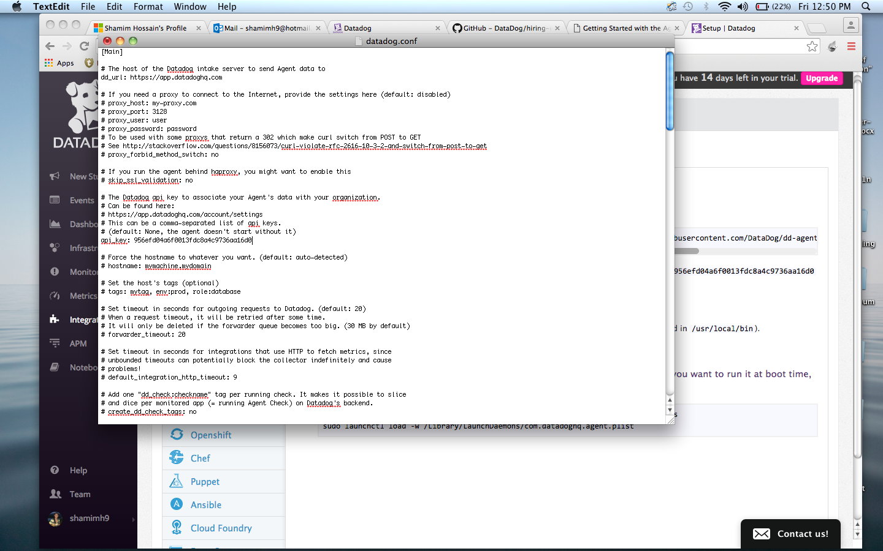

6) Run the following command in Terminal: /usr/local/bin/datadog-agent start. This should now ensure the DataDog agent being up and running.

**Getting the Agent Reporting Metrics:**

1) Hover over Dashboards in the left pane > click on Dashboards List.

2) Click on Melanie-Munozs-MacBook-Pro.local under Host Dashboards.

3) See the metrics and their corresponding values:

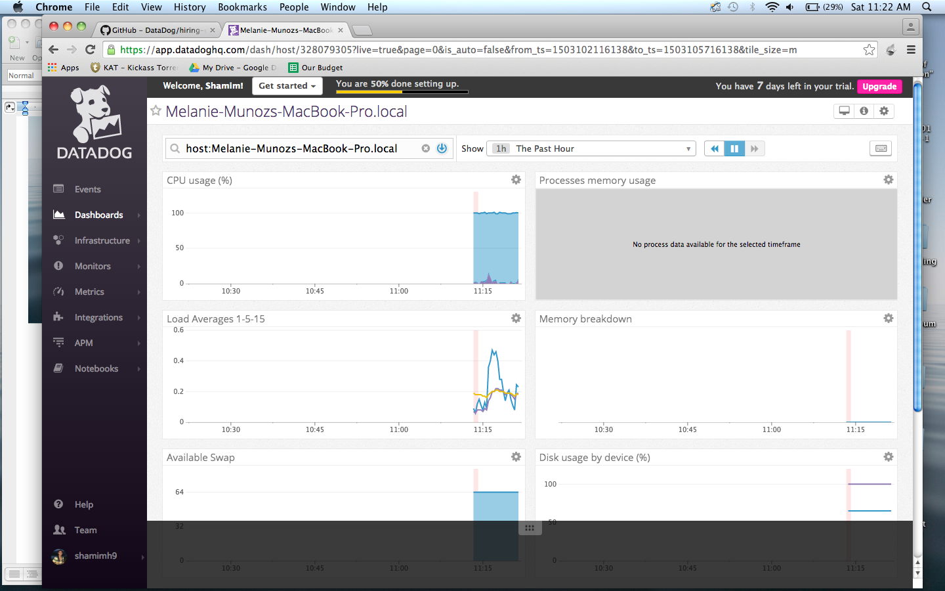

**Question:** What is an Agent?

**Answer:** An Agent is an application that is installed on a server/machine. It’s purpose is to collect data from the machine it is installed on and feed this back to DataDog.

**Tagging:**

1) Hover over Dashboards in the left pane > click on Dashboards List.

2) Click on Infrastructure on the right of the Host Dashboards.

3) Click on Update Host Tag in the top-right corner.

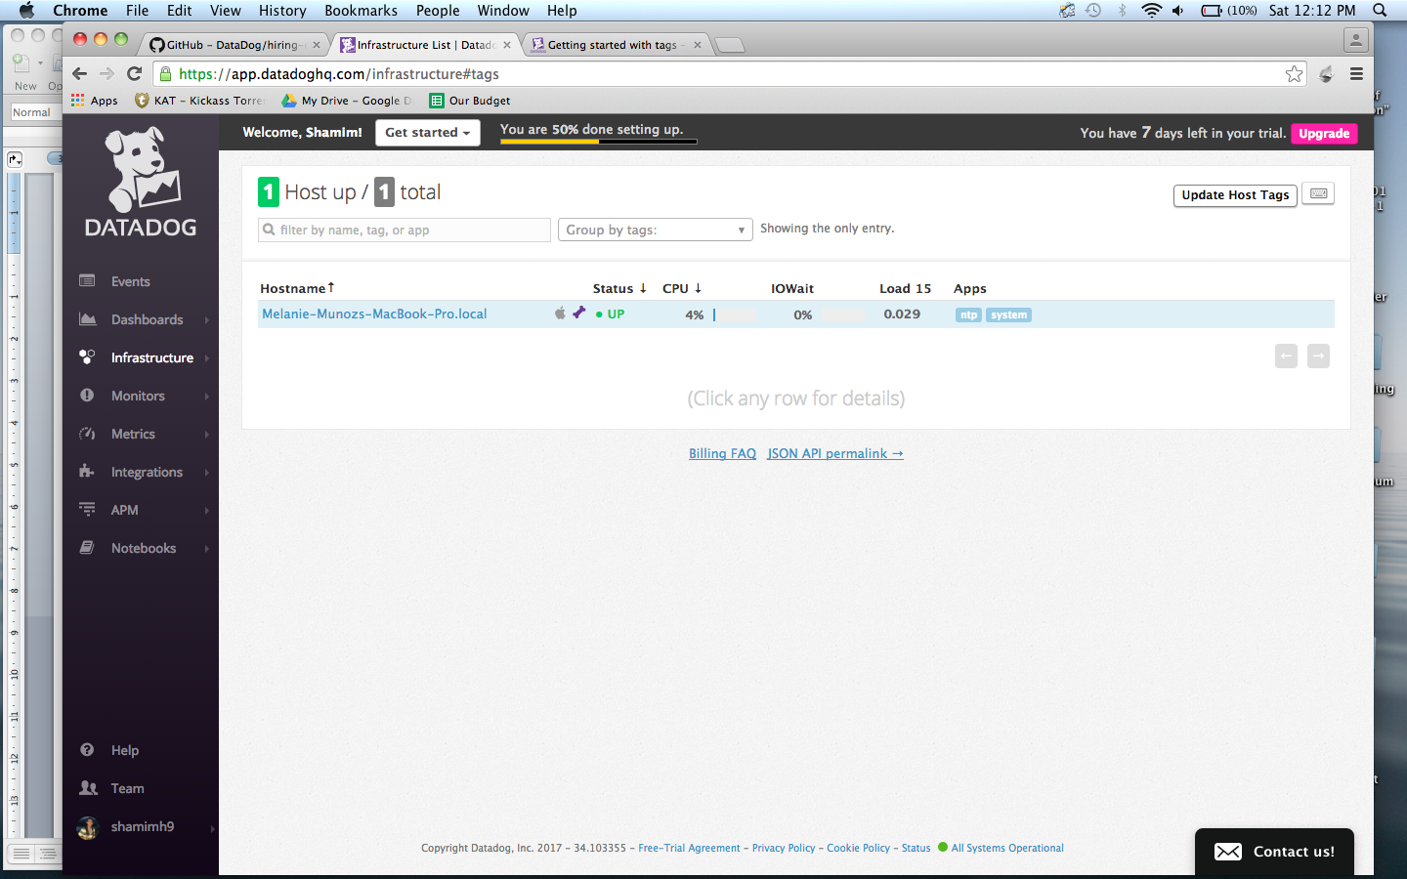

4) Click on Edit tags.

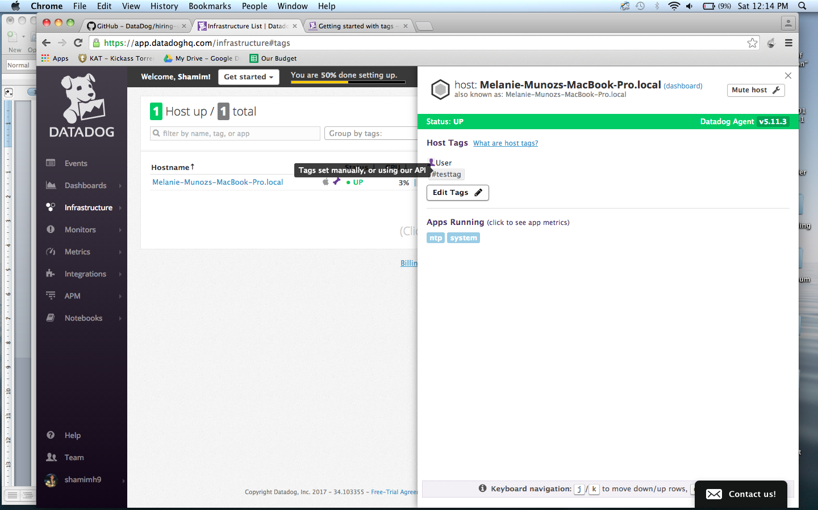

5) Type in the name of the new tag to be added > Save tags.

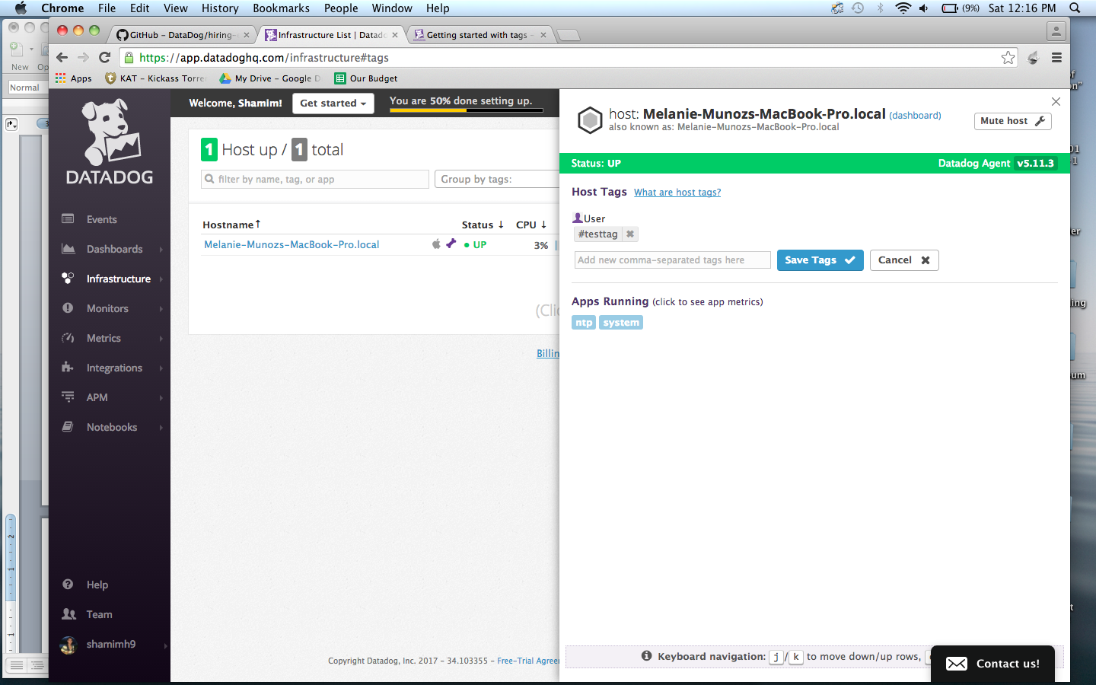

6) Close the window when completed.

7) Click on Group By tags to view the metrics based on the tags that were added.

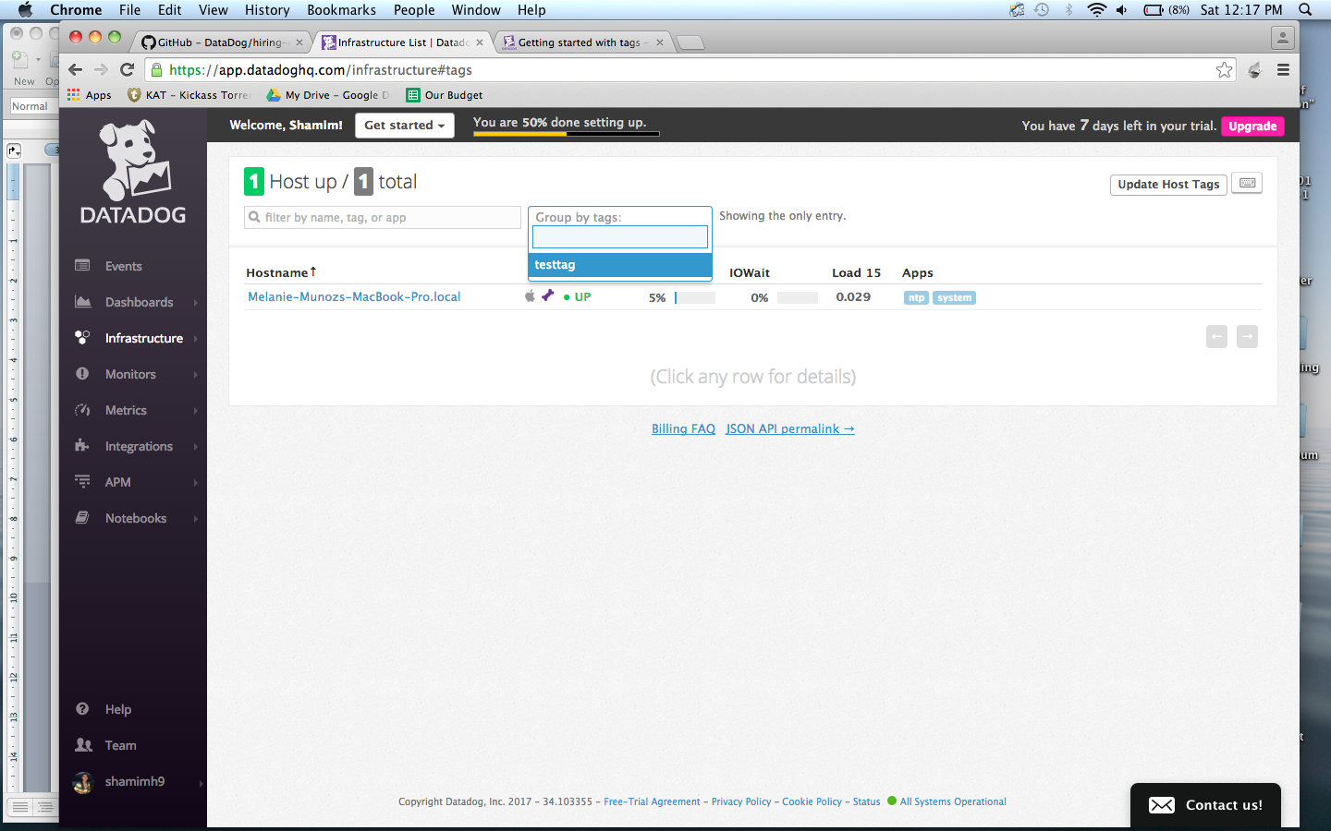

**Database Integration:**

1. Setup MySQL on Mac as per <https://dev.mysql.com/doc/refman/5.6/en/osx-installation-pkg.html>.
2. Hover over Integrations in Datadog > left pane > click on Integrations.
3. Search for MySQL.
4. Once found, click on Configure on MySQL.
5. Click on the Configurations tab on the popup and follow the prompts.

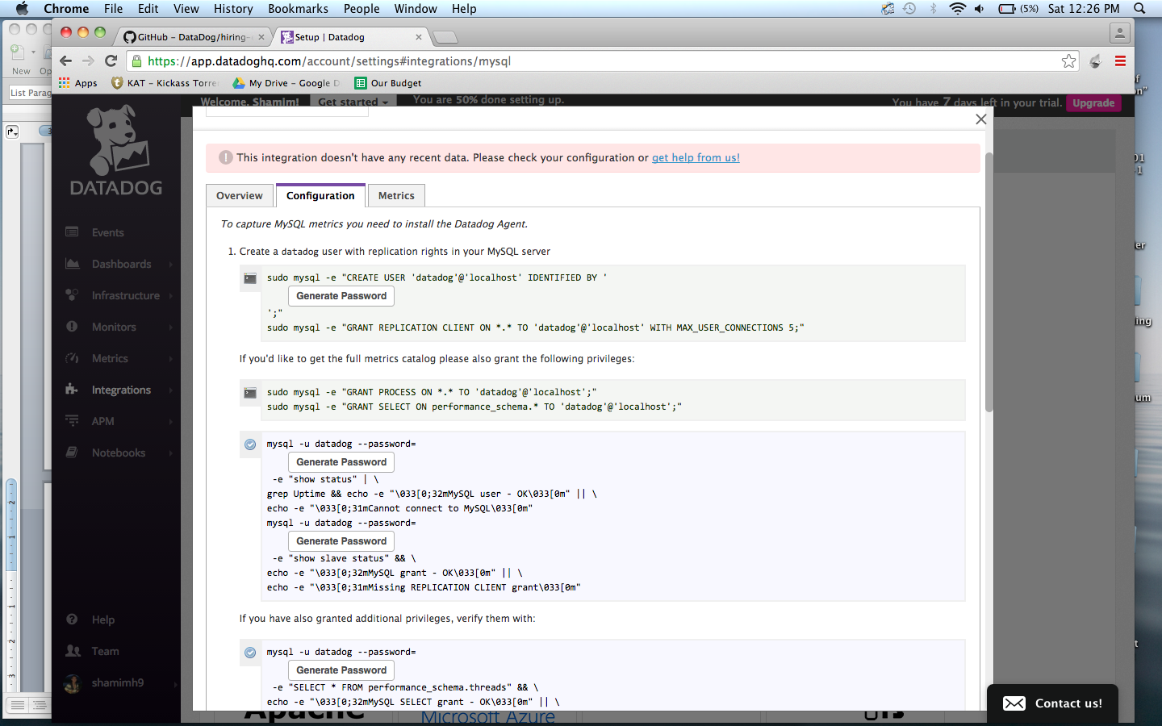

1. The MySQL Integration should be listed as installed on the integration page, once the above is complete.

