Table of Contents

ICT702 Assessment 2 - Database Design and Implementation

Football Tournament Management System
Student Name: [Your Name]
Student ID: [Your ID]
Course: ICT702 - Introduction to Relational Database
Assessment: Assignment 2 - Individual Assignment
Due Date: Sunday, 7/12/2025 23:59

1. Case Study

1.1 Scenario Description
The Football Tournament Management System is designed to manage comprehensive data for professional and amateur football tournaments. This system tracks multiple tournaments, participating teams, players, matches, officials, venues, sponsors, and related activities.
The system manages tournaments organized throughout the year, where teams register and compete. Each team has players with specific positions and performance statistics. Matches are scheduled at various venues (stadiums) with assigned referees and linesmen. The system tracks match events such as goals, assists, yellow cards, and red cards. Sponsors can support tournaments, teams, or individual players. Medical staff are assigned to teams to handle player injuries. Coaches manage teams with specific contract details.

1.2 Business Rules
- Tournaments can have multiple teams, but each team participates in one tournament at a time
- Teams consist of multiple players, and each player belongs to one team
- Players can be categorized into specific types: Goalkeepers, Defenders, Midfielders, and Forwards (specialization hierarchy)
- Matches involve exactly two teams (home team and away team) and are played at one venue
- Match Events (goals, cards) are dependent on matches (weak entity)
- Referees and Linesmen are types of Officials (specialization hierarchy)
- Venues (Stadiums) host multiple matches
- Sponsors can sponsor multiple tournaments, teams, or players
- Medical Staff are assigned to teams to manage player injuries
- Coaches manage teams with contract details
- Each match must have one main referee and at least two linesmen
- Players can have multiple match events across different matches

2. Entity Names
The system consists of 12 entities:
- Tournament
- Team
- Player (Supertype)
- Goalkeeper (Subtype - Disjoint)
- FieldPlayer (Subtype - Disjoint, further divided)
- Match
- MatchEvent (Weak Entity)
- Official (Supertype)
- Venue
- Sponsor
- MedicalStaff
- Coach

3. Attributes

3.1 Tournament
- TournamentID (PK, Surrogate Key) - Numeric
- TournamentName - Varchar
- StartDate - Date
- EndDate - Date
- Season - Varchar
- PrizeMoney - Numeric
- Location - Varchar

3.2 Team
- TeamID (PK, Surrogate Key) - Numeric
- TeamName - Varchar
- FoundedYear - Numeric
- City - Varchar
- HomeStadium - Varchar
- TournamentID (FK) - Numeric

3.3 Player (Supertype)
- PlayerID (PK, Surrogate Key) - Numeric
- FirstName - Varchar
- LastName - Varchar
- DateOfBirth - Date
- Nationality - Varchar
- Height - Numeric
- Weight - Numeric
- JerseyNumber - Numeric
- TeamID (FK) - Numeric

3.4 Goalkeeper (Subtype)
- PlayerID (PK, FK) - Numeric
- SavePercentage - Numeric
- CleanSheets - Numeric
- GoalsConceded - Numeric

3.5 FieldPlayer (Subtype)
- PlayerID (PK, FK) - Numeric
- Position - Varchar (Defender/Midfielder/Forward)
- GoalsScored - Numeric
- Assists - Numeric
- PassAccuracy - Numeric

3.6 Match
- MatchID (PK, Surrogate Key) - Numeric
- MatchDate - Date
- KickOffTime - Varchar
- HomeTeamScore - Numeric
- AwayTeamScore - Numeric
- Attendance - Numeric
- TournamentID (FK) - Numeric
- VenueID (FK) - Numeric
- HomeTeamID (FK) - Numeric
- AwayTeamID (FK) - Numeric
- RefereeID (FK) - Numeric

3.7 MatchEvent (Weak Entity)
- MatchID, EventSequence (PK, Composite Key) - Numeric
- EventType - Varchar (Goal/YellowCard/RedCard/Substitution)
- EventTime - Numeric (minute)
- PlayerID (FK) - Numeric
- Description - Varchar

3.8 Official (Supertype)
- OfficialID (PK, Surrogate Key) - Numeric
- FirstName - Varchar
- LastName - Varchar
- Nationality - Varchar
- ExperienceYears - Numeric
- CertificationDate - Date

3.9 Venue
- VenueID (PK, Surrogate Key) - Numeric
- VenueName - Varchar
- City - Varchar
- Country - Varchar
- Capacity - Numeric
- SurfaceType - Varchar
- YearBuilt - Numeric

3.10 Sponsor
- SponsorID (PK, Surrogate Key) - Numeric
- SponsorName - Varchar
- Industry - Varchar
- ContactPerson - Varchar
- ContactEmail - Varchar
- SponsorshipAmount - Numeric
- ContractStartDate - Date
- ContractEndDate - Date

3.11 MedicalStaff
- StaffID (PK, Surrogate Key) - Numeric
- FirstName - Varchar
- LastName - Varchar
- Specialization - Varchar
- LicenseNumber - Varchar
- HireDate - Date
- TeamID (FK) - Numeric

3.12 Coach
- CoachID (PK, Surrogate Key) - Numeric
- FirstName - Varchar
- LastName - Varchar
- Nationality - Varchar
- DateOfBirth - Date
- CoachingLicense - Varchar
- ContractStartDate - Date
- ContractEndDate - Date
- Salary - Numeric
- TeamID (FK) - Numeric

4. Entity Relations

4.1 Relationship Summary
Relationship | Entity 1 | Entity 2 | Type
Organizes | Tournament | Team | 1:N
Employs | Team | Player | 1:N
Specializes | Player | Goalkeeper | 1:1
Specializes | Player | FieldPlayer | 1:1
Hosts | Venue | Match | 1:N
Participates (Home) | Team | Match | 1:N
Participates (Away) | Team | Match | 1:N
Schedules | Tournament | Match | 1:N
Records | Match | MatchEvent | 1:N
Involves | Player | MatchEvent | 1:N
Officiates | Official | Match | 1:N
Sponsors | Sponsor | Tournament | M:N
Sponsors | Sponsor | Team | M:N
Sponsors | Sponsor | Player | M:N
Assigns | Team | MedicalStaff | 1:N
Manages | Coach | Team | 1:1

4.2 Detailed Relationship Descriptions
- Tournament - Team (Organizes): A tournament organizes multiple teams; each team participates in one tournament
- Team - Player (Employs): A team employs multiple players; each player belongs to one team
- Player - Goalkeeper/FieldPlayer (Specialization): Disjoint specialization - a player is either a goalkeeper or a field player
- Venue - Match (Hosts): A venue hosts multiple matches; each match is held at one venue
- Team - Match (Participates): Each match has one home team and one away team
- Tournament - Match (Schedules): A tournament schedules multiple matches
- Match - MatchEvent (Records): A match records multiple events; events cannot exist without a match (identifying relationship)
- Player - MatchEvent (Involves): A player can be involved in multiple match events
- Official - Match (Officiates): An official can officiate multiple matches; each match has one main referee
- Sponsor - Tournament/Team/Player (Sponsors): Many-to-many relationships (requires junction tables)
- Team - MedicalStaff (Assigns): A team assigns multiple medical staff members
- Coach - Team (Manages): A coach manages one team; each team has one coach

5. Weak and Strong Entity

5.1 Strong Entities (11)
Strong entities have their own primary keys and can exist independently:
- Tournament - Independent entity
- Team - Independent entity
- Player - Independent entity (supertype)
- Goalkeeper - Subtype with own existence
- FieldPlayer - Subtype with own existence
- Match - Independent entity
- Official - Independent entity (supertype)
- Venue - Independent entity
- Sponsor - Independent entity
- MedicalStaff - Independent entity
- Coach - Independent entity

5.2 Weak Entity (1)
MatchEvent is a weak entity because: - It cannot exist without a Match - Its primary key is a composite key that includes the MatchID (from the parent Match entity) - The primary key is: (MatchID, EventSequence) - MatchID is a foreign key referencing Match - EventSequence is a partial key that uniquely identifies events within a specific match - If a Match is deleted, all associated MatchEvents are also deleted

6. Cardinalities and Connectivity

6.1 Relationship Cardinalities
Relationship | Entity 1 | Cardinality | Entity 2 | Connectivity
Organizes | Tournament | 1 | Team | N (One-to-Many)
Employs | Team | 1 | Player | N (One-to-Many)
Hosts | Venue | 1 | Match | N (One-to-Many)
Participates (Home) | Team | 1 | Match | N (One-to-Many)
Participates (Away) | Team | 1 | Match | N (One-to-Many)
Schedules | Tournament | 1 | Match | N (One-to-Many)
Records | Match | 1 | MatchEvent | N (One-to-Many)
Involves | Player | 1 | MatchEvent | N (One-to-Many)
Officiates | Official | 1 | Match | N (One-to-Many)
Assigns | Team | 1 | MedicalStaff | N (One-to-Many)
Manages | Coach | 1 | Team | 1 (One-to-One)
Sponsors (Tournament) | Sponsor | M | Tournament | N (Many-to-Many)
Sponsors (Team) | Sponsor | M | Team | N (Many-to-Many)
Sponsors (Player) | Sponsor | M | Player | N (Many-to-Many)

6.2 Cardinality Explanations
- 1:N (One-to-Many): Most relationships follow this pattern where one entity instance relates to multiple instances of another entity
- 1:1 (One-to-One): Coach-Team relationship is one-to-one; each team has exactly one head coach
- M:N (Many-to-Many): Sponsor relationships are many-to-many; sponsors can support multiple entities, and entities can have multiple sponsors (requires junction tables: TournamentSponsor, TeamSponsor, PlayerSponsor)

7. Optional and Mandatory Relationships

7.1 Mandatory Relationships (Total Participation)
These entities must participate in the relationship:
- Team → Tournament: Every team must participate in a tournament (mandatory)
- Player → Team: Every player must belong to a team (mandatory)
- Match → Tournament: Every match must be part of a tournament (mandatory)
- Match → Venue: Every match must be held at a venue (mandatory)
- Match → Team (Home): Every match must have a home team (mandatory)
- Match → Team (Away): Every match must have an away team (mandatory)
- Match → Official: Every match must have a referee (mandatory)
- MatchEvent → Match: Every match event must belong to a match (mandatory - weak entity)
- MatchEvent → Player: Every match event must involve a player (mandatory)
- MedicalStaff → Team: Every medical staff member must be assigned to a team (mandatory)
- Coach → Team: Every coach must manage a team (mandatory)
- Goalkeeper → Player: Every goalkeeper must be a player (mandatory - subtype)
- FieldPlayer → Player: Every field player must be a player (mandatory - subtype)

7.2 Optional Relationships (Partial Participation)
These entities may or may not participate in the relationship:
- Tournament → Team: A tournament may exist without teams initially (optional)
- Team → Player: A team may exist without players initially (optional)
- Venue → Match: A venue may exist without scheduled matches (optional)
- Tournament → Match: A tournament may exist before matches are scheduled (optional)
- Official → Match: An official may be registered but not assigned to matches yet (optional)
- Player → MatchEvent: A player may not have any match events (optional)
- Match → MatchEvent: A match may have no recorded events (optional)
- Sponsor → Tournament/Team/Player: Sponsors may exist without current sponsorships (optional)
- Tournament/Team/Player → Sponsor: Entities may exist without sponsors (optional)
- Team → MedicalStaff: A team may exist without medical staff (optional)
- Team → Coach: A team may temporarily exist without a coach (optional)

8. Primary and Foreign Keys

8.1 Primary Keys

Surrogate Keys (Auto-generated numeric IDs):
- Tournament: TournamentID
- Team: TeamID
- Player: PlayerID
- Match: MatchID
- Official: OfficialID
- Venue: VenueID
- Sponsor: SponsorID
- MedicalStaff: StaffID
- Coach: CoachID

Composite Primary Key:
- MatchEvent: (MatchID, EventSequence) - Composite key combining foreign key and partial key

Inherited Primary Keys (Subtypes):
- Goalkeeper: PlayerID (inherited from Player)
- FieldPlayer: PlayerID (inherited from Player)

8.2 Foreign Keys
Entity | Foreign Key | References | Relationship
Team | TournamentID | Tournament(TournamentID) | Organizes
Player | TeamID | Team(TeamID) | Employs
Goalkeeper | PlayerID | Player(PlayerID) | Specialization
FieldPlayer | PlayerID | Player(PlayerID) | Specialization
Match | TournamentID | Tournament(TournamentID) | Schedules
Match | VenueID | Venue(VenueID) | Hosts
Match | HomeTeamID | Team(TeamID) | Participates
Match | AwayTeamID | Team(TeamID) | Participates
Match | RefereeID | Official(OfficialID) | Officiates
MatchEvent | MatchID | Match(MatchID) | Records
MatchEvent | PlayerID | Player(PlayerID) | Involves
MedicalStaff | TeamID | Team(TeamID) | Assigns
Coach | TeamID | Team(TeamID) | Manages

8.3 Junction Tables for Many-to-Many Relationships
TournamentSponsor (resolves Sponsor-Tournament M:N): - TournamentID, SponsorID (Composite PK) - TournamentID (FK → Tournament) - SponsorID (FK → Sponsor) - SponsorshipAmount - StartDate - EndDate
TeamSponsor (resolves Sponsor-Team M:N): - TeamID, SponsorID (Composite PK) - TeamID (FK → Team) - SponsorID (FK → Sponsor) - SponsorshipAmount - StartDate - EndDate
PlayerSponsor (resolves Sponsor-Player M:N): - PlayerID, SponsorID (Composite PK) - PlayerID (FK → Player) - SponsorID (FK → Sponsor) - SponsorshipAmount - StartDate - EndDate

9. Specialization Hierarchy

9.1 Player Specialization (Disjoint)
Supertype: Player
Subtypes: - Goalkeeper - FieldPlayer
Type: Disjoint (a player can be either a Goalkeeper OR a FieldPlayer, not both)
Notation: - Player {Goalkeeper, FieldPlayer} - Disjoint specialization - Represented with a “d” in the specialization circle
Attributes: - Common attributes (in Player supertype): PlayerID, FirstName, LastName, DateOfBirth, Nationality, Height, Weight, JerseyNumber, TeamID - Goalkeeper-specific attributes: SavePercentage, CleanSheets, GoalsConceded - FieldPlayer-specific attributes: Position, GoalsScored, Assists, PassAccuracy

9.2 Official Specialization (Overlapping)
Supertype: Official
Subtypes: - Referee (can officiate as main referee) - Linesman (can officiate as assistant referee)
Type: Overlapping (an official could potentially be certified as both referee and linesman)
Notation: - Official {Referee, Linesman} - Overlapping specialization - Represented with an “o” in the specialization circle
Note: While the assignment requires only 12 entities, the Official subtypes (Referee/Linesman) are mentioned conceptually but counted as part of the Official entity to maintain the 12-entity limit.

10. ER Diagram Description

10.1 ER Diagram Visual
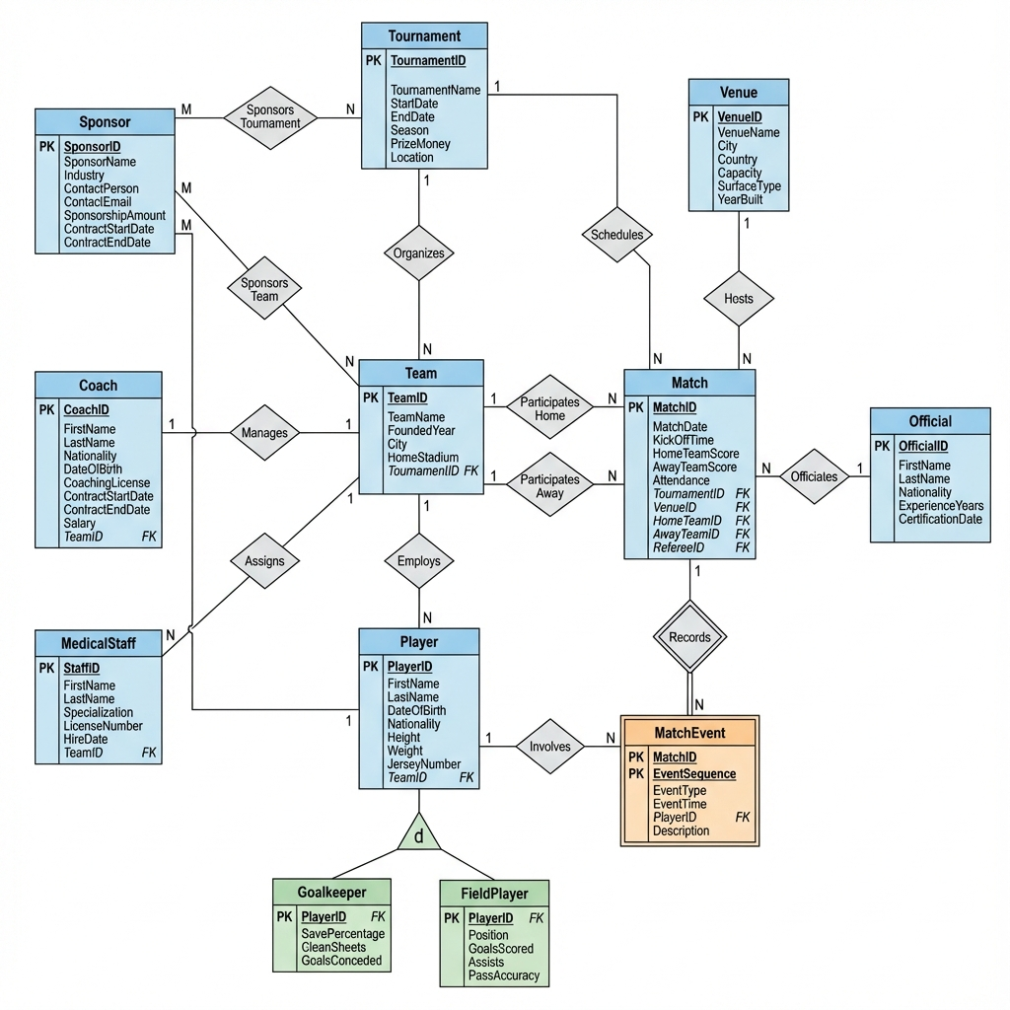
Football Tournament ER Diagram
Figure 1: Entity-Relationship Diagram for Football Tournament Management System

10.2 Diagram Components
The ER diagram includes:
- 12 Entities represented as rectangles
- Attributes shown as ovals connected to entities
- Primary Keys underlined
- Foreign Keys in italics
- Relationships shown as diamonds
- Cardinality notation (1, N, M) on relationship lines
- Participation constraints (single line for optional, double line for mandatory)
- Specialization hierarchy with ISA triangles
- Weak entity (MatchEvent) shown with double rectangle
- Identifying relationship (Match-MatchEvent) shown with double diamond

10.2 Key Design Features
10-12 Entities: Exactly 12 entities
Specialization Hierarchy: Player → {Goalkeeper, FieldPlayer} (Disjoint)
Composite Primary Key: MatchEvent (MatchID, EventSequence)
Surrogate Primary Keys: All main entities use auto-generated IDs
Numeric Fields: TournamentID, TeamID, PlayerID, Attendance, etc.
Varchar Fields: TournamentName, TeamName, FirstName, LastName, etc.
Date Fields: StartDate, EndDate, DateOfBirth, MatchDate, etc.
Weak Entity: MatchEvent
Strong Entities: All others
Normalized: All many-to-many relationships resolved with junction tables

11. Normalization Notes

11.1 Normal Forms Achieved
1NF (First Normal Form): - All attributes contain atomic values - No repeating groups - Each attribute contains only one value
2NF (Second Normal Form): - All non-key attributes are fully functionally dependent on the primary key - No partial dependencies
3NF (Third Normal Form): - No transitive dependencies - All non-key attributes depend only on the primary key

11.2 Many-to-Many Resolution
All M:N relationships have been resolved using junction tables: - Sponsor-Tournament → TournamentSponsor - Sponsor-Team → TeamSponsor - Sponsor-Player → PlayerSponsor

12. Summary
This Football Tournament Management System database design comprehensively addresses all assignment requirements:
- Unique, well-defined case study based on football tournament management
- Exactly 12 entities with clear relationships
- Specialization hierarchy with disjoint subtypes (Player → Goalkeeper/FieldPlayer)
- Composite primary key (MatchEvent)
- Surrogate primary keys (all main entities)
- Weak entity (MatchEvent) dependent on Match
- Strong entities (all others)
- Multiple data types: Numeric, Varchar, Date
- Cardinalities clearly defined (1:1, 1:N, M:N)
- Optional and mandatory relationships specified
- Normalized design with junction tables for M:N relationships
- Primary and foreign keys properly identified with correct notation
The design is scalable, normalized, and ready for implementation in a relational database management system.

End of Assignment

