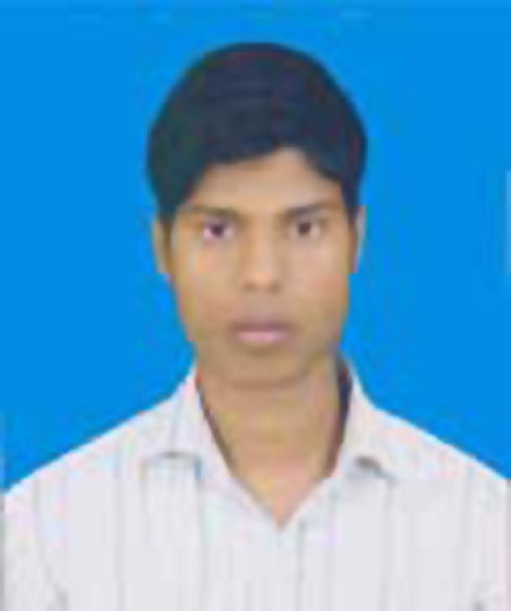
Resume
Of
MD.SHAMIM MIA
Email:shamimkumergata@gmail.com
Call: +8801989742580
Address of Correspondence:
4th no kumergata(Bottola),
Muktagachha, Mymenshingha.

Career Objective

To build a career with an organization where my merit . sincerity will contribute the best to again its derivable goals and want to be a result orientated personality . who likes to private corporate vacancies through a team based management approach.
Biographical information :

Name : Md. Shamim Mia
Father’s Name : Md. Hossain Ali
Mather’s Name : Shefaly Akter
Date of birth : 13/11/1997
Birth registration No : 19976116569106363
Nid card No : 19976116569000123
Nationality : Bangladeshi
Gender : Male
Religion : Islam
Marital status : Single
Permanent address : 4th no kumergata(Bottola),
Muktagachha, Mymenshingha.

Educational status
Title of Awarded Qualification : H.S.C (Business Studies)
Result : G.P.A 2.83 (out of 5)
Institutes : Govt.Shahid Smriti college, Muktagacha
Session : 2013-2014
Board :Dhaka
Passing Year : 2016

Title of Awarded Qualification : S.S.C (Business Studies)
Result : G.P.A 2.83 (out of 5)
Institutes : Khukshia High School, Muktagacha
Session : 2011-2012
Board :Dhaka
Passing year : 2013

Adjustments
Duplicate copies of all Necessary certificates .

Computer Skill

Well runner of Microsoft office ( MS word , MS Excel, MS power point , MS access ) And Internet Browsing , Email etc. Typing speed , Bangla - 25 and English -30.

Language proficiency

Writing and speaking skill in communication good at Bengali & English .

Self- Assessment

Excellent communication and interpersonal sensibility proactive and self- motivated Energetic.

Acknowledgement

I hereby declare that the submitted information is true and authentic, I have not concealed any facts or information .

Signature


Md. Shamim Mia

