**Roles within Data Analytics: “Data Architect”**

Shamim Sherafati

Date: 2022-10-18

NUID: 002742363

Vancouver Campus

Analyzing data collections to identify trends and make judgments about the information they contain is known as data analytics (DA). Data analytics is increasingly carried out with the use of specialist hardware and software.

**They are many different roles in data analytics;**

business analysts, intelligence analysts, data scientist, database administrator (DBA), etc.

**What Does a Data Analyst Do?**

Large data sets are analysed by data analysts in an effort to find answers to customer-related problems. Additionally, a data analyst informs management and other stakeholders of this information. These individuals have positions in a variety of professions, including those in business, finance, criminal justice, science, medicine, and government.

A data analyst is someone who has the knowledge and skills to turn raw data into knowledge and insight that can be applied to business decisions.

**Analysts in the field of Architecture as a: “Data Architect”:**

### In accordance with corporate strategy and business architecture, data architects envision and create an organization's enterprise data management structure. The procedures used to design, specify, enable, produce, acquire, manage, utilise, archive, retrieve, control, and delete data are described in this framework.

### Types of data architects:

### There are multiple ways that data architects can use their skills and a variety of roles they may fill. Examples include:

* Data architects define an organization's data vision and put it into practice.
* Project managers oversee projects associated with the planning and building of data architecture.
* Cloud architects employ company data in a cloud environment for optimal performance.
* Security architects design and employ safeguards to ensure data confidentiality, integrity, and availability.
* Machine learning architects design scalable systems for use with machine learning and artificial intelligence (AI) models.

## **Data architect responsibilities:**

• Converting technical specifications for data streams, integrations, transformations, databases, and data warehouses from business requirements.

• Determining how data flows are controlled and how data evolves throughout transition, i.e., which components of the organisation produce data and which require data to function.

• Outlining reference architecture, a model that others may use to build and enhance data systems.

• Working together with various departments within the firm to develop and implement data strategies, construct models, and evaluate the requirements and objectives of shareholders.

• Making data retrieval application programming interfaces (APIs).

A data architect is an IT professional responsible for defining the policies, procedures, models and technologies to be used in collecting, organizing, storing and accessing company information. The position is often confused with a database architect and data engineer.

## **Data architect vs. data engineer:**

Together, data engineers and data architects create and visualise the corporate data management framework.

Building the functional architecture for data search and retrieval is assisted by data engineers.

## **Data architect skills**

### Data management abilities, fluency in mathematics and computer science, and the capacity to understand and present statistical data are requirements for data architects.

### You'll need a combination of career-specific and more general workplace abilities that enable you to use data tools and technology to support data-driven business goals if you want to become a data architect. You'll require the following practical abilities, among others:

### Technical data architect skills

### • Data mining to sift through enormous data sets to find patterns, anomalies, and correlations.

### • Structured query language (SQL) to manipulate data

### • Data modelling tools like ERWin or Visio to visualise metadata and database schema

### • Structured query language (SQL) to manipulate data

### Workplace skills

• Effective communication abilities to enable you to work with other departments

• Time management and the capacity to multitask so that you can finish activities and complete projects in a fast-paced setting;

• Problem-solving and analytical abilities to protect data integrity, security, and organisation

## **How to become a data architect**

### To become a data architect, you must first acquire the necessary abilities. Here's a brief tutorial on how to get started if you're interested in this sophisticated data job.

### Think of studying computer or data science: If you want to start acquiring the abilities you'll need for work, think about getting a degree in computer science or data science.

### Start with a data entry-level position: A data architect role is rarely an entry-level one. Instead, businesses prefer to hire data architects with three to five years of experience in a comparable position, such as database administration, programming, managing data systems, or another related industry. Working your way up, you can begin as a solution architect, data engineer, or analyst.

## **Data architect job Outlook:**

In Canada, the average income for a data architect is $113,769, and in the Vancouver, BC area, it is $117,820. The average additional cash compensation for a Data Architect in the Vancouver, BC Area is $12,064, with a range from $7,726 - $18,839.   Salaries estimates are based on 11 salaries submitted anonymously to Glassdoor by Data Architect employees in the Vancouver, BC Area. (Updated Sep 29, 2022)Chart

This average salary also depends on years of experience, too.

Overall employment of database administrators and architects is projected to grow 9 percent from 2021 to 2031, faster than the average for all occupations. About 11,500 openings for database administrators and architects are projected each year, on average, over the decade. Many of those openings are expected to result from the need to replace workers who transfer to different occupations or exit the labor force, such as to retire.

An early career Data Architect with 1-4 years of experience earns an average total compensation (includes tips, bonus, and overtime pay) of C$90,329 based on 13 salaries. A mid-career Data Architect with 5-9 years of experience earns an average total compensation of C$94,359 based on 26 salaries. An experienced Data Architect with 10-19 years of experience earns an average total compensation of C$104,250 based on 39 salaries. In their late career (20 years and higher), employees earn an average total compensation of C$114,680

## **DATABASE ARCHITECT STATISTICS BY GENDER**

17.3% of database architects are women and 82.7% of database architects are men.

# **Top Companies Hiring for Data Architect Jobs:**

Top companies are rated based on anonymous employee reviews and are displayed with the total number of employees who have reviewed this company, the average salary, and the number of job openings. These highly rated companies include Amazon with an employee rating of 3.8 out of 5, Tech Mahindra rated 3.6 out of 5, Oracle with a rating of 3.9 out of 5, JPMorgan Chase & Co with a 4.0 out of 5, and IBM rated 4.1 out of 5 by employees, and more. (Reference: Glassdoor website).

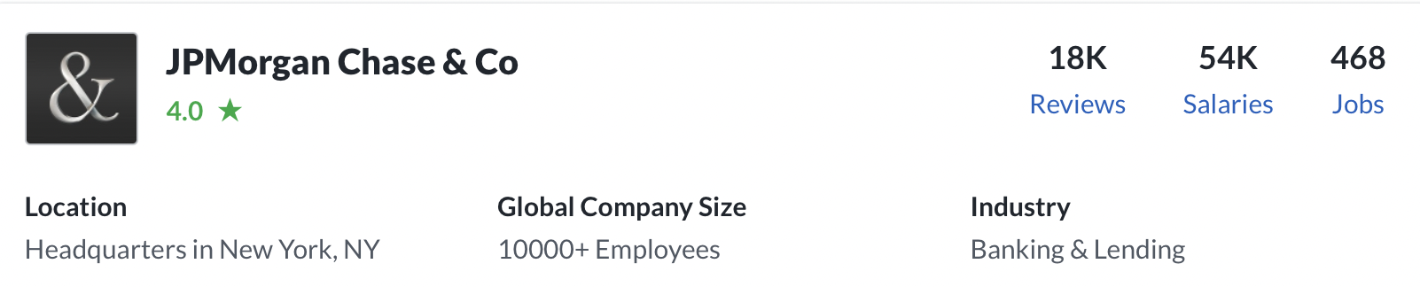

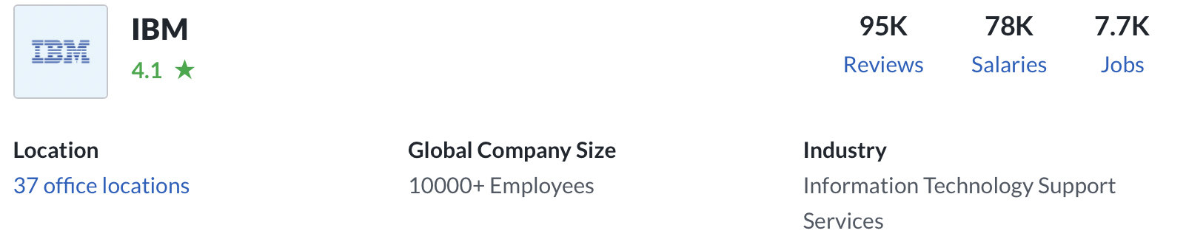

## How do Data Architects Rate Their Jobs?

### Based on 11 responses, the job of Data Architect has received a job satisfaction rating of 4.2 out of 5. On average, Data Architects are highly satisfied with their job. (based on surveys on this website: <https://www.payscale.com/research/CA/Job=Data_Architect/Salary> )

Skills that pay less than market rate include SQL, Business Intelligence, Data Warehouse, Data Modeling and Database Architecture.

Our data indicates that the lowest pay for a Data Architect is $80k / year and the highest pay for a Data Architect is $135k / year

## **Data Architect Salaries by Locations in Canada:**

Employees with Data Architect in their job title in Calgary, Alberta earns an average of 17.2% more than the national average. These job titles also find higher than average salaries in Regina, Saskatchewan (9.3% more) and Toronto, Ontario (5% more). The lowest salaries can be found in Montréal, Québec (8% less) , Mississauga, Ontario and Winnipeg, Manitoba (1.5% less).

**Numbers of job postings on LinkedIn for Data Architect:**

There are many opportunities on LinkedIn or Indeed related to data architect, out of which following were some key jobs I filtered out.;

* 1. Associate, Digital Solutions Architect – in: Davis Pier Consulting
  2. Cloud Solution Architect – in:  [WatServ](https://www.linkedin.com/company/watserv/life/)
  3. Solutions Architect, Database and Cloud – in: [Eclipsys Solutions Inc.](https://www.linkedin.com/company/eclipsys-solutions/life/)

## Solutions Architect – in: Cogeco Connexion

* 1. Solutions Architect – in: Deloitte

## Digital Solution Architect (M/F) – in: CMA CGM

## Snowflake Data Architect – IN: OUANTIPHI

## Director, Data Engineering – in: Four seasons Hotel and Resorts

## Big Data Tech Lead/ Architect – in: Falcon smart IT

### As can be seen, Solution Architect and Cloud Solution Architect has the most number and mentioned in LinkedIn which seems to be the most popular job in this role.

A WELL-ESTABLISHED Data Analyst;

#### **Andreas Kretz**

What connections may be seen between data science and plumbing? The majority of people believe that machine learning models must be super-cool and capable of fantastic predictions in order to qualify as data science.

In reality, developing these models is a portion of the process, and data engineering, or the "plumber of data science," is essential to this workflow that supports data science initiatives. Andreas is a specialist at developing large data systems that help data science initiatives.

**LINKEDIN PROFILE:** [**Andreas Kretz**](https://www.linkedin.com/in/andreas-kretz/)  
**YOUTUBE CHANNEL:** [**The Plumber of Data Science**](https://www.youtube.com/channel/UCY8mzqqGwl5_bTpBY9qLMAA)

### Summary:

### To sum up, we discuss the data architect function as one of the roles inside data analytics in this project. They vary from data engineers in that they help data engineers create the functional architecture for data search and retrieval.

### Data architects must also possess knowledge in mathematics and computer science, as well as the ability to comprehend and display statistical data.

### Some of their duties include converting technical requirements for data streams, figuring out how data flows, outlining reference architecture, and developing a model that others may use to construct and improve data systems. Other essential job abilities that they must possess are time management, problem-solving, and effective communication. Therefore, in order to become a data architect, we must develop these vital skills.

### At the conclusion, we discussed their salary and prospects for employment. As is clear, entry-level workers with up to four years of experience earn 90k$, while those with more than 20 years of experience receive the highest salaries. Future employment for this position is anticipated to increase by 9% up to 2030, according to projections.

References links:

1. <https://www.cio.com/article/190852/what-is-a-data-architect-its-data-framework-visionary.html>
2. <https://www.coursera.org/articles/data-architect>
3. <https://www.bls.gov/ooh/architecture-and-engineering/architects.htm>
4. <https://www.bls.gov/ooh/architecture-and-engineering/architects.htm#tab-1>
5. <https://www.glassdoor.ca/Salaries/vancouver-data-architect-salary-SRCH_IL.0,9_IM972_KO10,24.htm> (for salary and job outlook)
6. <https://www.payscale.com/research/CA/Job=Data_Architect/Salary>
7. <https://www.bmc.com/blogs/data-architecture/>