Comparison of Existing Systems
Development of an AI-Powered Plant Disease Detection and Treatment Recommendation System
Short name: Plant Disease AI. Diploma project, 2026-2027.
Team: Abdullayev Shynggys, Kalen Mukhammedali, Orynbasarov Alikhan. Supervisor: Kydyrbekova Aigerim.
Version: draft 1 for pre-defense 1 (24 October 2026). All web pages were read on 20 October 2026. Numbers in square brackets refer to the list of sources at the end.

1. Purpose and method
The comparison shows what similar systems already offer, what is missing, and why Plant Disease AI is needed. It checks the three weaknesses of existing applications that the project proposal assumes: (1) they only name the disease, (2) their advice has no sources, (3) they work worse on real field photos. It also checks the language support for Kazakh and Russian users.
Five systems are compared by nine criteria. The method has a limit that the reader must know:
- Documentation only. The matrix in section 4 is based on public descriptions (websites, app store pages, a registry of the FAO, scientific papers). In addition, the team tested three mobile applications (PictureThis, Agrio and a third app, Florin) in two rounds: first with a diseased beet leaf and a diseased tomato plant, then with a hand, a dark photo, a blurred photo and a healthy tomato leaf. The observations are in section 5 and the screenshots in Appendix A. Plantix and DoctorP were not tested.
- "Not stated" is not "no". If a source does not mention a feature, the cell says "Not stated in the sources reviewed". It does not mean that the feature is absent. Claims that depend on such cells are marked as not verified, unless the hands-on test in section 5 answers them.
- Self-reported numbers. Accuracy numbers that come from the vendor are marked as the vendor's own claims.

2. Selected systems
System | Developer and type | Main audience | Why it is included
Plantix | PEAT GmbH (Germany). Mobile app for Android with a farmer community [2] | Farmers | The most direct competitor: diagnosis from a photo with treatment suggestions for crops. In an independent review of 17 apps it had the highest overall quality score [11]
PictureThis | Glority Global Group Ltd. Mobile app and browser version [5][6] | Gardeners and home users | Main plant identification app with a disease diagnosis feature. Supports Russian [6]. Represents consumer apps for gardeners
Agrio | Mobile app with crop scouting tools and paid expert answers [7] | Farmers and agronomists | Crop disease diagnosis plus field monitoring. Was reviewed together with Plantix in the independent study [11]
DoctorP | Joint Institute for Nuclear Research (Russia), in the FAO AgriTech Observatory [8] | Gardeners and growers who read Russian | Free Russian-language app with treatment recommendations. Closest to the language situation of the project
PlantVillage Nuru | Penn State University and PlantVillage, with IITA for the cassava part. Free offline app for Android [9] | Smallholder farmers in Africa | Academic system with published field accuracy [10]. Shows what is known about field results and gives a reference for the field evaluation

Considered but not included
System | Reason
Plantin | The website page is promotional and does not describe the method, accuracy or treatment content. It lists seven European languages without Russian or Kazakh [13]. The App Store listing found for "Plantin AI" is English only, has no ratings, and the developer is an individual, so it is unclear whether it is the official app [14]. Too little evidence for a fair comparison.
Kindwise plant.health (Plant.id) | It is an API for developers (548 classes, confidence score, localized treatment text), not an application for end users [12]. It is useful as a technology reference: the vendor states that 73% of queries get the correct diagnosis among the top three results [12]. It is mentioned in the findings but is not compared as a product.

3. Criteria
No. | Criterion | Why it matters for the project | Related requirements
K1 | Diagnosis from a photo with AI | Core function | FR-04 to FR-07
K2 | Coverage: crops and problems | Shows the scope that competitors cover and what the MVP does not try to cover | FR-06
K3 | Treatment and prevention advice | Checks the assumption that applications only name the disease | FR-13 to FR-20
K4 | Sources of the advice are shown to the user | Checks the assumption that advice cannot be verified. Central for the RAG module | FR-14 to FR-16, FR-18
K5 | Explanation of the result: confidence, alternatives, heatmap | The user can judge how far to trust the result | FR-07, FR-08, FR-11
K6 | Handling of unclear or non-leaf photos | The system should ask for a new photo and not guess | FR-08 to FR-10
K7 | Evidence of accuracy on real field photos | Checks the assumption about the laboratory-field gap | DR-03, DR-06
K8 | Languages: Russian and Kazakh | Target users in Kazakhstan | FR-03, NFR-11
K9 | Platform, offline use and price | Shows access conditions of the target users | FR-28, FR-29

4. Comparison
Criterion | Plantix | PictureThis | Agrio | DoctorP | PlantVillage Nuru
K1 Diagnosis from a photo with AI | Yes. Photo of a sick crop gives a diagnosis in a few seconds [1][3] | Yes. Feature "Plant Disease Auto Diagnose & Cure". The main focus is plant identification [6] | Yes. AI suggests identifications. Human experts answer for paid subscribers [7] | Yes. Two neural network models: one gives the three closest matches, another is specific to the crop [8] | Yes. Object detection model that works offline on basic smartphones [9][10]
K2 Coverage | Google Play: 780+ problems on 30 major crops [2]. ICRISAT: over 700 classes on 60 crops [3]. Plantix API page: 970 problems on 57 crops [4]. The vendor's numbers differ between pages | Over 400,000 plant species for identification. Disease coverage: Not stated in the sources reviewed [6] | Not stated in the sources reviewed [7] | 12 crops and decorative houseplants. "Over 40" diseases and pests (the same page also says "over 100") [8] | Cassava (mosaic disease, brown streak disease, green mite) and maize fall armyworm damage [9]
K3 Treatment and prevention advice | Yes. Chemical and biological treatments (user testimonial on the home page [1]). "Science-based advisories" on biological and control management [3]. Dosage: Not stated in the sources reviewed | Yes. Treatment advice after diagnosis, step-by-step plan for houseplant problems [6] | Yes. Integrated pest management protocols. Chemical or biological, and dosage: Not stated in the sources reviewed [7] | Yes. Description and treatment recommendations. Russian text names products, English text mostly names active ingredients [8] | Yes. Information on how to control the disease or pest, and a recommendation to use healthy planting material [9]
K4 Sources of the advice are shown | Not stated in the sources reviewed. The vendor calls the advice "research-backed" and "science-based" without naming the research [3][4] | Tested: no source is shown for the diagnosis or the care advice. Only a general disclaimer: seek professional advice (section 5) | Tested: no source is shown. Advice is generic text with a legal notice about product labels (section 5) | Not stated in the sources reviewed [8] | Not stated in the sources reviewed [9]
K5 Explanation: confidence, alternatives, heatmap | The API returns a confidence score and a treatment plan. No visual explanation is described [4]. For the app: Not stated in the sources reviewed | Tested: the screens we captured show no confidence value for a disease and no heatmap. The "Treat Today" disease screen was not captured (section 5) | Tested: "moderate confidence" in words, one or two alternatives marked "Low confidence", no heatmap (section 5) | Shows three closest matches [8]. Heatmap and confidence: Not stated in the sources reviewed | Not stated in the sources reviewed [9]
K6 Unclear or non-leaf photos | Not stated in the sources reviewed. In Google Play replies the developer attributes failed detections to unclear images or unsupported crops [2] | Tested: a hand was identified as a coconut palm and a blurred beet leaf as common plantain, with normal result pages and no quality warning (section 5) | Tested: "We are not sure ... please ask the experts" for a hand and for a blurred leaf. The dark photo got an answer (section 5) | Not stated in the sources reviewed | Not stated in the sources reviewed
K7 Evidence of accuracy on field photos | Vendor claims only: "more than 93%" in farmers' fields [3]; about 73-74% on real field images versus about 95% on a curated test set [4]. No independent measurement was found | The "over 98%" claim is for plant identification. No figure for disease diagnosis [6] | None found [7] | No accuracy percentage. The page gives only the number of successful predictions per crop (for example 680 for tomato, May to September 2022) [8] | Published field test on cassava, compared with experts: one leaf 49% (mosaic disease 59%, brown streak 21%, green mite damage 56%); six leaves 93%, 73% and 93% [10]
K8 Languages: Russian and Kazakh | 19 languages on Google Play, 18 on the ICRISAT page [2][3]. The list is not given. Russian and Kazakh are not confirmed | 28 languages, Russian included. Kazakh is not listed [6] | English only [7] | English and Russian. Kazakh is not listed [8] | Translations were crowd-sourced, for example Swahili. The full list is not stated in the sources reviewed [9]
K9 Platform, offline use, price | Android app, 10M+ downloads, free with ads. 500+ community experts, weather, fertilizer calculator [2]. Offline library of pest and disease information [3]. Image diagnosis offline: Not stated in the sources reviewed | Mobile app and a browser version. Free with in-app purchases (Pro from $3.99 to $39.99, Family Plan $49.99). Rating 4.8 from about 1 million ratings [5][6] | iOS app (App Store reviewed). Free with in-app purchases from $4.49 to $349.99. Satellite maps, weather, scouting reports. Rating 4.6 from 482 ratings [7] | Android app (iOS was planned for 2023). Free. Needs an internet connection [8] | Android app, free, works offline, offered as a public good [9]

Independent review of 17 plant disease apps, including Plantix and Agrio, found: no app met all required functions; most apps cannot be used as a complete solution for detection, diagnosis and treatment; only one app visualised infected areas and only two offered expert or community support; the paper does not report confidence scores and recommends that apps show the likelihood of each disease; six of the 17 needed a constant internet connection; most apps were not multilingual. The study did not measure the accuracy of the apps [11].

5. Hands-on test
The team uploaded photos to three mobile applications and captured the results as screenshots. Round 1 (time stamps 16:06 to 16:22): a beet leaf with leaf spots and a tomato plant with diseased leaves. Round 2 (time stamps 22:24 to 22:44): a hand, a dark photo of the beet leaf, a blurred photo of the beet leaf, and a healthy tomato leaf. The test is small: a few photos, one session, free versions or trial access, no repeated runs, so it shows what the apps display, not how accurate they are.
- Florin is a third application that was not part of the documentation review, so it has no column in section 4. Its name was given by the team; the screenshots do not show its logo, and the developer was not recorded.
- Plantix and DoctorP were not tested.

5.1 Result, advice, sources and explanation (K3 to K5)
Criterion | Florin | PictureThis | Agrio
Result shown | Beet leaf: plant "Beet, 95% Confidence" (this is the plant identification). Diagnosis: Cercospora leaf spot, with a one-sentence symptom description and "Confidence: High" | Beet leaf: "unhealthy and stressed" or "unhealthy with serious issues", with a "Treat Today" or "Act Now" button. The disease report names Cercospora leaf spot and its cause (Cercospora beticola) | Moderate-confidence statements: "Fungal disease" (generic) and "Late Blight" (Phytophthora infestans) for the diseased tomato leaf
K3 Advice | Doctor tab: urgency, spread risk, recovery chance, a three-step plan (for example "prune and destroy severely infected leaves", "apply a copper-based biofungicide if the infection spreads"), things to avoid, likely cause, environmental triggers. Care tab. No dosage | Care and Explore tabs. The disease report has causes (with a local note about Kazakhstan in October), symptoms, treatment strategy, natural remedies with amounts (1 teaspoon of baking soda per 1 litre of water), commercial treatment with a dilution (15 ml per litre or per 4 litres), recovery care | Cultural, conventional, organic and biological control with long text. Conventional section lists active ingredients (for example chlorothalonil, mancozeb, azoxystrobin). Organic: copper-based fungicides. No dosage. "No registered products were found in your country"
K4 Sources shown | No. Only a disclaimer: the identification is generated by AI and may contain errors; verify with a certified local expert | No source for the diagnosis or the dosages. A disclaimer that the vendor assumes no liability and the user should seek professional advice | No. A caution notice: the user must follow the product label and local law. No reference to a publication or database
K5 Confidence, alternatives, heatmap | Confidence as a percentage for the plant and as the word "High" for the diagnosis. "Similar problems" are listed by name without scores. No heatmap | No confidence value or alternative diagnosis in the screens captured. A star rating of the diagnosis report. No heatmap | Confidence in words ("moderate"). One or two alternatives with the label "Low confidence" (for example Anthracnose, Early blight, Oedema). Thumbs up or down feedback. No heatmap
Other | Interface in English. Reminders for watering | Interface in English. "Cultivated in Kazakhstan" is shown on the distribution map. Free access banner | Expert help ("Ask Expert", for premium users) and an assistant ("Harvie") for treatment follow-up. Marks poisonous ingredients in red

5.2 Unclear and non-leaf photos (K6)
Photo | Florin | PictureThis | Agrio
Hand (not a leaf) | "No plant detected." with a Close button | Identified as "Common coconut palm" (Cocos nucifera) with the message "This plant looks healthy & beautiful!" | "We are not sure. Agrio is not confident about the results, please ask the experts."
Dark photo of the beet leaf | Beet, 95% Confidence. Diagnosis Cercospora leaf spot, "Confidence: High" | Beet, "unhealthy with serious issues!", disease report with Cercospora leaf spot and treatment | "With moderate confidence, it is: Fungal disease". Alternative: Oedema, low confidence
Blurred photo of the beet leaf | Identified as Lettuce, 85% Confidence. Diagnosis Downy mildew, "Confidence: High", with a treatment plan | Identified as "Common plantain" (Plantago major), "unhealthy and stressed". Disease report: "Septoria or Downy Mildew" | "We are not sure ... please ask the experts."
Healthy tomato leaf | Tomato, 95% Confidence. "No issues detected", "Confidence: High" | Tomato. "This plant is healthy but can be optimized!" | "With moderate confidence, it is: Healthy". Alternatives with low confidence: red spider mites, iron deficiency

What the test shows. Sources (K4): in all three apps the advice was text without a reference, so the assumption that advice cannot be checked is supported for these apps and this test. PictureThis gave dilution amounts without any source. Explanation (K5): Florin and Agrio show some confidence statement, Agrio adds low-confidence alternatives, none shows a heatmap or a full top-3 list with scores. Unclear input (K6): Agrio declined both the hand and the blurred photo, and Florin declined the hand ("No plant detected"). PictureThis named a plant and gave a normal result for both. Florin gave a wrong plant with "Confidence: High" for the blurred photo. No app warned about the dark or blurred photo or asked the user to retake it. Agrio's refusal sends the user to an expert (a premium feature) and does not ask for a better photo. Agrio gave an answer for the dark photo and Florin and PictureThis named the correct disease on it, so a dark photo was not a problem for the three apps in this test.

6. What the comparison shows
Status of the assumptions of the project proposal:
Assumption in the proposal | Finding | Status
Many applications only name the disease and give no advice | All five systems give some treatment or control advice (K3). This assumption is not supported for the systems reviewed. | Not supported. Reword the proposal
Advice is often given without sources, so the user cannot check it | None of the five descriptions says that sources are shown (K4). In the hands-on test none of the three apps (PictureThis, Agrio, Florin) showed a source for its advice; each showed only a disclaimer. Plantix and DoctorP were not tested. | Supported by the test of three apps
Models trained on laboratory images work worse on real field photos | The vendor of Plantix reports about 95% on a curated set and 73-74% on real field images [4]. The published Nuru test reports 49% for one leaf in the field [10]. These results are consistent with the assumption, but they are not a direct test of laboratory-trained models, and the Plantix numbers come from the vendor. | Supported by indirect evidence
Few systems explain their result | No description mentions a heatmap (K5), and none of the three tested apps showed one. Agrio and Florin show a confidence statement and Agrio one low-confidence alternative; no tested app showed a top-3 list with scores. In the independent review only one of 17 apps visualised infected areas [11]. | Supported
Systems guess instead of refusing on unclear or non-leaf photos | In the test Agrio declined a hand and a blurred leaf, and Florin declined the hand. PictureThis named a plant for both, and Florin named a wrong plant for the blurred leaf and showed "Confidence: High" for a wrong diagnosis. No app asked for a better photo (K6). Plantix and DoctorP were not tested. | Partly supported by the test of three apps
Kazakh-speaking users are not served | None of the five systems lists Kazakh (K8). Russian is supported by PictureThis and DoctorP. Plantix has 19 languages, but the list was not available. | Supported for the five systems

7. Positioning of Plant Disease AI
What existing systems do better, and what the project does not try to do:
- Coverage: Plantix reports hundreds of problems on dozens of crops, and PictureThis covers hundreds of thousands of plant species. The MVP has 38 PlantVillage classes (14 crops).
- Scale and services: communities of experts, weather, satellite maps, offline library, large user bases and ratings.
What the project adds, to be confirmed by the evaluation:
Capability | In the systems reviewed | In Plant Disease AI
Advice written only from cited passages, with a reference for every item | Not stated in any of the five descriptions (K4). Not shown in the three tested apps | Required: FR-14 to FR-16, FR-18. A lookup table is the baseline for comparison
Confidence, top 3 and a heatmap with each diagnosis | Top 3 in DoctorP [8]. Confidence in the Plantix API [4]. Confidence in words and one alternative in Agrio, percentage in Florin (tested). Heatmap: none of the tested apps | Required: FR-07, FR-08, FR-11
Clear refusal for low confidence, non-leaf and blurred photos | Tested: Agrio declines hand and blurred photos, Florin only the hand; neither asks for a better photo. PictureThis answers a wrong plant for both (K6) | Required: FR-08 to FR-10, evaluated in DR-09
Measured laboratory-to-field gap of the same model, with a published method | Vendor claims for Plantix. A published field test for Nuru (cassava only) | Required: DR-03, DR-06. The result is reported even if it is negative
Interface and advice in Kazakh, Russian and English | Kazakh is not listed by any of the five. Russian: PictureThis, DoctorP | Required: FR-03, NFR-11, NFR-12

8. Recommended changes in the proposal
The comparison does not support the first weakness that the proposal states. The Problem section should be reworded so that every statement is backed by a source or marked as an assumption. A suggested version of the three points:
- Existing applications give a diagnosis and treatment suggestions, but in a test of three of them (PictureThis, Agrio and Florin) none showed the source of its advice, so the user cannot check it.
- Few of them explain the result: the three tested apps show at most a confidence statement and one or two alternatives, and none highlights the affected area. On a hand and a blurred leaf, the apps often returned a wrong plant (PictureThis twice, Florin once) and none asked for a better photo.
- Accuracy on real field photos is lower than on curated sets (reported values: about 95% versus 73-74% for Plantix, according to the vendor; 49% for one leaf in the Nuru field test), and none of the reviewed systems lists Kazakh.

9. Limits of this comparison
- Only three apps were tested, with one beet photo and one tomato photo, not all apps with the same photos. Plantix and DoctorP were not tested. K6 used one hand photo and one blurred and one dark version of the same beet leaf, so it is a small probe. The origin and licence of the test photos were not recorded.
- Numbers of the vendors (coverage, accuracy, downloads) are their own claims. They differ between pages of the same vendor.
- App store pages show the version available in one region on the day of reading.
- The study of 17 apps [11] is a preprint of 2022. It did not measure the accuracy of the apps.

10. Sources
[1] Plantix, home page. https://www.plantix.net/en/ (read 20 October 2026).
[2] Plantix, Google Play listing (PEAT GmbH). https://play.google.com/store/apps/details?id=com.peat.GartenBank (read 20 October 2026).
[3] ICRISAT ISSCA, "Plant protection application app: Plantix". https://issca.icrisat.org/scalable-solutions/plant-protection-application-app-plantix (read 20 October 2026).
[4] Plantix Intelligence, API toolkit page. https://plantix.net/en/plantix-intelligence/api-toolkit/compare-plant-id/ (vendor claims, read 20 October 2026).
[5] PictureThis, home page. https://www.picturethisai.com/ (read 20 October 2026).
[6] PictureThis, App Store listing (Glority Global Group Ltd.). https://apps.apple.com/app/1252497129 (read 20 October 2026).
[7] Agrio, App Store listing. https://apps.apple.com/us/app/agrio-plant-diagnosis-app/id1239193220 (read 20 October 2026).
[8] FAO AgriTech Observatory, "DoctorP". https://agritechobservatory.review.fao.org/ru/doctorp (read 20 October 2026).
[9] IITA ProPAS, "Nuru for in-field pest/disease diagnosis". https://propas.iita.org/en/solutions/nuru-for-in-field-pestdisease-diagnosis/19/details/ (read 20 October 2026).
[10] Mrisho L.M., Mbilinyi N.A., Ndalahwa M., Ramcharan A.M., Kehs A.K., McCloskey P.C., Murithi H., Hughes D.P., Legg J.P. Accuracy of a Smartphone-Based Object Detection Model, PlantVillage Nuru, in Identifying the Foliar Symptoms of the Viral Diseases of Cassava: CMD and CBSD. Frontiers in Plant Science, 11, 2020. https://doi.org/10.3389/fpls.2020.590889
[11] Siddiqua A., Kabir M.A., Ferdous T., Ali I.B., Weston L.A. Evaluating Plant Disease Detection Mobile Applications: Quality and Limitations. arXiv:2208.02446 (preprint). https://arxiv.org/pdf/2208.02446
[12] Kindwise, plant.health. https://www.kindwise.com/plant-health (read 20 October 2026).
[13] Plantin, plant disease identifier page. https://myplantin.com/plant-disease-identifier (read 20 October 2026).
[14] "PicturePlant Ai Identifier / Plantin AI", App Store listing (Korean store). https://apps.apple.com/kr/app/id6749258247 (read 20 October 2026).

Appendix A. Screenshots of the hands-on test
Test photo of a beet leaf with leaf spots (supplied by the team), used in the test:
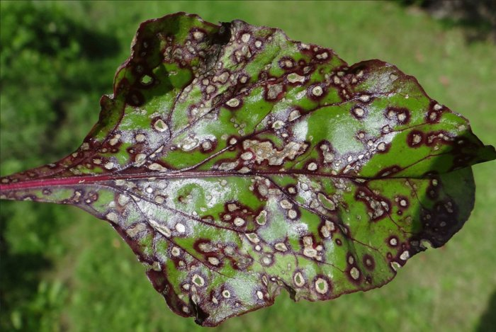
A1. Florin (beet leaf). Result with plant name and 95% confidence; Doctor tab with diagnosis; what to do next; watchlist and similar problems.
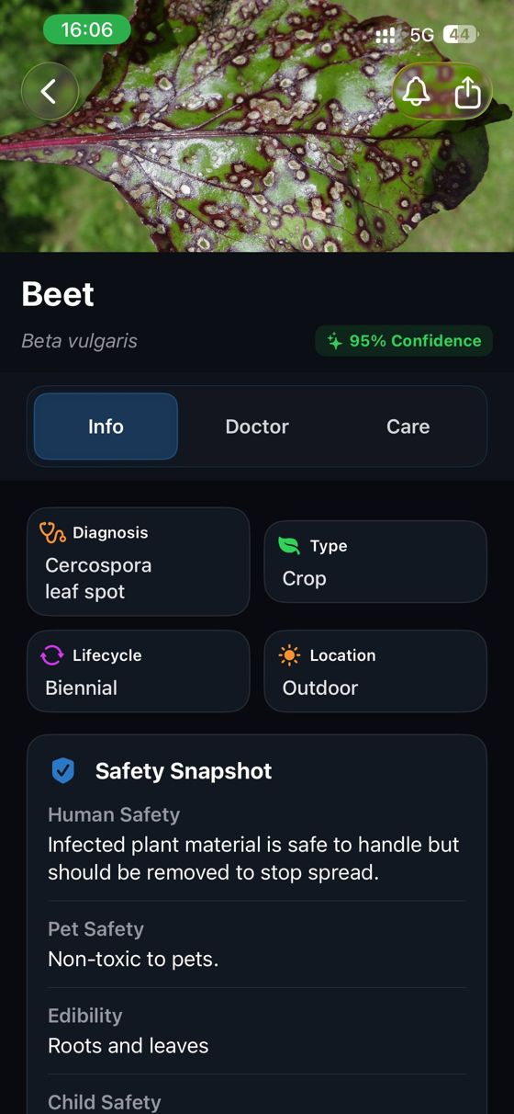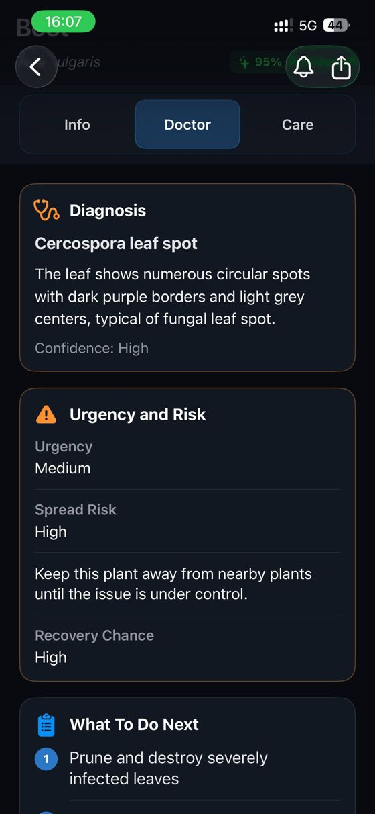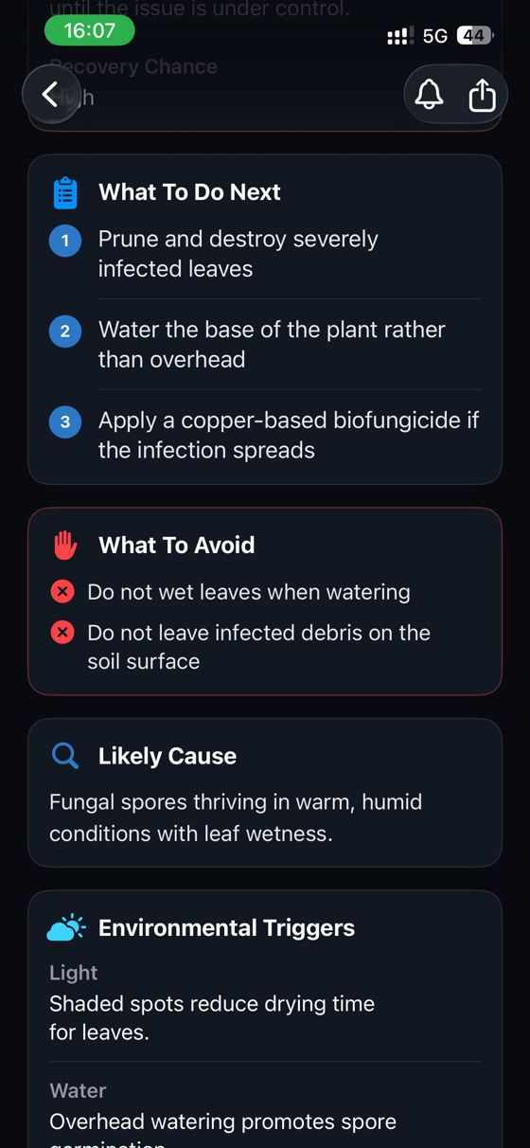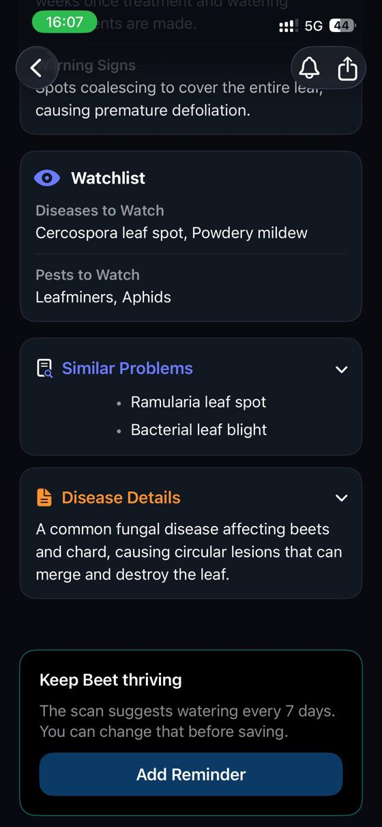
A2. PictureThis (beet and tomato). Beet: "unhealthy and stressed" with "Treat Today". Tomato: the same message. Common problems. Care questions with the vendor disclaimer.
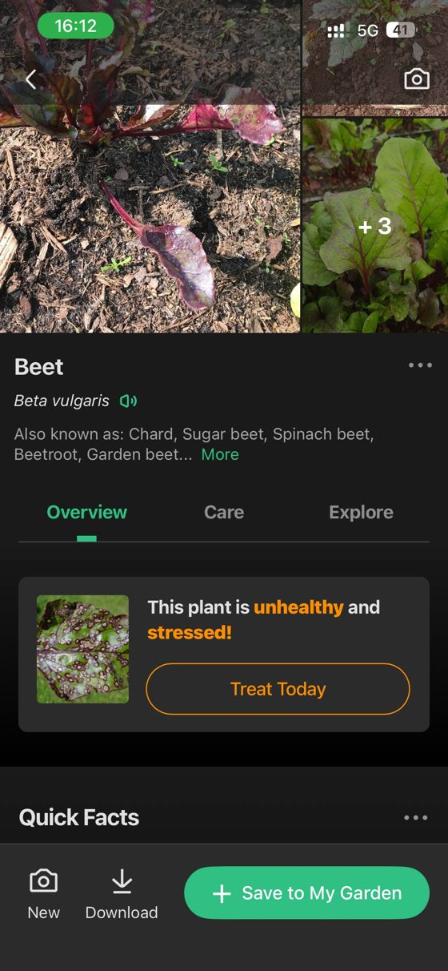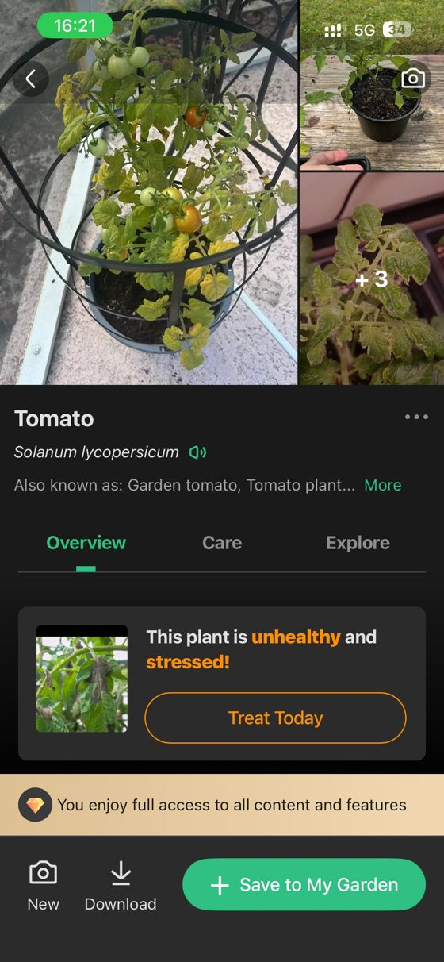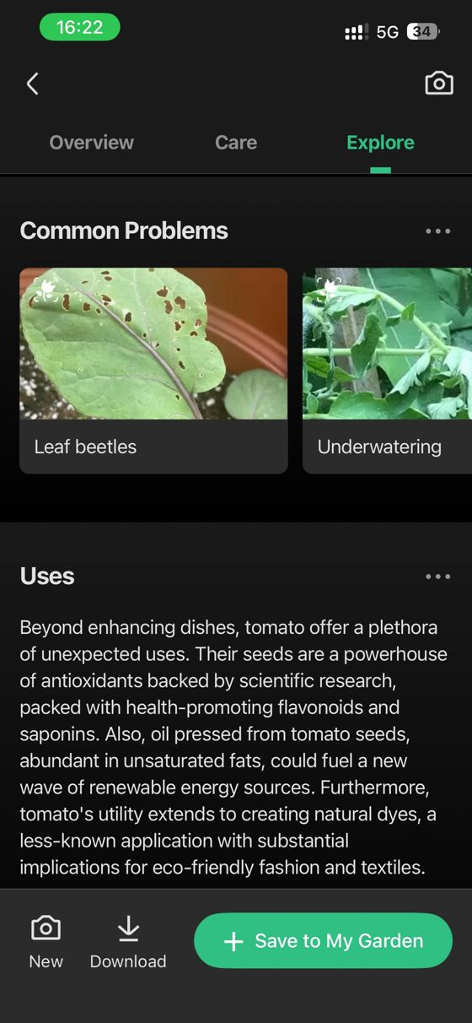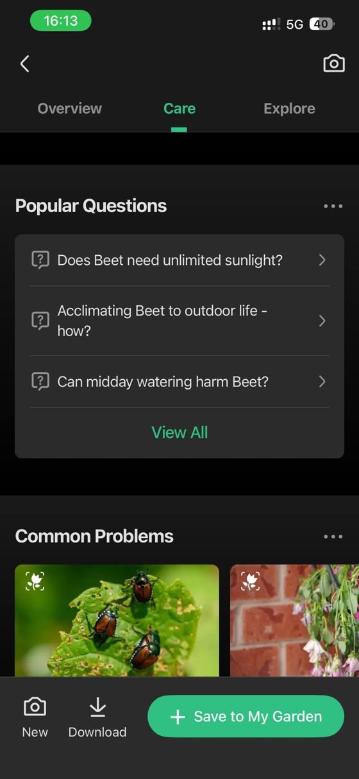
A3. Agrio. Generic "Fungal disease" result with an alternative; "No registered products"; Late Blight result with an alternative; conventional treatment ingredients.
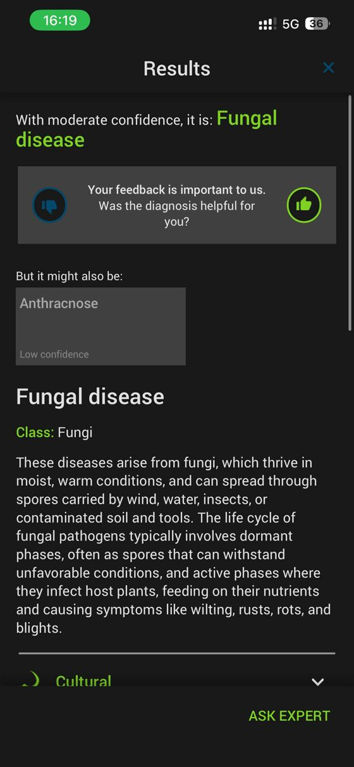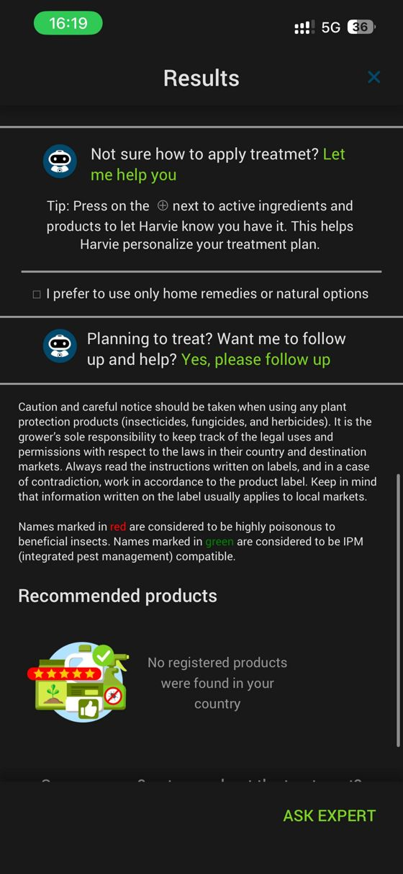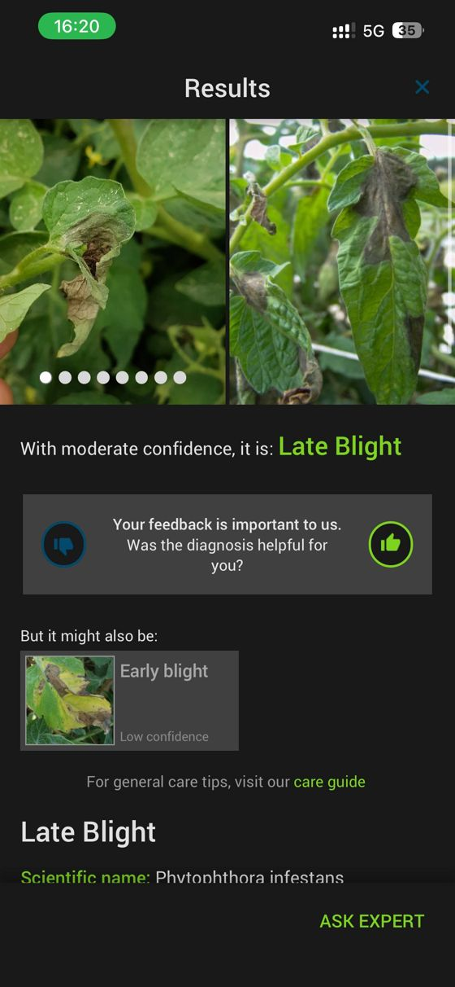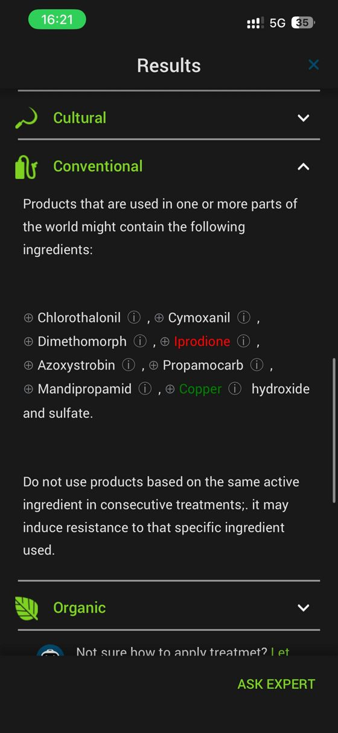
A4. Agrio, second round. Hand: "We are not sure". Healthy tomato leaf: "Healthy". Dark beet leaf: "Fungal disease". Blurred beet leaf: "We are not sure".
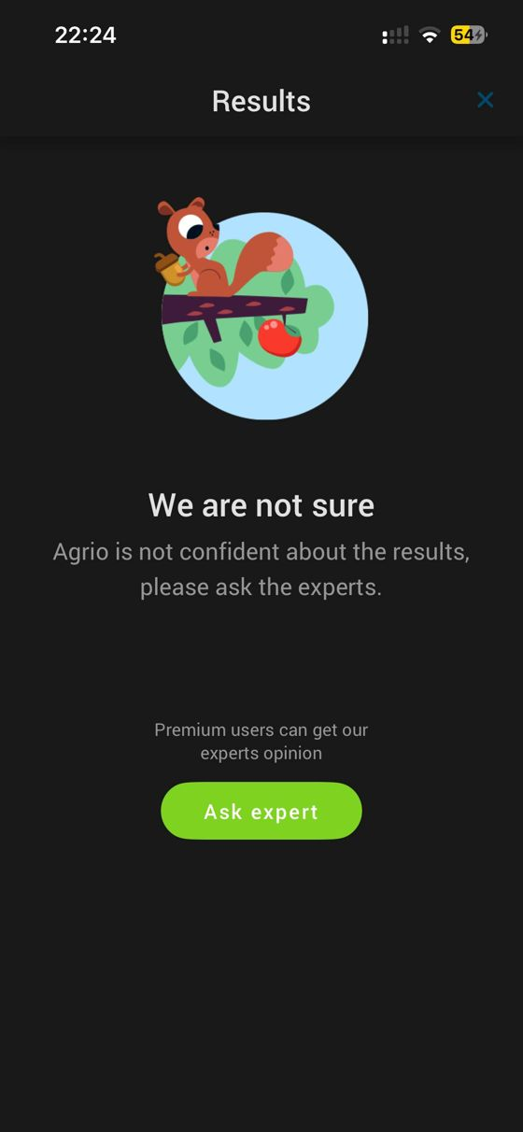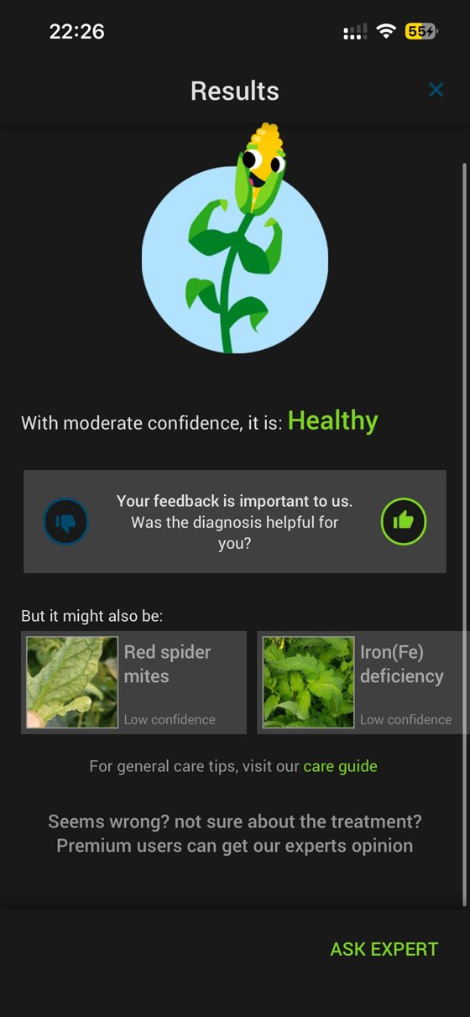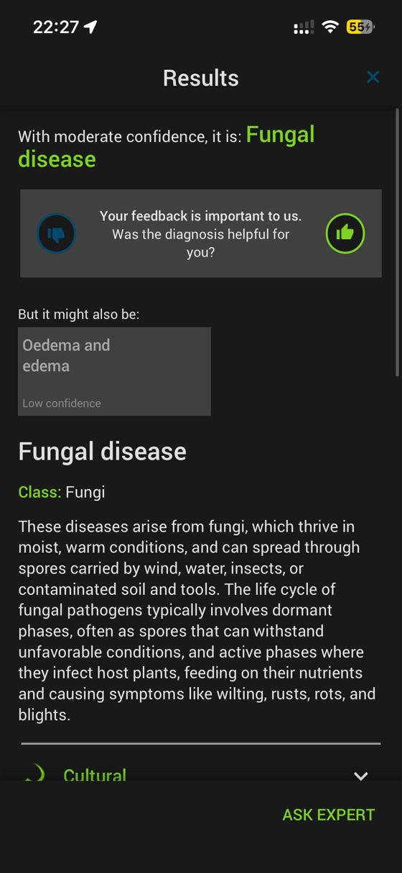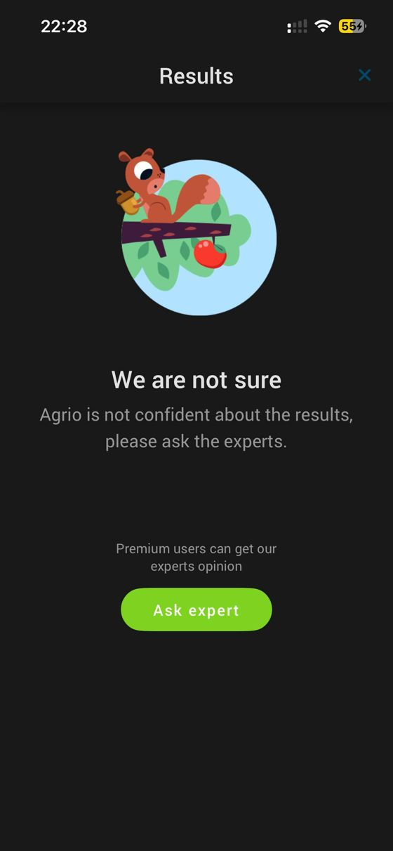
A5. PictureThis, second round. Hand: "Common coconut palm". Healthy tomato leaf: "healthy but can be optimized". Dark beet leaf: "unhealthy with serious issues". Blurred beet leaf: "Common plantain".
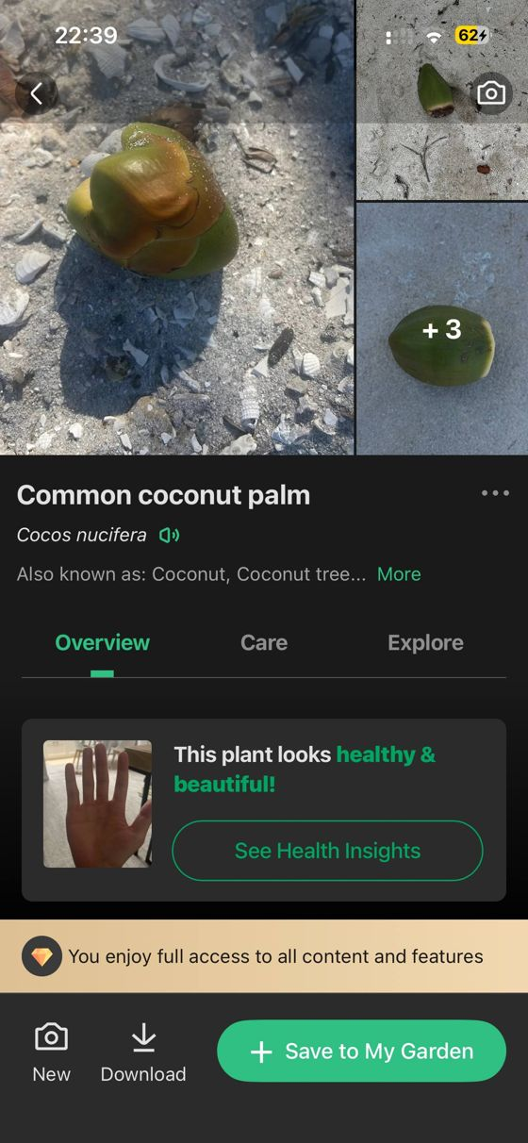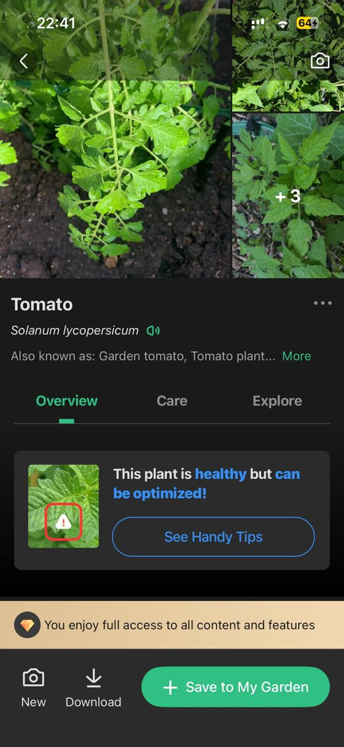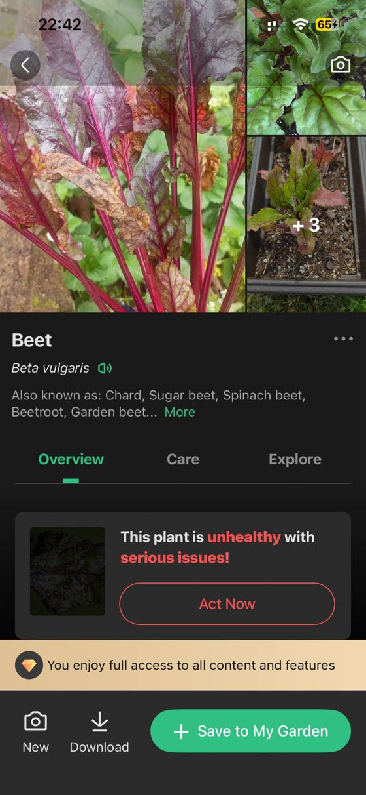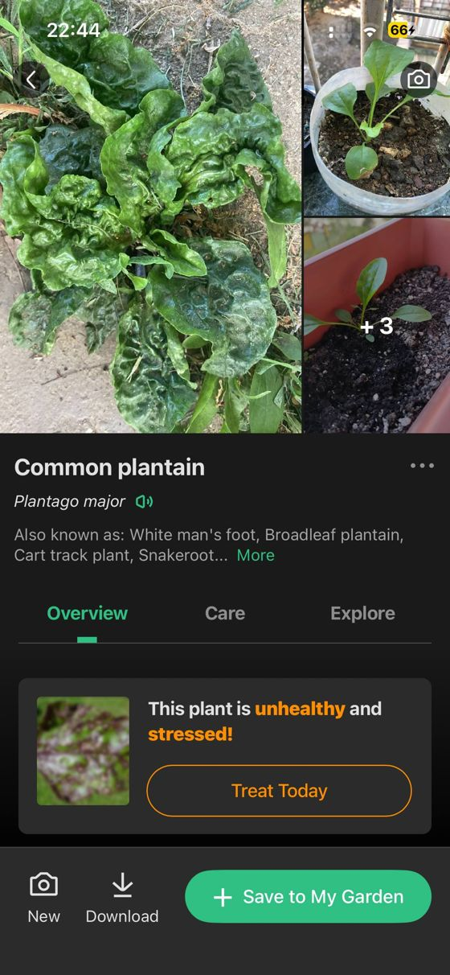
A6. Florin, second round. Healthy tomato leaf: "No issues detected". Dark beet leaf: Cercospora leaf spot. Blurred beet leaf: Lettuce, 85%, and Downy mildew. Hand: "No plant detected".
