Architecture and Diagrams
Development of an AI-Powered Plant Disease Detection and Treatment Recommendation System
Short name: Plant Disease AI. Diploma project, 2026-2027.
Team: Abdullayev Shynggys, Kalen Mukhammedali, Orynbasarov Alikhan. Supervisor: Kydyrbekova Aigerim.
Version: draft 1 for pre-defense 1 (24 October 2026). It follows the requirements specification (IDs FR, NFR, DR), the technology comparison and the README. The diagrams are drawn in PlantUML. The editable sources (.puml) and the exports (.png, .svg) are in the folder diagrams/ of the repository.

1. Overview
Plant Disease AI is a web application. A user takes a photo of a leaf, the system names the most likely disease with its confidence and a heatmap, and then gives treatment and prevention advice with links to the sources. The interface and the advice are available in Kazakh, Russian and English.
The architecture has three parts:
- Client. A React and TypeScript PWA that works in a phone browser.
- Backend. One FastAPI application with three modules: Diagnosis, Recommendation and Platform. It uses PostgreSQL with pgvector and MinIO. The modules are not separate services (decision of the technology comparison, section 7).
- Offline pipeline. Scripts and notebooks of the team that train and evaluate the models, export them, and fill the knowledge base. The pipeline is not part of the running system, it delivers the model files and the indexed passages.
Principles that the design follows:
- The system prefers to ask for a new photo to guessing (FR-08, FR-09, FR-10).
- Advice is written only from retrieved passages and every item has a reference. If no passage is found, the system says so (FR-14 to FR-16, FR-18).
- Only text goes to the external language model service. The photo and the email of the user never leave the system (NFR-10).
- The three modules are developed in parallel and connected by OpenAPI contracts. Until a real module is ready, a stub answers in the agreed format (NFR-15).
- The system runs on a CPU and starts locally with Docker Compose (NFR-01, NFR-14).

2. Diagram 1: system context
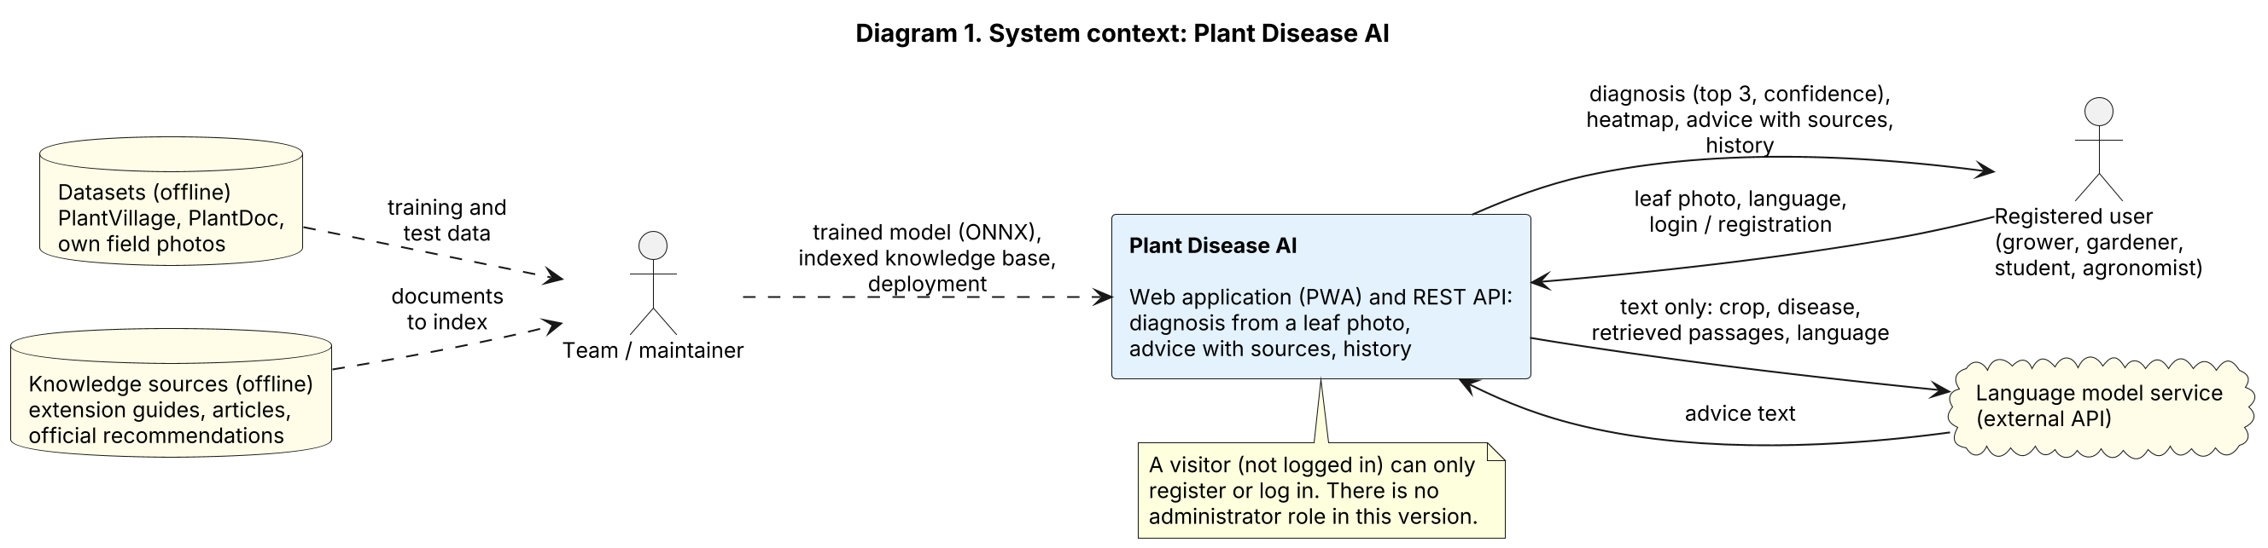
External entity | Role | Data exchanged | When
Registered user | Grower, gardener, student or agronomist who needs a quick first assessment | In: leaf photo, language, login or registration data.  Out: diagnosis with top 3 and confidence, heatmap, advice with references, history. | At run time
Visitor | A person who is not logged in. Can only register or log in | Registration and login data | At run time
Language model service | External service that writes the advice text from retrieved passages. Provider is not chosen yet | In: crop, disease, passages, language (text only).  Out: advice text. | At run time
Team / maintainer | The three students. There is no administrator role in the application | Trained model files (ONNX and PyTorch weights), indexed knowledge base, deployment | Offline
Datasets | PlantVillage, PlantDoc and our own field photos | Training and test data | Offline
Knowledge sources | Extension guides, articles and official recommendations that can be cited | Documents that are split and indexed | Offline

3. Diagram 2: use cases
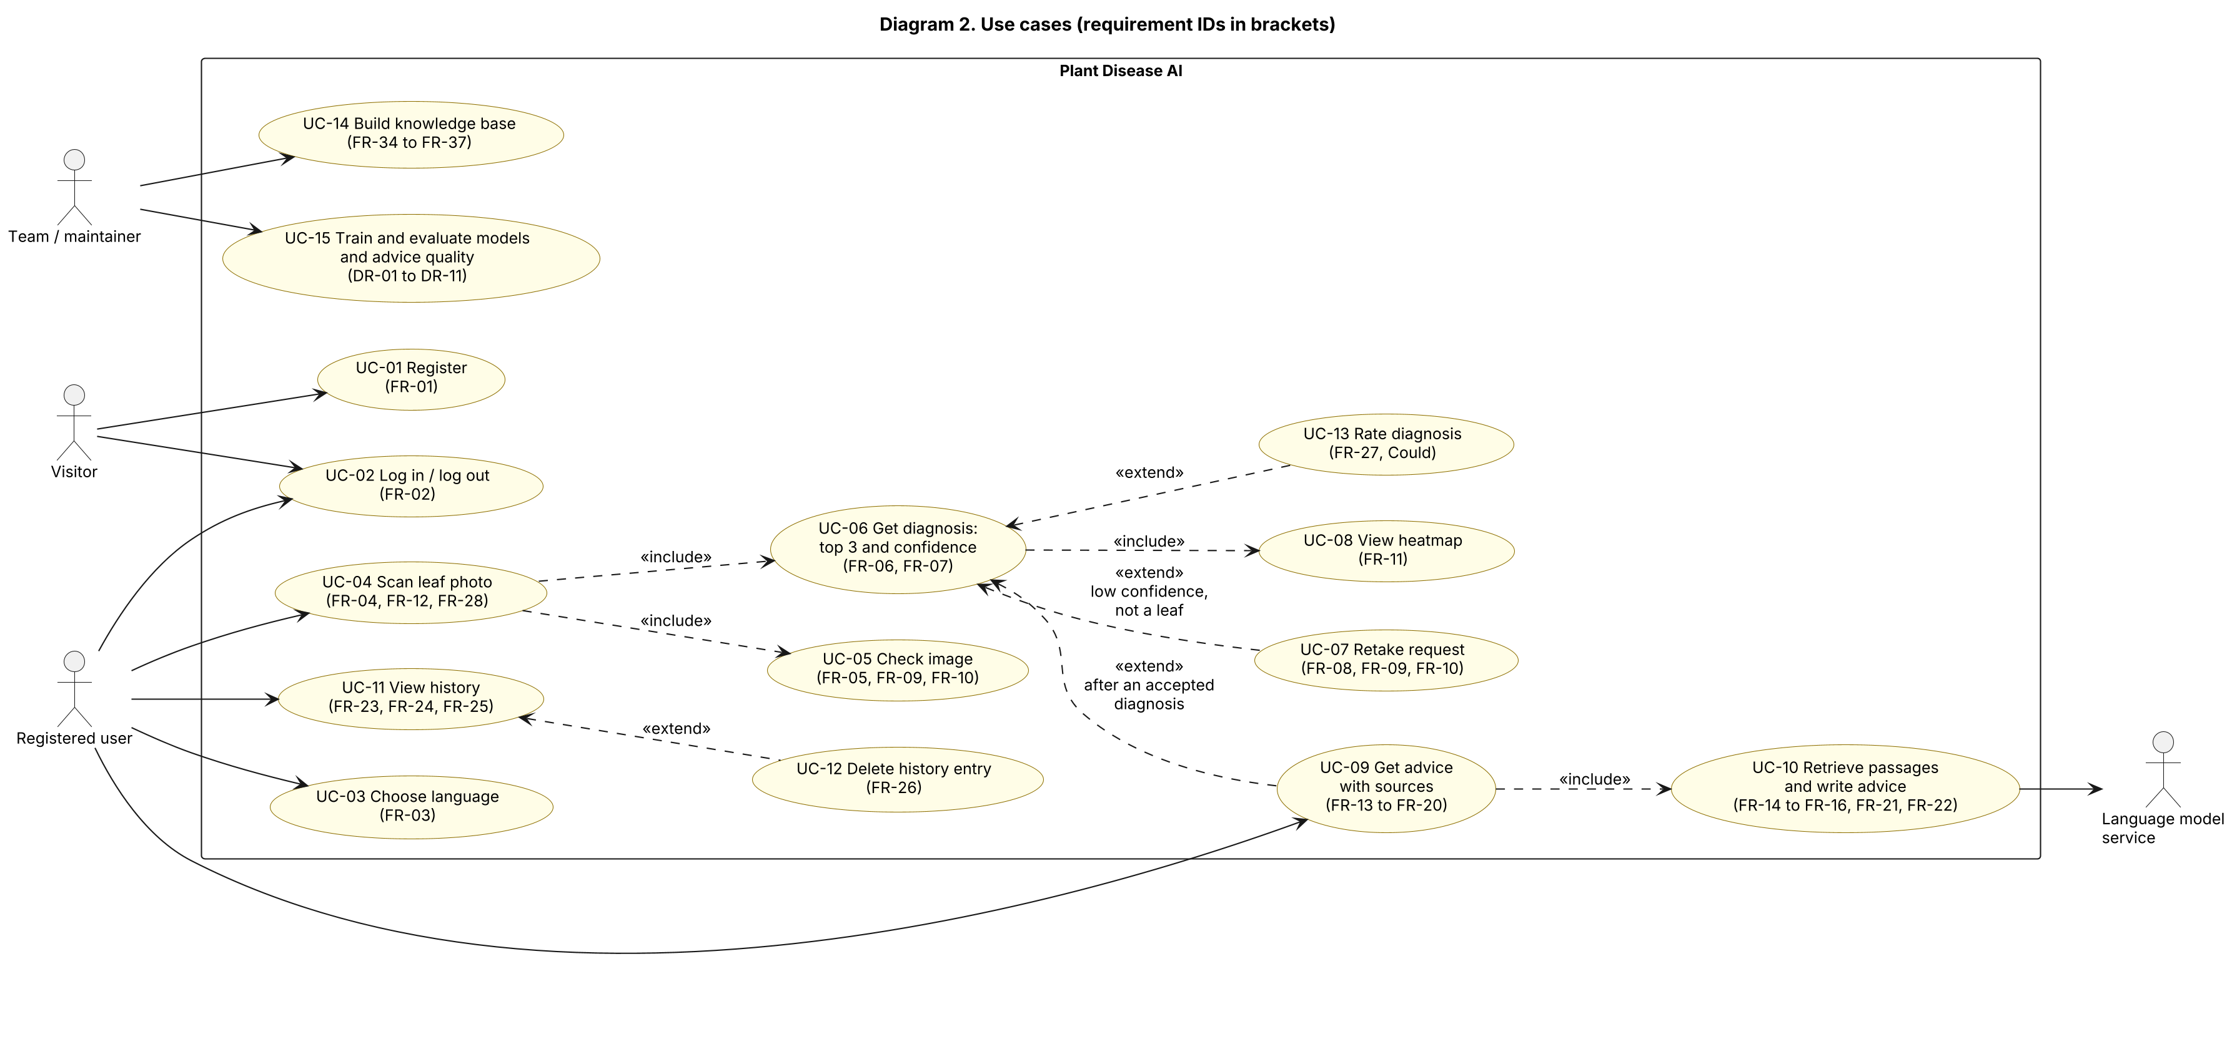
ID | Use case | Actor | Description | Requirements
UC-01 | Register | Visitor | Create an account with an email and a password | FR-01
UC-02 | Log in and log out | Visitor, registered user | Get and use a login token; protected endpoints need it | FR-02
UC-03 | Choose language | Registered user | Kazakh, Russian or English for the interface and for the advice; the choice is saved | FR-03
UC-04 | Scan leaf photo | Registered user | Take a photo or upload one; the photo is saved in storage | FR-04, FR-12, FR-28
UC-05 | Check image | System (included in UC-04) | Format, size, resolution, blur and darkness, and whether the image is a leaf | FR-05, FR-09, FR-10
UC-06 | Get diagnosis | Registered user | Top 3 predictions with confidence for crop and disease | FR-06, FR-07
UC-07 | Retake request | System (extends UC-06) | No single diagnosis is given when confidence is low, the image is not a leaf, or it is blurred; the user is asked for a new photo | FR-08, FR-09, FR-10
UC-08 | View heatmap | Registered user | Grad-CAM heatmap shows where the model looked | FR-11
UC-09 | Get advice with sources | Registered user | Treatment and prevention advice with references and a disclaimer | FR-13 to FR-20
UC-10 | Retrieve passages and write advice | System, language model service | Find passages, write advice only from them, use the lookup table when the service is not available | FR-14 to FR-16, FR-21, FR-22
UC-11 | View history | Registered user | List and open the own earlier diagnoses | FR-23, FR-24, FR-25
UC-12 | Delete history entry | Registered user | Delete an entry and its photo | FR-26
UC-13 | Rate diagnosis | Registered user | Mark a result as helpful or not (optional) | FR-27
UC-14 | Build knowledge base | Team | Index the cited sources and produce a coverage report (offline) | FR-34 to FR-37
UC-15 | Train and evaluate models and advice quality | Team | Split data, train and compare models, evaluate on laboratory and field sets, evaluate RAG against the lookup table (offline) | DR-01 to DR-11

4. Diagram 3: components (draft)
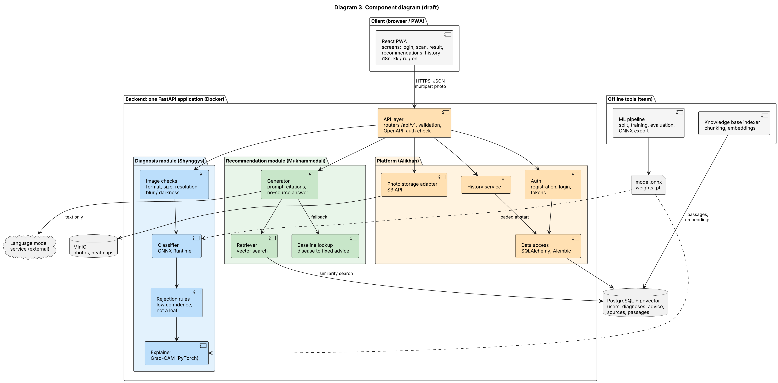
The full-size picture is in diagrams/03-components.png and .svg.
Component | Responsibility | Technology | Owner | Requirements
React PWA | Screens for login, scan, result, recommendations and history. Texts in kk, ru and en. Progress and error messages. Installable | React, TypeScript, Vite, PWA | Alikhan: shell, login, history. Shynggys: scan, result. Mukhammedali: recommendations, texts | FR-01 to FR-03, FR-28 to FR-31, NFR-11
API layer | Routers under /api/v1, request validation, token check, error format, OpenAPI documentation, health endpoint | FastAPI, Pydantic | Alikhan | FR-02, FR-32, NFR-05, NFR-15
Auth | Registration, login, password hashing, token issue and check | JWT, bcrypt or argon2 | Alikhan | FR-01, FR-02, NFR-06
History service | Save, list, open and delete entries. Only the owner has access | FastAPI service | Alikhan | FR-23 to FR-27
Data access | Database models and migrations | SQLAlchemy, Alembic | Alikhan | FR-23 to FR-27, NFR-09
Photo storage adapter | Save and read photos and heatmaps, give them only to the owner, delete them with the entry | S3 API (MinIO) | Alikhan | FR-12, FR-26, NFR-08
Image checks | Format, size, resolution, blur and darkness | Pillow, OpenCV | Shynggys | FR-04, FR-05, FR-10
Classifier | Top 3 predictions with confidence on a CPU | ONNX Runtime | Shynggys | FR-06, FR-07, NFR-01, DR-08
Rejection rules | Confidence threshold T and the not-a-leaf rule | Python | Shynggys | FR-08, FR-09, DR-09
Explainer | Grad-CAM heatmap for the top-1 class | PyTorch | Shynggys | FR-11, DR-08
Retriever | Embeds the question and finds passages by similarity, filtered by crop, disease and language | sentence-transformers, pgvector | Mukhammedali | FR-15, FR-16, FR-35
Generator | Builds the prompt from passages only, calls the language model, adds references, disclaimer and the no-source answer, checks the references | LLM API client | Mukhammedali | FR-14 to FR-20, NFR-10, NFR-17
Baseline lookup | Disease to fixed advice with a source. Used for the comparison and as a fallback | PostgreSQL table | Mukhammedali | FR-21, FR-22, DR-11
ML pipeline (offline) | Split without leakage, train and compare models, evaluate on laboratory and field sets, export to ONNX | PyTorch, timm, scikit-learn, W&B | Shynggys (field set: Alikhan) | DR-01 to DR-09
Knowledge base indexer (offline) | Read the source list, split into passages, create embeddings, store them, make the coverage report, evaluate RAG | Python scripts, sentence-transformers | Mukhammedali | FR-34 to FR-37, DR-10 to DR-12
PostgreSQL with pgvector | Users, history, sources, passages with embeddings, lookup table | PostgreSQL | Alikhan | FR-23 to FR-27, FR-35
MinIO | Photos and heatmaps. The bucket is not public | MinIO | Alikhan | FR-12, NFR-08
Language model service | Writes advice text from passages. Receives text only | Provider not chosen yet | Mukhammedali (choice) | NFR-10, NFR-17

5. Diagram 4: main scenario
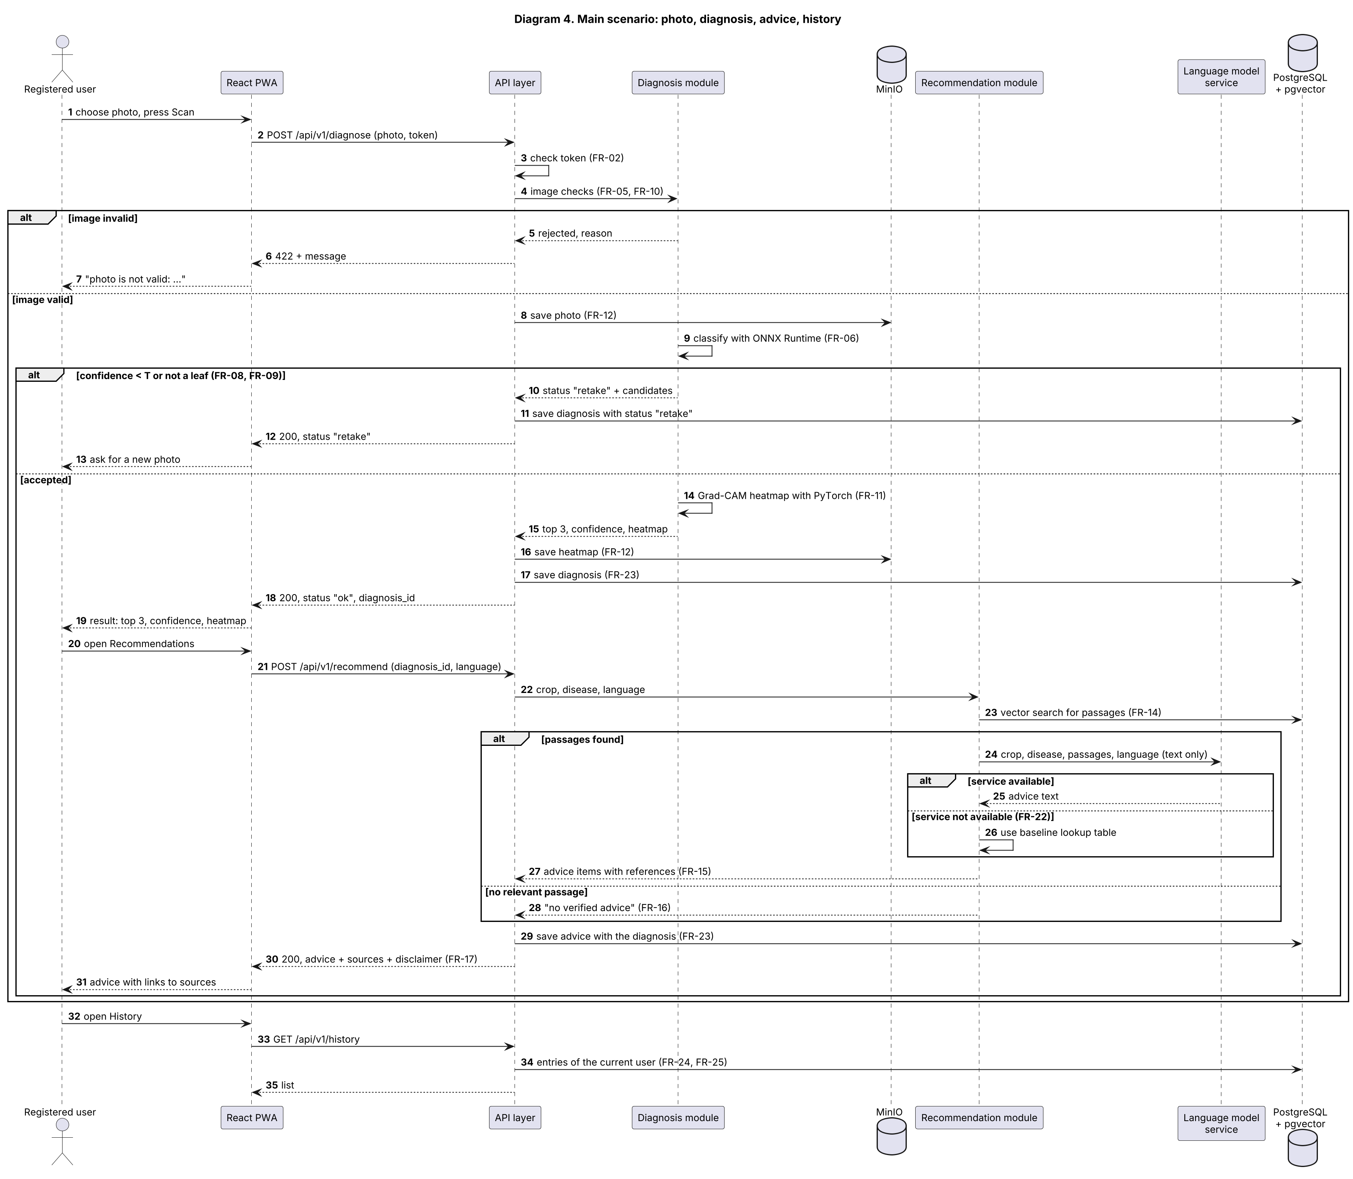
The full-size picture is in diagrams/04-sequence-main-scenario.png and .svg. Alternative flows shown in the diagram:
- Invalid image: the API answers 422 with the reason, nothing is classified (FR-05).
- Retake: low confidence, not a leaf, or a blurred photo. The API answers with the status "retake" and the candidates (FR-08 to FR-10).
- No relevant passage: the answer is "no verified advice" and no text is generated (FR-16).
- The language model service is not available: the lookup-table advice is used and marked as such (FR-22).

6. Diagram 5: data model
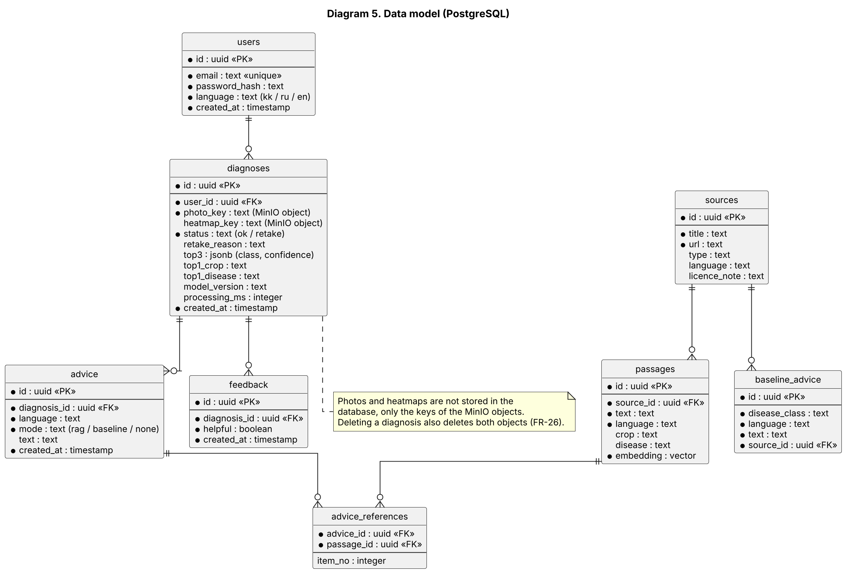
Entity | Content | Requirements
users | Email, password hash, language, creation time | FR-01 to FR-03, NFR-06, NFR-09
diagnoses | Owner, keys of the photo and heatmap objects in MinIO, status (ok or retake), top 3 as JSON, model version, processing time | FR-12, FR-23, FR-33
advice | Advice of one diagnosis: language, mode (rag, baseline or none), text | FR-13, FR-14, FR-21, FR-22
advice_references | Links from advice items to the passages that support them | FR-15
sources | Title, link, type, language, note on licence or permission | FR-34, DR-12
passages | Text of a passage, crop, disease, language, embedding vector | FR-35
baseline_advice | Fixed advice per disease class and language, with a source | FR-21, FR-22
feedback | Helpful or not helpful mark of a diagnosis | FR-27
Photos and heatmaps are not stored in the database, only the keys of the objects in MinIO. Deleting a diagnosis also deletes both objects (FR-26).

7. Interfaces (draft)
The exact formats are fixed in the OpenAPI file in the backend folder. The table shows the agreed idea. Endpoints that are new compared with the README are marked.
Method | Endpoint | Request | Response | Requirements
POST | /api/v1/auth/register | Email, password | 201 with the user, or an error | FR-01
POST | /api/v1/auth/login | Email, password | Login token | FR-02
POST | /api/v1/diagnose | Photo (multipart), token | Status "ok" or "retake". For "ok": diagnosis id, top 3 with confidence, heatmap link. For "retake": reason and candidates. 422 for an invalid image | FR-04 to FR-12
POST | /api/v1/recommend | Diagnosis id, language, token | Status "ok" or "no verified advice". Advice items with references, mode (rag or baseline), disclaimer | FR-13 to FR-22
GET | /api/v1/history | Token | List of the own entries, newest first | FR-23 to FR-25
DELETE | /api/v1/history/{id} (new) | Token | 204; the entry and its photo are deleted | FR-26
POST | /api/v1/history/{id}/feedback (new, optional) | Helpful or not, token | 204 | FR-27
GET | /api/v1/health | None | 200 when the service runs | FR-32

8. Deployment
- Docker Compose services: backend (FastAPI with ONNX Runtime, PyTorch for Grad-CAM, and the embedding model for questions), database (PostgreSQL with pgvector), MinIO. The frontend runs in development mode or as a static build.
- Offline work: training in Google Colab or Kaggle, experiments in Weights & Biases. Model files are published through GitHub Releases or external storage and are not committed. Indexing scripts are run by the team against the database.
- Configuration: secrets are kept in a local .env file, the repository has .env.example with placeholders (NFR-07).

9. Alignment with the requirements
Requirements | Realised by | Shown in
FR-01 to FR-03 accounts and language | Auth, API layer, React PWA texts | Diagrams 2, 3, 5
FR-04 to FR-12 diagnosis | Image checks, Classifier, Rejection rules, Explainer, Photo storage adapter | Diagrams 2, 3, 4
FR-13 to FR-22 recommendations | Retriever, Generator, Baseline lookup, language model service | Diagrams 2, 3, 4, 5
FR-23 to FR-27 history and feedback | History service, Data access, PostgreSQL, MinIO | Diagrams 2, 3, 5
FR-28 to FR-33 interface and platform | React PWA, API layer (health, errors), logging of diagnoses | Diagrams 3, 4
FR-34 to FR-37 knowledge base | Knowledge base indexer, PostgreSQL (sources and passages) | Diagrams 2, 3, 5
NFR performance and reliability | CPU inference with ONNX Runtime, stubs and fallbacks, input checks | Diagrams 3, 4
NFR security and privacy | Auth hashing and tokens, private bucket, owner-only history, text-only calls to the language model | Diagrams 1, 3
NFR portability and quality | Docker Compose, OpenAPI, CI with tests | Section 8
DR-01 to DR-12 model, data and evaluation | ML pipeline and knowledge base indexer (offline) | Diagrams 2, 3

10. Design decisions and open points
ID | Topic | Decision or question | Who decides
D-1 | One application, not microservices | The three modules are one FastAPI application, as chosen in the technology comparison. This fits a team of three and one Docker Compose setup. | Decided
D-2 | ONNX and PyTorch together | Predictions use ONNX Runtime and the heatmap uses PyTorch with the same weights. If this makes the backend too heavy, PyTorch is used for both (technology comparison, section 2). | Shynggys, after the baseline
D-3 | Input of /recommend | The diagrams use the diagnosis id and the language. The README says "crop and disease". The id is better: the server knows the diagnosis, the advice is linked to the history entry, and the client cannot ask advice for an arbitrary disease. The README should be changed. | Team
D-4 | Retake attempts | A retake attempt is stored in diagnoses with the status "retake" (for logs and evaluation, FR-33). The history list shows only entries with the status "ok". | Team, to confirm
D-5 | Method for the not-a-leaf rule | Option a: threshold on the confidence or entropy of the 38-class output. Option b: an extra class "not a leaf" trained on non-leaf photos. The choice and its evaluation are part of DR-09. | Shynggys
D-6 | Language model provider | Not chosen. The client of the service is isolated behind configuration (NFR-17). Criteria: price, limits, quality in Kazakh and Russian, privacy. | Mukhammedali
D-7 | Embedding model in the backend | The Retriever embeds each question, so the embedding model runs in the backend. It increases the image size and the response time (NFR-02). The model must support Kazakh and Russian. | Mukhammedali
D-8 | Contract first | The OpenAPI file in the backend folder is written before the modules. Stubs answer in the agreed format. | Alikhan, tech lead of the period

