UX Mockups
Plant Disease AI: Development of an AI-Powered Plant Disease Detection and Treatment Recommendation System
Clickable prototype ÖSIM-AI (MVP scope) mapped to the requirements. Pre-defense 1, 24 October 2026.
Team: Abdullayev Shynggys, Kalen Mukhammedali, Orynbasarov Alikhan. Supervisor: Kydyrbekova Aigerim.
1. Purpose and scope
The prototype is one HTML file (ÖSIM-AI-prototype-MVP.html). It opens in Chrome or Edge without internet. It shows every MVP screen and every error state in Kazakh, Russian and English. It is a mockup: the diagnoses, confidences and sources are fixed examples, not model output.
Naming: the interface brand is ÖSIM-AI; the project and the repository are called Plant Disease AI.
Removed from the prototype because they are not in the MVP (requirements W-01, W-02): plant and disease library, offline photo queue with geolocation, and guest mode. Only registered users scan (FR-02).
2. Screens and requirements
Screen | What it shows | Requirements | Scenario in the prototype
Login / Register | Email and password; validation messages (invalid email, email taken, password under 8 characters) | FR-01, FR-02, NFR-09 | Register with farmer@example.com or a short password
Scan | Take photo, upload from gallery, hint “JPEG or PNG, up to 10 MB”, photo tips; scan is one tap | FR-04, FR-30 | Good photo
Loading | Progress while the photo is checked and diagnosed | FR-31 | any scan
Result + Grad-CAM | Top-3 with confidence, heatmap toggle, advice button | FR-06, FR-07, FR-11 | Good photo
Low confidence | No single diagnosis, candidates, retake request; threshold not stated as a number | FR-08 | Low confidence
Retake | Reason (blurry, dark, not a leaf) and three hints | FR-09, FR-10 | Blurry, Dark, Not a leaf
Advice | Treatment and prevention tabs, numbered references to sources, disclaimer, helpful / not helpful | FR-13 to FR-15, FR-17, FR-27 | Good photo
Healthy leaf | “Healthy” and prevention tips only | FR-20 | Healthy leaf
No verified advice | Clear message, no advice is invented | FR-16, FR-18 | Disease without a source
Error | Server or network error with retry; photo is not lost | FR-31, NFR-04 | Server error
History | Own diagnoses, newest first, open one, delete with inline confirmation | FR-23, FR-24, FR-26 | History
Account | Language kk / ru / en (saved), privacy note, log out | FR-03, NFR-09, NFR-11 | Account
All screens | Usable at 390 px with no horizontal scroll; light and dark theme | FR-28 | Resize or open on a phone
3. Gaps between the prototype and the requirements
- FR-19: the treatment tab shows a copper fungicide without a warning about chemical use and without the biological option first. The real advice text must follow FR-19; the mockup text is only an example.
- FR-29 (PWA install) and FR-22 (language model unavailable, fall back to the lookup table) have no screen. FR-22 can reuse the Error screen with the text “Advice is temporarily unavailable”; add it before the final defense.
- FR-11 says the heatmap is shown for every accepted diagnosis. The prototype hides it until the user presses Show heatmap. Decision for the team: keep the toggle (the photo stays visible) or show it by default.
- FR-23: history shows colour thumbnails instead of the saved photos, and opening an entry shows the result only, not the saved advice.
- Sources in the advice are placeholders. In the real system each item links to a passage in the knowledge base (FR-15, FR-34).
- Kazakh and Russian texts need a native-speaker review (NFR-12).
4. How the screens were checked
Every scenario was run in Chromium at 1280 px and 390 px width. There were no console errors and no horizontal overflow on any screen. The screenshots below were taken from the final file.
5. Screenshots, desktop (1280 px)
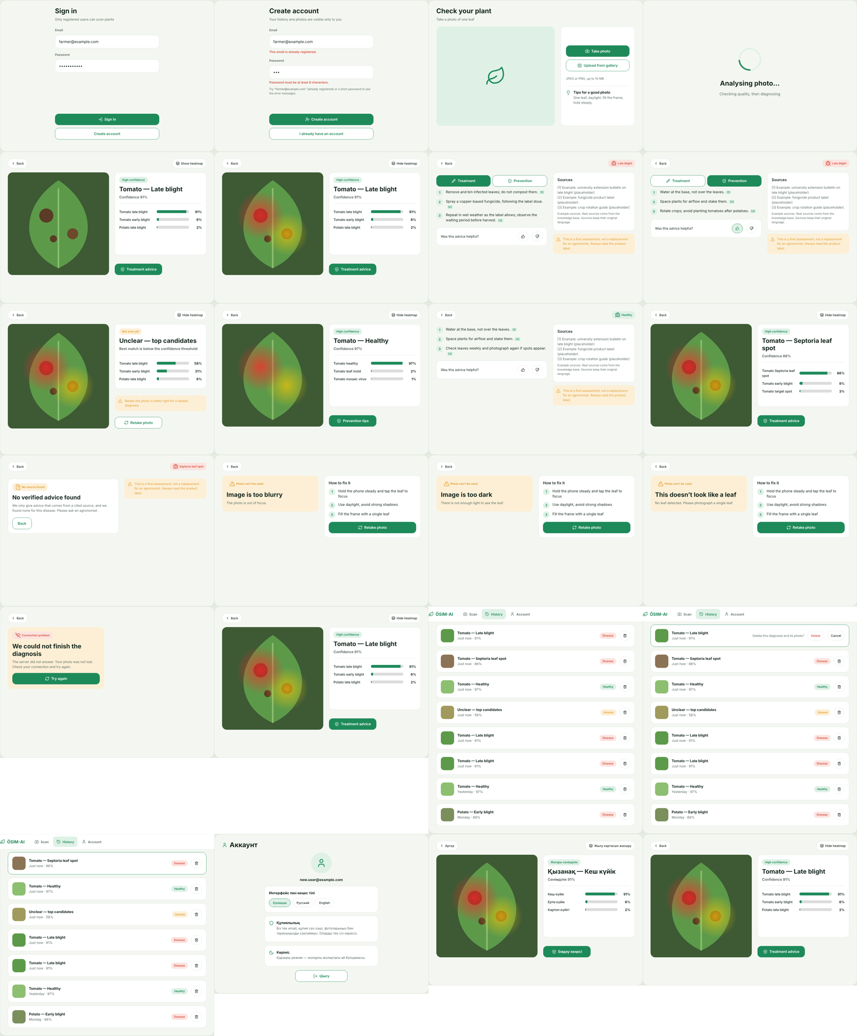
6. Screenshots, phone (390 px)
