CALORIE ADVISOR APPLICATION USING GEMINI PRO VISION.

**MINI PROJECT REPORT**

***Submitted by***

|  |  |
| --- | --- |
| **ROSHINI RAJA** | **2116210701216** |
| **SELVA NANDHINI** | **2116210701237** |
| **SHAMINI P N** | **2116210701239** |

***in partial fulfillment for the award of the degree of***

**BACHELOR OF ENGINEERING**

***in***

**COMPUTER SCIENCE AND ENGINEERING**



**RAJALAKSHMI ENGINEERING COLLEGE, CHENNAI ANNA UNIVERSITY:: CHENNAI 600 025**

**MAY 2024**

**BONAFIDE CERTIFICATE**

Certified that this Report titled “CALORIE ADVISOR APPLICATION USING GEMINI-PRO-VISION” is the bonafide work of **“ROSHINI RAJA (210701216) , SELVA NANDHINI (210701237) , SHAMINI (210701239)”** who carried out the work under my supervision. Certified further that to the best of my knowledge the work reported herein does not form part of any other thesis or dissertation on the basis of which a degree or award was conferred on an earlier occasion on this or any other candidate.

**SIGNATURE**

**Dr.** [**Rakesh Kumar M**](mailto:rakeshkumar.m@rajalakshmi.edu.in)**, M.E, PhD.,**

Assistant Professor,

Department of Computer Science and Engineering, Rajalakshmi Engineering College,

Chennai – 602015

Submitted to Mini Project Viva-Voce Examination held on

**Internal Examiner External Examiner**

**ABSTRACT**

Diet management is a critical aspect of achieving fitness goals, reducing chronic diseases, and maintaining good health. Food has always been at the heart of culture and tradition and it is impressive how our food options have evolved and become more convenient to access through delivery services. This convenience comes with the cost of high calories and several impacts on our bodies. Modern apps require you to manually enter what you're eating, which can be a daunting task. CalTrack is a calorie advisor application that uses Gemini Pro Vision, a multimodal (LLM) by Google that helps people keep track of their calorie intake.

This project investigates an innovative approach to estimating calories by identifying the items in the food by using Gemini-pro-vision-visual recognition technology just by uploading the image of food. Employing Python libraries such as dotenv, Stream lit, OS, Google, Generative AI, PIL the project seamlessly integrates diverse functionalities in the development of this application .

**ACKNOWLEDGEMENT**

Initially we thank the Almighty for being with us through every walk of our life and showering his blessings through the endeavor to put forth this report. Our sincere thanks to our Chairman **Mr. S.MEGANATHAN, B.E, F.I.E.**, our Vice Chairman **Mr. ABHAY SHANKAR MEGANATHAN, B.E., M.S.,** and our

respected Chairperson **Dr. (Mrs.) THANGAM MEGANATHAN**, **Ph.D.,** for providing us with the requisite infrastructure and sincere endeavoring in educating us in their premier institution.

Our sincere thanks to **Dr. S.N. MURUGESAN, M.E., Ph.D.,** our beloved Principal for his kind support and facilities provided to complete our work in time. We express our sincere thanks to **Dr. P. KUMAR, Ph.D.**, Professor and Head of the Department of Computer Science and Engineering for his guidance and encouragement throughout the project work. We convey our sincere and deepest gratitude to our internal guide, **Dr. Rakesh Kumar M, PhD.,** Assistant Professor, Department of Computer Science and Engineering. Rajalakshmi Engineering College for his encouragement and guiding us throughout the project to

build our project.

**ROSHINI RAJA SELVA NANDHINI S SHAMINI P N**

**TABLE OF CONTENTS**

**CHAPTER NO. TITLE**

**PAGE**

**NO.**

|  |  |  |
| --- | --- | --- |
|  | **ABSTRACT** | **iii** |
| **ACKNOWLEDGEMENT**  **LIST OF FIGURES** | **iv**  **vii** |
| **LIST OF TABLES** | **viii** |
| **1.** | **INTRODUCTION** | **10** |
|  | 1.1 GENERAL | 10 |
|  | 1.2 OBJECTIVE | 10 |
|  | 1.3 EXISTING SYSTEM | 10 |
|  | 1.4 PROPOSED SYSTEM | 10 |
| **2.** | **LITERATURE SURVEY** | **11** |
| **3.** | **SYSTEM DESIGN** | **15** |
|  | 3.1 DEVELOPMENT ENVIRONMENT | 15 |
|  | 3.1.1 HARDWARE SPECIFICATIONS | 15 |
|  | 3.1.2 SOFTWARE SPECIFICATIONS | 15 |
|  | 3.2 SYSTEM DESIGN | 16 |
|  | 3.2.1 ARCHITECTURE DIAGRAM | 16 |

1. **PROJECT DESCRIPTION** **18**
   1. MODULES DESCRIPTION 18
2. **IMPLEMENTATION AND RESULTS** 19
   1. IMPLEMENTATION 19
   2. OUTPUT SCREENSHOTS 21

**6. 22**

**CONCLUSION AND FUTURE ENHANCEMENT**

* 1. CONCLUSION 22
  2. FUTURE ENHANCEMENT 22

**REFERENCES**

**CHAPTER**

**INTRODUCTION**

* 1. **GENERAL**

Some of the newer developments relating to the convergence of AI are the use of LLMs for image processing. This project: LLM text and production of Large Image Models. They are deep learning models that have been trained on a massive corpus. The transformer is a deep learning model that has an encoder and a decoder, which enables the encoder to focus on the attention of the decoder and vice versa. It has the gemini pro vision and supports different python libraries like OI (PythonImage Library),Google.generativeAI,io,streamlit,os,dotenv.The LLM is more flexible in the ever-changing field of AI. The same model could be used for tasks such as QA, document summarization, translation and word/sentence completion. AI chatbots will influence the way humans produce content and engage with search engines and virtual assistants.

Image processing is concerned with treating an image and converting the said image into digital format and then performing useful operations on the digitized image. Most of the signal processing procedures employed by the image processing system treat the digital images as 2D signals. Gemini Pro can be described as a kind of a base for development processes for such libraries as dotenv, Streamlit, OS, Google. GenerativeAI, PIL, and pyttsx3.

It is possible to use the tools mentioned above in order to enjoy the power of language and image recognition and develop an easy to use and effective application[6].

This project is aimed at the determination of the energy content of a food or drink. The food and beverages that are taken contain energy needed to sustain the body in motion. For instance the body needs energy to breathe; it also requires energy to make the heart beat and to grow, and also for other physical activities including walking, jumping or running. This application is to determine the number of calories in the food which we consume and the over all proportion of that food and whether it is healthy or not.

* 1. **OBJECTIVE**

The specific application of the Calorie Advisor which is developed by an organization named Gemini Pro Vision, and through the process of engaging the images, the way of people’s transition to the healthy lifestyle is supported through consuming and evaluating. Here are its key objectives.

Estimate Calorie Content: The total calorie idea of the food placed was estimated through the Gemini Pro Vision .

Break Down Nutrients: Besides total amount of energy for 100g share one can state the portions of energy in terms of fat, protein, carbohydrate, fibre and sugar. It may include the ration such as the carbs to be fed in the required diets, proteins fats sugars and many of them.

Assess Meal Health: Besides to the conventional apps which merely dictate people their consumption and calories burnt, there is much more for Lifesum to bring. This can be utilized for the purpose of simplification of the procedure concerning decision making for the selection of meals that are needed to be taken.

Promote Informed Eating: Consequently, in case a particular user has uploaded some or all of this information through the website, then the same user should have a privileged position on deciding on the number of calories that have been consumed in a particular day or if the user has other kinds of chores that require the user to change the kind of diet that may be needed with regard to weight loss or even general healthy eating in a given day.

* 1. **EXISTING SYSTEM**

Existing System provide functionalities related to calorie tracking in that Myfitnesspal is one of the existing system[2],the main of the system is to provide calories for the food it used 11million food dataset. But there are several drawbacks in this system such as Baseline calories are often underestimated,it also provide high inaccurate weight gain or loss predictions[3].Cronometer is another application which provide nutritional information for the user it couldn’t be used by all people since the application is payable way for using advanced feature[3].Noom is a application it tracks calorie and also behavioral psychology. Noom doesn't offer in-person interactions with coaches or other Noom members. The cost, concerns around low calorie goals, and potential pitfalls of food tracking[4].Fat Secret is a uses large food dataset and measures the calorie. Measuring calorie and food logging ia the major disadvantage in this application.[5]

* 1. **PROPOSED SYSTEM**

This Proposal describes a new Calorie Advisor application that is aimed at reducing the complexity of tracking calories and providing an application that helps users understand the calorie intake of their foods. What sets apart this calorie tracker will be the utilization of the Gemini Pro Vision large language model from Google to offer you the latest possible means of tracking your calorie intake.

Think of a situation where instead of filling the form, you just upload a photo of your meal. The application, with the help of the Gemini Pro Vision, studies the image and identifies the distinct food items present in the picture. It then goes a step further from merely providing simple calorie breakdown to provide a detailed nutritional value. And not only the total energy value, you will also get detailed information about the distribution of these calories by food groups (proteins, carbohydrates, fats, etc. ). This equips you with information on how to make good dietary choices, hence promoting healthier dietary habits.

The image data is passed through a secure channel to the Google GenerativeAI service to protect your information.

The backbone of the system is the Gemini Pro Vision model. This massive large language model, trained on a large amount of data, also performs well in image analysis and understanding the relations between data items. It processes the image, detects the food items, and computes the approximate calorie content of each item. Using a well-developed nutritional database, the service then proceeds to provide a detailed response that is not limited to just a figure. Total calories and calorie distribution by food; analysis of the nutritional quality of the meal ..

**CHAPTER 2**

**2.1 LITERATURE SURVEY**

Calorieee Advisor may involve a literature review of empirical and theoretical works to identify areas of exploration that have not yet been adequately explored in the scholarly literature across a range of fields, including but not limited to: it includes aspects such as the implementation of the calorie counting concept, techniques used in nutritional analysis, ways of identifying meals through algorithms, and motives required for successful engagement of users in product utilization. It in fact involves evaluating the literature reviewing the precision and usefulness and of counting calories execution techniques such as apparatus, APPS, and wearable devices. Furthermore, it also involves the knowledge of the concept and the criteria related to the design of the principle and algorithms for choosing meals based on its personal preference, health, or any other restrictions. Moreover, the concern with recommendation systems is also presented in the survey regarding to food profiles and also the investigation of some of the recommendation methods including collaborative and content-based filtering related to recommending meals that may be preferable for the user and that may also meet the nutritional requirements of the users. In addition, the review involves evaluating the behaviour change interventions aimed at users regarding their consumption of foods and diets as per the set guidelines, which include using game-design elements, feedback mechanisms, and social enablers across mobile and web applications. In this regard, through the survey, it evaluates the preparedness of the technological structures and climates supportive to the development of the Calorie Advisor in terms of scalability and compatibility as well as performance in its compatibility with the Food Database and Nutrition Application Programming Interface (APIs). Therefore, it is important to consolidate knowledge from these fragmented fields of research in order to establish the Literature Survey as the foundation for creating the efficient and user-centric Calorie Advisor.

**2.2 METHODOLOGY:**

1. Data Acquisition and Preparation:

Compile a comprehensive dataset of high-quality food images representing diverse cuisines, dishes, ingredients, and portion sizes. It consider publicly available datasets or create your own through controlled photo shoots. Ensure the dataset reflects the target user base's dietary habits.

Each image in the dataset needs to be meticulously labeled with its corresponding calorie count. Utilize reliable sources like USDA food databases or collaborate with registered dietitians for accurate calorie labeling .Pre-process the image data to ensure consistency and facilitate model training. This may involve resizing, cropping, color normalization, and background removal.

1. Gemini Pro Vision Integration:

Employ Gemini Pro Vision's API to perform real-time food item recognition within the application. Craft efficient API calls to analyze user-captured or uploaded food images.

The API response should ideally return identified food items and their confidence scores. Depending on your development approach, you might consider deploying a pre-trained food recognition model based on Gemini Pro Vision within your application.

This would require expertise in model deployment frameworks and potentially on-device processing optimization for mobile apps.

1. Calorie Estimation and Tracking:

By Integrate a calorie database with our application. This database should map identified food items (from Gemini Pro Vision) to their corresponding calorie counts. By consider partnering with existing food databases or developing a custom one based on reliable sources

Identified food items from Gemini Pro Vision. Corresponding calorie information from the integrated database. Implement functionalities to track daily/weekly calorie intake based on user logs or application usage



1. Handling Uncertainty and Error:

Utilize confidence scores provided by Gemini Pro Vision's food recognition to assess the certainty of identified food items. Implement mechanisms to handle scenarios with low confidence scores (e.g., user confirmation, suggesting similar alternatives).Acknowledge the inherent limitations of AI-based calorie estimation. Provide users with disclaimers and educate them about potential inaccuracies in calorie counts. Consider offering options to manually adjust calorie values if needed.

1. User Interface (UI) Design:

Design a user-friendly interface that allows users to easily capture or upload food images, view identified items, and access calorie information.Ensure the interface is visually appealing and facilitates a seamless user experience. Provide clear visual and textual feedback to users regarding identified food items, confidence scores, and total calorie count.Offer options for users to review, edit, or confirm identifications.

1. Evaluation and Testing:

Evaluate the application's accuracy in identifying food items and estimating calorie counts using a separate testing dataset. Compare the application's performance with existing calorie tracking methods. Conduct user testing sessions to gather feedback on the application's usability, functionality, and overall user experience.

Refine the application based on user feedback to ensure it meets user needs

effectively.

**CHAPTER 3 SYSTEMDESIGN**

* + 1. **HARDWARE SPECIFICATIONS**

This project uses minimal hardware but in order to run the project efficiently without any lack of user experience, the following specifications are recommended

**Table 3.1.1 HARDWARE SPECIFICATIONS**

|  |  |
| --- | --- |
| **PROCESSOR** | Intel Core i5 |
| **RAM** | 4GB or above (DDR4 RAM) |
| **GPU** | Intel Integrated Graphics |
| **HARD DISK** | 6GB |
| **PROCESSOR FREQUENCY** | 1.5 GHz or above |

* + 1. **SOFTWARE SPECIFICATIONS**

The software specifications in order to execute the project has been listed down in the below table. The requirements in terms of the software that needs to be pre- installed and the languages needed to develop the project has been listed out below.

**Table 3.1.2** Software Specifications

|  |  |
| --- | --- |
| **FRONT END** | Streamlit |
| **BACK END** | Python |
| **FRAMEWORKS** | Streamlit |
| **SOFTWARES USED** | Gemini pro vision, PIL Google Chrome |

* 1. **SYSTEM DESIGN**

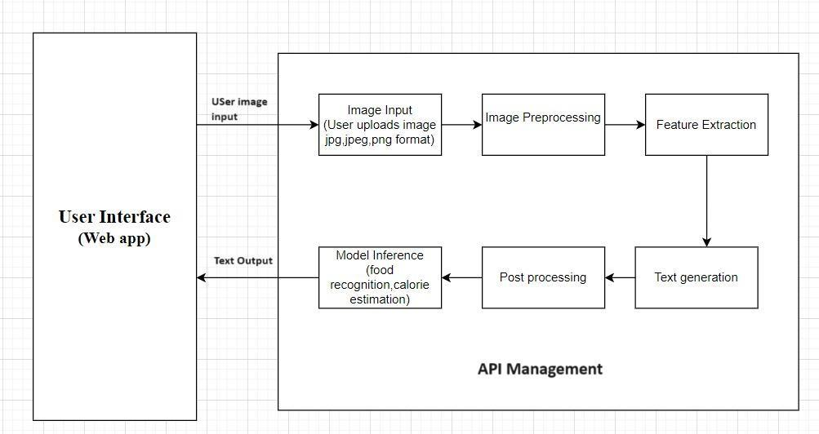

**Fig 3.2.1 Architecture Diagram**

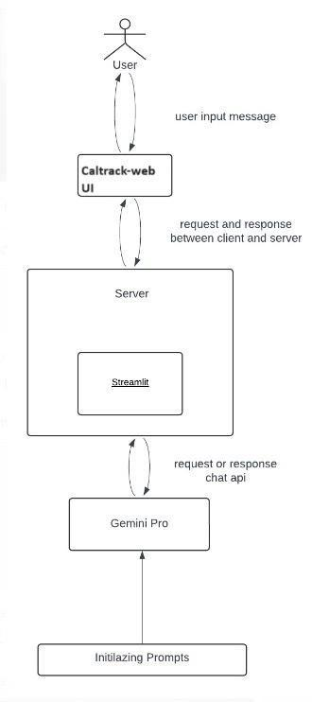

**Fig 3.2.2 Architecture Diagram**

**CODE**

import streamlit as st

import google.generativeai as genai import os

from dotenv import load_dotenv load_dotenv()

from PIL import Image import io

genai.configure(api_key=os.getenv("GOOGLE_API_KEY"))

def get_gemini_response(input_prompt,input):

pil_image = Image.open(io.BytesIO(image_data[0]["data"]))

model=genai.GenerativeModel('gemini-pro-vision')

response=model.generate_content([input_prompt,pil_image])

return response.text

def input_image_setup(uploaded_file):

# Check if a file has been uploaded if uploaded_file is not None:

# Read the file into bytes

bytes_data = uploaded_file.getvalue()

image_parts = [

{

"mime_type": uploaded_file.type, # Get the mime type of the

uploaded file

"data": bytes_data



}

]

return image_parts else:

raise FileNotFoundError("No file uploaded") ##initialize our streamlit app

st.set_page_config(page_title="CalTrack", page_icon='🍚', layout='centered',

initial_sidebar_state='collapsed')

st.header("CalTrack- A Calories Advisor Application")

uploaded_file = st.file_uploader("Choose an image...", type=["jpg", "jpeg", "png"])

image=""

if uploaded_file is not None:

image = Image.open(uploaded_file)

st.image(image, caption="Uploaded Image.", use_column_width=True) submit=st.button("Tell me the total calories")

input_prompt="""

You are an expert in nutritionist where you need to see the food items from the image

and calculate the total calories, also provide the details of every food items with calories intake

is below format

* + - 1. Item 1 - no of calories
      2. Item 2 - no of calories

Finally you can also mention whether the food is healthy or not and also mention the

percentage split of the ratio of carbohydrates,fats,fibers,sugar and other important things required in our diet....

"""

## If submit button is clicked if submit:

image_data=input_image_setup(uploaded_file) response=get_gemini_response(input_prompt,image_data) st.subheader("The Response is")

st.write(response)

**CHAPTER 4 PROJECT DESCRIPTION**

**4.1 MODULE DESCRIPTION**

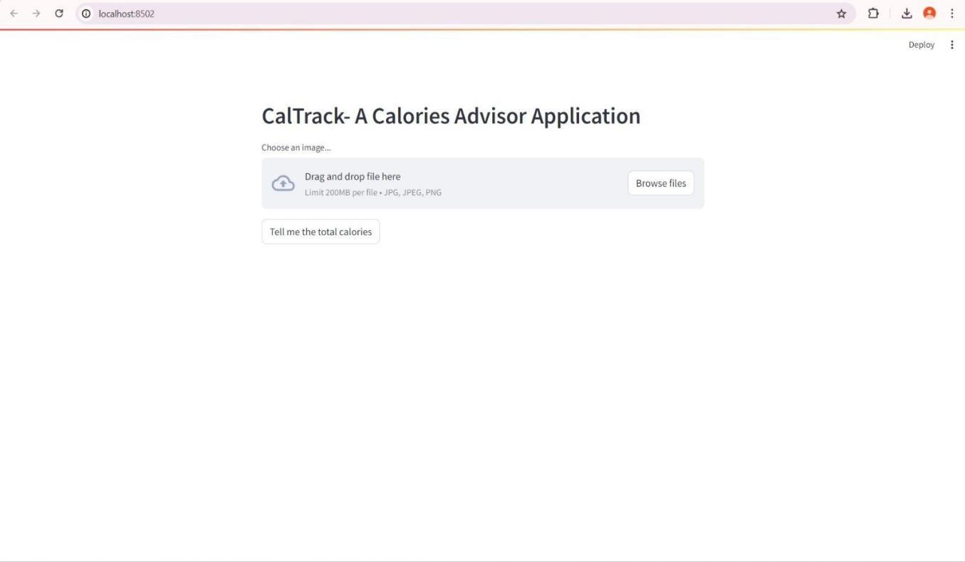

**1.UserInteraction page where the user interacts with the web page and the input is processed to get the output.**

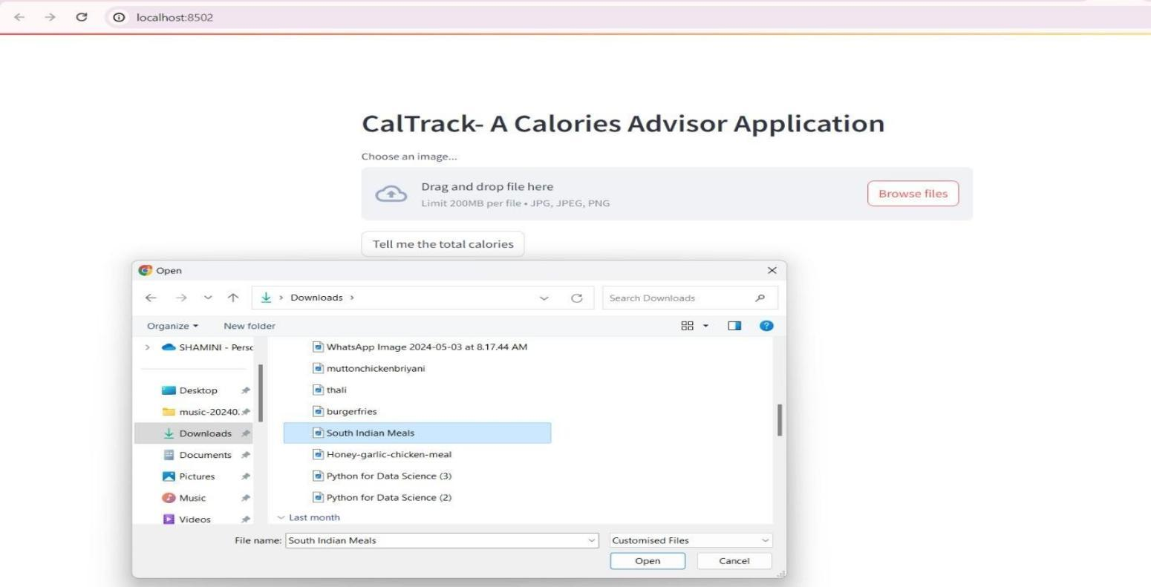

**2. The user can upload the food image by clicking on browser file, where the file opens in their desktop.The user select the desired image and click open.**

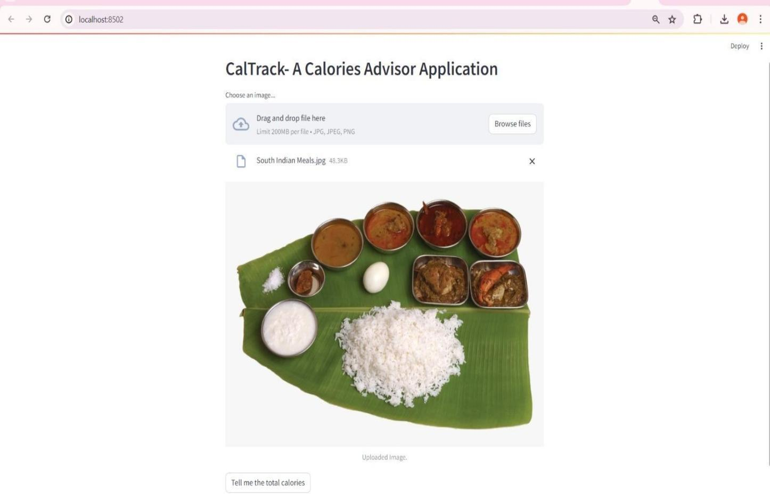

**3. The user can upload the food image by clicking on browser file, where the file opens in their desktop.The user select the desired image and click open.**

**CHAPTER 5 RESULTS**

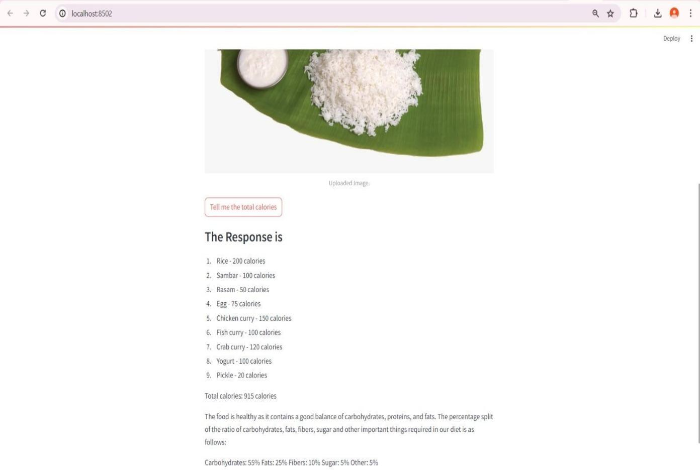

**The Image is seen and By clicking the prompt button , the application generates the response based on the image uploaded**

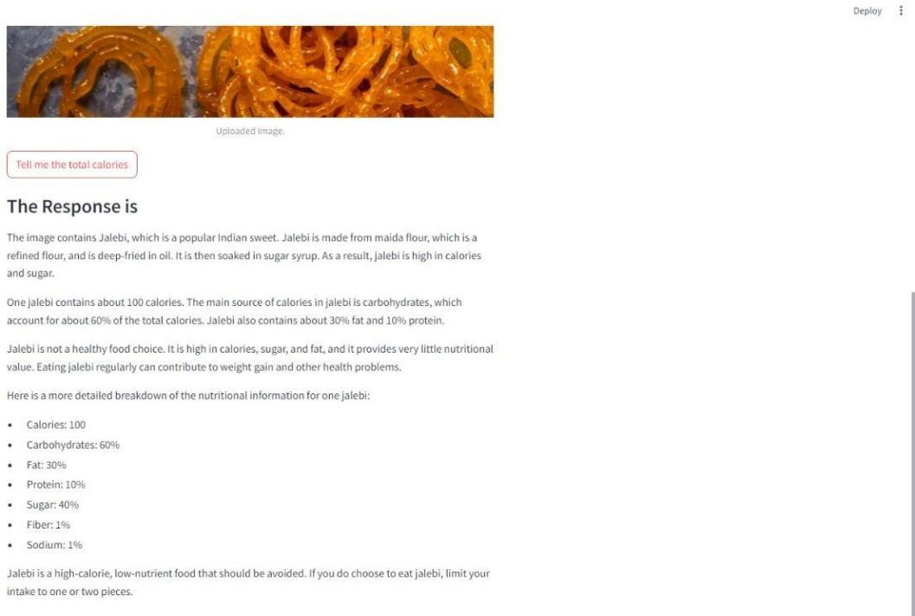

**The response contains the information of list of the food items in the image and their estimated calories count. It is also states whether it is healthy or not**

**CHAPTER 6**

**CONCLUSION AND FUTURE ENHANCEMENTS**

* 1. **CONCLUSION**

Our findings provide new information about how calories are estimated from food images, which can inform the design of related software and analyse.

These results imply that calorie labeling alone may not be enough to make sustainable reductions in calorie intake in fast food restaurants.

It should however be noted that when applied to calorie advising the machine learning for a calorie advising system has the capacity to establish nutrition recommendations that are learning for the individual.

* 1. **FUTURE ENHANCEMENTS**

For Future enhancements, the app could allow users to simply point their phone's camera at their meal, and the application would automatically recognize the food items, estimate portion sizes, and calculate the nutritional content. This would significantly streamline the process of tracking calorie intake, making it more convenient and accurate for users. The AR feature could overlay nutritional information in real-time, providing an interactive and engaging experience.

Moreover, it would also expand on the use of the deep learning algorithm to recommend meals based on the user’s health requirements and food preferences. Through the given eating and lifestyle data of a user, the application could suggest possible changes such as a better choice of foods or even portion control advice. This would aid the users in their approach towards selecting meals and balance in their lifestyle more efficiently. Incorporating Gemini Pro Vision into the calorie advisor application will help improve users’ engagement with the application and make the process of tracking food more convenient.

**REFERENCES**

1.[https://www.researchgate.net/publication/379171804_Gemini_or_ChatGPT_Capability_ Performance_and_Selection_of_Cutting-edge_Generative_Artificial_Intelligence_AI_in_Business_Management](https://www.researchgate.net/publication/379171804_Gemini_or_ChatGPT_Capability_Performance_and_Selection_of_Cutting-edge_Generative_Artificial_Intelligence_AI_in_Business_Management)

2.[https://www.researchgate.net/publication/378393097_Public_acceptance_of_using_artificial_intelligence-assisted_weight_management_apps_in_high-income_southeast_Asian_adults_with_ov](https://www.researchgate.net/publication/378393097_Public_acceptance_of_using_artificial_intelligence-assisted_weight_management_apps_in_high-income_southeast_Asian_adults_with_overweight_and_obesity_a_cross-sectional_study) [erweight_and_obesity_a_cross-sectional_study](https://www.researchgate.net/publication/378393097_Public_acceptance_of_using_artificial_intelligence-assisted_weight_management_apps_in_high-income_southeast_Asian_adults_with_overweight_and_obesity_a_cross-sectional_study)

3.<https://www.healthline.com/nutrition/noom-diet-review#recommendation>

4.[https://www.researchgate.net/publication/377963001_Effect_of_FatSecret_App_Implementatio](https://www.researchgate.net/publication/377963001_Effect_of_FatSecret_App_Implementation_on_Increased_Physical_Activity_and_Weight_Loss) [n_on_Increased_Physical_Activity_and_Weight_Loss](https://www.researchgate.net/publication/377963001_Effect_of_FatSecret_App_Implementation_on_Increased_Physical_Activity_and_Weight_Loss)

5.<https://assets.bwbx.io/documents/users/iqjWHBFdfxIU/r7G7RrtT6rnM/v0>

6[. https://cloud.google.com/bigquery/docs/image-analysis](https://cloud.google.com/bigquery/docs/image-analysis)

7.[https://www.researchgate.net/publication/346111006_Overview_of_the_Transformer-based_](https://www.researchgate.net/publication/346111006_Overview_of_the_Transformer-based_Models_for_NLP_Tasks) [Models_for_NLP_Tasks](https://www.researchgate.net/publication/346111006_Overview_of_the_Transformer-based_Models_for_NLP_Tasks)

8.[https://www.researchgate.net/publication/319164243_Natural_Language_Processing_State_of_](https://www.researchgate.net/publication/319164243_Natural_Language_Processing_State_of_The_Art_Current_Trends_and_Challenges) [The_Art_Current_Trends_and_Challenges](https://www.researchgate.net/publication/319164243_Natural_Language_Processing_State_of_The_Art_Current_Trends_and_Challenges)

9.<https://www.jmlr.org/papers/volume12/collobert11a/collobert11a.pdf> [11.](https://www.researchgate.net/publication/377530197_Multimodal_analysis)

10.<https://www.researchgate.net/publication/377530197_Multimodal_analysis>

[11.https://ieee](https://ieeexplore.ieee.org/document/8269806)[xplore.ieee.org/document/8269806](http://xplore.ieee.org/document/8269806)

12.[https://www.researchgate.net/publication/361136117_A_Survey_on_IBM_Watson_and_Its_S](https://www.researchgate.net/publication/361136117_A_Survey_on_IBM_Watson_and_Its_Services) [ervices](https://www.researchgate.net/publication/361136117_A_Survey_on_IBM_Watson_and_Its_Services)

<https://ieeexplore.ieee.org/abstract/document/9222960>

13. <https://www.ncbi.nlm.nih.gov/pmc/articles/PMC10874304/>

[14.https://www.sciencedirect.com/science/article/pii/S2666827022000445](https://www.sciencedirect.com/science/article/pii/S2666827022000445)

15.[https://www.researchgate.net/publication/376812352_Welcome_to_the_Gemini_era_Google_](https://www.researchgate.net/publication/376812352_Welcome_to_the_Gemini_era_Google_DeepMind_and_the_Information_Industry) [DeepMind_and_the_Information_Industry](https://www.researchgate.net/publication/376812352_Welcome_to_the_Gemini_era_Google_DeepMind_and_the_Information_Industry)

16.[https://www.researchgate.net/publication/335830561_The_Effect_of_Nano_Gemini_Ionic_Li](https://www.researchgate.net/publication/335830561_The_Effect_of_Nano_Gemini_Ionic_Liquid_Type_Surfactant_on_Interfacial_Tension_for_Enhanced_Oil_Recovery) [quid_Type_Surfactant_on_Interfacial_Tension_for_Enhanced_Oil_Recovery](https://www.researchgate.net/publication/335830561_The_Effect_of_Nano_Gemini_Ionic_Liquid_Type_Surfactant_on_Interfacial_Tension_for_Enhanced_Oil_Recovery)