



THE YENEPOYA INSTITUTE OF ARTS SCIENCE COMMERCE AND MANAGEMENT

(a constituent unit of Yenepoya Deemed to be University)

HASTURE

# PROJECT SYNOPSIS

# HASTURE

**MASTER OF SCIENCE**

**Data Science and Big Data Analytics**

SUBMITTED BY:

Shamir Havas 23MSDS06

GUIDED BY:

MR. SHASHANK



**TITLE PAGE**

1. Name of the student: Shamir Havas
2. Class Roll No. 23MSDS06
3. Campus ID: 32323
4. Present official Address: YIASCM Blamatta, Mangalore 575002
5. Email:[32323@yenepoya.edu.in](mailto:32323@yenepoya.edu.in)
6. Phone No. +91 8089703995
7. Branch: Data Science and Big Data Analytics
8. Batch: 2023-2025
9. Proposed Topic: HASTURE



# TABLE OF CONTENTS

Cover page - - - - - - - - - - - - - - - - - - - - - - - - - - - - - - - - - - - - - 1

Title - - - - - - - - - - - - - - - - - - - - - - - - - - - - - - - - - - - - - - - - - - 2

Content - - - - - - - - - - - - - - - - - - - - - - - - - - - - - - - - - - - - - - - - 3

* 1. Introduction - - - - - - - - - - - - - - - - - - - - - - - - - - - - - - - - - - - 4
  2. Literature Survey - - - - - - - - - - - - - - - - - - - - - - - - - - - - - - -- 4
  3. Methodology - - - - - - - - - - - - - - - - - - - - - - - - - - - - - - - - - - - 4
  4. Facilities Required- - - - - - - - - - - - - - - - - - -- - - - - - - - - - - - - 5
  5. System Architecture and Diagrams- - - - - - - - - - - - -- - - - - - - - 5
  6. References- - - - - - - - - - - - -- - - - - - - - - - - - -- - - - - - - - - - - - 7



**1. Introduction**

HASTURE is an AI-powered hospital management system built to enhance the operational efficiency of healthcare institutions. It integrates two key technologies: Gated Recurrent Unit (GRU) neural networks for forecasting medical inventory demand and HUOMIL (High Utility Occupancy Mining with Indexed List) for pattern mining. The objective is to proactively manage resources, reduce waste, and streamline patient care workflows.

The system is developed using Python and Django for backend processing, MySQL for database management, and TensorFlow/Kera’s for implementing machine learning models. It offers role-based access for admins, doctors, inventory managers, and ward in-charges, with real-time dashboards and forecasting tools to support better decision-making.

This project is categorized under Data Science and Artificial Intelligence with a specific focus on healthcare analytics and resource optimization.

**2. Literature Survey**

Several researchers have explored the use of forecasting models and pattern mining in hospital operations. GRU, introduced by Cho et al., is a type of RNN that provides efficient memory handling and is suitable for time-series forecasting tasks. GRU has been widely used for predicting hospital admissions, medicine demand, and patient trends.

Traditional frequent pattern mining algorithms like Apriori and FP-Growth have limitations in considering the importance (utility) of items. HUOMIL addresses this by combining utility and occupancy measures, enabling hospital systems to identify not just frequent but valuable inventory patterns.

HASTURE builds on these foundational studies to provide a unified system that combines predictive analytics and intelligent mining for hospital resource management.

**3. Methodology**

The development of HASTURE followed these key phases:

* **Phase 1**: Data Collection – Hospital datasets, including inventory logs and patient treatment histories, were compiled and formatted.
* **Phase 2**: Preprocessing – Null values were handled, dates standardized, and data aggregated monthly.
* **Phase 3**: GRU Forecasting – A GRU model was trained to predict 12-month inventory demand using TensorFlow and Keras.
* **Phase 4**: Pattern Mining – HUOMIL algorithm was used to extract frequently and valuably used inventory items.
* **Phase 5**: System Development – A Django web application was created with secure login and role-
* specific views.
* **Phase 6**: Testing – Forecast accuracy and usability were evaluated using MSE and dashboard testing.

**4. Facilities Required**

Hardware Requirements

* Intel Core i5/i7 Processor or AMD equivalent
* Minimum 8 GB RAM
* 512 GB SSD
* Optional NVIDIA GPU for model training

Software Requirements

* Operating System: Windows 10/11 or Ubuntu 20.04+
* Python 3.8+
* Django 3.2+, TensorFlow, Keras
* MySQL 8.0
* Libraries: Pandas, NumPy, Matplotlib
* Tools: VS Code / PyCharm, Jupyter Notebook

**5. System Architecture and Diagrams**

Fig. 1: High-Level Design of the HASTURE System

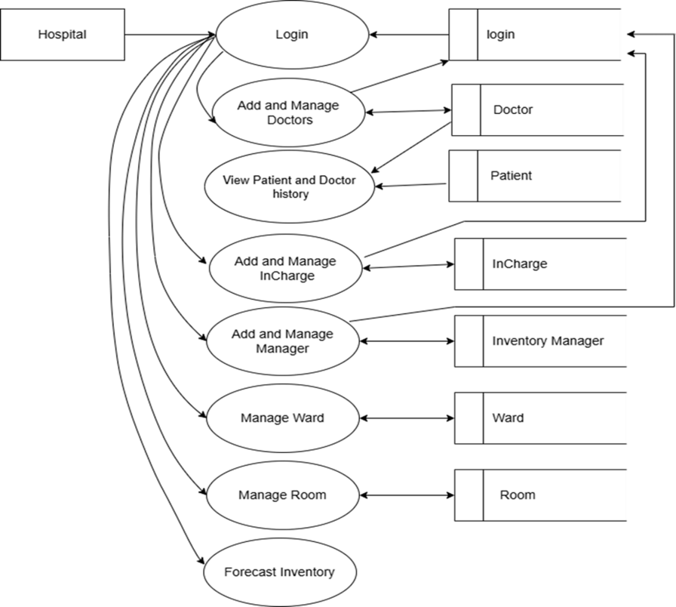

Fig. 2: Role-Based Access Structure of the Hospital Admin

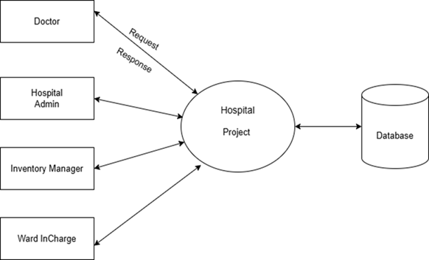

Fig. 3: Role-Based Access Structure of the Doctor

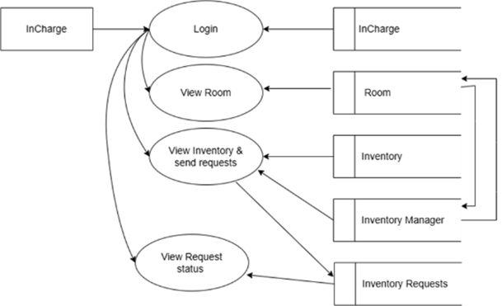

Fig. 4: Role-Based Access Structure of the In Charge

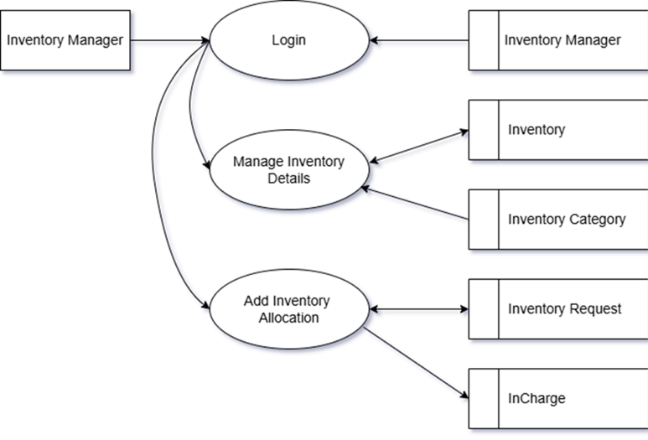

Fig. 5: Role-Based Access Structure of the Inventory Manager

Each user interface is tailored to their role, enabling better control, analytics, and security. The system architecture supports modular deployment and future integration with third-party APIs.

**6. References**

1. Zhang, Y., Jiang, Y., & Li, L. (2021). *Patient demand forecasting in hospital emergency departments using GRU networks*. IEEE Access.
2. Liu, H., & Qu, J. (2015). *HUOMIL: High utility occupancy pattern mining using indexed list structure*. Springer.
3. François Chollet. *Deep Learning with Python*. Manning Publications, 2017.
4. TensorFlow Documentation – <https://www.tensorflow.org>
5. Django Documentation – <https://docs.djangoproject.com>