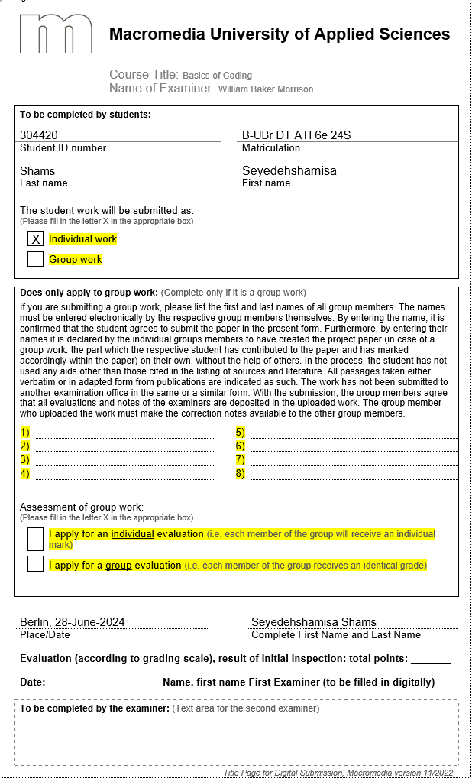

Basics of Coding

Guess The Number

# Introduction

This assessment is based on a simple game written in Python. The game starts with generating a random number between 1 and 100 and asks the player to guess the number within 5 guesses while giving the player feedback and hints.

# Project concept

What I had in mind for this project was to create an interactive and engaging game where the user needs to guess a number randomly selected by the program. The game provides hints to the user if they are close to the correct number and keeps a record of the user's guesses. The game aims to improve user engagement through feedback within a limited number of attempts.

# Design concept

# Figure 1: Activity diagram of the project

The diagram for this project is an activity diagram, which seemed the most suitable for the project, since it consists of one main loop for the whole game with one input of the user that can mainly have two outcomes: true or false. If the input is true, the user wins, and if it is false, there are again two outcomes: too low or too high.

According to the simple structure of the program, an activity diagram is a perfect fit to display the flow of the game.

# Technical implementation

Below is an explanation of the code with screenshots to illustrate the key sections.

The random module is imported to generate random numbers for the game.

iihihih


Figure 2: Importing Required Libraries

The guess_my_number function encapsulates the game logic.



Figure 3: Function Definition

Here, the random number is generated, and variables are initialized. The guesses.txt file is cleared at the start of each game.

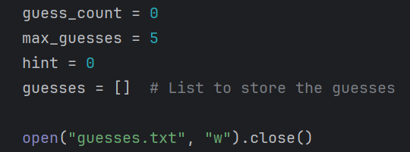

Figure 4: Variable Initialization and File Handling

The greeting text is read from greetings.txt and displayed to the user.

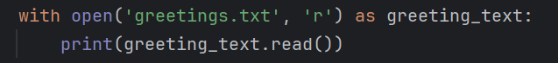

Figure 5: Reading and Displaying Greeting Text

The user is prompted to enter their guess. Input validation is performed to ensure a valid number is entered.

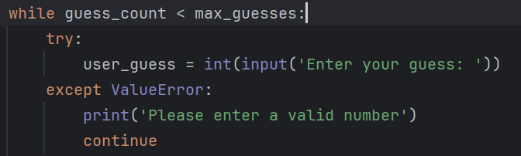

Figure 6: Main Game Loop

The user's guess is compared with the random number, and appropriate feedback is given. Hints are provided if the guess is close.

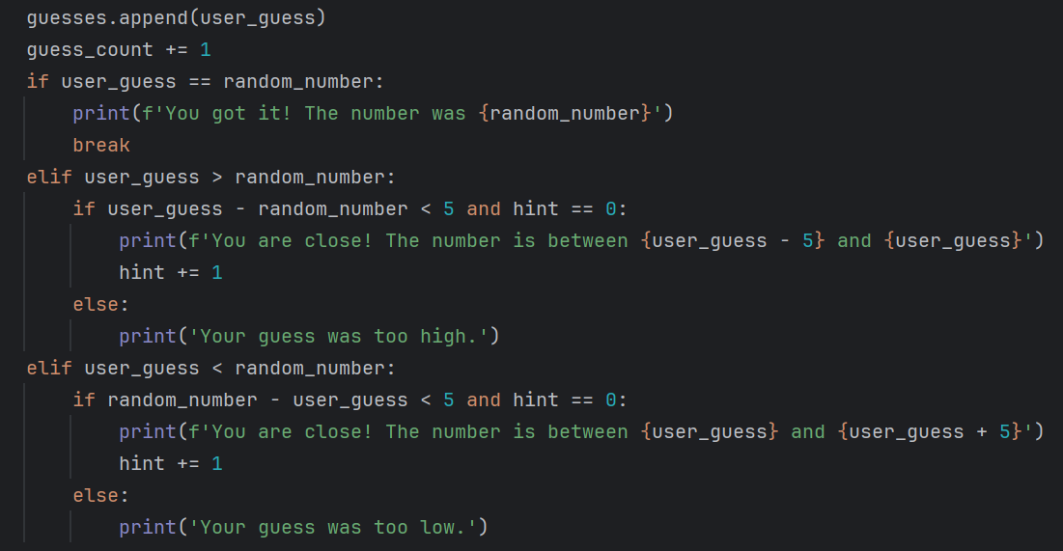

Figure 7: Guess Handling and Feedback

The remaining guesses are calculated and displayed to the player. The guesses are recorded in a text file and displayed at the end of the game.

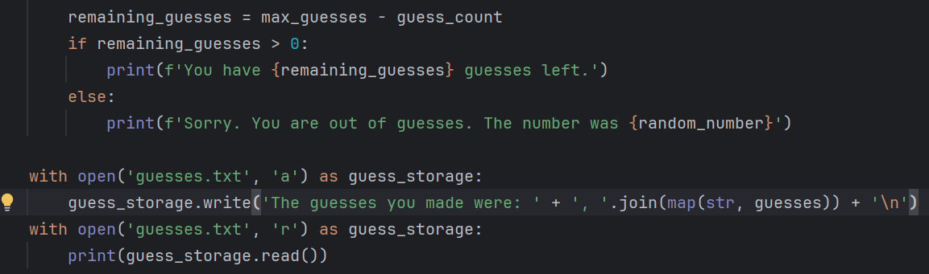

Figure 8: Recording Guesses

The user is asked if they want to play again, and the game loop continues based on their response.

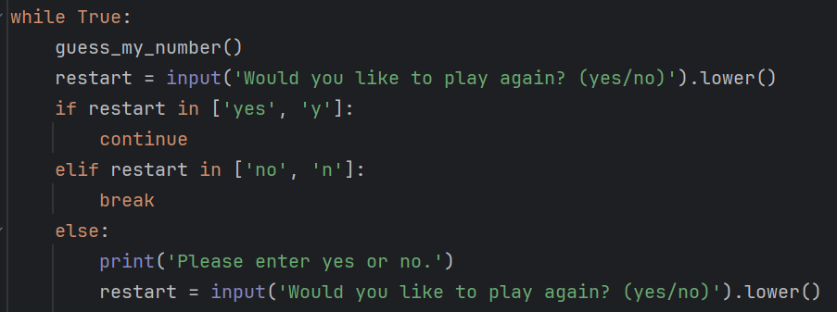

Figure 9: Loop for Replay

# GitHub link

<https://github.com/shamisashams/GuessTheNumber>

# Conclusion

This project is a simple number guessing game written in Python. The game includes generating a random number and asking the user to guess with feedback and hints. The guesses are stored and displayed at the end, letting the player know the pattern of their guesses. Overall, this project consists of functions, while loops, if-else conditions and file manipulations.

