SOFTWARE ENGINEERING PROJECT
Winter Semester 2021/2022

MADE BY:
SHAMISTAN ALIZADA 60001
COACH MANAGEMENT SYSTEM

Coaching is a developmental approach to working and interacting with other people. It can help people develop their personal capabilities, interpersonal skills and capacity to understand and empathise with others. In turn, this can help people understand more about their own challenges and make informed choices about their future. It can strengthen their ability to use a range of influencing and leadership styles. Coaching
can help people feel more empowered to make a difference and improve their own effectiveness.
1. Features of the activity UML Diagram of Coach Management System

- Admin user can search Seat, view description of a selected Seat, add Seat, update Seat and delete Seat.
- Its shows the activity flow of editing, adding and updating of Coach History.
- User will be able to search and generate report of Train, Coach, Coach Number.
- All objects such as (Seat, Coach History, Coach Number) are interlinked.
- Its shows the full description and flow of Seat, Coach, Coach Number, Train, Coach History.

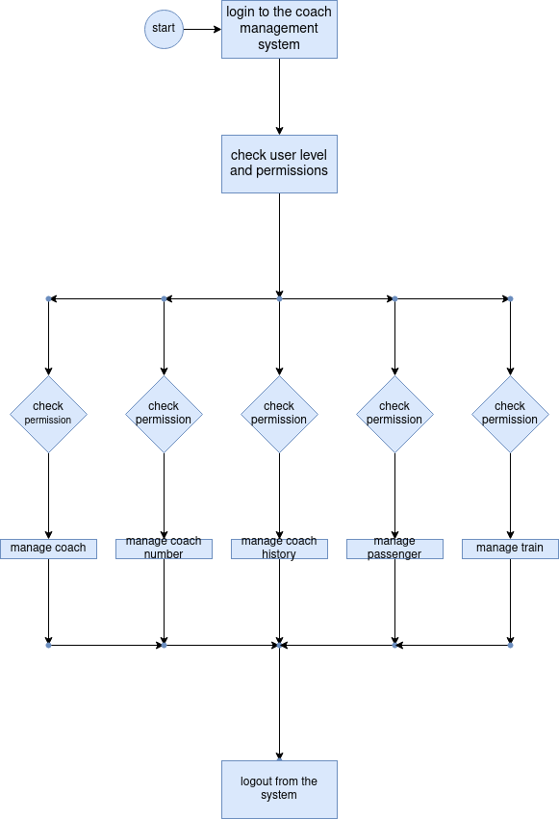

2. Login Activity Diagram of Coach Management System:

This is the Login Activity Diagram of Coach Management System, which shows the flows of Login Activity, where admin will be able to login using their username and password. After login user can manage all the operations on Train, Seat, Coach History, Coach Number, Coach. All the pages such as Coach History, Coach Number, Coach are secure and user can access these page after login. The diagram below helps demonstrate how the login page works in a Coach Management System. The various objects in the Coach Number, Train, Seat, Coach History, and Coach page—interact over the course of the Activity, and user will not be able to access this page without verifying their identity.

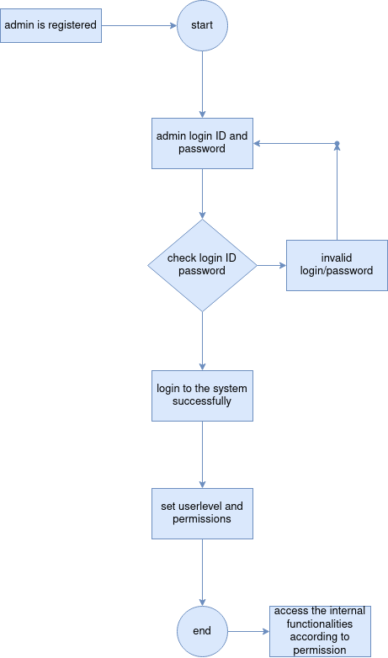
3. Coach Management System Class Diagram

Coach Management System Class Diagram describes the structure of a Coach Management System classes, their attributes, operations (or methods), and the relationships among objects. The main classes of the Coach Management System are Coach, Coach Number, Passenger, Train, Seat, Report.

Classes of Coach Management System Class Diagram:

- Coach Class : Manage all the operations of Coach
- Coach Number Class : Manage all the operations of Coach Number
- Passenger Class : Manage all the operations of Passenger
- Train Class : Manage all the operations of Train
- Seat Class : Manage all the operations of Seat
- Report Class : Manage all the operations of Report

Classes and their attributes of Coach Management System Class Diagram:

- Coach Attributes : coach_id, coach_number, coach_type, coach_description
- Coach Number Attributes : coach_number_id, coach_number_type, coach_number_description
- Passenger Attributes : passenger_id, passenger_name, passenger_mobile, passenger_email, passenger_username, passenger_password, passenger_address
- Train Attributes : train_id, train_name, train_number, train_seat_number, train_ticket, train_type, train_description
- Seat Attributes : seat_id, seat_bus_id, seat_customer_id, seat_number, seat_type, seat_description
- Report Attributes : report_id, report_title, report_type, report_description

Classes and their methods of Coach Management System Class Diagram:

- Coach Methods : addCoach(), editCoach(), deleteCoach(), updateCoach(), saveCoach(), searchCoach()
- Coach Number Methods : addCoach Number(), editCoach Number(), deleteCoach Number(), updateCoach Number(), saveCoach Number(), searchCoach Number()
- Passenger Methods : addPassenger(), editPassenger(), deletePassenger(), updatePassenger(), savePassenger(), searchPassenger()
- Train Methods : addTrain(), editTrain(), deleteTrain(), updateTrain(), saveTrain(), searchTrain()
- Seat Methods : addSeat(), editSeat(), deleteSeat(), updateSeat(), saveSeat(), searchSeat()
- Report Methods : addReport(), editReport(), deleteReport(), updateReport(), saveReport(), searchReport()

Class Diagram of Coach Management System :

Class Diagram Image :

