**HTML CSS ASSIGNMENT 1**

**PART A**

**Source code for Index Page:**

[**https://github.com/shamitha-k/htmlpart1assignment/blob/main/index.html**](https://github.com/shamitha-k/htmlpart1assignment/blob/main/index.html)

**Webpage looks like below with heading tag, navigation bar, unordered list, header and footer and also with image.**

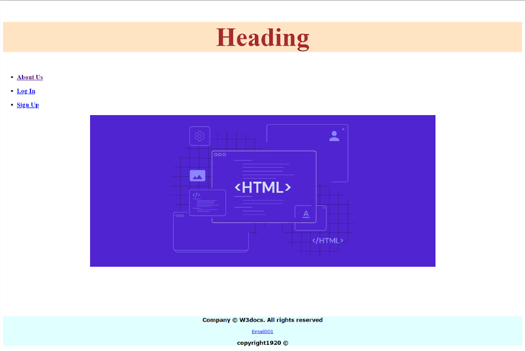

**Source code for About Us page:**

[**https://github.com/shamitha-k/htmlpart1assignment/blob/main/about.html**](https://github.com/shamitha-k/htmlpart1assignment/blob/main/about.html)

**Webpage looks like below with heading tag, navigation bar, unordered list, header and footer and also with image along with anchor tag for Learn more and paragraph tag for description.**

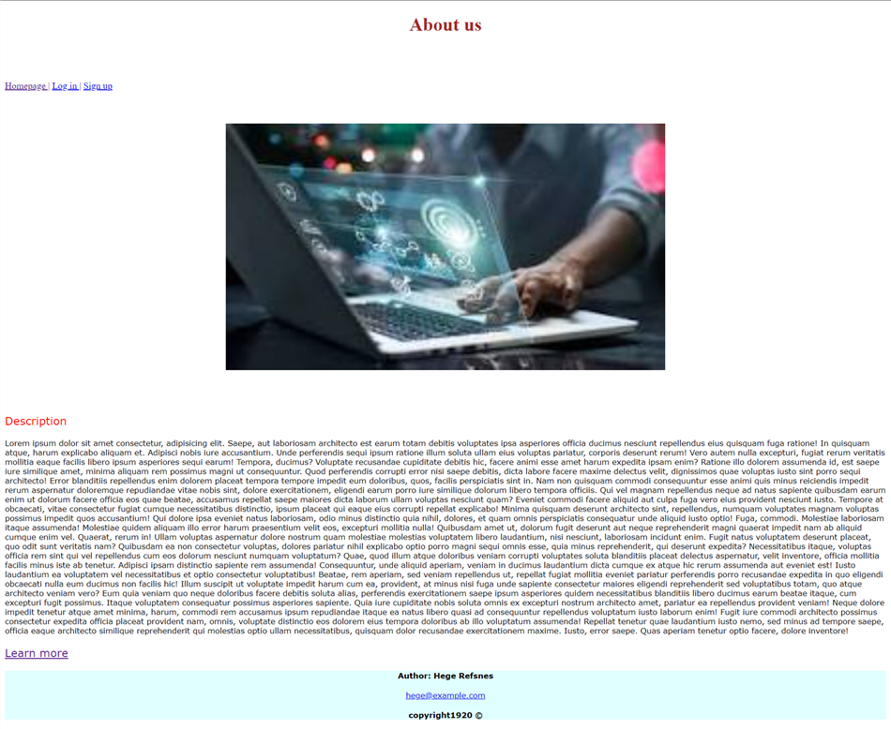

**Source code for Login page:**

[**https://github.com/shamitha-k/htmlpart1assignment/blob/main/log%20in.html**](https://github.com/shamitha-k/htmlpart1assignment/blob/main/log%20in.html)

**Webpage looks like below with heading tag, navigation bar, forms, button tag ,background images**

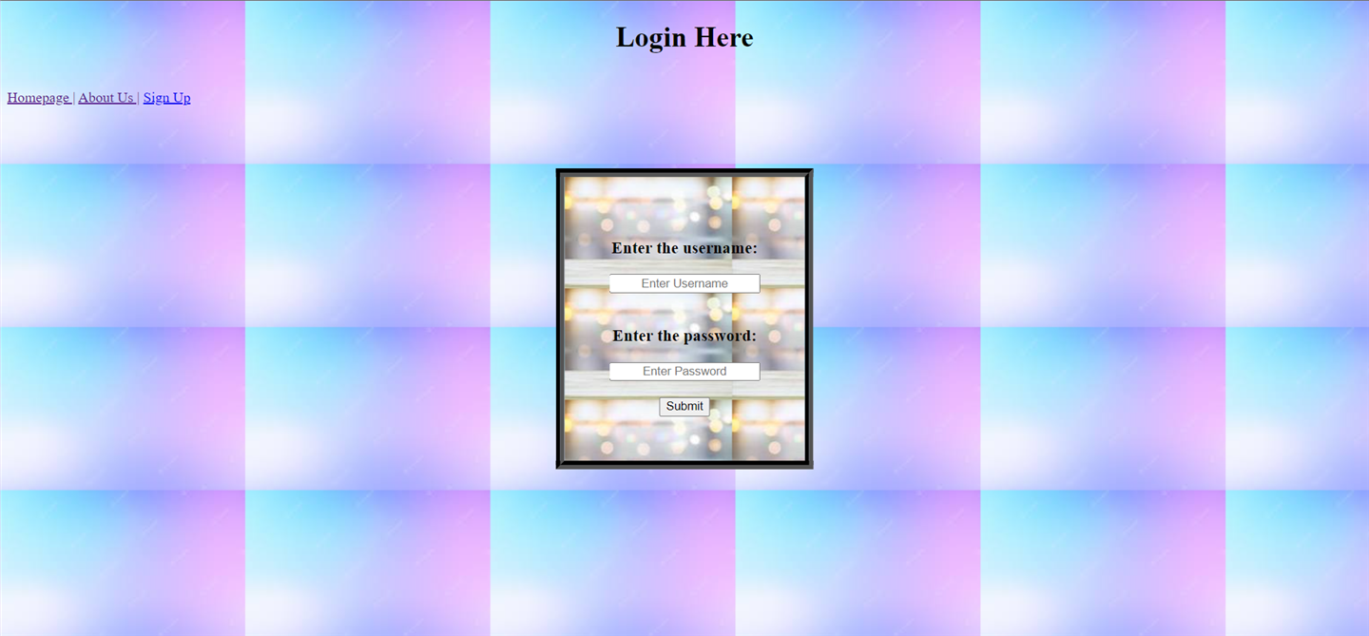

**Source code for Sign up page:**

[**https://github.com/shamitha-k/htmlpart1assignment/blob/main/signup.html**](https://github.com/shamitha-k/htmlpart1assignment/blob/main/signup.html)

**Webpage looks like below with heading tag, navigation bar, forms, button tag ,background images.**

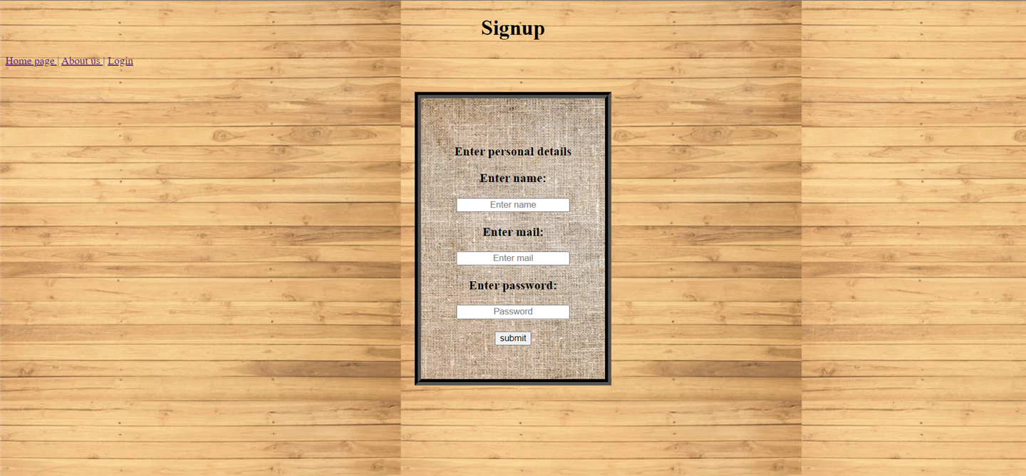

**PART B:**

[**https://github.com/shamitha-k/htmlpart2assignment/blob/main/html%20part2%20assighment/index.html**](https://github.com/shamitha-k/htmlpart2assignment/blob/main/html%20part2%20assighment/index.html)

