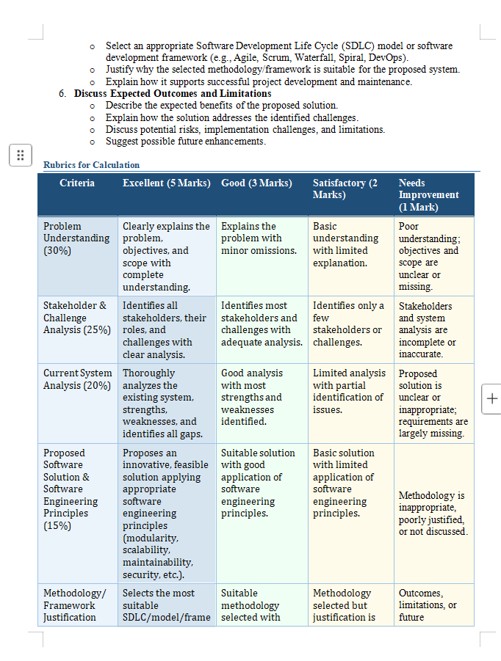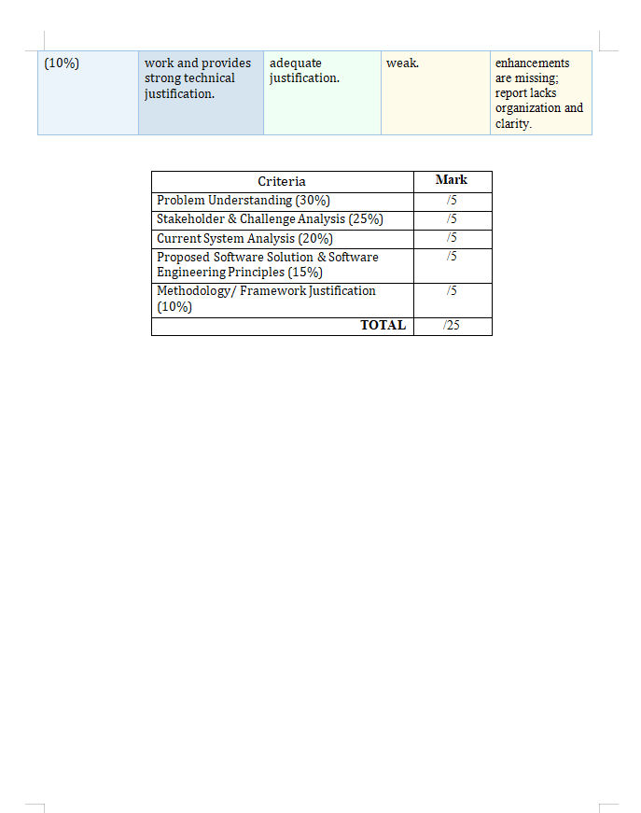

Executive Summary
Urban parking is difficult to regulate when parking-zone details, vehicle permissions, parking durations, evidence, fines, and appeals are handled through separate manual processes. These processes can delay enforcement, create inconsistent records, and make it difficult for drivers to understand or challenge a violation. This report proposes a Smart Parking Enforcement and Violation Management System (SPEVMS), a centralized software platform for managing parking zones, authorized vehicles, parking sessions, violations, evidence, notifications, penalties, payments, appeals, and enforcement analytics.
The proposed system combines a web-based interface for authorized staff and administrators with a driver-facing portal. Optional integration with cameras, sensors, or number-plate recognition can support detection, but the system should allow human review before a disputed or uncertain observation becomes an enforceable violation. Role-based access, audit trails, data protection, reliable records, and a clear appeal process are essential. An Agile development approach is recommended so that the system can be built in increments, tested with users, and improved using feedback.

1. Understand the Problem Statement

1.1 Problem in Our Own Words
In busy urban areas, drivers may park in no-parking zones, exceed the permitted time, use reserved spaces without authorization, or occupy spaces in ways that break local parking rules. When officers depend mainly on manual patrols, paper notes, phone calls, or disconnected spreadsheets, violations may be missed or recorded late. Evidence can be misplaced, fine calculations may be inconsistent, and drivers may find it difficult to check a notice or submit an appeal. The proposed system provides one secure place to record parking activity and manage the complete enforcement process from detection to final resolution.

1.2 Objectives of the Proposed System
- Maintain accurate records of parking zones, rules, time limits, fees, and restricted or reserved areas.
- Register vehicles and link them to permits, resident permissions, accessible bays, or other approved categories where applicable.
- Record parking sessions, including vehicle, zone, start time, end time, and payment or permit status.
- Identify possible violations using officer reports, time-based rules, sensors, or camera integrations.
- Store evidence such as photographs, timestamps, location, and officer observations with each violation record.
- Generate unique violation references and send notifications through configured channels.
- Calculate penalties according to approved rules and record payments, outstanding balances, and receipts.
- Allow drivers to submit appeals and allow authorized reviewers to decide them fairly.
- Maintain searchable historical records and generate reports on violations, payments, appeals, and parking-space use.
- Protect enforcement data through authentication, authorization, audit logs, backups, and secure data handling.

1.3 Scope of the Problem
Included in scope:
- A centralized database for zones, vehicles, parking sessions, violations, evidence, penalties, payments, appeals, and users.
- Web dashboards for administrators, enforcement officers, supervisors, finance staff, and appeal reviewers.
- A driver portal to view notices, access evidence permitted for disclosure, make payments, and submit appeals.
- Rule-based violation checks and optional integration with cameras, parking sensors, payment gateways, email, or SMS services.
- Reports and analytics for enforcement planning and parking-space utilization.
Outside the initial scope:
- Replacing all physical parking infrastructure or guaranteeing that every violation is detected.
- Automatically issuing final penalties solely from uncertain AI or camera output without appropriate verification.
- Replacing the authority's legal rules, payment provider, or formal dispute-resolution policy.
- City-wide deployment before a controlled pilot, security review, and operational approval.

2. Identify Key Stakeholders and Challenges
A stakeholder is any person or organization that uses, manages, funds, regulates, or is affected by the system. The main stakeholders and their responsibilities are summarized below.
Stakeholder | Roles and responsibilities | Major challenges / needs
Municipal / parking authority | Owns the service; defines zones, rules, penalty schedules, retention policies, and operating procedures. | Accurate data, legal compliance, public trust, budget, and measurable enforcement outcomes.
Enforcement officers | Inspect zones, record observations, capture evidence, verify suspected violations, and update case status. | Large patrol areas, poor connectivity, time pressure, incorrect plate reads, and personal safety.
System administrators / IT team | Manage user accounts, roles, configuration, integrations, backups, updates, and incident response. | Cybersecurity, availability, integration complexity, support workload, and access control.
Drivers / vehicle owners | Register vehicle details where required, view notices, pay valid penalties, and submit appeals. | Unclear notices, incorrect violations, privacy concerns, payment difficulties, and limited digital access.
Appeal reviewers / supervisors | Review evidence and submissions, request more information, uphold or cancel cases, and record reasons. | Fairness, workload, consistent decisions, conflicts of interest, and complete case histories.
Finance / payment staff | Reconcile payments, issue receipts, handle refunds where approved, and report outstanding penalties. | Failed transactions, duplicate payments, reconciliation errors, and fraud prevention.
Parking facility operators | Maintain local zone layouts, bay availability, restrictions, and operational updates. | Outdated zone maps, sensor failures, and coordination with authorities.
Technology / service providers | Provide hosting, messaging, payment, camera, sensor, or number-plate recognition services. | Service outages, data-sharing boundaries, compatibility, and service-level commitments.
Auditors / regulators | Review access logs, compliance, data retention, and the fairness and accuracy of enforcement. | Traceability, reliable records, privacy safeguards, and explainable decisions.
Public / local community | Experience the effects of parking availability, traffic flow, and enforcement policy. | Fair access, accessibility, congestion, and confidence in the system.

3. Analyze the Current Approach

3.1 Existing System / Current Process
In a typical manual or partly computerized process, an officer patrols a parking area, checks a vehicle against posted restrictions, writes down the registration number and time, and may take a photograph. The details may be entered later into a spreadsheet or a separate enforcement application. A notice is printed or sent to the vehicle owner, who pays through an available channel or contacts the authority to dispute it. Staff then check payments and appeals using separate records. The exact process varies by authority; this report treats it as a general baseline rather than claiming that every organization uses the same procedure.

3.2 Strengths of the Current Approach
- Officers can use direct observation and local knowledge to interpret unusual situations.
- Manual checks can work with minimal technology and may be inexpensive for a small parking area.
- Human judgment can help identify temporary signs, emergencies, and exceptional circumstances.
- Existing paper forms or spreadsheets may be familiar to staff and easy to start using.

3.3 Limitations and Gaps
- Coverage is limited by staff availability, patrol frequency, and the size of the parking area.
- Handwritten notes and separate spreadsheets can contain duplicate, missing, or inconsistent records.
- Evidence may be stored separately from the violation, making review and appeals slower.
- Drivers may receive notices late or have difficulty tracking the status of a case.
- Penalty calculation and payment reconciliation may require repeated manual work.
- Historical analysis is difficult when records use different formats or are incomplete.
- Weak access controls or informal sharing may expose personal and vehicle information.
- There may be limited auditability: it can be difficult to establish who changed a record and why.

3.4 Problems the Proposed System Must Address
The main gaps are fragmented information, delayed processing, limited visibility for drivers, inconsistent evidence handling, manual reconciliation, and weak analytics. The proposed platform addresses these gaps by using a common data model, guided workflows, time-stamped evidence, status notifications, controlled permissions, auditable case decisions, and standardized reports.

4. Proposed Solution Using Software Engineering Principles

4.1 Proposed System Design
SPEVMS will be a secure, responsive web application backed by a centralized relational database and an evidence file store. Authorized officers can create or review violation cases using a desktop or mobile browser. Drivers can use a portal to view notices and follow the appeal or payment process. A rules engine checks parking-session details against zone rules. Optional camera or sensor integrations create candidate observations, while uncertain cases are routed for human verification. A notification service sends updates, and a reporting module summarizes operational performance.

4.2 High-Level Architecture
Layer / component | Purpose
User interface | Responsive dashboards for administrators, officers, supervisors, finance staff, reviewers, and drivers.
Application / API layer | Validates requests and coordinates workflows for vehicles, zones, sessions, violations, appeals, and payments.
Rules and review engine | Applies approved zone restrictions and time limits; flags candidate violations and supports human verification.
Database | Stores structured records with unique identifiers, relationships, validation rules, and transaction consistency.
Evidence storage | Stores photos and supporting files with access controls, timestamps, and references to violation cases.
Integration layer | Connects, where approved, to cameras, sensors, payment gateways, email/SMS, and authority systems.
Security and audit layer | Handles authentication, role-based authorization, audit trails, encryption, monitoring, and backups.
Analytics and reporting | Produces summaries by zone, violation type, time period, payment status, appeals, and resolution time.

Typical workflow: configure zone and rules → register vehicle or permit (if required) → record parking session or observation → check for a possible violation → verify details and evidence → issue notice → receive payment or appeal → review and resolve case → retain the record according to policy → analyze trends.

4.3 Major Functional Modules
- 1. User and Role Management: Create accounts, authenticate users, assign permissions, deactivate accounts, and review access logs.
- 2. Parking Zone Management: Create zones and bays; define operating hours, time limits, restrictions, tariffs, and reserved-space rules.
- 3. Vehicle and Permit Management: Maintain vehicle registration details and approved permits with validity periods and status.
- 4. Parking Session Management: Record arrival and departure times, zone/bay, payment or permit details, and session status.
- 5. Violation Detection and Classification: Compare observations and session data with rules; classify possible violations such as overstaying, restricted-zone parking, or unauthorized reserved-bay use.
- 6. Evidence Management: Attach photos, timestamps, location, officer notes, and relevant sensor or camera references; preserve traceability.
- 7. Notification Management: Generate a unique case reference and issue notices and reminders through configured channels; record delivery status.
- 8. Penalty and Payment Management: Apply the approved penalty schedule, record payment status and transaction references, generate receipts, and support reconciliation.
- 9. Appeals and Case Resolution: Accept appeal reasons and supporting documents, route cases to authorized reviewers, record decisions and reasons, and notify the driver.
- 10. Historical Records and Analytics: Search prior cases and produce reports on zone trends, repeat violations, payments, appeals, processing time, and utilization.
- 11. Audit, Backup, and Configuration: Record important actions, configure retention and system settings, back up data, and support restoration.

4.4 Functional Requirements
- FR1: The system shall allow authorized administrators to create, edit, deactivate, and view parking zones and their rules.
- FR2: The system shall store vehicle and permit records and validate required fields.
- FR3: The system shall record parking sessions and link them to the relevant zone and vehicle.
- FR4: The system shall compare parking observations or session data with configured rules and flag possible violations.
- FR5: The system shall allow authorized officers to verify, classify, update, or cancel a suspected violation with a recorded reason.
- FR6: The system shall store evidence and link each item to the relevant violation case.
- FR7: The system shall generate a unique violation ID and a notice containing the violation type, time, location, penalty, and appeal instructions.
- FR8: The system shall record payments, transaction references, receipts, and payment status.
- FR9: The system shall allow drivers to submit appeals and supporting documents within the configured period.
- FR10: The system shall allow authorized reviewers to record appeal outcomes and reasons.
- FR11: The system shall maintain historical records and provide search, filtering, and report-generation features.
- FR12: The system shall restrict functions and records according to each user's assigned role.

4.5 Non-Functional Requirements
Requirement | Proposed expectation / design response
Security | Use secure authentication, least-privilege role permissions, encrypted network traffic, protected evidence storage, and monitored access.
Privacy | Collect only necessary information, restrict access, define retention/deletion rules, and follow applicable privacy and records policies.
Reliability | Use database transactions, validation, error handling, backups, and tested restoration procedures.
Performance | Set measurable targets during requirements analysis; common searches and dashboard actions should respond promptly under expected load.
Usability | Provide clear forms, readable notices, accessible layouts, helpful error messages, and a simple driver appeal process.
Scalability | Separate modules and services where useful, index frequently searched fields, and support growth in zones, users, and records.
Maintainability | Use modular code, documentation, automated tests, version control, and controlled configuration changes.
Availability | Define service-level targets and monitoring; provide graceful handling of temporary network or integration outages.
Auditability | Record who performed important actions, when they occurred, and what changed, while preventing ordinary users from altering audit logs.
Interoperability | Use documented APIs and standard data formats for approved external systems.
Accuracy and fairness | Validate data, show the basis of a violation, preserve evidence, and provide human review and an appeal mechanism.

4.6 Applying Software Engineering Principles
Modularity: Separate zone, vehicle, session, violation, evidence, payment, appeal, notification, and analytics functions. Changes in one module should have minimal effect on others.
Scalability: Use a structured database, appropriate indexes, pagination, and independently scalable integration or notification components. Begin with a pilot and expand based on measured demand.
Maintainability: Follow coding standards, use version control, document APIs and data fields, maintain automated tests, and keep configuration separate from source code.
Reliability: Validate inputs, use transactions for important updates, make payment callbacks idempotent, log failures, back up data, and test recovery.
Usability: Design task-focused screens for each role, support mobile use for officers, provide plain-language notices, and test workflows with real users.
Security: Apply least-privilege access, strong authentication, encryption in transit and at rest where supported, secure secret storage, audit logging, and periodic security testing.
Testability: Use unit tests for rules, integration tests for payment and notification flows, and acceptance tests for end-to-end cases.
Data integrity: Use unique case IDs, foreign keys, validation rules, timestamps, and controlled status transitions to reduce duplicate or inconsistent records.

4.7 Suggested Data Entities
Entity | Example key information
User | User ID, name, role, account status, contact details
ParkingZone | Zone ID, name, location, operating hours, restrictions, time limit, tariff
Vehicle | Vehicle ID, registration number, vehicle category, permit status
ParkingSession | Session ID, vehicle ID, zone/bay ID, start/end time, status
Violation | Violation ID, vehicle/session/zone references, type, timestamp, status, penalty amount
Evidence | Evidence ID, violation ID, file reference, capture time, location, uploaded-by user
Notification | Notification ID, violation ID, channel, sent time, delivery status
Payment | Payment ID, violation ID, amount, transaction reference, payment status, timestamp
Appeal | Appeal ID, violation ID, reason, submitted time, documents, decision, decision reason
AuditLog | Log ID, user ID, action, record reference, timestamp, outcome

5. Justify the Chosen Methodology / Framework

5.1 Selected Methodology: Agile with Scrum
Agile development, organized into short Scrum-style iterations, is recommended. The system involves multiple stakeholders and integrations, and requirements such as notice wording, appeal workflows, reporting, and device connectivity may change after users test an early version. Agile allows the team to deliver a working subset early and improve it through feedback rather than waiting until the entire system is complete.

5.2 Why Agile / Scrum Is Suitable
- Incremental delivery: begin with zone management, user access, and manual violation recording, then add evidence, notifications, payments, appeals, and analytics.
- Stakeholder feedback: officers, drivers, reviewers, and finance staff can test prototypes and clarify real workflow needs.
- Early risk discovery: integration, usability, privacy, and performance issues can be identified in early iterations.
- Prioritization: essential enforcement functions can be delivered before optional camera, sensor, or analytics features.
- Continuous testing: each increment can be checked against acceptance criteria and regression tests.
- Adaptability: rules, forms, reports, and integrations can be adjusted as policy or pilot feedback changes.

5.3 Suggested Development Phases
Phase / sprint group | Main activities and deliverables
Discovery and planning | Interview stakeholders, map current workflows, confirm local rules, identify privacy/security needs, and define acceptance criteria.
Sprint group 1: Foundation | Set up repository, database, authentication, roles, audit framework, and parking-zone management.
Sprint group 2: Core records | Implement vehicle/permit records, parking sessions, and manual observation entry.
Sprint group 3: Violations and evidence | Implement rule checks, classification, evidence storage, officer verification, and case status.
Sprint group 4: Notifications and payments | Generate notices, integrate a payment provider in a test environment, record receipts, and reconcile statuses.
Sprint group 5: Appeals and analytics | Implement driver appeal submission, reviewer decisions, history search, and reports.
Pilot and release | Conduct security, performance, usability, and acceptance testing; train users; deploy to a limited area and monitor results.
Maintenance iterations | Fix defects, apply security updates, review feedback, improve reports, and add approved integrations.

5.4 How the Methodology Supports Success and Maintenance
A prioritized product backlog makes work visible and keeps the team focused on high-value requirements. Sprint planning sets a realistic goal; daily coordination helps identify blockers; sprint reviews gather stakeholder feedback; and retrospectives improve the team's process. Definition of Done should include code review, tests, documentation, security checks appropriate to the change, and demonstrable acceptance criteria. After release, the same backlog can manage bug fixes, policy updates, and enhancements.

6. Expected Outcomes and Limitations

6.1 Expected Benefits
- Improved parking regulation through consistent recording and rule-based checks.
- Faster violation processing because evidence, notices, payments, and appeals are linked in one case record.
- Reduced opportunities for missed or duplicated records and less repetitive data entry.
- Greater transparency through clear notices, evidence references, case status, and recorded appeal decisions.
- More convenient driver access to notices, payment status, and appeals.
- Better financial tracking through payment records, receipts, and reconciliation reports.
- More informed enforcement planning using trends by zone, time, violation type, and appeal outcome.
- Improved parking-space utilization when reliable session or occupancy data is available.
- Stronger accountability through role-based access and audit trails.

6.2 How the Solution Addresses Stakeholder Challenges
Challenge | System response | Expected improvement
Missed or delayed violations | Centralized records, guided officer workflow, optional sensor/camera alerts, and rule checks. | Quicker review and more consistent case processing.
Incomplete evidence | Required evidence fields, time stamps, file-to-case links, and validation. | Easier verification and appeal review.
Unclear status for drivers | Driver portal, unique case reference, notices, and status updates. | Better access to information and fewer status enquiries.
Payment reconciliation errors | Transaction references, payment status tracking, receipts, and reconciliation reports. | More accurate financial records.
Slow appeals | Structured submissions, reviewer queues, deadlines, and recorded decisions. | More traceable and organized dispute resolution.
Limited management insight | Standardized dashboards and historical reports. | Evidence-based staffing and parking policy decisions.
Privacy and misuse risks | Role permissions, audit logs, retention controls, and secure storage. | Reduced unauthorized access and stronger accountability.

6.3 Risks and Implementation Challenges
- Incorrect vehicle identification or sensor readings may create false alerts. Mitigation: require verification for uncertain cases, calibrate devices, and provide correction workflows.
- Poor data quality or outdated zone rules can cause incorrect enforcement. Mitigation: assign data owners, validate changes, and maintain effective dates and change history.
- Personal and vehicle data may be exposed through unauthorized access or insecure integrations. Mitigation: minimize collected data, encrypt it, restrict access, monitor logs, and conduct security reviews.
- Network, hosting, camera, or payment outages can interrupt processing. Mitigation: monitor dependencies, queue retryable events safely, and define manual fallback procedures.
- Users may resist a new process or need training. Mitigation: involve users in design, provide simple guides, and introduce the system through a pilot.
- Integration and hosting costs may exceed the initial budget. Mitigation: prioritize core manual workflows first and evaluate optional hardware using a cost-benefit analysis.
- Unfair or inconsistent enforcement can reduce public trust. Mitigation: publish understandable rules, retain evidence, provide accessible appeals, and audit outcomes for unusual patterns.
- Payment callbacks or retries may create duplicate records. Mitigation: use unique transaction references, idempotent processing, and reconciliation checks.
- Legal requirements and retention periods may vary by jurisdiction. Mitigation: obtain approval from the relevant authority and configure policies before launch.

6.4 Limitations
- The software cannot guarantee detection of every violation, particularly where camera coverage, connectivity, or parking data is incomplete.
- Automated number-plate recognition may perform differently under poor lighting, weather, obstruction, or unusual plate formats.
- Reliable occupancy analytics depend on accurate and sufficiently frequent session or sensor data.
- The system requires staff training, ongoing technical support, cybersecurity maintenance, and a budget for hosting and integrations.
- The effectiveness of enforcement depends on local policy, staffing, signage, payment arrangements, and fair appeal procedures—not software alone.

6.5 Future Enhancements
- Integrate approved IoT bay sensors and camera systems to provide near-real-time parking observations.
- Use privacy-aware number-plate recognition to assist officers, with confidence thresholds and human review for uncertain results.
- Develop a mobile application or progressive web app for officers to work in low-connectivity environments with controlled synchronization.
- Add occupancy prediction and demand analysis to help authorities plan parking capacity and enforcement patrols.
- Provide multilingual, accessible notices and additional notification channels.
- Integrate with approved municipal permit, vehicle, payment, and grievance systems through documented APIs.
- Add dashboards for repeat locations, appeal reversal rates, average resolution time, and service reliability.
- Introduce configurable retention, anonymization, and deletion workflows aligned with applicable rules.
- Use geospatial maps to visualize zones, hotspots, restricted areas, and occupancy trends.
- Conduct periodic fairness, security, accessibility, and performance assessments as usage grows.

7. Testing and Evaluation Plan
The system should be evaluated before full deployment using realistic test cases and measurable acceptance criteria. Exact targets should be agreed with the authority during requirements analysis rather than assumed in advance.
Test type | Example test / success condition
Unit testing | Verify time-limit calculations, restriction rules, penalty calculations, and case-status transitions.
Integration testing | Verify that evidence uploads, notification delivery, payment callbacks, and database updates work together.
Security testing | Confirm that users cannot access functions or evidence outside their permissions; test common input and session vulnerabilities.
Usability testing | Ask officers and drivers to complete key tasks and record completion rate, errors, and feedback.
Performance testing | Measure search, dashboard, and case-creation response under expected and peak loads.
Recovery testing | Restore a backup in a test environment and verify record consistency and evidence references.
Acceptance testing | Confirm that zone setup, violation review, notice delivery, payment, appeals, and reporting meet approved requirements.
Pilot evaluation | Compare processing time, record completeness, appeal resolution time, and user feedback against a documented baseline.

8. Conclusion
The Smart Parking Enforcement and Violation Management System provides a structured, secure, and transparent approach to managing urban parking enforcement. By bringing zone rules, vehicle and session records, violations, evidence, notifications, penalties, payments, appeals, and analytics into one platform, it can reduce fragmented work and help stakeholders resolve cases more consistently. Modular design, strong access control, auditability, human review, and a clear appeal process are important to making the system reliable and fair. Agile development with Scrum-style iterations supports gradual delivery, stakeholder feedback, and continuous improvement. A limited pilot followed by measurable evaluation is recommended before broader deployment.

Appendix A: Example Violation Workflow
- An officer or approved device records a possible parking violation.
- The system captures the zone, vehicle registration, timestamp, violation category, and available evidence.
- The rules engine checks the observation against the zone's active restrictions.
- An authorized officer verifies the information and corrects or rejects inaccurate observations.
- If confirmed, the system creates a violation case and calculates the applicable penalty using approved rules.
- The system issues a notice and records the notification status.
- The driver pays the penalty or submits an appeal through the permitted process.
- The payment or appeal is processed, and the case status is updated with an audit trail.
- The final record is retained according to policy and included in appropriate reports.

Appendix B: Suggested Success Indicators
Indicator | How it can be measured
Violation processing time | Average time from initial observation to verified notice.
Record completeness | Percentage of cases containing all required fields and evidence.
Appeal resolution time | Average time from valid appeal submission to decision.
Notification delivery | Percentage of notices successfully delivered through configured channels.
Payment reconciliation accuracy | Percentage of transactions matched correctly to violation records.
System availability | Measured uptime against the approved service target.
User satisfaction | Feedback scores and task-completion results from officers and drivers.
Parking utilization | Occupancy or session-based measures where sufficiently reliable data is available.

