Project Title:

**GK QUIZ**



**Submitted By:**

* Savio Nazareth | 2462362 | savio.john@btech.christuniversity.in
* Tenzin Rigzin | 2460462 | tenzin.rigzin@btech.christuniversity.in
* Shamith Gowda | 2462530 | shamith.m@btech.christuniversity.in

**Course:** Web Design Fundamentals **Instructor Name:** Narendra Kumar **Institution:** Christ University **Date of Submission:** 24/09/2025

**2. Abstract**

This project is an Interactive Quiz Application designed with a user-friendly interface using HTML, CSS, Bootstrap, and JavaScript (with jQuery). The app allows users to attempt a series of general knowledge questions with a timer, real-time validation of answers, and score tracking. The main goal is to enhance the learning experience through an engaging, responsive, and interactive quiz platform.

3. Objectives

* To design a clean and responsive front-end UI for an interactive quiz.
* To make the quiz engaging with timed questions and instant feedback (correct/wrong highlight).
* To implement dynamic question loading, scoring, and results.
* To demonstrate the use of Bootstrap for layout and styling, jQuery/JavaScript for logic, and CSS for customization.

4. Scope of the Project

* Suitable for educational platforms and self-learning apps.
* Can be expanded with different categories of quizzes, leaderboards, and user authentication.
* Focuses primarily on the front-end implementation, with potential to integrate backend later for user data storage and analytics.

5. Tools & Technologies Used

* HTML5 – Structure and semantic design.
* CSS3 – Custom styling for quiz interface.
* Bootstrap 5.3 – Responsive layout, buttons, and card components.
* JavaScript (ES6) – Quiz logic, timer, and scoring.
* jQuery 3.7 – Simplified DOM manipulation and event handling.

6.HTML Structure Overview

* <div class="quiz-container card"> – Main quiz box with card layout.
* Timer Section – Displays question number and countdown timer.
* Question Section – Dynamically updates with each question.
* Options Section – Uses Bootstrap list-group for clickable options.
* Next Button – Navigates to the next question.
* Result Section – Shows final score after quiz completion.

7. CSS Styling Strategy

* Light background color (#f8f9fa) for a clean look.
* Custom classes .correct and .wrong to highlight selected answers with green/red backgrounds.
* Styling for .quiz-container to center align and add card shadow for UI depth.
* Font sizes adjusted for better readability of questions and options.

8. JavaScript Implementation

* Quiz Data Array: Stores all questions, options, and answers.
* Dynamic Rendering: Loads questions and options dynamically into the DOM.
* Timer Functionality: A countdown timer resets for each question.
* Answer Validation: Highlights correct/wrong answers instantly on selection.
* Score Calculation: Tracks correct answers and displays final score.
* jQuery Usage: Simplifies element selection, event handling (.click()), and DOM manipulation.

9. Bootstrap Implementation

* Card Component for the quiz container.
* List Group for quiz options (list-group-item-action).
* Button Styling for "Next" button.
* Grid & Utility Classes for spacing, margins (mb-3, p-4), and text alignment (text-center, text-end).
* Responsive Design ensures the quiz looks good across devices.

10. Key Features

* Timer-based questions (15 seconds each).
* Instant feedback with color highlights.
* Responsive design (mobile and desktop friendly).
* Score tracking with a final result display.
* Disable options after selection to prevent multiple answers.

11. Challenges Faced & Solutions

1. Challenge: Preventing multiple clicks on options.  
   Solution: Disabled all options after one is selected.
2. Challenge: Timer running into next question.  
   Solution: Used clearInterval() before loading each new question.
3. Challenge: Ensuring responsive UI for mobile devices.  
   Solution: Leveraged Bootstrap grid system and utility classes for layout.

12. Outcome

* Successfully developed an interactive quiz app that is responsive, functional, and user-friendly.
* The project demonstrates effective use of front-end technologies and UI/UX principles.
* Provides a working prototype that can be extended into a full-fledged e-learning tool.

13. Future Enhancements

* Add categories and difficulty levels.
* Include leaderboards and user profiles.
* Store results in a database using backend integration (Node.js, Firebase, etc.).
* Add animations and sound effects for a more engaging experience.
* Implement review mode to revisit correct/wrong answers.

14. Sample Code

<!doctype html>

<html lang="en">

<head>

  <meta charset="utf-8">

  <meta name="viewport" content="width=device-width, initial-scale=1">

  <title>Interactive Quiz App</title>

  <!-- Bootstrap CSS -->

  <link href="https://cdn.jsdelivr.net/npm/bootstrap@5.3.2/dist/css/bootstrap.min.css" rel="stylesheet">

  <style>

    body { *background-color*:#f8f9fa; }

    .quiz-container { *max-width*:700px; *margin*:auto; }

    .question { *font-size*:1.25rem; *margin-bottom*:1rem; }

    .option { *cursor*:pointer; }

    .option.correct { *background-color*:#d4edda !important; }

    .option.wrong { *background-color*:#f8d7da !important; }

    .timer { *font-weight*:bold; *font-size*:1.2rem; }

    #result { *font-size*:1.3rem; *font-weight*:bold; }

  </style>

</head>

<body>

  <div class="container py-5">

    <div class="quiz-container card shadow p-4">

      <h2 class="text-center mb-4">General Knowledge Quiz</h2>

      <!-- Timer -->

      <div class="d-flex justify-content-between mb-3">

        <div>Question <span id="qNum">1</span>/<span id="totalQ"></span></div>

        <div class="timer text-danger">⏱ <span id="timer">15</span>s</div>

      </div>

      <!-- Question -->

      <div id="question" class="question"></div>

      <!-- Options -->

      <div id="options" class="list-group mb-3"></div>

      <!-- Next Button -->

      <div class="text-end">

        <button id="nextBtn" class="btn btn-primary" disabled>Next</button>

      </div>

      <!-- Result -->

      <div id="result" class="text-center mt-4 d-none"></div>

    </div>

  </div>

  <!-- jQuery -->

  <script src="https://code.jquery.com/jquery-3.7.1.min.js"></script>

  <!-- Bootstrap Bundle -->

  <script src="https://cdn.jsdelivr.net/npm/bootstrap@5.3.2/dist/js/bootstrap.bundle.min.js"></script>

  <script>

    // Expanded General Knowledge Quiz Questions

*const* quizData = [

      { question: "What is the capital city of Australia?", options: ["Sydney", "Melbourne", "Canberra", "Brisbane"], answer: "Canberra" },

      { question: "Who painted the Mona Lisa?", options: ["Vincent van Gogh", "Pablo Picasso", "Leonardo da Vinci", "Claude Monet"], answer: "Leonardo da Vinci" },

      { question: "Which is the largest planet in our solar system?", options: ["Earth", "Saturn", "Jupiter", "Neptune"], answer: "Jupiter" },

      { question: "What is the national currency of Japan?", options: ["Yen", "Won", "Rupee", "Ringgit"], answer: "Yen" },

      { question: "In which year did World War II end?", options: ["1940", "1942", "1945", "1950"], answer: "1945" },

      { question: "Which continent is known as the ‘Dark Continent’?", options: ["Asia", "Africa", "South America", "Antarctica"], answer: "Africa" },

      { question: "Who is known as the Father of the Indian Constitution?", options: ["Mahatma Gandhi", "Jawaharlal Nehru", "B. R. Ambedkar", "Sardar Patel"], answer: "B. R. Ambedkar" },

      { question: "Which gas do plants absorb from the atmosphere during photosynthesis?", options: ["Oxygen", "Nitrogen", "Carbon Dioxide", "Helium"], answer: "Carbon Dioxide" },

      { question: "Who was the first man to step on the Moon?", options: ["Yuri Gagarin", "Neil Armstrong", "Buzz Aldrin", "Michael Collins"], answer: "Neil Armstrong" },

      { question: "Which country is known as the Land of the Rising Sun?", options: ["China", "Japan", "Thailand", "Korea"], answer: "Japan" },

      { question: "Who wrote the play 'Romeo and Juliet'?", options: ["William Shakespeare", "Charles Dickens", "Oscar Wilde", "Mark Twain"], answer: "William Shakespeare" },

      { question: "Which is the longest river in the world?", options: ["Amazon", "Nile", "Yangtze", "Mississippi"], answer: "Nile" },

      { question: "Which sport is associated with Wimbledon?", options: ["Football", "Tennis", "Cricket", "Hockey"], answer: "Tennis" },

      { question: "Who was the first Prime Minister of India?", options: ["Mahatma Gandhi", "Jawaharlal Nehru", "Subhas Chandra Bose", "Rajendra Prasad"], answer: "Jawaharlal Nehru" },

      { question: "Which is the smallest planet in our solar system?", options: ["Mercury", "Mars", "Venus", "Pluto"], answer: "Mercury" }

    ];

*let* currentQ = 0;

*let* score = 0;

*let* timerInterval;

*let* timeLeft = 15;

    $(document).ready(*function*(){

      $("#totalQ").text(quizData.length);

      loadQuestion();

      $("#nextBtn").click(*function*(){

        currentQ++;

        if(currentQ < quizData.length){

          loadQuestion();

        } else {

          showResult();

        }

      });

    });

*function* loadQuestion(){

      clearInterval(timerInterval);

      timeLeft = 15;

      $("#timer").text(timeLeft);

      timerInterval = setInterval(updateTimer,1000);

*const* qData = quizData[currentQ];

      $("#qNum").text(currentQ+1);

      $("#question").text(qData.question);

      $("#options").empty();

      $("#nextBtn").prop("disabled",true);

      qData.options.forEach(*opt* *=>* {

*const* btn = $(`<button class="list-group-item list-group-item-action option">${*opt*}</button>`);

        btn.click(*function*(){

          checkAnswer($(this), qData.answer);

        });

        $("#options").append(btn);

      });

    }

*function* checkAnswer(*$btn*, *correctAnswer*){

      clearInterval(timerInterval);

      $("#options .option").prop("disabled",true);

*const* chosen = *$btn*.text();

      if(chosen === *correctAnswer*){

*$btn*.addClass("correct");

        score++;

      } else {

*$btn*.addClass("wrong");

        $("#options .option").filter(*function*(){ return $(this).text()===*correctAnswer*; }).addClass("correct");

      }

      $("#nextBtn").prop("disabled",false);

    }

*function* updateTimer(){

      timeLeft--;

      $("#timer").text(timeLeft);

      if(timeLeft<=0){

        clearInterval(timerInterval);

        $("#nextBtn").prop("disabled",false);

        $("#options .option").prop("disabled",true);

      }

    }

*function* showResult(){

      $(".quiz-container .question, #options, #nextBtn, .timer, #qNum").hide();

      $("#result").removeClass("d-none").text(`You scored ${score} out of ${quizData.length}!`);

    }

  </script>

</body>

</html>

15. Screenshots of Final Output

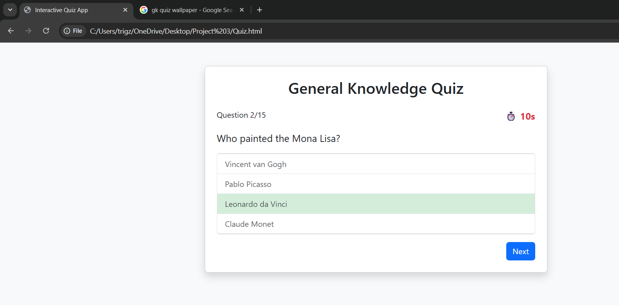

16. Conclusion

The project showcases how UI/UX design, Bootstrap, JavaScript, and jQuery can come together to build an engaging quiz app. It not only meets the project objectives but also provides a strong foundation for future development. With further enhancements, this quiz application can evolve into a scalable platform for learning and assessment.