SOFTWARE REQUIREMENTS
SPECIFICATION
INSTALLMENT SCHEDULE GENERATOR
BCA FINAL YEAR MINOR PROJECT

Shamith M Ramdurg (01FE24BCA272)
Gurukiran Hippargi (01FE24BCA261)
Srigouri Chikkeri (01FE24BCA271)
S Kavyasri (01FE24BCA290)
Department of Computer Applications
Bachelor of Computer Applications (BCA)

DOCUMENT CONTROL
Item | Details
Document Title | Software Requirements Specification – Installment Schedule Generator
Project Type | BCA Final Year Minor Project
Version | 1.0
Document Status | Final Draft

TABLE OF CONTENTS
1. Introduction
2. Overall Description
3. Specific Requirements
4. Functional Requirements
5. Non-Functional Requirements
6. Hardware and Software Requirements
7. System Modules
8. Database Design
9. Use Case Diagram – Textual Representation
10. Data Flow Diagram (DFD)
11. System Workflow
12. Installment / EMI Calculation
13. Sample Input and Output
14. Assumptions and Constraints
15. Expected Output
16. Future Enhancements
17. Benefits of the System
18. Conclusion

1. INTRODUCTION
The Installment Schedule Generator is a software application designed to calculate installment amounts and automatically generate a detailed repayment schedule for loans or purchases. The system accepts important financial inputs such as principal amount, interest rate, loan tenure, installment frequency, and starting date, and produces a clear schedule showing the installment number, due date, principal component, interest component, and remaining balance.
The project is intended as a BCA final-year minor project and demonstrates the use of database management, application logic, financial calculations, user input validation, and report generation.

1.1 Purpose
The main purpose of the system is to reduce manual calculation of installment schedules and provide accurate, organized, and easy-to-understand repayment information.

1.2 Scope
- Calculate monthly or periodic installment amounts.
- Generate a complete installment schedule.
- Display principal, interest, installment amount, and outstanding balance.
- Allow users to save and view loan records.
- Generate printable or downloadable reports.
- Provide simple validation for financial inputs.

2. OVERALL DESCRIPTION
The proposed system can be implemented as a web-based application. A user enters the required loan or purchase information, and the system processes the data using the installment calculation formula. The generated schedule can then be viewed, stored, and printed.

2.1 Product Perspective
The system works as an independent installment calculation and schedule-generation application. It consists of a user interface, calculation module, database, and reporting module.

2.2 Users
- User: Enters loan details, generates schedules, views saved records, and prints reports.
- Admin: Manages users and stored loan records and maintains the system.

2.3 Product Functions
- User registration and login.
- Loan or purchase detail entry.
- Installment/EMI calculation.
- Automatic schedule generation.
- Schedule viewing and report generation.
- Storage and retrieval of loan records.
- Basic administration of users and records.

3. SPECIFIC REQUIREMENTS
The system shall provide a simple interface through which users can enter valid financial information and obtain an installment schedule. The application shall validate required fields before performing calculations.

4. FUNCTIONAL REQUIREMENTS
ID | Requirement | Description
FR1 | User Registration | The system shall allow a new user to create an account.
FR2 | User Login | The system shall authenticate registered users.
FR3 | Loan Input | The system shall accept principal amount, interest rate, tenure, frequency, and start date.
FR4 | Input Validation | The system shall validate numeric and date inputs before calculation.
FR5 | Installment Calculation | The system shall calculate the installment using the selected parameters.
FR6 | Schedule Generation | The system shall generate installment-wise repayment details.
FR7 | Balance Calculation | The system shall calculate the remaining balance after each installment.
FR8 | Schedule Viewing | The system shall display the complete schedule in tabular form.
FR9 | Record Storage | The system shall save loan and schedule information in the database.
FR10 | Record Retrieval | The system shall allow users to view previously saved schedules.
FR11 | Report Generation | The system shall provide a printable/downloadable repayment report.
FR12 | Administration | The system shall provide administrative functions for managing users and records.

5. NON-FUNCTIONAL REQUIREMENTS
- Usability: The interface should be simple and understandable for users with basic computer knowledge.
- Performance: The system should generate a schedule within a few seconds for normal inputs.
- Reliability: Calculations should be consistent and accurate for valid inputs.
- Security: Login credentials and stored user data should be protected.
- Maintainability: The software should be modular so that changes can be made easily.
- Scalability: The design should support additional loan types and payment frequencies in the future.
- Portability: The application should work on common modern browsers if implemented as a web application.

6. HARDWARE AND SOFTWARE REQUIREMENTS

6.1 Hardware Requirements
- Processor: Intel Core i3 or equivalent and above.
- RAM: Minimum 4 GB.
- Storage: Minimum 20 GB free space.
- Keyboard and mouse.
- Display monitor.
- Internet connection for web-based deployment, if required.

6.2 Software Requirements
- Operating System: Windows/Linux/macOS.
- Frontend: HTML, CSS, JavaScript.
- Backend: Python/Java/PHP/Node.js (as selected for implementation).
- Database: MySQL or another relational database.
- Web Browser: Chrome, Edge, Firefox, or equivalent.
- Development Environment: VS Code, Eclipse, IntelliJ IDEA, or equivalent.

7. SYSTEM MODULES

7.1 User Management Module
Handles registration, login, authentication, and basic user information.

7.2 Loan Input Module
Accepts principal amount, interest rate, tenure, payment frequency, and starting date.

7.3 Installment Calculation Module
Performs EMI/installment calculations based on the entered parameters.

7.4 Schedule Generation Module
Creates installment-wise due dates, principal, interest, payment amount, and balance.

7.5 Report Module
Displays and formats the schedule for printing or downloading.

7.6 Database Module
Stores users, loan details, and generated schedules.

8. DATABASE DESIGN
The proposed database may contain the following main tables:
Table | Main Fields
Users | user_id, name, email, password, role
Loans | loan_id, user_id, principal, interest_rate, tenure, frequency, start_date, total_payment, total_interest
Installment_Schedule | schedule_id, loan_id, installment_no, due_date, installment_amount, principal_paid, interest_paid, balance

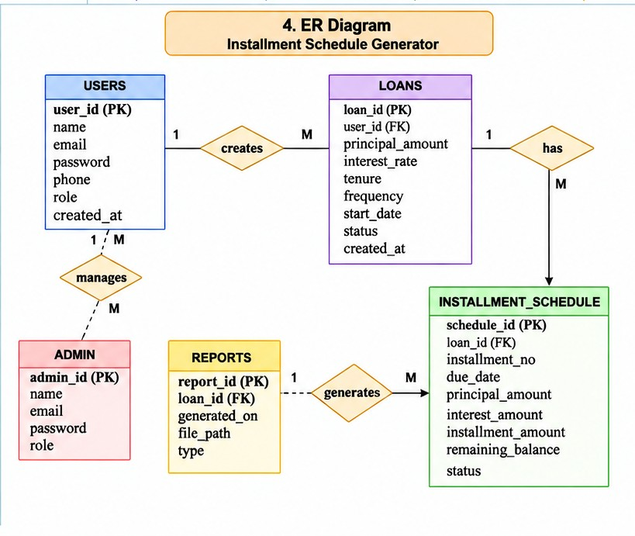

9. USE CASE DIAGRAM – TEXTUAL REPRESENTATION
The following textual representation can be used as a guide for preparing the actual UML use-case diagram:
Actors: User and Admin. User use cases include registration, login, entering loan details, generating an installment schedule, viewing saved schedules, and printing or downloading reports. Admin use cases include managing users and stored loan records.
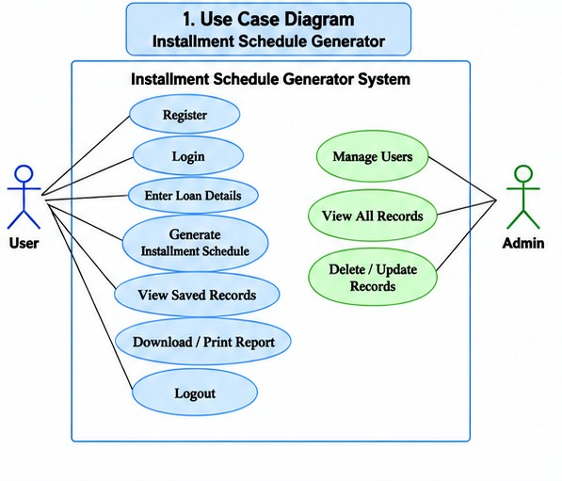

10. DATA FLOW DIAGRAM (DFD)
The DFD describes how data moves between users, system processes, and data stores.

10.1 DFD Level 0
The user provides loan details to the Installment Schedule Generator. The system calculates installments, generates the repayment schedule, stores the records, and returns the schedule/report to the user.
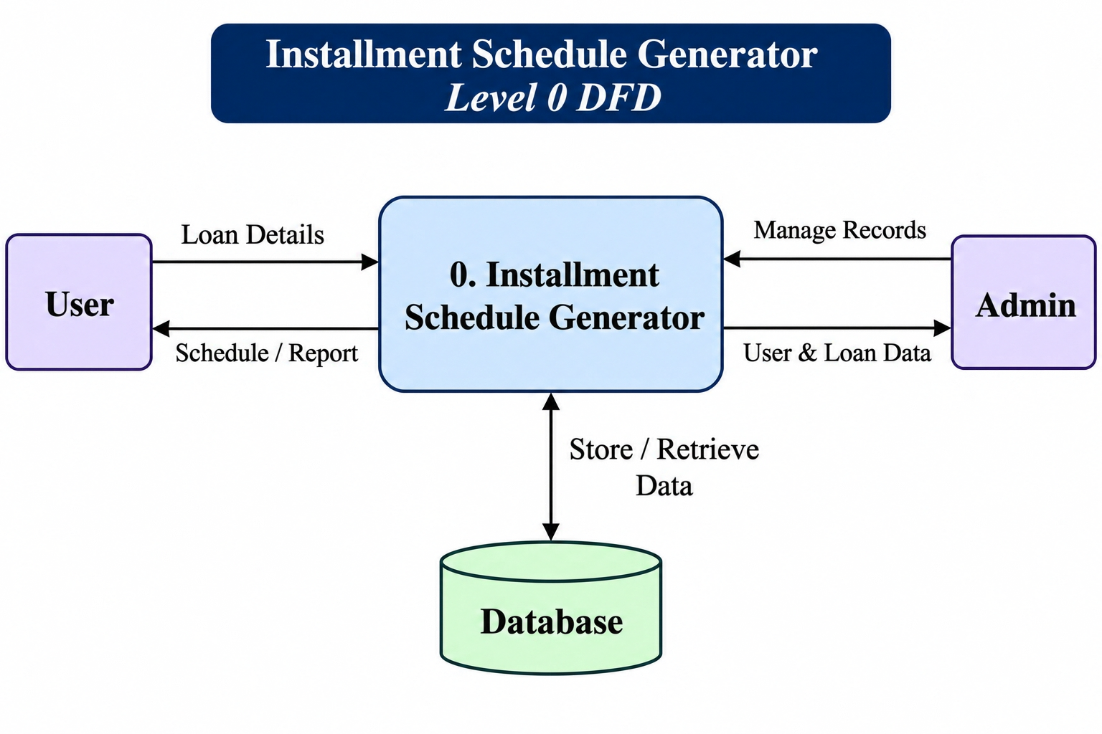

10.2 DFD Level 1
- 1.0 User Management
- 2.0 Loan Details Processing
- 3.0 Installment Calculation
- 4.0 Schedule Generation
- 5.0 Report Generation
- D1 – Users Database
- D2 – Loans Database
- D3 – Installment Schedule Database

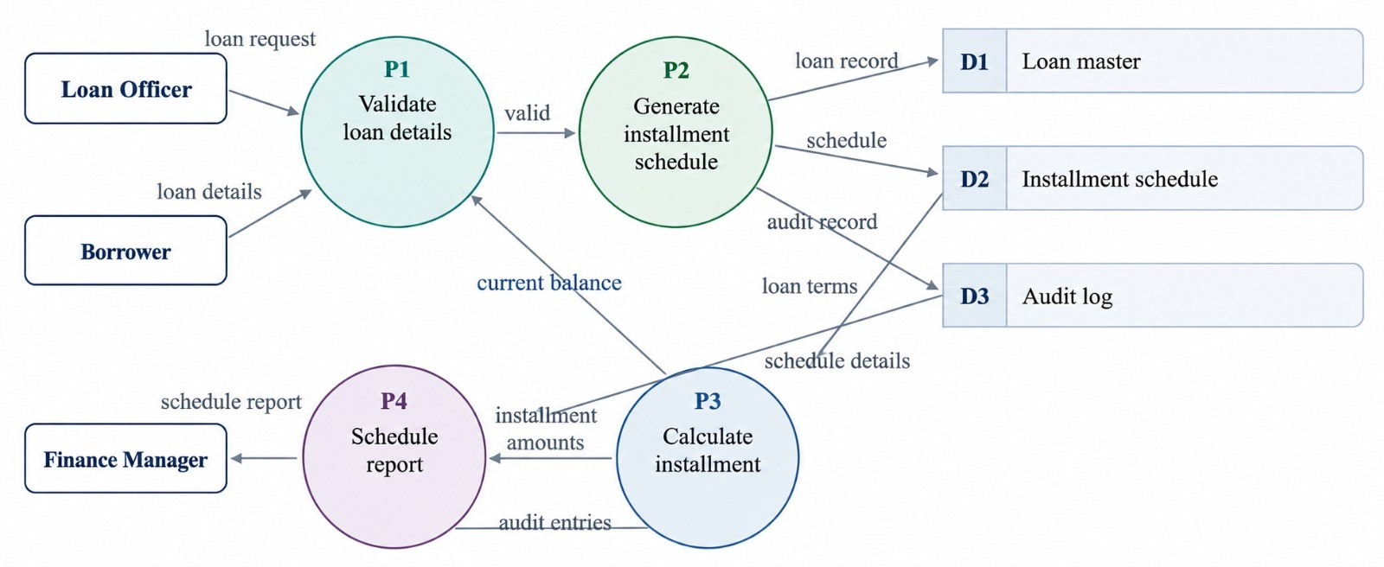11. SYSTEM WORKFLOW
- User opens the application.
- User registers or logs in.
- User enters principal amount.
- User enters interest rate and loan tenure.
- User selects installment frequency.
- User selects or enters the starting date.
- System validates the input.
- System calculates the installment amount.
- System generates the complete repayment schedule.
- User views, saves, prints, or downloads the report.

11.1 Sequence Diagram

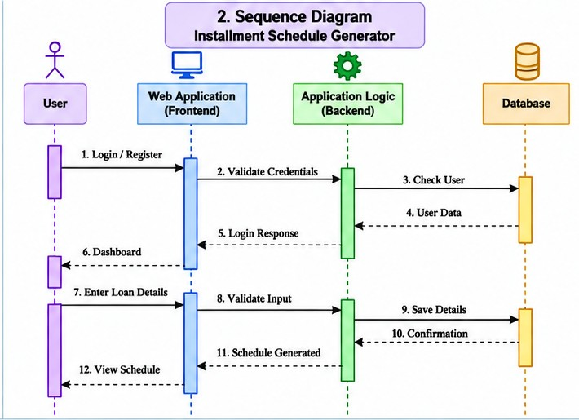11.2 Activity Diagram

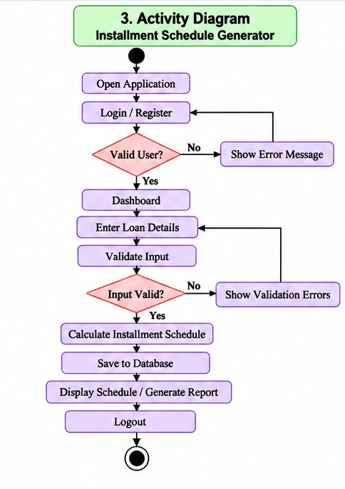

12. INSTALLMENT / EMI CALCULATION
For a standard monthly reducing-balance loan, the EMI can be calculated using the following formula:
EMI = P × R × (1 + R)ᴺ / [(1 + R)ᴺ − 1]
- P = Principal loan amount.
- R = Monthly interest rate in decimal form (annual rate ÷ 12 ÷ 100).
- N = Total number of monthly installments.
The system can then calculate the interest and principal components for each installment and update the outstanding balance after every payment.

13. SAMPLE INPUT AND OUTPUT

13.1 Sample Input
Parameter | Value
Principal Amount | ₹1,00,000
Annual Interest Rate | 10%
Tenure | 12 months
Frequency | Monthly
Start Date | 01-11-2026

13.2 Sample Output
- Monthly EMI: approximately ₹8,791.59
- Total Payment: approximately ₹1,05,499.08
- Total Interest: approximately ₹5,499.08

14. ASSUMPTIONS AND CONSTRAINTS
- The user provides correct and valid financial information.
- Interest rate is entered as an annual percentage unless otherwise specified.
- The standard EMI formula is used for reducing-balance monthly repayment.
- The application may initially support only selected installment frequencies.
- The system is intended for educational/project use and should not replace official lender calculations.

15. EXPECTED OUTPUT
- Calculated installment/EMI amount.
- Total repayment amount.
- Total interest payable.
- Installment number.
- Due date of each installment.
- Principal paid in each installment.
- Interest paid in each installment.
- Remaining loan balance.
- Printable/downloadable schedule report.

16. FUTURE ENHANCEMENTS
- Support for multiple loan types.
- Support for weekly, bi-weekly, quarterly, and yearly schedules.
- Prepayment and part-payment calculations.
- Late-payment penalty calculation.
- Email/SMS reminders for due dates.
- Graphical charts for principal and interest distribution.
- PDF and Excel export.
- Mobile application version.
- Cloud-based backup and synchronization.

17. BENEFITS OF THE SYSTEM
- Reduces manual calculation errors.
- Saves time in preparing repayment schedules.
- Provides a clear view of future payments.
- Helps users understand principal and interest components.
- Stores records for future reference.
- Provides a simple and organized reporting mechanism.

18. CONCLUSION
The Installment Schedule Generator is a useful software solution for automatically calculating installment amounts and generating detailed repayment schedules. The project provides practical experience in requirements analysis, database design, programming, financial computation, validation, and report generation. The proposed SRS defines the major requirements and structure needed to develop the system as a BCA final-year minor project.

