
Dhaka International University
Department of Business Administration
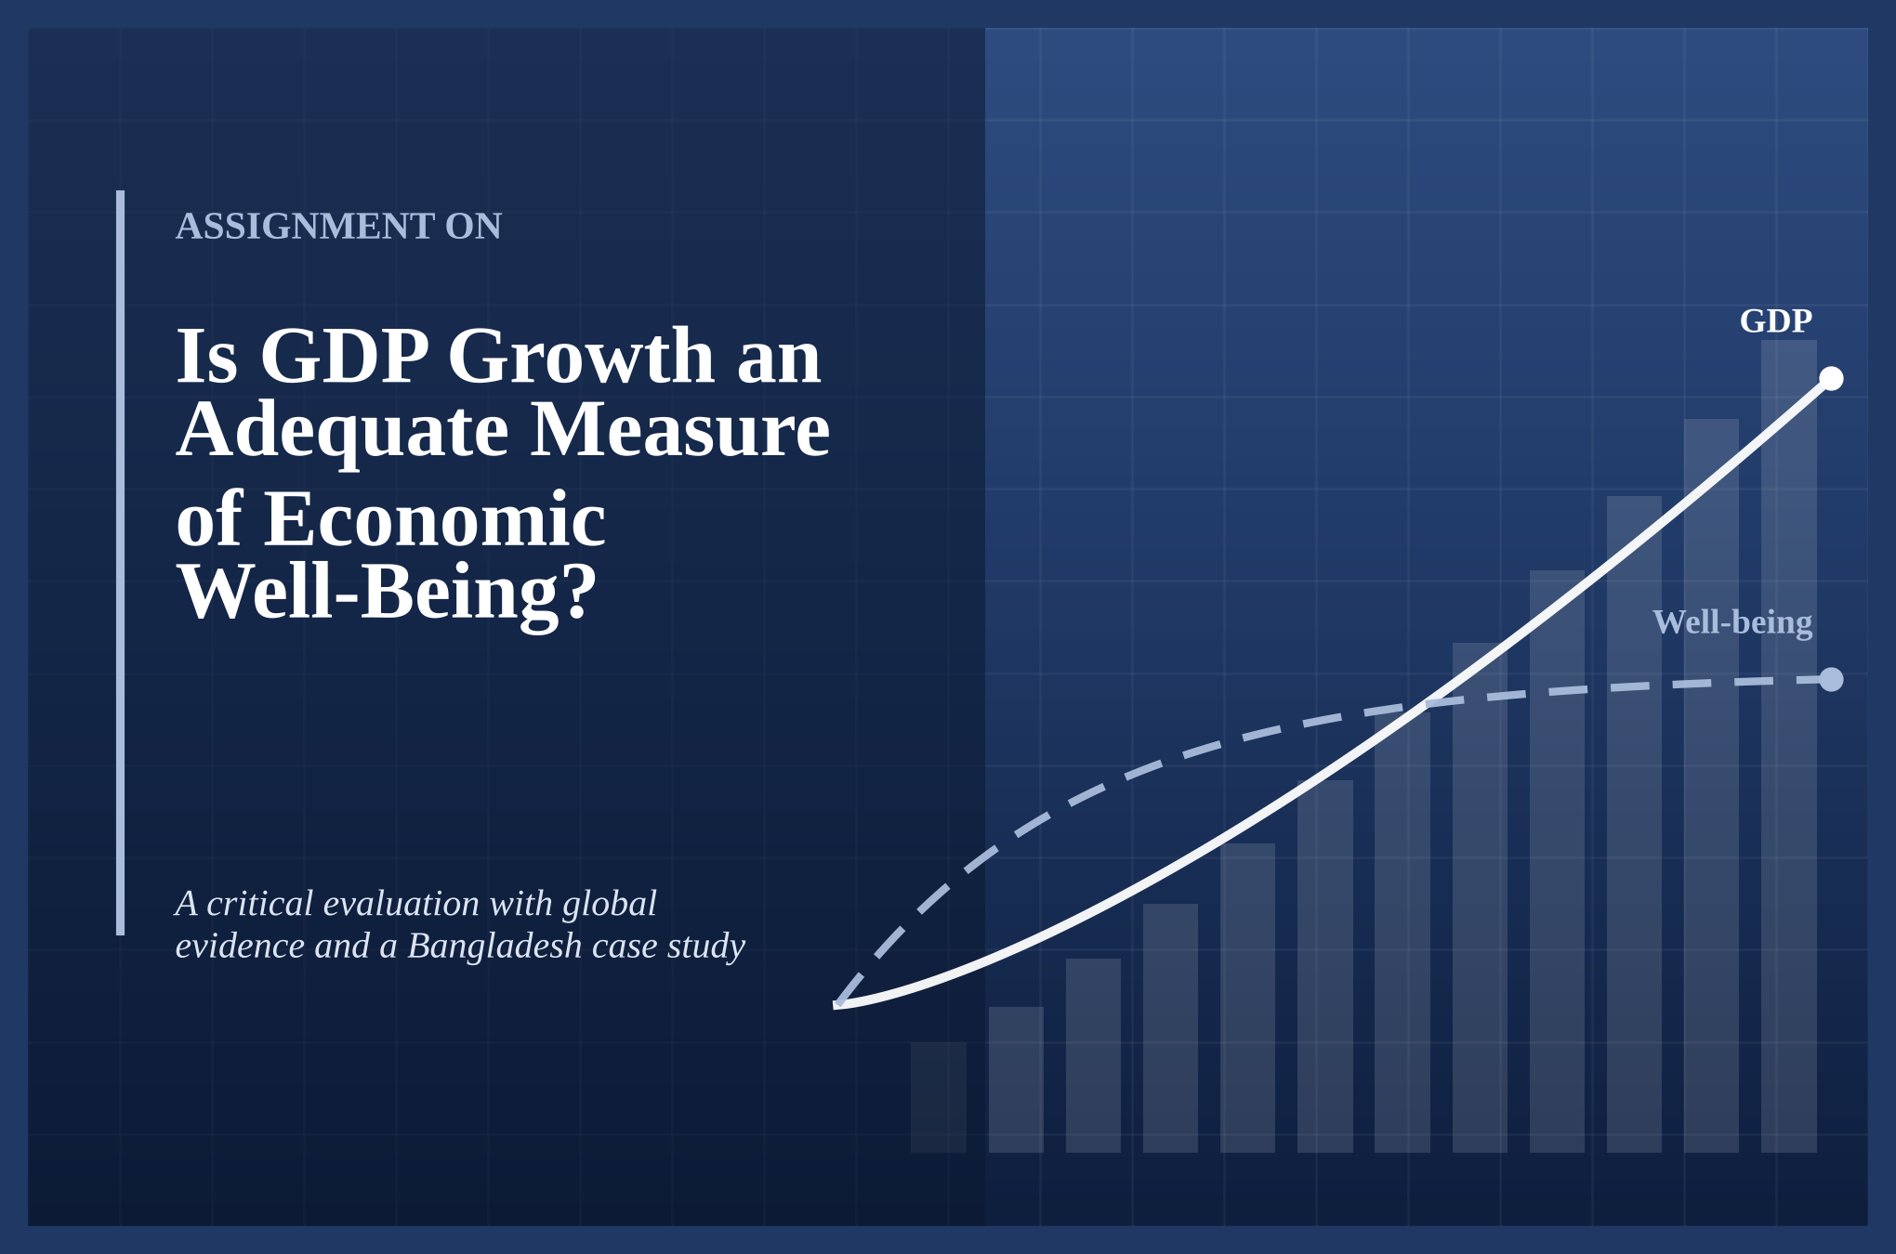
Course Title : | [Write course title, e.g. Macroeconomics]
Course Code : | [Write course code, e.g. ECO-201]

Submitted To |  |  | Submitted By
Name | [Teacher's Name] |  | Name | [Your Full Name]
Designation | [Lecturer / Assistant Professor] |  | Student ID | [Your ID]
Department | [Department Name] |  | Batch | [Batch]
University | [University Name] |  | Section | [Section]
 |  |  | Semester | [Semester]
 |  |  | Program | [BBA / BSS / BSc]
Date of Submission : [DD Month YYYY]

Abstract
Gross Domestic Product (GDP) is the most widely quoted number in economics. Governments set growth targets around it, the media report it every quarter, and international bodies use it to rank countries. Yet GDP was designed to measure the market value of production, not the quality of people's lives. This assignment asks whether GDP growth is an adequate measure of economic well-being.
The study uses secondary data from the World Bank, UNDP, the World Inequality Lab, the World Happiness Report, the Bangladesh Bureau of Statistics (BBS) and peer-reviewed literature. It first explains how GDP is measured and what economists mean by well-being. It then sets out the case for GDP, followed by its main limitations: it ignores distribution, unpaid and informal work, environmental damage, defensive spending, leisure and subjective life satisfaction. Five worked demonstrations and seventeen charts show these points with numbers. Alternative measures, including the Human Development Index (HDI) and the Genuine Progress Indicator (GPI), are compared, and Bangladesh is used as a case study.
The evidence shows that GDP growth is closely linked to falling poverty and better health in low-income countries, so it remains a necessary indicator. However, the link weakens at higher income levels, and GDP can rise while inequality, environmental loss and stress also rise. The study concludes that GDP growth is necessary but not sufficient: it is a good measure of economic activity but an inadequate measure of economic well-being on its own. A dashboard approach that reports GDP alongside distribution, human development and sustainability indicators is recommended, especially for Bangladesh.
Keywords: GDP, economic growth, economic well-being, Human Development Index, Genuine Progress Indicator, inequality, sustainability, beyond GDP, Bangladesh

Table of Contents
1. Introduction 1
1.1 Background of the Study 1
1.2 Statement of the Problem 1
1.3 Objectives of the Study 1
1.4 Research Questions 1
1.5 Methodology and Data Sources 2
1.6 Scope and Limitations 2
2. Understanding Gross Domestic Product 3
2.1 Definition of GDP 3
2.2 Three Approaches to Measuring GDP 3
2.3 Nominal GDP, Real GDP and GDP per Capita 3
2.4 How GDP Became the Headline Number 4
3. The Concept of Economic Well-Being 5
3.1 Defining Economic Well-Being 5
3.2 Dimensions of Well-Being 5
3.3 The Stiglitz-Sen-Fitoussi Commission 5
3.4 GDP and Well-Being: A Conceptual Comparison 6
4. The Case for GDP: Why Growth Still Matters 6
4.1 Growth and Living Standards 6
4.2 Growth and Poverty Reduction: Evidence from Bangladesh 7
4.3 Practical Advantages of GDP 8
5. Limitations of GDP as a Measure of Well-Being 8
5.1 GDP Ignores the Distribution of Income 8
5.2 Non-Market and Unpaid Work 10
5.3 The Informal Economy 11
5.4 Environmental Degradation and Resource Depletion 11
5.5 Defensive Expenditure and the Broken-Window Problem 12
5.6 Spending More Does Not Always Mean Living Better 13
5.7 Happiness and the Easterlin Paradox 13
5.8 Quality Change, Free Digital Goods and Leisure 14
6. Alternative and Complementary Measures 15
6.1 The Human Development Index (HDI) 15
6.2 The Genuine Progress Indicator (GPI) 17
6.3 Other Measures 17
7. Case Study: Bangladesh 18
7.1 Growth Performance 18
7.2 Human Development Progress 18
7.3 What GDP Growth Does Not Show 19
8. Comparative Analysis: A Dashboard Approach 20
9. Findings and Discussion 22
9.1 Key Findings 22
9.2 Discussion 22
10. Conclusion and Recommendations 22
10.1 Conclusion 22
10.2 Recommendations 23
References 24
Appendix A: Glossary of Key Terms 26

List of Figures
Figure 1: Framework of the study 2
Figure 2: What GDP counts and what it misses 6
Figure 3: GDP per capita and life expectancy (the Preston curve) 7
Figure 4: Real GDP growth in Bangladesh, FY2011-FY2024 (%) 7
Figure 5: Poverty headcount rates in Bangladesh, 2000-2022 8
Figure 6: Income inequality across selected countries (Gini index) 9
Figure 7: Global distribution of income and wealth, 2021 9
Figure 8: Average income by quintile in Country A and Country B 10
Figure 9: World real GDP and global CO₂ emissions, 1990-2022 (index, 1990 = 100) 11
Figure 10: GDP, wealth and well-being after a flood (hypothetical) 13
Figure 11: Health spending and life expectancy in selected countries, 2021 13
Figure 12: United States: GDP per capita and reported happiness, 1972-2018 14
Figure 13: GDP per capita and life evaluation across countries 14
Figure 14: GDP per capita and Human Development Index, 2022 16
Figure 15: GDP per capita compared with the Genuine Progress Indicator (stylised) 17
Figure 16: Human Development Index of Bangladesh, 1990-2022 19
Figure 17: Well-being dashboard for two hypothetical countries 21

List of Tables
Table 1: Main data sources used in the study 2
Table 2: The three approaches to measuring GDP 3
Table 3: Hypothetical economy: nominal and real GDP 4
Table 4: Dimensions of economic well-being and example indicators 5
Table 5: Same GDP, different well-being: Country A and Country B 10
Table 6: GDP and well-being after a flood (hypothetical) 12
Table 7: Summary of the main limitations of GDP 15
Table 8: Calculation of Bangladesh's HDI, 2022 16
Table 9: Comparison of GDP with alternative well-being measures 18
Table 10: Bangladesh: growth versus broader well-being indicators 19
Table 11: Selected countries: GDP per capita compared with well-being indicators 20
Table 12: Dashboard scores for two hypothetical countries (0-100) 21
Table 13: Glossary of key terms used in the assignment 26

List of Abbreviations
BBS | Bangladesh Bureau of Statistics
CO₂ | Carbon dioxide
GDP | Gross Domestic Product
GNH | Gross National Happiness (Bhutan)
GNI | Gross National Income
GPI | Genuine Progress Indicator
HDI | Human Development Index
HIES | Household Income and Expenditure Survey
ILO | International Labour Organization
IHDI | Inequality-adjusted Human Development Index
LFS | Labour Force Survey
MPI | Multidimensional Poverty Index
OECD | Organisation for Economic Co-operation and Development
PPP | Purchasing Power Parity
SDG | Sustainable Development Goals
SEEA | System of Environmental-Economic Accounting
SNA | System of National Accounts
UNDP | United Nations Development Programme
WHR | World Happiness Report
WIR | World Inequality Report

1. Introduction

1.1 Background of the Study
When a finance minister presents a budget, the first number most people hear is the expected GDP growth rate. A growth rate of 7 per cent is treated as good news and a rate of 3 per cent as a warning. Behind this habit lies an assumption that a bigger economy means a better life for the people who live in it. For much of the twentieth century this assumption was rarely questioned, because rising output usually brought more food, better housing, more schools and longer lives.
Over the last few decades, however, economists, statisticians and policymakers have pointed out that GDP can rise while many people feel no better off. Inequality has widened in many countries, climate change and pollution impose costs that GDP does not subtract, and surveys of happiness show that life satisfaction does not always follow income. These concerns led to the influential Stiglitz-Sen-Fitoussi Commission (2009), the OECD Better Life Initiative and the United Nations' “Beyond GDP” work.
Bangladesh is a useful example. The country grew at an average of more than 6 per cent a year for over a decade and moved into the lower-middle-income group in 2015. Poverty fell by more than half. At the same time, income inequality rose, most workers remain in informal jobs, and Dhaka regularly ranks among the most polluted cities in the world. These facts raise the question this assignment sets out to answer.

1.2 Statement of the Problem
GDP measures the market value of all final goods and services produced in a country in a given period. Economic well-being, in contrast, refers to how well people are able to live: their income and consumption, their security, their health, the time they have and the environment around them. The problem is that policy debates often treat the two as the same thing. If GDP is a weak guide to well-being, then policies designed to maximise growth may not maximise welfare, and some may even reduce it.

1.3 Objectives of the Study
The broad objective is to evaluate whether GDP growth is an adequate measure of economic well-being. The specific objectives are:
▪ To explain how GDP is measured and what it is designed to capture.
▪ To define economic well-being and identify its main dimensions.
▪ To assess the evidence linking GDP growth with well-being outcomes.
▪ To identify and demonstrate the main limitations of GDP as a welfare measure.
▪ To compare GDP with alternative measures such as the HDI and GPI.
▪ To apply the analysis to Bangladesh and suggest practical recommendations.

1.4 Research Questions
1. Does an increase in GDP reliably lead to an increase in people's economic well-being?
2. What important aspects of well-being does GDP fail to capture?
3. Which alternative or complementary measures give a fuller picture?
4. What does the Bangladesh experience tell us about growth and well-being?

1.5 Methodology and Data Sources
This is a descriptive and analytical study based on secondary data. Quantitative data were collected from international and national sources and presented through tables and charts. Simple worked examples (called demonstrations) are used to show how GDP can move differently from well-being. The study follows the steps shown in Figure 1, and Table 1 lists the main data sources.
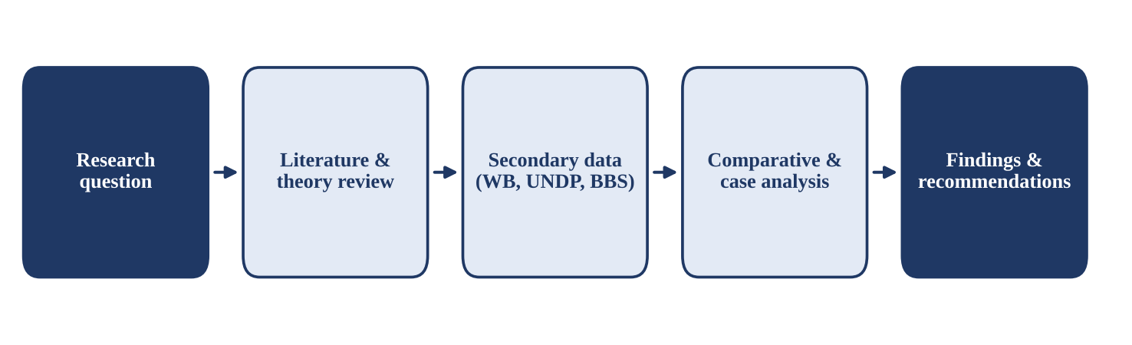
Figure 1: Framework of the study
Source: Prepared by the author.
Table 1: Main data sources used in the study
Source | Data used | Period
World Bank, World Development Indicators | GDP per capita, life expectancy, Gini index, health spending | 2010-2023
UNDP Human Development Report 2023/24 | HDI values and components | 1990-2022
Bangladesh Bureau of Statistics (BBS) | GDP growth, HIES poverty rates, Labour Force Survey | 2000-2024
World Inequality Report 2022 | Global income and wealth shares | 2021
World Happiness Report 2024 | Life evaluation scores | 2021-2023
Global Carbon Project; World Bank | CO₂ emissions and world real GDP | 1990-2022
Academic literature | GPI, Easterlin paradox, Stiglitz-Sen-Fitoussi report | 1934-2024
Source: Compiled by the author.

1.6 Scope and Limitations
The study focuses on the conceptual adequacy of GDP growth as a welfare measure, using global comparisons and Bangladesh as a case study. It does not build an econometric model. Figures are rounded and some cross-country values refer to the latest available year, so small differences from the original databases are possible. Charts marked as illustrative or stylised are designed to explain a concept rather than report exact statistics.

2. Understanding Gross Domestic Product

2.1 Definition of GDP
Gross Domestic Product is the total market value of all final goods and services produced within a country's borders during a specific period, usually a quarter or a year (Mankiw, 2021). Each part of the definition matters. Market value means goods are weighted by their prices. Final goods exclude intermediate inputs to avoid double counting. Within a country means production by foreign firms located in Bangladesh counts in Bangladesh's GDP, while income earned by Bangladeshi workers abroad does not (it is part of Gross National Income instead).

2.2 Three Approaches to Measuring GDP
Because every taka spent by a buyer is a taka of income for a seller, GDP can be measured in three ways that should, in principle, give the same answer (Table 2). The most familiar is the expenditure identity:
GDP = C + I + G + (X − M)
where C is household consumption, I is investment, G is government purchases, X is exports and M is imports. Each of these items is a flow of spending in the market. Nothing in the formula asks whether the spending made anyone happier, healthier or more secure.
Table 2: The three approaches to measuring GDP
Approach | What is added up | Formula / example
Expenditure approach | Spending on final goods and services | GDP = C + I + G + (X − M)
Income approach | Incomes earned in production | Wages + rent + interest + profit + (taxes − subsidies) + depreciation
Production (value-added) approach | Value added at each stage of production | GDP = Value of output − Value of intermediate inputs
Source: Adapted from Mankiw (2021) and the System of National Accounts 2008.

2.3 Nominal GDP, Real GDP and GDP per Capita
Nominal GDP values output at current prices, so it rises with inflation. Real GDP values output at constant base-year prices and therefore measures changes in quantity. The GDP growth rate is the percentage change in real GDP. GDP per capita divides GDP by population and is the version most often used as a rough indicator of average living standards.
Demonstration 1: Separating price rises from real growth
Consider a simple economy that produces only rice. Table 3 shows its data for two years.
Nominal GDP growth = (4,664 − 4,000) / 4,000 × 100 = 16.6%
Real GDP growth (Year 1 prices) = (4,240 − 4,000) / 4,000 × 100 = 6.0%
Real GDP per capita growth = (24,651 − 23,529) / 23,529 × 100 = 4.8%
Lesson: the headline nominal figure (16.6%) mostly reflects inflation. Even real growth (6%) overstates the gain per person (4.8%) because population also grew. And none of these numbers tells us whether the extra rice reached poor families.

Table 3: Hypothetical economy: nominal and real GDP
Item | Year 1 (base) | Year 2
Quantity of rice (million tonnes) | 100 | 106
Price of rice (Tk per tonne) | 40,000 | 44,000
Nominal GDP (Tk billion) | 4,000 | 4,664
Real GDP at Year 1 prices (Tk billion) | 4,000 | 4,240
Population (million) | 170 | 172
Real GDP per capita (Tk) | 23,529 | 24,651
Source: Author's hypothetical example.

2.4 How GDP Became the Headline Number
Modern national accounts were developed in the 1930s by Simon Kuznets for the United States government, which needed to understand the collapse of output during the Great Depression. During the Second World War, GDP proved useful for planning production, and after the Bretton Woods conference in 1944 it became the standard yardstick for international comparison. The United Nations' System of National Accounts (SNA), first issued in 1953 and last revised in 2008, now provides common rules for all countries.
Interestingly, the creator of the measure warned against using it as a welfare index. In his 1934 report to the US Congress, Kuznets wrote:
“The welfare of a nation can scarcely be inferred from a measurement of national income.”
— Simon Kuznets (1934)
Robert F. Kennedy made a similar point in 1968 when he said that the gross national product “measures everything in short, except that which makes life worthwhile.” These warnings form the starting point for the critique developed in this assignment.

3. The Concept of Economic Well-Being

3.1 Defining Economic Well-Being
Economic well-being refers to people's command over the resources they need to live a good life, both now and in the future. The Canadian economists Osberg and Sharpe (2002) describe it through four components: consumption flows, accumulation of wealth for future generations, equality of income, and economic security against risks such as unemployment, illness and old age. Amartya Sen's capability approach goes further and argues that what finally matters is what people are able to do and be, such as being well nourished, educated and able to take part in community life (Sen, 1999).
Two features separate well-being from GDP. First, well-being is about people, not production: it asks how households fare, not how much is made. Second, well-being has a time dimension: a country that grows today by running down its forests or groundwater may reduce the well-being of tomorrow's citizens.

3.2 Dimensions of Well-Being
Most modern frameworks treat well-being as multi-dimensional. Table 4 brings together the dimensions used by the Stiglitz-Sen-Fitoussi Commission and the OECD Better Life Index, with an example indicator for each.
Table 4: Dimensions of economic well-being and example indicators
Dimension | What it means | Example indicator
Material living standards | Income, consumption and wealth of households | Median household disposable income
Distribution | How income and wealth are shared | Gini index, top 10% income share
Health | Length and quality of life | Life expectancy, child mortality
Education and skills | Knowledge and capabilities | Mean years of schooling
Work and leisure | Job quality, working hours, free time | Share working over 48 hours a week
Security | Economic and physical safety | Unemployment rate, crime rate
Environment | Quality and stock of natural resources | Air quality (PM2.5), forest cover
Subjective well-being | How people evaluate their own lives | Life satisfaction score (0-10)
Source: Based on Stiglitz, Sen and Fitoussi (2009) and the OECD Better Life Index.

3.3 The Stiglitz-Sen-Fitoussi Commission
In 2008 the French government asked Joseph Stiglitz, Amartya Sen and Jean-Paul Fitoussi to examine the limits of GDP. Their report (2009) made twelve recommendations. The most important for this assignment are:
▪ Look at income and consumption rather than production.
▪ Consider income and consumption together with wealth.
▪ Emphasise the household perspective and give more prominence to the distribution of income.
▪ Broaden income measures to non-market activities such as household work.
▪ Measure quality of life (health, education, security, social connections) and subjective well-being.
▪ Assess sustainability separately, through stocks of natural, physical and human capital.

3.4 GDP and Well-Being: A Conceptual Comparison
Figure 2 summarises the gap. The left panel shows items that GDP counts, including some that reflect harm rather than benefit. The right panel shows items that matter for well-being but are missing or mis-valued in GDP. The rest of this assignment examines both panels with evidence.
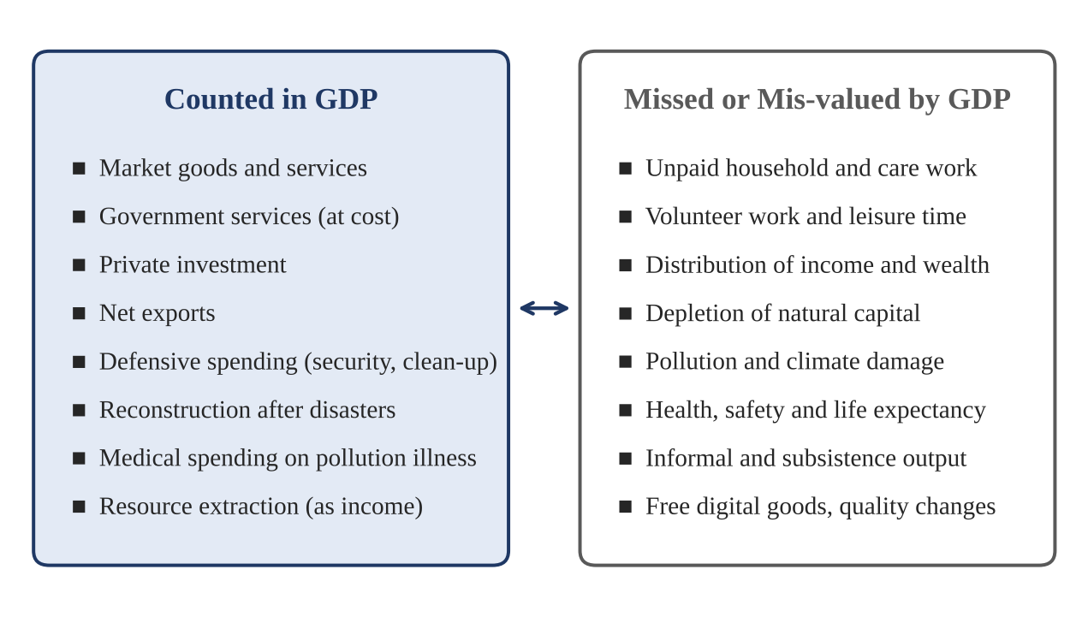
Figure 2: What GDP counts and what it misses
Source: Prepared by the author, based on Stiglitz et al. (2009).

4. The Case for GDP: Why Growth Still Matters
A fair evaluation must begin with what GDP does well. Critics of GDP do not argue that growth is useless; rather, they argue that it is incomplete. The evidence shows that, especially for poorer countries, GDP growth is strongly connected with improvements in people's lives.

4.1 Growth and Living Standards
Figure 3 plots life expectancy against GDP per capita for a range of countries. This relationship, known as the Preston curve (Preston, 1975), is steep at low incomes and flattens at higher incomes. Moving from US$1,000 to US$10,000 per person is associated with about ten extra years of life, but moving from US$50,000 to US$100,000 adds very little. Higher income pays for food, clean water, vaccines and hospitals, so in poor countries growth and health tend to move together.
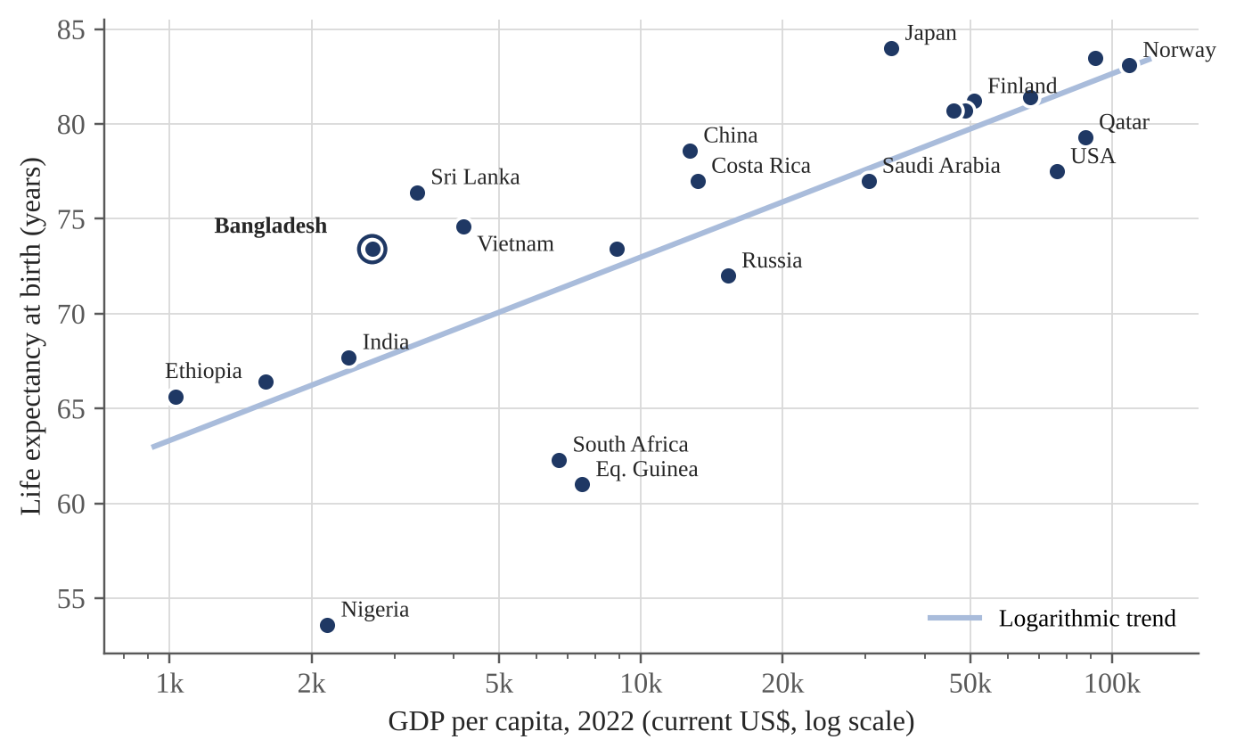
Figure 3: GDP per capita and life expectancy (the Preston curve)
Source: World Bank (2024), World Development Indicators; values for 2022, rounded.
The chart also shows that income is not the whole story. Bangladesh and Sri Lanka have higher life expectancy than their income would predict, while South Africa, Equatorial Guinea and Nigeria fall well below the trend line. The United States, one of the richest countries, has lower life expectancy than Costa Rica or China. Points far from the line show that how income is used matters as much as how much is produced.

4.2 Growth and Poverty Reduction: Evidence from Bangladesh
Bangladesh offers strong evidence that sustained growth can reduce poverty. Figure 4 shows real GDP growth from FY2011 to FY2024. Apart from the COVID-19 shock in FY2020, growth stayed between 6 and 8 per cent for most of the period, before slowing in FY2023 and FY2024.
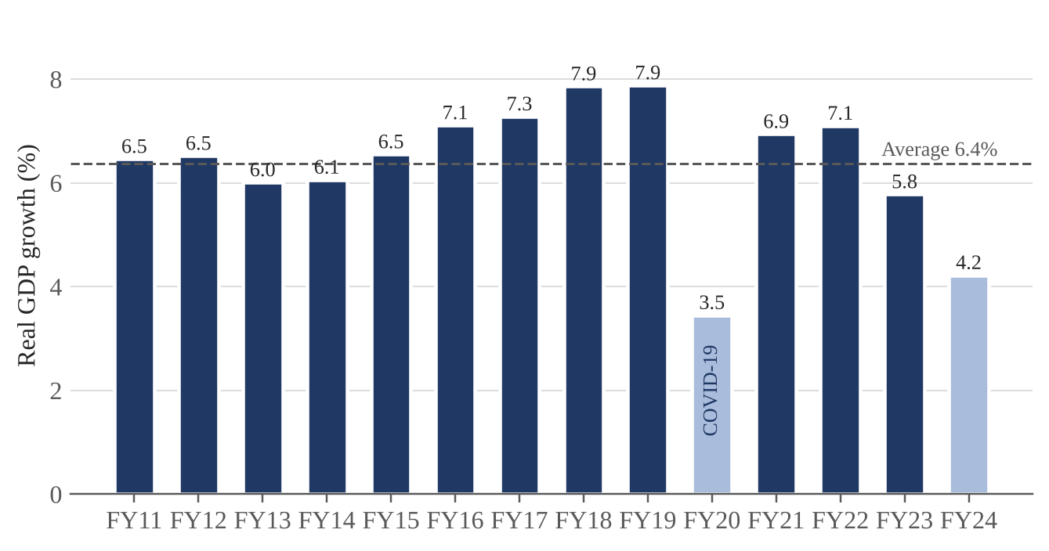
Figure 4: Real GDP growth in Bangladesh, FY2011-FY2024 (%)
Source: Bangladesh Bureau of Statistics; FY2024 is provisional. Light bars mark growth below 5%.
Over roughly the same period, poverty fell sharply. According to the Household Income and Expenditure Survey (HIES), the share of people below the upper poverty line dropped from 48.9 per cent in 2000 to 18.7 per cent in 2022, and extreme poverty fell from 34.3 per cent to 5.6 per cent (Figure 5). Growth in garment exports, remittances and agricultural productivity created jobs and raised incomes for millions of households.
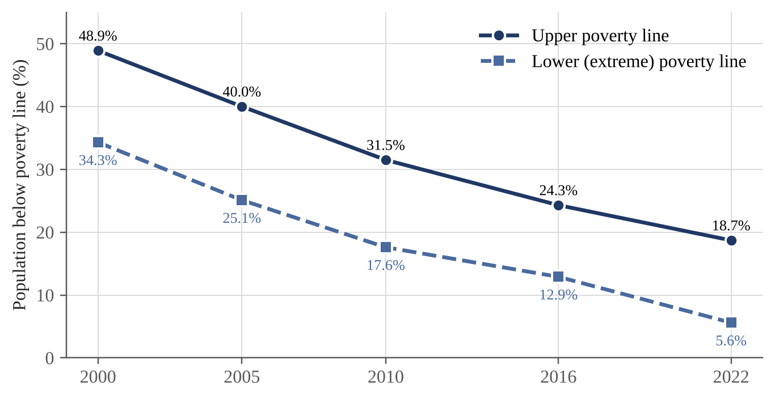
Figure 5: Poverty headcount rates in Bangladesh, 2000-2022
Source: BBS, Household Income and Expenditure Survey (2000-2022).

4.3 Practical Advantages of GDP
Beyond its link with poverty and health, GDP has several practical strengths that explain why it remains the headline indicator:
▪ Standardised: all countries follow the same SNA rules, so figures can be compared.
▪ Timely and frequent: many countries publish quarterly estimates, which helps short-term policy.
▪ Objective: it is based on market prices rather than opinions or arbitrary weights.
▪ Linked to jobs: changes in output are closely connected to employment (Okun's law).
▪ Linked to public finance: tax revenue, debt sustainability and budget planning depend on GDP.
▪ Single number: it is easy to communicate to the public and to track over time.
These advantages make GDP an excellent measure of economic activity. The question is whether they make it a good measure of economic well-being, which is the subject of the next chapter.

5. Limitations of GDP as a Measure of Well-Being

5.1 GDP Ignores the Distribution of Income
GDP and GDP per capita are totals and averages. If all the gains from growth go to a small group, average income rises even though most people are no better off. Figure 6 compares the Gini index, the standard measure of inequality, across countries. Brazil and South Africa have similar or higher GDP per capita than many Asian countries, but far higher inequality, which helps explain their weaker health and social outcomes.
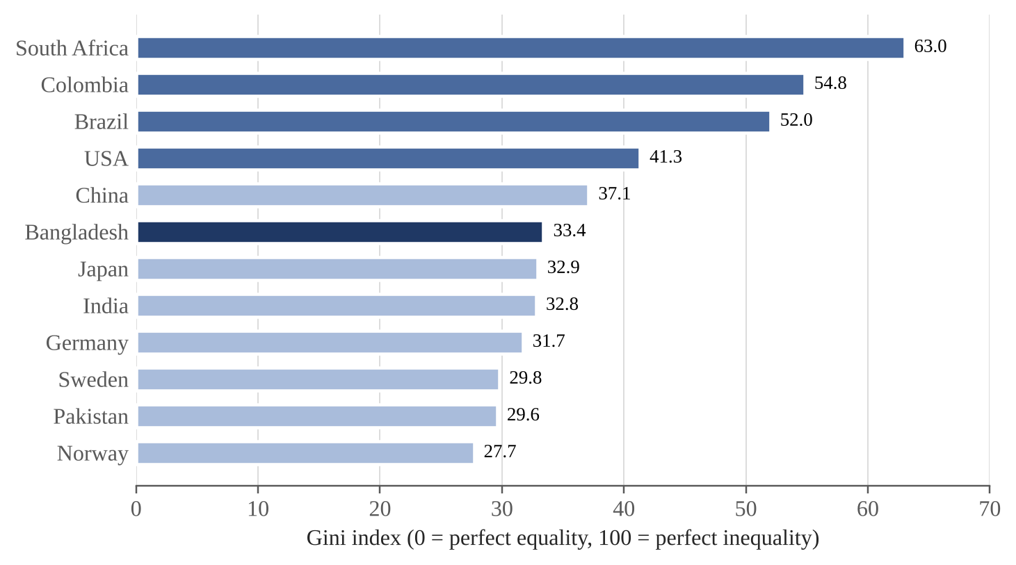
Figure 6: Income inequality across selected countries (Gini index)
Source: World Bank (2024), Poverty and Inequality Platform; latest available year. Mid-tone bars mark Gini of 40 or more.
At the global level, inequality is even more striking. According to the World Inequality Report 2022, the richest 10 per cent of the world's population receive 52 per cent of global income and own 76 per cent of global wealth, while the poorest half receive only 8.5 per cent of income and own just 2 per cent of wealth (Figure 7). A rise in world GDP tells us nothing about which of these groups gains.
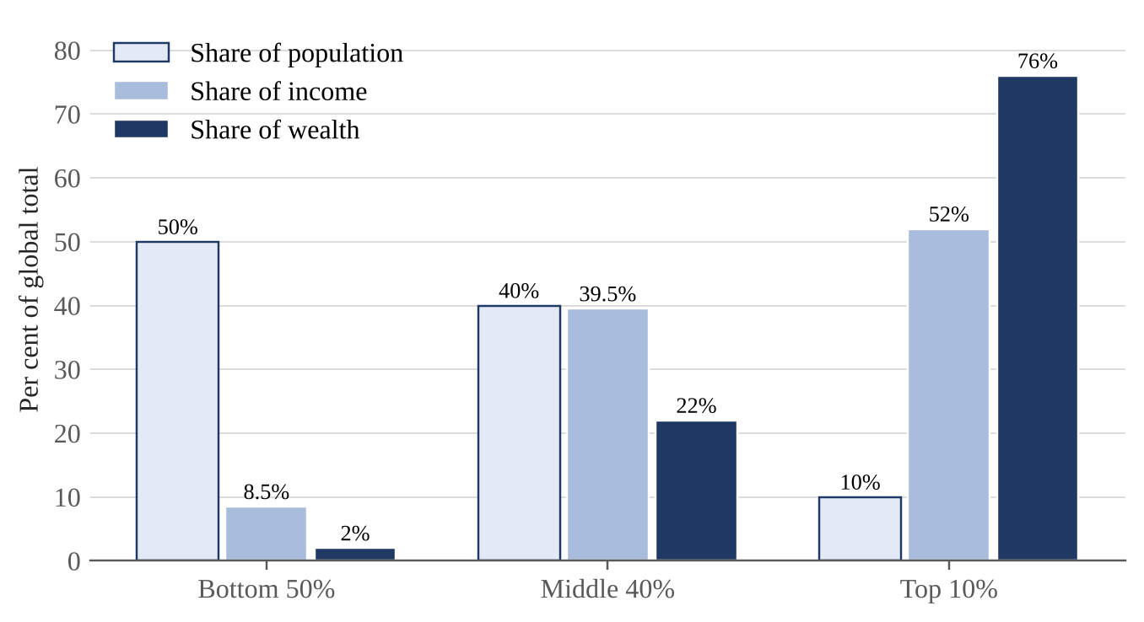
Figure 7: Global distribution of income and wealth, 2021
Source: Chancel, Piketty, Saez and Zucman (2022), World Inequality Report 2022.
Demonstration 2: Two countries with the same GDP
Country A and Country B both have GDP per capita of US$5,000 and both grow at 6 per cent a year. A statistician looking only at GDP would say they are equally well off. Table 5 and Figure 8 show what the averages hide.
Average income of a quintile = (income share ÷ 20%) × mean income
Poorest 20% in Country A: (6% ÷ 20%) × 5,000 = US$1,500
Poorest 20% in Country B: (9% ÷ 20%) × 5,000 = US$2,250
Lesson: the poorest fifth in Country B earns 50 per cent more than in Country A, even though GDP is identical. Because an extra dollar adds more to the welfare of a poor family than a rich one (diminishing marginal utility), Country B has higher economic well-being.

Table 5: Same GDP, different well-being: Country A and Country B
Indicator | Country A | Country B
GDP per capita (US$) | 5,000 | 5,000
Annual GDP growth | 6% | 6%
Income share of poorest 20% | 6% | 9%
Income share of richest 20% | 47% | 36%
Average income of poorest 20% (US$) | 1,500 | 2,250
Ratio richest 20% : poorest 20% | 7.8 times | 4.0 times
Approximate Gini index | 0.38 | 0.25
Source: Author's hypothetical example.
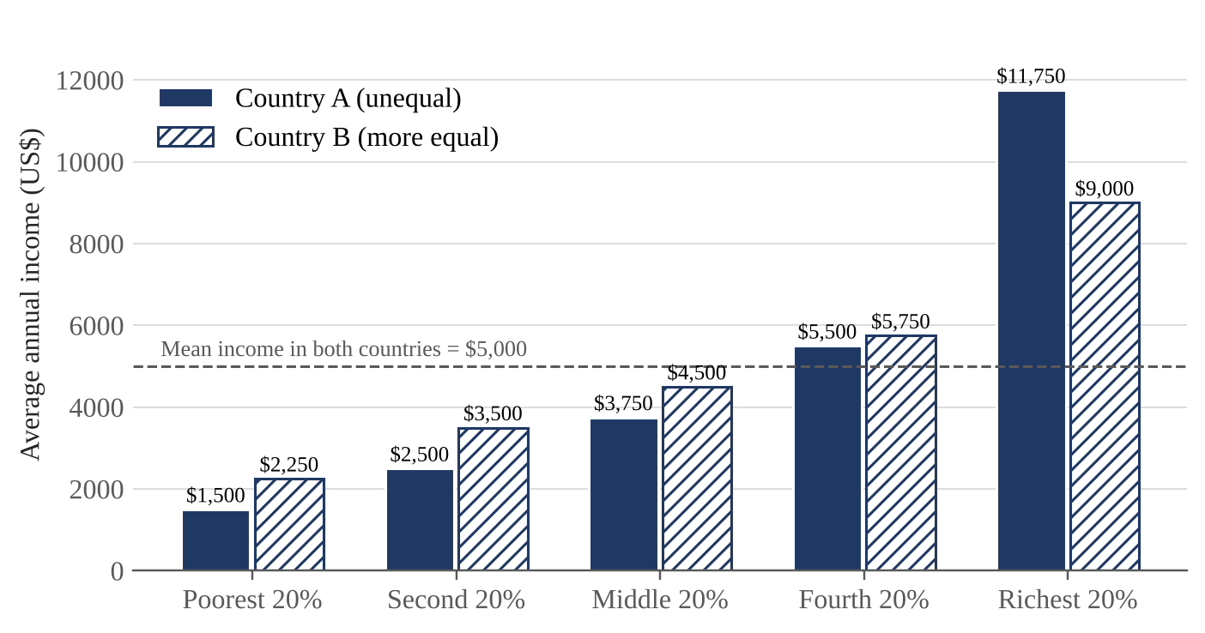
Figure 8: Average income by quintile in Country A and Country B
Source: Author's hypothetical example (Demonstration 2).

5.2 Non-Market and Unpaid Work
GDP counts only work that is bought and sold. When a family hires a cook, the cook's wage is part of GDP; when a mother cooks the same meal at home, nothing is recorded. The International Labour Organization estimates that people spend about 16.4 billion hours every day on unpaid care work, which would be worth around 9 per cent of global GDP if paid at the minimum wage (ILO, 2018). Most of this work is done by women.
In Bangladesh, a study by the Centre for Policy Dialogue estimated that the value of women's unpaid household work was equivalent to roughly three-quarters of GDP or more, depending on the valuation method used (CPD, 2015). Leaving this work out does two things: it undervalues women's contribution, and it can make GDP rise simply because work moves from the home into the market, for example when families buy ready-made food instead of cooking, even if total work and welfare do not change.

5.3 The Informal Economy
In developing countries a large share of production takes place in the informal sector: small farms, street vendors, rickshaw pullers and home-based workers. Statistical offices try to estimate this activity, but it is often under-recorded. According to the Labour Force Survey 2022, about 84.9 per cent of employed people in Bangladesh work informally (BBS, 2023b). Informal workers usually have no contract, pension or sick leave. So even where their output is counted, GDP says nothing about their insecurity, which is a core part of economic well-being.

5.4 Environmental Degradation and Resource Depletion
GDP treats the extraction of natural resources as income, without subtracting the loss of the resource itself. A country that cuts down its forests and sells the timber records higher GDP, even though its natural wealth has fallen. Pollution is also ignored, unless it creates spending on clean-up or medical treatment, which actually adds to GDP.
Figure 9 shows that world real GDP more than doubled between 1990 and 2022, while global CO₂ emissions from fossil fuels rose by about 64 per cent. Growth has become somewhat less carbon-intensive, but emissions are still rising, and the damage from climate change does not appear in GDP. For Bangladesh, the World Bank (2018) estimated that environmental degradation, mainly air and water pollution in urban areas, cost the country about US$6.5 billion a year, equal to roughly 3.4 per cent of GDP in 2015.
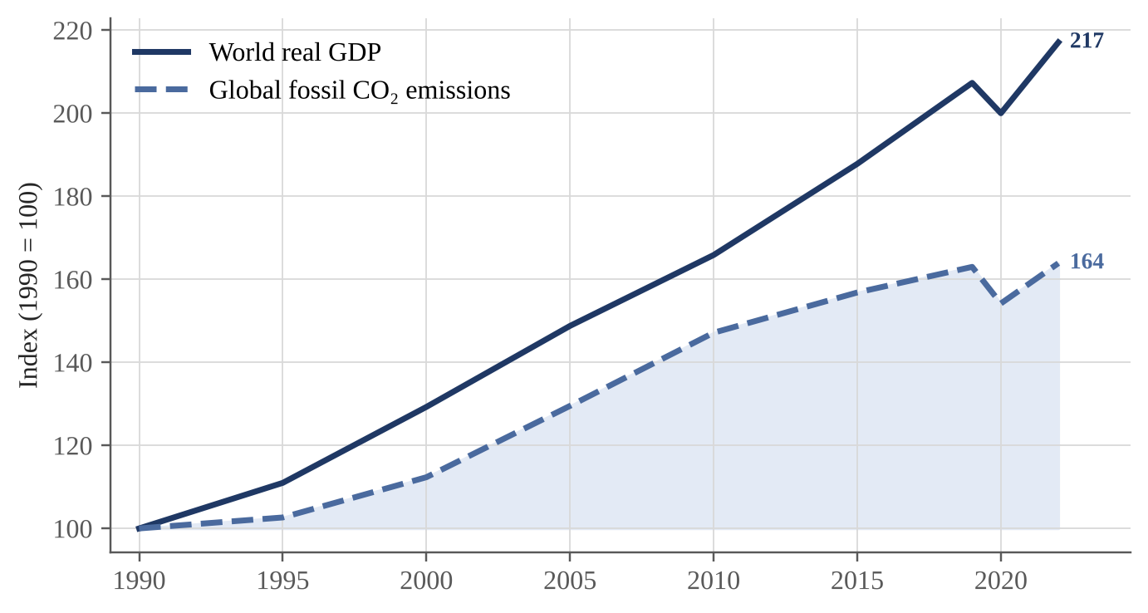
Figure 9: World real GDP and global CO₂ emissions, 1990-2022 (index, 1990 = 100)
Source: World Bank (2024) for real GDP; Global Carbon Project (2023) for emissions. Values rounded.

5.5 Defensive Expenditure and the Broken-Window Problem
Some spending does not make people better off; it only protects them from something bad or repairs damage. Examples include security guards, air purifiers, flood repairs and treatment for illnesses caused by pollution. These defensive or regrettable expenditures raise GDP. The French economist Frédéric Bastiat illustrated a related error with the story of the broken window: replacing the glass creates work for the glazier, but society is not richer, because the money would otherwise have been spent on something new.
Demonstration 3: A flood that raises GDP
Imagine an economy with normal output of US$1,000 billion and national wealth of US$5,000 billion. A severe flood destroys houses, roads and crops worth US$300 billion and disrupts output by US$100 billion. The government and households then spend US$150 billion on reconstruction (Table 6).
Measured GDP = 900 + 150 = US$1,050 billion (+5%)
National wealth = 5,000 − 300 = US$4,700 billion (−6%)
Lesson: GDP rises by 5 per cent in the year of a disaster, while the stock of wealth falls and households suffer losses, injury and displacement (Figure 10). For a flood-prone country such as Bangladesh, this is a practical warning against reading a post-disaster growth figure as good news.

Table 6: GDP and well-being after a flood (hypothetical)
Item (US$ billion) | Scenario 1: no flood | Scenario 2: flood
Normal output | 1,000 | 900
Reconstruction spending | 0 | 150
Measured GDP | 1,000 | 1,050
Houses, roads and crops destroyed | 0 | 300
National wealth at year end | 5,000 | 4,700
Household well-being index (100 = normal) | 100 | 88
Source: Author's hypothetical example.
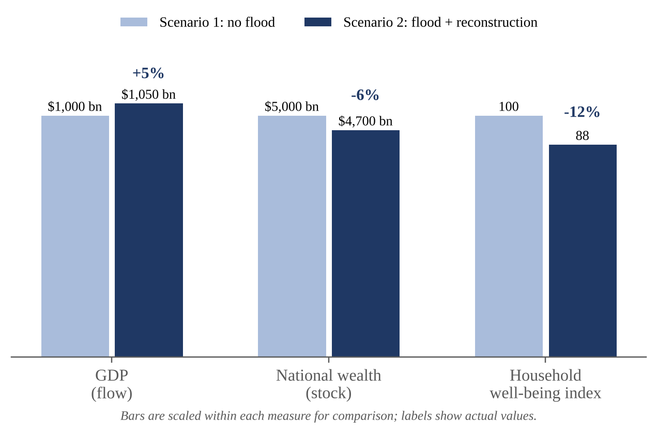
Figure 10: GDP, wealth and well-being after a flood (hypothetical)
Source: Author's hypothetical example (Demonstration 3).

5.6 Spending More Does Not Always Mean Living Better
Health care shows clearly that more spending, and therefore more GDP, does not automatically produce better outcomes. The United States spends about 17 per cent of its GDP on health, far more than any other country, yet its life expectancy is lower than in Japan, France or Canada, which spend much less (Figure 11). Sri Lanka and Costa Rica achieve life expectancy close to that of rich countries at a fraction of the cost. GDP records the spending, but it cannot tell whether that spending is efficient or whether it reflects worse underlying health.
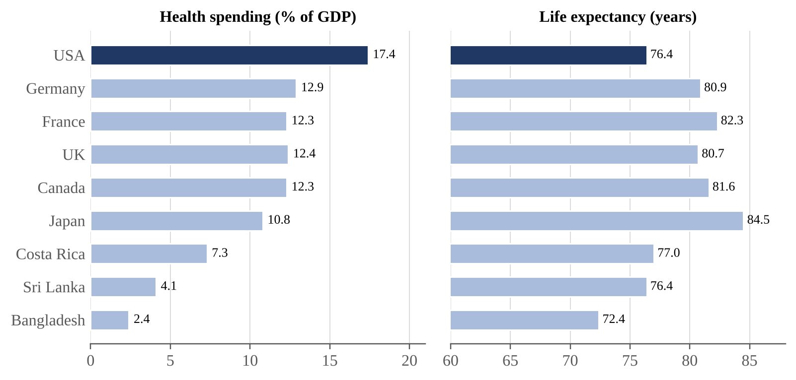
Figure 11: Health spending and life expectancy in selected countries, 2021
Source: World Bank (2024) and WHO Global Health Expenditure Database; values rounded.

5.7 Happiness and the Easterlin Paradox
If GDP measured well-being, we would expect people in countries with rising GDP to report rising satisfaction with life. Richard Easterlin (1974) found that this did not happen. In the United States, real GDP per capita roughly doubled between 1972 and 2018, but the share of people describing themselves as “very happy” in the General Social Survey stayed at around 30 per cent (Figure 12). This is known as the Easterlin paradox.
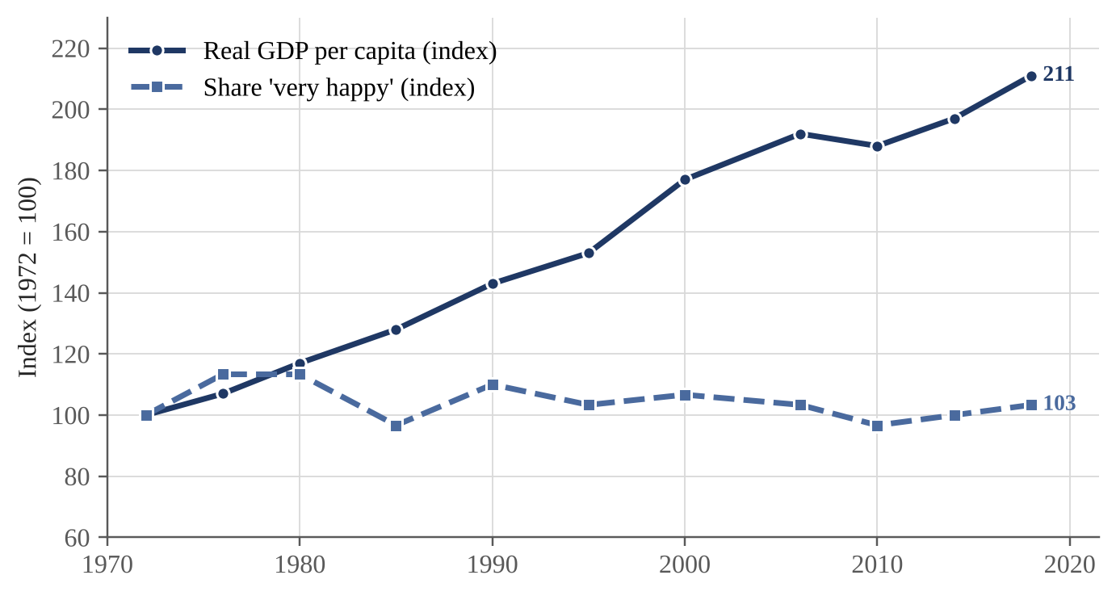
Figure 12: United States: GDP per capita and reported happiness, 1972-2018
Source: US Bureau of Economic Analysis and NORC General Social Survey; illustrative, values rounded.
Across countries the picture is more nuanced. Figure 13 shows that richer countries do, on average, report higher life evaluations, so income clearly matters (Stevenson and Wolfers, 2008). But there are large differences at similar income levels. Costa Rica reports much higher life satisfaction than Russia or China at a similar GDP per capita, and Vietnam reports more than countries twice as rich. Social support, trust, freedom and good governance explain much of this gap (Helliwell et al., 2024).
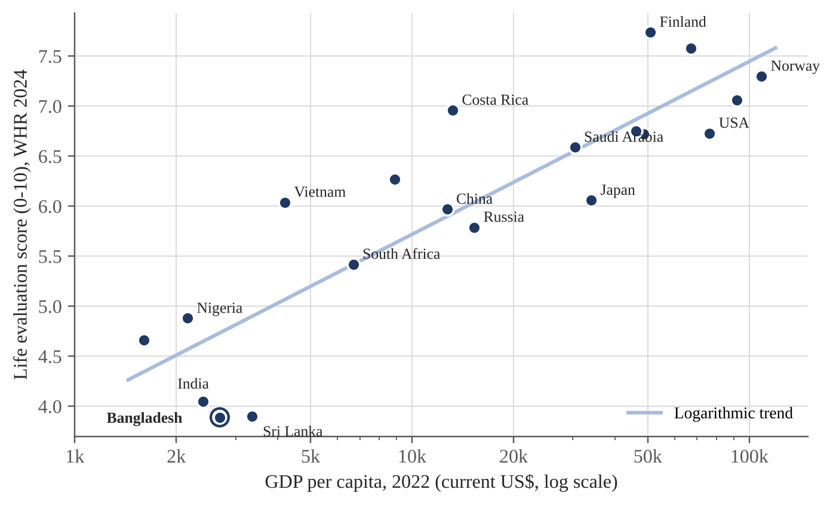
Figure 13: GDP per capita and life evaluation across countries
Source: Helliwell et al. (2024), World Happiness Report; World Bank (2024) for GDP per capita.

5.8 Quality Change, Free Digital Goods and Leisure
GDP also struggles with changes in quality. A smartphone today is far more powerful than a computer of twenty years ago, yet may cost less. Many digital services, such as search engines, maps and online learning, are free to users and hardly appear in GDP even though they add real value. In the other direction, GDP gives no value to leisure. If people work longer hours, GDP rises, even if the extra work leaves them exhausted and with less time for family. A country where people work 60 hours a week could have the same GDP as one where they work 40 hours with higher productivity, but the second clearly enjoys higher well-being.
Table 7 summarises the limitations discussed in this chapter.
Table 7: Summary of the main limitations of GDP
Limitation | Example | Effect on GDP as a well-being measure
Ignores distribution | Growth captured by the top 10% | Average rises while most people gain little
Excludes unpaid work | Cooking, childcare, caring for elders | Undervalues women's contribution
Misses informal output | Street vendors, small farms | Understates real activity in poor countries
Ignores environmental loss | Air pollution, river damage, deforestation | Counts depletion as income
Counts defensive spending | Flood repair, security guards, pollution illness | GDP rises when life gets worse
Ignores leisure | Longer working hours | More output, less free time
Weak link to happiness | Easterlin paradox | Rising income, flat life satisfaction
Quality and free goods | Free apps, better medicines | Under-records real gains
Source: Compiled by the author from the discussion in Chapter 5.

6. Alternative and Complementary Measures
The limitations of GDP have encouraged the development of several alternative measures. Some replace GDP with a different single number, while others use a group of indicators (a dashboard). This chapter reviews the most important ones.

6.1 The Human Development Index (HDI)
The HDI was introduced by the United Nations Development Programme in 1990, based on the ideas of Mahbub ul Haq and Amartya Sen. It combines three dimensions: a long and healthy life (life expectancy), knowledge (expected and mean years of schooling) and a decent standard of living (GNI per capita in PPP terms, on a log scale). Each component is turned into an index between 0 and 1 using fixed minimum and maximum values (goalposts), and the HDI is their geometric mean:
Dimension index = (Actual value − Minimum) / (Maximum − Minimum)
HDI = (Health index × Education index × Income index)^(1/3)
Demonstration 4: Calculating Bangladesh's HDI
Using UNDP data for 2022, the steps are:
Health index = (73.7 − 20) / (85 − 20) = 0.826
Education index = [(11.9 / 18) + (7.4 / 15)] / 2 = (0.661 + 0.493) / 2 = 0.577
Income index = [ln(6,511) − ln(100)] / [ln(75,000) − ln(100)] = 4.176 / 6.620 = 0.631
HDI = (0.826 × 0.577 × 0.631)^(1/3) = 0.670
Lesson: Bangladesh's health index (0.826) is much stronger than its income index (0.631). Judged by GDP alone, the country's progress in health would be understated, while its weaker education outcomes would be invisible. Table 8 shows the full calculation.

Table 8: Calculation of Bangladesh's HDI, 2022
Component | Actual value | Min / Max (goalposts) | Index
Life expectancy at birth (years) | 73.7 | 20 / 85 | 0.826
Expected years of schooling | 11.9 | 0 / 18 | 0.661
Mean years of schooling | 7.4 | 0 / 15 | 0.493
Education index (average of the two) | - | - | 0.577
GNI per capita (2017 PPP $) | 6,511 | 100 / 75,000 | 0.631
HDI = (0.826 × 0.577 × 0.631)^(1/3) | - | - | 0.670
Source: Author's calculation using UNDP (2024) data and method.
Figure 14 shows that the HDI is strongly related to GDP per capita, as expected, since income is one of its components. Still, some countries perform much better on the HDI than their income would suggest (Sri Lanka, Vietnam), while others perform worse (Equatorial Guinea, Qatar, Nigeria). The ranking of a country can change considerably depending on whether GDP or HDI is used.
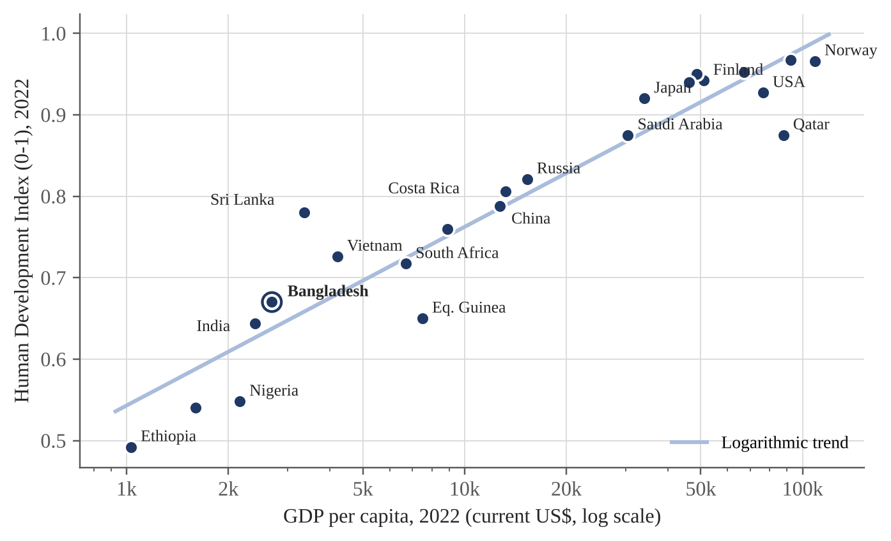
Figure 14: GDP per capita and Human Development Index, 2022
Source: UNDP (2024), Human Development Report 2023/24; World Bank (2024).

6.2 The Genuine Progress Indicator (GPI)
The GPI starts with personal consumption, adjusts it for income inequality, adds the value of household and volunteer work, and subtracts costs such as crime, pollution, commuting, loss of leisure, depletion of resources and long-term environmental damage. Studies for the United States and for the world as a whole find that GPI per capita rose with GDP until the late 1970s and then stopped growing, even as GDP continued to rise (Kubiszewski et al., 2013). Figure 15 shows this pattern in stylised form. The widening gap suggests that, after a certain point, the costs of growth began to cancel out its benefits.
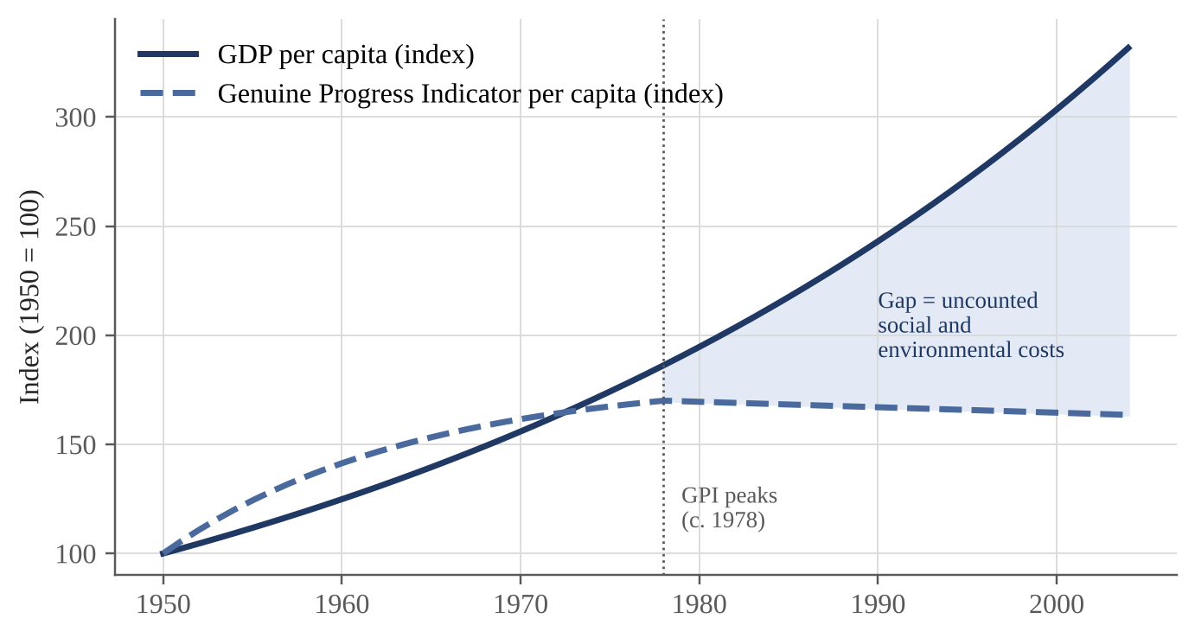
Figure 15: GDP per capita compared with the Genuine Progress Indicator (stylised)
Source: Stylised representation of the findings of Kubiszewski et al. (2013) and Talberth, Cobb and Slattery (2007).

6.3 Other Measures
▪ Inequality-adjusted HDI (IHDI): reduces the HDI according to how unequally health, education and income are shared. The difference between HDI and IHDI shows the loss due to inequality.
▪ Multidimensional Poverty Index (MPI): counts people who are deprived in several areas at once, such as nutrition, schooling, cooking fuel and sanitation.
▪ OECD Better Life Index: lets users compare countries across 11 dimensions, including housing, jobs, community, environment, civic engagement and work-life balance.
▪ Gross National Happiness (Bhutan): a national index of 9 domains and 33 indicators that guides public policy in Bhutan.
▪ Green GDP and SEEA: the UN System of Environmental-Economic Accounting adjusts national accounts for the use and depletion of natural resources.
▪ Inclusive Wealth Index: measures the stock of produced, human and natural capital, which indicates whether development is sustainable.
Table 9 compares these measures with GDP. Each alternative has its own weaknesses, mainly data requirements and value judgements in choosing weights. This is why most experts now recommend using them alongside GDP rather than as a complete replacement.
Table 9: Comparison of GDP with alternative well-being measures
Measure | Developed by | What it captures | Main weakness
GDP | Kuznets; UN SNA | Market production | Ignores distribution, environment, unpaid work
HDI | UNDP (1990) | Income, health, education | Only three dimensions; no environment
IHDI | UNDP (2010) | HDI adjusted for inequality | Data gaps in many countries
GPI | Cobb, Daly and others (1989/95) | Consumption adjusted for social and environmental costs | Valuation choices are subjective
Better Life Index | OECD (2011) | 11 dimensions of well-being | Mainly OECD countries
Gross National Happiness | Bhutan (2008 index) | 9 domains, 33 indicators | Hard to compare across countries
Life evaluation (WHR) | Gallup / WHR (2012) | Self-reported life satisfaction | Cultural and survey bias
Inclusive Wealth / SEEA | UNEP; UN Statistics | Produced, human and natural capital | Complex to compile
Source: Compiled by the author from UNDP (2024), OECD (2011), Kubiszewski et al. (2013) and UN (2021).

7. Case Study: Bangladesh

7.1 Growth Performance
Bangladesh is often described as a development success story. Its average real GDP growth of about 6.4 per cent between FY2011 and FY2024 (Figure 4) was among the fastest in the world, and GDP per capita rose above that of several neighbouring countries. The country is scheduled to graduate from the United Nations' Least Developed Country list in 2026. On a GDP basis, the story is very positive.

7.2 Human Development Progress
Human development has also improved. Bangladesh's HDI rose from about 0.394 in 1990 to 0.670 in 2022 (Figure 16), taking it into the medium human development group. Gains in life expectancy, child survival, girls' schooling and access to sanitation were achieved partly through growth, but also through low-cost public health programmes, NGO activity and community health workers. This shows that policy choices, and not only the growth rate, shape well-being.
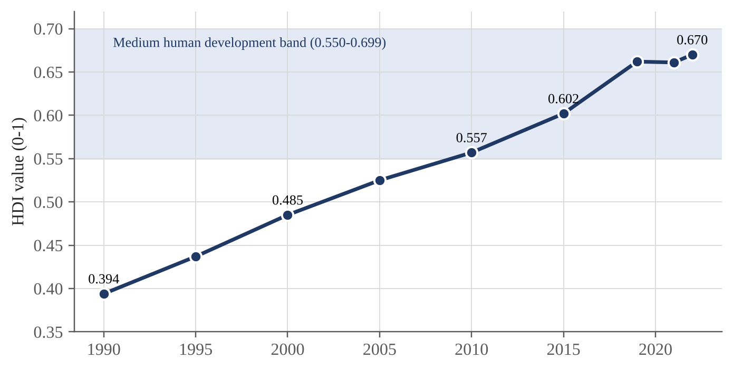
Figure 16: Human Development Index of Bangladesh, 1990-2022
Source: UNDP (2024), Human Development Report 2023/24.

7.3 What GDP Growth Does Not Show
Table 10 places Bangladesh's growth record next to broader indicators. Several important issues are hidden by the headline growth figure:
▪ Rising inequality: the income Gini coefficient rose to 0.499 in 2022, one of the highest levels recorded by HIES. The richest 10 per cent received about 41 per cent of total income (BBS, 2023a).
▪ Informal and insecure work: about 85 per cent of workers are informal, with little social protection.
▪ Environmental pressure: air pollution in Dhaka, river pollution from industry, and climate risks such as floods, cyclones and salinity impose large costs that GDP does not subtract.
▪ Unpaid work: women carry most unpaid household and care work, which is not counted.
▪ Low reported life satisfaction: Bangladesh scores 3.89 out of 10 on the World Happiness Report life evaluation, well below countries with similar income such as Vietnam.
▪ Data reliability: in 2024 a government-appointed white paper committee raised concerns that official growth figures in earlier years may have been overstated, which further weakens reliance on a single number.
Table 10: Bangladesh: growth versus broader well-being indicators
Indicator | Value | Year | What it tells us
Average real GDP growth | 6.4% | FY11-FY24 | Strong and stable growth
GDP per capita (current US$) | about 2,690 | 2022 | Lower-middle-income status
Upper poverty rate | 18.7% | 2022 | Poverty fell sharply
Income Gini coefficient | 0.499 | 2022 | Income inequality is high and rising
Informal employment | 84.9% | 2022 | Most jobs lack protection
Female labour force participation | about 43% | 2022 | Large unpaid work burden
Life expectancy at birth | about 72-74 years | 2022 | Better than income level predicts
HDI value | 0.670 | 2022 | Medium human development
Life evaluation (WHR) | 3.89 / 10 | 2021-23 | Low reported life satisfaction
Source: BBS (2023a, 2023b), UNDP (2024), World Bank (2024), Helliwell et al. (2024).
The Bangladesh case therefore supports both sides of the debate. Growth has clearly helped to reduce poverty and improve health, but the GDP figure alone would give a misleadingly positive picture of how evenly the benefits were shared and how sustainable they are.

8. Comparative Analysis: A Dashboard Approach
Table 11 compares eleven countries across GDP per capita and three well-being indicators. Ranking by GDP and ranking by well-being give different results. The United States has more than twice Japan's GDP per capita but lower life expectancy. Finland, with less than half of Norway's GDP per capita, reports the highest life evaluation in the world. Costa Rica, Vietnam and Sri Lanka achieve much more health than their income suggests, while South Africa and Nigeria achieve much less.
Table 11: Selected countries: GDP per capita compared with well-being indicators
Country | GDP per capita (US$) | Life expectancy | HDI | Life evaluation (0-10)
Norway | 108,700 | 83.1 | 0.966 | 7.30
United States | 76,300 | 77.5 | 0.927 | 6.73
Finland | 50,900 | 81.2 | 0.942 | 7.74
Japan | 34,000 | 84.0 | 0.920 | 6.06
Costa Rica | 13,200 | 77.0 | 0.806 | 6.96
China | 12,700 | 78.6 | 0.788 | 5.97
South Africa | 6,700 | 62.3 | 0.717 | 5.42
Vietnam | 4,200 | 74.6 | 0.726 | 6.04
Sri Lanka | 3,350 | 76.4 | 0.780 | 3.90
Bangladesh | 2,690 | 73.4 | 0.670 | 3.89
Nigeria | 2,160 | 53.6 | 0.548 | 4.88
Source: World Bank (2024), UNDP (2024), Helliwell et al. (2024); values rounded, 2022 or latest year.
One practical way to look beyond GDP is to use a dashboard, which shows several indicators side by side instead of combining them into one number. The next demonstration shows how a dashboard can change a judgement based on GDP alone.
Demonstration 5: Reading a well-being dashboard
Country X has followed a high-growth strategy and scores 80 out of 100 on GDP per capita. Country Y has grown more slowly (score 60) but invested in health, education and environmental protection. Table 12 and Figure 17 show both countries on seven dimensions.
Average score: Country X = 375 / 7 = 53.6; Country Y = 502 / 7 = 71.7
Lesson: judged by GDP, Country X is ahead. Judged by the full dashboard, Country Y offers its people a better life on six of seven dimensions. A dashboard makes such trade-offs visible to policymakers and voters.

Table 12: Dashboard scores for two hypothetical countries (0-100)
Dimension | Country X | Country Y
GDP per capita | 80 | 60
Income equality | 40 | 75
Health | 60 | 80
Education | 65 | 75
Environment | 35 | 70
Life satisfaction | 50 | 72
Leisure and work balance | 45 | 70
Average of all seven dimensions | 53.6 | 71.7
Source: Author's hypothetical example.
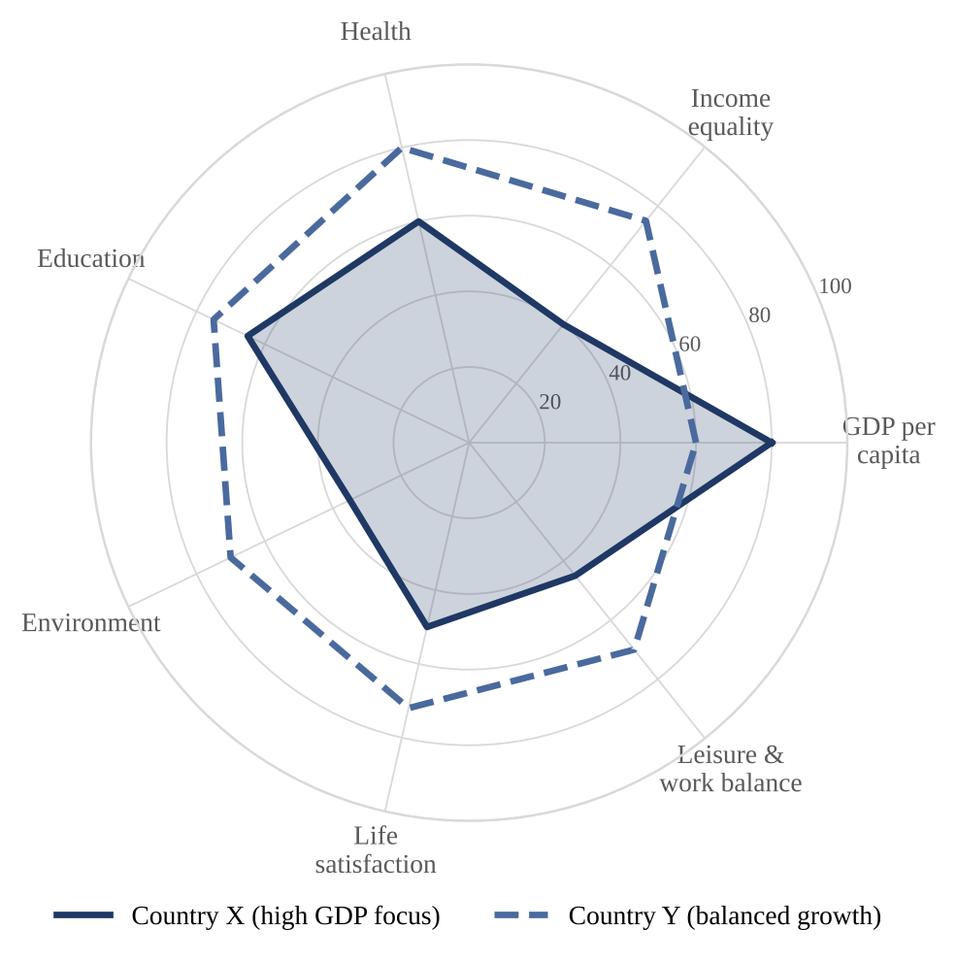
Figure 17: Well-being dashboard for two hypothetical countries
Source: Author's hypothetical example (Demonstration 5).

9. Findings and Discussion

9.1 Key Findings
1. GDP growth matters most where incomes are low. The Preston curve and Bangladesh's poverty record show that growth is strongly linked to better health and lower poverty in poor countries.
2. The link weakens as countries get richer. Above a certain income level, extra GDP adds little to life expectancy or happiness (Figures 3, 12 and 13).
3. GDP hides distribution. Two countries with the same GDP can have very different living standards for the poor (Demonstration 2). Inequality in Bangladesh has risen even during rapid growth.
4. GDP counts some harms as gains. Disasters, pollution-related illness and defensive spending can raise GDP while lowering well-being (Demonstration 3).
5. GDP ignores sustainability. It counts the depletion of natural resources as income and does not subtract environmental damage (Figure 9).
6. GDP excludes unpaid and under-records informal work, which is especially large in Bangladesh and falls mainly on women.
7. Alternative measures change the picture. The HDI, GPI and life-evaluation data rank countries differently from GDP, and the GPI suggests that well-being stopped rising decades before GDP did.

9.2 Discussion
The findings show that the answer to the research question depends on what we expect from GDP. As a measure of market production, GDP does exactly what it was designed to do, and it does so in a consistent and comparable way. Problems arise when GDP growth is used as a measure of well-being and becomes the main goal of policy. In that role, it gives an incomplete and sometimes misleading signal.
It is also important not to swing to the opposite extreme. For a country like Bangladesh, where millions of people still live close to the poverty line, faster growth remains essential. The more useful question is not “growth or well-being?” but “what kind of growth?” Growth that creates decent jobs, is shared widely, invests in people and protects the environment will raise well-being. Growth that is concentrated, polluting or based on running down natural capital may raise GDP without improving lives, or may borrow well-being from the future.

10. Conclusion and Recommendations

10.1 Conclusion
This assignment asked whether GDP growth is an adequate measure of economic well-being. The evidence reviewed shows that GDP growth is a necessary but not a sufficient indicator. It captures the expansion of market production, which in poorer countries is closely tied to falling poverty and better health. But it does not show who benefits from growth, it leaves out unpaid and much informal work, it ignores environmental damage and the loss of leisure, it can rise because of disasters and defensive spending, and it is only weakly related to how satisfied people are with their lives in richer countries.
Therefore, GDP growth is not an adequate measure of economic well-being on its own. It should be kept as one important indicator in a wider set that includes measures of distribution, human development, sustainability and subjective well-being. As Kuznets warned almost a century ago, the welfare of a nation cannot be read from national income alone.

10.2 Recommendations
Based on the findings, the following recommendations are made, with special reference to Bangladesh:
1. Adopt a well-being dashboard. The government should report GDP growth together with median household income, the Gini coefficient, poverty, HDI, informal employment and environmental indicators in the annual budget and the Bangladesh Economic Review.
2. Focus on median, not only average, income. Median household income and the income of the bottom 40 per cent better reflect what typical families experience.
3. Develop environmental accounts. BBS should expand work under the UN SEEA framework to estimate the depletion of natural resources and the cost of pollution.
4. Value unpaid work. Regular time-use surveys and satellite accounts for household work would make women's contribution visible in policy.
5. Strengthen data quality and independence. Transparent methods and independent review of national accounts would increase trust in official statistics.
6. Link the dashboard to the SDGs. Bangladesh already reports on the Sustainable Development Goals; these indicators can form the basis of a national well-being framework.
7. Teach beyond GDP. Universities and the media should present GDP as a measure of economic activity, not as a scorecard of national success.

References
Bangladesh Bureau of Statistics. (2023a). Household Income and Expenditure Survey (HIES) 2022: Final report. BBS.
Bangladesh Bureau of Statistics. (2023b). Labour Force Survey 2022. BBS.
Centre for Policy Dialogue. (2015). Estimating women's contribution to the economy: The case of Bangladesh. CPD.
Chancel, L., Piketty, T., Saez, E., & Zucman, G. (2022). World inequality report 2022. World Inequality Lab.
Easterlin, R. A. (1974). Does economic growth improve the human lot? Some empirical evidence. In P. A. David & M. W. Reder (Eds.), Nations and households in economic growth (pp. 89-125). Academic Press.
Global Carbon Project. (2023). Global carbon budget 2023. https://globalcarbonbudget.org
Helliwell, J. F., Layard, R., Sachs, J. D., De Neve, J.-E., Aknin, L. B., & Wang, S. (Eds.). (2024). World happiness report 2024. Wellbeing Research Centre, University of Oxford.
International Labour Organization. (2018). Care work and care jobs for the future of decent work. ILO.
Kennedy, R. F. (1968, March 18). Remarks at the University of Kansas [Speech]. Lawrence, Kansas.
Kubiszewski, I., Costanza, R., Franco, C., Lawn, P., Talberth, J., Jackson, T., & Aylmer, C. (2013). Beyond GDP: Measuring and achieving global genuine progress. Ecological Economics, 93, 57-68.
Kuznets, S. (1934). National income, 1929-1932 (Senate Document No. 124). US Government Printing Office.
Mankiw, N. G. (2021). Principles of economics (9th ed.). Cengage Learning.
OECD. (2011). How's life? Measuring well-being. OECD Publishing.
Osberg, L., & Sharpe, A. (2002). An index of economic well-being for selected OECD countries. Review of Income and Wealth, 48(3), 291-316.
Preston, S. H. (1975). The changing relation between mortality and level of economic development. Population Studies, 29(2), 231-248.
Sen, A. (1999). Development as freedom. Oxford University Press.
Stevenson, B., & Wolfers, J. (2008). Economic growth and subjective well-being: Reassessing the Easterlin paradox. Brookings Papers on Economic Activity, 2008(1), 1-87.
Stiglitz, J. E., Sen, A., & Fitoussi, J.-P. (2009). Report by the Commission on the Measurement of Economic Performance and Social Progress. Paris.
Talberth, J., Cobb, C., & Slattery, N. (2007). The Genuine Progress Indicator 2006: A tool for sustainable development. Redefining Progress.
United Nations. (2021). System of Environmental-Economic Accounting: Ecosystem accounting (SEEA EA). United Nations.
United Nations Development Programme. (2024). Human development report 2023/2024: Breaking the gridlock. UNDP.
World Bank. (2018). Enhancing opportunities for clean and resilient growth in urban Bangladesh: Country environmental analysis 2018. World Bank.
World Bank. (2024). World development indicators. https://databank.worldbank.org

Appendix A: Glossary of Key Terms
Table 13: Glossary of key terms used in the assignment
Term | Meaning
Defensive expenditure | Spending that protects against or repairs harm (e.g. flood repair) rather than adding new welfare.
Easterlin paradox | The finding that average happiness in a country may not rise as its income per person grows over time.
Economic well-being | People's command over resources needed for a good life now and in the future, including income, security, equality and wealth.
GDP per capita | GDP divided by population; a rough indicator of average income.
Gini coefficient | A measure of inequality from 0 (everyone has the same income) to 1 or 100 (one person has everything).
Informal sector | Economic activity that is not registered or regulated and usually offers no social protection.
Natural capital | The stock of natural resources (forests, water, soil, minerals, clean air) that supports the economy.
Nominal GDP | GDP measured at current prices.
Preston curve | The relationship between income per person and life expectancy, steep at low incomes and flat at high incomes.
Purchasing power parity | An exchange rate that adjusts for differences in price levels between countries.
Real GDP | GDP measured at constant prices, showing changes in quantity rather than prices.
Satellite account | An extension of the national accounts that covers an area such as unpaid work or the environment.

