PROJECT REPORT | DATA ANALYSIS USING PYTHON
Relationship Between Screen Time, Physical Activity, and Health Problems in Children
Exploratory data analysis of 6,054 school-age children (6–17 years)
Submitted by
Shamshad Mansoor
Date: 21.10.2026

1. Abstract
This project studies how daily screen time and physical activity relate to five common health problems in school-age children: eye problems, sleeping issues, obesity, vitamin D deficiency and chronic constipation. The Kaggle dataset child_health_lifestyle initially held 6,064 records and 14 columns. After removing duplicates and invalid ages, standardising labels and imputing missing values, 6,054 records remained. Analysis was done in Python using Pandas, NumPy, Matplotlib and Seaborn.
Eye problems were the most common issue (22.68%), followed by vitamin D deficiency (22.27%). Eye problems rose from 5.22% at 0 hours of daily screen time to 36.56% at 5 hours, and sleeping issues rose from 4.02% to 28.47%. In contrast, obesity fell from 23.6% at 0 hours of daily activity to 8.2% at 3 hours.

2. Introduction
Children now spend a large part of the day on phones, tablets, computers and televisions, while many get little physical exercise. Public health guidance links long screen exposure to poor sleep and eyestrain, and low activity to weight gain and other problems. Schools and parents need clear evidence to set sensible limits. This project uses a school-based dataset from eight schools in sixteen US cities to examine these links.

3. Problem Statement
It is not clear how much daily screen time and physical activity are related to common health problems among children aged 6–17, or which children face the highest risk. The project aims to answer this using the data, so that practical, evidence-based limits and school programmes can be suggested.

4. Project Objectives
- Clean and prepare the dataset: remove duplicates, standardise categories, handle missing values and outliers.
- Measure how common each health problem is.
- Examine whether higher screen time is linked to eye problems and sleeping issues.
- Examine whether lower physical activity is linked to obesity and vitamin D deficiency.
- Count the number of health issues per child and identify which factors matter most.
- Summarise findings with charts and practical recommendations, such as healthy screen-time limits.

5. Dataset Description
Source: Kaggle – child_health_lifestyle (file used: MAIN_PROJECT-health_dataset_v7.xlsx).
Size: 6,064 rows and 14 columns in the raw file; 6,054 rows after cleaning. Four columns are numeric and ten are text.
Column | Type | Description
ID | Number | Unique student identifier
Name | Text | Student name (500 unique names)
Gender | Text | Male / Female
Age | Number | Age in years (6–17 after cleaning)
School | Text | One of 8 schools
City | Text | One of 15 US cities (plus 3 Unknown)
Country | Text | USA
Physical_Activity_hours_per_day | Number | Daily physical activity (0–3 hours)
Screen_Time_hours_per_day | Number | Daily screen time (0–5 hours)
Eye_Problems | Yes/No | Child has eye problems
Sleeping_Issues | Yes/No | Child has sleeping issues
Obesity | Yes/No | Child is obese
Vitamin_D_Deficiency | Yes/No | Child has vitamin D deficiency
Chronic_Constipation | Yes/No | Child has chronic constipation

6. Tools and Technologies Used
- Python – main programming language, run in a Jupyter-style notebook (.ipynb).
- Pandas – loading the Excel file, cleaning, grouping and summarising data.
- NumPy – numeric operations and handling of missing values (NaN).
- Matplotlib and Seaborn – histograms, pie chart, bar charts, box plot, scatter plot and count plots.
- Plotly – imported in the notebook (plotly.express and graph_objects) but not used for the final charts.

7. Data Loading and Initial Inspection
The data was read from an Excel file with pd.read_excel(). It was inspected using head(), tail(), info(), shape, dtypes, describe(), isnull().sum() and duplicated().sum().
- Shape: (6064, 14).
- Missing values: City 3, Country 8, Physical activity 5, Screen time 3.
- Duplicate rows: 5.
- Raw describe() showed impossible values: Age up to 199, physical activity from −3 to 48 hours.
- Text columns held mixed spellings, for example male / MALE / M, and yes / Y / YES.

8. Data Cleaning and Preprocessing
Issue | Action taken | Result
Duplicate records | drop_duplicates() | 5 rows removed; ID confirmed unique
Invalid ages (105, 112, 120, 150, 199) | Dropped rows with Age > 17 or < 6 | 5 rows removed; ages now 6–17
Invalid physical activity (< 0 or > 20 h) | Set to NaN | 8 values flagged (13 missing in total)
Missing activity and screen time | Filled with median | Activity 1 h; screen time 3 h
Missing City / Country | City → "Unknown"; Country → "USA" | 3 and 8 values filled
Data types | Checked with info() and dtypes | ID and Age int64; hours float64; others object; no conversion needed
Gender labels | Mapped M, m, f, FEMALE etc. to Male / Female | 2 clean categories
City and Country text | Title case; USA variants unified | 16 city values; 1 country value
Yes/No health columns | Mapped yes, Y, n, NO etc. to Yes / No | All five columns have 2 values

Key code snippets
df = df.drop_duplicates()
df = df.drop(df[(df['Age'] > 17) | (df['Age'] < 6)].index)
df.loc[(act < 0) | (act > 20), 'Physical_Activity_hours_per_day'] = np.nan
df[col] = df[col].fillna(df[col].median())

9. Exploratory Data Analysis (EDA)

Summary statistics (cleaned data)
Variable | Mean | Median | Min | Max | Std
Age | 11.54 | 11 | 6 | 17 | 3.43
Physical activity (h/day) | 1.29 | 1 | 0 | 3 | 0.81
Screen time (h/day) | 2.77 | 3 | 0 | 5 | 1.28

Group-by analysis
- Screen time by school: highest at Roosevelt High (2.82 h), lowest at Franklin Elementary (2.68 h).
- Screen time by city: highest in Seattle (2.89 h), lowest in Chicago (2.61 h).
- Physical activity by school: highest at Oak Ridge (1.35 h), lowest at Kennedy High (1.24 h).
- Screen time by age rises steadily from 2.51 h at age 6 to 3.01 h at age 17.
- Physical activity by age stays close to 1.2–1.3 hours for every age, so activity is independent of age.

Categorical analysis
- Gender: Male 3,200 (52.86%), Female 2,854 (47.14%).
- Schools: 8 schools with 702 to 799 students each; Kennedy High School is the largest.
- Cities: 16 values; Miami (449) and Dallas (442) have the most students.
Health problem | Yes (count) | Yes (%) | No (%)
Eye problems | 1,373 | 22.68 | 77.32
Vitamin D deficiency | 1,348 | 22.27 | 77.73
Sleeping issues | 1,086 | 17.94 | 82.06
Obesity | 1,035 | 17.10 | 82.90
Chronic constipation | 421 | 6.95 | 93.05

10. Data Visualization
All charts below were produced in the project notebook with Matplotlib and Seaborn on the cleaned dataset of 6,054 children. Each chart is followed by its interpretation.

10.1 Histograms (univariate analysis)
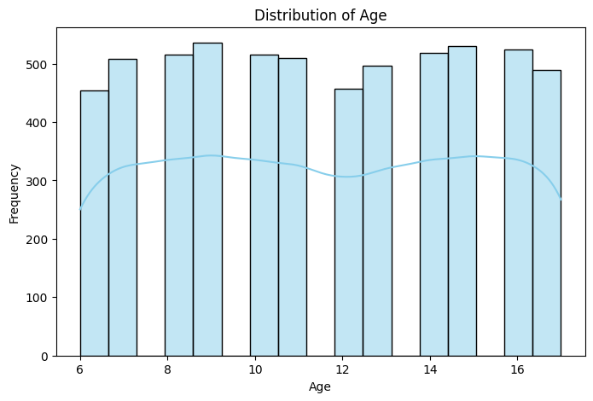
Figure 1: Distribution of Age
Every age group from 6 to 17 has roughly the same number of students, so no age dominates the analysis.
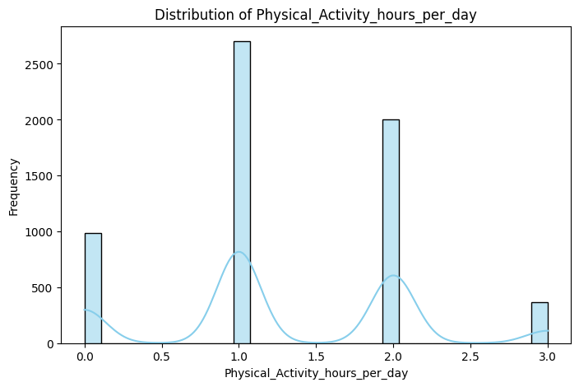
Figure 2: Distribution of Physical_Activity_hours_per_day
Most students are active for 1 to 2 hours a day, with 1 hour the most common. Only a small number do 3 hours, while around 1,000 students do none at all.
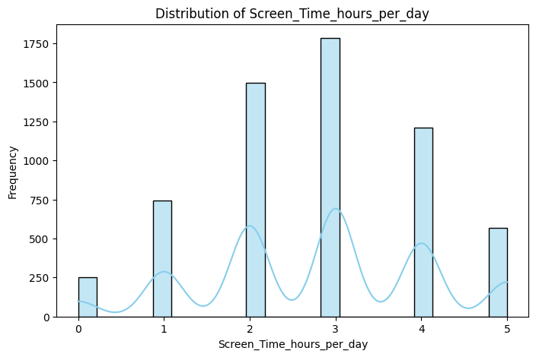
Figure 3: Distribution of Screen_Time_hours_per_day
Most students use screens for 2 to 4 hours a day, with 3 hours the most common. Very few spend 5 hours on screens, and few have 0 hours.

10.2 Pie chart: gender distribution
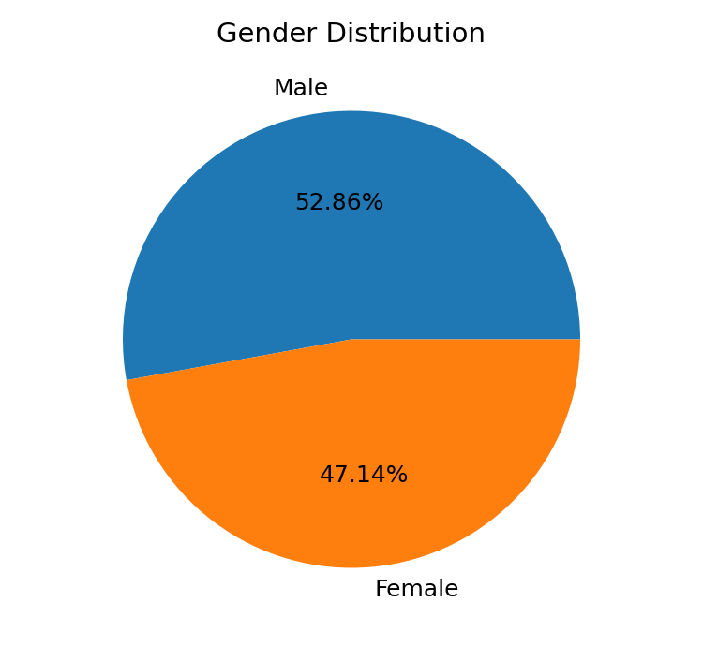
Figure 4: Gender distribution
Male students make up 52.86% and female students 47.14%. The split is fairly even, so later results are not strongly affected by gender.

10.3 Line chart: average screen time by age
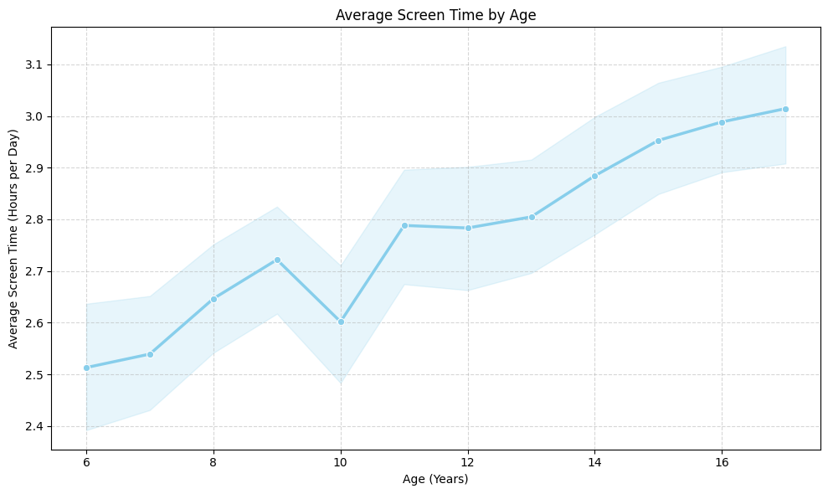
Figure 5: Average screen time by age
Average screen time shows an overall increasing trend, from about 2.51 hours at age 6 to 3.01 hours at age 17. Older children generally have higher screen time than younger children.

10.4 Bar chart: number of students by school
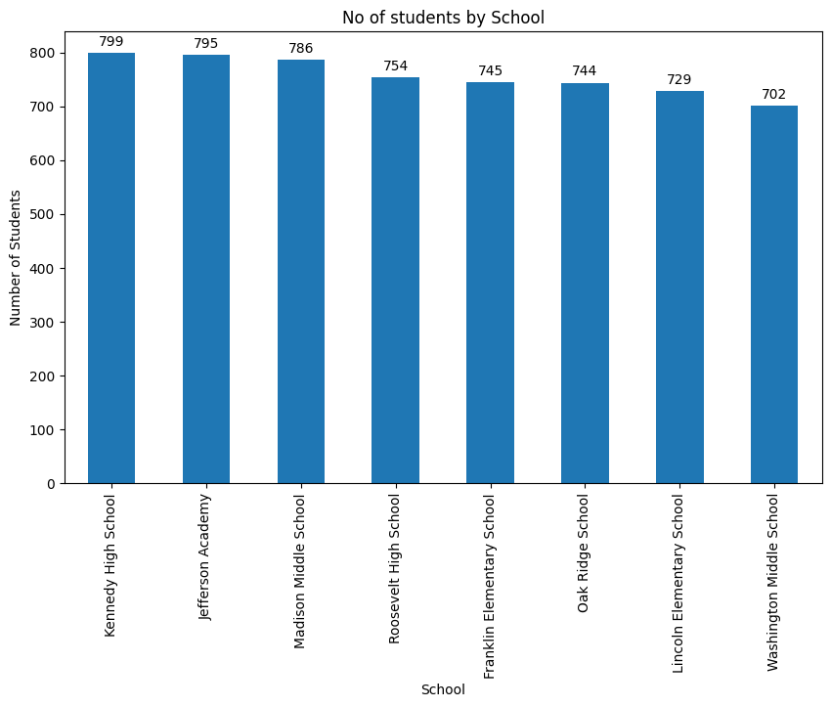
Figure 6: Number of students by school
There are 8 schools in the dataset. The distribution is almost uniform, with 702 to 799 students per school.

10.5 Box plot: age analysis
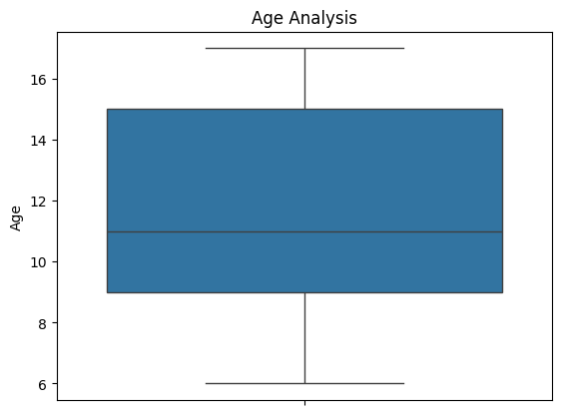
Figure 7: Box plot of age
The box shows the middle 50% of ages and the central line shows the median (11 years). There are no outliers after cleaning.

10.6 Scatter plot: age vs physical activity
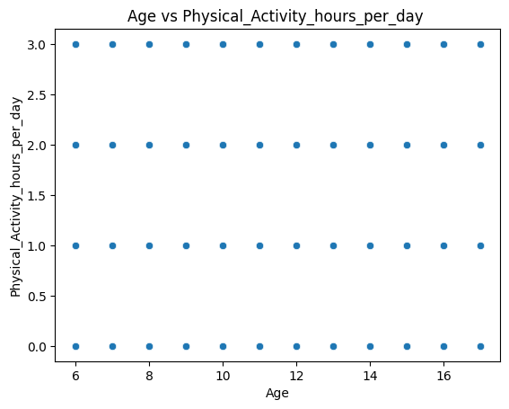
Figure 8: Age vs Physical_Activity_hours_per_day
The plot shows no correlation. Physical activity is independent of age, and every age shows the same four levels of activity (0, 1, 2 and 3 hours).

10.7 Bar chart: prevalence of health problems
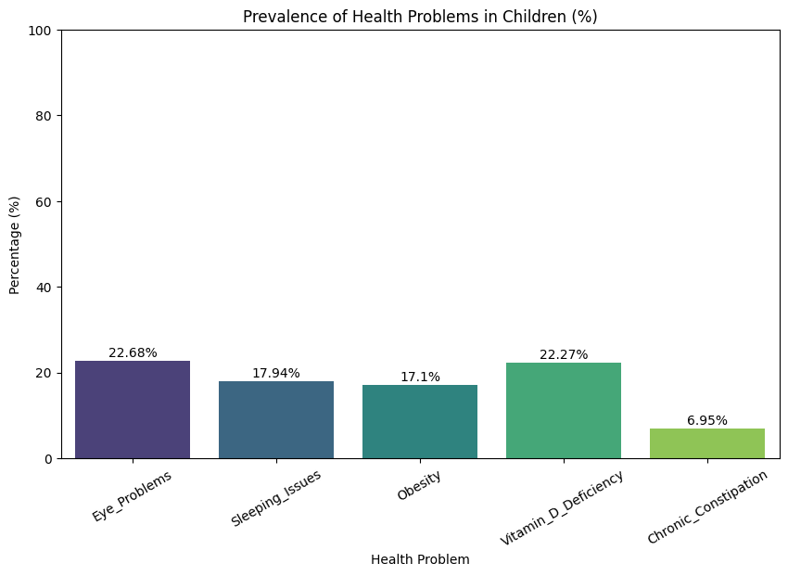
Figure 9: Prevalence of health problems in children (%)
Eye problems are the most common (22.68%), followed by vitamin D deficiency (22.27%), sleeping issues (17.94%) and obesity (17.10%). Chronic constipation is the least common (6.95%).

10.8 Heat map: physical activity vs health issues
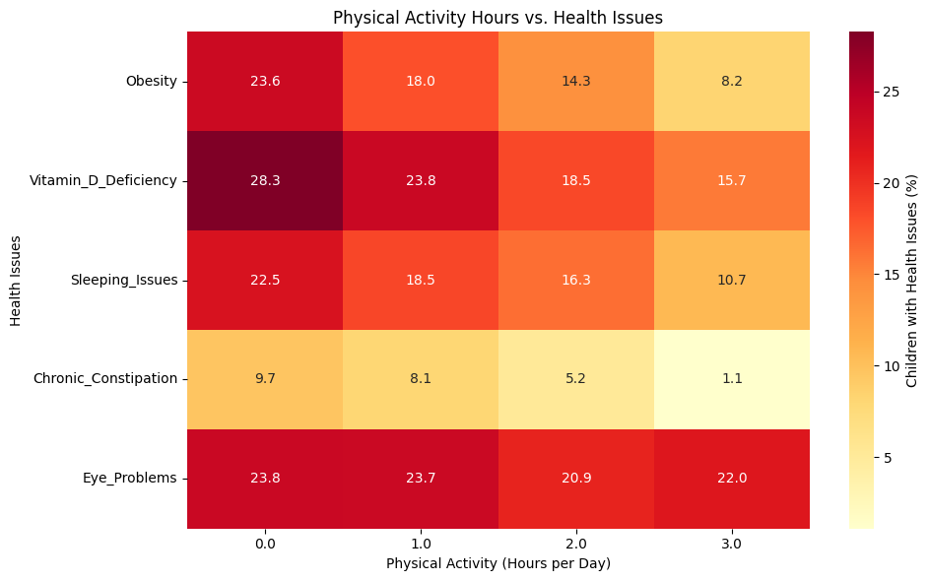
Figure 10: Physical activity hours vs health issues (% of children)
Health issue (%) | 0 h | 1 h | 2 h | 3 h
Obesity | 23.6 | 18.0 | 14.3 | 8.2
Vitamin D deficiency | 28.3 | 23.8 | 18.5 | 15.7
Sleeping issues | 22.5 | 18.5 | 16.3 | 10.7
Chronic constipation | 9.7 | 8.1 | 5.2 | 1.1
Eye problems | 23.8 | 23.7 | 20.9 | 22.0

More physical activity is linked to lower rates of obesity, vitamin D deficiency, sleeping issues and chronic constipation. Eye problems stay almost unchanged across all activity levels (23.8%, 23.7%, 20.9%, 22.0%), so they occur independently of physical activity.

10.9 Grouped bar chart: screen time vs eye and sleeping problems
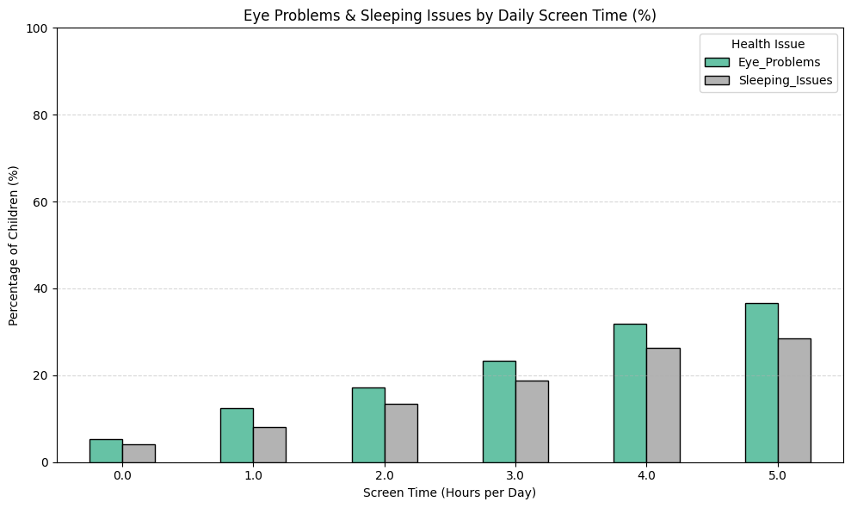
Figure 11: Eye problems and sleeping issues by daily screen time (%)
Screen time (h/day) | Eye problems (%) | Sleeping issues (%)
0 | 5.22 | 4.02
1 | 12.42 | 8.10
2 | 17.14 | 13.34
3 | 23.31 | 18.82
4 | 31.96 | 26.26
5 | 36.56 | 28.47

Both problems rise steadily with screen time. Eye problems climb from 5.22% at 0 hours to 36.56% at 5 hours (about seven times higher), and sleeping issues from 4.02% to 28.47%.

10.10 Count plot: number of health issues per child
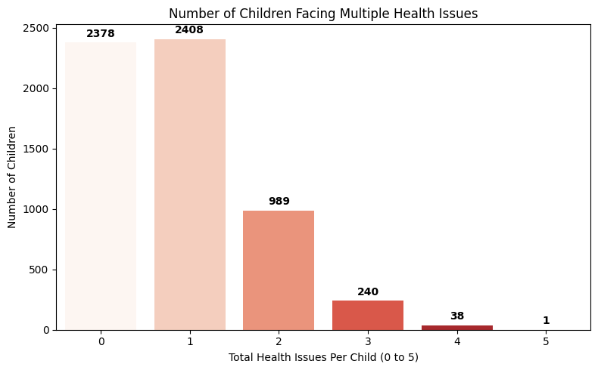
Figure 12: Number of children facing multiple health issues
Most children have 0 (2,378) or 1 (2,408) health issue. A further 989 children have two issues, 240 have three, 38 have four and one child has all five. In total 1,268 children (about 21%) have two or more issues, and the average is 0.87 issues per child.

11. Key Findings and Insights
- The cleaned dataset covers 6,054 children aged 6–17 from 8 schools and 16 US cities, with balanced gender and school representation.
- Children average 2.77 hours of screen time and 1.29 hours of physical activity a day.
- Eye problems (22.68%) and vitamin D deficiency (22.27%) are the most common health problems; chronic constipation (6.95%) is the least common.
- Higher screen time goes with much higher rates of eye problems and sleeping issues.
- Higher physical activity goes with lower rates of obesity, vitamin D deficiency, sleeping issues and chronic constipation, but not eye problems.
- Screen time rises with age, while physical activity does not change with age.
- Around 21% of children have two or more health issues, and this group is the highest risk.

12. Recommendations
- Set screen-time limits: keep recreational screen time below 2 hours a day, with extra attention to students aged 14–17.
- Bedtime rule: no screens for at least 1 hour before sleep to protect sleep quality.
- Remove zero-activity days: introduce 60 minutes of daily physical education or active recess for children who report no activity.
- Use sunlight: hold physical activities outdoors to help with vitamin D.
- Screen early: run annual vision, BMI and nutrition checks in all schools, and follow up children with several issues.

13. Conclusion
The project cleaned and analysed health and lifestyle data for 6,054 school-age children. It met its objectives: the data was prepared, the prevalence of five health problems was measured, and clear links were found between screen time and eye and sleep problems, and between physical activity and obesity, vitamin D deficiency, sleeping issues and constipation. The results support limiting screen time, building daily physical activity into school days and screening children early.

14. Limitations and Future Scope

Limitations
- The analysis shows association, not cause. Other factors such as diet, family income and sleep schedule were not available.
- Health problems are recorded only as Yes/No, with no BMI, vision test or vitamin D level.
- Screen time and activity are whole-hour values, which limits detail.
- All students are in the USA, and the names repeat often (500 unique names in 6,054 rows), so the data may be simulated; real-world results should be checked.
- Missing values were filled with the median, and no statistical significance tests were run.

Future scope
- Add statistical tests (for example chi-square) and a risk model such as logistic regression.
- Use richer data: BMI, sleep hours, diet and outdoor time.
- Build interactive Plotly or Power BI dashboards for schools.

15. References
- Dataset: Kaggle – child_health_lifestyle.
- Pandas documentation: https://pandas.pydata.org
- NumPy documentation: https://numpy.org
- Matplotlib documentation: https://matplotlib.org
- Seaborn documentation: https://seaborn.pydata.org
- Project notebook: child_health_lifestyle_analysis.ipynb

