IT3101 - Data Warehousing and Business Intelligence

Design and Implementation of a Hospital Data Warehouse and Business Intelligence Solution

Healthcare Domain - Integrated Hospital Analytics

Item | Details
Student Name | [Your Name]
Student ID | [Your Student ID]
Programme | BSc (Hons) in Information Technology
Institution | Sri Lanka Institute of Information Technology (SLIIT)
Module | IT3101 - Data Warehousing and Business Intelligence
Submission Date | 04 October 2026

Assignment Report

Executive Summary
This report documents the design and implementation of an end-to-end Data Warehouse and Business Intelligence solution for a healthcare scenario. Two independently published hospital management datasets were treated as two operational source systems. The solution integrates CSV and Excel data through SQL Server Integration Services (SSIS), stores cleansed and conformed data in an enterprise dimensional warehouse, creates a finance-focused data mart, exposes the analytical model through SQL Server Analysis Services (SSAS) Tabular, and presents management information through Microsoft Power BI.
The implemented warehouse uses shared dimensions with multiple related fact tables for appointments, admissions, treatments, and billing. The Finance Data Mart contains 50,200 integrated billing records and supports analysis by source system, date, department, doctor, patient attributes, payment status, and payment method. The final Power BI solution contains three pages: Executive Summary, Trend Analysis, and Interactive Analysis. The dashboards demonstrate KPIs, trend analysis, filters, slicers, drill-down, and roll-up functionality.

Table of Contents
- Task 1 - Dataset Selection and Business Scenario Identification
- Task 2 - Data Source Identification and Preparation
- Task 3 - Data Warehouse Architecture Design
- Task 4 - Dimensional Data Warehouse Design and Implementation
- Task 5 - ETL Process Development
- Task 6 - Data Mart Development
- Task 7 - OLAP Analysis and Business Intelligence Dashboard Development
- Task 8 - Business Insights and Recommendations
- Conclusion
- References
- AI Usage Acknowledgement

Task 1: Dataset Selection and Business Scenario Identification

1.1 Business Scenario
The selected scenario is hospital management and healthcare analytics. Operational hospital systems typically record patients, doctors, appointments, admissions, treatments, billing, departments, and calendar information. These records are useful for day-to-day transactions, but management requires an integrated analytical environment to understand activity volumes, financial performance, payment patterns, department contribution, and trends over time.
The business problem addressed by this project is the fragmentation of operational data across separate source structures. The project integrates two independent hospital management datasets into a unified Data Warehouse and BI environment so that management can analyse common business processes without directly querying operational files.

1.2 Selected Datasets
Logical Source | Dataset | Format | Main Entities | Scale
Source System A | Hospital management dataset | CSV files | Patients, Doctors, Appointments, Treatments, Billing | 650 total source rows
Source System B | Hospital management dataset | Excel workbook | Patients, Doctors, Departments, Admissions, Treatment, Billing, Calendar | 162,039 rows across sheets*

*Source System B includes 10,000 patients, 200 doctors, 12 departments, 50,000 admissions, 50,000 treatments, 50,000 billing rows and 1,827 calendar rows. The datasets are treated as independent operational systems for the purposes of the warehouse design; they are not claimed to represent two verified real hospitals.

1.3 Dataset Suitability
- The sources represent OLTP-style operational entities and relationships.
- They contain multiple business processes suitable for fact tables, including appointments, admissions, treatments, and billing.
- They provide descriptive entities suitable for dimensions, including patients, doctors, departments, treatment types, hospital source, and date.
- The second source contains tens of thousands of records, providing sufficient volume for analytical processing.
- The mix of CSV and Excel formats supports a realistic data integration and ETL scenario.

1.4 Dataset Sources
Dataset 1: https://www.kaggle.com/datasets/garimakochale/hospital-management-dataset
Dataset 2: https://www.kaggle.com/datasets/kanakbaghel/hospital-management-dataset

Task 2: Data Source Identification and Preparation

2.1 Source System A - CSV Files
File | Rows | Important Attributes
patients.csv | 50 | patient_id, name, gender, date_of_birth, contact, address, registration_date, insurance, email
doctors.csv | 10 | doctor_id, name, specialization, phone, years_experience, hospital_branch, email
appointments.csv | 200 | appointment_id, patient_id, doctor_id, appointment_date, appointment_time, reason, status
treatments.csv | 200 | treatment_id, appointment_id, treatment_type, description, cost, treatment_date
billing.csv | 200 | bill_id, patient_id, treatment_id, bill_date, amount, payment_method, payment_status

2.2 Source System B - Excel Workbook
Sheet | Rows | Important Attributes
Patients | 10,000 | Patient_ID, Patient_Name, Gender, Date_of_Birth, Blood_Group, Phone, City
Doctors | 200 | Doctor_ID, Doctor_Name, Department_ID, Specialization, Consultation_Fee
Departments | 12 | Department_ID, Department_Name, Floor_Number
Admissions | 50,000 | Admission_ID, Patient_ID, Doctor_ID, Admission_Date, Room_Type, Discharge_Date
Treatment | 50,000 | Treatment_ID, Admission_ID, Treatment_Type, Treatment_Cost, Medicine_Cost, Lab_Cost
Billing | 50,000 | Admission_ID, Total_Bill, Insurance_Cover, Final_Amount_Payable, Payment_Mode, EMI_Months, Monthly_EMI, Payment_Status
Calendar | 1,827 | Date, Month, Month_No, Quarter, Year

2.3 Source Relationships and Preparation
Source System A uses the chain Patient -> Appointment <- Doctor, Appointment -> Treatment, and Treatment -> Billing. Source System B links Patient and Doctor to Admission, Doctor to Department, Admission to Treatment and Billing, and uses a Calendar table for time analysis. During integration, operational IDs were never assumed to be globally unique. Each source was assigned a SourceSystemCode (CSV or XLSX), and the warehouse uses source-aware business keys together with surrogate keys.
A staging database named Hospital_Staging was created. Source-specific tables were loaded using SSIS before warehouse transformation. The CSV staging row counts were 50 patients, 10 doctors, 200 appointments, 200 treatments and 200 billing rows. The Excel staging row counts were 10,000 patients, 200 doctors, 12 departments, 50,000 admissions, 50,000 treatments, 50,000 billing rows and 1,827 calendar rows.
- Gender values were standardised to consistent values such as Male and Female.
- Dates were converted from source text/date representations to SQL DATE and integer DateKey values.
- Treatment type, payment method and payment status values were trimmed and standardised.
- Source attributes unavailable in one system were retained as NULL rather than fabricated.
- Duplicate protection was implemented through unique source-aware keys and NOT EXISTS checks.

Task 3: Data Warehouse Architecture Design
The architecture follows a layered approach that separates operational sources, data integration, storage, analytical modelling, and presentation. This separation improves traceability, maintainability, and the ability to validate each stage independently.
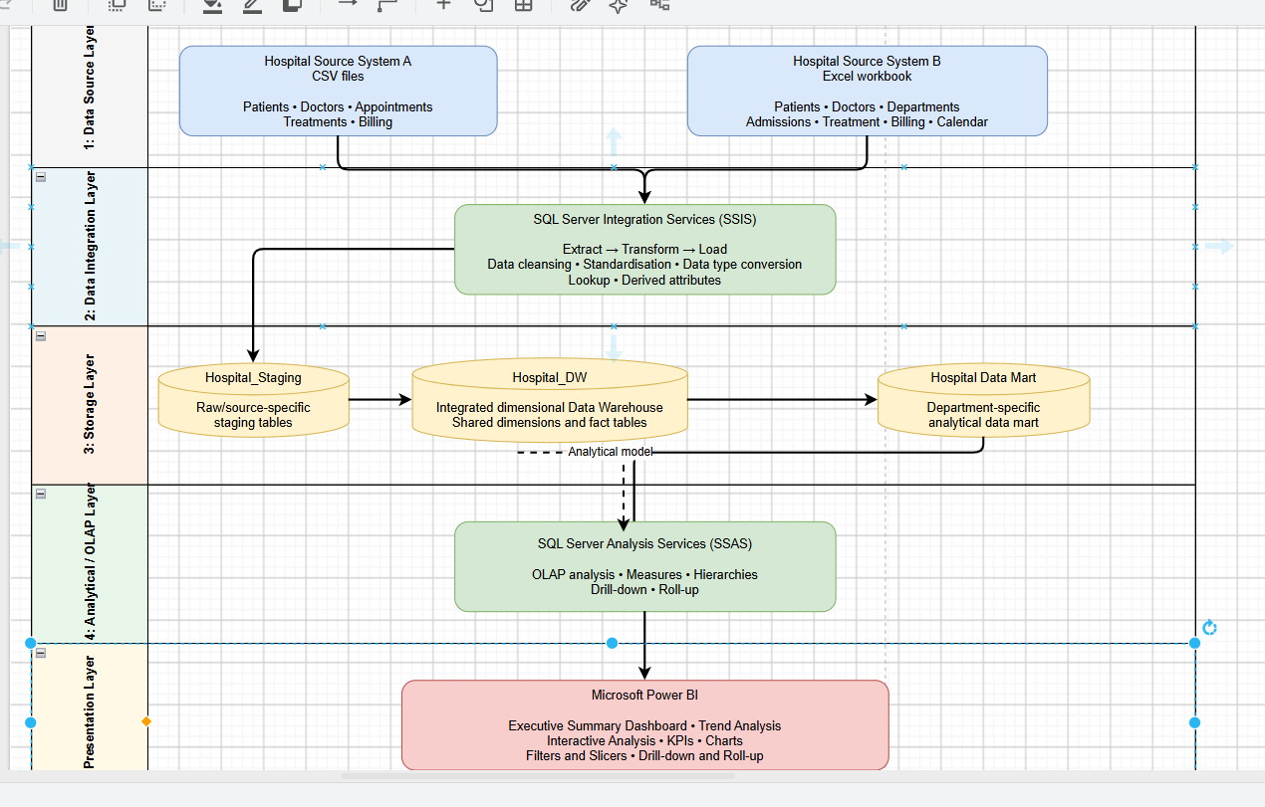
Figure 1. Hospital Data Warehouse and Business Intelligence Architecture

3.1 Architecture Components
Layer | Implemented Components | Purpose
Data Source Layer | Hospital Source A (CSV), Hospital Source B (Excel) | Provides operational healthcare data from independent source structures.
Data Integration Layer | SQL Server Integration Services (SSIS) | Extracts, cleanses, standardises, converts, derives and loads data.
Storage Layer | Hospital_Staging, Hospital_DW, Hospital_Finance_DM | Separates raw staging, integrated enterprise warehouse and department-specific analytical data.
Analytical / OLAP Layer | SQL Server Analysis Services (SSAS) Tabular | Provides measures, relationships, hierarchies, drill-down and roll-up capability.
Presentation Layer | Microsoft Power BI | Provides KPI cards, charts, trends, filters, slicers and interactive analysis.

Task 4: Dimensional Data Warehouse Design and Implementation
A single integrated warehouse was implemented using multiple related star schemas that share conformed dimensions. Appointment and admission were kept as separate facts because they represent different business processes and grains. Shared dimensions allow consistent analysis across facts while preserving the meaning of each source process.
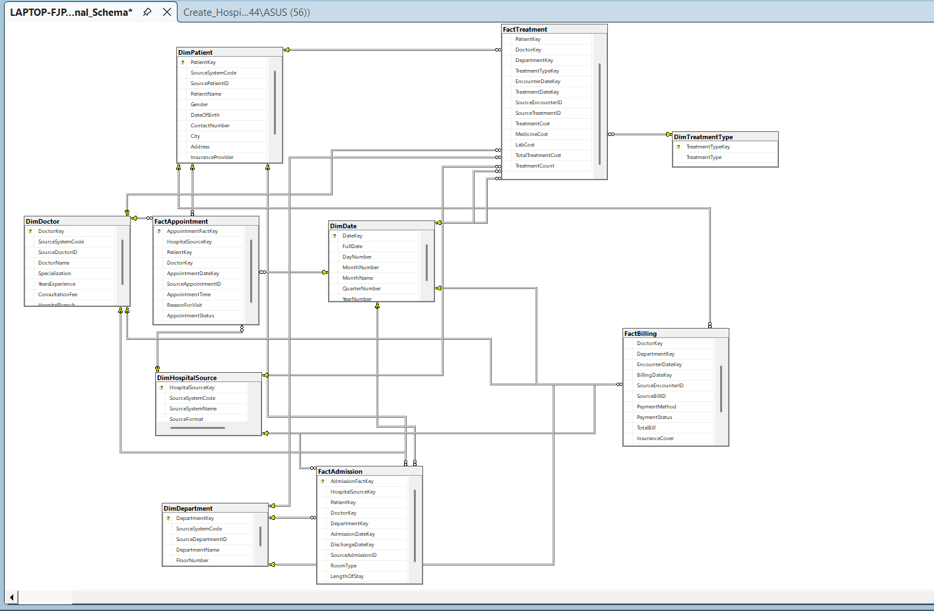
Figure 2. Implemented Hospital_DW Dimensional Schema

4.1 Dimension Tables
Dimension | Purpose
DimHospitalSource | Identifies the originating source system and format.
DimPatient | Conformed patient attributes with source-aware patient IDs.
DimDoctor | Doctor name, specialization, experience/fee and source attributes.
DimDepartment | Department details from the Excel source.
DimTreatmentType | Standardised treatment type values shared by treatment facts.
DimDate | Role-playing date dimension for appointment, admission, discharge, encounter, treatment and billing dates.

4.2 Fact Tables, Grain and Measures
Fact | Grain | Main Measures
FactAppointment | One row per CSV appointment | AppointmentCount
FactAdmission | One row per Excel admission | AdmissionCount, LengthOfStay
FactTreatment | One row per treatment record within a source-system event | TreatmentCost, MedicineCost, LabCost, TotalTreatmentCost, TreatmentCount
FactBilling | One row per billing record associated with a service event | TotalBill, InsuranceCover, FinalAmountPayable, EMIMonths, MonthlyEMI, BillingCount

4.3 Key Design Assumptions
- Source IDs are unique only within their own source system; therefore SourceSystemCode is retained as part of the natural key logic.
- CSV hospital_branch is not treated as a department because it is conceptually different from the Excel Department entity.
- Missing source attributes remain NULL. For example, CSV billing has no insurance-cover or EMI fields, and Excel treatment has no independent treatment date.
- The date dimension is role-playing and is reused through multiple date foreign keys.

Task 5: ETL Process Development

5.1 SSIS Packages and Workflow
The ETL solution was implemented in the Visual Studio Integration Services project Hospital_ETL. The Load_Staging package extracts raw CSV and Excel data into Hospital_Staging. The Load_DW package transforms and loads the enterprise warehouse. During development, individual Data Flow Tasks were executed separately to avoid accidental reloading; the final package uses precedence constraints so dimensions load before facts.
The final Load_DW sequence is: DimHospitalSource -> DimDate -> DimPatient -> DimDoctor -> DimDepartment -> DimTreatmentType -> FactAppointment -> FactAdmission -> FactTreatment -> FactBilling. Green precedence constraints ensure that each downstream task runs only after the previous task succeeds.

5.2 Major Transformation Logic
Transformation | Implementation Example
Data cleansing and standardisation | TRIM/UPPER logic for treatment types, payment methods and statuses; consistent gender values.
Data type conversion | TRY_CONVERT/CAST for dates, decimal costs, IDs and DateKey values.
Surrogate key lookup | SSIS Lookup components resolve PatientKey, DoctorKey, DepartmentKey, TreatmentTypeKey and HospitalSourceKey.
Derived attributes | LengthOfStay using DATEDIFF; TotalTreatmentCost; integer date keys; technical SourceBillID for Excel billing.
Missing value handling | Unavailable attributes are loaded as NULL rather than substituted with false values.
Duplicate protection | NOT EXISTS filters and unique source-aware constraints make the ETL rerunnable.

5.3 Validation Results
Warehouse Object | Validated Rows / Result
DimHospitalSource | 2 source systems
DimPatient | 10,050
DimDoctor | 210
DimDepartment | 12
FactAppointment | 200
FactAdmission | 50,000
FactTreatment | 50,200
FactBilling | 50,200
FactBilling department validation | CSV: 200 rows with NULL department; XLSX: 50,000 rows with valid DepartmentKey

The validation results confirm that the two source systems were integrated without merging unrelated source identifiers. Referential integrity is enforced through warehouse foreign keys, and the final rerun logic prevents duplicate insertion of already-loaded records.

Task 6: Data Mart Development

6.1 Finance Data Mart
A department-focused Finance Data Mart named Hospital_Finance_DM was created from the enterprise warehouse. It contains DimHospitalSource, DimDate, DimPatientFinance, DimDoctorFinance, DimDepartmentFinance, and FactFinanceBilling. The mart intentionally includes only attributes needed for financial analysis rather than duplicating the full enterprise warehouse.
FactFinanceBilling contains 50,200 integrated billing records. A ReportingDateKey was created for integrated trend reporting: when a billing date exists it is used; otherwise the related encounter date is used as the common reporting date. This is a reporting key and is not interpreted as an actual billing date when the source did not provide one.

6.2 Purpose, Target Users and Benefits
Aspect | Description
Purpose | Provide focused analysis of billing amounts, insurance cover, final payable amounts, payment status, payment method and EMI information.
Target Users | Finance managers, billing officers and hospital management personnel.
Analytical Benefits | Simpler financial queries, source-system comparison, department-level analysis, time trends, payment-pattern analysis and management KPI reporting.

Task 7: OLAP Analysis and Business Intelligence Dashboard Development

7.1 SSAS Tabular Model
The Finance Data Mart was imported into a SQL Server Analysis Services Tabular project. Six tables were modelled with one-to-many relationships from the dimensions to FactFinanceBilling. The model was deployed to the local Analysis Services instance and successfully processed. Technical key columns were hidden from client tools to provide a cleaner semantic model for Power BI.
Measures created in the Tabular model include Total Billing, Billing Records, Total Insurance Cover, Total Final Payable and Average Bill. A Date Hierarchy was created using Year, Quarter, Month and Full Date to support drill-down and roll-up analysis.

7.2 Power BI - Executive Summary
The Executive Summary page presents high-level finance KPIs, source-system filtering, department contribution and payment-status distribution. With the XLSX source selected, the dashboard shows approximately 1.89 billion total billing, 50,000 billing records, an average bill of 37.77K, 472.80 million insurance cover and approximately 1.42 billion final payable.
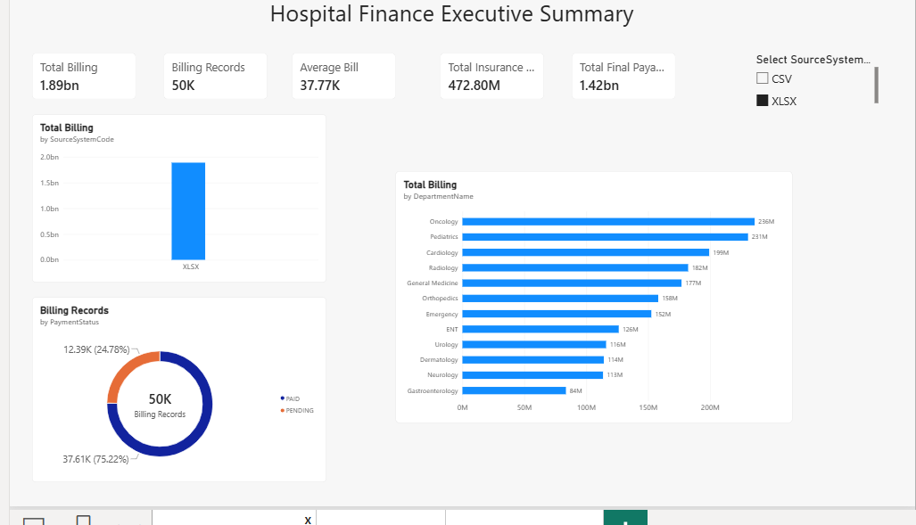
Figure 3. Power BI Executive Summary Dashboard

7.3 Power BI - Trend Analysis
The Trend Analysis page provides time-based analysis using the shared date model. It includes total billing trends, final payable trends, source/year comparison, monthly billing analysis and slicers for source and year. The date hierarchy supports OLAP-style drill-down from year to quarter, month and date.
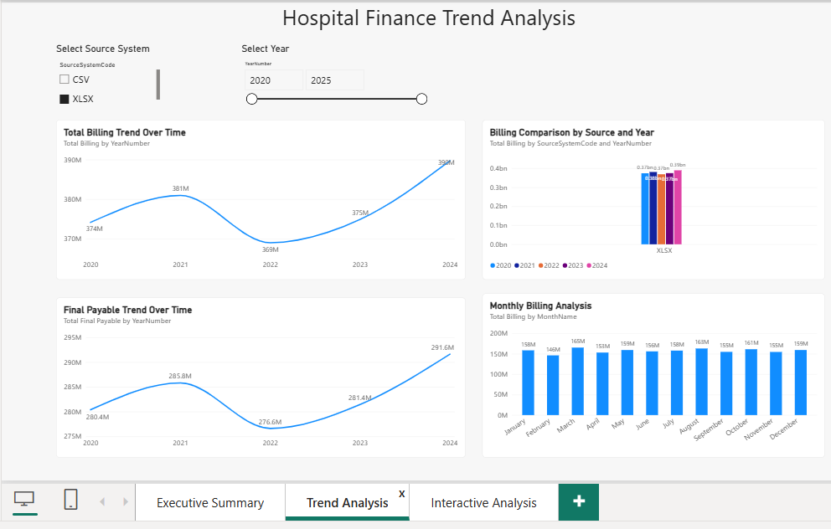
Figure 4. Power BI Trend Analysis Dashboard

7.4 Power BI - Interactive Analysis
The Interactive Analysis page combines source, year, department and payment-status slicers with drillable department/doctor analysis, an expandable matrix, insurance-provider analysis and payment-method distribution. The matrix supports hierarchical expansion and collapse, demonstrating drill-down and roll-up behaviour.
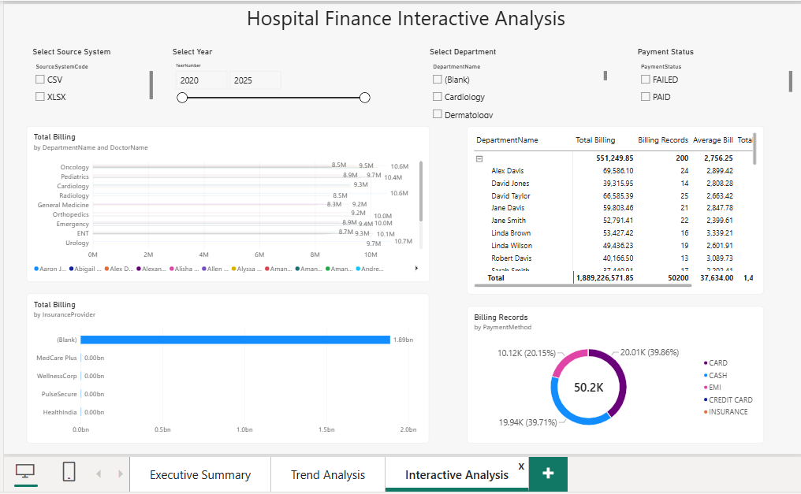
Figure 5. Power BI Interactive Analysis Dashboard

Task 8: Business Insights and Recommendations
The following insights are based on the actual Power BI outputs produced by the implemented model. Recommendations focus on how the observed patterns can support finance and management decision-making.

8.1 Insight 1 - Source System Billing Contribution
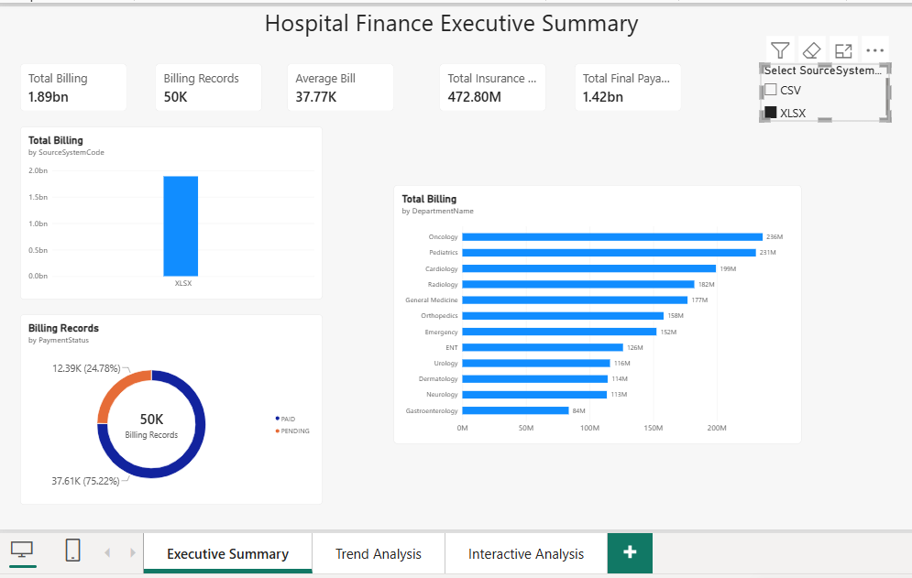
Figure 6. Source-system billing dashboard view
Finding: The XLSX source dominates the integrated finance dataset, with 50,000 billing records and approximately 1.89 billion in total billing. By comparison, the CSV source contains only 200 billing records and contributes a very small share of the integrated totals. This difference reflects the very different source-system volumes rather than a direct comparison of two equal-sized hospitals.
Recommendation: Management dashboards should continue to allow source filtering so users can distinguish source-volume effects from genuine operational differences. Source-level KPIs should be reviewed before making cross-source performance comparisons.

8.2 Insight 2 - Department Financial Performance
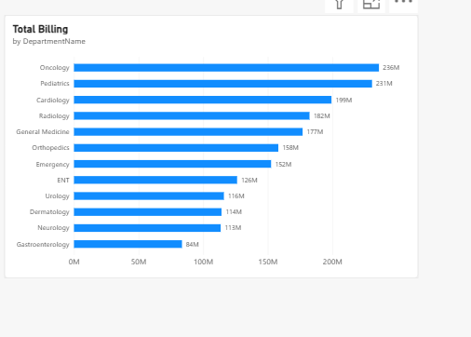
Figure 7. Department-level total billing
Finding: Oncology generated the highest total billing at approximately 236 million, followed by Pediatrics at approximately 231 million and Cardiology at approximately 199 million. Gastroenterology was the lowest among the displayed departments at approximately 84 million. The difference between departments shows that financial activity is unevenly distributed across clinical areas.
Recommendation: Hospital management should combine these billing patterns with workload and resource information when planning budgets, staffing and equipment. High-billing departments may require stronger capacity planning, while lower-billing departments should be reviewed in the context of service demand rather than judged by revenue alone.

8.3 Insight 3 - Billing Trend Over Time
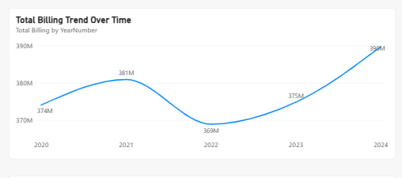
Figure 8. Total billing trend by year
Finding: Total billing increased from about 374 million in 2020 to 381 million in 2021, declined to about 369 million in 2022, recovered to 375 million in 2023, and reached the highest value of about 390 million in 2024. The trend therefore shows a temporary decline in 2022 followed by a two-year recovery.
Recommendation: Finance managers can use the 2022 decline as a point for further investigation and use the recovery pattern for budgeting and forecasting. Trend analysis should be repeated with operational indicators to determine whether the changes were driven by patient volumes, treatment mix, pricing or other factors.

8.4 Insight 4 - Payment Method Behaviour
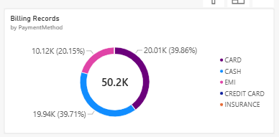
Figure 9. Billing records by payment method
Finding: Card and cash are the dominant payment methods, accounting for about 20.01K (39.86%) and 19.94K (39.71%) billing records respectively. EMI accounts for about 10.12K (20.15%), while credit card and insurance payment methods form only a very small remainder. This shows a strong preference for immediate card/cash settlement with a meaningful secondary use of EMI.
Recommendation: The hospital should ensure reliable support for card and cash workflows while also monitoring EMI collections and repayment risk. Payment-channel capacity and reconciliation controls can be prioritised according to the actual method distribution.

8.5 Insight 5 - Doctor and Department Contribution
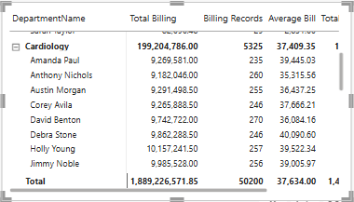
Figure 10. Cardiology doctor-level contribution matrix
Finding: Cardiology generated approximately 199.20 million from 5,325 billing records, with an average bill of approximately 37.41K. The expanded doctor-level view shows that billing is distributed across multiple doctors, with visible doctor totals generally around 9-10 million. This demonstrates the value of hierarchical analysis for moving from department-level performance to individual doctor contribution.
Recommendation: Management should use doctor-level billing together with workload, clinical complexity and service-quality measures rather than treating billing as a standalone performance score. The drill-down view is useful for identifying unusual workload or billing patterns that require further investigation.

8.6 Additional Payment Status Observation
The Executive Summary shows approximately 37.61K paid billing records (75.22%) and 12.39K pending records (24.78%). A pending share of nearly one quarter is operationally significant and should be monitored as part of revenue-cycle management. Follow-up procedures, ageing analysis and collection workflows can be prioritised for outstanding records.

Conclusion
The project successfully implemented an end-to-end hospital Data Warehouse and Business Intelligence solution using SQL Server, SSIS, SSAS and Power BI. Two independent operational sources were staged, cleansed and integrated into a conformed dimensional warehouse. Separate fact tables preserved the grain of appointments, admissions, treatments and billing while shared dimensions enabled consistent analysis across business processes.
The Finance Data Mart provided a focused analytical layer for departmental financial reporting. The SSAS Tabular model added reusable measures and date hierarchy support, while Power BI delivered executive KPIs, trend analysis, slicers, filters, drill-down and roll-up. The final insights demonstrate how the implemented solution can support budgeting, payment management, department analysis and management decision-making.

References
Kaggle Dataset 1: Hospital Management Dataset - garimakochale
Kaggle Dataset 2: Hospital Management Dataset - kanakbaghel
Microsoft SQL Server, SQL Server Integration Services (SSIS), SQL Server Analysis Services (SSAS), SQL Server Management Studio (SSMS) and Microsoft Power BI were used to implement the solution.

AI Usage Acknowledgement
Generative AI was used as a supporting learning and development tool during this assignment. It was used to clarify Data Warehouse concepts, suggest implementation steps, help debug SSIS/SSAS configuration issues, improve explanations, and assist with report organisation. All practical implementation, configuration, screenshots, validation results and dashboard outputs were produced and verified during the project. AI-generated suggestions were reviewed and adapted to match the implemented solution and actual results.

Appendix - Key Implemented Objects
Database / Project | Key Objects
Hospital_Staging | Source-specific CSV and XLSX staging tables
Hospital_DW | 6 conformed dimensions and 4 fact tables
Hospital_ETL | Load_Staging.dtsx and Load_DW.dtsx SSIS packages
Hospital_Finance_DM | Finance dimensions and FactFinanceBilling
Hospital_Finance_SSAS | SSAS Tabular semantic model and measures
Power BI | Executive Summary, Trend Analysis, Interactive Analysis

