HOSPITAL DATA WAREHOUSE &
BUSINESS INTELLIGENCE SOLUTION

Personal Individual Project
Healthcare Analytics Project
An end-to-end data warehousing and business intelligence solution that integrates multiple hospital operational data sources into a unified analytical environment for financial and management analysis.
TECHNOLOGY STACK
SQL Server • SSIS • SSAS • Power BI • SSMS • Visual Studio
PROJECT SCOPE
Data Integration • Dimensional Data Warehouse • Finance Data Mart • OLAP Analysis • Interactive BI Dashboards
Developed by
[Your Name]

Executive Summary
In this individual project, I designed and implemented an end-to-end Data Warehouse and Business Intelligence solution for a healthcare scenario. I worked with two independently published hospital-management datasets and treated them as two separate operational source systems. The solution brings CSV and Excel data together through SQL Server Integration Services (SSIS), stores the cleaned and integrated data in a dimensional warehouse, creates a finance-focused data mart, exposes the analytical model through SQL Server Analysis Services (SSAS) Tabular, and presents the final analysis in Microsoft Power BI.
The warehouse is built around shared dimensions and separate fact tables for appointments, admissions, treatments, and billing. The Finance Data Mart contains 50,200 integrated billing records and supports analysis by source system, date, department, doctor, selected patient attributes, payment status, and payment method. I developed three Power BI pages - Executive Summary, Trend Analysis, and Interactive Analysis - to demonstrate KPIs, trends, filters, slicers, drill-down, and roll-up.

Table of Contents
- Task 1 - Dataset Selection and Business Scenario Identification
- Task 2 - Data Source Identification and Preparation
- Task 3 - Data Warehouse Architecture Design
- Task 4 - Dimensional Data Warehouse Design and Implementation
- Task 5 - ETL Process Development
- Task 6 - Data Mart Development
- Task 7 - OLAP Analysis and Business Intelligence Dashboard Development
- Task 8 - Business Insights and Recommendations
- Conclusion
- References
- AI Usage Acknowledgement

Task 1: Dataset Selection and Business Scenario Identification

1.1 Business Scenario
I selected hospital management and healthcare analytics as the business scenario because hospital systems naturally produce several related operational records, such as patients, doctors, appointments, admissions, treatments, billing, departments, and dates. These records are useful for daily operations, but by themselves they are not convenient for management-level analysis. A warehouse makes it possible to bring them together and examine activity levels, financial performance, payment behaviour, department contribution, and changes over time.
The main problem I addressed was that the operational data was split across different source structures. Instead of analysing each source separately, I integrated the two hospital-management datasets into one Data Warehouse and BI environment. This allowed common business processes to be analysed consistently without querying the raw files directly.

1.2 Selected Datasets
Logical Source | Dataset | Format | Main Entities | Scale
Source System A | Hospital management dataset | CSV files | Patients, Doctors, Appointments, Treatments, Billing | 650 total source rows
Source System B | Hospital management dataset | Excel workbook | Patients, Doctors, Departments, Admissions, Treatment, Billing, Calendar | 162,039 rows across sheets*

*Source System B contains 10,000 patients, 200 doctors, 12 departments, 50,000 admissions, 50,000 treatments, 50,000 billing rows, and 1,827 calendar rows. For this project, I treated the two datasets as independent operational systems. I do not claim that they are verified datasets from two named real hospitals.

1.3 Dataset Suitability
- The source data has clear OLTP-style entities and relationships, which made it suitable for modelling operational business processes.
- It includes several processes that can be represented as facts, especially appointments, admissions, treatments, and billing.
- It also contains descriptive data that can be modelled as dimensions, including patients, doctors, departments, treatment types, source system, and date.
- The second source has tens of thousands of records, so the project includes enough data volume to demonstrate analytical processing rather than only a small classroom example.
- Using both CSV and Excel also gave me a realistic opportunity to demonstrate source integration, data cleaning, standardisation, and ETL.

1.4 Dataset Sources
Dataset 1: https://www.kaggle.com/datasets/garimakochale/hospital-management-dataset
Dataset 2: https://www.kaggle.com/datasets/kanakbaghel/hospital-management-dataset

Task 2: Data Source Identification and Preparation

2.1 Source System A - CSV Files
File | Rows | Important Attributes
patients.csv | 50 | patient_id, name, gender, date_of_birth, contact, address, registration_date, insurance, email
doctors.csv | 10 | doctor_id, name, specialization, phone, years_experience, hospital_branch, email
appointments.csv | 200 | appointment_id, patient_id, doctor_id, appointment_date, appointment_time, reason, status
treatments.csv | 200 | treatment_id, appointment_id, treatment_type, description, cost, treatment_date
billing.csv | 200 | bill_id, patient_id, treatment_id, bill_date, amount, payment_method, payment_status

2.2 Source System B - Excel Workbook
Sheet | Rows | Important Attributes
Patients | 10,000 | Patient_ID, Patient_Name, Gender, Date_of_Birth, Blood_Group, Phone, City
Doctors | 200 | Doctor_ID, Doctor_Name, Department_ID, Specialization, Consultation_Fee
Departments | 12 | Department_ID, Department_Name, Floor_Number
Admissions | 50,000 | Admission_ID, Patient_ID, Doctor_ID, Admission_Date, Room_Type, Discharge_Date
Treatment | 50,000 | Treatment_ID, Admission_ID, Treatment_Type, Treatment_Cost, Medicine_Cost, Lab_Cost
Billing | 50,000 | Admission_ID, Total_Bill, Insurance_Cover, Final_Amount_Payable, Payment_Mode, EMI_Months, Monthly_EMI, Payment_Status
Calendar | 1,827 | Date, Month, Month_No, Quarter, Year

2.3 Source Relationships and Preparation
For Source System A, the main relationship path is Patient -> Appointment <- Doctor, followed by Appointment -> Treatment and Treatment -> Billing. Source System B links Patient and Doctor to Admission, Doctor to Department, and Admission to Treatment and Billing, with a separate Calendar table for date analysis. During integration, I did not assume that operational IDs were unique across both datasets. I assigned each source a SourceSystemCode (CSV or XLSX) and used source-aware business keys together with warehouse surrogate keys.
I created a staging database named Hospital_Staging and loaded the raw files into source-specific staging tables through SSIS before applying warehouse transformations. After correcting duplicate reloads during development, the final CSV staging counts were 50 patients, 10 doctors, 200 appointments, 200 treatments, and 200 billing rows. The Excel staging counts were 10,000 patients, 200 doctors, 12 departments, 50,000 admissions, 50,000 treatments, 50,000 billing rows, and 1,827 calendar rows.
- I standardised inconsistent gender values so the warehouse uses a consistent representation such as Male and Female.
- I converted source date values into SQL DATE values and generated integer DateKey values for dimensional analysis.
- I trimmed and standardised treatment type, payment method, and payment status values before loading them into the analytical structures.
- When an attribute was not available in one source, I kept it as NULL rather than creating a value that did not exist in the source data.
- I added source-aware unique keys and NOT EXISTS checks so that rerunning the ETL does not insert the same warehouse rows again.

Task 3: Data Warehouse Architecture Design
I used a layered architecture so that each stage of the solution has a clear responsibility. The design separates the operational sources, ETL processing, warehouse storage, analytical modelling, and BI presentation. This made the implementation easier to test and also made it possible to validate each layer independently.
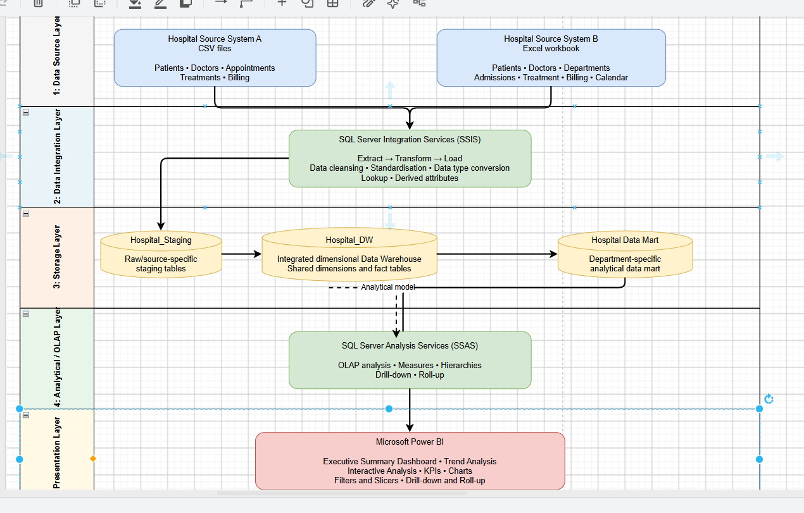
Figure 1. Hospital Data Warehouse and Business Intelligence Architecture

3.1 Architecture Components
Layer | Implemented Components | Purpose
Data Source Layer | Hospital Source A (CSV), Hospital Source B (Excel) | Provides operational healthcare data from independent source structures.
Data Integration Layer | SQL Server Integration Services (SSIS) | Extracts, cleanses, standardises, converts, derives and loads data.
Storage Layer | Hospital_Staging, Hospital_DW, Hospital_Finance_DM | Separates raw staging, integrated enterprise warehouse and department-specific analytical data.
Analytical / OLAP Layer | SQL Server Analysis Services (SSAS) Tabular | Provides measures, relationships, hierarchies, drill-down and roll-up capability.
Presentation Layer | Microsoft Power BI | Provides KPI cards, charts, trends, filters, slicers and interactive analysis.

Task 4: Dimensional Data Warehouse Design and Implementation
I implemented one integrated warehouse rather than creating two separate warehouses. The design uses multiple related star schemas that share conformed dimensions. Appointment and admission remain separate fact tables because they represent different business processes and have different grains, while the shared dimensions make cross-process analysis consistent.
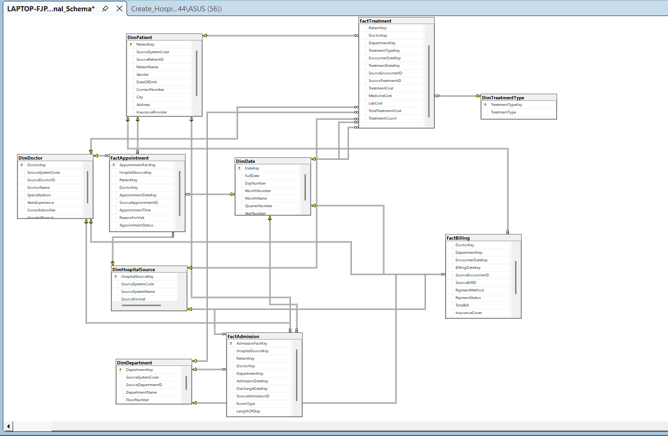
Figure 2. Implemented Hospital_DW Dimensional Schema

4.1 Dimension Tables
Dimension | Purpose
DimHospitalSource | Identifies the originating source system and format.
DimPatient | Conformed patient attributes with source-aware patient IDs.
DimDoctor | Doctor name, specialization, experience/fee and source attributes.
DimDepartment | Department details from the Excel source.
DimTreatmentType | Standardised treatment type values shared by treatment facts.
DimDate | Role-playing date dimension for appointment, admission, discharge, encounter, treatment and billing dates.

4.2 Fact Tables, Grain and Measures
Fact | Grain | Main Measures
FactAppointment | One row per CSV appointment | AppointmentCount
FactAdmission | One row per Excel admission | AdmissionCount, LengthOfStay
FactTreatment | One row per treatment record within a source-system event | TreatmentCost, MedicineCost, LabCost, TotalTreatmentCost, TreatmentCount
FactBilling | One row per billing record associated with a service event | TotalBill, InsuranceCover, FinalAmountPayable, EMIMonths, MonthlyEMI, BillingCount

4.3 Key Design Assumptions
- Operational IDs are only guaranteed to be unique inside their own source system, so SourceSystemCode is kept as part of the natural-key logic.
- I did not treat the CSV hospital_branch field as a department because it represents a different concept from the Excel Department entity.
- Missing source attributes remain NULL. For example, CSV billing does not provide insurance-cover or EMI values, while the Excel treatment data does not provide a separate treatment date.
- The same DimDate table is reused for different date roles, including appointment, admission, discharge, encounter, treatment, and billing dates.

Task 5: ETL Process Development

5.1 SSIS Packages and Workflow
I implemented the ETL work in the Visual Studio Integration Services project Hospital_ETL. The Load_Staging package extracts the CSV and Excel data into Hospital_Staging, while Load_DW performs the transformations and loads the dimensional warehouse. During development, I ran individual Data Flow Tasks while testing so that I did not repeatedly reload every source. After the tasks were stable, I connected them with precedence constraints to create the final execution sequence.
The final Load_DW sequence is: DimHospitalSource -> DimDate -> DimPatient -> DimDoctor -> DimDepartment -> DimTreatmentType -> FactAppointment -> FactAdmission -> FactTreatment -> FactBilling. I used green precedence constraints so that a downstream task starts only when the previous task has completed successfully.

5.2 Major Transformation Logic
Transformation | Implementation Example
Data cleansing and standardisation | TRIM/UPPER logic for treatment types, payment methods and statuses; consistent gender values.
Data type conversion | TRY_CONVERT/CAST for dates, decimal costs, IDs and DateKey values.
Surrogate key lookup | SSIS Lookup components resolve PatientKey, DoctorKey, DepartmentKey, TreatmentTypeKey and HospitalSourceKey.
Derived attributes | LengthOfStay using DATEDIFF; TotalTreatmentCost; integer date keys; technical SourceBillID for Excel billing.
Missing value handling | Unavailable attributes are loaded as NULL rather than substituted with false values.
Duplicate protection | NOT EXISTS filters and unique source-aware constraints make the ETL rerunnable.

5.3 Validation Results
Warehouse Object | Validated Rows / Result
DimHospitalSource | 2 source systems
DimPatient | 10,050
DimDoctor | 210
DimDepartment | 12
FactAppointment | 200
FactAdmission | 50,000
FactTreatment | 50,200
FactBilling | 50,200
FactBilling department validation | CSV: 200 rows with NULL department; XLSX: 50,000 rows with valid DepartmentKey

The validation results showed that the two operational sources were integrated without incorrectly merging unrelated source identifiers. Foreign keys enforce referential integrity in the warehouse, and the final NOT EXISTS logic allows the package to be rerun without duplicating rows that were already loaded.

Task 6: Data Mart Development

6.1 Finance Data Mart
For Task 6, I created a finance-focused data mart named Hospital_Finance_DM from the enterprise warehouse. It contains DimHospitalSource, DimDate, DimPatientFinance, DimDoctorFinance, DimDepartmentFinance, and FactFinanceBilling. I kept the mart focused on finance analysis instead of copying every attribute from the enterprise warehouse.
FactFinanceBilling contains 50,200 integrated billing records. I also created ReportingDateKey for common trend reporting. When a real billing date is available, that date is used; otherwise the related encounter date becomes the reporting date. This key is only for consistent analysis and is not treated as an actual billing date when the source did not provide one.

6.2 Purpose, Target Users and Benefits
Aspect | Description
Purpose | Provide focused analysis of billing amounts, insurance cover, final payable amounts, payment status, payment method and EMI information.
Target Users | Finance managers, billing officers and hospital management personnel.
Analytical Benefits | Simpler financial queries, source-system comparison, department-level analysis, time trends, payment-pattern analysis and management KPI reporting.

Task 7: OLAP Analysis and Business Intelligence Dashboard Development

7.1 SSAS Tabular Model
I imported the Finance Data Mart into an SSAS Tabular project and modelled the six tables with one-to-many relationships from the dimensions to FactFinanceBilling. After resolving the local SSAS deployment and credential issues, the model was deployed successfully and processed without errors. I also hid technical key columns from client tools so the model presented to Power BI was easier to use.
The Tabular model includes the measures Total Billing, Billing Records, Total Insurance Cover, Total Final Payable, and Average Bill. I also created a Date Hierarchy using Year, Quarter, Month, and Full Date so that the Power BI reports could support drill-down and roll-up.

7.2 Power BI - Executive Summary
I designed the Executive Summary page to give a quick view of the hospital finance data. It combines KPI cards with source-system filtering, department contribution, and payment-status analysis. With the XLSX source selected, the dashboard shows about 1.89 billion in total billing, 50,000 billing records, an average bill of 37.77K, 472.80 million in insurance cover, and about 1.42 billion in final payable amount.
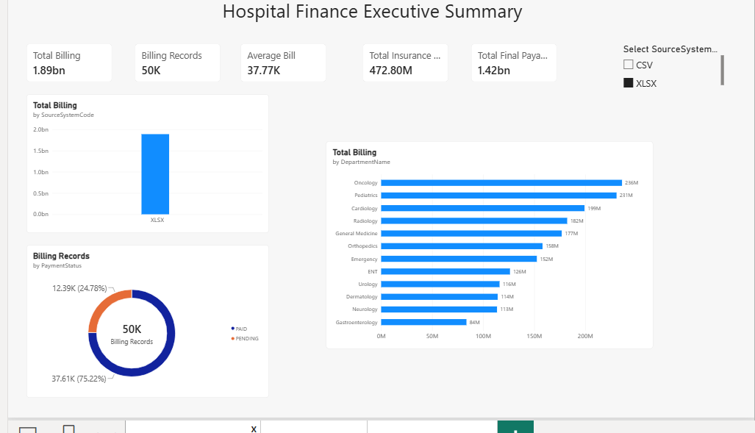
Figure 3. Power BI Executive Summary Dashboard

7.3 Power BI - Trend Analysis
The Trend Analysis page focuses on changes over time. It includes yearly total billing, final payable trends, a source-and-year comparison, monthly billing analysis, and slicers for source system and year. The date hierarchy allows the analysis to move from year to quarter, month, and date when more detail is needed.
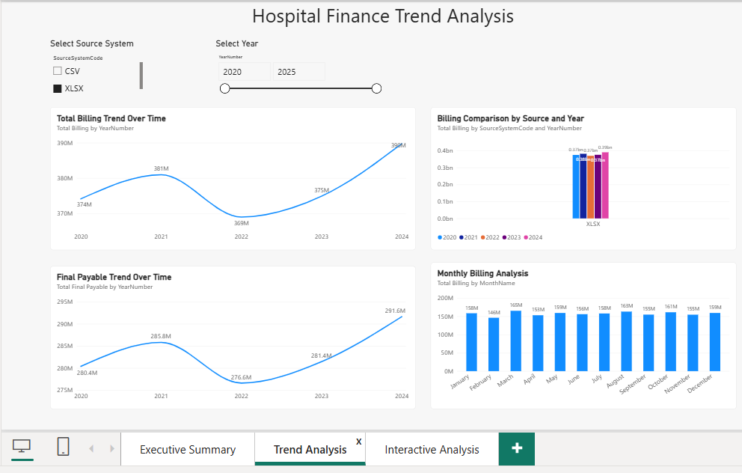
Figure 4. Power BI Trend Analysis Dashboard

7.4 Power BI - Interactive Analysis
The Interactive Analysis page was created for more detailed exploration. It combines source, year, department, and payment-status slicers with department-to-doctor drill-down, an expandable matrix, insurance-provider analysis, and payment-method distribution. The matrix can be expanded and collapsed, which demonstrates drill-down and roll-up in a way that is easy for a report user to understand.
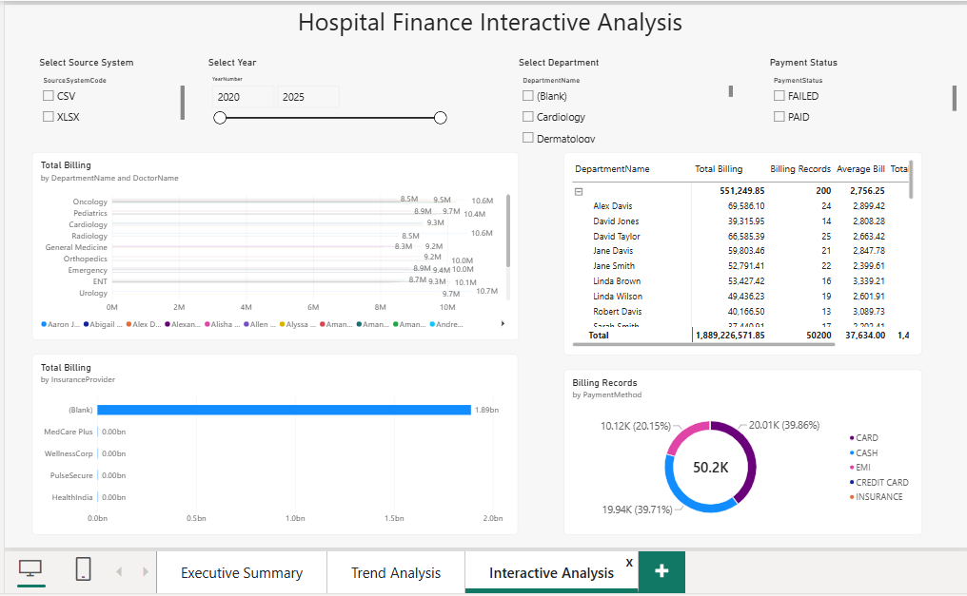
Figure 5. Power BI Interactive Analysis Dashboard

Task 8: Business Insights and Recommendations
I used the completed Power BI dashboards to identify the following business insights. The recommendations are based on the patterns visible in my own dashboard results and are intended to show how the BI solution could support finance and management decisions.

8.1 Insight 1 - Source System Billing Contribution
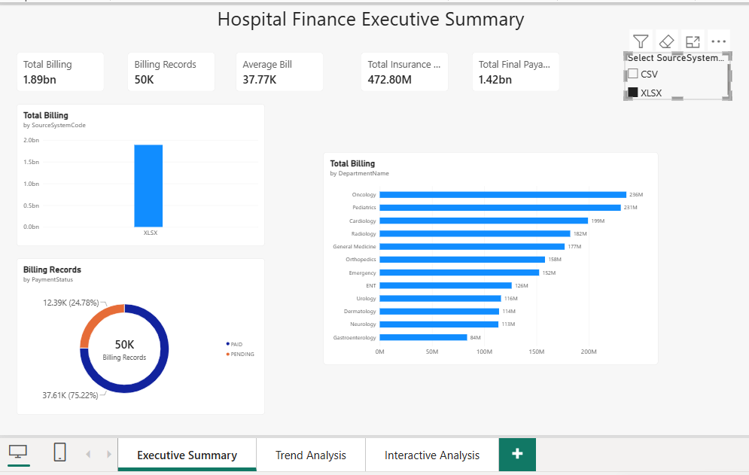
Figure 6. Source-system billing dashboard view
Finding: The XLSX source contributes almost all of the integrated finance activity, with 50,000 billing records and about 1.89 billion in total billing. The CSV source contains only 200 billing records, so its contribution to the combined totals is very small. This is mainly a source-volume difference and should not be interpreted as a fair performance comparison between two equal-sized hospitals.
Recommendation: Source filtering should remain available in management dashboards so that users can separate source-size effects from real operational patterns. I would review source-level KPIs before making any direct comparison between the two source systems.

8.2 Insight 2 - Department Financial Performance
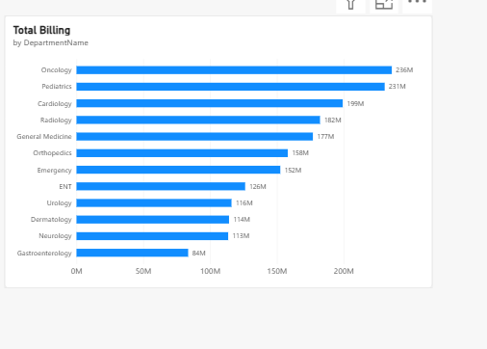
Figure 7. Department-level total billing
Finding: Oncology has the highest displayed total billing at about 236 million, followed by Pediatrics at about 231 million and Cardiology at about 199 million. Gastroenterology is the lowest among the displayed departments at about 84 million. The spread across departments shows that financial activity is not evenly distributed.
Recommendation: These billing totals should be considered together with workload, staffing, equipment needs, and clinical demand. A high-billing department may need more capacity, while a lower-billing department should not be judged only by revenue because its clinical role may be different.

8.3 Insight 3 - Billing Trend Over Time
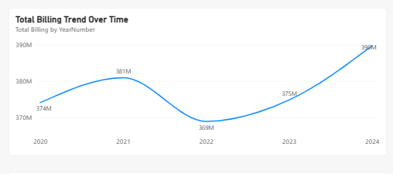
Figure 8. Total billing trend by year
Finding: Total billing rises from about 374 million in 2020 to 381 million in 2021, falls to about 369 million in 2022, then recovers to 375 million in 2023 and reaches about 390 million in 2024. The main pattern is therefore a temporary decline in 2022 followed by a two-year recovery.
Recommendation: The 2022 decline is a useful point for further investigation. In a real hospital setting, I would compare the financial trend with patient volume, treatment mix, pricing, and other operational measures before deciding what caused the change. The recovery trend can also support future budgeting and forecasting.

8.4 Insight 4 - Payment Method Behaviour
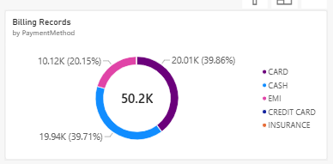
Figure 9. Billing records by payment method
Finding: Card and cash are the two dominant payment methods, with about 20.01K (39.86%) and 19.94K (39.71%) billing records respectively. EMI contributes about 10.12K (20.15%), while credit card and insurance represent only a very small remaining share. This suggests that most payments are settled through card or cash, with EMI still representing a meaningful secondary option.
Recommendation: The hospital should maintain reliable card and cash payment workflows because they handle most transactions. EMI collections should also be monitored carefully because instalment-based payments introduce an additional follow-up and reconciliation requirement.

8.5 Insight 5 - Doctor and Department Contribution
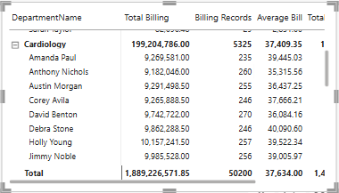
Figure 10. Cardiology doctor-level contribution matrix
Finding: Cardiology contributes about 199.20 million from 5,325 billing records, with an average bill of about 37.41K. Expanding the matrix shows that the department total is spread across several doctors, with many visible doctor totals around 9-10 million. This demonstrates how the model can move from a department-level summary to individual doctor contribution.
Recommendation: Doctor-level billing should be interpreted together with workload, case complexity, and quality measures rather than being used as a standalone performance score. The drill-down view is most useful for spotting unusual billing or workload patterns that may need a closer review.

8.6 Additional Payment Status Observation
The Executive Summary also shows about 37.61K paid billing records (75.22%) and 12.39K pending records (24.78%). A pending share of almost one quarter is large enough to matter for revenue-cycle management. In practice, this could be followed up with ageing analysis, collection priorities, and more detailed monitoring of outstanding balances.

Conclusion
This individual project brought together the full Data Warehouse and BI workflow, starting from raw CSV and Excel files and ending with an interactive Power BI solution. I staged and cleaned the two independent source systems, integrated them into a conformed dimensional warehouse, and kept appointments, admissions, treatments, and billing as separate facts so that each business process retained its correct grain.
The Finance Data Mart provided a focused layer for financial reporting, while SSAS added reusable measures and a date hierarchy for analysis. Power BI then turned the model into executive KPIs, time trends, slicers, filters, and drillable views. Overall, the project shows how a structured DWBI solution can make fragmented operational hospital data more useful for budgeting, payment monitoring, department analysis, and management decision-making.

References
Kaggle Dataset 1: Hospital Management Dataset - garimakochale
Kaggle Dataset 2: Hospital Management Dataset - kanakbaghel
Microsoft SQL Server, SQL Server Integration Services (SSIS), SQL Server Analysis Services (SSAS), SQL Server Management Studio (SSMS) and Microsoft Power BI were used to implement the solution.

AI Usage Acknowledgement
I used generative AI as a supporting learning tool during this individual project. It helped me clarify Data Warehouse concepts, plan some implementation steps, troubleshoot SSIS and SSAS configuration problems, improve explanations, and organise the final report. I completed the practical implementation myself, including the configuration, screenshots, validation checks, and Power BI outputs. I reviewed and adapted AI suggestions so that the final report matches the system I actually implemented and the results I obtained.

Appendix - Key Implemented Objects
Database / Project | Key Objects
Hospital_Staging | Source-specific CSV and XLSX staging tables
Hospital_DW | 6 conformed dimensions and 4 fact tables
Hospital_ETL | Load_Staging.dtsx and Load_DW.dtsx SSIS packages
Hospital_Finance_DM | Finance dimensions and FactFinanceBilling
Hospital_Finance_SSAS | SSAS Tabular semantic model and measures
Power BI | Executive Summary, Trend Analysis, Interactive Analysis

