QUARTERLY OPERATIONS REPORT
July to September 2026

DRAFT · Practice file for Microsoft Word: Build Better Documents

About this practice file
This draft contains the problems covered in the course. Turn on Show/Hide ¶ (Ctrl+Shift+8) and the Navigation Pane (Ctrl+F), then fix:
- Headings typed in bold instead of using Heading styles (only one heading uses a style)
- A typed contents page that never updates
- Empty paragraphs and spaces used for layout
- A budget table that runs off the page: give it a landscape page of its own
- A long staffing table whose header row doesn’t repeat on the next page
- Page numbers that restart at 1 in the Appendix
- A large chart that needs compressing and alt text
- A blank page at the very end

Contents
1. Executive summary .................................................. 4
2. Operations ......................................................... 4
2.1 Service delivery ............................................... 5
3. Budget ............................................................. 6
4. Staffing ........................................................... 7

1. Executive summary
This report summarises operational performance for July to September 2026. Service volumes increased, response times improved and the quarter closed within budget overall.

Key result: 91% of requests were resolved within target.
Region Resolved Target

2. Operations
Demand for front-line services rose steadily through the quarter, driven by seasonal enquiries and two new programs launched in February.
Teams responded by extending opening hours at three regional offices and moving routine requests to the online portal.
The portal now handles just over a third of all requests, up from a quarter last quarter.
2.1 Service delivery
Demand for front-line services rose steadily through the quarter, driven by seasonal enquiries and two new programs launched in February.
Teams responded by extending opening hours at three regional offices and moving routine requests to the online portal.
The portal now handles just over a third of all requests, up from a quarter last quarter.
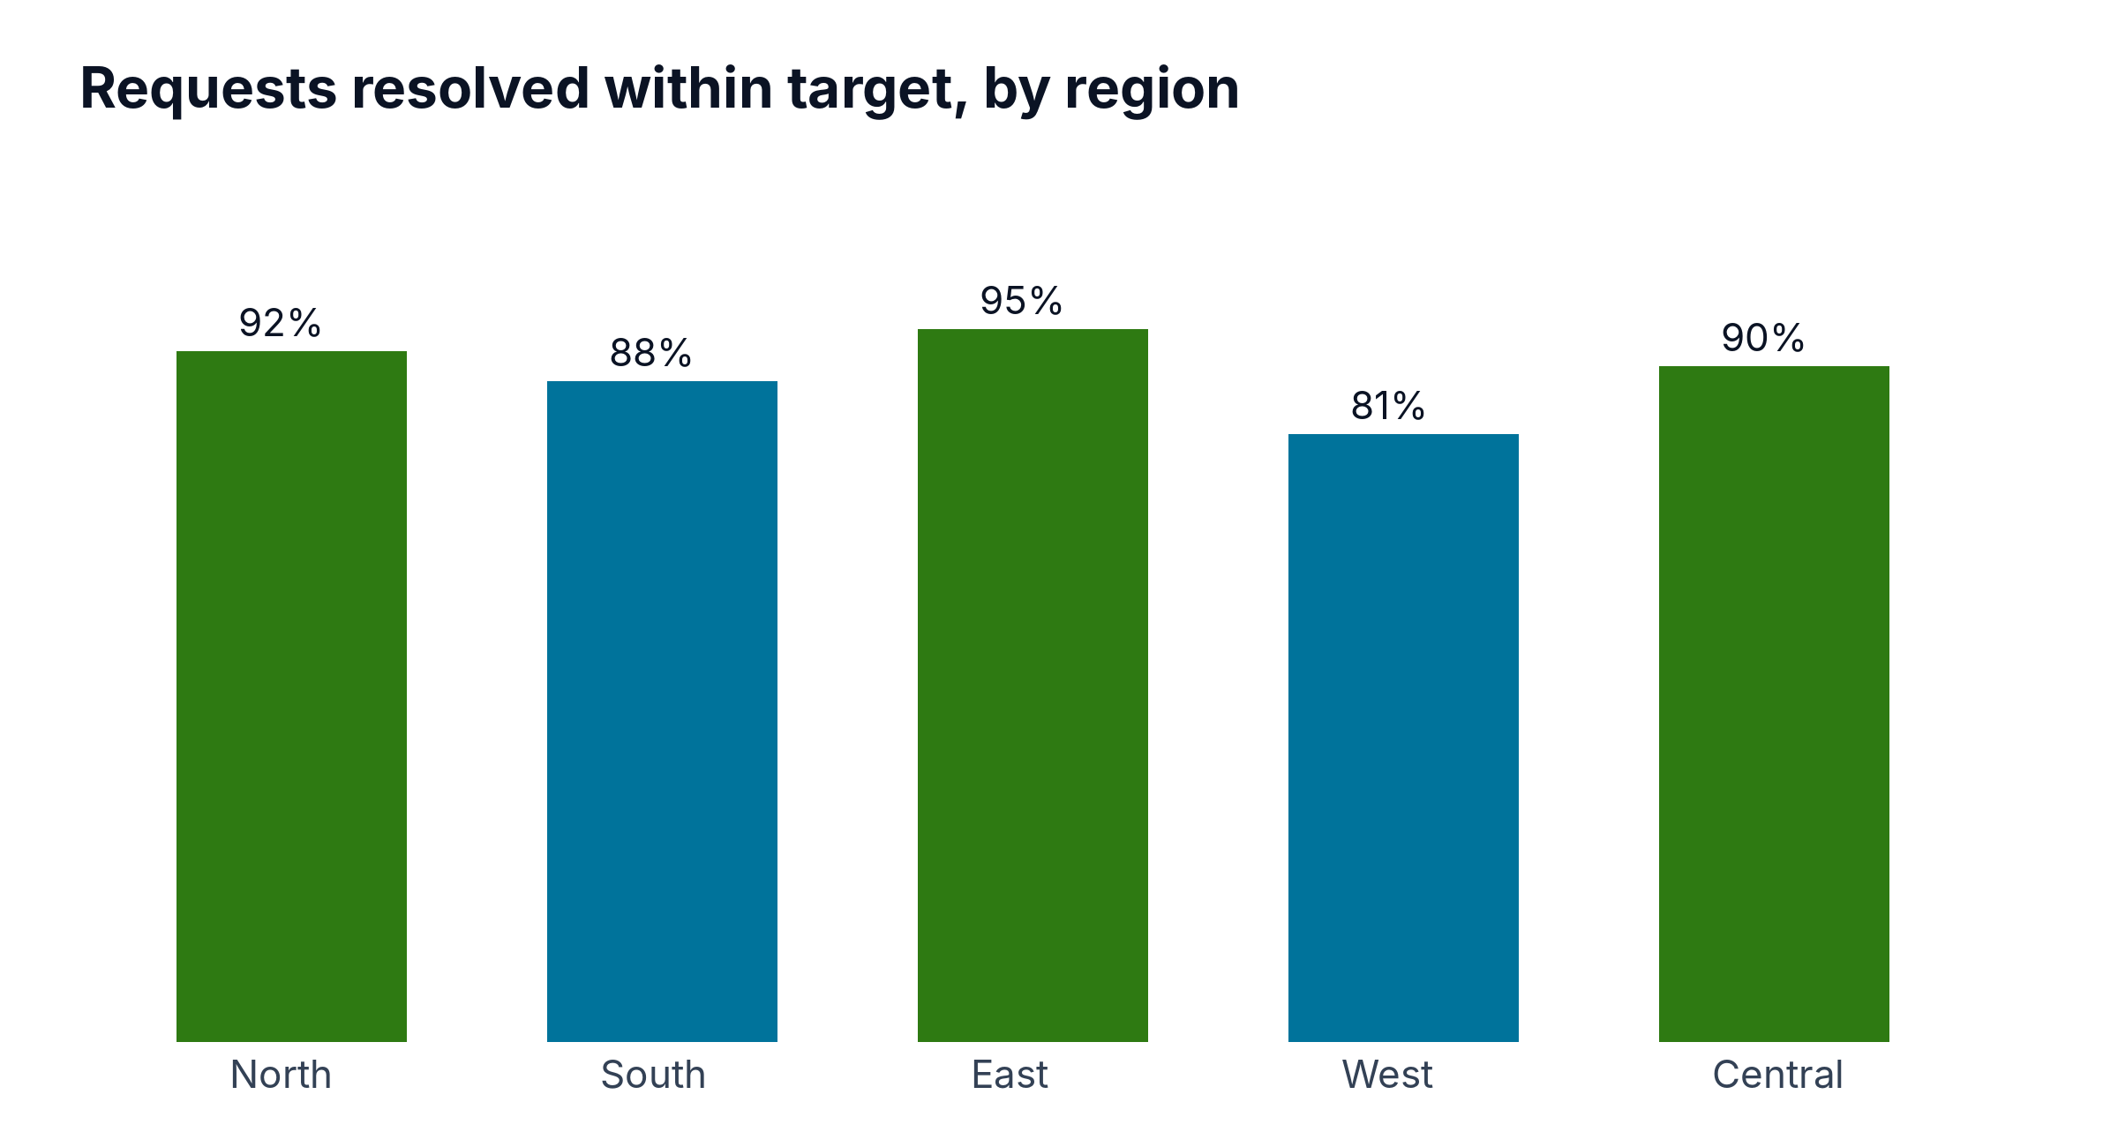

3. Budget
The budget table below compares budget and actual expenditure for the first three quarters.
Cost centre | Q1 budget | Q1 actual | Q2 budget | Q2 actual | Q3 budget | Q3 actual | Variance | Notes
Service delivery | 412,000 | 405,300 | 418,000 | 421,900 | 420,000 | 416,200 | -3,800 | Within tolerance
Facilities | 96,000 | 101,400 | 96,000 | 98,700 | 96,000 | 99,100 | +3,100 | Lease increase
ICT | 158,000 | 149,900 | 158,000 | 161,250 | 158,000 | 155,600 | -2,400 | Licence savings
Training | 42,000 | 38,150 | 42,000 | 44,900 | 42,000 | 47,800 | +5,800 | Word upskilling
Travel | 21,000 | 17,300 | 21,000 | 19,650 | 21,000 | 22,900 | +1,900 | Regional visits

4. Staffing
All positions by team, type and status at 30 September.
Position | Team | Type | Status
Position 101 | Service delivery | Full time | Filled
Position 102 | Facilities | Part time | Filled
Position 103 | ICT | Contract | Vacant
Position 104 | Policy | Full time | Filled
Position 105 | Finance | Part time | Filled
Position 106 | People & Culture | Contract | Filled
Position 107 | Communications | Full time | Vacant
Position 108 | Service delivery | Part time | Filled
Position 109 | Facilities | Contract | Filled
Position 110 | ICT | Full time | Filled
Position 111 | Policy | Part time | Vacant
Position 112 | Finance | Contract | Filled
Position 113 | People & Culture | Full time | Filled
Position 114 | Communications | Part time | Filled
Position 115 | Service delivery | Contract | Vacant
Position 116 | Facilities | Full time | Filled
Position 117 | ICT | Part time | Filled
Position 118 | Policy | Contract | Filled
Position 119 | Finance | Full time | Vacant
Position 120 | People & Culture | Part time | Filled
Position 121 | Communications | Contract | Filled
Position 122 | Service delivery | Full time | Filled
Position 123 | Facilities | Part time | Vacant
Position 124 | ICT | Contract | Filled
Position 125 | Policy | Full time | Filled
Position 126 | Finance | Part time | Filled
Position 127 | People & Culture | Contract | Vacant
Position 128 | Communications | Full time | Filled
Position 129 | Service delivery | Part time | Filled
Position 130 | Facilities | Contract | Filled
Position 131 | ICT | Full time | Vacant
Position 132 | Policy | Part time | Filled
Position 133 | Finance | Contract | Filled
Position 134 | People & Culture | Full time | Filled
Position 135 | Communications | Part time | Vacant
Position 136 | Service delivery | Contract | Filled
Position 137 | Facilities | Full time | Filled
Position 138 | ICT | Part time | Filled
Position 139 | Policy | Contract | Vacant
Position 140 | Finance | Full time | Filled
Position 141 | People & Culture | Part time | Filled
Position 142 | Communications | Contract | Filled
Position 143 | Service delivery | Full time | Vacant
Position 144 | Facilities | Part time | Filled
Position 145 | ICT | Contract | Filled
Position 146 | Policy | Full time | Filled
Position 147 | Finance | Part time | Vacant
Position 148 | People & Culture | Contract | Filled
Position 149 | Communications | Full time | Filled
Position 150 | Service delivery | Part time | Filled
Position 151 | Facilities | Contract | Vacant
Position 152 | ICT | Full time | Filled
Position 153 | Policy | Part time | Filled
Position 154 | Finance | Contract | Filled
Position 155 | People & Culture | Full time | Vacant
Position 156 | Communications | Part time | Filled
Position 157 | Service delivery | Contract | Filled
Position 158 | Facilities | Full time | Filled
Position 159 | ICT | Part time | Vacant
Position 160 | Policy | Contract | Filled
Position 161 | Finance | Full time | Filled
Position 162 | People & Culture | Part time | Filled
Position 163 | Communications | Contract | Vacant
Position 164 | Service delivery | Full time | Filled
Position 165 | Facilities | Part time | Filled
Position 166 | ICT | Contract | Filled
Position 167 | Policy | Full time | Vacant
Position 168 | Finance | Part time | Filled
Position 169 | People & Culture | Contract | Filled
Position 170 | Communications | Full time | Filled
Position 171 | Service delivery | Part time | Vacant
Position 172 | Facilities | Contract | Filled

5. Risks
Two risks need attention next quarter: rising facilities costs and three vacant ICT positions.
6. Recommendations
Fill vacant ICT positions, review the facilities lease and continue moving routine requests online.

Appendix A: Data sources
Service volumes: case management system extract, 1 October 2026.
Budget: finance system report, 3 October 2026.

