Q.0. How have you got the values of SRAD as provided in the Excel sheet you shared the last time?

I have used insolation incident on a horizontal surface as the value of solar radiation (SRAD). In NASA dataset, the value of this on January 1, 2018 for Khulna is 8.16 MJ/m^2/day or 8160 kJ/m^2/day. But in your excel file, the total value of SRAD on January 1, 2018 for Khulna is 2720 kJ/m^2/day.

Q.1. How is the value of e_s between 1 and 3.5 in your calculation?

The calculation of e_s is described in the paper as

e_s = 25.375 * exp(17.62 - (5271 / T_wc))

So if the value of T_wc is as low as 10 degree, the value of e_s will be 1.380554e-220 and if the value of T_wc is as high as 30 degree, the value of e_s will be 5.63812e-68. But in your calculation, the values of e_s are roughly between 1 and 3.53. How?

Q.2 How is the value of e_a between 0.2 and 0.7 in your calculation?

The formula described in the paper is

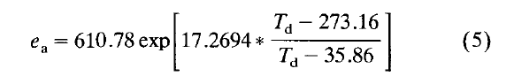

According to the paper, average daily dew-point temperature or T_d may be estimated by subtracting 20 C from the morning minimum dry-bulb temperature. Here, I considered minimum air temperature as morning minimum dry-bulb temperature. Thus Td is calculated as

T_d = (tmin_air - 2) + 273.15

If tmin_air range between 60 and 300, T_d ranges between 277.15 and 301.15 and thus e_a ranges between 812.65 and 3777.367. But, in your calculation, e_a is between 0.2 and 0.7.