Numerical Damping of the Diurnal Ground Heat Flux over Urban Substrates
Shammunul Islam — CLIM-715 Course Project

Abstract
Three numerical schemes for the 1-D substrate heat conduction equation — FTCS, BTCS, and Crank–Nicolson — are compared on three urban substrate columns (asphalt road, concrete roof with rigid insulation, bare soil) coupled to a fully prognostic surface energy balance solved by Newton iteration. FTCS is conditionally stable with the textbook bound ν ≤ 1/2; for the asphalt road and concrete roof the layer-by-layer FTCS critical Δt is 33 s and 17 s respectively, well below operational time steps. At Δt = 600 s, BTCS over-amplifies the diurnal G amplitude by 40 % on asphalt and concrete and 19 % on bare soil, with surface temperature RMSE up to 3.7 K on the roof; CN halves these errors. Empirical Δt-refinement ratios are close to 10:1 for both BTCS and CN — first-order in Δt for both schemes — identifying the dominant error as a first-order operator-splitting error in the column-then-SEB ordering, not the schemes' own per-substep accuracy. The daily storage integral ∫G dt is preserved across schemes to within ±5 %, so the diurnal amplitude inflation is symmetric in day/night. A SHAP attribution analysis on N = 150 synthetic substrate columns identifies top-cell thermal diffusivity κ_top as the dominant predictor of BTCS coarse-Δt error (R² = 0.92 from κ_top alone), with bulk admittance secondary and layer-interface descriptors a small but non-zero residual contribution.

1. Introduction
The conductive ground heat flux G is the smallest term in the urban surface energy balance by daily mean but the largest control on the diurnal range of surface temperature, and on the nocturnal urban heat island. The diurnal damping depth in dense concrete and asphalt is ~10 cm, requiring cm-scale near-surface layers to resolve. The FTCS stability bound ν ≤ 1/2 then forces Δt < ~17 s for a 1 cm concrete layer, far below operational time steps. Implicit (BTCS) and Crank–Nicolson schemes are unconditionally stable but introduce wavenumber-dependent damping that distorts the high-frequency content of the diurnal cycle, particularly at sharp interfaces in layered urban substrates. This project compares all three schemes on three idealised urban substrates and supplements the mechanistic analysis with a SHAP attribution on a 150-column synthetic substrate ensemble.

2. Methods

2.1 Discretization
Substrate temperature is on a stretched grid of 24–30 cell centres from z₀ = 0 (surface) to z = 2 m, with Δz_top = 0.5–1.0 cm and geometric stretch 1.18–1.25. Thermal conductivity is half-level harmonic-mean to preserve flux across material discontinuities. Boundary conditions: Dirichlet (Ts⁰) at the surface; Neumann (zero-flux) at z = 2 m. The conductivity form Cs ∂Ts/∂t = ∂z(λs ∂z Ts) is used to handle layered substrates exactly.

2.2 Three time-stepping schemes (α-method)
The α-weighted θ-method takes a convex combination of explicit and implicit flux divergence: α = 0 (FTCS), α = 1 (BTCS), α = 1/2 (CN). These are the Euler, Backward, and Trapezoidal schemes of Lecture 6, Section 6 (Slides 15–17). The diffusion-equation amplification factors derived in Notes #9 ("Pure Diffusion (Von Neumann Analysis)" and "Implicit Diffusion") are A_FTCS = 1 − 2ν(1−cos kΔz), A_BTCS = 1/[1 + 2ν(1−cos kΔz)], A_CN = [1 − ν(1−cos kΔz)] / [1 + ν(1−cos kΔz)], with ν = κs Δt / Δz². FTCS is conditionally stable (ν ≤ 1/2 for the 2Δz mode); BTCS is unconditionally stable and strictly damping; CN is unconditionally stable but A_CN(ν, π) → −1 as ν → ∞ (preserves magnitude, flips sign of the 2Δz mode).
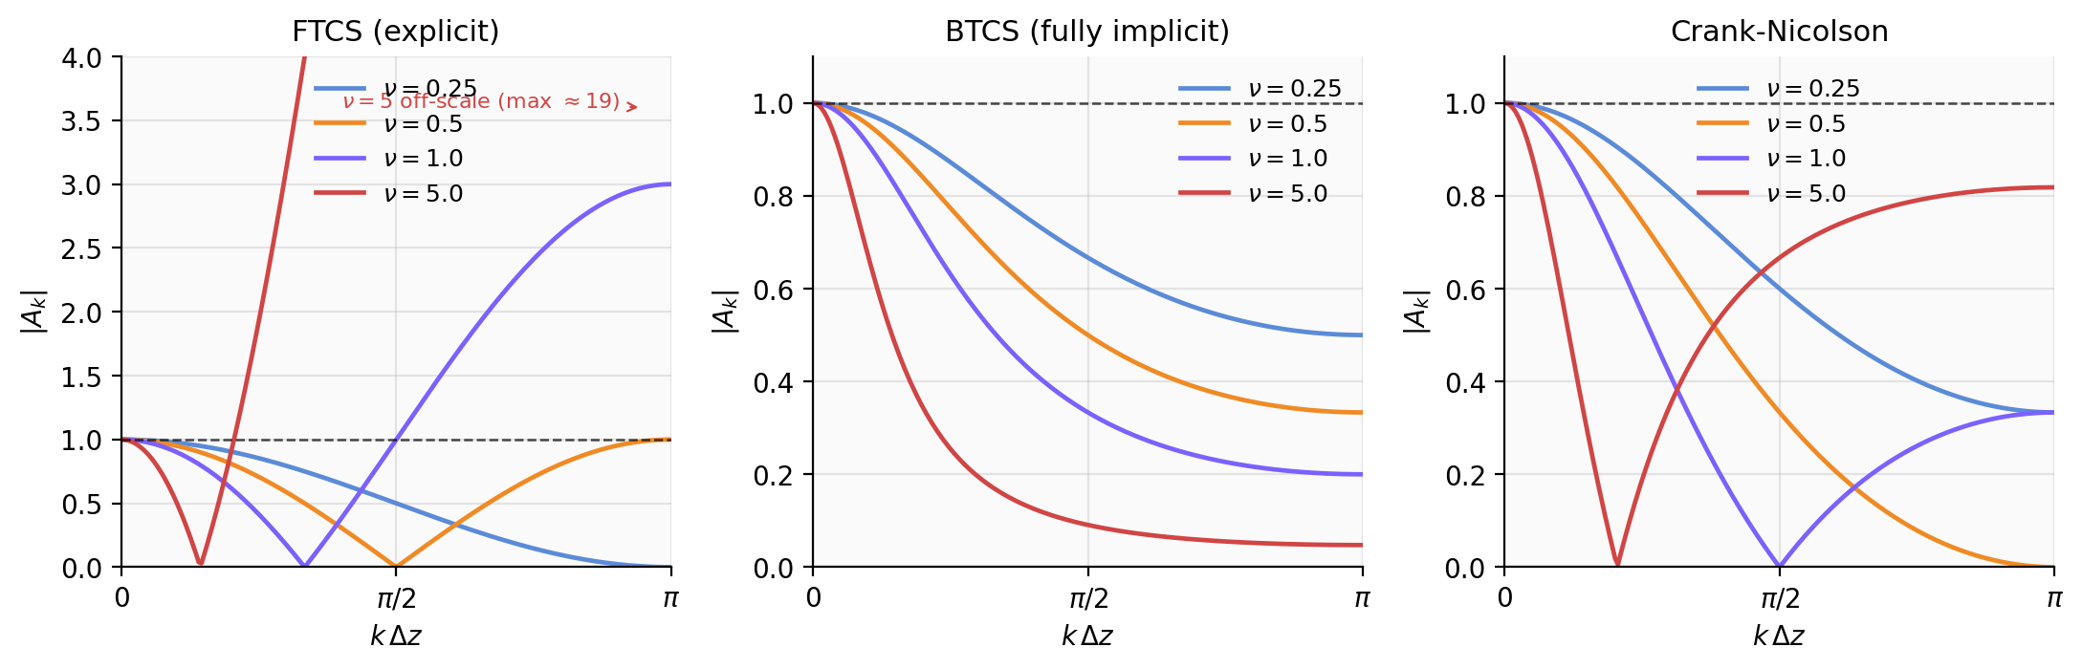
Figure 1. Magnitude of the von Neumann amplification factors |A_k(ν, kΔz)| for FTCS (left), BTCS (centre), and CN (right). Dashed line is the |A| = 1 stability bound. FTCS at ν = 5 is off-scale at the 2Δz wave (|A| ≈ 19).

2.3 Substrates and SEB
Asphalt road: 0–5 cm asphalt (λ = 0.75, C = 2.0e6); 5–25 cm aggregate (1.40, 2.4e6); 25–100 cm dry soil (0.30, 1.3e6); 100–200 cm subsoil (0.50, 1.8e6). Concrete roof: 0–10 cm concrete deck (1.50, 2.1e6); 10–20 cm rigid insulation (0.04, 0.08e6); 20–200 cm interior (0.15, 1.5e6). Bare soil: uniform sandy loam (0.30, 1.3e6). The SEB Rn − H − LE − G = 0 is solved at each step by Newton iteration with analytical Jacobian (LE = 0 strict-impervious; r_a = 1/(C_H U), C_H = 5e-3, U = 3 m/s). Synthetic forcing: S↓ peaks 1000 W/m² at noon, T_air = 292.5 + 7.5 cos(ω(t−14h)) K. Initialisation: analytical damping-depth profile, refined by one Newton step. Test 1 verifies against the analytical sinusoidal-Dirichlet solution. Test 2 = 27 cells (3 substrates × 3 schemes × 3 Δt ∈ {15, 60, 600} s).

3. Results

3.1 Test 1 verification
On a uniform sandy-loam column with prescribed sinusoidal Ts⁰, all three schemes match the analytical damping-depth solution closely. FTCS at ν = 0.4 gives day-5 RMSE in T at z = 10 cm of 0.007 K. FTCS at ν = 0.6 (only 20 % above the stability bound) blows up at step 53, consistent with |A_FTCS(0.6, π)| = 1.4. BTCS error grows roughly linearly with Δt (0.024 K at Δt = 300 s, 0.062 K at Δt = 900 s — first-order); CN error is essentially flat (0.005 K at 300 s, 0.006 K at 900 s — second-order). CN at ν = 2.08 produces a smaller error than FTCS at ν = 0.4 with 5× fewer steps, confirming the textbook second-order accuracy.

3.2 Test 2 cross-substrate summary
Table 2 reports A_G/A_ref / RMSE_Ts (K) / S/S_ref for each of the 27 cells. Bare-soil errors at Δt = 600 s are about one quarter of asphalt errors despite admittance ratio 1:2, indicating bulk admittance does not explain the substrate dependence on its own. The daily storage integral S = ∫G dt is within ±5 % of the FTCS Δt = 15 s reference across every cell, confirming that the diurnal amplitude inflation is symmetric in day/night and does not bias the daily mean.
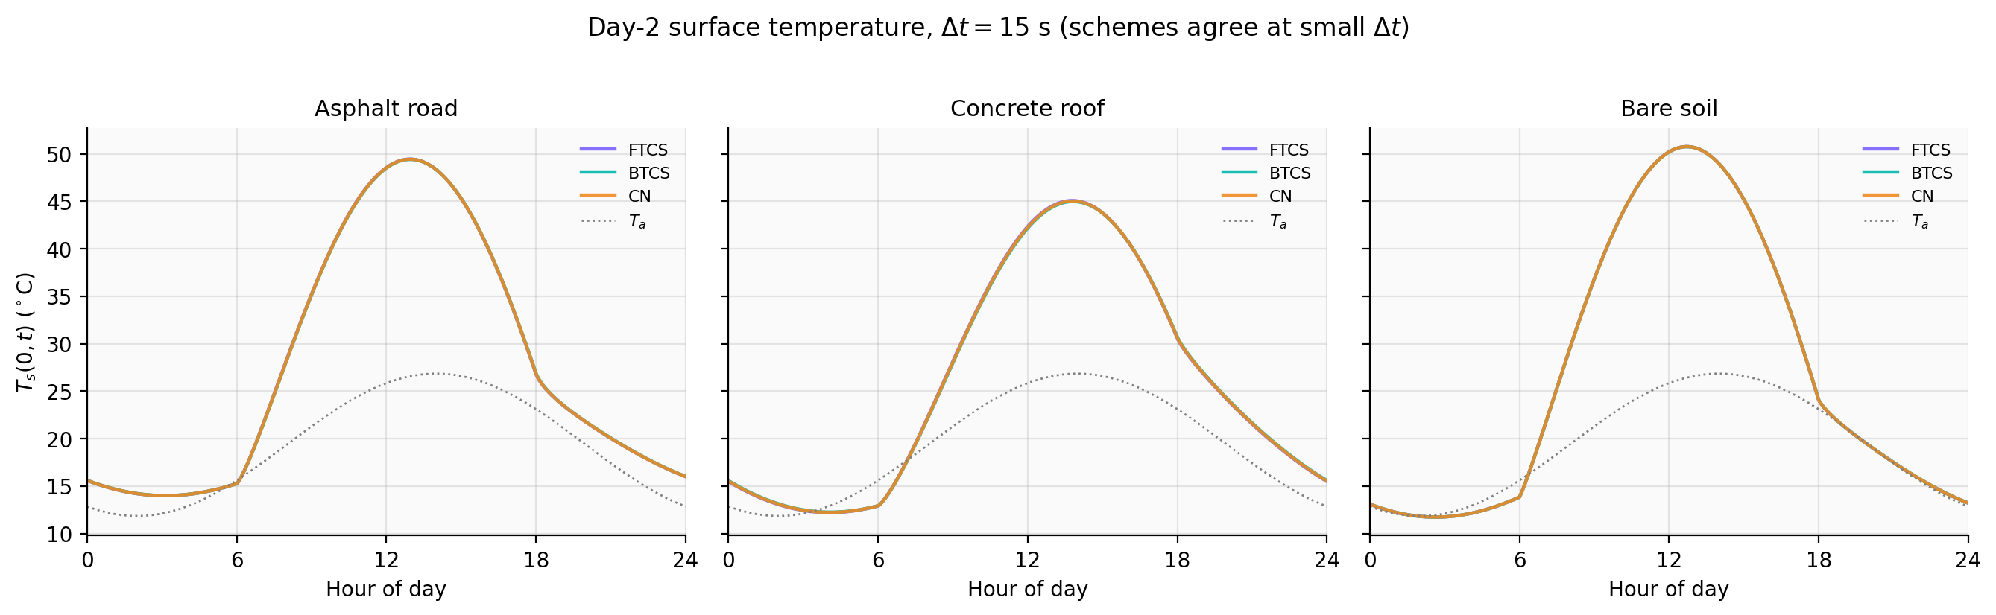
Figure 2. Day-2 surface temperature at Δt = 15 s; the three numerical schemes are visually indistinguishable on every substrate at this small time step.
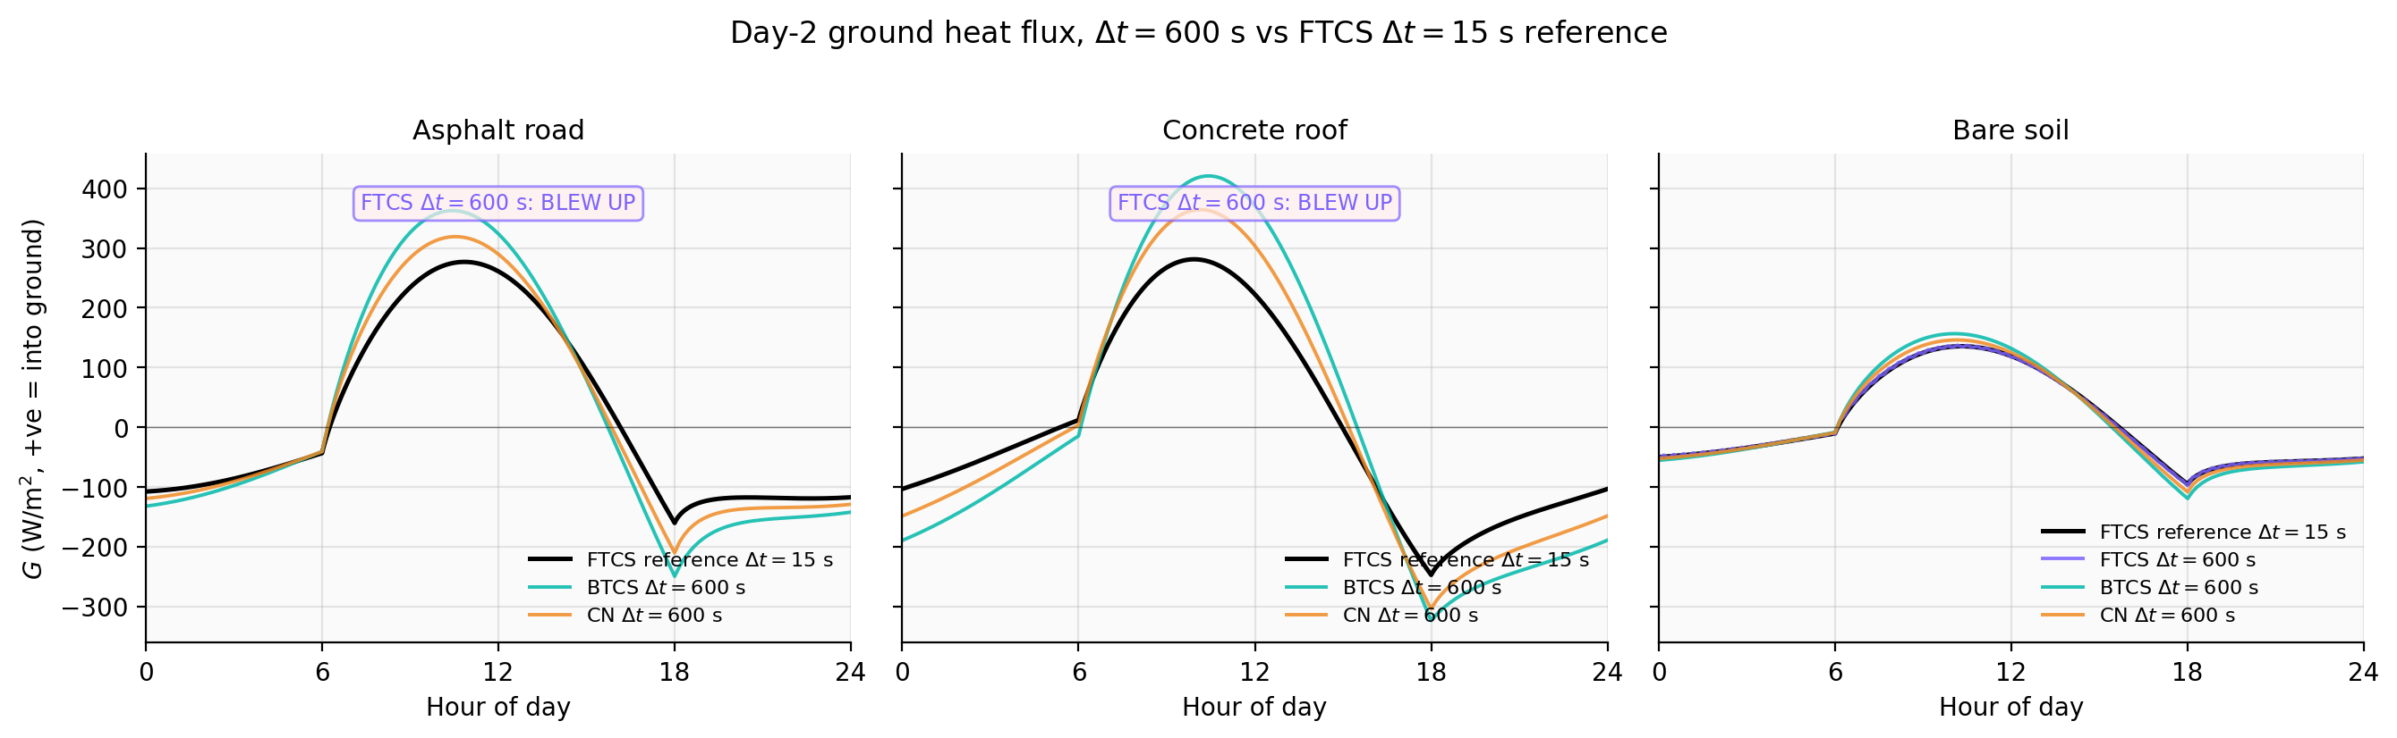
Figure 3. Day-2 ground heat flux at Δt = 600 s vs the FTCS Δt = 15 s reference. BTCS overshoots the daytime peak by 40 % on asphalt and concrete; CN is intermediate; soil errors are smallest. FTCS at Δt = 600 s is unstable on asphalt and roof.
Surface | Scheme | Δt = 15 s | Δt = 60 s | Δt = 600 s
Asphalt | FTCS | 1.000 / 0.000 / 1.000 (ref) | 1.000 / 0.003 / 1.000 | BLEW UP
Asphalt | BTCS | 1.010 / 0.056 / 1.001 | 1.042 / 0.225 / 1.003 | 1.400 / 2.104 / 1.033
Asphalt | CN | 1.005 / 0.028 / 1.000 | 1.021 / 0.114 / 1.002 | 1.211 / 1.115 / 1.017
Roof | FTCS | 1.000 / 0.000 / 1.000 (ref) | BLEW UP | BLEW UP
Roof | BTCS | 1.015 / 0.113 / 1.000 | 1.061 / 0.450 / 0.999 | 1.409 / 3.686 / 0.958
Roof | CN | 1.008 / 0.057 / 1.000 | 1.032 / 0.229 / 1.000 | 1.265 / 2.102 / 0.991
Soil | FTCS | 1.000 / 0.000 / 1.000 (ref) | 1.001 / 0.002 / 1.000 | 1.017 / 0.049 / 1.001
Soil | BTCS | 1.005 / 0.013 / 1.000 | 1.019 / 0.053 / 1.001 | 1.195 / 0.529 / 1.007
Soil | CN | 1.002 / 0.006 / 1.000 | 1.010 / 0.027 / 1.000 | 1.102 / 0.279 / 1.004
Table 2. Cross-substrate quantitative summary. Each cell reports A_G/A_ref / RMSE_Ts (K) / S/S_ref, all evaluated on day 2.

3.3 Δt-refinement: first-order splitting error
Table 3 reports the ratio of RMSE_Ts at Δt = 600 s to RMSE_Ts at Δt = 60 s. Both BTCS and CN show ratios close to 10 across all three substrates (range 8.2–10.2), exactly what is expected for a first-order error in Δt. Critically, CN by itself is second-order in time, so a CN ratio close to 10 (rather than 100) is direct evidence that the dominant error is not the within-substep CN truncation but the operator-splitting error between the column and SEB updates, which is first-order regardless of the per-substep scheme. The factor-of-two reduction in CN error compared to BTCS at fixed Δt then reflects the prefactor in front of the splitting term.
Surface | Scheme | RMSE_Ts at Δt = 60 s (K) | RMSE_Ts at Δt = 600 s (K) | Ratio (10× = first-order)
Asphalt | BTCS | 0.225 | 2.104 | 9.4
Asphalt | CN | 0.114 | 1.115 | 9.8
Roof | BTCS | 0.450 | 3.686 | 8.2
Roof | CN | 0.229 | 2.102 | 9.2
Soil | BTCS | 0.053 | 0.529 | 9.9
Soil | CN | 0.027 | 0.279 | 10.2
Table 3. Δt-refinement ratios for BTCS and CN. Both schemes show first-order Δt scaling, identifying operator splitting as the dominant error.

4. Discussion

4.1 Why BTCS over-amplifies G at large Δt
BTCS is strictly damping in the von Neumann sense, so naive expectation is that it would under-amplify G — but that is for an unforced decay problem. With a prognostic SEB, Notes #10 Section 8 of the course material warns that running an implicit/fast process first relaxes the system toward an "equilibrium with respect to only one process" — the wrong equilibrium. Our column-first-then-SEB ordering does this every step: the column relaxes toward Dirichlet equilibrium with the previous Ts⁰, after which the SEB updates Ts⁰ from the new T₁. At small Δt the gap between this single-process equilibrium and the true coupled equilibrium is negligible. At large Δt, Ts⁰ swings further between updates than it would in the limit Δt → 0, the gradient at the top half-level is correspondingly steeper, and BTCS evaluates the diffusion operator entirely at the post-swing temperature and amplifies the gradient effect. CN's α = 1/2 splits the evaluation between old and new time levels, partially cancelling the swing.

4.2 Implications for the simulated UHI
The daily storage integral is preserved within ±5 %, so the simulated nocturnal UHI is not biased in its daily mean but is inflated in its diurnal range: simulated nocturnal warming is too large and simulated dawn cooling too sharp. This is consistent with Notes #11 Misconception #8, which notes that surface conditions are diagnosed from a balance and that errors in any budget component propagate directly into the simulated near-surface temperature. For a mesoscale model running at Δt = 60 s with BTCS, the present results suggest a nocturnal G inflation of about 6 % on asphalt and concrete and 2 % on bare soil; at Δt = 600 s, the inflation grows to 40 % and 20 %.

5. Independent SHAP attribution analysis
To obtain a methodologically distinct line of evidence on the substrate-dependence of the BTCS coarse-Δt error, we sample N = 150 three-layer substrate columns from a wide prior over plausible urban-substrate parameters and run each at BTCS Δt = 600 s vs a BTCS Δt = 15 s reference. Six substrate descriptors (top-cell thermal diffusivity κ_top, bulk admittance μ_eff, max λ contrast across internal interfaces, # significant interfaces, depth of first interface, top-layer thickness) are regressed against day-2 RMSE_Ts using a GradientBoostingRegressor. In-sample R² = 0.96; 5-fold CV R² = 0.61.
SHAP TreeExplainer identifies κ_top as the dominant feature (mean |SHAP| = 0.71 K), explaining 92 % of the variance on its own. Bulk admittance is the strongest residual predictor after κ_top is partialled out; layer-interface descriptors enter the residual but are not the dominant signal. The §3.2 three-substrate finding is reconcilable with this picture: the three substrates differ jointly in κ_top, admittance, and layer structure, and the κ_top scaling alone (soil 2.3e-7, asphalt 3.8e-7, roof 7.1e-7 m²/s) approximately reproduces the observed error ordering. Limitations: the synthetic ensemble uses a fixed grid, so it does not separate κ_top from the dimensionless ratio Δt × κ_top / Δz²_top; the 150-sample dataset is small for an ML attribution.
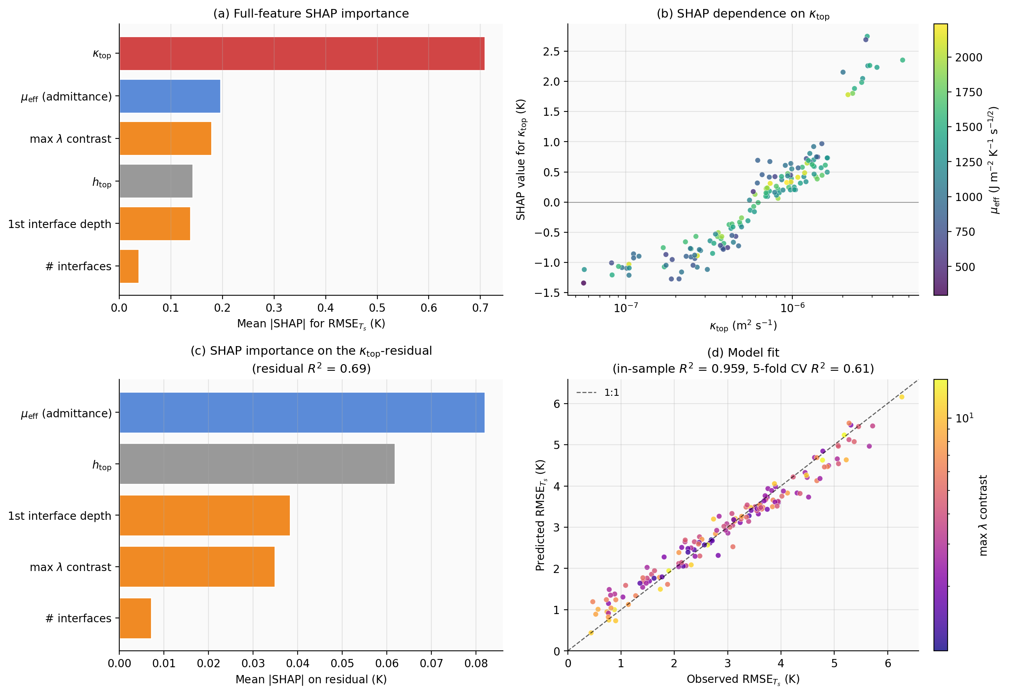
Figure 4. SHAP attribution analysis on N = 150 synthetic 3-layer substrate columns. (a) κ_top dominates the full-feature importance. (b) Monotone log-linear positive dependence of SHAP on κ_top. (c) On the κ_top-residual, μ_eff (admittance) is the strongest secondary predictor. (d) In-sample fit R² = 0.96; 5-fold CV R² = 0.61.

6. Conclusions
(i) FTCS is conditionally stable (ν ≤ 1/2). On a stretched-grid layered substrate the bound is set by the most thermally stiff layer; for asphalt and concrete-roof columns the critical Δt is 33 s and 17 s respectively, below operational time steps.
(ii) BTCS and CN are unconditionally stable. At Δt = 600 s, BTCS over-amplifies diurnal G by 40 % on asphalt and concrete, 19 % on bare soil; CN halves these errors.
(iii) Empirical Δt-refinement ratios are ~10 for both BTCS and CN — first-order in Δt for both — identifying operator splitting in the column-then-SEB ordering as the dominant error, not the schemes' own per-substep temporal accuracy. The factor-of-two CN advantage is a prefactor effect.
(iv) Daily storage ∫G dt is preserved across schemes to within ±5 %, so the diurnal amplitude inflation translates into an inflation of the nocturnal-UHI diurnal range rather than its mean.
(v) SHAP attribution on a 150-column synthetic substrate ensemble identifies κ_top as the dominant predictor of BTCS coarse-Δt error (R² = 0.92 from κ_top alone), with bulk admittance secondary and layer-interface descriptors smaller still. The reconciliation with the three-substrate finding is that κ_top, admittance, and layer structure differ jointly across the three idealised substrates.

References
Best et al. (2011) Geosci. Model Dev., 4, 677–699. Grimmond and Oke (1999) J. Appl. Meteorol., 38, 922–940. Kusaka et al. (2001) Boundary-Layer Meteorol., 101, 329–358. Lundberg and Lee (2017) NeurIPS 30, 4768–4777. Masson (2000) Boundary-Layer Meteorol., 94, 357–397. Oke (1987) Boundary Layer Climates, 2nd ed., Routledge.

