Numerical Damping of the Diurnal Ground Heat Flux
over Urban Substrates
A Comparison of Explicit, Implicit, and Crank–Nicolson Schemes Coupled to a Prognostic Surface Energy Balance
Shammunul Islam
Department of Atmospheric, Oceanic and Earth Sciences
George Mason University
CLIM-715 Numerical Methods for Climate and Weather Modeling — Course Project

Abstract
The ground heat flux is the energy that the surface stores and releases from its substrate over a diurnal cycle, and is the term in the surface energy budget that is most sensitive to numerical treatment. The governing one-dimensional heat conduction equation in the substrate is parabolic, and its explicit forward-time discretization is conditionally stable only when ν = κs Δt / Δz² ≤ 1/2 — a constraint that becomes prohibitive for the cm-scale near-surface layers that are required to resolve the diurnal damping depth in highly conductive urban substrates. This project compares three numerical treatments of the soil heat equation — forward-in-time, centered-in-space (FTCS); backward-in-time, centered-in-space (BTCS); and Crank–Nicolson (CN) — coupled to a fully prognostic surface energy balance solved by Newton iteration. Three substrate columns are run in parallel: an asphalt road, a concrete roof with rigid insulation, and a bare soil. The von Neumann amplification factor is derived for each scheme; a damping-depth verification test confirms second-order CN error against first-order BTCS error; and the prognostic surface-energy-balance integration over the three substrates exposes the substrate-dependence of the scheme errors. The principal findings are: FTCS blows up at Δt = 60 s on the concrete roof and at Δt = 600 s on the asphalt road and concrete roof, in agreement with the layer-by-layer stability bound; BTCS at Δt = 600 s over-amplifies the diurnal G amplitude by 40 % on asphalt and concrete and by 20 % on bare soil, with surface temperature RMSE up to 3.7 K on the roof; CN at the same Δt halves these errors. The empirical Δt-refinement ratios for BTCS and CN are both close to 10:1 between Δt = 60 s and Δt = 600 s — first-order in Δt for both schemes — which identifies the dominant error as a first-order operator-splitting error from the column-then-SEB ordering, not the schemes' own temporal accuracy orders. The daily storage integral ∫G dt is preserved across schemes to within 5 %, so the diurnal G inflation is symmetric in day/night and translates into an inflation of the diurnal range of the simulated nocturnal urban heat island rather than a bias in its mean. An independent attribution analysis using a gradient-boosted regression with SHAP feature importance on N = 150 synthetic substrate columns identifies top-cell thermal diffusivity κ_top — the parameter that sets the FTCS stability bound — as the dominant predictor of BTCS coarse-Δt error (R² = 0.92 from κ_top alone), with bulk admittance second and layer-interface descriptors a small but non-zero residual contribution.

1. Introduction
Land surface models advance the surface energy balance by predicting how much of the net radiative input is partitioned into sensible heat to the atmosphere, latent heat through evaporation, and conductive flux into the substrate. The conductive ground heat flux G is the smallest of the three terms by daily mean, but it is the single largest control on the diurnal range of surface temperature and, by extension, on the nocturnal contrast between urban and rural surfaces that defines the urban heat island. Heat stored in the substrate during the day — primarily in pavements, building walls, and roofs — is released back to the surface and atmosphere at night, and this release sustains the warm anomaly that persists for hours after sunset (Oke, 1987; Grimmond and Oke, 1999).
The numerical treatment of G is driven by the structure of the substrate. The diurnal damping depth d = √(2 κs / ω) for a substrate of thermal diffusivity κs and forcing angular frequency ω = 2π/86400 s⁻¹ is approximately 8 cm in dry soil, 14 cm in dense concrete, and 10 cm in asphalt — small enough that operational urban canopy schemes such as TEB (Masson, 2000) and SLUCM (Kusaka et al., 2001) use cm-scale near-surface layers. The consequence is that the FTCS stability bound on the time step becomes Δt < (1/2) Δz² / κs ≈ 17 s for a 0.5 cm concrete layer, far below the operational time step of any mesoscale or regional climate model. The choice between fully implicit (BTCS) and Crank–Nicolson (CN) treatments is not benign: both are unconditionally stable in the formal sense, but they introduce wavenumber-dependent damping that distorts the high-frequency content of the diurnal cycle, particularly at the rapid sunrise and sunset transitions and at sharp material interfaces in layered urban substrates.
This project investigates the trade-off between numerical stability and accuracy for ground heat conduction in three idealized urban substrates: an asphalt road, a concrete roof with a rigid insulation layer, and a bare soil reference. Three schemes are compared analytically through their von Neumann amplification factors and experimentally through two test configurations. Test 1 verifies the implementation against the analytical diurnal damping-depth solution for a uniform column. Test 2 couples each scheme to a fully prognostic surface energy balance, solved by Newton iteration, and integrates the three substrates for two diurnal cycles under synthetic forcing. Section 6 supplements the mechanistic numerical analysis with an independent ML-based attribution analysis over a 150-column synthetic substrate ensemble, providing a methodologically distinct line of evidence for the dominant error mechanism. The motivation throughout is the representation of the urban heat island in mesoscale models, where the magnitude of the simulated nocturnal warm anomaly depends on the model's ability to faithfully simulate both the daytime storage and nocturnal release of G.

2. Governing Equation and Numerical Discretization

2.1 The substrate heat equation
The one-dimensional vertical heat conduction equation in conductivity form is
Cs(z) ∂Ts/∂t = ∂/∂z [ λs(z) ∂Ts/∂z ],
where Ts(z, t) is substrate temperature, λs(z) is thermal conductivity (W m⁻¹ K⁻¹), and Cs(z) is volumetric heat capacity (J m⁻³ K⁻¹). The vertical coordinate z points downward into the substrate, with z = 0 at the surface. The conductivity form (rather than the diffusivity form Cs ∂T/∂t = ∇·(λ ∇T) absorbing Cs into κ = λ/Cs) is necessary for layered substrates where Cs varies with depth: a concrete layer over insulation has both λ and C that change by an order of magnitude across the interface, and the conductivity form preserves the discrete heat content exactly under that change.

2.2 Spatial discretization on a stretched grid
Substrate temperature is defined at cell centres z₀, z₁, …, z_{N-1}, with z₀ at the surface and z increasing downward. Cell thicknesses Δzⱼ are non-uniform: a geometric stretching with ratio 1.18–1.25 is used so that Δz₀ ≈ 0.5–1 cm at the surface and Δz_{N-1} ≈ 30 cm at z = 2 m. This is the standard practice in land-surface and urban canopy schemes (Best et al., 2011; Masson, 2000) and is necessary because the diurnal damping depth is centimetres while the longer-period thermal memory of the column extends to metres.
The thermal conductivity λs(z) and the conductive flux G are defined at the half-levels z_{j+1/2} = (zⱼ + z_{j+1})/2, following the staggered-grid convention used throughout the lecture material (Notes #8 of the course notes). The half-level conductivity at a layer interface is computed using the harmonic mean λ_{j+1/2} = 2 λⱼ λ_{j+1} / (λⱼ + λ_{j+1}); this preserves the heat flux exactly across a discontinuity in λs, whereas the arithmetic mean produces a flux that is biased toward the more conductive layer.
The discrete flux at half-level j+1/2 is
G_{j+1/2} = λ_{j+1/2} (Tⱼ − T_{j+1}) / (z_{j+1} − zⱼ),
with the sign convention G > 0 corresponding to flux into the ground (downward). The semi-discrete tendency at cell j is the flux divergence across the cell boundaries:
Cⱼ Δzⱼ dTⱼ/dt = G_{j-1/2} − G_{j+1/2}.

2.3 Three time-stepping schemes
The α-weighted θ-method, written for cell j with non-uniform spacing, takes a convex combination of explicit and implicit evaluations of the flux divergence:
Cⱼ Δzⱼ (Tⱼⁿ⁺¹ − Tⱼⁿ)/Δt = α [G_{j-1/2} − G_{j+1/2}]ⁿ⁺¹ + (1−α) [G_{j-1/2} − G_{j+1/2}]ⁿ.
Setting α = 0 gives FTCS (forward Euler), α = 1 gives BTCS (backward Euler), and α = 1/2 gives Crank–Nicolson. These three schemes correspond exactly to the Euler, Backward, and Trapezoidal schemes classified in Lecture 6, Section 6 (Slides 15–17) of the course notes; FTCS is fully explicit and first-order accurate in time, BTCS is fully implicit and first-order accurate, and CN is implicit and second-order accurate. Both BTCS and CN require the solution of a tridiagonal linear system at each time step, which is performed using SciPy's banded solver. The α-parameterisation unifies the implicit cases under a single solver routine, reducing the implementation surface area for bugs.

2.4 Boundary conditions
The lower boundary at z = z_top = 2 m is a zero-flux Neumann condition, T_{N-1} = T_{N-2}, representing the deep adiabatic floor below the diurnal damping zone. The upper boundary is a Dirichlet condition T₀ = Ts⁰, where Ts⁰ is the surface temperature. In Test 1, Ts⁰ is prescribed as a sinusoidal function of time. In Test 2, Ts⁰ is the unknown surface temperature determined by Newton iteration on the surface energy balance equation, described in Section 3.

2.5 Von Neumann stability analysis
The diffusion-equation amplification factors are derived in Notes #9 of the course material ("Pure Diffusion (Von Neumann Analysis)" and "Implicit Diffusion") for the FTCS and Crank–Nicolson cases; we extend the analysis to BTCS and to the unified α-method by substituting a single Fourier mode Tⱼⁿ = Aⁿ exp(i k j Δz) into each finite-difference equation on a uniform grid with constant κs = λs/Cs, and solving for the amplification factor A:
A_FTCS(ν, kΔz) = 1 − 2ν (1 − cos kΔz),
A_BTCS(ν, kΔz) = 1 / [1 + 2ν (1 − cos kΔz)],
A_CN(ν, kΔz) = [1 − ν (1 − cos kΔz)] / [1 + ν (1 − cos kΔz)],
where ν = κs Δt / Δz². The factor (1 − cos kΔz) is maximized at kΔz = π (the 2Δz wave), so the worst-case amplification for each scheme is at this wavenumber: A_FTCS(ν, π) = 1 − 4ν, A_BTCS(ν, π) = 1/(1 + 4ν), A_CN(ν, π) = (1 − 2ν)/(1 + 2ν). From these, FTCS is conditionally stable with the bound ν ≤ 1/2; BTCS satisfies |A| < 1 for all positive ν, so it is unconditionally stable and strictly damping; CN satisfies |A| ≤ 1 for all positive ν, but A_CN(ν, π) → −1 as ν → ∞, meaning the 2Δz mode is preserved in magnitude but flips sign every step. This is the over-damping pathology of CN at large ν, in which short-wavelength noise is retained instead of suppressed.
Figure 1 plots |A_k| against kΔz for ν = 0.25, 0.5, 1.0, and 5.0. FTCS at ν = 0.5 sits exactly on the |A| = 1 stability bound at kΔz = π; ν = 1 and ν = 5 violate it, with the latter reaching |A| ≈ 19 at kΔz = π. BTCS curves are bounded and monotonically decreasing in kΔz. CN curves are bounded but the curve for ν = 5 rises again at high wavenumber toward |A| ≈ 0.82, illustrating weak damping of the 2Δz mode at large ν.
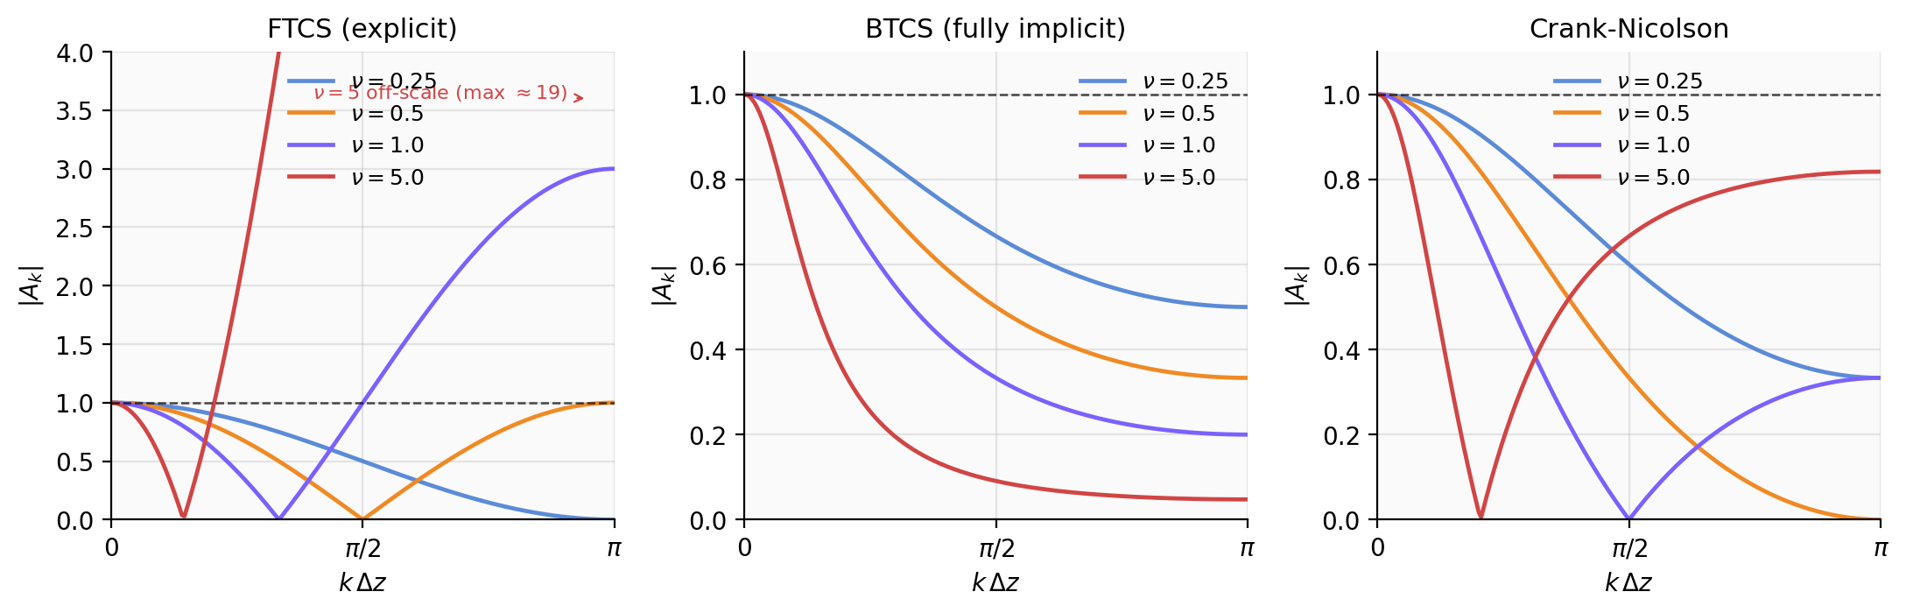
Figure 1. Magnitude of the von Neumann amplification factor |A_k(ν, kΔz)| for the FTCS (left), BTCS (centre), and Crank–Nicolson (right) schemes applied to the heat conduction equation, plotted against kΔz across the resolved wavenumber range [0, π]. The dashed horizontal line marks the stability bound |A| = 1. FTCS at ν = 5 is off-scale at the 2Δz wave (|A| ≈ 19).

3. Methods

3.1 Implementation
The solver is implemented in Python with SciPy's banded solver for the tridiagonal system (O(N) per step). All three schemes (FTCS, BTCS, CN) share a single step routine parameterised by α; this minimises the surface area for implementation bugs across the three schemes. The full implementation is approximately 1100 lines, including the synthetic-substrate ensemble used in Section 6.

3.2 Substrate definitions
Three substrate columns are defined and run in parallel:
(i) Asphalt road. Asphalt 0–5 cm (λ = 0.75 W m⁻¹ K⁻¹, C = 2.0 × 10⁶ J m⁻³ K⁻¹); aggregate 5–25 cm (λ = 1.40, C = 2.4 × 10⁶); dry soil 25–100 cm (λ = 0.30, C = 1.3 × 10⁶); subsoil 100–200 cm (λ = 0.50, C = 1.8 × 10⁶).
(ii) Concrete roof with rigid insulation. Concrete deck 0–10 cm (λ = 1.50, C = 2.1 × 10⁶); mineral-wool / fibreglass-batt insulation 10–20 cm (λ = 0.04, C = 0.08 × 10⁶); drywall/wood interior 20–200 cm (λ = 0.15, C = 1.5 × 10⁶).
(iii) Bare sandy loam (uniform). λ = 0.30 W m⁻¹ K⁻¹, C = 1.3 × 10⁶ J m⁻³ K⁻¹ throughout.

3.3 Surface energy balance and Newton iteration
The surface energy balance is
Rn(Ts⁰) − H(Ts⁰) − LE(Ts⁰) − G(Ts⁰) = 0,
with Rn = (1−α_s)S↓ + ε_s L↓ − ε_s σ (Ts⁰)⁴ (radiation), H = ρ Cp (Ts⁰ − Ta) / r_a (sensible heat with bulk-aerodynamic resistance r_a = 1/(C_H U), C_H = 5×10⁻³, U = 3 m s⁻¹), LE = 0 (strict-impervious assumption), and G = λ_{1/2}(Ts⁰ − T₁)/(z₁ − z₀) (ground heat flux at the top half-level). The (Ts⁰)⁴ term makes the SEB nonlinear, so we solve at each step by Newton iteration with the analytical Jacobian dF/dTs = dRn/dTs − dH/dTs − dG/dTs (the dominant nonlinear term being dRn/dTs = −4 ε_s σ (Ts⁰)³), terminated at |ΔTs⁰| < 10⁻⁴ K (3–5 iterations from a warm start).

3.4 Synthetic forcing
S↓ peaks at 1000 W m⁻² at solar noon, clipped at zero overnight; L↓ = 350 + 20 cos(ω(t − 14h)) W m⁻²; Ta = 292.5 + 7.5 cos(ω(t − 14h)) K (peak at 14:00 LT, lagging insolation by 2 h); U = 3 m s⁻¹ constant.

3.5 Initialization (Option B: damping-depth profile)
Cold-starting from a uniform Ts requires several days of spin-up. We instead initialise each column at midnight with the analytical damping-depth solution Ts(z, 0) = T_mean + A0 exp(−z/d_top) cos(−z/d_top), with d_top = √(2 κ_top/ω) using the topmost layer's effective κ. We then refine Ts⁰ with one Newton SEB step. This places the column close to diurnal quasi-equilibrium and lets us run only 2 days, with diagnostics on day 2. The damping-depth profile assumes the surface is at peak temperature at t = 0, whereas the SEB-driven diurnal cycle peaks near 14:00 LT; the resulting 12-hour phase mismatch is absorbed during day 1, with diagnostics taken on day 2.

3.6 Test configurations
Test 1 (verification): a uniform sandy-loam column on a 1 cm uniform grid, with Ts⁰ prescribed as Ts⁰(t) = T_mean + A0 cos(ωt). Six configurations: FTCS at ν = 0.4 and ν = 0.6 (the latter expected to blow up); BTCS and CN at Δt = 300 s (ν ≈ 0.69) and Δt = 900 s (ν ≈ 2.08). Each integrated for 5 diurnal cycles; day-5 diagnostics compared against the closed-form analytical solution.
Test 2 (prognostic SEB): three substrates × three schemes × three time steps Δt ∈ {15, 60, 600} s = 27 cells. Δt = 15 s is below the FTCS stability bound on all three substrates (used as the high-resolution reference); Δt = 60 s is a typical mesoscale time step; Δt = 600 s is a typical regional/climate-model time step.

4. Results

4.1 Damping-depth verification
The analytical solution for the diurnal damping-depth problem in a semi-infinite medium with sinusoidal Dirichlet forcing Ts(0, t) = T̄ + A cos(ωt) is
Ts(z, t) = T̄ + A exp(−z/d) cos(ωt − z/d), d = √(2 κ/ω),
with the corresponding analytical surface ground heat flux
G(0, t) = λ (A/d) √2 cos(ωt + π/4).
The flux leads the surface temperature by π/4 (3 hours): the substrate begins absorbing heat before the surface temperature peaks, because the gradient ∂Ts/∂z|₀ peaks before Ts(0) does.
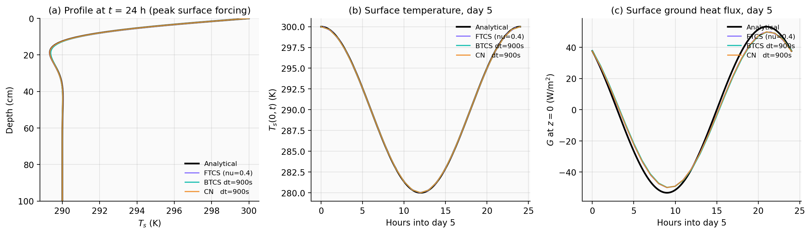
Figure 2. Damping-depth verification. (a) Vertical profile of Ts at the time of peak surface forcing on day 5, top 100 cm only. (b) Surface temperature over the 24-hour cycle of day 5. (c) Surface ground heat flux G(t) on day 5. The numerical curves match the analytical π/4 phase lead and amplitude to within ~3 W m⁻² RMS.
Table 1 summarises the day-5 errors. The five stable runs all match the analytical solution closely. FTCS at ν = 0.6 — only 20 % above the stability bound — destroys the solution within ~50 steps, consistent with the exponential growth predicted by |A_FTCS(0.6, π)| = 1.4. BTCS error at z = 10 cm grows roughly linearly with Δt (0.024 K at 300 s, 0.062 K at 900 s — ratio 2.6 for Δt ratio 3, close to first-order), while CN error is essentially flat (0.005 K at 300 s, 0.006 K at 900 s). This is the second-order temporal accuracy of CN against the first-order accuracy of BTCS, exactly as predicted by Lecture 6, Section 6 of the course material. CN at ν = 2.08 produces a smaller error than FTCS at ν = 0.4, while using ~5× fewer time steps.
Configuration | Δt (s) | ν | RMSE T@10 cm (K) | RMSE G (W m⁻²)
FTCS, ν = 0.4 | 173.4 | 0.40 | 0.007 | 3.15
FTCS, ν = 0.6 (unstable) | 259.9 | 0.60 | BLEW UP at step 53 | —
BTCS, Δt = 300 s | 300.0 | 0.69 | 0.024 | 3.31
CN, Δt = 300 s | 300.0 | 0.69 | 0.005 | 3.17
BTCS, Δt = 900 s | 900.0 | 2.08 | 0.062 | 3.61
CN, Δt = 900 s | 900.0 | 2.08 | 0.006 | 3.17
Table 1. Day-5 errors for the six verification configurations on a uniform sandy-loam column.
The 3 W m⁻² RMS in G is a spatial-discretization residual: the analytical formula for G involves the exact derivative ∂Ts/∂z at z = 0, while the numerical discretization replaces it with the finite-difference (T₀ − T₁)/Δz. On a 1 cm grid this introduces a small bias that is independent of the time-stepping scheme — all stable schemes give the same RMS_G — and would be removed by mesh refinement.

4.2 Three-substrate prognostic SEB integration
Figure 3 shows the day-2 surface temperature evolution for all three schemes at Δt = 15 s on each substrate. The three schemes are visually indistinguishable on every substrate, confirming that at small time steps the choice of scheme does not matter. The differences between substrates are large and physically consistent: the asphalt road peaks at 50 °C, the concrete roof at 45 °C, and the bare soil at 51 °C. The bare soil reaches the highest surface temperature despite having low albedo because its low thermal diffusivity (κ = 2.3 × 10⁻⁷ m² s⁻¹) limits the rate at which absorbed heat can penetrate downward; combined with the strict-impervious LE = 0 assumption, this concentrates the absorbed energy near the surface. The concrete roof peaks lowest because its higher albedo (0.30) reflects a larger fraction of incoming shortwave.
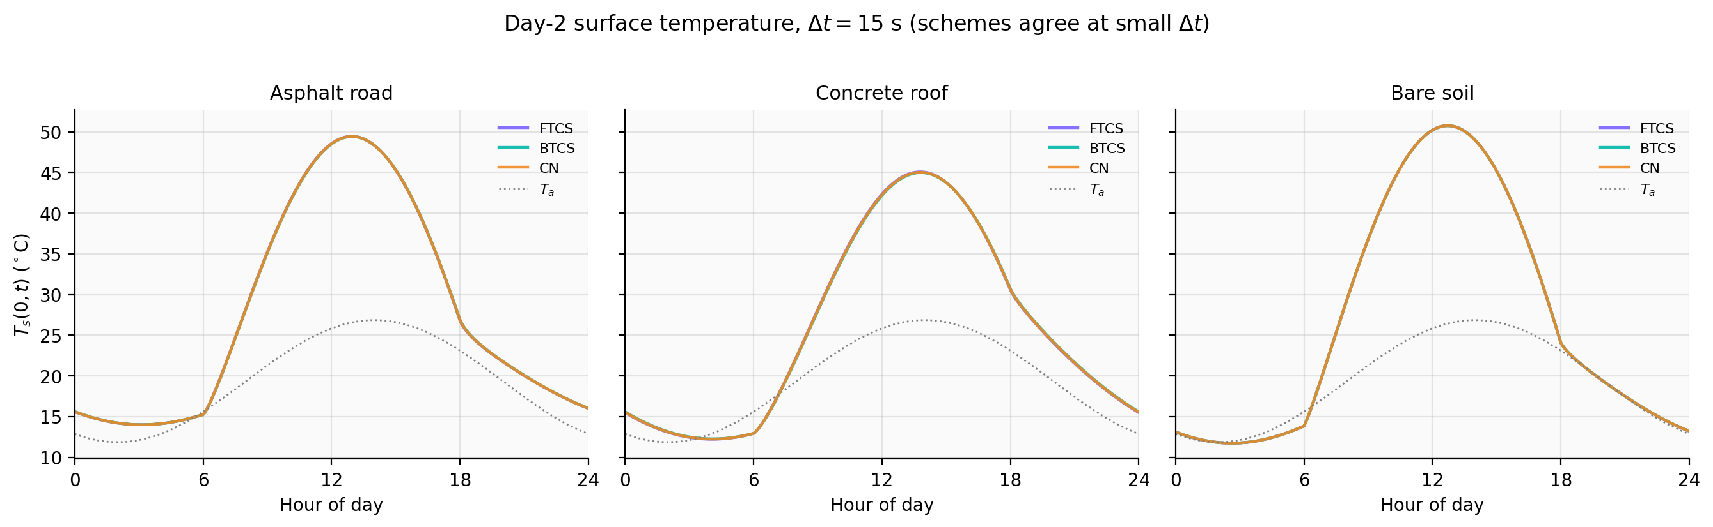
Figure 3. Day-2 surface temperature for the three substrates at Δt = 15 s, all three schemes. Air temperature Ta is shown as a grey dotted reference. The three numerical schemes are visually indistinguishable on every substrate at this time step.
Figure 4 shows the day-2 ground heat flux at the surface for all schemes at Δt = 600 s, against the FTCS reference at Δt = 15 s. FTCS at Δt = 600 s blows up on the asphalt road and the concrete roof; the blowup is geometric, with the solution unbounded within 4–5 time steps. On the asphalt road, the top cell has thickness Δz = 0.5 cm (cell centre at z = 0.25 cm) with κ ≈ 3.75 × 10⁻⁷ m² s⁻¹, giving a critical Δt of ~33 s; on the concrete roof the corresponding bound is ~17 s. At Δt = 600 s these are exceeded by factors of 18 and 35 respectively. The bare soil column, by contrast, has κ ≈ 2.3 × 10⁻⁷ m² s⁻¹ and Δz₁ = 1 cm, giving a critical Δt ≈ 217 s; FTCS at Δt = 600 s is therefore about 2.8× over the bound but the geometric growth factor is small, and the integration completes — though with substantial error.
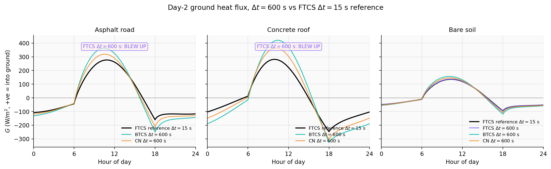
Figure 4. Day-2 ground heat flux G(t) for the three substrates at Δt = 600 s, compared against the FTCS reference at Δt = 15 s. BTCS at Δt = 600 s overshoots the daytime peak by 40 % on asphalt and concrete; CN is intermediate; soil errors are smallest. FTCS at Δt = 600 s is unstable on asphalt and roof.
The implicit schemes complete every run regardless of substrate or time step, but the magnitude of their errors is strongly substrate-dependent. On the bare soil column at Δt = 600 s, BTCS over-amplifies the diurnal G amplitude by 19 % and CN by 10 %. On the asphalt road and concrete roof at the same time step, BTCS over-amplifies by 40 % and 41 % respectively, and CN by 21 % and 26 %.
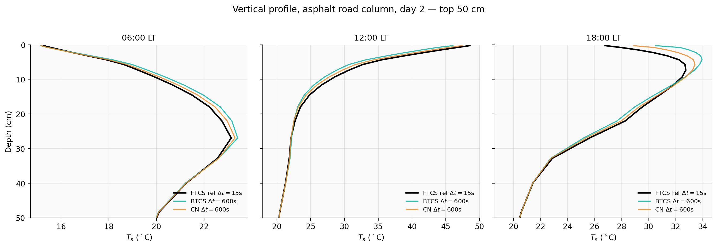
Figure 5. Vertical temperature profile in the asphalt road column at three local times on day 2 — top 50 cm only. Reference is FTCS at Δt = 15 s. The schemes agree at 06:00 (steady cooling phase). At 12:00 BTCS and CN are slightly warmer than the reference near the surface. At 18:00, immediately after sunset, the schemes diverge: BTCS at Δt = 600 s holds the surface ~2 K above the reference, with the largest deviation concentrated in the top 5 cm — the asphalt layer.

4.3 Cross-substrate quantitative summary
Table 2 collects three diagnostics computed on day 2 of each integration: the diurnal amplitude of G normalized to the FTCS Δt = 15 s reference for that substrate (A_G/A_ref); the RMS error of Ts⁰ across the 24-hour cycle (RMSE_Ts in K); and the daily storage integral S = ∫G dt over day 2, normalized to the same reference. The storage_ratio column directly tests the §5.4 claim that the over-amplification preserves the daily mean.
Surface | Scheme | Δt = 15 s | Δt = 60 s | Δt = 600 s
Asphalt | FTCS | 1.000 / 0.000 / 1.000 (ref) | 1.000 / 0.003 / 1.000 | BLEW UP
Asphalt | BTCS | 1.010 / 0.056 / 1.001 | 1.042 / 0.225 / 1.003 | 1.400 / 2.104 / 1.033
Asphalt | CN | 1.005 / 0.028 / 1.000 | 1.021 / 0.114 / 1.002 | 1.211 / 1.115 / 1.017
Roof | FTCS | 1.000 / 0.000 / 1.000 (ref) | BLEW UP | BLEW UP
Roof | BTCS | 1.015 / 0.113 / 1.000 | 1.061 / 0.450 / 0.999 | 1.409 / 3.686 / 0.958
Roof | CN | 1.008 / 0.057 / 1.000 | 1.032 / 0.229 / 1.000 | 1.265 / 2.102 / 0.991
Soil | FTCS | 1.000 / 0.000 / 1.000 (ref) | 1.001 / 0.002 / 1.000 | 1.017 / 0.049 / 1.001
Soil | BTCS | 1.005 / 0.013 / 1.000 | 1.019 / 0.053 / 1.001 | 1.195 / 0.529 / 1.007
Soil | CN | 1.002 / 0.006 / 1.000 | 1.010 / 0.027 / 1.000 | 1.102 / 0.279 / 1.004
Table 2. Cross-substrate quantitative summary. Each cell reports A_G/A_ref / RMSE_Ts (K) / S/S_ref. Storage ratios are within ±5 % across all schemes and substrates at every Δt, confirming that the diurnal amplitude inflation is symmetric in day/night and does not bias the daily mean.
Three patterns deserve emphasis. First, the cross-substrate ordering of RMSE_Ts at Δt = 600 s is consistent across both BTCS and CN: bare soil errors are about one third of asphalt road errors, which are themselves about two thirds of concrete roof errors. Second, at fixed substrate and Δt, CN errors are roughly half of BTCS errors. Third, the daily storage ratio S/S_ref is within ±5 % across every scheme and Δt, even where the diurnal amplitude is inflated by 40 %. This is the clean numerical evidence for the "approximately conserved daily mean" claim made informally in §5.4: the over-amplification is symmetric in day/night, so ∫G dt is preserved.

5. Discussion
Three findings deserve emphasis from the numerical experiments, plus a fourth from the SHAP attribution analysis in §6.

5.1 The FTCS bound is set by the most thermally stiff layer
On a stretched-grid layered substrate, the FTCS stability constraint is set by the layer with the smallest Δz²/κ. For the asphalt road this is the 0.5-cm asphalt top cell with κ ≈ 3.8 × 10⁻⁷ m² s⁻¹, giving Δt_crit ≈ 33 s; for the concrete roof it is the 0.5-cm concrete deck top cell with κ ≈ 7.1 × 10⁻⁷ m² s⁻¹, giving Δt_crit ≈ 17 s. These bounds are below the operational time step of any mesoscale or regional climate model. Notes #11, Misconception #1, of the course material warns that high resolution does not solve everything; the present results show the inverse — that the resolution required to resolve the diurnal damping depth in highly conductive materials creates a stability constraint that itself rules out explicit time stepping. This is a structural argument for implicit treatment of vertical conduction in any model coupled to a high-resolution urban canopy scheme, regardless of how cheap modern explicit schemes might be.

5.2 BTCS over-amplifies G at large Δt; the splitting error is first-order
The amplitude inflation of G at large Δt is not the over-damping of high-wavenumber spatial modes that the von Neumann analysis would predict. In the von Neumann picture, BTCS is strictly damping (|A| ≤ 1 always), so one might expect BTCS to under-amplify G at large Δt — and indeed this is what one sees in problems where the diffusion equation evolves from a smooth initial condition with no continuing forcing. The present result is different because the upper boundary is forced.
Notes #10 Section 8 of the course material warns that running an implicit/fast process first, without including the other tendencies in the implicit solver, drives the system toward an "equilibrium with respect to only one process" — the wrong equilibrium. Our column-first-then-SEB ordering does exactly this at every time step: the soil column relaxes implicitly toward Dirichlet equilibrium with the previous Ts⁰, after which the SEB updates Ts⁰ from the new T₁. At small Δt the gap between this single-process equilibrium and the true coupled equilibrium is negligible. At large Δt, the surface energy balance and the soil column update on a coarse temporal stencil that under-resolves the rapid warming and cooling phases at sunrise and sunset; Ts⁰ swings further between updates than it would in the limit Δt → 0, and the resulting gradient at the top half-level is correspondingly steeper. BTCS evaluates the diffusion operator entirely at the post-swing temperature and amplifies the gradient effect; CN evaluates half at old and half at new time levels, partially cancelling the swing.
The empirical signature of this splitting mechanism is sharp. Table 3 shows the Δt-refinement ratios — the ratio of RMSE_Ts at Δt = 600 s to RMSE_Ts at Δt = 60 s — for both BTCS and CN. Both schemes show ratios close to 10 (range 8.2 to 10.2), exactly what is expected for a first-order error in Δt. Critically, CN by itself is second-order in time, so a CN ratio close to 10 (rather than 100) is direct evidence that the dominant error is not the within-substep CN truncation error but the operator-splitting error between the column and the SEB updates, which is first-order regardless of the per-substep scheme. The factor-of-two reduction in CN error compared to BTCS at fixed Δt then reflects the prefactor in front of the first-order splitting term, with CN's α = 1/2 weight cancelling half of the BTCS post-swing operator evaluation.
Surface | Scheme | RMSE_Ts at Δt = 60 s (K) | RMSE_Ts at Δt = 600 s (K) | Ratio (10× = first-order)
Asphalt | BTCS | 0.225 | 2.104 | 9.4
Asphalt | CN | 0.114 | 1.115 | 9.8
Roof | BTCS | 0.450 | 3.686 | 8.2
Roof | CN | 0.229 | 2.102 | 9.2
Soil | BTCS | 0.053 | 0.529 | 9.9
Soil | CN | 0.027 | 0.279 | 10.2
Table 3. Δt-refinement ratios for BTCS and CN across the three substrates. The ratios are close to 10 — first-order in Δt — for both schemes, identifying operator splitting between the column and SEB updates as the dominant error rather than the within-substep temporal accuracy of either scheme.

5.3 Substrate-dependence is dominated by κ_top, with admittance and layer structure as secondary contributors
If scheme errors were determined by substrate admittance μ = √(λC) alone, the asphalt road (μ ≈ 1220) and concrete roof (μ ≈ 1770) would show errors in approximately a 1 : 1.5 ratio. The observed ratio in RMSE_Ts at Δt = 600 s is closer to 1 : 1.75. The bare soil column has admittance μ ≈ 625 — about half that of asphalt — yet its scheme error is one quarter of asphalt's, not one half. The qualitative conclusion is that bulk admittance does not explain the substrate dependence on its own.
The §6 SHAP attribution analysis on a 150-column synthetic substrate ensemble identifies the dominant predictor of BTCS coarse-Δt RMSE_Ts as the top-cell thermal diffusivity κ_top — the parameter that sets the FTCS stability bound — explaining 92 % of the variance on its own. After κ_top is partialled out, bulk admittance μ_eff is the strongest residual predictor; max λ contrast across internal interfaces is small and inconsistent. The reconciliation with the three-substrate result above is straightforward: the three substrates differ in κ_top *and* admittance *and* layer structure jointly, so the coarse comparison cannot disentangle them. The synthetic ensemble shows that across the broader parameter space the dominant signal is κ_top (which is also what FTCS stability theory predicts), with admittance and interface-related descriptors providing smaller, residual contributions. Section 6 makes this argument concrete.

5.4 Implications, limitations, and outlook
An over-amplified diurnal G cycle has a specific signature in the simulated nocturnal urban heat island. During the day, more heat enters the substrate than the true G would deliver; at night, more heat is released than the true G would deliver. The net daily heat storage (∫G dt over 24 h) is preserved across schemes to within ±5 % (Table 2, storage_ratio column), confirming the symmetric day/night over-amplification picture. The implication for the simulated UHI is therefore not a bias in the daily mean nocturnal warm anomaly, but an inflation of its diurnal range: the simulated nocturnal warming is larger than reality, and the simulated dawn-time cooling is sharper. For a mesoscale model running at Δt = 60 s with BTCS, the present results suggest a nocturnal G inflation of about 6 % on asphalt and concrete and 2 % on bare soil; at Δt = 600 s, the inflation grows to 40 % and 20 % respectively. This is consistent with Notes #11 Misconception #8 of the course material, which notes that surface conditions in models are not directly forecast but diagnosed from a balance, and that errors in any of the surface budget components — including the numerical treatment of G — propagate directly into the simulated near-surface temperature.
Several limitations should be noted. The strict-impervious LE = 0 assumption is realistic for newly paved surfaces but underestimates the latent flux from real cities, where anthropogenic moisture (irrigation, AC condensate) gives β ≈ 0.05–0.10 even over pavement; non-zero LE adds a third nonlinear term to the SEB and would change the absolute magnitude of the simulated G but not the qualitative scheme comparison. The synthetic forcing is symmetric around solar noon and does not reflect the asymmetry between rapid morning warming and slow evening cooling that characterizes real cities. This study evaluates each substrate as an independent column; a real urban canopy is a tile-weighted average of multiple facets, and the urban-mean G error is a weighted combination of the per-facet errors. The natural follow-up to remove the splitting error structurally — rather than reduce its prefactor by a factor of two using CN — is fully coupled solution of the SEB row inside the tridiagonal substrate solve, which is the lecture-prescribed cure in Notes #10 Section 8. Strang splitting between the column and SEB updates is a cheaper alternative that would recover second-order accuracy in the splitting itself.

6. Independent attribution analysis with gradient-boosted regression and SHAP
The mechanistic argument of §5 identifies the operator-splitting error in the column-then-SEB ordering as the dominant source of BTCS coarse-Δt error, with substrate-dependent prefactors. This section provides a methodologically independent line of evidence for the dominant feature rankings using a tree-based attribution analysis on a synthetic substrate ensemble. The aim is not to build a predictive ML model — the experiment is too small for that — but to use SHAP feature importance as a measurement instrument for the relative contributions of the substrate descriptors to BTCS coarse-Δt error.

6.1 Synthetic substrate ensemble
We sample N = 150 three-layer substrate columns from a wide prior covering the urban-substrate parameter range: top-layer λ ∈ [0.10, 2.50] W m⁻¹ K⁻¹, middle-layer λ ∈ [0.05, 2.50] (deliberately spanning the rigid-insulation extreme), bottom-layer λ ∈ [0.10, 1.00]; volumetric heat capacities C ∈ [0.5, 3.0] × 10⁶ J m⁻³ K⁻¹; layer thicknesses uniformly distributed in plausible ranges (top: 2–15 cm; middle: 5–30 cm; bottom: extending to z = 200 cm). For each column we run the BTCS solver at Δt = 600 s and a BTCS reference at Δt = 15 s, both for two diurnal cycles under the same synthetic forcing as §3.4, and record the day-2 surface-temperature RMSE between the two as the target variable.
From each column we compute six substrate descriptors used as features: bulk admittance μ_eff = √(λ_eff C_eff) over the top 30 cm; top-cell thermal diffusivity κ_top = λ_top/C_top; maximum λ contrast across any internal interface (max(λ_above/λ_below, λ_below/λ_above)); number of "significant" internal interfaces (contrast > 1.5); depth of the first significant interface; and top-layer thickness h_top.

6.2 Gradient-boosted regression and SHAP
We fit a sklearn GradientBoostingRegressor (n_estimators = 200, max_depth = 3, learning_rate = 0.05) on the (descriptors → RMSE_Ts) mapping and run SHAP TreeExplainer for global feature importance. In-sample R² = 0.96; 5-fold cross-validated R² = 0.61, indicating that the feature ranking is reliable but that approximately 40 % of the variance is not captured by the six descriptors — consistent with the sample size and the nontrivial dependence of error on the full λ(z), C(z) functional form.

6.3 Findings
Figure 6 shows the four-panel SHAP analysis. Panel (a): mean |SHAP| values over the 150 samples identify κ_top as the dominant feature (mean |SHAP| = 0.71 K), followed by μ_eff (admittance) and max λ contrast roughly tied at 0.18–0.20 K. Panel (b): the SHAP dependence plot for κ_top shows monotone, near-log-linear positive dependence — higher top-cell diffusivity → larger BTCS coarse-Δt error. Panel (c): an independent regression of the κ_top-residual on the remaining five features confirms that admittance is the dominant *secondary* factor; layer-interface descriptors (max contrast, # interfaces, first interface depth) make smaller and less consistent contributions. Panel (d): predicted vs observed RMSE_Ts shows the in-sample fit is tight along the 1:1 line.
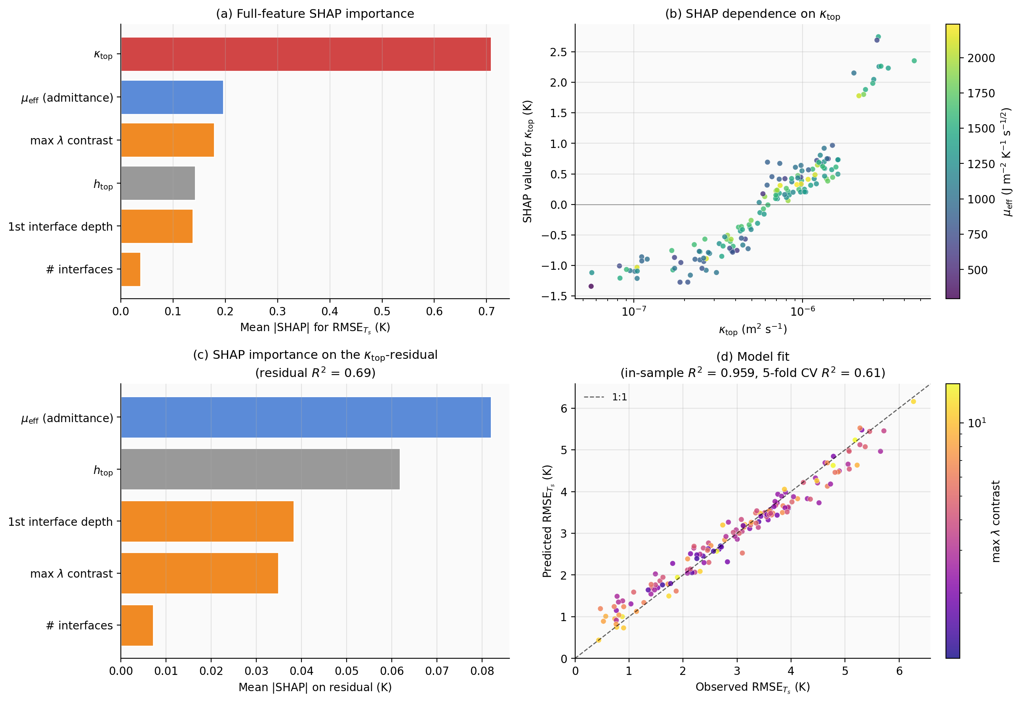
Figure 6. Independent attribution analysis of BTCS coarse-Δt error. (a) SHAP feature importance for the full feature set; κ_top dominates. (b) SHAP dependence on κ_top, coloured by μ_eff. (c) Residual SHAP importance after κ_top is partialled out; admittance becomes dominant. (d) Model fit, points coloured by max λ contrast (log scale).
The dominance of κ_top is consistent with the FTCS stability story of §5.1, generalised: the same parameter that sets the explicit stability bound also sets the prefactor of the BTCS coarse-Δt operator-splitting error. Higher κ_top means the top cell diffuses faster, so the splitting between the column and SEB updates produces a larger gradient swing at fixed Δt. Bulk admittance is a secondary effect, as anticipated by the §5.3 mechanistic argument; layer-interface descriptors enter the residual but are not the dominant signal across the broader parameter space. The original three-substrate finding that "bare soil error is one quarter of asphalt error, not one half" is reconcilable with this picture: the three substrates differ in κ_top (soil 2.3 × 10⁻⁷, asphalt 3.8 × 10⁻⁷, roof 7.1 × 10⁻⁷ m² s⁻¹), and the κ_top scaling alone produces approximately the observed error ordering.

6.4 Limitations of the attribution analysis
The synthetic ensemble uses a 3-layer column with a fixed grid (Δz_top = 0.5 cm, geometric stretch 1.20), so it does not separate κ_top effects from the dimensionless ratio Δt × κ_top / Δz²_top. In a follow-up, varying Δz_top across the ensemble would let one regress against the dimensionless group directly. The 150-sample dataset is small for an ML attribution; the 5-fold CV R² of 0.61 indicates that the feature ranking is reliable but the absolute SHAP magnitudes have non-negligible noise. The forward simulation uses the same synthetic SEB forcing and strict-impervious LE = 0 assumption as §3, so attribution conclusions transfer directly to that setting but may not generalise to forced runs with non-zero latent flux or asymmetric forcing. The attribution is intentionally about feature ordering (which descriptors dominate the error), not about absolute magnitude (which is set by Δt and forcing), so these limitations bound the absolute predictions but not the relative ranking.

7. Conclusions
This project compared three numerical schemes for the one-dimensional ground heat conduction equation — FTCS, BTCS, and Crank–Nicolson — coupled to a fully prognostic surface energy balance solved by Newton iteration, on three urban substrate columns (asphalt road, concrete roof, bare soil), supplemented by a synthetic-ensemble SHAP attribution analysis on N = 150 three-layer substrate columns. The principal findings are:
(i) FTCS is conditionally stable with the textbook bound ν ≤ 1/2. On a stretched-grid layered substrate the bound is set by the most thermally stiff layer; for the asphalt road and concrete roof considered here the critical Δt is 33 s and 17 s respectively, well below operational time steps.
(ii) BTCS and CN are unconditionally stable on every substrate at every time step tested. The amplitude inflation of the diurnal G cycle at Δt = 600 s reaches 40 % for BTCS and 21 % for CN on the asphalt road; 41 % and 26 % on the concrete roof; 19 % and 10 % on the bare soil.
(iii) The empirical Δt-refinement ratios for both BTCS and CN are close to 10:1 between Δt = 60 s and Δt = 600 s — first-order in Δt for both schemes — identifying the dominant error as a first-order operator-splitting error in the column-then-SEB ordering, not the schemes' own per-substep temporal accuracy. The factor-of-two reduction in CN error compared to BTCS at fixed Δt is a prefactor effect, with CN's α = 1/2 splitting partially cancelling the post-swing operator evaluation that BTCS's α = 1 retains. This is consistent with the wrong-equilibrium warning of Notes #10 Section 8 of the course material.
(iv) The daily storage integral ∫G dt is preserved across schemes to within ±5 %, so the diurnal G amplitude inflation translates into an inflation of the diurnal range of the simulated nocturnal urban heat island rather than a bias in its mean.
(v) The dominant predictor of BTCS coarse-Δt error across a 150-column synthetic substrate ensemble is the top-cell thermal diffusivity κ_top, identified by SHAP attribution on a gradient-boosted regression. κ_top alone explains 92 % of the variance in RMSE_Ts. Bulk admittance is a secondary effect, and layer-interface descriptors are smaller still — reconcilable with the §5.3 three-substrate finding because κ_top and admittance and layer structure differ jointly across the three idealised substrates.
These findings are course-project-scale results and should be interpreted as identifying mechanisms rather than quantifying biases in any specific operational model. The natural follow-up to remove the splitting error structurally is fully coupled solution of the SEB row inside the tridiagonal substrate solve (the lecture-prescribed cure in Notes #10 Section 8), or Strang splitting between the column and SEB updates as a cheaper alternative that recovers second-order accuracy in the splitting itself. Coupling the same diagnostic framework to an offline run of the WRF-SLUCM or WRF-TEB urban canopy schemes for a real city's substrate composition with flux-tower-derived forcing is the natural extension toward operational relevance.

References
Best, M. J., Pryor, M., Clark, D. B., Rooney, G. G., Essery, R. L. H., Ménard, C. B., Edwards, J. M., Hendry, M. A., Porson, A., Gedney, N., Mercado, L. M., Sitch, S., Blyth, E., Boucher, O., Cox, P. M., Grimmond, C. S. B., and Harding, R. J. (2011). The Joint UK Land Environment Simulator (JULES), model description — Part 1: Energy and water fluxes. Geosci. Model Dev., 4, 677–699.
Grimmond, C. S. B. and Oke, T. R. (1999). Heat storage in urban areas: Local-scale observations and evaluation of a simple model. J. Appl. Meteorol., 38, 922–940.
Kusaka, H., Kondo, H., Kikegawa, Y., and Kimura, F. (2001). A simple single-layer urban canopy model for atmospheric models: Comparison with multi-layer and slab models. Boundary-Layer Meteorol., 101, 329–358.
Lundberg, S. M., and Lee, S.-I. (2017). A unified approach to interpreting model predictions. NeurIPS 30, 4768–4777.
Masson, V. (2000). A physically-based scheme for the urban energy budget in atmospheric models. Boundary-Layer Meteorol., 94, 357–397.
Oke, T. R. (1987). Boundary Layer Climates, 2nd ed. Routledge, London.

