**Q1.Write a program to initialize an integer array and print the sum and average of the array**

**PROGRAM:**

import java.util.*;

class Array

{

public static void main(String args[])

{

Scanner sc = new Scanner(System.in);

int arr[ ] = new int[20];

int sum=0;

System.out.println("Enter the number of element : ");

int n = sc.nextInt();

System.out.println("Enter the element in Array :");

for(int i=0;i<n;i++)

{

arr[i]=sc.nextInt();

}

for (int j = 0; j < n; j++)

{

sum = sum + arr[j];

}

int avg = (sum/n);

System.out.println("average of array :" + avg);

System.out.println("sum of an array element is :" + sum);

}

}

**Q 2 : Given a string and a non-empty word string, return a string made of each char just before and just after every appearance of the word in the string. Ignore cases where there is no char before or after the word, and a char may be included twice if it is between two words.**

**PROGRAM:**

import java.util.*;

class prog

{

public static void main(String args[])

{

Scanner sc = new Scanner(System.in);

System.out.println("Enter the string :");

String str1 =sc.next();

System.out.println("Enter the string of char of which you want before and after apperance of word :");

String str2 =sc.next();

int nm;

int num,num1;

String str ;

try

{

for(int i=0;i<str1.length();i++)

{

char ch = str1.charAt(i);

String s = "" + ch;

char ch11 = str2.charAt(0);

char ch12 = str2.charAt(str2.length()-1);

String s11 = "" + ch11;

String s12 = ""+ ch12;

if(s.equals(s11))

{

char ch1 =str1.charAt(i-1);

String ss = ""+ch1;

str = ss;

System.out.print(str);

}

if(s.equals(s12))

{

char chh1 =str1.charAt(i+1);

String sss = ""+chh1;

str = sss;

System.out.print(str);

}

}

}

catch(Exception e)

{

System.out.println(e);

}

}

}

**Q3: You are appoint as Computer Programmer in Cameron Hotel, Chandigarh. A task is given to you for generate a WiFi password for new customer who book a room in a hotel. A customer registration will contains Customer First Name and Room No. Instructions for generating a WiFi password as:**

* + 1. **Your password is of 6 digits long only.**
    2. **Unit digit will be alphabet character (lower case) that will calculated by the length of customer first name.**
    3. **Tenth digit will be sum of customer room no.**
    4. **Hundreds digit will be special character (! ,@,#,$,%,^,&,*,(,) ) calculate by the length of Room No.**
    5. **Thousands unit will be numeric calculated on basis of sum of room number as follows.** 
       1. **If sum is odd, then same number will be allocated**
       2. **If sum is even, then add one digit to the result.**

**PROGRAM:**

class Pswd

{

String alphabet="abcdefghijklmnopqrstuvwxyz";

String special = "!@#$%^&*(,)";

String wIFIPASSWORD="";

String str = "Nikhil Mishra";

String s;

char ch,spc;

int num,nm,total;

int a[] = {1,3,3};

int pswrd,result;

void function()

{

for(int i=0;i<str.length();i++)

{

char c = str.charAt(i);

String s = "" + c;

if(s.equals(" "))

{

nm = i;

}

}

ch = alphabet.charAt(nm-1);

for(int i=0 ;i<a.length;i++)

{

total = (a[i] + total);

}

String tot = String.valueOf(total);

char spc = special.charAt(total-1);

if(total % 2 == 0)

{

int result = total + 1;

}

else

result = total;

String rs = String.valueOf(result);

wIFIPASSWORD = wIFIPASSWORD.concat(rs);

wIFIPASSWORD = wIFIPASSWORD.concat(""+spc);

wIFIPASSWORD = wIFIPASSWORD.concat(tot);

wIFIPASSWORD = wIFIPASSWORD.concat(""+ch);

System.out.println("WIFI PASSWORD IS : " + wIFIPASSWORD );

}

}

class Password

{

public static void main(String args[])

{

Pswd p = new Pswd();

p.function();

}}

**OutPut:**

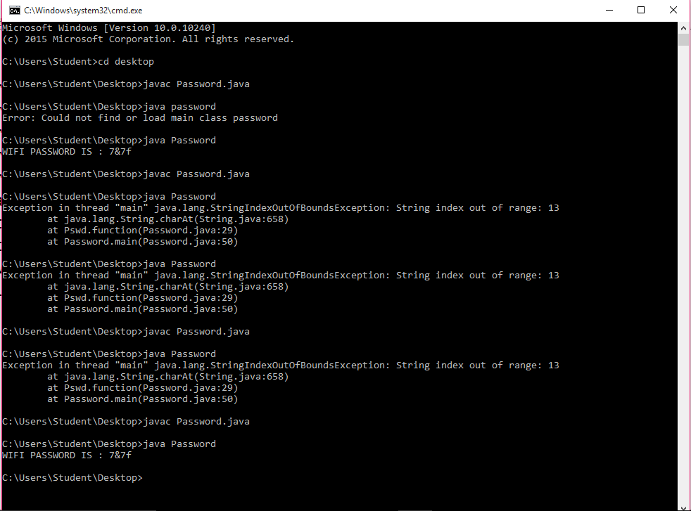

**Ques 4:**

**Get the input String from user and parse it to integer, if it is not a number it will throw number format exception Catch it and print "Entered input is not a valid format for an integer." or else print the square of that number. (Refer Sample Input and Output).**

**Sample input and output 1:**

**Enter an integer: 12**

**The square value is 144**

**The work has been done successfully**

**Sample input and output 2:**

**Enter an integer: Java**

**Entered input is not a valid format for an integer.**

**PROGRAM:**

public class SquareException

{

public static void main(String[] args) throwsIOException

{

BufferedReaderbr = newBufferedReader(newInputStreamReader(System.***in***));

try

{

System.*out*.println("Enter Number");

String input = br.readLine();

intnum = Integer.*parseInt*(input);

System.*out*.println("Squere of the "+num+" is : "+(num*num));

System.*out*.println("The work has been done successfully");

}

catch(NumberFormatExceptionnf)

{

System.*out*.println("Entered input is not a valid format for an integer");

}

}

}

**Ques5:Create a package called test package;**

**Define a class called foundation inside the test package;**

**Inside the class, you need to define 4 integer variables;**

**Var1 as private;**

**Var2 as default;**

**Var3 as protected;**

**Var4 as public;**

**Import this class and packages in another class.**

**Try to access all 4 variables of the foundation class and see what variables are accessible and what are not accessible.**

**PROGRAM:**

package testpackage;

public class Foundation

{

int var1 = 1;

private int var2 = 2;

public int var3 = 3;

protected int var4 = 4;

}

package pack;

import testpackage.*;

public class Class2 extends Foundation

{

public void accessVars()

{

System.out.println(var1);

System.out.println(var2);

System.out.println(var3);

System.out.println(var4);

}

public static void main(String args[])

{

Class2 c = new Class2();

c.accessVars();

}

}

You cannot access private variables outside the class. Change them to public or protectd if you want them to be accessible in Class2

* If you are compiling packaged java files, then compile from the directory from where package structure starts. e.g. in your case javac pack1.Class1.java
* When trying to launch those, use fully qualified class names e.g. java pack1.Class2