1. Feature Implemented

|  |  |
| --- | --- |
| Id | Title |
| UC-01 | Login |
| UC-02 | Logout |
| UC-03 | Search Contact List |
| UC-04 | Add contact |
| UC-05 | Chatting, both individual and group chatting. |

1. Feature Not Implemented

|  |  |
| --- | --- |
| Id | Title |
| UC-06 | Create a group |
| UC-07 | Add user to group |
| UC-08 | remove user |

1. Class Diagram Comparison

The old Class Diagram:

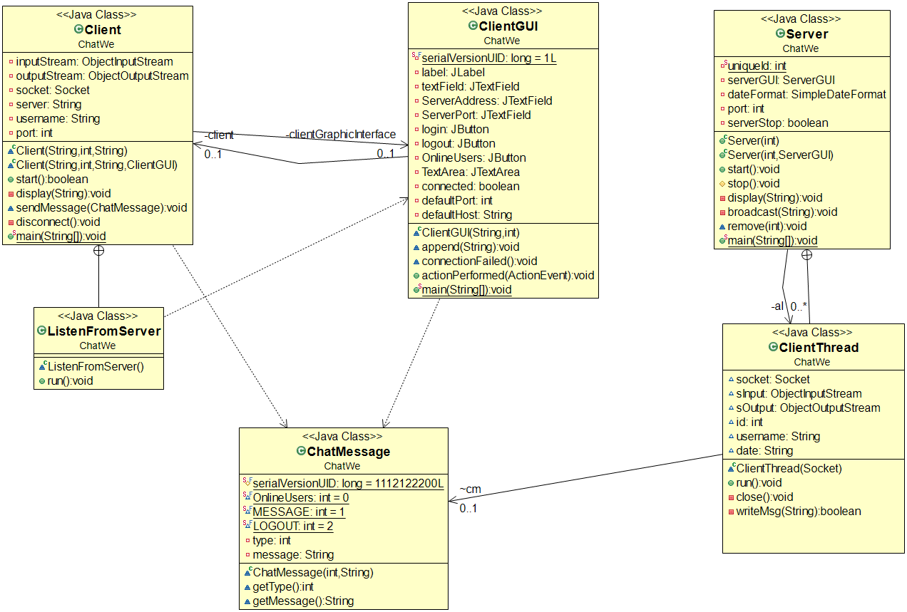

In the final project,

The above classes still remain with some changes. But the above client design is too simple, and it supports group chatting but doesn’t support individual to individual chatting, so we made a dramatic change in:

1. Create a much nicer UI which is using JTabbePane and is able to create multiple tabs. One chat tab for one contact/group;
2. The framework of Server remains the same but a lot more message types are defined to handle complex messaging; you can see the change from the definition of class ChatMessage, which had no fields for FromUserId/FromUserName/FromGroupId/FromGroupName/AllContactList, etc. and there’s no password field.
3. Design Pattern Used
4. Adapter:

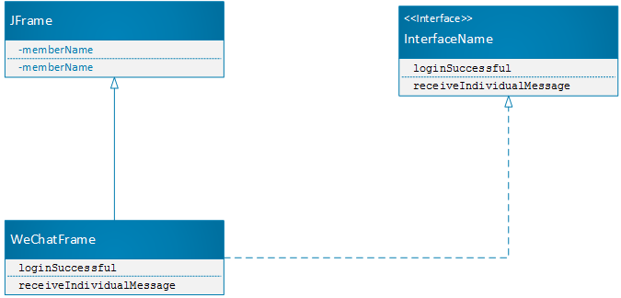

1. Factory and Singleton

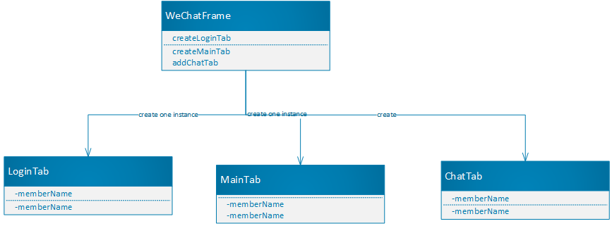

1. Visitor

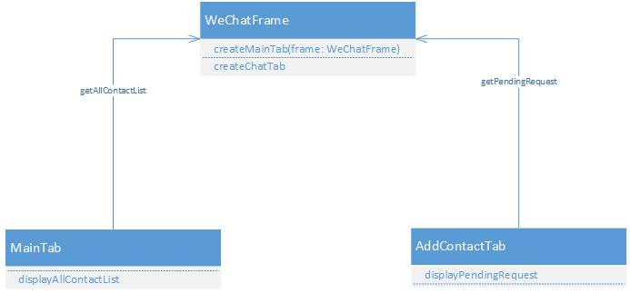

1. Observer

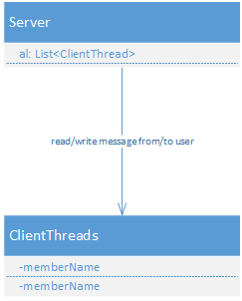

1. Lesson Learn

What we learned from analysis and design is, during analysis, don’t go too deep with design, especially low level design like class diagrams. Because things will be changed, the final design and class diagram will be dramatically different from the initial design (class diagram). It’s very good to get a pro-type work earlier, since it will help to validate the requirements and figure out potential technical difficulties at the early stage.