

Logging

python



September 14, 2020

wipro technologies

Bangalore

Table of Contents

S.No Topic Name P.NO

1. What is logging………………………………………………………………………………………………………………………………2

2. Why to use logging………………………………………………………………………………………………………………………..3

3. Levels of logging…………………………………………………………………………………………………………………………….4

4. Simple Example of logging……………………………………………………………………………………………………………..5

5. Logging to a file………………………….………………………………………………………………………………………………….6

6. Logging from multiple files……………………………………………………………………………………………………………7

7. Logging Variable data…………………………………………………………………………………………………………………..9

8. Changing the format of displayed messages………………………………………………………………………………..10

9. Displaying the date/time in messages…………………………………………………………………………………………11

# What is logging ?

Logging is a means of tracking events that happen when some software runs. The software’s developer adds logging calls to their code to indicate that certain events have occurred.

# Why to use logging ?

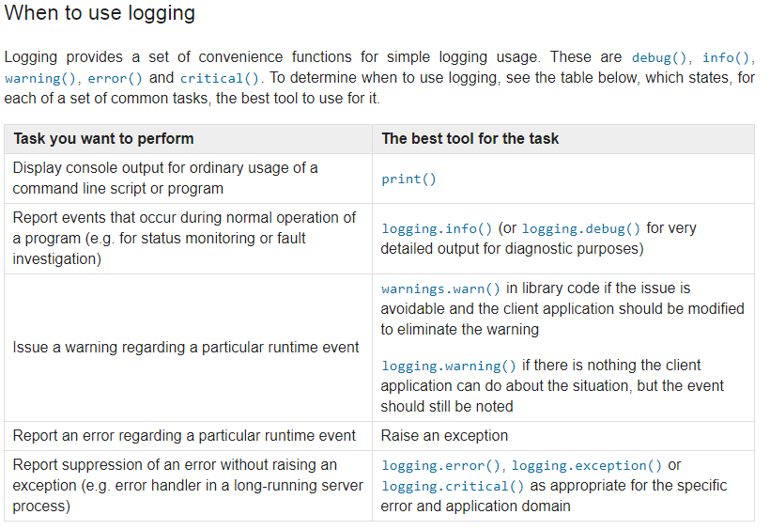

# Levels of logging

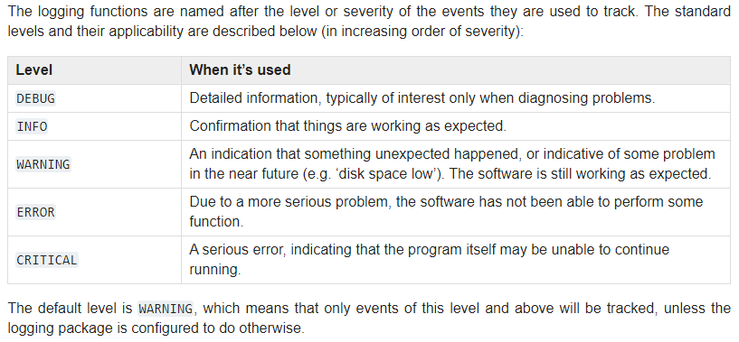

# Simple example

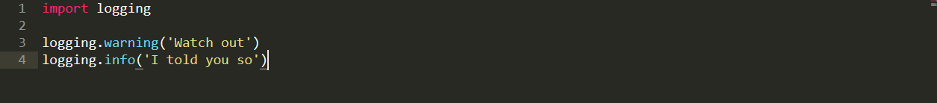

Output:

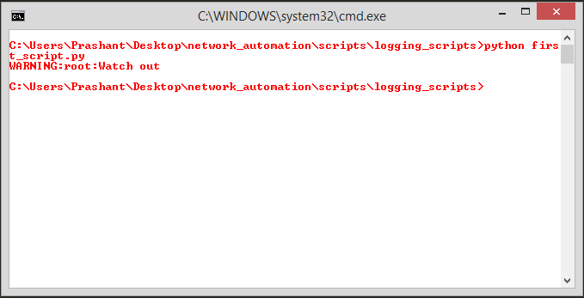

# Logging to a file

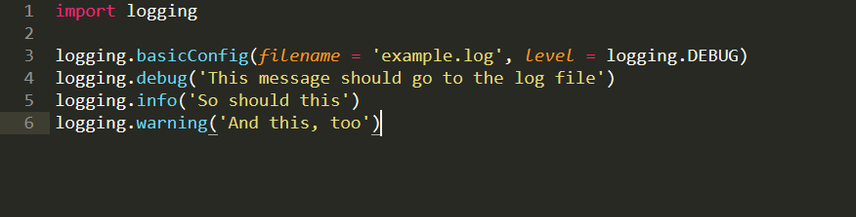

Output:

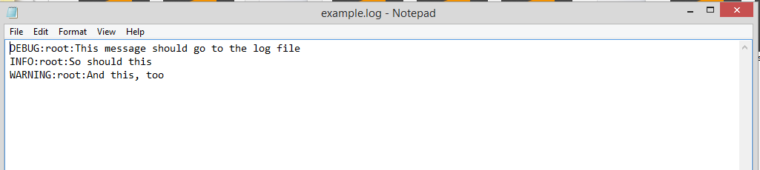

# Logging from multiple files

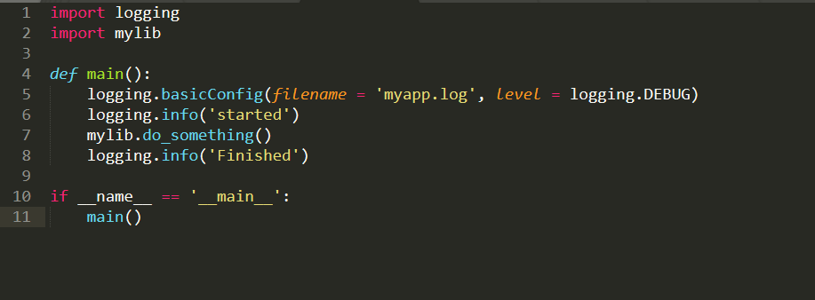

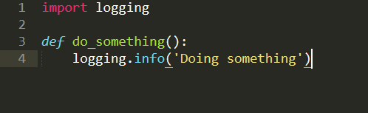

Output:

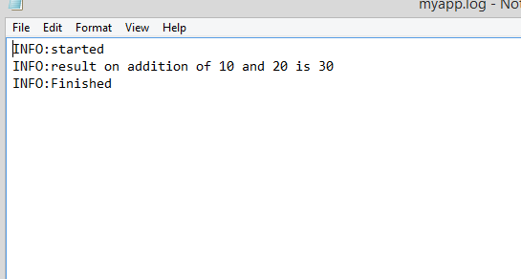

# Logging Variable data



Output:

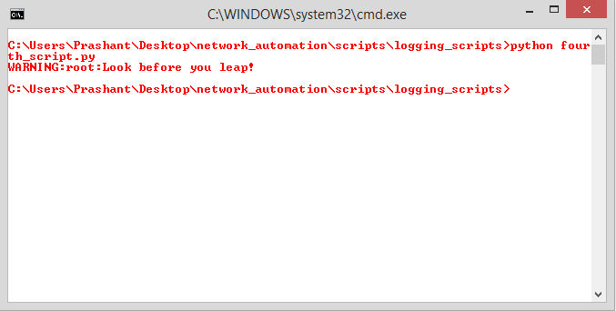

# Changing the format of displayed messages

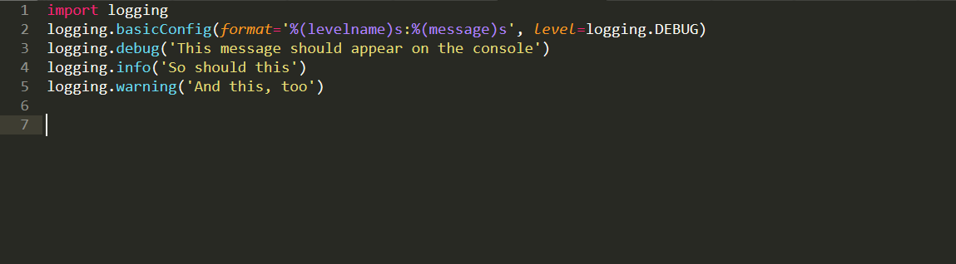

Output:

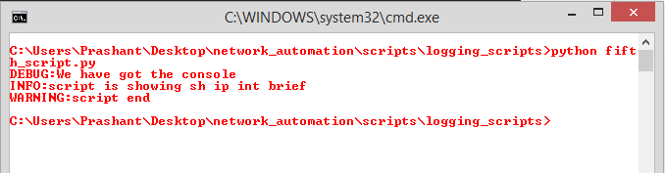

# Displaying the date/time in messages

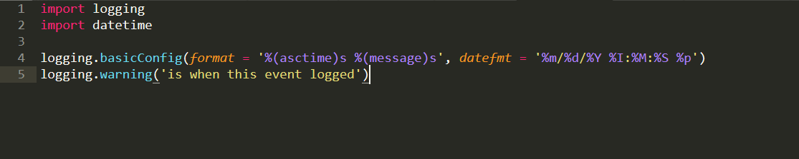

Output:

