

UNIVERSITY OF SIALKOT
_{WEB ENGINEERING}

Semester Project – Deliverable 1 (Client-Side Architecture)

GROUP MEMBERS
SHAMRAIZ ALI – 23010101-006
MUHAMMAD BIN ATHAR – 23010101-035

BSSE-VI BLUE FALL 2023

TOTAL GRADE POINT 10

GRADE POINT
ALLOCATED

ASSESSOR’S COMMENTS

Instructor: Museb Khalid

Scholarship Finder: Client-Side Architecture
Semester Project — Deliverable 1 (Client-Side Architecture), Web Engineering, University of Sialkot

Abstract
This report documents the client-side architecture of Scholarship Finder, a Vue 3 single-page application that helps Pakistani students identify international scholarships matching their academic profile. The application is implemented entirely on the client side using Vue 3, Vite, and Vue Router, with no backend or database integration at this stage, in accordance with the requirements of Deliverable 1. This report describes the routing structure, component hierarchy, inter-component communication mechanisms, and the data strategy adopted for this phase of development.

I. Introduction
Scholarship Finder is a frontend web application that allows a user to enter academic details — including education level, field of study, household income level, and Grade Point Average (GPA) — and receive a list of matching international scholarships. If no exact match is found, the application presents the closest available options along with an explanation of which eligibility criteria the user does not currently satisfy. The project was developed as the Web Engineering semester project and is being submitted in phases. This document covers the first phase: full client-side implementation using Vue 3 and Vite, with backend integration (Express.js and MongoDB) reserved for a later deliverable.

II. Technology Stack
The following table summarizes the tools and technologies used in this phase of the project.
Layer | Technology
Framework | Vue 3 (Composition API)
Build Tool | Vite
Routing | Vue Router 4
Data Source | Local JSON file (scholarships.json)
Styling | Scoped CSS within Single File Components
Backend / Database | Not implemented in this phase (planned: Express.js, MongoDB)

III. System Architecture
The application follows a modular, component-based architecture organized into views (route-level pages) and reusable components. Figure 1 illustrates the component hierarchy.

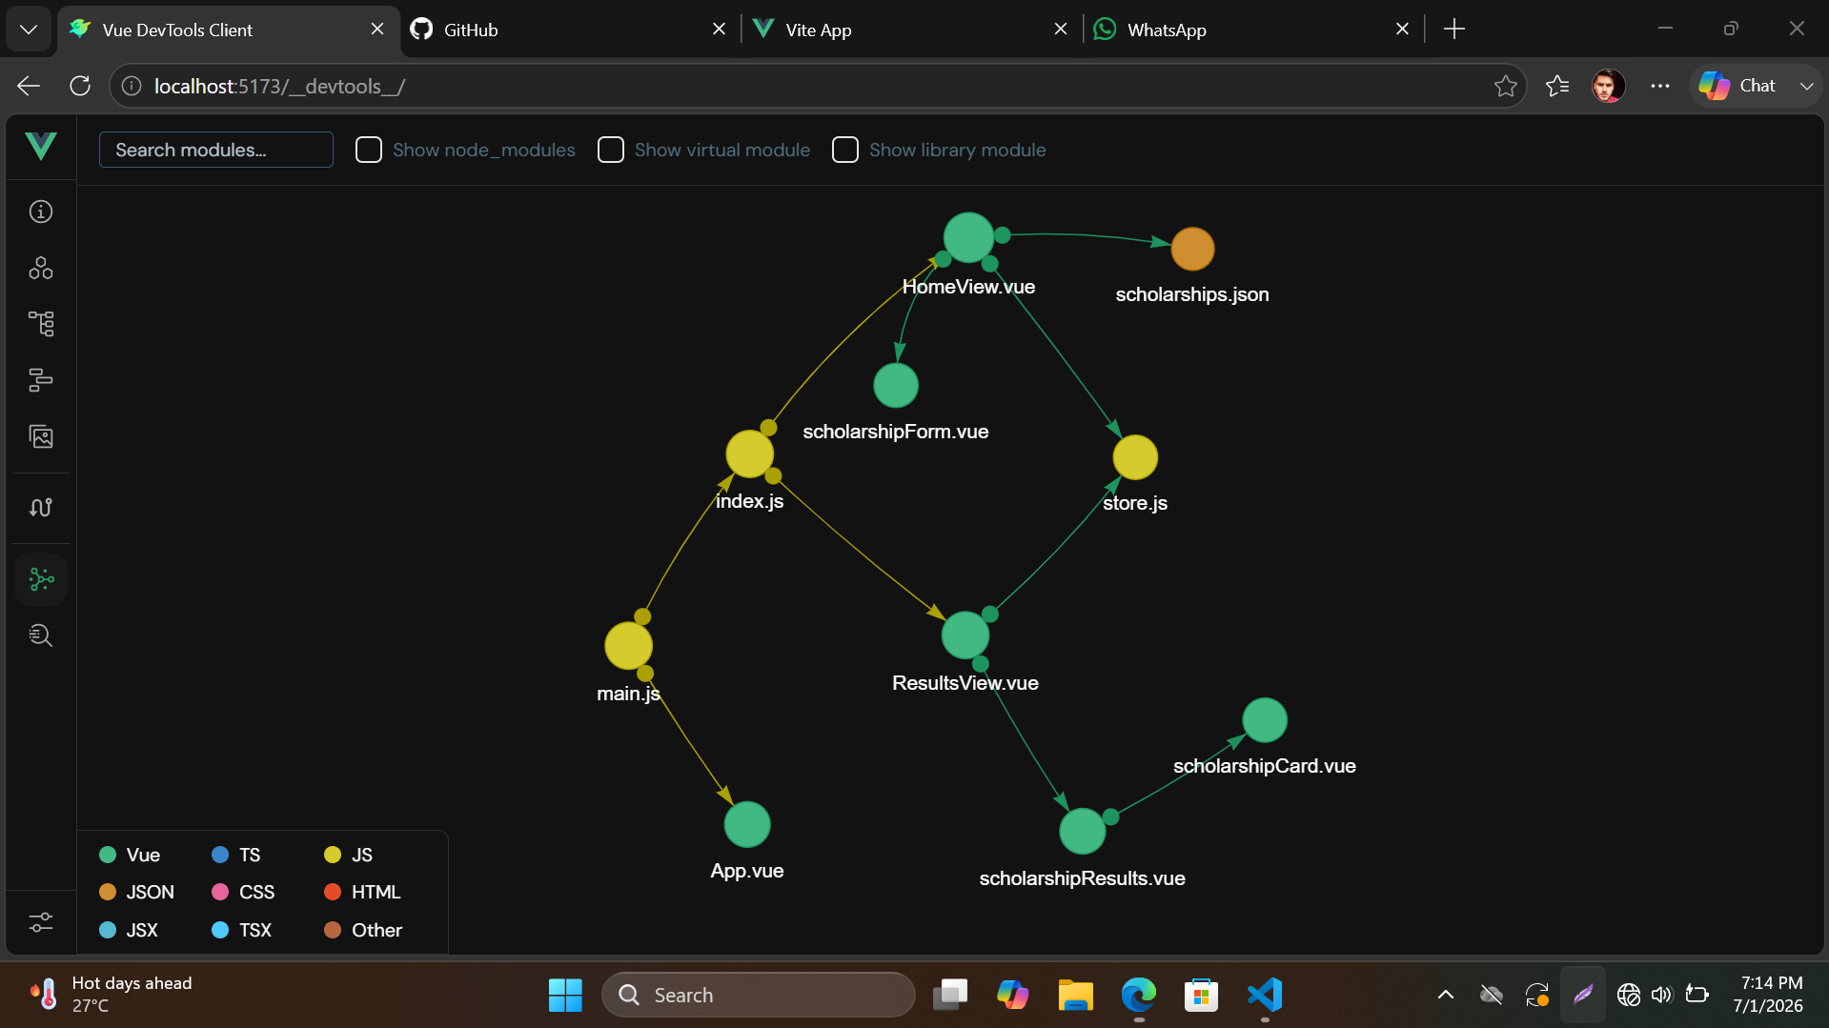

A. Component Tree
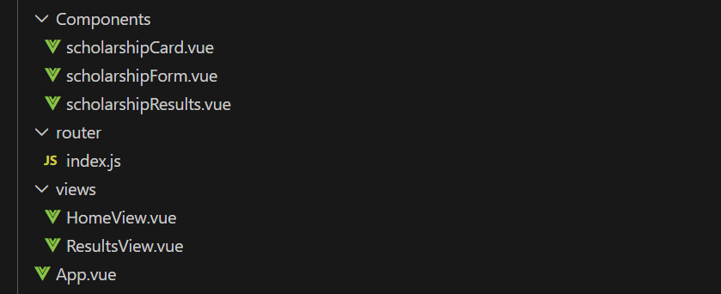
Figure 1. Component hierarchy of the Scholarship Finder application.

B. Directory Structure
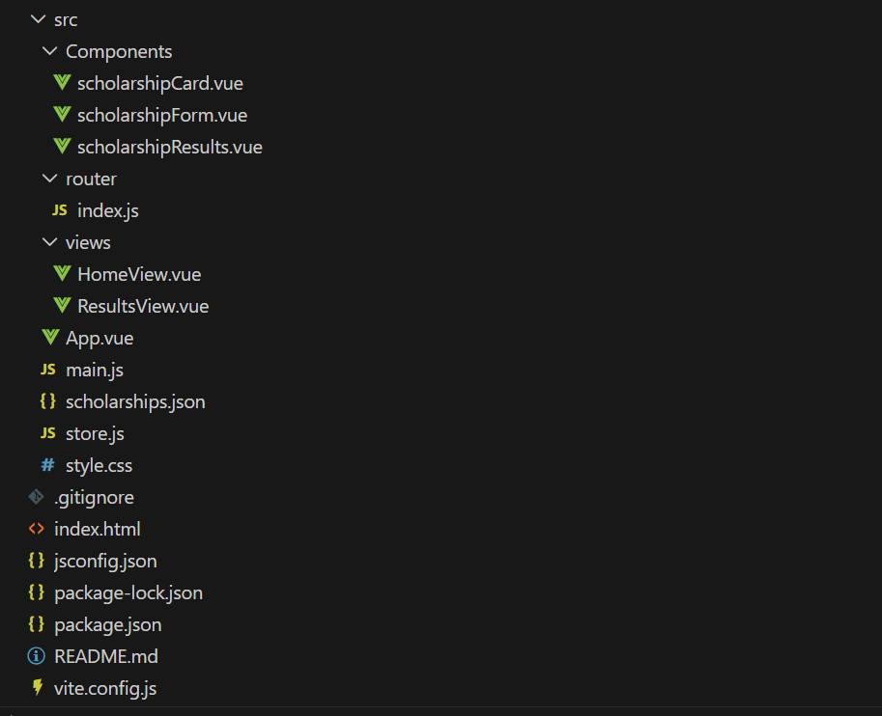
Figure 2. Directory Structure of the Scholarship Finder application.

IV. Single Page Application Routing
Vue Router is used to manage navigation between two core views: the Home view, containing the scholarship search form, and the Results view, which displays matched scholarships. Navigation is rendered through the <RouterLink> component in the application's navigation bar, and the active route's component is rendered through <RouterView> in App.vue. Figure 3 shows the router configuration.
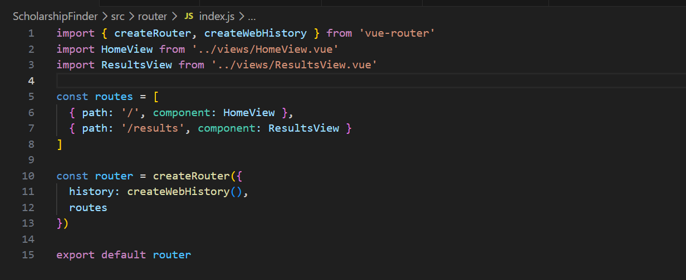
Figure 3. Vue Router configuration defining the application's two routes.
In App.vue, the layout wrapper uses RouterLink for navigation and RouterView to render the active page, as shown in Figure 4.
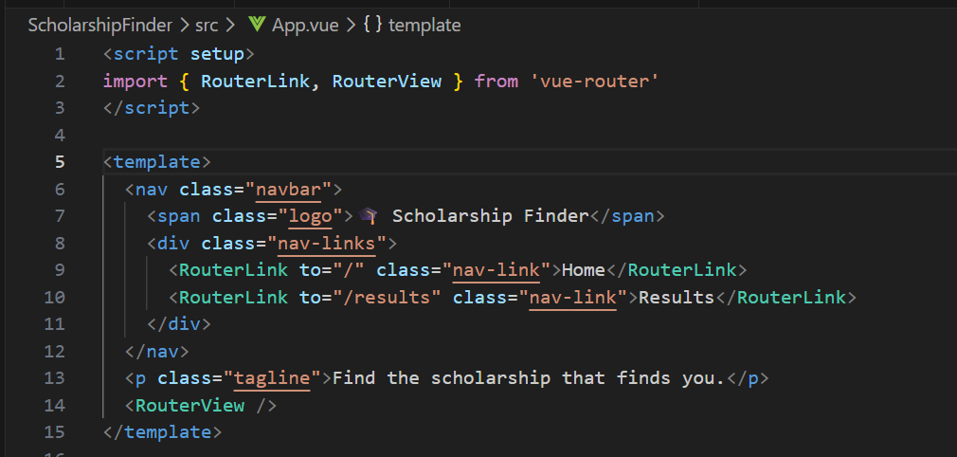
Figure 4. Layout wrapper using RouterLink and RouterView.

V. Modular Component Architecture
The user interface is decomposed into small, single-responsibility components. ScholarshipForm.vue is responsible only for collecting user input; ScholarshipCard.vue is responsible only for displaying a single scholarship; and ScholarshipResults.vue is responsible only for arranging multiple ScholarshipCard instances based on the search outcome. This separation makes each component easy to test, reuse, and reason about independently.

VI. Inter-Component Communication
Data flows downward from parent to child using typed props, while user actions flow upward from child to parent using custom events (emits). This unidirectional data flow is a core principle of Vue's component design.

A. Props Example
ScholarshipCard.vue receives a scholarship object and an optional gap message as typed props from its parent, ScholarshipResults.vue, as shown in Listing 3.
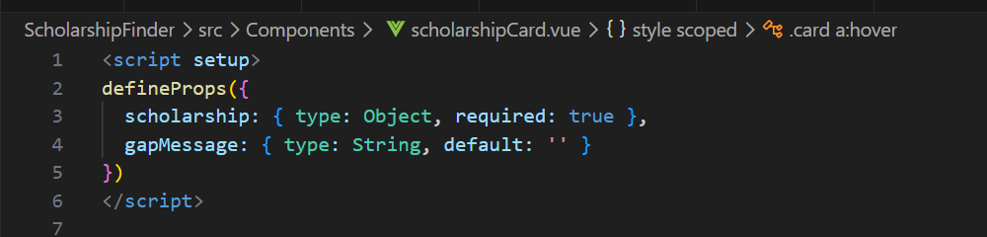
Figure 5. Typed props declaration in ScholarshipCard.vue.

B. Emits Example
ScholarshipForm.vue collects user input and, upon submission, emits a custom event carrying the form data upward to its parent view, which performs the matching logic. This is shown in Listing 4.
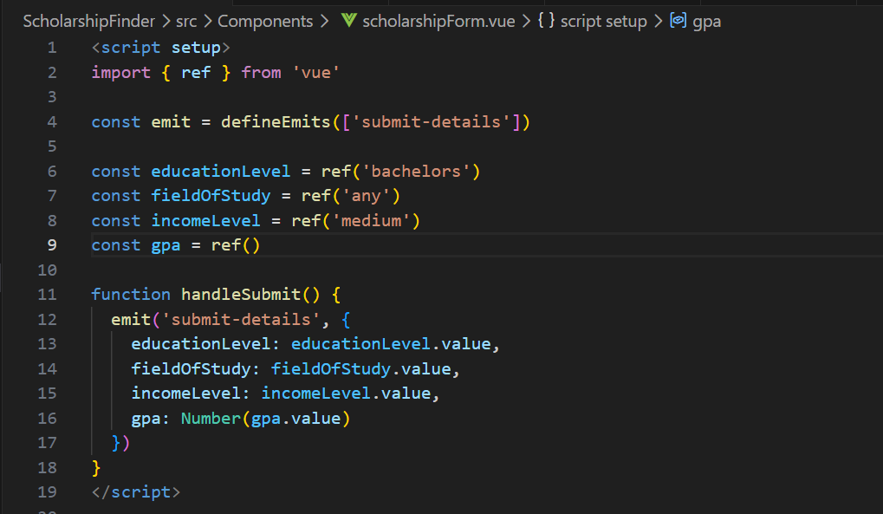
Figure 6. Emitting a custom event with form data from child to parent.
The parent view listens for this event using the v-on directive shorthand, as shown in Listing 5.
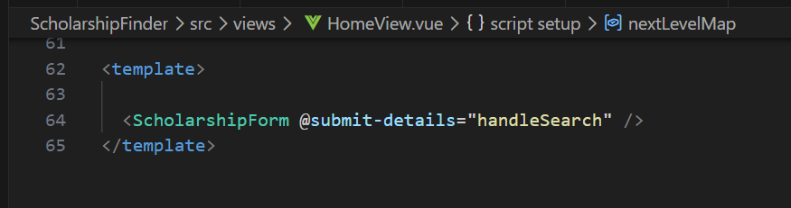
Figure 7. Parent component listening for the emitted event.

VII. Web Page View

A. HomeView
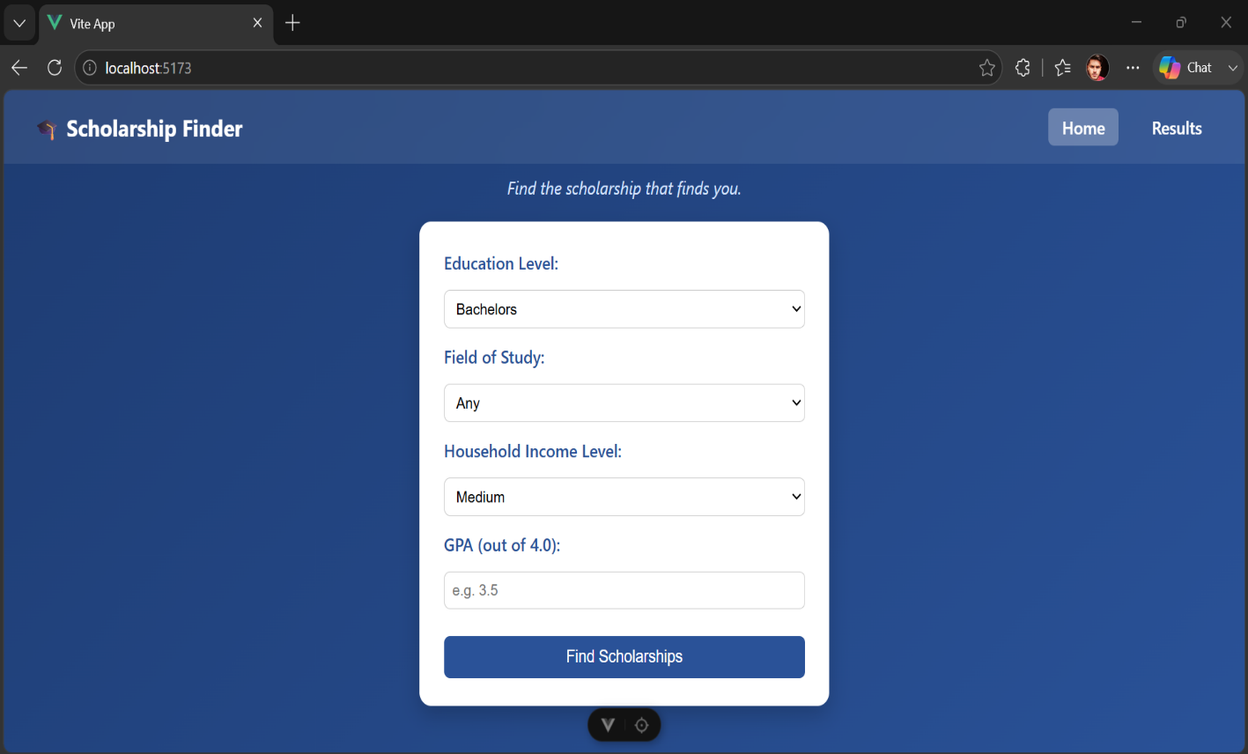

B. ResultsView
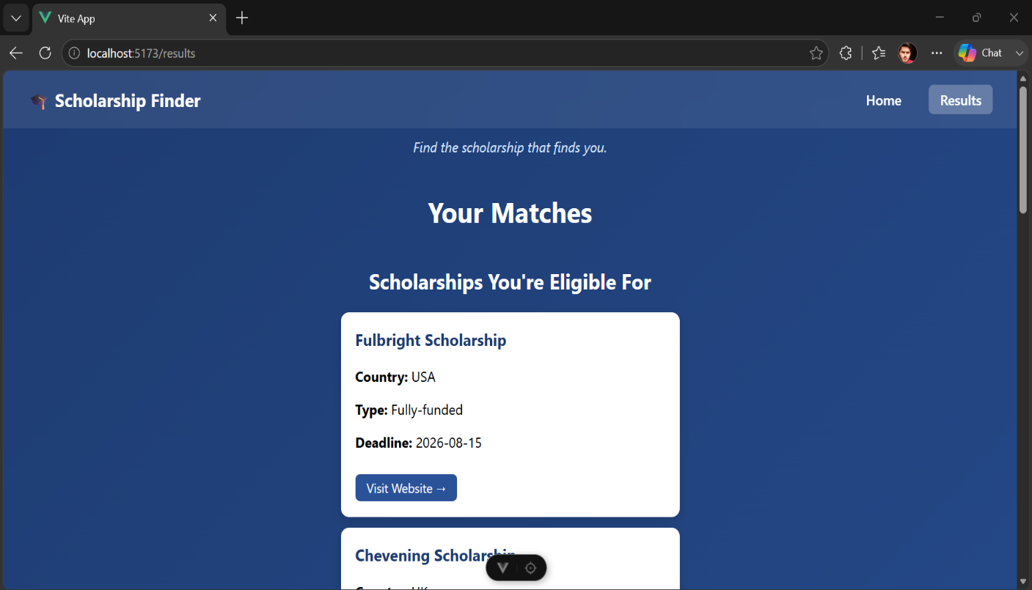

VIII. Data Strategy for This Phase
For this client-side phase, scholarship data is stored in a local JSON file, scholarships.json, located within the src directory. This file is imported directly into the application's JavaScript using a standard ES module import statement, and is treated as a static, in-memory data source for the purposes of demonstrating component structure, routing, and matching logic.
It is important to note that the eligibility values associated with each scholarship in this file — including minimum GPA and income-level thresholds — are representative placeholder values rather than verified figures sourced directly from each scholarship provider's official website. Accurate, verified eligibility data will be sourced and integrated when the backend and database layer are implemented in a subsequent deliverable.
The matching logic itself is implemented using standard JavaScript array methods (map and filter) within HomeView.vue. The application first attempts to find scholarships matching all of the user's criteria. If no exact match exists, it falls back to presenting the two or three closest scholarships, each annotated with the specific criteria the user does not currently meet.

IX. Conclusion
This deliverable presents a fully functional client-side implementation of the Scholarship Finder application using Vue 3 and Vite. The application demonstrates Single Page Application routing through Vue Router, a modular and reusable component hierarchy, and structured inter-component communication using typed props and custom emitted events. The current data layer relies on a static local JSON file, which will be replaced with a live Express.js and MongoDB backend in the next phase of the project.

