Shahzaib

FA21-BSE-034

OSSE lab mids

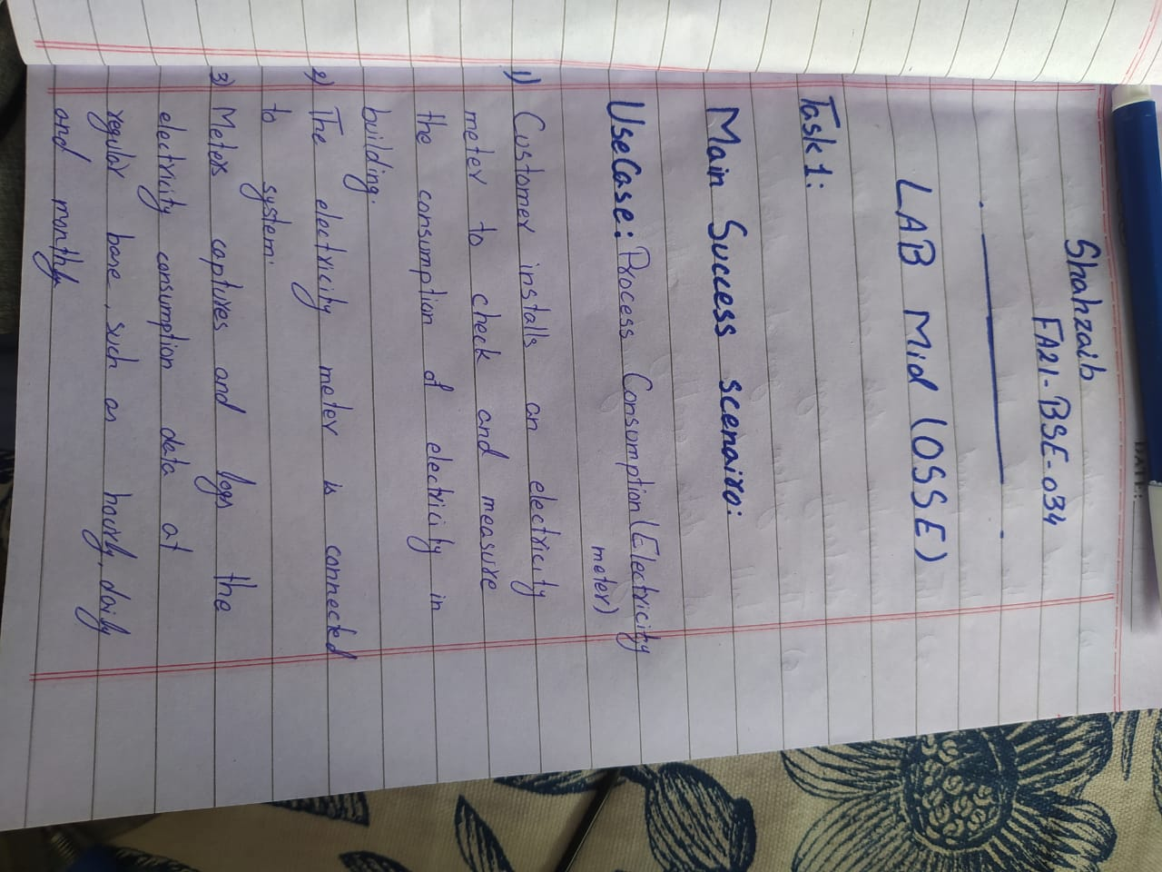Main Success Scenario:

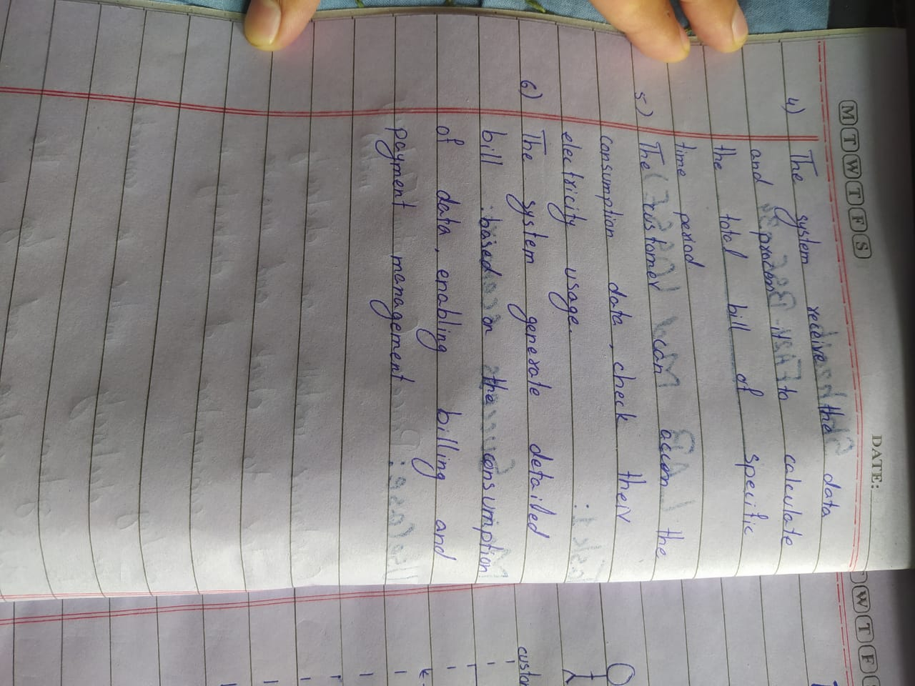

SSD:

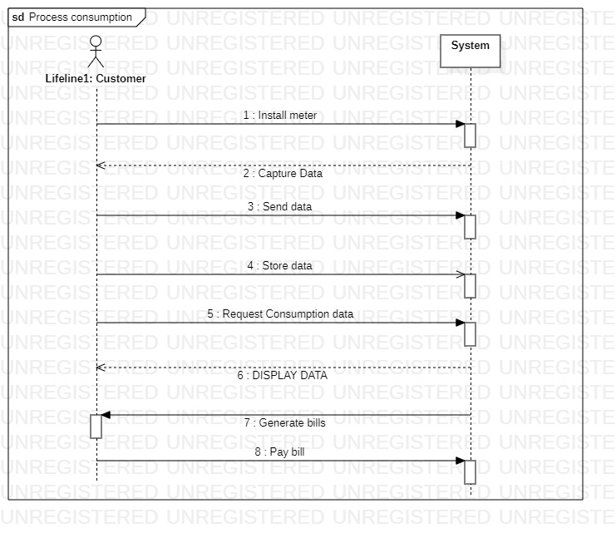

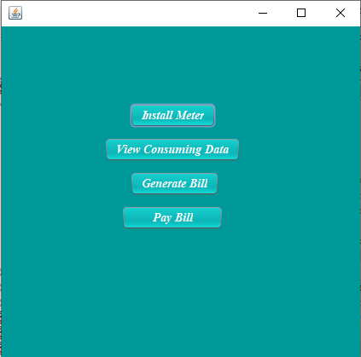Prototypes:

