**MAKING TEST CASES FOR GAMEOVER EVENT IN TEMPLE RUN**

**GAME**

SCREENS

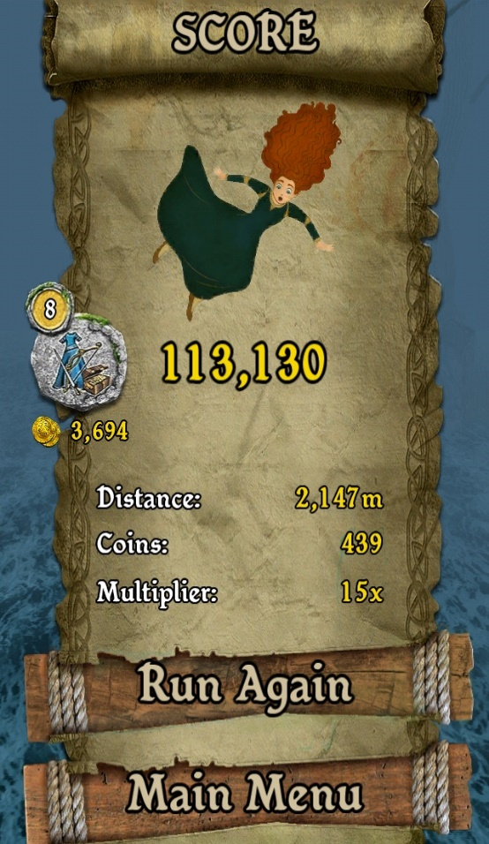

|  |  |  |  |  |  |
| --- | --- | --- | --- | --- | --- |
| **Test case ID** | **Description** | **input** | **Expected outcome** | **Actual outcome** | **status** |
| TC- 1 | User hit any obstacle for first time | Hitting obstacle | Health decreases to 50% | Health decreases to 50% | pass |
| TC-2 | User hit any obstacle for first time | Hitting obstacle | Health decreases to 50% | Health didn’t decreases to 50% | fail |
| TC-3 | User health is <50 and hit obstacle | 49 | Message:  Game over ,  play again | Message:  Game over ,  play again | pass |
| TC-4 | User health is <50 and hit obstacle | 49 | Message:  Game over ,  play again | User didn’t die and continue to play game | fail |
| TC-5 | User health is = 50 and hits obstacle | 50 | Message:  Game over ,  play again | Message:  Game over ,  play again | pass |
| TC-6 | User health is = 50 and hits obstacle | 50 | Message:  Game over ,  play again | User didn’t die and continue to play game | fail |
| TC-7 | Due to network delay or latency game automatically over | Poor internet ping  e.g. 999+ | Game automatically overs | Game automatically overs | pass |
| TC-8 | Due to network delay or latency game automatically over | Poor internet ping  e.g. 999+ | Game automatically overs | User didn’t die and continue to play game | fail |
| TC-9 | User quits the game during playing | Clicks menu button and quit | User is automatically died | User is automatically died | pass |
| TC-10 | User quits the game during playing | Power off the phone | User is automatically died | User is automatically died | pass |
| TC-11 | User quits the game during playing | Power off the phone | User is automatically died | User didn’t die and resume the game | fail |
| TC-12 | User quits the game during playing | Clicks menu button and quit | User is automatically died | User didn’t die and resume the game | fail |