**Exercises for lab**

Students are provided the Checklist and they must identify and explore each type of general errors that may arise during inspection session.

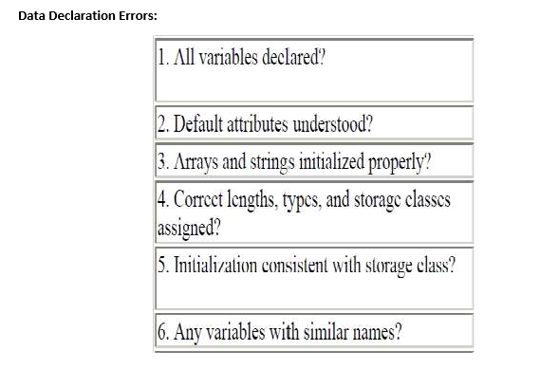

CODE:

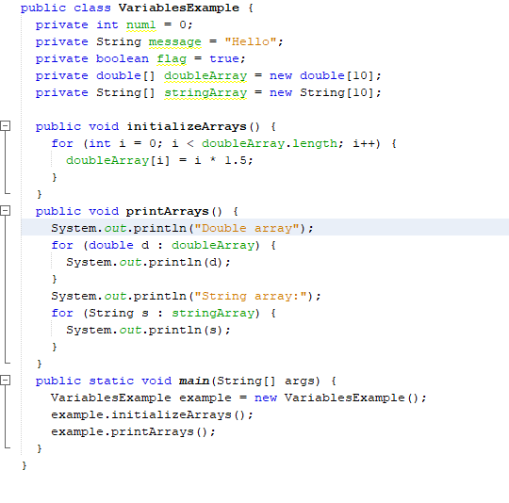

|  |  |  |
| --- | --- | --- |
| **Criteria** | **Description** | **Error Found** |
| 1. All variables declared? | All variables used in the code are properly declared within the class. | No Error |
| 2. Default attributes understood? | The code uses default access modifiers, but there's a missing semicolon. | Missing semicolon after String declaration |
| 3. Arrays and strings initialized properly? | Only double array is initialized in the loop string array is not. | String array is not initialized within the loop |
| 4. Correct lengths, types, and storage classes assigned? | Lengths and data types are correct, but storage class initialization might be missing. | No Error ,Lengths and data types are correct |
| 5. Initialization consistent with storage class? | Primitive num1 is initialized correctly. Arrays lack proper initialization within the loop. | Arrays not consistently initialized |
| 6. Any variables with similar names? | No variable names appear to be confusingly similar. | No Error |

|  |  |  |  |  |  |
| --- | --- | --- | --- | --- | --- |
| **Testcase** | **Description** | **Input Data** | **Expected Result** | **Actual Result** | **Status** |
| TC-01 | Check for existence of declared variables | -- | Compilation success |  | Pass |
| TC-02 | Semicolon check  after String declaration | Private String message = “Hello” | No compilation error | Compilation error | Fail |
| TC-04 | Check  Stringarray  initialization | -- | All elements of String Array with values | Some or all elements empty | Fail |
| TC-05 | Complete  array initialization | -- | All elements of arrays with assigned values | All elements of arrays with assigned values | Pass |
| TC-06 | Array declaration with type mismatch | private double[] doubleArray = new int[10]; | Compilation error. | Compilation error | pass |
| TC-07 | Array declaration with type mismatch | private double[] doubleArray = new int[10]; | Compilation error. | No compilation error | fail |
| TC-08 | Primitive variable initialization mismatch | int num1 = "Ten" | Compilation error | Compilation error | pass |
| TC-09 | Primitive variable initialization | int num1 = 10; | No Compilation error | No compilation error | pass |
| TC-08 | Primitive variable initialization mismatch | int num1 = "Ten" | Compilation error | No Compilation error | fail |