May 15, 2026

Project: Marketing Analytics ETL Pipeline Using Google Ads API and Power BI

Background
- UofL College of Business uses multiple platforms like Google Ads, Meta Ads Manager, LinkedIn Ads Manager and Slate CRM to track paid media performance and ROI.
- These digital advertising platforms generate large volumes of campaign performance data which need to be consolidated for faster and more automated reporting workflows to monitor KPIs and campaign effectiveness.
- I want to start with POC on automating Google Ads reporting combined with Slate CRM leads data in this project by focusing on building an automated marketing analytics pipeline using Google Ads API, Python, and Power BI.
- As a future roadmap the workflow will also explore AI assisted insight generation using summarized campaign metrics, since it’s a paid API this feature will be out of scope for this project.

Problem Statement
- Marketing reporting workflows are manual, repetitive, and time consuming.
- Raw data (CSV downloads) requires cleaning, transformation, and structuring before analysis.
- There is a need for a repeatable ETL pipeline that automates campaign data ingestion, KPI calculation, and dashboard reporting.
- Current reporting workflow requires manual Python execution, CSV refreshes, and Power BI updates and the Ads spend reporting is refreshed monthly instead of daily (human data entry).
- My goal is to update it daily in an automated way.

Objectives (Specific Aims)
- Extract campaign performance data from Google Ads API using Python
- Transform and clean API responses into structured datasets
- Use cleaned CSV datasets as the source of truth for program wise lead and conversion analysis (This is output coming from python script that cleans, normalizes, merges and transforms Slate data)
- Calculate marketing KPIs including spend, CTR, CPC, CPL, and conversion rate
- Store processed data in Supabase PostgreSQL tables to support scalable analytics and reporting workflows
- Build an interactive Dash analytics application connected to PostgreSQL for campaign performance monitoring and KPI analysis.
- Automate data refresh and reporting workflows
- Implement data quality validation and incremental loading logic to prevent duplicate records and improve data reliability
- Explore AI assisted insight generation using aggregated campaign metrics (out of scope for this project but in scope for the real life roadmap)

Methodology / Technical Approach
Data Source
- Google Ads API (for future real life road map Meta & LinkedIn will also be connected)
- Campaign performance and conversion data
- Program level lead and conversion datasets (CSV)
- Program level historic spends by channel and leads (CSV)

Technology Stack (This may change during actual project implementation)
- Python
- Google Ads API
- Supabase PostgreSQL
- Dash
- Plotly
- SQLAlchemy
- OpenAI API (future scope)

ETL Workflow
- Extract campaign data from Google Ads API
- Parse and normalize API responses
- Clean and transform datasets using Python
- Merge campaign and program level conversion datasets
- Calculate KPIs and aggregated metrics
- Perform data quality validation checks including null detection, duplicate detection, schema validation, and referential integrity validation
- Load transformed datasets into Supabase PostgreSQL tables using SQLAlchemy
- Implement incremental loading logic to append only new records and prevent duplicate data loads
- Create analytics-ready datasets for interactive Dash visualizations and KPI reporting.
Automation
- Schedule automated API pulls and ETL execution every 24 hours using Windows Task Scheduler
- Automate ETL execution, database loading, and analytics dataset refresh workflows
- Generate AI assisted campaign summaries using aggregated metrics (future scope)

Dashboard / Visualization
- Program Spend Budget vs Actual Forecast calculated on run rate
- Program wise leads and cost per lead
- Cost per lead analysis comparing last week, last month, last year
- Spend, Leads, CPL, and month over month program performance tracking
- Top performing campaigns and programs
- Users can: Filter by Program, Source, view KPI cards, explore interactive charts, view trends without refreshing application

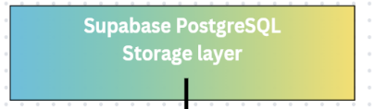
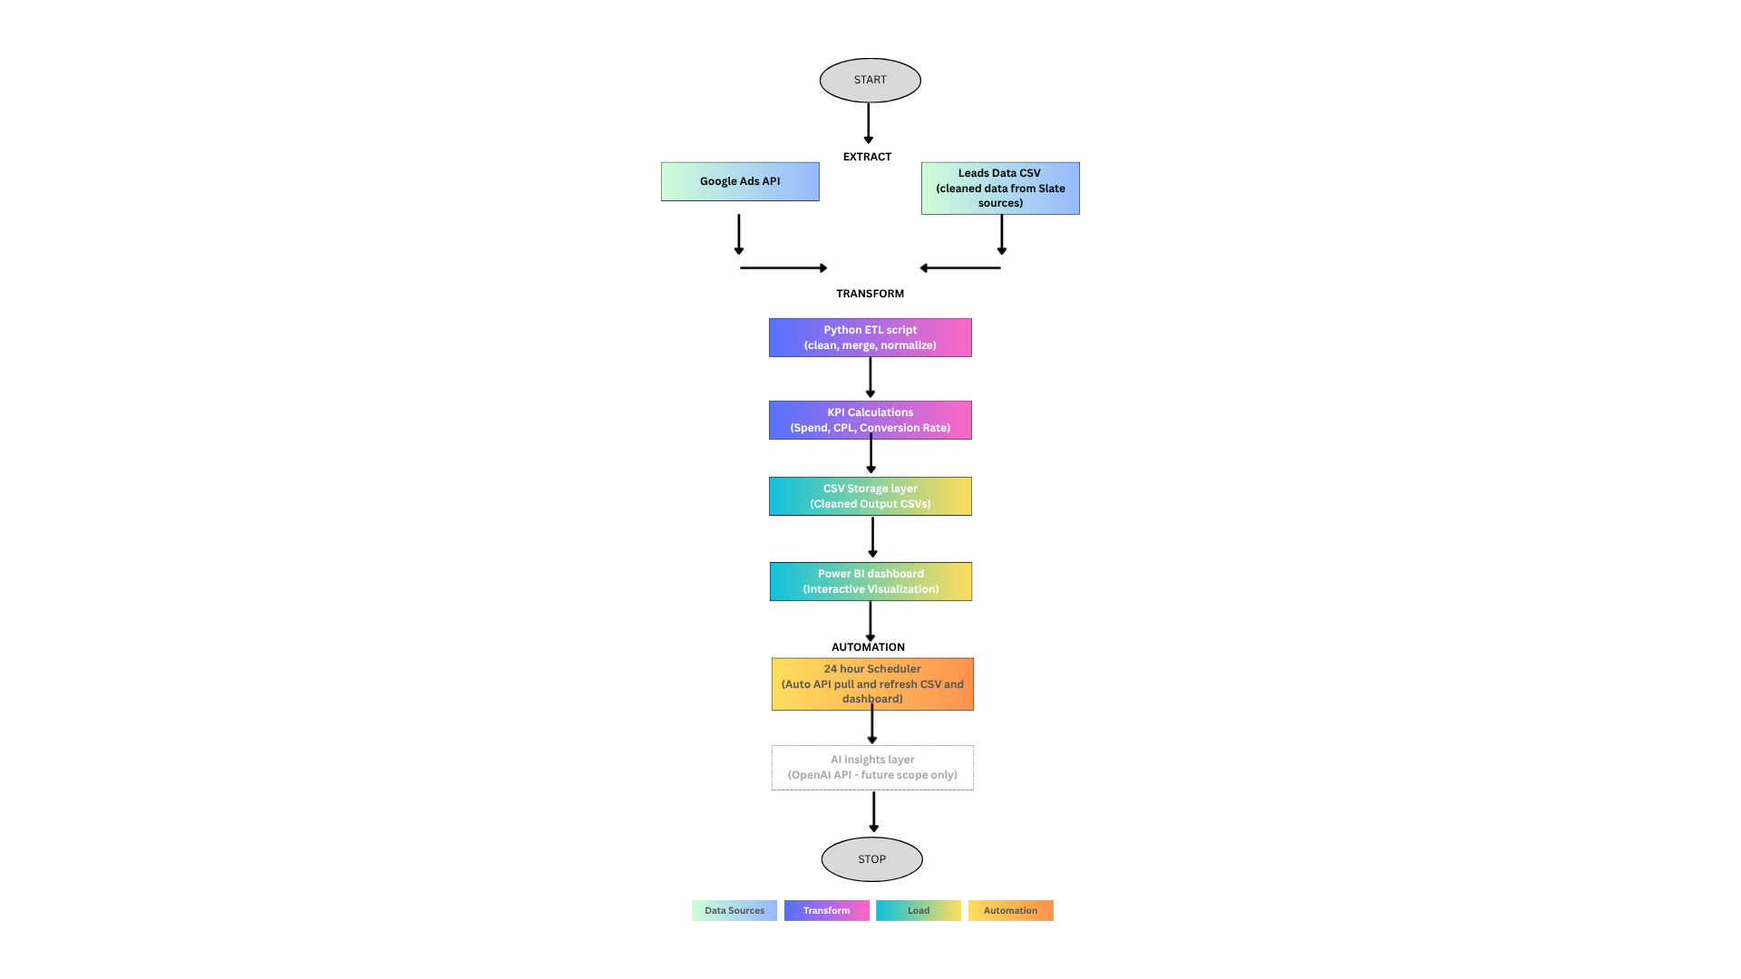
Pipeline Architecture

Timeline
Week | Tasks
Week 1 | Finalize project proposal, evaluate Google Ads API documentation
Week 2 | Request API Access from Manager, Set up API authentication, extract campaign data using Python, test API requests
Week 3 | Build ETL workflow, clean and transform datasets, calculate KPIs completing the storage layer
Week 4 | Develop Dash application with PostgreSQL integration, KPI cards, interactive filters and visualizations.
Week 5 | Automate refresh workflow, test pipeline, finalize presentation

Expected Outcomes
- Functional ETL pipeline using Google Ads API and Python
- Automated campaign data ingestion and transformation workflow
- Analytics ready datasets stored in Supabase PostgreSQL and exported for Power BI reporting
- Interactive Dash analytics application connected to PostgreSQL with live KPI reporting, filtering, and visualization capabilities.
- Automated KPI reporting workflow

