|  |  |  |  |
| --- | --- | --- | --- |
| **ASSIGNMENT SUBMISSION FORM** | | | |
| STUDENT USE | | STAFF USE | |
| Module Name | **Web Technologies** | First Marker |  |
| Module Code | **4BUIS011C** | Second Marker |  |
| Module Leader | **Subair Ali** | Agreed mark |  |
| Student ID | 00007645 | For Registrar’s office use only (hard copy submission) | |
| Deadline Date | Monday, November 21, 2019;  Time: 17:00 |
| Assignment Type | Portfolio of Individual Exercises I |
|  | | | |



**Word count: 731**

**Audience Profile**

Today running online business is the most popular in developed country and consumers can’t also help doing buying online because of its comforts. Also, shamsbio.github.io is created in order to sell products which is produced in a company “Shams Bio Agro”. “Shams Bio Agro” is a company which is produced agricultural preparade. In this company there are 2 types of preparade such as Gold-Gumi and KR-1. The main purpose of this website is increasing the rate of selling (by online), giving information about the products as well as the company too. Also, the main advantage of this website is that there are 3 languages (English, Russian, Uzbek) for user and other countries’ users don’t face any language problem during using time.

What is more, by buying online users can get some profits. To be more precise, in this website some types of discounts are given by buyers which is less possibility in real life. Also, delivering services are allowed in the website which can lead users (buyers) to take their precious time.

**FUNCTION and FEATURES**

In this project, I used html, css, java script, Node.js. One of the main features of the website is that users can use in any devices’ screen. What I mean by this is that it is user-friendly users can use this website on their phone tablets or laptop. It is completely responsive. Also, in this website appropriate color was chosen for each page by,which can lead users to console the eyes of a user from being tired.

Lets begin:

If I describe from the first page, the index page was created providing all requirements which is given is in coursework’s task, if I start describing from the beginning, NAV bar is created with bootstrap functions and the navigation is 100% responsive and this is one of the main features of my website.

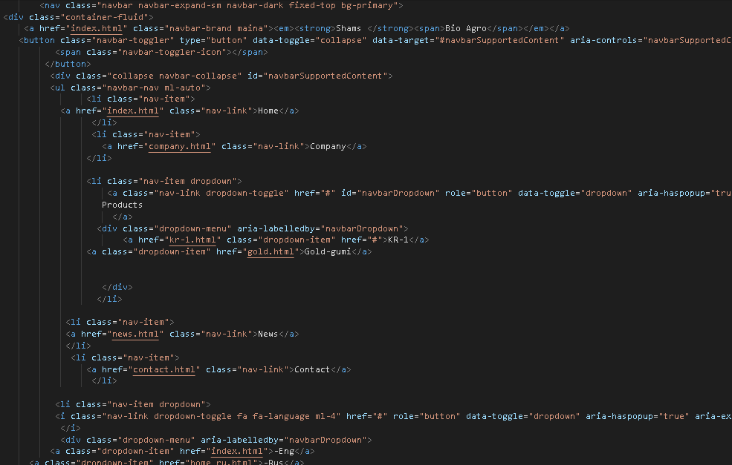

at the beginning of this page I put carousel which was created javascript functions.

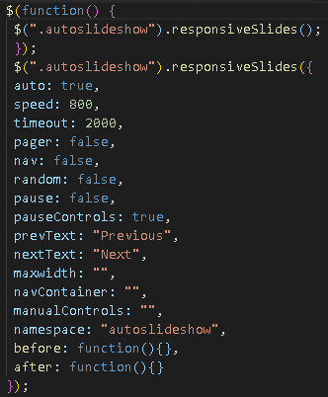

Also, the next3 sections were created in JQuery, which are Biologic, Products, Buy .

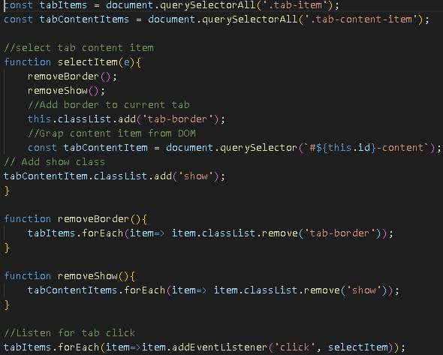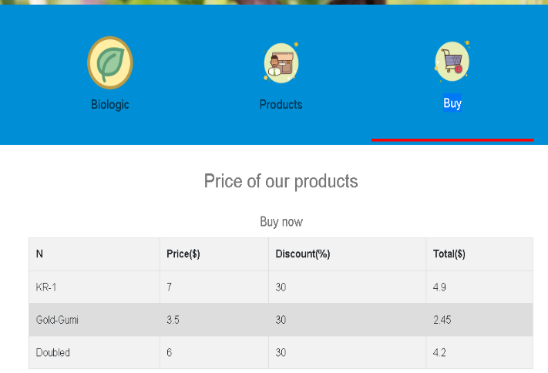

Here active section is buy and in it the price of the products which are prepared in “Shams Bio Agro” are showed. One of the features of this website is that this table and conculations of the cost of products is created with javascript functions.

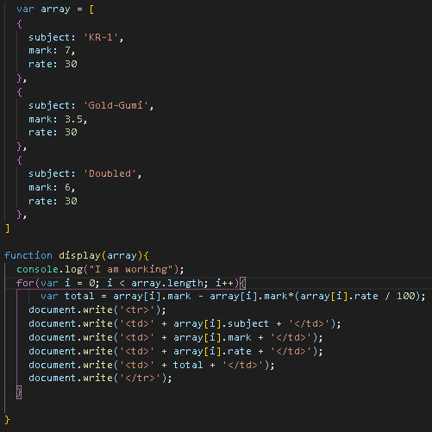

When it comes to the Products section, you can get information about the products like what are they and how can you buy them. When you click Biologic section, you learn what are the biologic substances and products.

The next page is the company page which include company information. In this page, java script function was used only logo section. To be more precise, the border of the loge change to different size. For creating this function I used some conculations like:

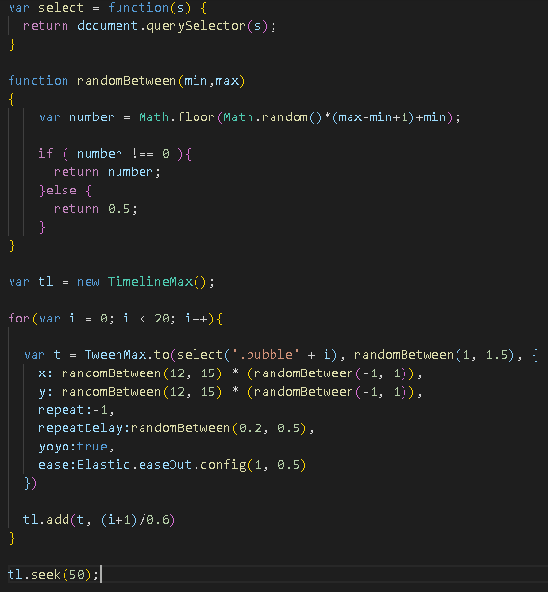



In the NAV bar, products is a dropdown and when you click it, the types of products which is produced in “shams Bio Agro” shows. The functions and design of the two the pages (“KR-1 and Gold-Gumi”) were created nearly the same and in this page only HTML, CSS, and Bootstrap were used and a video was installed on the top section with the class of overlay. Also, in all pages for footer this class was used in order to give opacity like that

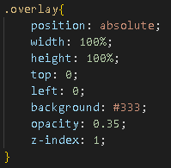

When it comes to news section, it was created very simple using HTML and CSS. In this page, a video was installed with autoplay property which provides when u move to this page this video began showing auto, which can help to take users time. The Coding is:

<video width="85%" height="auto" autoplay controls class="vid">

<source src="./video/Benefits of Farming with Biologicals- Bradyrhizobia & Trichoderma - YouTube (720p).mp4" type="video/mp4">

</video>

If I write about the contact page, it is one of the very important page in my website, because it consists of full information about the company like where it is located (with map and address) ; telephone numbers; motto; Call Center; Service Delivering; Email. The main important of this page is that it was created in javascript and all properties were given very clearly. Also, there is a section which provides to send massages for the companies services, which is created in Bootstrap -- ***SEND MAILS***:

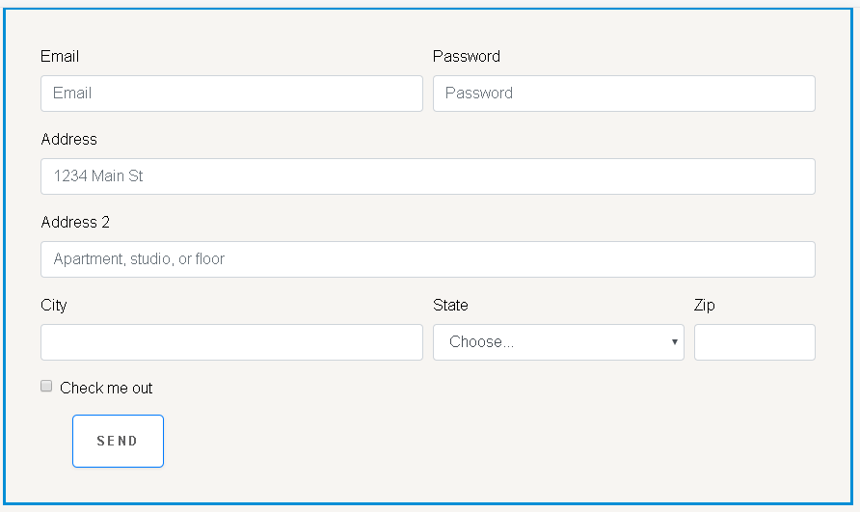

**Bibliography**

Anthony, D. (2019). *Photo by Anthony Dean on Unsplash*. [online] Unsplash.com. Available at: https://unsplash.com/photos/yOZqOufsdwI [Accessed 19 Nov. 2019].

Eva, F. (2019). *Photo by Eva Fan on Unsplash*. [online] Unsplash.com. Available at: https://unsplash.com/photos/SxIRJsdHtGo [Accessed 19 Nov. 2019].

Downing, T. (2019). *Photo by Trisha Downing on Unsplash*. [online] Unsplash.com. Available at: https://unsplash.com/photos/pyud8ZaVq4I [Accessed 19 Nov. 2019].

Askew, M. (2019). *Photo by Melissa Askew on Unsplash*. [online] Unsplash.com. Available at: https://unsplash.com/photos/y4xZxzN754M [Accessed 19 Nov. 2019].

nyas. (2019). *Chemical Biology Discussion Group | The New York Academy of Sciences*. [online] Available at: https://www.nyas.org/programs/frontiers-of-science/chemical-biology-discussion-group/ [Accessed 19 Nov. 2019].

Google.com. (2019). [online] Available at: https://www.google.com/search?q=contact+us&tbm=isch&ved=2ahUKEwjVvMj88vblAhX7wcQBHTaLBvgQ2-cCegQIABAA&oq=contact+us&gs_l=img.3..0l10.265804.275458..277636...3.0..4.213.2804.0j17j2......0....1..gws-wiz-img.....10..35i39j35i362i39j0i67j0i10.PhKhS2ovP-s&ei=jDPUXdXGHPuDk74PtpaawA8&bih=576&biw=1366&rlz=1C1GCEA_enUZ778UZ778#imgrc=2Teh6W0Yhd2RGM [Accessed 19 Nov. 2019].

Shutterstock. (2019). *Moving Around Fresh Ripe Tomatoes Stock Footage Video (100% Royalty-free) 1009132157 | Shutterstock*. [online] Available at: https://www.shutterstock.com/video/clip-1009132157-moving-around-fresh-ripe-tomatoes-on-vine [Accessed 19 Nov. 2019].

**Ather pictures were taken from the company(“Shams Bio Agro”).**