HW10-Team: Market Research (2 p) Fall 2025
Team Name and Number:
List all students who actively worked on this Assignment:
- Name: Ritujit Chaudhury
- Name: Rhea Roy
- Name: Prakriti Mishra
- Name: Shamsheer Hussain
- Name: Nehal Vaiti

Instructions
Part 1: Market Sizing (1 point)
Using the Food Delivery Service example (see Market Research slides), conduct a simple market sizing (in $), using assumptions. NOTE: Make sure to list all the assumptions. Please round up “dollars and cents” to millions.

Part 2: Competitive Analysis (1 point)
Using the Music App example (see Market Research slides), create a Competitive Analysis Table. Find as many competitors as you can and think what key features you need to compare. NOTE: Do not include your app in the table.

Page max: 3 (for the entire assignment). 10% deduction if over page max and/or not using this Template.

Part 1: Market Sizing (1 p)

Template

ChowPal Market Sizing Analysis

MARKET SIZING: CULTURAL COOKING PLATFORM FOR INTERNATIONAL STUDENTS (US MARKET)

Potential Customers

- 1.1 million international students in the United States
- Assumption 1: 50% are graduate students = 550,000 students
- Assumption 2: 60% live off-campus with cooking facilities = 330,000 students (550,000
× 0.60)

Cultural Cooking & Grocery Spending

- Assumption 3: 70% attempt cultural cooking at least monthly = 231,000 active cultural cooks (330,000 × 0.70)
- Assumption 4: Average cultural grocery spending = $150/month per student
- Assumption 5: 40% spent at ethnic grocery stores = $60/month per student ($150 × 0.40)

231,000 × $60 = $13,860,000 in ethnic grocery spending per month Market Potential
- Assumption 6: ChowPal adoption rate = 20% of active cultural cooks = 46,200 platform users (231,000 × 0.20)
- Assumption 7: 40% of users make purchases through platform monthly = 18,480 transactions/month (46,200 × 0.40)

18,480 × $60 = $1,108,800 in monthly grocery transactions through platform Revenue Calculation
- Assumption 8: Affiliate commission rate = 5% on grocery purchases
- $1,108,800 × 0.05 = $55,440/month in commission revenue

$55,440 × 12 = $665,280 or about $0.7 million/year Additional Revenue Streams
- Assumption 9: 15% of platform users subscribe to premium features at $5/month
- 46,200 × 0.15 × $5 = $34,650/month premium revenue
- $34,650 × 12 = $415,800 or about $0.4 million/year
- Assumption 10: Partnership fees from 100 ethnic grocery stores at $200/month
- 100 × $200 = $20,000/month
- $20,000 × 12 = $240,000 or about $0.2 million/year

TOTAL MARKET POTENTIAL: $0.7M + $0.4M + $0.2M = ~$1.3 million/year
LIST OF ALL ASSUMPTIONS
- 50% of US international students are graduate students (vs. undergrad)
- 60% of graduate students live off-campus with cooking facilities
- 70% of off-campus students attempt cultural cooking monthly
- Average cultural grocery spending = $150/month per student
- 40% of grocery spending goes to ethnic stores (vs. mainstream stores)
- ChowPal achieves 20% adoption rate among active cultural cooks
- 80% of platform users make purchases through affiliate links monthly
- Platform earns 5% affiliate commission on grocery purchases
- 15% of users convert to premium subscription ($5/month)
- 100 ethnic grocery stores nationally pay $200/month partnership fees

CRITICAL ASSUMPTIONS TO TEST

Highest Impact on Model:

  - Adoption rate (20%) - Most uncertain variable. Could range 10-30% based on network effects
  - Purchase conversion (80%) - Depends on UX and trust in affiliate links
  - Affiliate commission (5%) - Requires negotiation with grocery partners
  - Grocery spending ($60/month at ethnic stores) - Needs validation through surveys

Lower Risk Assumptions:

  - Graduate student percentage (50%) - Based on US immigration data
  - Cooking facility access (60%) - Reasonable for graduate students vs. undergrads in dorms
  - Cultural cooking frequency (70%) - Validated by our customer interviews

SENSITIVITY ANALYSIS

Conservative Scenario (10% adoption, 20% purchase conversion, 3% commission):
  - Users: 23,100 | Monthly transactions: 4,620 | Commission: 3%
  - Revenue: 4,620 × $60 × 0.03 × 12 = ~$100,000/year

Aggressive Scenario (30% adoption, 60% purchase conversion, 8% commission):
  - Users: 69,300 | Monthly transactions: 41,580 | Commission: 8%
  - Revenue: 41,580 × $60 × 0.08 × 12 = ~$2.4 million/year
Base Case: $1.3 million/year represents middle ground with conservative 40% purchase conversion rate validated by understanding that users browse recipes for inspiration but may not always purchase through platform immediately.

Part 2: Table: Competitive Analysis (1 p)
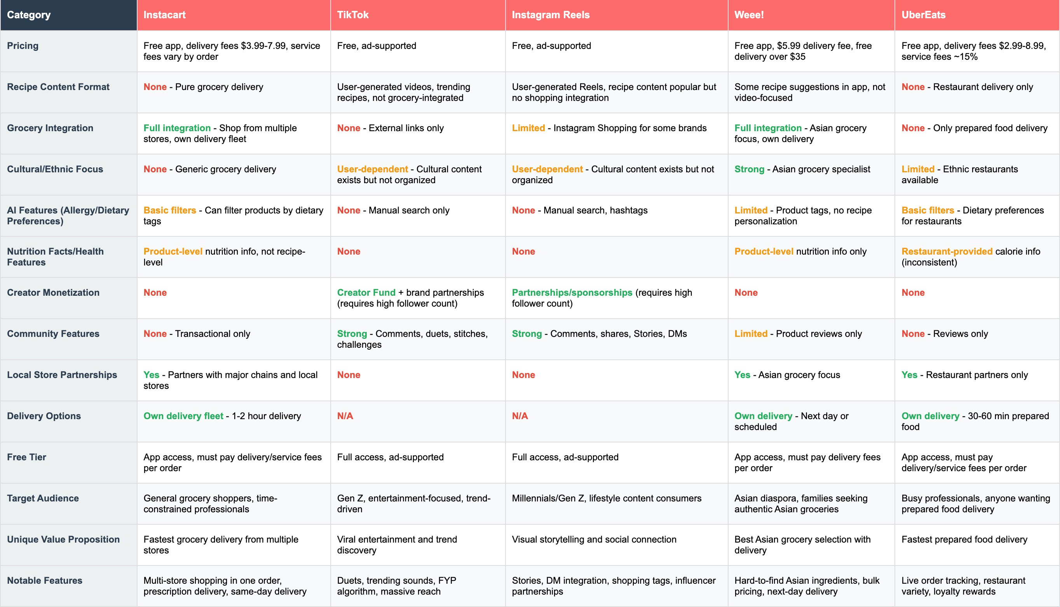

White Space Identified: No competitor combines peer-to-peer cultural recipe content with instant grocery purchasing and creator monetization specifically for international students. ChowPal would occupy unique position as "TikTok meets Instacart for cultural cooking."
Key Gaps in Current Market:

  - Recipe + Grocery Integration: TikTok and Instagram have recipe content but no shopping. Instacart and Weee have shopping but no recipe content.
  - Cultural Specificity: No platform organizes by cultural community or provides location-based peer guidance for ethnic cooking.
  - Accessible Creator Monetization: Social platforms require high follower counts. ChowPal could monetize creators from first recipe through affiliate model.
  - AI-Powered Dietary + Cultural Filtering: No competitor offers recipe personalization combining cultural preferences with dietary restrictions (halal vegetarian, kosher vegan, etc.)
  - Nutrition Tracking for Cultural Recipes: Existing nutrition apps don't understand cultural dishes or provide accurate macros for ethnic cooking.

Competitive Threats: Instagram and TikTok could add grocery shopping features (Instagram already has Shopping infrastructure). Instacart could add recipe content. Weee could expand beyond Asian to all cultural groceries. ChowPal's defensibility lies in hyper-focus on international student community and local ethnic store partnerships that larger platforms won't prioritize.

