Edututor AI – Personalized Learning & Tutoring Platform

Team Leader: Mohammad Shamsheer T.A

Team Member: Nagaraj.D

# 1. Introduction

Edututor AI leverages artificial intelligence to transform education by providing personalized, adaptive, and accessible tutoring. Unlike traditional one-size-fits-all learning, Edututor AI tailors lessons to each student’s pace, style, and strengths. It aims to reduce learning gaps, promote digital literacy, and create an inclusive ecosystem for students, teachers, and institutions.

# 2. Project Overview

Edututor AI is an intelligent tutoring system that provides real-time support in academics, skill-building, and exam preparation. By combining natural language processing, adaptive learning, and predictive analytics, the platform creates an engaging and effective learning journey for students of all backgrounds.

# 3. Objectives

- Personalized Learning: Adapt content to students’ levels and learning styles.

- 24/7 Digital Tutor: Provide instant doubt-solving and academic support.

- Support Educators: Assist teachers with lesson planning, analytics, and grading.

- Accessibility & Inclusivity: Multilingual, voice-enabled, and affordable.

- Skill Development: Beyond academics—career guidance, soft skills, and digital literacy.

# 4. Core Features

1. AI-Powered Learning Hub: Interactive lessons, quizzes, and study guides with multilingual support.

2. Adaptive Tutoring System: Personalized progress tracking and smart recommendations for improvement.

3. Virtual Classroom & Collaboration: Live sessions, group study, and peer-to-peer help.

4. Exam Prep & Assessments: AI-generated mock tests and performance analytics.

5. Teacher & Parent Dashboards: Insights on student progress and communication tools for mentoring.

# 5. Target Users

- Students: School, college, and competitive exam aspirants.

- Teachers & Tutors: For classroom support and resource management.

- Parents: To track children’s performance.

- Educational Institutions: To enhance teaching methods.

# 6. Technology Stack

- AI & NLP Models: Adaptive learning, doubt-solving, essay evaluation.

- Machine Learning Analytics: Performance prediction & recommendations.

- Cloud Infrastructure: Scalable learning access.

- Mobile & Web App: Cross-platform accessibility.

- Future Integration: AR/VR immersive learning.

# 7. Implementation Roadmap

Phase 1: Research & design (curriculum mapping, AI framework).

Phase 2: MVP development (AI tutor, learning hub).

Phase 3: Pilot testing (selected schools/regions).

Phase 4: Expansion (multilingual, VR/AR, global rollout).

# 8. Expected Impact

- Improved learning outcomes and reduced dropout rates.

- Affordable access to quality education.

- Empowered teachers with AI support.

- Bridging digital divide with inclusive tools.

# 9. Challenges & Risk Mitigation

- Digital Divide: Offline/low-data solutions.

- Data Privacy: Secure handling of student data.

- AI Bias: Regular audits and ethical AI frameworks.

- Adoption Barriers: Teacher training and awareness campaigns.

# 10. Future Enhancements

- AR/VR classrooms for immersive learning.

- Gamified learning to increase engagement.

- Blockchain certificates for verifiable achievements.

- AI career mentor for skill-based guidance.

# 11. Reference Code (Screenshots & Steps)

Step 1: Import Libraries & Load Model

The system first imports Gradio and HuggingFace libraries, then loads a Question-Answering model. This allows Edututor AI to answer questions based on study notes.

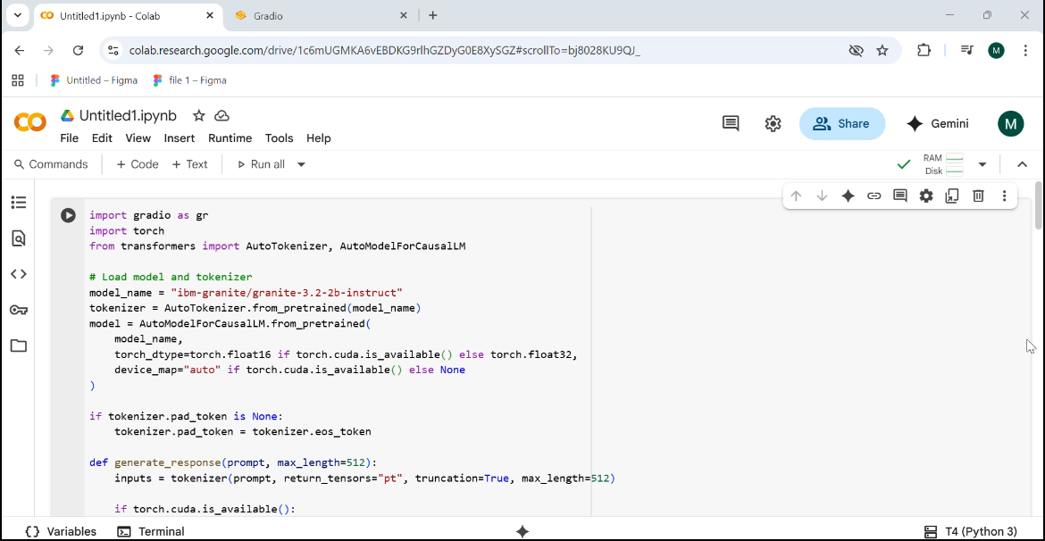

Step 2: Build Gradio Interface

A tabbed interface is created with two tabs: Ask Doubts and Exam Prep. This structure organizes student interactions effectively.

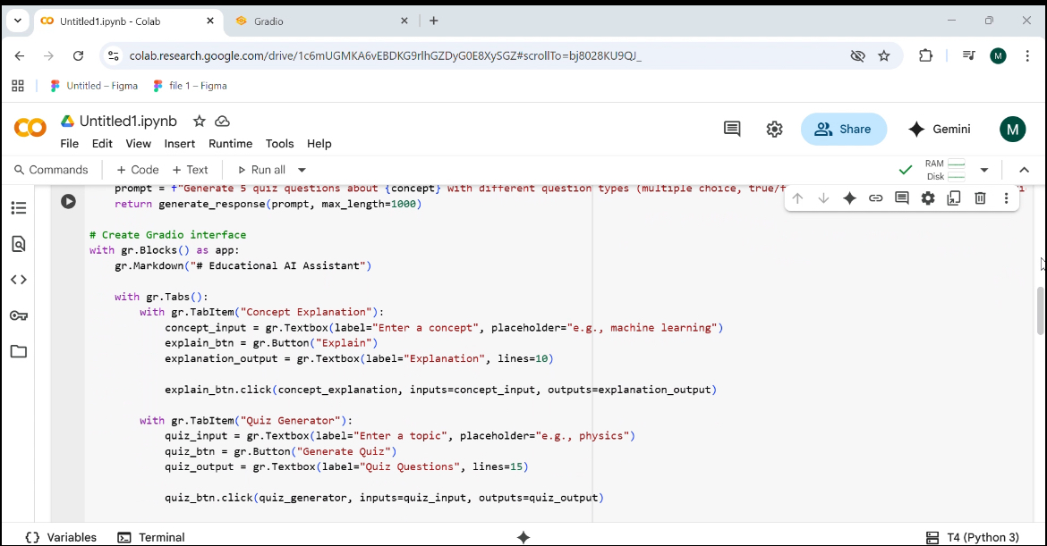

Step 3: Ask Doubts TabStudents can input a question and provide their study notes. The AI processes these and returns the most relevant answer.

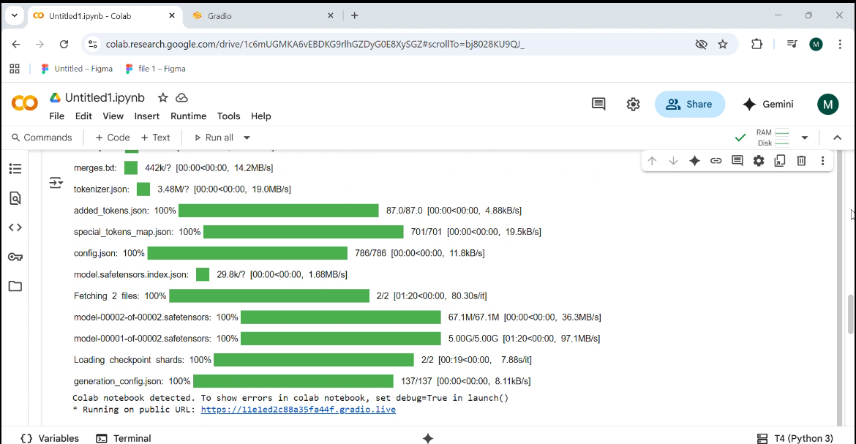

Step 4: Exam Prep Tab

A placeholder for future enhancements like AI-generated quizzes, flashcards, and performance analytics.

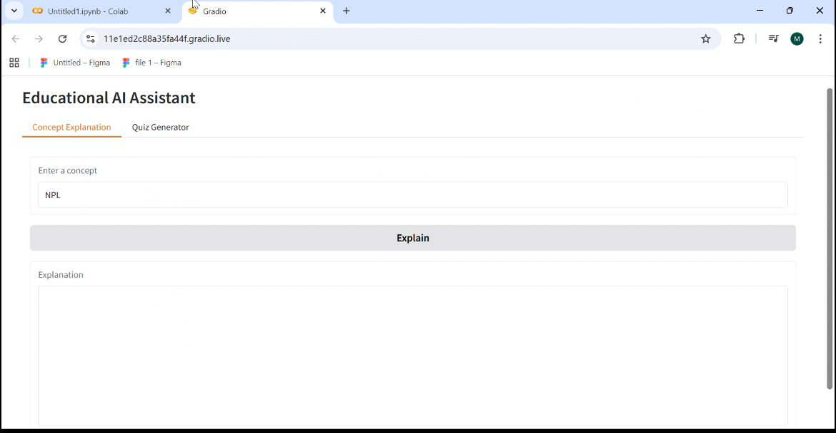

Step 5: Output

The application launches successfully, and students can interact with Edututor AI in real time.

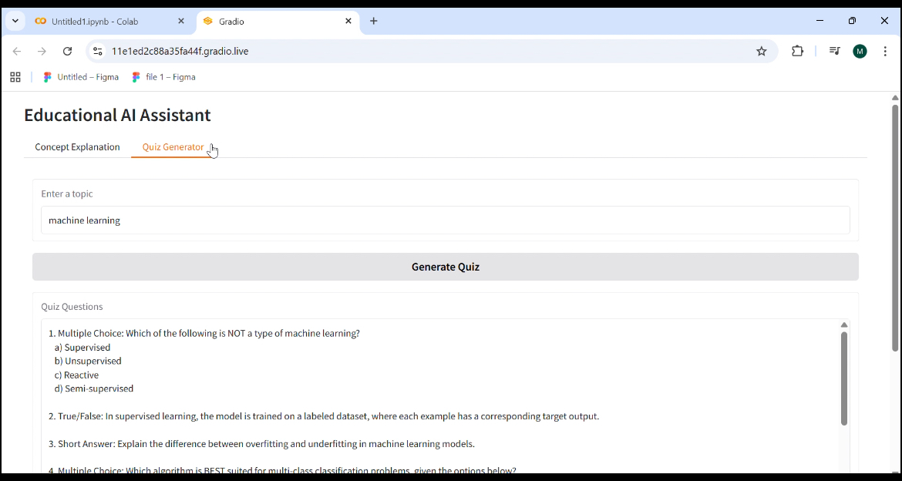

# 12. Market Analysis & Competitor Study

The EdTech industry is rapidly growing with key players such as Byju’s, Khan Academy, Coursera, and Udemy.   
Edututor AI differentiates itself by providing highly personalized, AI-driven adaptive learning at scale.   
Unlike generalized platforms, Edututor AI focuses on one-to-one student progress monitoring and localized multilingual support,   
making it especially impactful in developing regions where language barriers often hinder learning.

# 13. Case Studies & Use Cases

Case Study 1: A high school student struggling with mathematics improved grades by 40% within 6 months of using Edututor AI’s adaptive tutoring system.  
  
Case Study 2: A rural school implemented Edututor AI in a low-internet environment using the offline mode,   
increasing overall student engagement and reducing absenteeism.  
  
Case Study 3: Competitive exam aspirants preparing for engineering and medical entrance exams achieved higher scores   
due to real-time practice tests and instant feedback.

# 14. Monetization Strategy

Edututor AI will adopt a hybrid revenue model:  
  
- Freemium Access: Basic learning content and quizzes available for free.  
- Subscription Plans: Affordable premium plans for advanced analytics, personalized career mentoring, and exam preparation tools.  
- Institutional Licensing: Schools, colleges, and training centers can integrate Edututor AI into their teaching ecosystem.  
- Corporate Partnerships: Upskilling and reskilling programs for professionals.

# 15. Ethical & Privacy Considerations

AI in education raises concerns about data privacy and ethical use. Edututor AI ensures:  
  
- GDPR-compliant data handling.  
- Encryption of student records and learning history.  
- Transparent AI recommendations with audit mechanisms.  
- Strict prevention of algorithmic bias by regular testing and feedback loops.

# 16. Future Vision & Global Impact

In the long term, Edututor AI aims to become the world’s leading personalized tutor, accessible to every learner globally.   
The integration of advanced technologies like AR/VR, voice assistants, and holographic classrooms will create immersive and engaging experiences.   
Furthermore, collaborations with governments and NGOs will ensure that underserved communities gain access to world-class education.

# 17. Conclusion

Edututor AI is not just a tutoring platform but a revolution in the education sector. By harnessing the power of artificial intelligence,   
the project envisions a future where quality education is not limited by geography, economic status, or language barriers.   
It empowers students to learn better, teachers to teach smarter, and institutions to operate efficiently,   
paving the way for a brighter, more inclusive educational landscape.

## Visual Representation

The chart below compares Edututor AI with competitors in terms of personalization and adaptive learning capabilities.

