



Economic Development Committee Meeting
August 13, 2015
8:00 a.m.
Citrus Heights Chamber of Commerce Office
7920 Alta Sunrise Ave. Ste 100
Citrus Heights, CA 95610

2nd Thursday 8:00 a.m. to 9 a.m. each month

A SPECIAL THANKS TO THE CHAIRMAN'S CIRCLE SPONSORS

DIAMOND SPONSOR
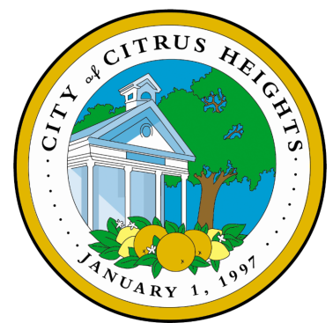

PLATINUM SPONSORS



GOLD SPONSORS


BRONZE SPONSORS


