**Optimizing public transportation**

**Abstract—** Internet of Things (IoT) is a platform that the device used to be smart, everydayis processed to be smarter, and every day communication becomes more informative. IoT is still growing and continues to be researched by some researchers. Various models, platforms and applications are proposed and designed in such a way as to benefit society. This paper was developed using the systematic literature review (SLR) method by conducting surveys on issues oriented towards the utilization of IoT related to the development of intelligent public transport. The architecture presented proposes solving real-life problems by building and disseminating powerful ideas. The purpose of this study is to explore opportunities and challenges for the application of IoT on public transport. The results of this study show that IoT utilization till now tends to give priority to safety in avoiding road accidents but has not yet discussed how intelligent transportation system can be developed by integrating bus scheduling, bus presence detection, and payment efficiency by passengers by booking seat system so that minimize congestion and reduce wasted time passengers. This research proposes breakthroughs incorporating the concept of the Internet with the integration of platforms of industrial actors involved in order to harness the power of IoT for various conveniences especially in the field of public transport and produce intelligence transportation system which is one of the smart city concept indicators.

**Keywords:** Internet of Thing, intelligence transportation system, smart transportation, public transportation, smart city, integration of Platform.

1. **Introduction:** The progress of information technology in IoT development is very influential on the various aspects of human activities. The paradigm of the IoT provides a reference to connect all physical objects in the global Internet base as well as the existing infrastructure for information and communication exchange. IoT aims to support rapid and precise identification such as location tracking, monitoring and management. Therefore, IoT is based on multiple integration of communications solutions, technology identification and tracking, sensor networks and actuators, and sharing of other information distribution [1]. According to Chen [2], IoT Architecture network consists of several layers such as layers of sensing, access layer, network layer, middleware layer and application layer. The application layer integrates the functions of the lower system, and builds practical applications from various industries, such as smart grid, smart logistics, intelligent transportation, precision farming, disaster monitoringand remote medical care. IoT's main function is to collect data to be measured by a sensor where it is integrated into a shortrange wireless network such as Bluetooth, ZigBee or Wi-Fi, and then transmit data to a larger network such as an internet network gateway [3]. IOT sensors use low cost, highly scalable, efficient, lowpower, and integrated data across all sub-networks. The more sensors combined and with the increase of data collection time, the data will become larger and known as the "Big Data". Big Data was introduced by Gartner Report in 2001 [4] and has three dimensions covering 3Vs: Volume, Velocity, and Variety. This definition has been rewritten and reasserted by others to include the fourth V: Veracity [5]. In short, IoT provides a means of data collection, detection and monitoring of an event, an algorithm for acting on an activity, storage of data and a considerable analysis. From several papers, the authors observed and found that most researchers tend to use and utilize IoT on passenger safety, so they focus more on features that help control drivers in driving the bus, monitoring bus lines and utilizing radio signals and LAN networks and other applications to maximizing IoT functionality on transport. The goal is to minimize the occurrence of accidents. But what about passenger comfort in choosing public transportation? Inspired from the public transport navigation system [6][7][8], The purpose of this research is to know the opportunities that can be used to maximize IoT function on public transportation. if previous researchers have made a monitoring system for bus travel, bus scheduling as well as early detector of the accident then this research tries to explore opportunities that can be obtained and used to produce a better public transportation system. Based on this, the research question is what the IoT function can be usedfor smart public transportation?

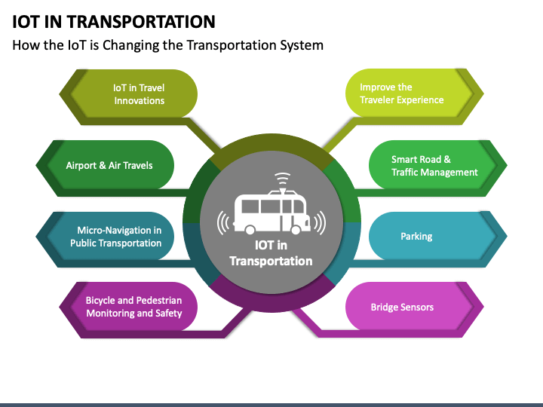

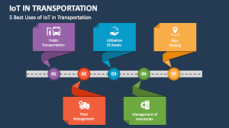

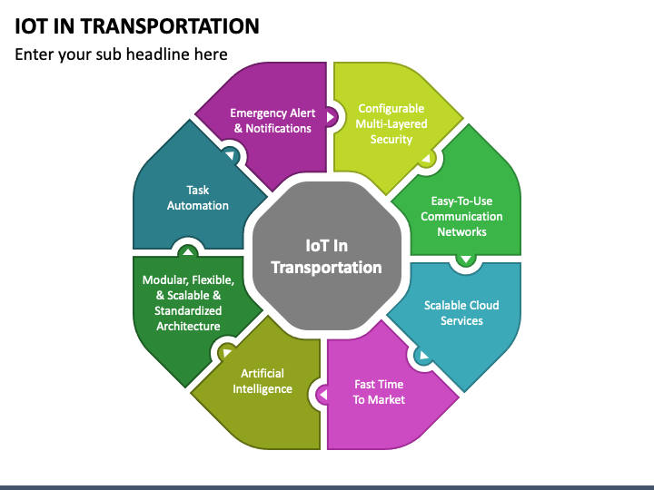

Public transportation optimization in the context of the Internet of Things (IoT) involves utilizing connected devices and sensors to enhance the efficiency, safety, and passenger experience. Here are some ways IoT can be applied:

**1. *Real-Time Monitoring*:** Install sensors on vehicles and infrastructure to monitor real-time data such as location, speed, and passenger load. This information can be used to adjust routes and schedules dynamically.

**2. *Predictive Maintenance*:** IoT sensors can track the condition of vehicles and infrastructure, allowing for predictive maintenance. This reduces downtime and improves service reliability.

**3. *Smart Traffic Management*:** IoT can integrate with traffic management systems to prioritize public transportation vehicles, reducing congestion and improving on-time performance.

**4. *Passenger Information*:** Provide passengers with real-time information about bus or train arrivals, delays, and alternate routes through mobile apps or displays at stations.

**5. *Automated Fare Collection*:** Implement contactless payment systems using IoT for quick and convenient fare collection.

**6. *Energy Efficiency*:** Optimize energy consumption in public transportation by monitoring and controlling lighting, heating, and cooling systems in vehicles and stations.

**7. *Safety and Security*:** Use IoT cameras and sensors for surveillance, accident detection, and emergency response systems to enhance passenger safety.

**8. *Environmental Impact*:** Monitor and reduce emissions by collecting data on vehicle performance and implementing eco-friendly driving practices.

**9. *Data Analytics*:** Analyze data collected from IoT devices to identify patterns, optimize routes, and plan for future expansion or improvements.

**10. *Integration with Smart Cities*:** Public transportation systems can be integrated into broader smart city initiatives, sharing data and resources with other city services.

**11. *Passenger Feedback*:** Collect feedback from passengers through IoT-enabled kiosks or mobile apps to make data-driven improvements.

**12. *Adaptive Pricing*:** Implement dynamic pricing based on real-time demand data to balance revenue and ridership.

IoT can revolutionize public transportation by providing a wealth of data and control mechanisms that enable more efficient and passenger-friendly services. However, it also comes with challenges like data security and privacy, which must be addressed to ensure successful implementation.