Q)What is a database?

Ans:

It is collection of interrelated data/information

Q)Differentiate between DBMS and RDBMS?

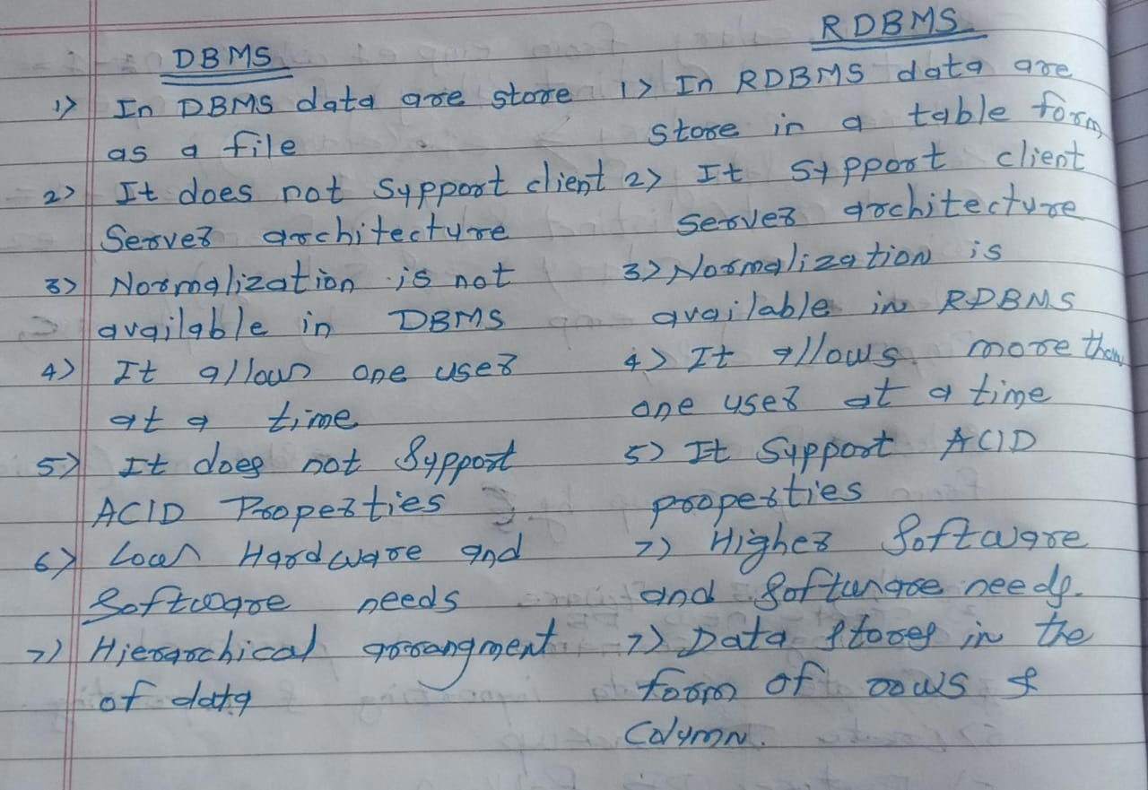

Q)Explain the ACID properties of a transaction?

Ans:

All databases are having “ACID” properties by default.by using ACID properties database will manage and maintain data/information accurately

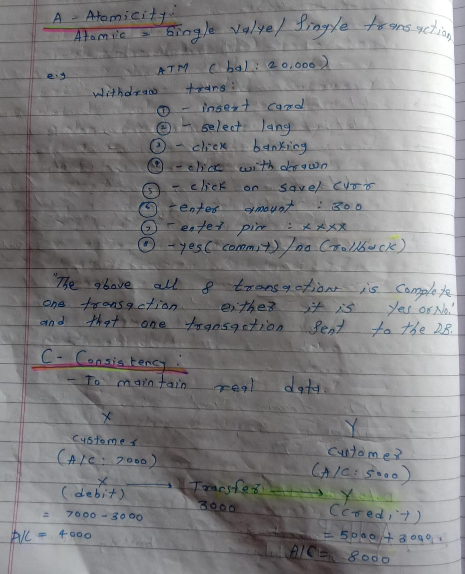

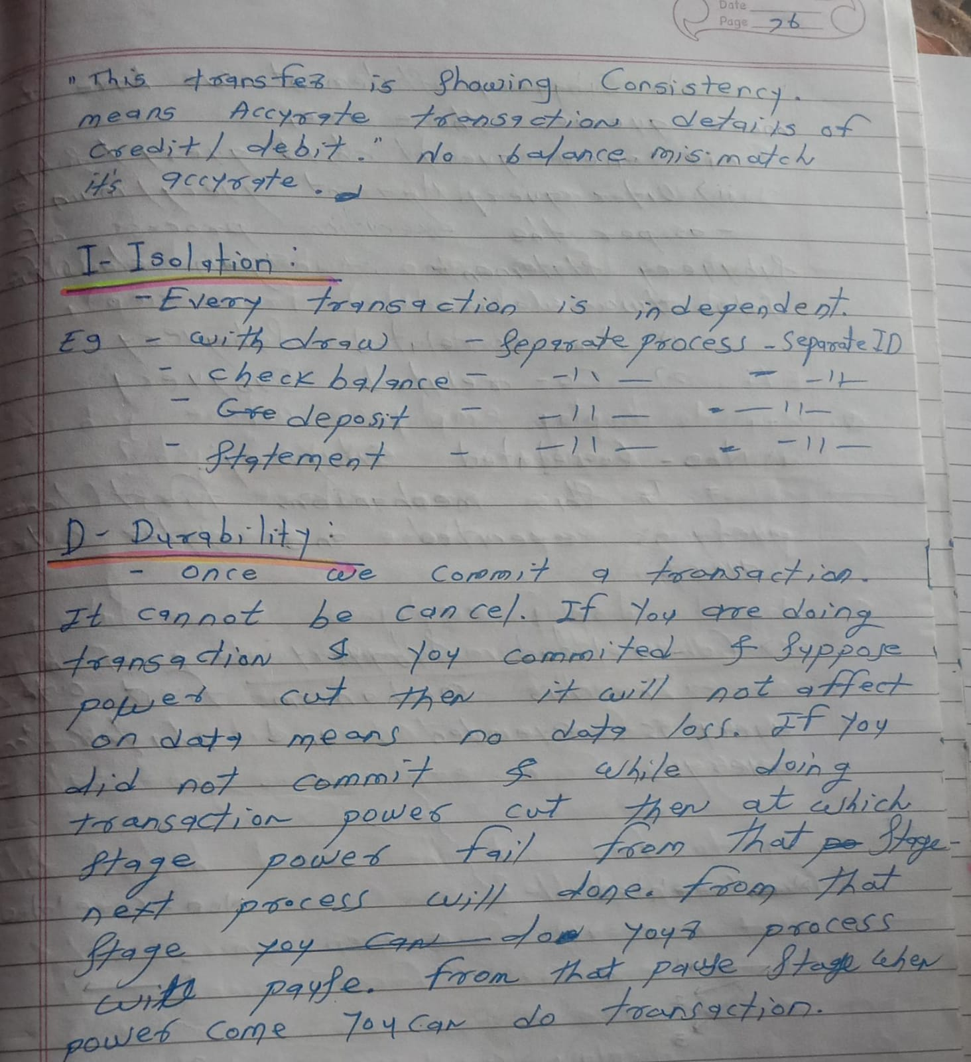

Q)What are the different types of database normalization?

Ans:

It is technique which is used to organised data in multiple tables

Page 113 to 115

Q)What is a primary key, foreign key, and unique key?

Ans:

Primary Key:

It is combination of unique and not null constraints. A table is having only one primary key constraint

e.g.,

create table test(sno int primary key, sal number(10));

alter table parent add constraint pk_eid primary key(eid);

Foreign Key:

Foreign It is used to create relationship between table

e.g.,

create table dept1(no int primary key, dname varchar(10));

create table emp1(eid int primary key, dname varchar(10), no int references dept1(no));

alter table child add constraint fk_eid foreign key(eid) references parent(eid);

Unique:

To restrict duplicate values but allows nulls

e.g.,

create table test(sno int unique, name varchar(10));

create table test(sno int, name varchar(10), unique(sno, name));

alter table parent add constraint uq_ename unique(ename);

Q)What is indexing in database?

Ans:

Index is an db object which is used to retrieval the required row from a table fastly

Create index i1 on emp(sal);

Q)Explain the concept of data integrity in databases?

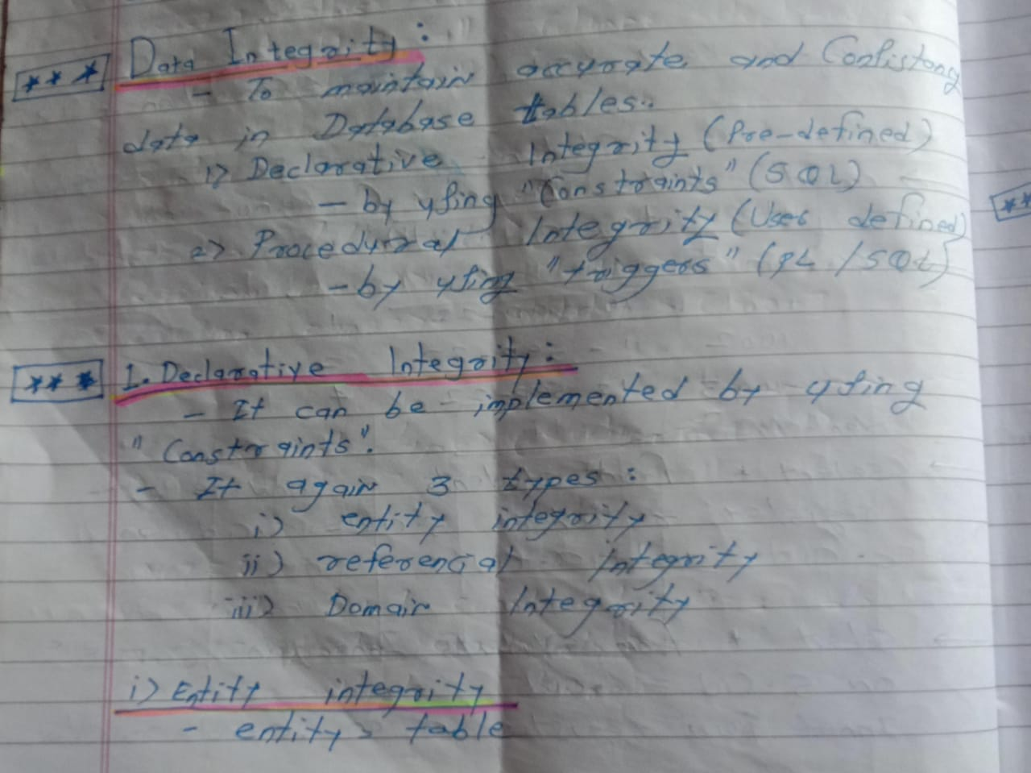

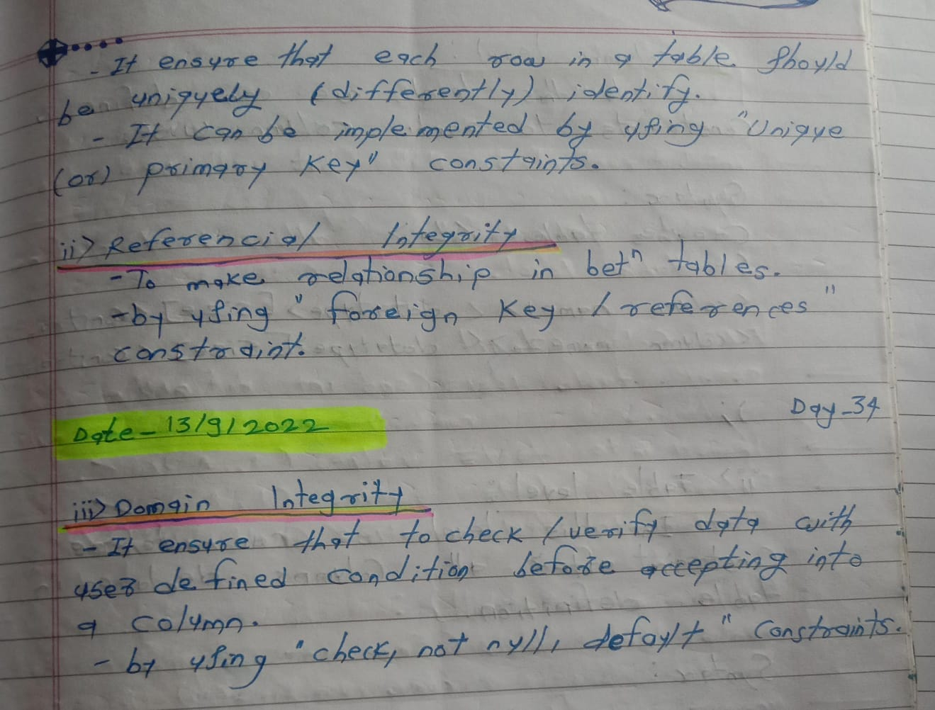

Q)Describe the difference between clustered and non-clustered indexes?

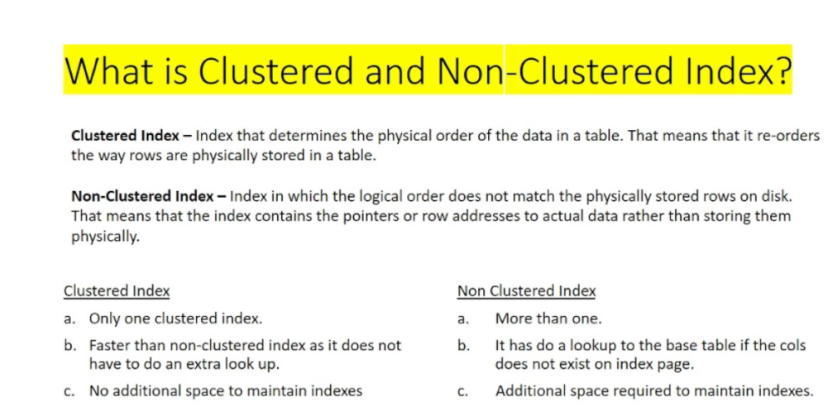

Q)What are stored procedures, triggers, and functions?

stored procedures

It is a block of code to perform some operations and may or may not return a value

CREATE PROCEDURE studentList

AS

BEGIN

SELECT name, age, salary

FROM STUDENT

ORDER BY salary;

END;

Functions

It is a block of code to perform some operations and return a value

Trigger

A trigger is a stored procedure that executes when a specific event occurs, such as a row update, insertion, or deletion

Create or replace trigger tr1

Before update on test

For each row begin

Dbms_output.put_line(‘hello’);

End;

/

Q)What is the difference between OLTP and OLAP databases?

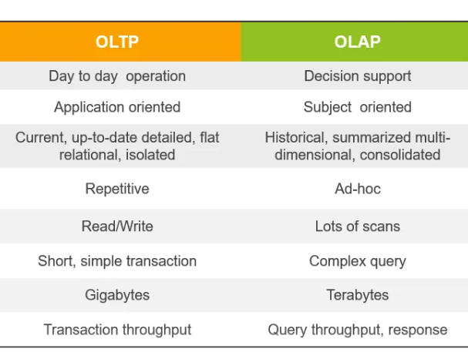

Q)What is a deadlock in a database, and how can it be prevented?

Ans:

Both users are waiting for there resources is called deadlock.  To prevent deadlocks, there are several methods such as Deadlock Avoidance, Deadlock Detection, and Deadlock Prevention

1)share lock: lock table mydb6pm.emp in share mode

2)Exclusive lock: lock table mydb6pm.emp in exclusive mode

Q)Explain the concept of database replication?

Database replication is the process of creating copies of a database and storing them across various on-premises or cloud destinations

Q)What is a SQL injection, and how can it be prevented?

SQL injection is one of the most common web hacking techniques. To avoid SQL injection Stop writing dynamic queries with string concatenation

Q)Can you explain the concept of database sharding?

Ans:

Database sharding is the process of storing a large database across multiple machines

Q)How do you optimize database performance?

Ans:

1. Query Optimization
2. Data Defragmentation
3. Increase Memory
4. Overhaul CPU
5. Improve Indexes
6. Upgrade Database Versions
7. Implemening Automatic Workload Repository Tool

Q)Roles of DB Admin?

Ans:

1. Installing Database software
2. Creating new DB
3. Creating username and password
4. DB data importing
5. DB data exporting
6. DB upgradation
7. Create DB backup
8. Restore DB

Q) Write a query to find duplicate records from a table

delete from test where rowid not in (select max(rowid) from test group by sno);

Q) Write a query to retrieve the nth highest salary

select id,salary from emp e1 where n-1=(select count(distinct salary) from emp e2 where e2.salary>e1.salary);

Q) What is a Oracle?

Oracle is a DB software. It is Relational Database Management System

Q) Difference between Delete and Truncate?

|  |  |
| --- | --- |
| Delete | Truncate |
| It is DML command | It is DDL command |
| It can delete a specific row | It can’t delete a specific row |
| It is temporary deletion | It is permamant deletion |
| It can restore data into a table by using rolback | It can restore data into a table by using rolback |
| The execution speed is slow | The execution speed is fast |

Q) Difference between view and Materialized view?

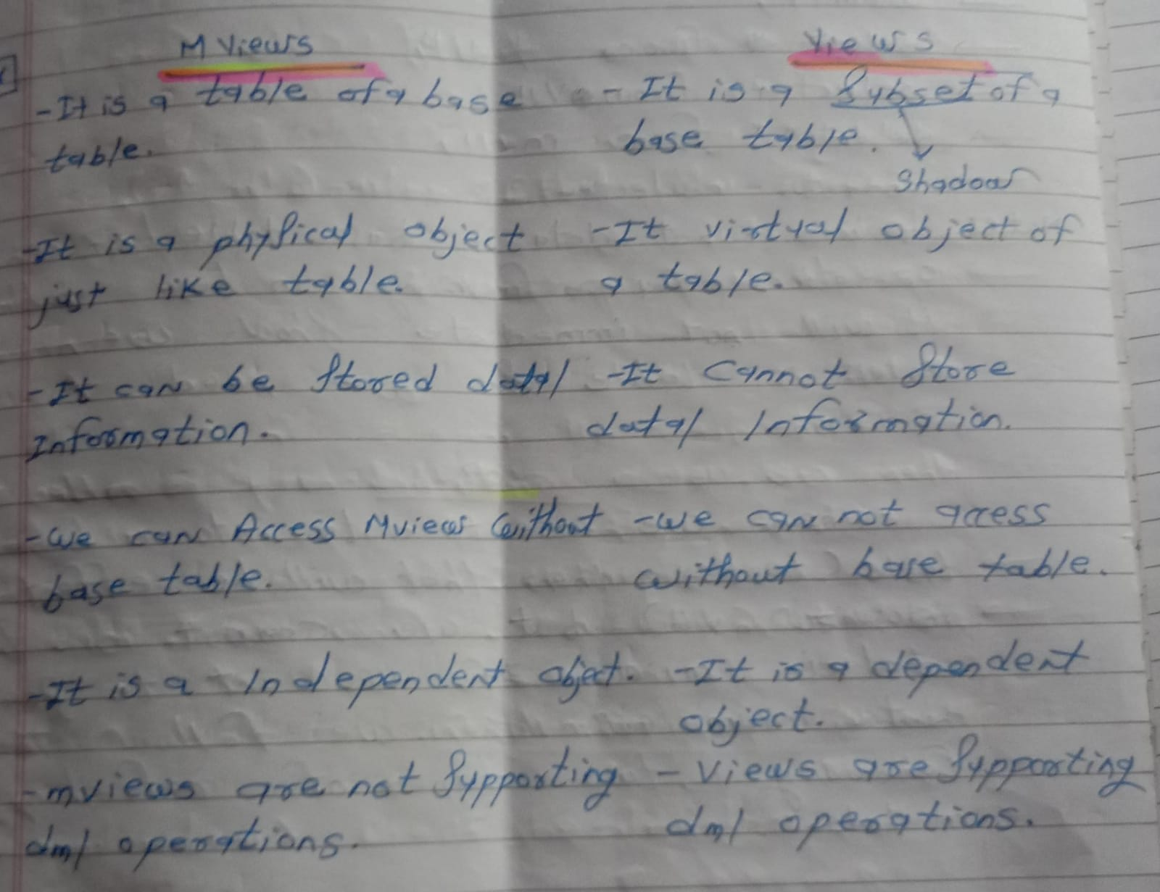

Q) Joins and types of Join?

Ans:

Joins are used to retrieving the required data from multiple tables at a time

TYPES OF JOIN

1.Inner Join

Retrieve all the matching rows from both table is inner join

select * from students inner join course on students.cid=course.cid;

2.Left Outer Join

Retrieving matching rows from both table but unmatching rows from left side table is left outer join

select * from students left outer join course on students.cid=course.cid;

3.Right Outer Join

Retrieving matching rows from both table but unmatching rows from right side table is right outer join

select * from students right outer join course on students.cid=course.cid;

4.Full Outer Join

Retrieving matching and unmatching rows from both table is full outer join

select * from students full outer join course on students.cid=course.cid;

5.Cross Join

Cross join is used to join each row of a table with each row of another table

select * from students cross join course;

6.Self Join

Joining a table by itself is called as self join

select t1.ename,t1.city from test8 t1,test8 t2 where t1.city=t2.city and t2.ename='smith';

Q) Date Functions?

1)sysdate()

2)add_months(sysdate,5)

3)last_day(sysdate)

4)months_between(date1,date2)

Q) Replace(), Translate(), substr(), instr()?

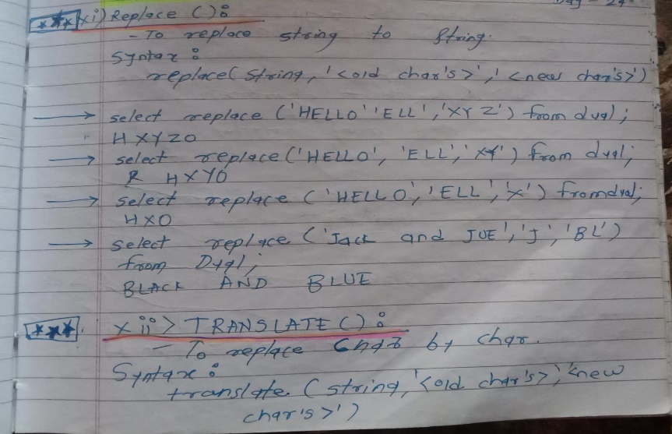

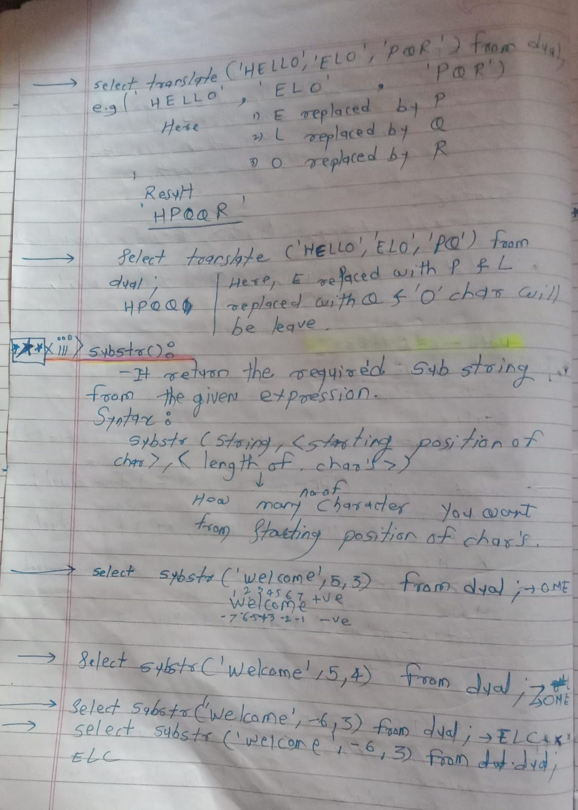

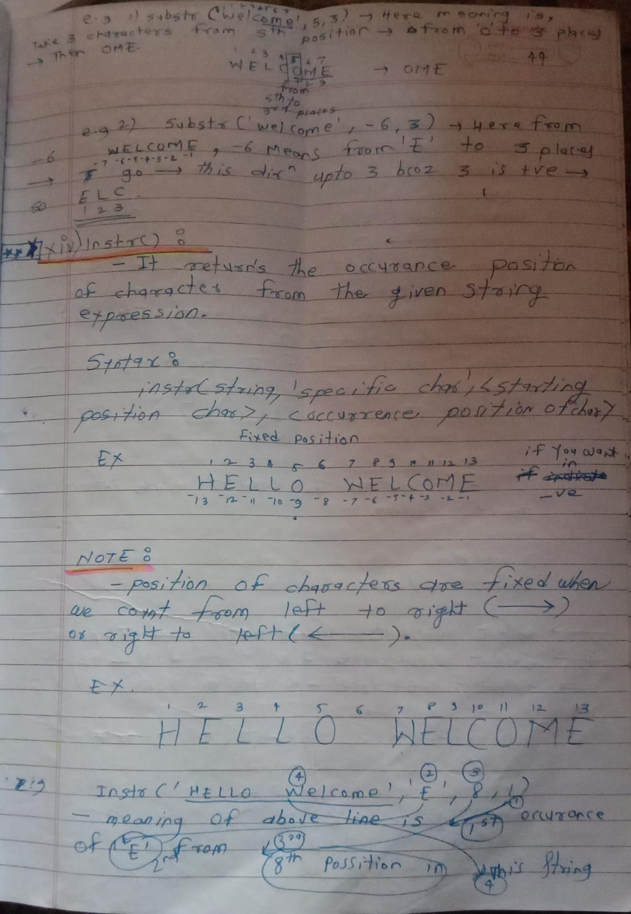

Q) What is Sub Query?

A query inside another query is called as subquery

1)Co-related Subquery

In this mechanism first outer query is executed and later inner query executed

2)Non Co-related Subquery

In this mechanism first ineer query is executed and later outer query executed

1. Single row subquery
2. Multiple row subquery
3. Multiple column subquery
4. Inline view

Q) What is package?

It is collection of variables, procedures and functions together save in same location

