**Assignment Integer Clock Divider**

|  |
| --- |
| Name |
| Shams Khaled Ezzat |

1. Initializing ports

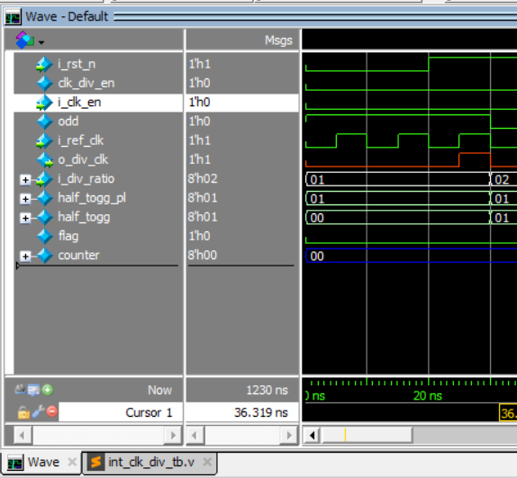

1. Dividing clk frequency by 2 with enable =0

1. Dividing clk frequency by 2 with active enable A screen shot of a computer

   AI-generated content may be incorrect.
2. Dividing clk frequency by 4 with active enable A screenshot of a computer

   AI-generated content may be incorrect.
3. Dividing clk frequency by 6 with active enable A screen shot of a computer

   AI-generated content may be incorrect.
4. Dividing clk frequency by 1 with active enable A screen shot of a computer

   AI-generated content may be incorrect.
5. Dividing clk frequency by 3 with active enableA screen shot of a computer

   AI-generated content may be incorrect.
6. Dividing clk frequency by 5 with active enable A screen shot of a computer

   AI-generated content may be incorrect.
7. Dividing clk frequency by 7 with active enable A screenshot of a computer

   AI-generated content may be incorrect.
8. Full wave form

* Design A screen shot of a computer program

  AI-generated content may be incorrect.
* Testbench

* Tasks

* Run file

* Source list

* Wave.do A screenshot of a computer

  AI-generated content may be incorrect.