**Group 1: Humanities courses:**

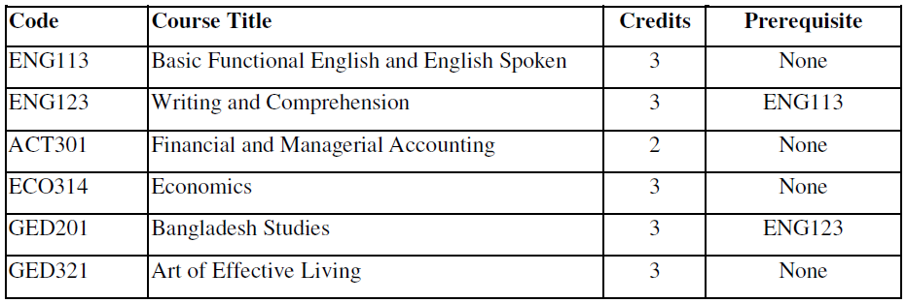

**Group 2: Mathematics and General Science Courses:**

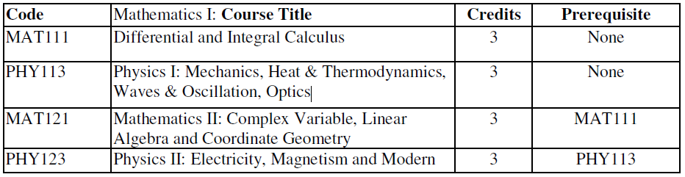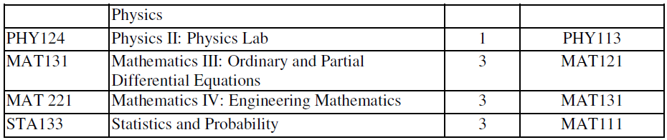

**Group 3: Core Courses:**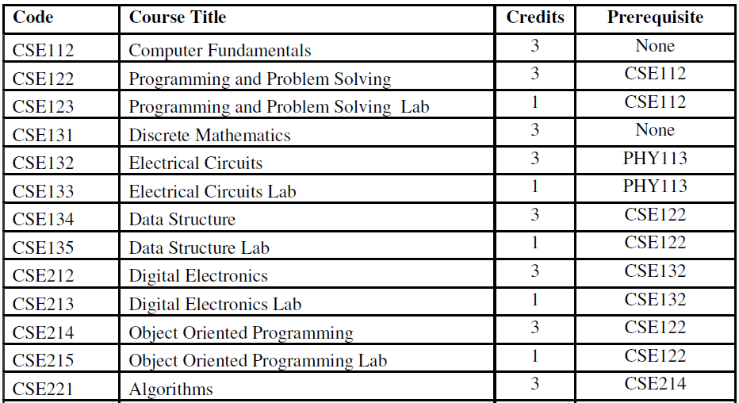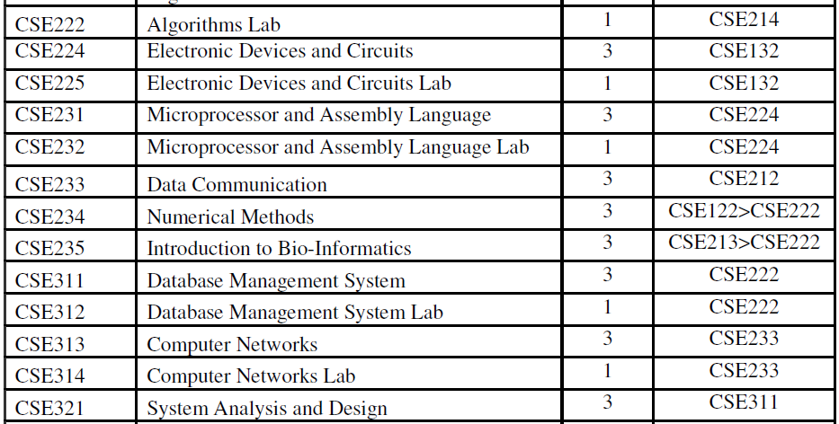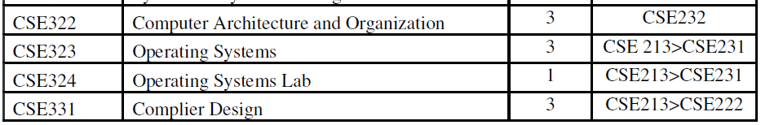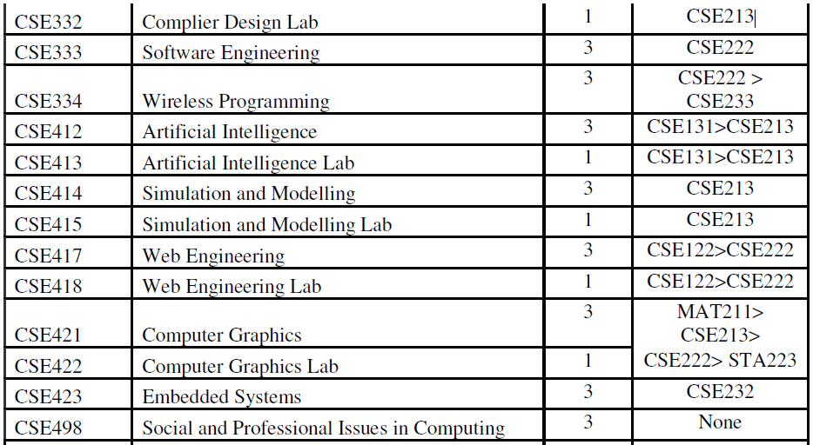

**Group 4: Elective Courses:**

