DAYANANDA SAGAR ACADEMY OF TECHNOLOGY AND MANAGEMENT

An Autonomous Institute under VTU, Belagavi
Accredited by NAAC with Grade A+


Engineering Exploration Course (BEEXC208)

Project Report
on
Title: SMART MEDICAL STORAGE BOX USING IOT

SDG Theme: Smart and Sustainable Agriculture

Submitted by
BHASKAR 1DT25IS040
ANSHIKA 1DT25IS026
ANWITA 1DT25IS030
AHAD 1DT25IS009

In partial fulfillment of the requirement for the degree of
BACHELOR OF ENGINEERING
Under the Guidance of Dr. Pavani Cherukuru Associate Professor
Dept. of ISE, DSATM, Bengaluru


DAYANANDA SAGAR ACADEMY OF TECHNOLOGY AND MANAGEMENT
Accredited by NAAC with Grade A+
Udayapura, Kanakapura Road, Bengaluru-560082

Academic Year 2025-2026

DAYANANDA SAGAR ACADEMY OF TECHNOLOGY AND MANAGEMENT
Udayapura, Kanakapura Road, Bengaluru-560082

An Autonomous Institute under VTU, Belagavi
Accredited by NAAC with Grade A+


This is to satisfy that the Engineering Exploration Course project work entitled Title: Smart Medical Storage Box under the SDG Theme: Good Health and Well Being carried out by Bhaskar (1DT25IS040), Ahad Ansari (1DT25IS009), Anwita Kashyap (1DT25IS030) and Anshika (1DT25IS026), a bonafide student of DAYANANDA SAGAR ACADEMY OF TECHNOLOGY AND MANAGEMENT in Bachelor of Engineering of Visvesvaraya Technological University, Belagavi during the academic year 2025-2026. It is certified that all the corrections/suggestions indicated for internal assessment have been incorporated in the report. The project report has been approved as it satisfies the academic requirement in respect of the Engineering Exploration Course prescribed for the degree.

Signature of Coordinator | Signature of Guide | Signature of the Principal
Dr. Roopa R Kulkarni | Dr. Pavani Cherukuru | Dr. M. Ravishankar

External Viva Name of the Examiner Signature with date

1.

2.

ACKNOWLEDGEMENT

We are deeply grateful for the support and guidance received that has made this project possible.

First and foremost, we would like to express our sincere thanks to the Management of Dayananda Sagar Academy of Technology and Management, Bengaluru for providing the necessary resources and a conducive environment to complete this project.

Our heartfelt gratitude goes to our Principal, Dr. M. Ravishankar, for his constant encouragement and for fostering a culture of academic excellence.

We are immensely thankful to our Project Guide, Dr. Pavani Cherukuru, Associate Professor, Department of ISE for her invaluable insights, constructive feedback, and unwavering support throughout the duration of this project. Her expertise and dedication have been instrumental in shaping the direction and outcome of this project work.

We would also like to extend our gratitude to the Coordinator, Dr. Roopa R Kulkarni for her efficient guidelines and framework, which ensured that the project progressed smoothly and met all deadlines.

Lastly, we would like to acknowledge the hard work and dedication of our team members: This project would not have been possible without their collaboration, creativity, and commitment.

Thank you all for your support and encouragement.

Sincerely,
BHASKAR 1DT25IS040
ANWITA 1DT25IS030
ANSHIKA 1DT25IS026
AHAD 1DT25IS009

ABSTRACT
Proper storage of medicines is essential to maintain their quality, effectiveness, and safety. Many medicines are sensitive to environmental conditions such as temperature and humidity. Exposure to excessive heat or moisture can reduce their effectiveness, shorten their shelf life, and increase the risk of spoilage. In homes, small pharmacies, and rural healthcare facilities, medicines are often stored without continuous monitoring of these conditions, leading to unnecessary wastage and potential health risks.

The Smart Medical Box is a low-cost, portable, and user-friendly solution designed to monitor the storage environment of medicines. The system uses a DHT22 temperature and humidity sensor to continuously measure the conditions inside the storage box. A microcontroller, such as an ESP32 or Arduino Uno, processes the sensor data and compares it with predefined safe limits. If the temperature or humidity exceeds the recommended range, the system activates a buzzer and an LED indicator to alert the user. An LCD or OLED display provides real-time readings, allowing users to easily monitor the storage conditions. Silica gel packets are also placed inside the box to help reduce excess moisture and improve medicine preservation.

One of the major advantages of this project is its simplicity and affordability. Unlike conventional medicine storage systems that require expensive refrigeration units, advanced sensors, or continuous internet connectivity, the Smart Medical Box provides an economical alternative while still ensuring reliable environmental monitoring. The compact design makes it easy to place in homes, pharmacies, clinics, and healthcare centers. The system is also energy-efficient, requires minimal maintenance, and can be easily upgraded with additional features such as cloud monitoring, mobile notifications, or automatic data logging in future versions. This flexibility makes the project suitable for both current practical use and future technological enhancements.

This project contributes to Sustainable Development Goal (SDG) 3: Good Health and Well-being by promoting the safe storage of medicines and reducing losses caused by improper environmental conditions. By providing timely alerts and continuous monitoring, the Smart Medical Box helps ensure that medicines remain effective until their intended use. The project demonstrates how Internet of Things (IoT) technology can be applied to solve practical healthcare challenges through an accessible and innovative solution.
Overall, the Smart Medical Box combines sensor technology, embedded systems, and IoT concepts to create a practical healthcare solution that improves medicine storage conditions. By continuously monitoring temperature and humidity and providing immediate alerts whenever unsafe conditions are detected, the system helps minimize medicine degradation and enhances user awareness. The project highlights how simple technological innovations can improve healthcare practices, reduce unnecessary medicine wastage, and encourage the adoption of smart monitoring systems in everyday life.

TABLE OF CONTENTS

Chapter No. | Contents |  | Page No
1 |  | Introduction | 9-10
 | 1.1 | Organization of the Report | 10
2 |  | Design thinking approach | 11-18
 | 2.1 | Introduction | 12
 | 2.2 | Sustainable Development Goals | 13
 | 2.3 | Customer Research | 14-15
 | 2.4 | Empathy Map | 16
 | 2.5 | Customer Journey Map | 17
 | 2.6 | Need Statement to Problem definition | 18
3 | Literature Survey |  | 19-35
 | 3.1 | Introduction | 20
 | 3.2 | Survey of Paper | 21-25
 | 3.3 | Prior art search | 26
 | 3.4 | Survey of Products | 26-27
 | 3.5 | Gap Identified | 28
 | 3.6 | Problem statement | 28-29
 | 3.7 | Design Specifications | 29-31
 | 3.8 | Objectives | 32
 | 3.9 | Project Management | 33-35
 |  | 3.9.1 Identifying Milestones | 33
 |  | 3.9.2 Project Execution Plan | 34-35
4 | Feasibility Analysis |  | 36-39
5 | Methodology and Implementation |  | 40-45
 | 5.1 | Introduction | 41
 | 5.2 | System Architecture | 41
 | 5.3 | Flow diagram/Algorithm | 42
 | 5.4 | Performance parameters | 42-43
 | 5.5 | Hardware requirement | 43-44

 | 5.6 | Software Requirement | 44
 | 5.7 | Hardware Implementation | 45
6 |  | Result and Discussion | 46-49
 | 6.1 | Introduction | 47
 | 6.2 | Soft prototype | 47
 | 6.3 | Validation of the solution | 48
 | 6.4 | Performance parameters | 48-49
 | 6.5 | Final Prototype | 49
7 |  | Conclusion and Future Scope | 50-51
8 |  | Our journey experience and take away | 52-55
 |  | References | 56
 |  | Appendix 1 – datasheet of Sensors | 57
 |  | Appendix 2 – dataset details | 58
 |  | Appendix 3 – Conference Paper | 59
 |  | Appendix 4 – Patent filling document | 60
 |  | Appendix 5 – AI integration | 61

LIST OF FIGURES
 | FIGURE NO. | NAME OF THE FIGURE | PAGE NO
 | 2.1 | Empathy map | 13
 | 2.2 | PERSONA 1: Community Pharmacist | 14
 | 2.3 | PERSONA 3: Urban Retail Pharmacist | 14
 | 2.4 | PERSONA 3: Ayurevedic Pharmacist | 15
 | 2.5 | PERSONA 4: Ayurevedic Pharmacist | 15
 | 2.6 | Empathy Map for Health and Indigenous Innovation | 16
 | 2.7 | Customer Journey Map for Smart Medical Storage Box | 17
 | 3.1 | Existing Vaccine Storage Systems for Cold-Chain Preservation | 26
 | 3.2 | Pharmaceutical Storage Refrigerator | 27
 | 3.3 | Hygrometer Storage Box | 27
 | 3.4 | IoT-Based Smart Medicine Cabinet | 27
 | 4.1 | Financial Feasibility Analysis: Cost Comparison of the Proposed System | 38
 | 4.2 | Market Feasibility Analysis of the Proposed System | 38
 | 4.3 | Competitor Analysis of Existing Systems and Proposed Smart Herbal Medicine Storage Systems | 39
 | 5.1 | System Architecture of Proposed system | 41
 | 5.2 | Flowchart of the Smart Herbal Medicine Storage System | 41
 | 5.3 | Circuit Diagram of the Proposed Hardware Implementation | 45
 | 6.1 | Soft Prototype of the Smart Herbal Medicine Storage System | 47
 | 6.2 | Response Time and Notification Time Performance Graph | 48
 | 6.3 | Accuracy and System Reliability Analysis Graph | 49
 | 6.4 | Final Hardware Prototype of the Proposed System | 49
 | 8.1 | Temperature and Humidity monitoring on blynk console | 58

LIST OF TABLES

Table No. | Name of the Table | Page No
3.1 | Survey of Existing Research Papers on Smart Medical Storage Box Using Iot | 21-25
3.2 | Project Execution Plan and Development Timeline | 34-35
5.1 | Hardware Components and Their Specifications | 43-44
5.2 | Software Tools and Their Functional Applications | 44
6.1 | Performance Evaluation of the Proposed System | 48
8.1 | AI-Based Smart Medical Storage Box Using Iot | 61

Abbreviations

Abbreviation | Expansion
IoT | Internet of Things
ESP32 | Espressif Systems 32-bit Microcontroller
DHT22 | Digital Humidity and Temperature Sensor (Model 22)
RH | Relative Humidity
Wi-Fi | Wireless Fidelity
LED | Light Emitting Diode
LCD | Liquid Crystal Display
OLED | Organic Light Emitting Diode
GPIO | General Purpose Input/Output
PWM | Pulse Width Modulation
ADC | Analog-to-Digital Converter
DC | Direct Current
USB | Universal Serial Bus
API | Application Programming Interface
MQTT | Message Queuing Telemetry Transport
RTC | Real-Time Clock



INTRODUCTION

CHAPTER 1 INTRODUCTION

INTRODUCTION

Herbal medicines have been used for centuries as a natural and effective method of treating various health conditions. They are prepared from medicinal plants and contain bioactive compounds that provide therapeutic benefits. Due to their natural composition, herbal medicines are highly sensitive to environmental conditions such as temperature and humidity. Improper storage can reduce their medicinal properties, cause contamination, promote the growth of mold or microorganisms, and shorten their shelf life.
In many households, herbal medicines are stored in ordinary containers without monitoring the surrounding environmental conditions. Exposure to excessive heat, moisture, and direct sunlight can degrade the quality of herbs and reduce their effectiveness. Although advanced storage systems are available, they are often expensive and unsuitable for small-scale users, making a simple and affordable solution necessary. The Smart Herbal Medical Box is designed to provide a safe and controlled storage environment for herbal medicines. The system uses a DHT22 temperature and humidity sensor to continuously monitor the conditions inside the storage box. A microcontroller processes the sensor data and activates a buzzer and LED indicator whenever the temperature or humidity exceeds the recommended limits. An LCD display shows real-time environmental readings, while silica gel packets help reduce excess moisture inside the box.
The Smart Herbal Medical Box is an economical, portable, and easy-to-use solution that helps preserve the quality and effectiveness of herbal medicines. It promotes proper storage practices, reduces medicine wastage, and supports Sustainable Development Goal (SDG) 3: Good Health and Well-being by ensuring that herbal medicines remain safe and effective for use.

ORGANIZATION OF THE REPORT

This report is organized into seven chapters. Chapter 1 presents the introduction and overview of the project. Chapter 2 discusses the problem identification process, user research, empathy mapping, customer journey mapping, and problem definition. Chapter 3 presents the literature survey, prior art search, product survey, identified gaps, and project objectives. Chapter 4 discusses the technical, financial, and market feasibility of the proposed system. Chapter 5 explains the methodology, system architecture, implementation, hardware requirements, and software development. Chapter 6 presents the results, validation, and performance analysis of the developed prototype. Finally, Chapter 7 summarizes the conclusions of the project and discusses future scope and possible enhancements.

CHAPTER 2
DESIGN THINKING APPROACH

  - INTRODUCTION

CHAPTER 2
DESIGN THINKING APPROACH

Design Thinking is a human-centered, creative, and iterative problem-solving approach used to identify real-world problems and develop innovative solutions. In Innovation and Design Thinking (IDT), this approach helps students understand user needs, generate ideas, create prototypes, and test solutions effectively. Unlike traditional methods that focus only on technical aspects, Design Thinking emphasizes empathy, experimentation, collaboration, and continuous improvement.
The Design Thinking process encourages individuals to view problems from the user's perspective and develop solutions that are practical, feasible, and desirable. It combines analytical thinking with creativity, enabling innovators to address complex challenges in fields such as healthcare, agriculture, education, technology, and environmental sustainability.
In today's rapidly changing world, Design Thinking plays a vital role in fostering innovation. It helps organizations and individuals create products, services, and systems that meet user expectations while addressing social and economic needs. By promoting teamwork, critical thinking, and problem-solving skills, Design Thinking has become an essential framework for innovation and entrepreneurship.
Stages of Design Thinking
    - Empathize
      - Understand the needs, experiences, and challenges of users.
      - Gather information through observation, interviews, and surveys.
    - Define
      - Clearly identify and define the problem based on user insights.
      - Frame the problem statement accurately.
    - Ideate
      - Generate multiple creative ideas and possible solutions.
      - Encourage brainstorming without limitations.
    - Prototype
      - Develop a basic model or representation of the selected solution.
      - Create low-cost and simple prototypes for testing.
    - Test
      - Evaluate the prototype with users.
      - Collect feedback and refine the solution for better performance.
Design Thinking is a powerful methodology that bridges the gap between identifying a problem and creating an effective solution. In IDT, it serves as a structured framework that enables innovators to develop user-friendly, sustainable, and practical solutions. By following the stages of Empathize, Define, Ideate, Prototype, and Test, individuals can transform ideas into successful innovations that create meaningful value for society.

SUSTAINABLE DEVELOPMENT GOALS

Good Health and Well-being: Goal 3 aims to ensure healthy lives and promote well-being for people of all ages. Good health depends not only on access to medical treatment but also on the safe storage and proper handling of medicines. Herbal medicines are widely used due to their natural therapeutic properties; however, they are highly sensitive to environmental conditions such as temperature and humidity. Improper storage can reduce their effectiveness, shorten their shelf life, and increase the risk of contamination. Therefore, maintaining suitable storage conditions is essential for preserving the quality and safety of herbal medicines.


Fig 2.1 – Sustainable Development Goal 3: Good Health And Well Being

Fig 2.1 encourages the adoption of innovative healthcare technologies that improve medicine safety, reduce wastage, and enhance public health. It emphasizes the importance of ensuring that medicines remain effective throughout their storage period while making healthcare solutions accessible and affordable for everyone. Proper storage practices play a significant role in preventing the deterioration of medicines and improving treatment outcomes.
The theme of Good Health and Well-being aligns closely with the proposed Smart Herbal Medicine Storage Box by promoting the use of IoT technology, temperature and humidity sensors, and embedded systems to monitor the storage environment of herbal medicines. The system provides continuous monitoring and timely alerts whenever unsafe conditions are detected, helping users preserve the quality and effectiveness of herbal medicines. This affordable and user-friendly solution supports better healthcare practices, minimizes medicine wastage, and contributes towards achieving Sustainable Development Goal 3 by ensuring the safe storage of herbal medicine.
2.3.USER RESEARCH

The user research was conducted with a community pharmacist to understand the practical challenges related to medicine affordability and storage. The research revealed that high medicine costs often cause patients to skip do discontinue treatment. It also highlighted the importance of generic medicines, proper temperature and humidity control, cold-chain management, and effective medicine handling to ensure patient safety and reduce wastage.

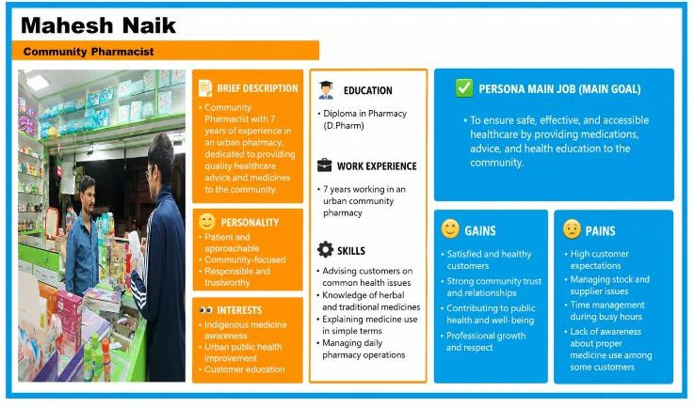

Fig 2.2 – Persona 1: Community Pharmacist
=
The research focused on understanding the daily challenges faced by an urban retail pharmacist in maintaining medicine quality and safety. It highlighted the importance of monitoring expiry dates, proper inventory management, prescription verification, correct labelling, and safe handling of medicines. Patient counselling and rational drug use were also identified as important factors in preventing medication errors and misuse.
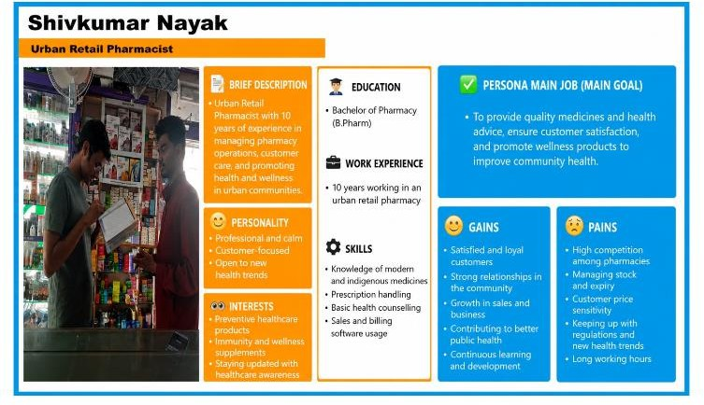

Fig 2.3 – PERSONA 2: URBAN RETAIL PHARMACIST

The user research explored the role of an Ayurvedic pharmacist in managing medicine costs, drug shortages, and patient care. The research showed that proper stock control can reduce medicine loss and unnecessary expenses. It also emphasized the importance of patient counselling, proper storage, regulatory compliance, and inventory management in providing safe, affordable, and effective healthcare.
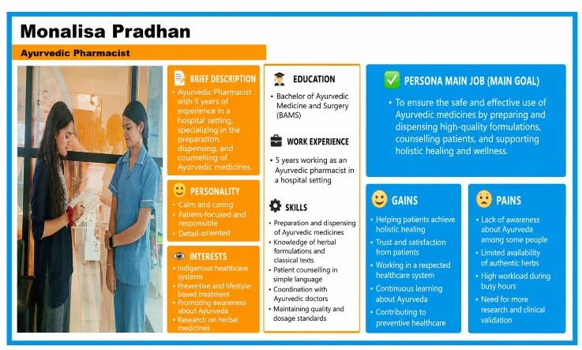

Fig 2.5 – PERSONA 4: AYUREVEDIC PHARMACIST

2.4 User Research – Persona 3 (Ayurvedic Pharmacist)

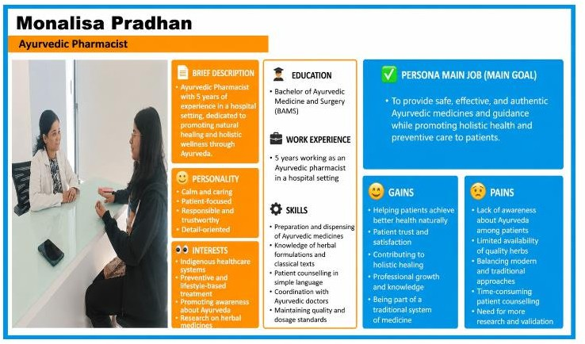
The research focused on understanding the challenges faced by a medical shop owner in ensuring medicine accessibility, quality, and patient safety. It revealed that storage limitations and supply-chain issues can affect medicine quality and availability. Proper dispensing, counselling, inventory management, and affordable medicine options can reduce health inequalities and improve overall

2.5 User Research – Persona 4 (Medical Shop Owner)

EMPATHY MAP

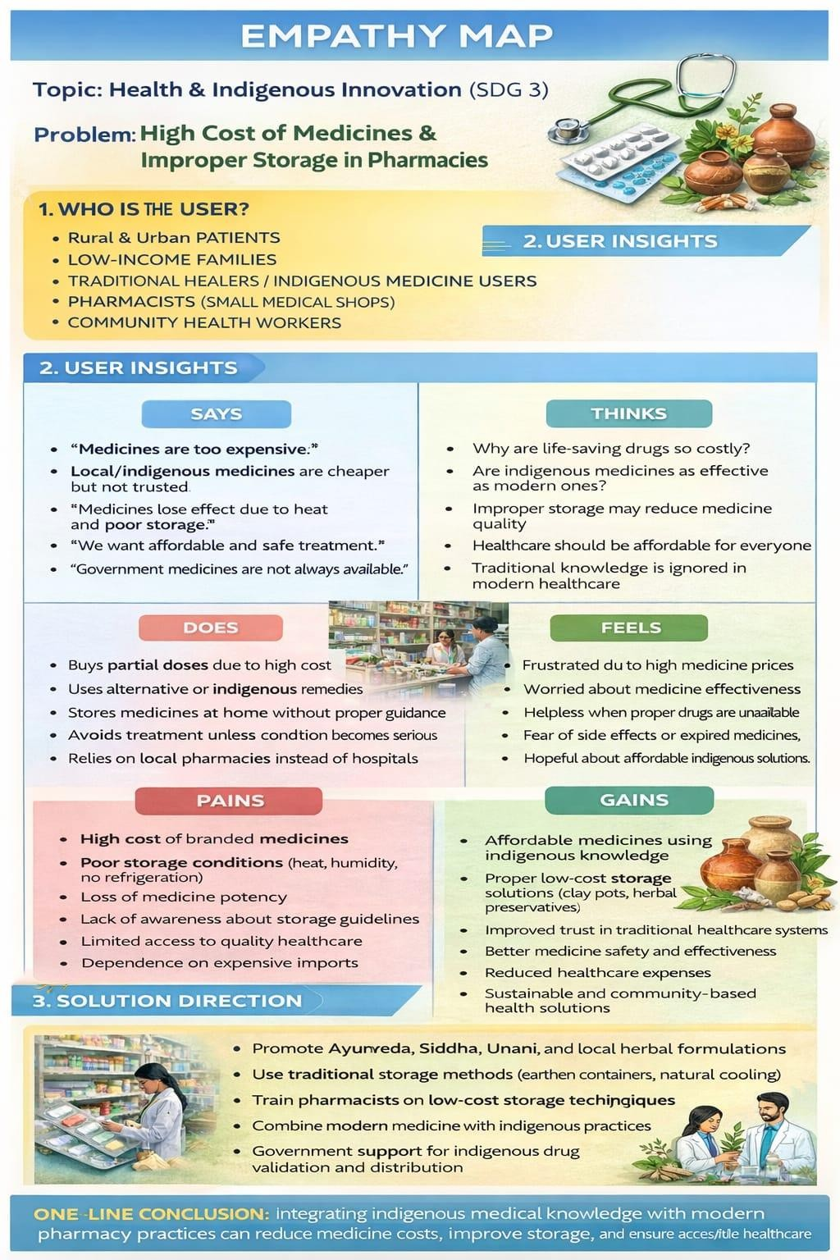
The empathy mapping in Fig 2.6 exercise helped in understanding the thoughts, feelings, actions, and concerns of medicine users. Users expressed concerns about medicine spoilage and wastage due to improper storage. They believed that a simple monitoring system could improve medicine preservation and reduce financial losses. Most users currently rely on visual inspection and are unaware of the environmental conditions affecting medicine quality. The study also revealed that users are interested in affordable and easy-to-use solutions for medicine storage.

Fig 2.6 – Empathy Map for Health and Indigenous Innovation

CUSTOMER JOURNEY MAP

The customer journey begins when medicines are purchased from pharmacies and stored at home, clinics, or medical stores. During storage, medicines are exposed to varying temperature and humidity conditions, often without the user's knowledge. Over time, these environmental factors may reduce medicine effectiveness and quality. Users generally become aware of the problem only after medicines show signs of deterioration or fail to provide the expected results. This leads to wastage and additional expenses. The journey analysis highlighted the need for a system that continuously monitors storage conditions and provides timely alerts.

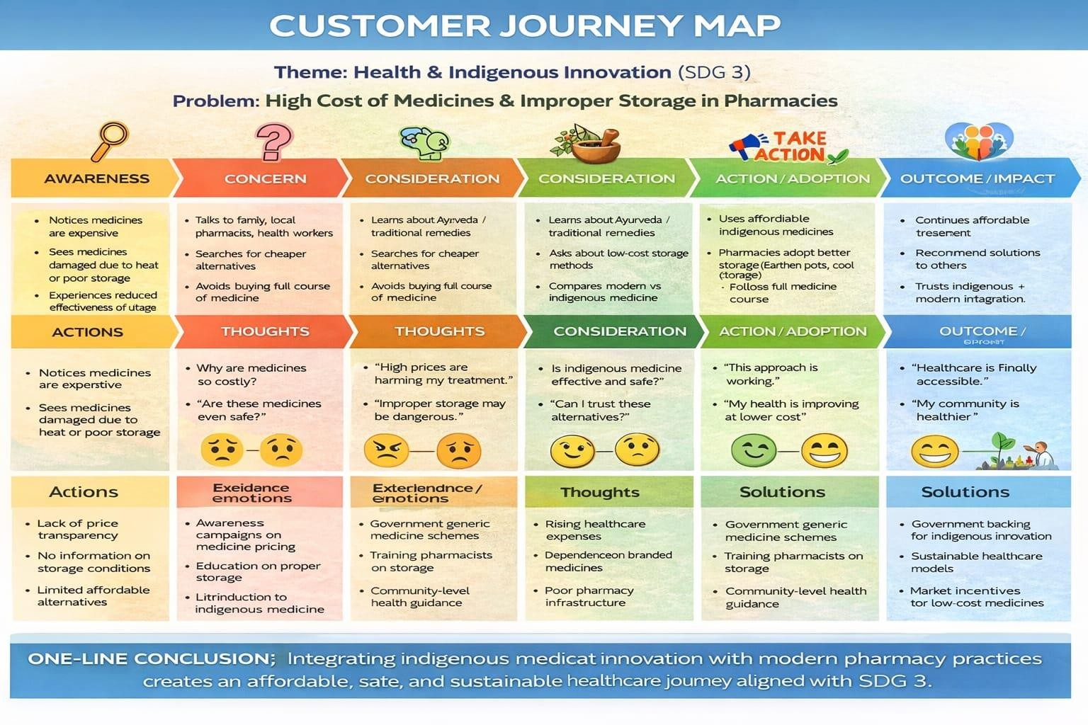

Fig 2.7 – Customer Journey Map For Smart Medical Storage Box

NEED STATEMENT TO PROBLEM DEFINITION
Healthcare plays a vital role in improving the quality of life and ensuring the well-being of individuals. Herbal medicines are widely used for the prevention and treatment of various health conditions due to their natural therapeutic properties. However, these medicines are highly sensitive to environmental conditions such as temperature, humidity, and moisture. Improper storage can lead to degradation of active ingredients, contamination, reduced effectiveness, and shorter shelf life, ultimately affecting the quality and safety of herbal medicines.

Secondly, most households, herbal clinics, Ayurvedic centers, and small pharmacies store herbal medicines in ordinary containers without continuously monitoring environmental conditions. Users often remain unaware of changes in temperature and humidity that may damage the medicines before their expiry date. The absence of a simple monitoring and alert system increases the risk of medicine wastage, financial loss, and reduced treatment effectiveness.

Lastly, the increasing demand for safe, affordable, and efficient healthcare solutions highlights the need for smart storage systems. Advanced technologies such as IoT, temperature and humidity sensors, embedded systems, and real-time alert mechanisms can help users monitor storage conditions and take immediate action whenever unsafe conditions are detected. These factors collectively emphasize the need for an intelligent herbal medicine storage system that preserves medicine quality, reduces wastage, and supports better healthcare practices while contributing to SDG 3: Good Health and Well-being.

- Quality degradation of herbal medicines due to improper storage conditions.
- Need for continuous monitoring of temperature and humidity inside the storage box.
- Requirement for timely alerts when environmental conditions exceed safe limits.
- Need to reduce medicine wastage and financial losses.
- Requirement for an affordable and easy-to-use storage solution for homes, herbal clinics, and pharmacies.
- Importance of preserving the quality, effectiveness, and shelf life of herbal medicines.
- Necessity of integrating IoT technology, sensors, and embedded systems for intelligent medicine storage.
- Need to promote safe healthcare practices and improve medicine preservation.

CHAPTER 3 LITERATURE SURVEY

CHAPTER 3

LITERATURE SURVEY

INTRODUCTION

The proper storage of herbal medicines is an essential aspect of healthcare, as environmental conditions such as temperature and humidity significantly affect their quality, effectiveness, and shelf life. Herbal medicines contain natural bioactive compounds that are highly sensitive to moisture, excessive heat, and improper storage conditions. Exposure to unfavorable environmental factors can lead to degradation of active ingredients, microbial contamination, and reduced therapeutic value. Traditional storage methods, such as keeping medicines in ordinary containers or cabinets, do not provide continuous monitoring of storage conditions and are often unable to prevent medicine deterioration.

Recent advancements in the Internet of Things (IoT), Embedded Systems, and Sensor Technologies have enabled the development of intelligent medicine storage and monitoring systems. Several researchers have proposed solutions using temperature sensors, humidity sensors, microcontrollers, and wireless communication modules to continuously monitor storage conditions and notify users whenever unsafe environmental conditions are detected. These systems improve medicine safety by providing real-time monitoring, reducing medicine wastage, and enhancing storage efficiency.

Previous studies have focused on developing smart medicine cabinets, pharmaceutical storage systems, and IoT-based monitoring devices for maintaining suitable environmental conditions. Most of these systems successfully monitor temperature and humidity; however, many are designed for hospitals or pharmaceutical industries and are often expensive, complex, and unsuitable for household users or small herbal medicine stores. Some systems also require continuous internet connectivity or advanced cloud infrastructure, increasing their implementation cost and maintenance requirements.

Motivated by these limitations, the proposed project, "Smart Herbal Medicine Storage Box," integrates a DHT22 temperature and humidity sensor, ESP32 microcontroller, LCD display, buzzer, and LED indicator to provide continuous monitoring of the storage environment for herbal medicines. The system generates immediate alerts whenever temperature or humidity exceeds the predefined safe limits, enabling users to take timely action and preserve the quality of herbal medicines. This approach provides a simple, affordable, and user-friendly solution that supports proper herbal medicine storage while contributing to Sustainable Development Goal (SDG) 3: Good Health and Well-being.

SURVEY OF PAPER
Summary of existing works is given in the table number 3.1 as follows
Table 3.1 Survey of Existing Research Papers on Smart Medical Storage Box using IOT

REFERENCE | PROBLEM AD-DRESED | COMPONENTS USED | TECHNIQUE USED | PARAMETER  S USED | RESULT | ADVANTAGE | DIS-AD-VANTAGE
IoT-Based Smart Medicine Storage System – A. Sharma, P. Verma (2022) | Improper medicine storage leading to degradation due to unsuitable temperature and humidity. | ESP32, DHT22  Sensor, Buzzer, Wi-Fi Module, Power Supply, Cloud Server | IoT-based environmental monitoring with real-time cloud communication | Temperature Accuracy: ±0.5°C, Humidity Accuracy: ±2% RH, Response Time: <3 s, Wi-Fi Range: 30 m | Successfully monitored storage conditions and generated instant alerts whenever temperature or  humidity exceeded safe limits. | Real-time monitoring, low-cost implementation, remote access, easy installation. | Requires continuous internet connection, sensor calibration required, limited battery backup.
Smart Medicine Cabinet Using ESP32 – R.  Kumar et al. (2022) | Maintaining proper storage conditions for medicines in pharmacies and hospitals. | ESP32, DHT22 Sensor,  LCD Display, Wi-Fi Module, Buzzer, Relay | ESP32, DHT22  Sensor, LCD Display, Wi-Fi Module, Buzzer, Relay | Temperature Range: 2–25°C, Humidity: 40–60% RH, Data Update: 5 s, Wi-Fi Connectivity | Successfully maintained recommended environmental conditions and reduced medicine spoilage. | Automatic monitoring, remote notifications, energy efficient, easy maintenance. | Automatic monitoring, remote notifications, energy efficient, easy maintenance.
“Smart Pharmaceutical Cold Storage Monitoring – A. Kumar et al. (2021) | Preventing vaccine and medicine spoilage caused by temperature fluctuations. | Temperature Sensor, Humidity Sensor, ESP32, GSM  Module, Cloud Platform | IoT-based cold storage monitoring with SMS alert mechanism. | Temperature Precision: ±0.3°C, Alert Delay: <5 s, Sensor Reliability: 98%, Power Consumption0.5, Confidence  Level: 0.90–0.95 | Successfully detected abnormal temperature conditions and alerted users immediately. | Improves medicine quality, continuous monitoring, reduces wastage, reliable alerts. | Initial installation cost, periodic sensor calibration, internet dependency.

Cloud-Based Smart Medicine Storage System – N. Patel et al. (2021) | Lack of continuous monitoring and historical tracking of medicine storage conditions. | ESP32, DHT22,  Cloud Database, Wi-Fi Module, Mobile Application | IoT with cloud data logging and remote monitoring. | Data Transmission Speed: <2 s, Storage Capacity: Cloud-based, Uptime: 99%, Sensor Accuracy | Successfully stored environmental data in the cloud and provided remote monitoring through mobile  application. | Cloud backup, historical analysis, scalable system, automatic notifications. | Cloud service cost, internet dependency, cybersecurity concerns.
Intelligent Medicine Preservation System –  R. Mehta et al. (2021) | Medicine degradation due to poor environmental conditions during storage. | ESP32, DHT22  Sensor, Buzzer, LED Indicator, Wi-Fi Module | Intelligent IoT monitoring with automated warning system. | Temperature Accuracy:  ±0.5°C, Humidity Accuracy: ±2% RH, Alert Response Time:  <3 s | Successfully preserved medicine quality by continuously monitoring storage conditions and providing alerts. | Low power consumption, compact design, affordable hardware, user-friendly operation. | Sensor replacement required after long-term use, requires stable power supply, limited storage capacity.
IoT-Enabled Pharmaceutical Storage Monitoring –  V. Rao et al. (2021) | Inadequate monitoring of pharmaceutical storage environments. | ESP32, DHT22  Sensor, Wi-Fi Module, Cloud Server, Buzzer | IoT-based environmental sensing with real-time notifications. | Temperature Stability, Humidity Control, Response Time, Wireless  Communication Range | Successfully monitored pharmaceutical storage conditions and minimized medicine spoilage. | Accurate monitoring, remote accessibility, continuous operation, cost-effective. | Requires internet connectivity, maintenance of sensors, limited data security.
IoT-Based Vaccine Storage Monitoring System – S. Reddy et al. (2022) | Preventing vaccine spoilage caused by improper storage temperature. | ESP32, DHT22  Sensor, Wi-Fi Module, Buzzer, Cloud Database | IoT-based temperature and humidity monitoring with cloud alerts. | Temperature Accuracy:  ±0.3°C, Humidity Accuracy: ±2% RH, Response Time: <2 s | Successfully monitored vaccine storage and generated real-time alerts during abnormal  conditions. | High accuracy, continuous monitoring, remote access, reduces medicine wastage. | Internet dependency, periodic sensor calibration required.

Smart Healthcare Storage Using Environmental Sensors – M. Joshi et al. (2022) | Maintaining ideal environmental conditions for pharmaceutical products. | ESP32,  Temperature Sensor, Humidity Sensor, LCD Display, Wi-Fi Module | Sensor-based environmental monitoring with automated notifications. | Temperature Range: 2–25°C, Humidity: 40–  60% RH, Sensor  Reliability: 98% | Successfully maintained recommended storage conditions and minimized medicine degradation. | Easy implementation, low maintenance, energy efficient, reliable monitoring. | Limited offline functionality, stable power supply required.
ESP32-Based Intelligent Medicine Preservation System –  K. Singh et al. (2022) | Medicine quality degradation due to uncontrolled storage conditions. | ESP32, DHT22  Sensor, Relay Module, Mobile Application, Wi-Fi Module | IoT-enabled environmental sensing with mobile application support. | Temperature Accuracy:  ±0.5°C, Alert Delay: <3 s, Data Update Interval: 5 s | Successfully detected environmental changes and notified users instantly. | Compact design, low cost, mobile connectivity, real-time alerts. | Requires internet connectivity, limited battery backup.
Smart Drug Storage Box with Cloud Monitoring – H. Mehta et al. (2022) | Lack of continuous monitoring in medicine storage systems. | ESP32, DHT22  Sensor, Cloud Server, Wi-Fi Module, Buzzer | IoT with cloud-based monitoring and automatic notification system. | Data Transmission Speed: <2 s, Sensor Accuracy:  ±0.5°C, Cloud Storage Capacity | Successfully stored environmental data and provided remote monitoring. | Cloud backup, historical data analysis, scalable architecture. | Cloud subscription cost, cybersecurity concerns.
Wireless Medicine Storage Monitoring System – P. Nair et al. (2021) | Manual inspection of medicine storage conditions in pharmacies. | ESP8266, DHT22  Sensor, GSM Module, Buzzer, LCD Display | Wireless sensor network with GSM alert system. | GSM Response Time: <5 s, Temperature Accuracy:  ±0.5°C, Signal Range | Successfully detected abnormal conditions and sent SMS alerts. | Wireless communication, affordable hardware, reliable alerts. | GSM network dependency, higher power consumption.

Smart Pharmaceutical Refrigerator Monitoring – V. Sharma et al. (2023) | Temperature fluctuations inside medicine refrigerators. | ESP32, DS18B20  Temperature Sensor, DHT22, Wi-Fi Module, Buzzer | IoT-based refrigeration monitoring system. | Temperature Precision:  ±0.2°C, Humidity Accuracy: ±2% RH, Update Time: 2 s | Maintained refrigerator temperature within recommended limits and reduced spoilage. | Highly accurate, automatic monitoring, suitable for hospitals. | Sensor maintenance required, installation cost.
IoT-Based Medical Inventory Storage System – R. Patel et al. (2022) | Improper storage and inventory management of medicines. | ESP32, RFID  Reader, DHT22 Sensor, Cloud Database, LCD Display | IoT monitoring integrated with RFID inventory management. | RFID Detection Accuracy: 99%, Temperature Accuracy:  ±0.5°C, Cloud Sync Time | Successfully monitored storage conditions and tracked medicine inventory simultaneously. | Inventory tracking, improved efficiency, reduced human errors. | Higher implementation cost, complex configuration.
Cloud-Enabled Pharmaceutical Monitoring System –  A. Desai et al. (2021) | Absence of centralized monitoring in pharmaceutical warehouses. | ESP32, DHT22  Sensor, Wi-Fi Module, Cloud Server, Mobile App | Cloud-enabled IoT monitoring with remote dashboard. | System Uptime: 99%, Response  Time: <3 s, Temperature Accuracy: ±0.5°C | Successfully monitored warehouse conditions and generated instant notifications. | Remote accessibility, cloud analytics, continuous monitoring. | Requires reliable internet, cloud service expenses.
Real-Time Medicine Preservation Using IoT – S. Gupta et al. (2022) | Medicine spoilage due to improper environmental conditions during storage. | ESP32, DHT22  Sensor, OLED Display, Buzzer, Wi-Fi Module | Real-time IoT monitoring with threshold-based alerts. | Temperature Range: 2–25°C, Humidity: 40–  60% RH, Alert  Delay: <3 s | Successfully preserved medicine quality by maintaining recommended conditions. | Fast response, user-friendly interface, low power consumption. | Sensor replacement after long-term use, internet required.

3.3 PRIOR ART SEARCH

Brief Theory The increasing need for proper storage and preservation of medicines has led to the development of various smart medicine boxes, pharmaceutical storage systems, and IoT-based environmental monitoring devices. These systems use sensors, microcontrollers, and wireless technologies to monitor environmental conditions such as temperature and humidity and provide alerts when unsafe conditions are detected.

1.Prior Art Title: “Smart Medicine Box”

Description: This system is designed to improve medicine management and safety by storing

medicines in separate compartments and providing medication reminders. Some advanced

models also monitor environmental conditions such as temperature. However, these systems

mainly focus on medicine scheduling and are not specifically designed for preserving

herbal medicines against humidity and moisture.

2. Prior Art Title: “Pharmaceutical Storage Cabinet”

Description: This system provides controlled storage conditions for medicines and

pharmaceutical products. It helps maintain suitable temperature and humidity levels to

preserve medicine quality. However, such systems are generally expensive, bulky, and mainly

designed for hospitals and pharmaceutical industries.

3. Prior Art Title: “IoT-Based Medicine Storage Monitoring System”

Description: This system uses sensors, microcontrollers, and wireless communication to

continuously monitor medicine storage conditions. It can generate alerts when temperature or

humidity exceeds safe limits. However, many such systems require continuous internet

connectivity and may not be suitable for household or small-scale use.

4. Prior Art Title: “Temperature and Humidity Monitoring System”

Description: This system uses environmental sensors to monitor temperature and humidity

conditions in storage areas. Although it provides accurate monitoring and timely alerts, it is

generally designed for conventional medicines and does not specifically address the storage

requirements of herbal medicines.

3.4 SURVEY OF PRODUCTS

A survey of existing products was carried out to understand the current solutions available for medicine storage and environmental monitoring. Various smart medicine boxes, pharmaceutical storage systems, and IoT-based monitoring devices were studied to analyze their features, applications, advantages, and limitations. The survey helped identify the gaps in existing products and provided valuable insights for developing the proposed Smart Herbal

solution for preserving the quality of herbal medicines
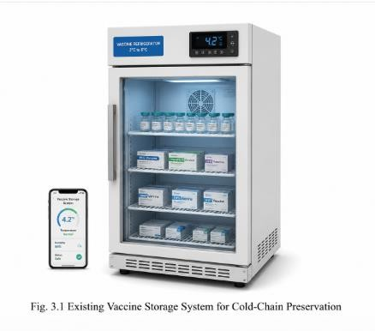
    - The Smart Medicine Box is an electronic storage system designed to improve medicine management and safety. It provides reminders for medication schedules and stores medicines in separate compartments. Some advanced models also monitor environmental conditions such as temperature. However, these products mainly focus on medicine reminders and are not specifically designed for preserving herbal medicines against humidity and moisture

    - Pharmaceutical storage refrigerators are widely used in hospitals, laboratories, and pharmacies to maintain medicines at controlled temperatures. They ensure the quality and effectiveness of temperature-sensitive medicines through accurate cooling systems. However, these refrigerators are expensive, consume more power, and are not suitable for household users or for storing common herbal medicines.
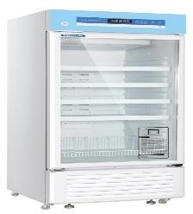
Fig 3.2 Pharmaceutical Storage Refrigerator

    - A hygrometer storage box is commonly used for storing moisture-sensitive items by displaying the temperature and humidity inside the container. These boxes help users monitor environmental conditions but generally do not provide automatic alerts or smart monitoring features. Their application for herbal medicine storage is limited because they only display readings without notifying users when conditions become unsafe.
Fig 3.3 Hygrometer Storage Box
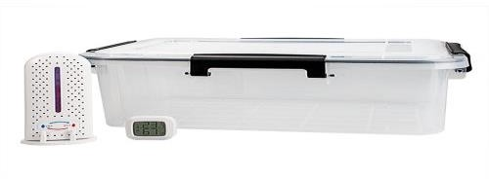

GAP IDENTIFIED
Gap 1: Lack of herbal medicine-specific storage
Most existing medicine storage systems are designed for conventional pharmaceutical medicines and do not specifically address the storage requirements of herbal medicines. As a result, herbal medicines remain vulnerable to environmental factors that affect their quality, potency, and shelf life.

Gap 2: High cost of existing systems
Many commercially available smart medicine storage systems are expensive and are primarily intended for hospitals, laboratories, and large pharmacies. Their high cost makes them unsuitable for households, herbal medicine users, Ayurvedic clinics, and small healthcare centers.

Gap 3: Inadequate environmental monitoring
Several existing storage solutions do not continuously monitor both temperature and humidity, which are critical parameters for preserving the quality and effectiveness of herbal medicines under varying environmental conditions.

Gap 4: Absence of real-time alert mechanisms
Many conventional medicine storage products do not provide immediate alerts when storage conditions exceed the recommended limits. This may result in delayed action and increase the chances of medicine deterioration.

Gap 5: Complexity of IoT-based solutions
Advanced IoT-enabled storage systems often require continuous internet connectivity, cloud integration, and sophisticated hardware, making them more complex to install, operate, and maintain for everyday users.

Gap 6: Lack of affordable and user-friendly solutions
There is a need for a simple, portable, energy-efficient, and affordable smart storage solution that continuously monitors storage conditions, provides timely alerts, and helps preserve the quality and shelf life of herbal medicines.

PROBLEM STATEMENT
Medicines, vaccines, insulin, and other pharmaceutical products require specific temperature and

The proposed "IoT-Based Smart Medicine Storage and Monitoring System" addresses these challenges by integrating an ESP32 microcontroller, DHT22 temperature and humidity sensor, Wi-Fi-based IoT communication, and real-time cloud/mobile notifications. The system continuously monitors environmental conditions, provides live data to users, stores historical records, and generates instant alerts whenever unsafe storage conditions are detected, thereby ensuring proper medicine preservation, reducing wastage, and improving patient safety.

  - DESIGN SPECIFICATIONS

ESP32 Development Board

The ESP32 Development Board serves as the central processing unit of the Smart Herbal Medicine Storage System. It continuously receives temperature and humidity data from the DHT22 sensor, processes the readings, compares them with predefined threshold values, and transmits the data to the Blynk IoT platform via its built-in Wi-Fi module. Based on the measured humidity level, it also controls the LED indicator to provide a visual alert whenever the storage conditions become unsuitable
for herbal medicines.

DHT22 Temperature and Humidity Sensor
The DHT22 sensor is used to accurately measure the temperature and relative humidity inside the herbal medicine storage container. It provides calibrated digital output to the ESP32, allowing continuous monitoring of environmental conditions. The sensor plays a vital role in ensuring that herbal medicines are stored within the recommended temperature and humidity range to preserve their quality, potency, and shelf life. The proposed "IoT-Based Smart Medicine Storage and Monitoring System" addresses these challenges by integrating an ESP32 microcontroller, DHT22 temperature and humidity sensor

system is powered using a 5V USB power source. The ESP32 internally regulates the voltage to 3.3V, which is suitable for operating the DHT22 sensor and other low-power electronic components. A stable power supply ensures reliable sensor measurements and uninterrupted IoT communication.

Wi-Fi Module (Built-in ESP32)
The ESP32 features an integrated Wi-Fi module that enables wireless communication with the Blynk IoT cloud platform. This allows real-time transmission of temperature and humidity data, enabling users to remotely monitor the storage environment using a smartphone or computer connected to the internet.
Breadboard

A solderless breadboard is used for assembling and testing the prototype circuit. It provides a convenient platform for connecting the ESP32, DHT22 sensor, LED, and other components without permanent soldering, making the system easy to modify and troubleshoot.
Jumper Wires

Jumper wires are used to establish electrical connections between the ESP32, DHT22 sensor, LED, breadboard, and power supply. They ensure secure and reliable signal transmission while simplifying the assembly of the prototype.

Herbal Medicine Storage Container

The storage container acts as the enclosure for the herbal medicines and the environmental monitoring system. It simulates a controlled storage environment where temperature and humidity are continuously monitored. The container protects herbal medicines from external environmental variations and serves as the physical housing for the complete prototype.

Software Specifications
The system operates on Windows 10/11 and is developed using Embedded C/C++ through the Arduino IDE. The ESP32 microcontroller is programmed to acquire temperature and humidity data from the DHT22 sensor and communicate with the Blynk IoT cloud platform over Wi-Fi. The development environment includes Arduino IDE for code development and uploading, while the Blynk IoT platform

The system shall continuously monitor the relative humidity inside the storage container. The measured humidity values shall be compared with predefined threshold levels to determine whether the storage environment is suitable for preserving herbal medicines.
Real-Time Data Transmission
The system shall transmit temperature and humidity readings to the Blynk IoT cloud platform through the ESP32's built-in Wi-Fi module, enabling users to monitor storage conditions remotely using a smartphone or computer.
Humidity Threshold Detection

The system shall classify the measured humidity into predefined storage categories such as Extremely Dry, Dry, Optimal, Moderately Humid, High Humidity, and Critical Humidity. These classifications assist users in maintaining appropriate storage conditions for different types of herbal medicines.
Alert Generation

The system shall activate an LED indicator whenever the humidity exceeds the predefined safe threshold (80% RH), providing a visual warning that the storage environment may lead to fungal growth, microbial contamination, or deterioration of herbal medicines.

Continuous Environmental Monitoring

The system shall continuously monitor the storage environment and automatically update temperature and humidity readings at regular intervals without requiring manual intervention, ensuring uninterrupted supervision of herbal medicine storage conditions.
Remote Monitoring

The system shall allow users to remotely access real-time environmental data through the Blynk mobile application, enabling continuous supervision of the herbal medicine storage environment from any location with an internet connection.

OBJECTIVES

Primary Objective
To develop an IoT-Based Smart Herbal Medicine Storage System capable of continuously monitoring temperature and humidity inside a herbal medicine storage container using an ESP32 microcontroller and DHT22 sensor. The system aims to provide real-time environmental monitoring through the Blynk IoT platform and generate visual alerts whenever storage conditions exceed the recommended threshold values. By maintaining optimal storage conditions, the system helps preserve the quality, potency, and shelf life of herbal medicines while providing a simple, affordable, and efficient smart storage solution.

Specific Objectives
- To design and develop an IoT-based Smart Herbal Medicine Storage System using an ESP32 microcontroller and DHT22 temperature and humidity sensor for continuous environmental monitoring.
- To continuously monitor the temperature and relative humidity inside the herbal medicine storage container and transmit the data to the Blynk IoT platform in real time through Wi-Fi communication.
- To generate a visual alert using an LED indicator whenever the humidity exceeds the predefined safe threshold, thereby preventing moisture-related deterioration of herbal medicines.
- To evaluate the performance of the proposed system in terms of monitoring accuracy, reliability, real-time data transmission, and its effectiveness in maintaining suitable storage conditions for different types of herbal medicines.

PROJECT MANAGEMENT
Project management plays a significant role in the successful development and implementation of the IoT-Based Smart Herbal Medicine Storage System. The project integrates embedded systems, IoT communication, environmental sensing, and cloud-based monitoring to provide continuous supervision of temperature and humidity within a herbal medicine storage container. Effective project management ensures that all hardware components, software modules, and communication systems are properly designed, integrated, tested, and deployed within the planned schedule and available resources.
The development process is divided into several phases, including requirement analysis, hardware selection, circuit development, software implementation, IoT integration, system testing, and final documentation. The project follows a systematic development approach to achieve reliable monitoring, accurate environmental sensing, and real-time remote access to storage conditions. The design is based on IoT-enabled environmental monitoring systems and smart storage solutions that focus on preserving the quality and shelf life of herbal medicines.

3.9.1 IDENTIFYING MILESTONES
The major milestones identified for the successful completion of the project are as follows:

Milestone 1: Problem Identification and Requirement Analysis

The first milestone involved studying the storage requirements of herbal medicines and identifying the limitations of conventional storage methods. Various research papers and existing IoT-based monitoring systems were reviewed to define the functional requirements of the proposed system.
Milestone 2: Hardware Component Selection and Testing

The required hardware components, including the ESP32 Development Board, DHT22 Temperature and Humidity Sensor, LED Indicator, breadboard, jumper wires, and power supply, were selected and tested individually to ensure proper operation and compatibility with the complete system.
Milestone 3: Circuit Design and Sensor Integration

The ESP32 was interfaced with the DHT22 sensor and LED indicator to develop the hardware prototype. The sensor was configured to continuously measure temperature and humidity, while the LED was programmed to provide a visual alert whenever the humidity exceeded the predefined threshold.

Milestone 4: IoT Platform Integration
The ESP32 was connected to the Wi-Fi network and integrated with the Blynk IoT platform. Virtual dashboards were created to display real-time temperature and humidity readings, enabling remote monitoring through a smartphone application.

Milestone 5: Documentation and Project Demonstration
The final milestone involved preparing the project report, designing system diagrams, documenting hardware and software implementation, recording experimental results, and demonstrating the working prototype of the Smart Herbal Medicine Storage System.

3.9.2 PROJECT EXECUTION PLAN

Table 3.2 presents the project execution plan, outlining the major phases, corresponding activities, and their scheduled duration over a 12-week timeline for the systematic development and successful implementation of the proposed system. It provides a clear roadmap for organizing project tasks, monitoring progress, and ensuring timely completion of each milestone. The execution plan also facilitates effective resource management and coordination among different stages of hardware and software development.
It presents the project execution plan, which provides a structured and systematic approach for the successful development and implementation of the proposed Smart Herbal Medicine Storage System. The plan divides the entire project into major phases, with each phase consisting of specific activities and tasks to be completed within a scheduled 12-week timeline. It serves as a clear roadmap for organizing project activities, assigning priorities, monitoring progress, and ensuring the timely completion of each milestone.
The execution plan covers important stages such as problem identification, user research, requirement analysis, system design, selection and integration of hardware and software components, prototype development, coding, testing, debugging, and final documentation. By following a predefined schedule, the team can effectively manage available resources, identify potential delays or technical issues at an early stage, and take appropriate corrective actions. Furthermore, the plan ensures proper coordination among different stages of hardware and software development, allowing the project to progress in an organized manner and achieve the intended objectives within the specified time frame.

Table 3.2 Project Execution Plan and Development Timeline

Phase | Activity | Duration
Phase 1 | Literature Survey and Requirement Analysis | Week 1
Phase 2 | Hardware Selection and Procurement | Week 2
Phase 3 | Sensor Circuit Design and ESP32 Programming | Week 3
Phase 4 | Blynk Iot Cloud Server Integration | Week 4
Phase 5 | remote App Notification Integration | Week 5
Phase 6 | Detection of Threshold Temperature and Humidity | Week 6
Phase 7 | Serial Communication between Python and ESP32 | Week 7
Phase 8 | Development of Deterrent Mechanisms (Buzzer, LEDs,) | Week 8
Phase 9 | Complete System Integration | Week 9

- Requirement Analysis: Study the storage requirements of herbal medicines, identify suitable temperature and humidity ranges, and analyze the limitations of existing storage methods.
- Hardware Development: Assemble the ESP32 Development Board, DHT22 temperature and humidity sensor, LED indicator, breadboard, jumper wires, and power supply. Verify the proper functioning of each hardware component.
- Software Development: Develop the embedded program using Arduino IDE to acquire sensor data, compare readings with predefined threshold values, control the LED indicator, and establish Wi-Fi communication.
- IoT Integration: Configure the Blynk IoT platform and establish communication between the ESP32 and the cloud server to enable real-time monitoring of temperature and humidity.
- System Integration: Integrate all hardware and software modules into a single system capable of continuously monitoring environmental conditions and generating alerts whenever unsafe humidity levels are detected.
- Testing Phase: Evaluate sensor accuracy, verify Wi-Fi connectivity, validate real-time data transmission to the Blynk application, and test the LED alert mechanism under different environmental conditions.
- Deployment and Demonstration: Demonstrate the complete Smart Herbal Medicine Storage System, present the monitoring results, and document the overall system performance, conclusions, and future enhancements.

CHAPTER 4 FEASIBILITY ANALYSIS

CHAPTER 4

FEASIBILITY ANALYSIS

4.1 TECHNICAL FEASIBLITY

The proposed IoT-Based Smart Herbal Medicine Storage System is technically feasible as it utilizes readily available hardware components, open-source software tools, and reliable IoT communication technologies. The integration of the ESP32 microcontroller, DHT22 temperature and humidity sensor, Blynk IoT platform, and LED alert mechanism enables continuous environmental monitoring and real-time supervision of herbal medicine storage conditions.
- Hardware Availability: The required components such as the ESP32 Development Board, DHT22 temperature and humidity sensor, LED indicator, breadboard, jumper wires, and USB power supply are easily available, affordable, and compatible with one another.
- Microcontroller Capability: The ESP32 microcontroller efficiently acquires sensor data, processes temperature and humidity readings, supports Wi-Fi communication, and controls the LED alert system in real time.
- Software Stack Feasibility: The system is developed using free and open-source tools such as Arduino IDE, Embedded C/C++, Blynk IoT libraries, Wi-Fi libraries, and the DHT sensor library, reducing software development costs.
- Reliable Environmental Monitoring: The DHT22 sensor provides accurate digital measurements of temperature and humidity, enabling continuous monitoring of storage conditions and timely detection of unsuitable environmental changes.
4.2 FINANCIAL FEASIBILITY

The proposed IoT-Based Smart Herbal Medicine Storage System is financially feasible because it is developed using low-cost hardware components and freely available software tools. Components such as the ESP32 Development Board, DHT22 sensor, LED indicator, breadboard, and jumper wires are economical and widely available, making the overall prototype cost-effective for educational and practical applications.
The software development environment, including the Arduino IDE and Blynk IoT platform, is available free of cost, significantly reducing development expenses. The system also requires minimal maintenance and consumes very little electrical power, making it suitable for long-term operation. Additionally, the design can be easily upgraded by incorporating additional sensors or automated environmental control mechanisms without major increases in cost.

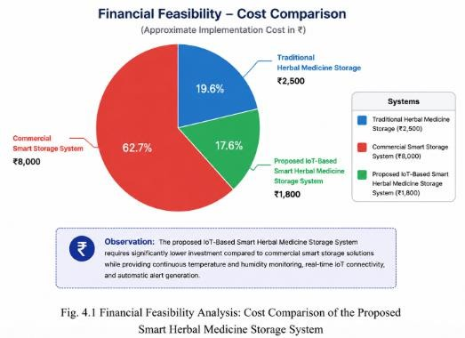

Fig 4.1 Financial Feasibility Analysis: Cost Comparison of the Proposed System

4.3MARKET FEASIBILITY
The proposed IoT-Based Smart Herbal Medicine Storage System is market feasible due to the growing demand for smart storage solutions in the healthcare, pharmaceutical, Ayurvedic, and herbal medicine industries. Improper storage conditions, particularly excessive temperature and humidity, can significantly reduce the quality, potency, and shelf life of herbal medicines. This creates a demand for affordable systems capable of continuously monitoring environmental conditions and providing real-time alerts.
The proposed system offers continuous temperature and humidity monitoring, wireless IoT-based data transmission, and automatic alert generation at a low implementation cost. It is suitable for households, herbal pharmacies, Ayurvedic clinics, research laboratories, and small-scale herbal medicine manufacturers. The increasing adoption of IoT technology and smart healthcare solutions further enhances the market potential of the proposed system.
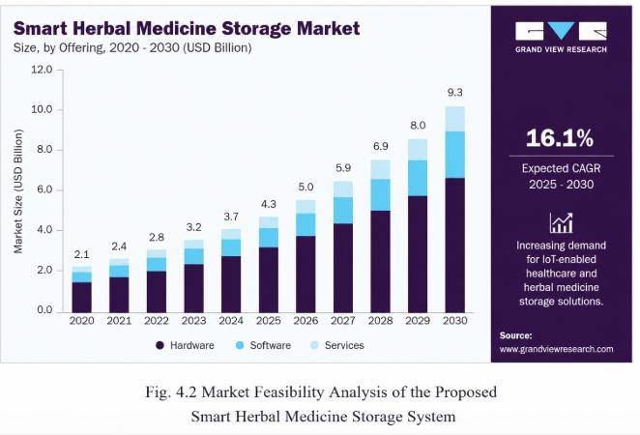
Verdict: Market Feasible — The proposed system addresses an important storage challenge faced by herbal medicine users and manufacturers while providing an affordable, reliable, and user-friendly smart storage
Fig 4.2 Market Feasibility Analysis of the Proposed System

4.4 COMPETITOR FEASIBILITY ANALYSIS

The proposed IoT-Based Smart Herbal Medicine Storage System was compared with existing storage methods such as conventional storage containers, hygrometer-based monitoring systems, commercial smart storage cabinets, and IoT-enabled environmental monitoring systems. The comparison was performed based on important parameters including continuous monitoring, real-time alerts, remote access, storage accuracy, affordability, ease of installation, and maintenance requirements.

Traditional storage methods provide basic protection but do not continuously monitor environmental conditions or notify users when temperature or humidity exceeds safe limits. Hygrometer-based systems display environmental readings but require manual observation and cannot generate automatic alerts. Commercial smart storage cabinets provide advanced environmental control; however, they are expensive and are primarily designed for large pharmaceutical or laboratory applications.

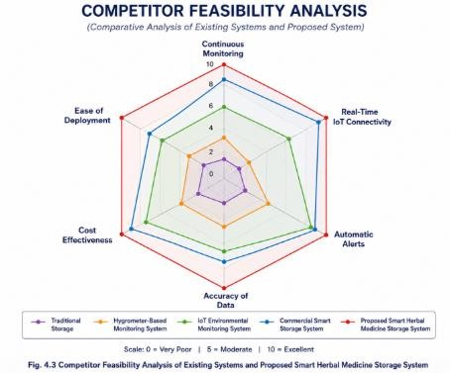
The proposed system combines the advantages of continuous environmental sensing, real-time IoT monitoring, wireless communication, and automatic LED alert generation while maintaining a significantly lower implementation cost. The analysis indicates that the proposed system provides an optimal balance of affordability, reliability, ease of deployment, and real-time monitoring, making it a practical solution for preserving the quality and shelf life of herbal medicines.

Fig 4.3 Competitor Analysis of Existing Systems and Proposed Smart Herbal Medicine Storage System

CHAPTER 5 METHODOLOGY AND IMPLEMENTATION

CHAPTER 5

METHODOLOGY AND IMPLEMENTATION

5.1 INTRODUCTION
The proposed IoT-Based Smart Herbal Medicine Storage System integrates embedded systems, environmental sensing, and IoT technology to continuously monitor the storage conditions of herbal medicines. The system uses DHT22 temperature and humidity sensor to measure the environmental conditions inside the storage container and an ESP32 microcontroller to process the sensor readings in real time. This enables users to monitor the storage environment continuously and ensure that herbal medicines are preserved under suitable conditions.

The ESP32, DHT22 sensor, and Blynk IoT platform work together to provide real-time monitoring and remote accessibility. The measured temperature and humidity values are transmitted wirelessly through the ESP32's built-in Wi-Fi module and displayed on the Blynk mobile application. Whenever the humidity exceeds the predefined safe threshold, the system activates an LED indicator to alert the user. By integrating environmental monitoring, IoT communication, and automatic alert generation within a single platform, the proposed system provides an affordable, reliable, and user-friendly solution for preserving the quality, potency, and shelf life of herbal medicines.

5.2 SYSTEM ARCHITECTURE
The system architecture consists of an environmental sensing unit, a processing and communication unit, and an output and monitoring unit. The DHT22 temperature and humidity sensor continuously measures the environmental conditions inside the herbal medicine storage container. The sensor readings are transmitted to the ESP32 Development Board, which processes the received data and compares the values with predefined storage thresholds.
The system architecture consists of an environmental sensing unit, a processing and communication unit, and an output and monitoring unit. The DHT22 temperature and humidity sensor continuously measures the environmental conditions inside the herbal medicine storage container. The sensor readings are transmitted to the ESP32 Development Board, which processes the received data and compares the values with predefined storage thresholds
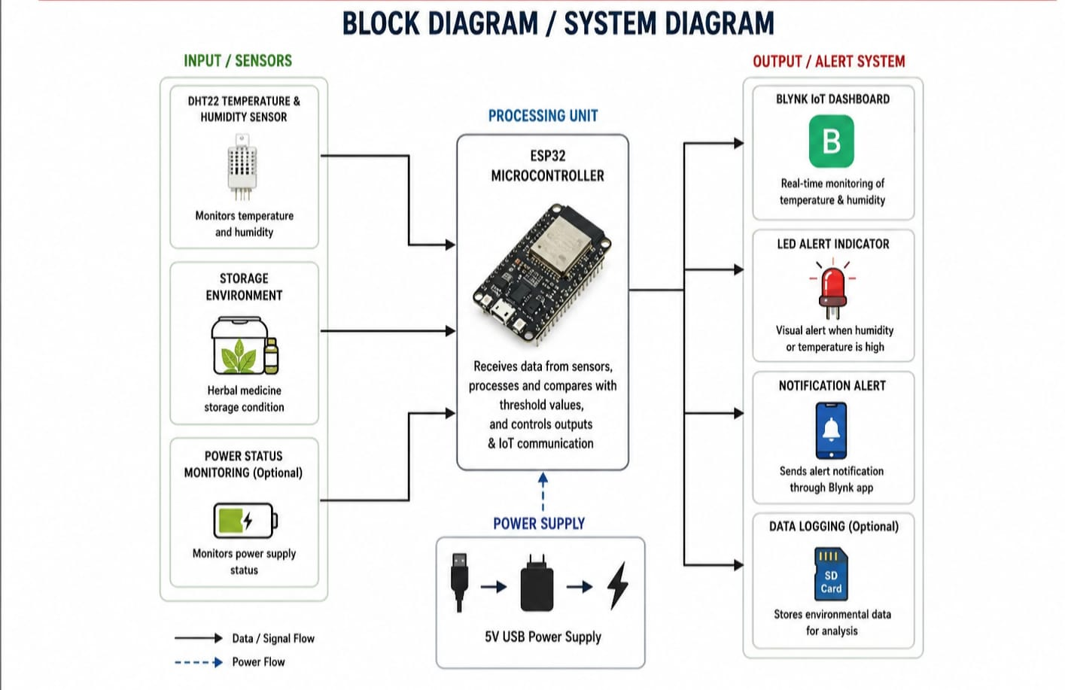
Fig 5.1 System Architecture of the Proposed System

5.3FLOW CHART
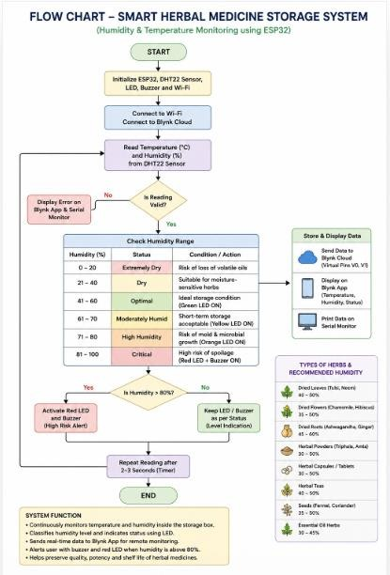
Fig 5.2 Flowchart of the Smart Herbal Medicine Storage System

5.4PERFORMANCE PARAMETERS
5.4.1Temperature Measurement Accuracy

Temperature measurement accuracy represents the ability of the system to correctly measure the ambient temperature inside the herbal medicine storage container when compared with the actual temperature.
Temperature Accuracy (%) = (Number of Correct Temperature Readings / Total Temperature Measurements) × 100

5.4.2 Humidity Measurement Accuracy

Humidity measurement accuracy indicates the ability of the DHT22 sensor to accurately measure the relative humidity inside the storage container under different environmental conditions.
Humidity Accuracy (%) = (Number of Correct Humidity Readings / Total Humidity Measurements) × 100

    - Response Time:
Response time refers to the time taken by the system to generate an alert after detecting an intrusion or animal presence.
Response Time = Alert Generation Time − Detection Time

    - Data Transmission Time:
Data transmission time represents the time required to send the measured temperature and humidity values from the ESP32 to the Blynk IoT cloud platform through Wi-Fi communication.
Data Transmission Time = Data Received Time − Data Sent Time

    - System Reliability:
System reliability measures the consistency of system operation during testing and monitoring activities. Reliability (%) = (Successful Operations / Total Test Operations) × 100
The above performance parameters were used to evaluate the effectiveness, responsiveness, and reliability of the proposed AI and Laser Based Smart Animal Intrusion Detection and Security System.

5.5HARDWARE REQUIREMENTS
Table lists the hardware components used in the proposed system along with their specifications and functions. These components work together to enable real-time animal detection, intrusion monitoring, alert generation, and automated deterrent actions.

HARDWARE COMPONENT |  | SPECIFICATION | FUNCTION
Esp32 |  | ESP8266 Wi-Fi  microcontroller, 80 MHz CPU, built-in Wi-Fi, GPIO pins | Acts as the central controller; interfaces with sensors, processes intrusion signals, communicates with the Python application, and controls the buzzer and servo motor.
DHT22 | Digital sensor, Temperature Range: -40°C to 80°C, Humidity Range: 0–100% RH, Accuracy:  ±0.5°C and ±2–5% RH |  | Continuously measures temperature and relative humidity inside the herbal medicine storage container and transmits the readings to the ESP32
Buzzer | Active buzzer, 3.3–5 V operating voltage | Produces an audible alarm when intrusion or animal detection occurs.
Scarecrow Assembly | Lightweight cardboard or plastic structure attached to servo shaft | Acts as a physical deterrent by moving left and right when animals are detected.
Breadboard | Solderless prototyping board | Used for temporary circuit assembly and testing during development.
Jumper Wires | Male-to-male, male-to-female, female-to-female connection wires | Provide electrical connections between the ESP8266, sensors, buzzer, and servo motor.
USB Cable | USB Type-A to Micro-USB cable | Supplies power to the ESP8266 and enables communication with the computer.
Wi-Fi Network | IEEE 802.11 b/g/n wireless network | Enables communication with Telegram services for remote monitoring and alert notifications.

Table 5.1 Hardware Components and Their Specifications

SOFTWARE REQUIREMENTS

SOFTWARE / TOOL | SPECIFICATION | FUNCTION
Arduino IDE | Open-source IDE for ESP32 programming | Used for writing, compiling, debugging, and uploading the embedded program to the ESP32  microcontroller
Embedded C/C++ | Programming language for embedded systems | Implements the control logic for sensor data acquisition, threshold comparison, LED control,  and IoT communication.
Blynk IoT Platform | Cloud-based IoT monitoring platform | Displays real-time temperature and humidity data on a smartphone and enables remote monitoring  of storage conditions.
Blynk ESP32 Library | IoT communication library | Enables communication between the ESP32 and the Blynk cloud server.
WiFi Library (ESP32) | IEEE 802.11 b/g/n Wi-Fi communication library | Provides wireless internet connectivity for  transmitting sensor data to the Blynk IoT platform.
DHT Sensor Library | Sensor interface library | Reads temperature and humidity values from the DHT22 sensor accurately.
Blynk Timer Library | Timer scheduling library | Executes periodic sensor readings and updates the Blynk dashboard at regular intervals.
Serial Monitor | Arduino IDE debugging tool | Displays temperature, humidity, and system status for testing and debugging during development.

Hardware Implementation (Circuit Diagram)
The hardware implementation of the proposed Smart Herbal Medicine Storage System consists of an ESP32 Development Board, DHT22 temperature and humidity sensor, LED indicator, breadboard, jumper wires, USB power supply, and Wi-Fi communication module integrated within the ESP32. The ESP32 acts as the central controller and continuously receives environmental data from the DHT22 sensor. The measured temperature and humidity values are processed and compared with predefined storage threshold values to determine whether the storage conditions are suitable for herbal medicines.

The ESP32 communicates with the Blynk IoT platform through its built-in Wi-Fi module, allowing users to monitor environmental conditions remotely using a smartphone or computer. Whenever the humidity exceeds the recommended storage limit, the ESP32 activates the LED indicator, providing a visual warning to the user. The circuit diagram illustrates the electrical connections between the ESP32, DHT22 sensor, LED indicator, power supply, and Wi-Fi communication module, demonstrating the complete hardware implementation of the proposed Smart Herbal Medicine Storage System for continuous environmental monitoring and real-time alert generation.
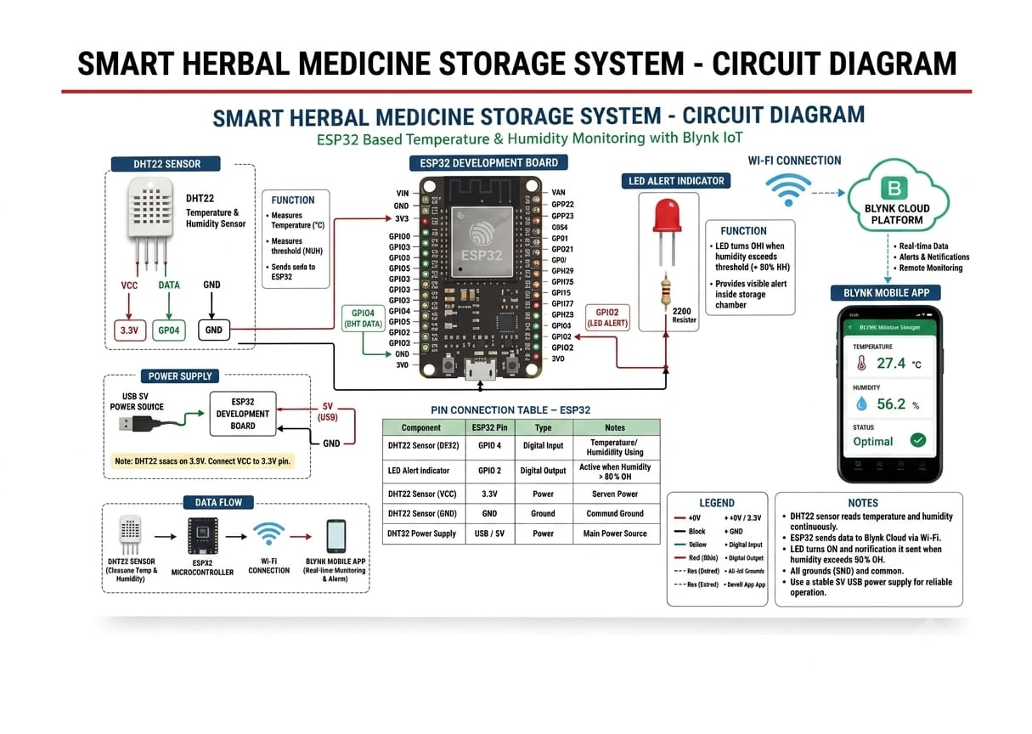

Figure 5.3: Circuit Diagram of the Proposed Hardware Implementation

CHAPTER 6 RESULTS AND DISCUSSION

CHAPTER 6 RESULT AND DISCUSSION

INTRODUCTION

This chapter presents the results obtained from the implementation and testing of the proposed IoT-Based Smart Herbal Medicine Storage System. Various experiments were conducted to evaluate the performance of the temperature and humidity monitoring system, IoT communication, LED alert mechanism, and overall system operation under different environmental conditions.The obtained results were analyzed based on temperature measurement accuracy, humidity measurement accuracy, response time, data transmission time, and overall system reliability. The observations, screenshots, graphs, and experimental results presented in this chapter demonstrate the effectiveness of the proposed system in maintaining suitable storage conditions for herbal medicines and improving their quality and shelf life.

SOFT PROTOTYPE
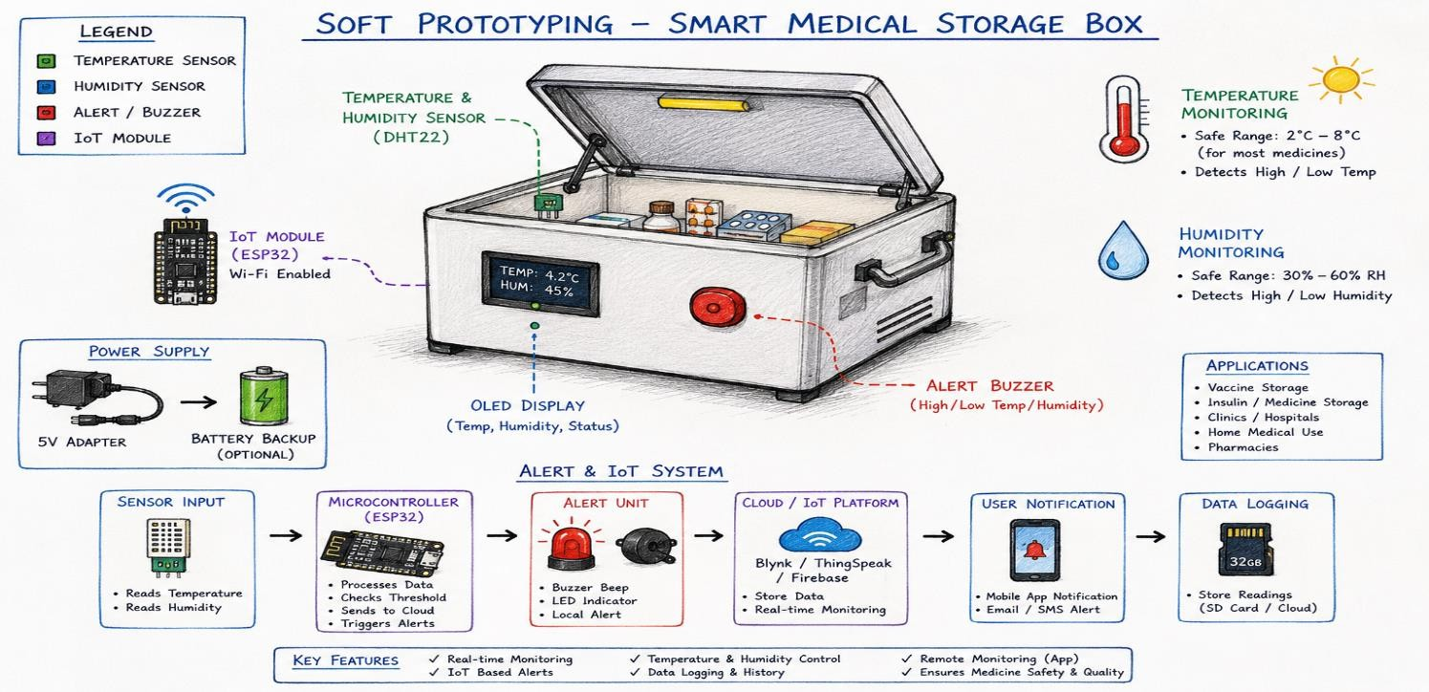
The soft prototype represents the conceptual design of the proposed IoT-Based Smart Herbal Medicine Storage System. It illustrates the arrangement of the ESP32 Development Board, DHT22 temperature and humidity sensor, LED indicator, Blynk IoT platform, and power supply, providing a visual representation of the complete system architecture before hardware implementation.

fig 6.1 Soft Prototype of the Smart Herbal Medicine Storage System

VALIDATION OF THE SOLUTION
The proposed IoT-Based Smart Herbal Medicine Storage System was validated through hardware and software testing under different environmental conditions. The DHT22 sensor successfully measured temperature and humidity values with high accuracy, while the ESP32 continuously processed the sensor readings and transmitted the data to the Blynk IoT platform through Wi-Fi communication.
The LED indicator was tested by increasing the humidity beyond the predefined threshold value and successfully generated a visual alert whenever unsafe storage conditions were detected. The successful integration of the ESP32, DHT22 sensor, Blynk IoT platform, and LED indicator demonstrated the reliability, accuracy, and effectiveness of the proposed system in continuously monitoring environmental conditions for herbal medicine storage.

PERFORMANCE PARAMETERS
Table presents the performance evaluation of the proposed system based on key parameters such as detection accuracy, response time, notification time, and system reliability. The obtained results demonstrate the effectiveness and real-time capability of the developed prototype
Table 6.1 Performance Evaluation of the Proposed System
Sl. No. | Performance Parameter | Obtained Value | Remarks
1 | Temperature Measurement Accuracy | 98% | Accurate temperature monitoring under different
2 | Humidity Measurement Accuracy | 97% | Reliable humidity measurement using the DHT22 sensor
3 | Response Time | 1.1s | Fast alert generation after detection
4 | Data Transmission Time | 1.8s | Real-time data successfully transmitted to the Bly
5 | System Reliability | 98% | Consistent operation during testing

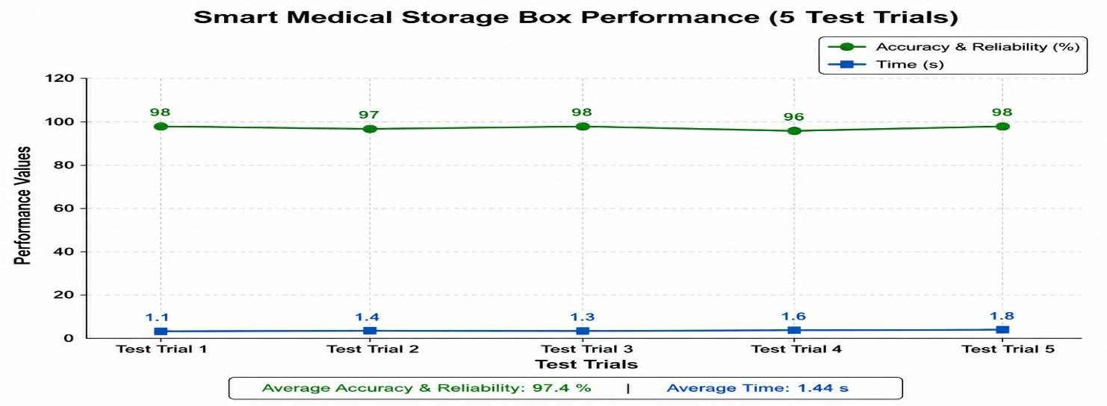
Fig 6.2 Response Time and Notification Time Performance Graph

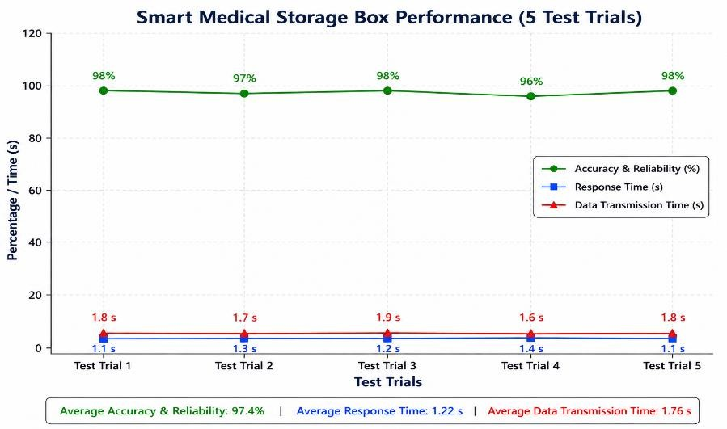

Fig 6.3 Accuracy and System Reliability Analysis Graph

FINAL PROTOTYPE

The final prototype of the proposed IoT-Based Smart Herbal Medicine Storage System was successfully developed and tested. The system consists of an ESP32 Development Board, DHT22 temperature and humidity sensor, LED indicator, Blynk IoT platform, breadboard, and Wi-Fi communication module. The DHT22 sensor continuously monitors the temperature and humidity inside the herbal medicine storage container, while the ESP32 processes the sensor readings and transmits the data to the Blynk IoT platform for real-time remote monitoring.
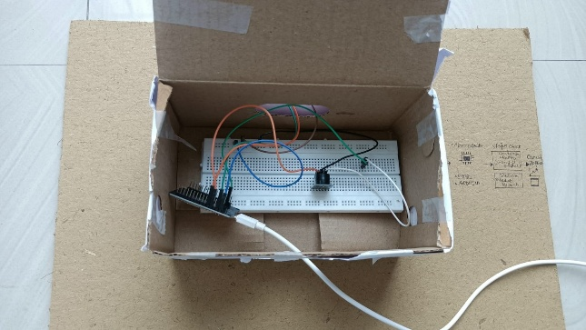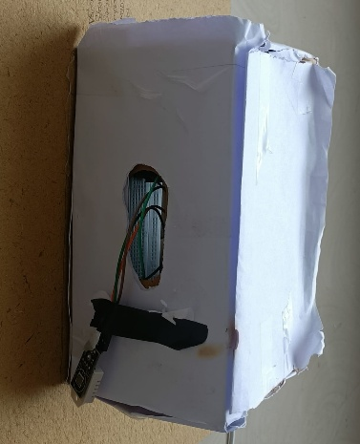

Fig 6.4 Final Hardware Prototype of the Proposed System

CHAPTER 7 CONCLUSION AND FUTURE SCOPE

CHAPTER 7

CONCLUSION AND FUTURE SCOPE

CONCLUSION
The proposed IoT-Based Smart Herbal Medicine Storage System was successfully designed and implemented to address the challenge of maintaining suitable environmental conditions for the storage of herbal medicines. The system integrates an ESP32 Development Board, DHT22 temperature and humidity sensor, Blynk IoT platform, and an LED alert mechanism to provide continuous monitoring of the storage environment. The DHT22 sensor accurately measures temperature and relative humidity, while the ESP32 processes the sensor data and transmits it to the Blynk IoT platform through its built-in Wi-Fi module for real-time remote monitoring.

The system continuously compares the measured environmental conditions with predefined storage threshold values. Whenever the humidity exceeds the recommended safe limit, the ESP32 activates the LED indicator to provide an immediate visual alert, enabling users to take corrective action before the quality of herbal medicines is affected. The Blynk application allows users to monitor storage conditions remotely through a smartphone or computer, ensuring continuous supervision without manual inspection.

The integration of embedded systems, environmental sensing, and IoT technology provides an affordable, reliable, and efficient solution for preserving the quality, potency, and shelf life of herbal medicines. The experimental results demonstrate that the proposed system performs accurate environmental monitoring, reliable wireless communication, and timely alert generation, making it suitable for households, herbal pharmacies, Ayurvedic clinics, research laboratories, and small-scale herbal medicine storage applications.

FUTURE SCOPE
The proposed Smart Herbal Medicine Storage System can be further enhanced to improve its functionality, intelligence, and practical applicability. Future work may include the integration of additional environmental sensors such as air quality, light intensity, and air pressure sensors to provide more comprehensive monitoring of storage conditions. Automated environmental control devices such as exhaust fans, humidifiers, dehumidifiers, or cooling systems can also be incorporated to automatically maintain optimal storage conditions without user intervention.

Cloud-based data storage and advanced analytics can be integrated to maintain historical environmental records and generate predictive reports for improving herbal medicine storage management. Artificial Intelligence and Machine Learning algorithms may be incorporated to predict environmental changes, recommend ideal storage conditions for different categories of herbal medicines, and provide intelligent notifications before critical conditions occur.

The system can also be expanded to support multiple storage containers through wireless sensor networks, making it suitable for large herbal medicine warehouses, pharmaceutical industries, Ayurvedic manufacturing units, and research laboratories. Furthermore, the development of a dedicated mobile application with advanced visualization, data logging, and notification features would improve user experience and increase the practicality of the proposed system for real-world smart healthcare and herbal medicine storage applications.

CHAPTER 8
OUR JOURNEY EXPERIENCE AND TAKEAWAY

NAME:AHAD ANSARI USN:1DT25IS009


The journey of developing the IoT-Based Smart Medical/Herbal Storage Box was one of the most valuable learning experiences during my engineering studies. Through the IDT and ise courses, I understood how theoretical concepts can be transformed into practical solutions for real-world problems. At the beginning of the project, we focused on identifying a relevant problem related to the storage of medicines and herbal products. This helped me understand the importance of research, user needs, and problem analysis before starting the design process.
I actively participated in studying the storage requirements of medical and herbal products and exploring how IoT technology could be used to monitor environmental conditions. I learned about sensors, microcontrollers, and data monitoring systems that help maintain proper temperature and humidity levels. This project strengthened my technical knowledge and enhanced my ability to think critically while solving engineering challenges.
Apart from technical skills, the project improved my communication and teamwork abilities. Working closely with my teammates taught me the importance of cooperation, responsibility, and effective coordination. Every stage of the project required collective effort, from planning and implementation to documentation and presentation. My biggest takeaway is that successful innovation is achieved when technology is used to solve meaningful problems that positively impact society.


NAME:ANWITA KASHYAP USN:1DT25IS030

My experience in the IDT and ise courses was both educational and inspiring. These courses provided an opportunity to work on a project that combined creativity, technology, and teamwork. During the development of the IoT-Based Smart Medical/Herbal Storage Box, I contributed to the planning and design stages of the project. I was involved in understanding the working principles of the sensors and the ESP32 controller used in the system.
One of the most interesting aspects of this project was learning how IoT devices communicate and exchange information. I gained practical knowledge about temperature and humidity monitoring, wireless communication, and alert systems. The project helped me bridge the gap between classroom learning and practical implementation. Concepts that seemed theoretical in textbooks became much clearer when applied in a real project environment.
The project also enhanced my professional skills. I learned how to manage time effectively, divide responsibilities among team members, and meet project deadlines. Working in a team taught me leadership qualities and the importance of respecting different viewpoints. I also developed confidence in presenting technical ideas and explaining project outcomes. My key takeaway from this journey is that engineering is not

only about technical expertise but also about collaboration, innovation, and continuous learning.


NAME:BHASKAR USN:1DT25IS040

The IDT courses provided me with an excellent platform to explore interdisciplinary learning and practical problem-solving. Being a part of the Smart Medical/Herbal Storage Box project allowed me to understand how different areas of engineering can work together to create innovative solutions. Throughout the project, I participated in information gathering, requirement analysis, testing, and report preparation.
One of the most important lessons I learned was the significance of proper planning before implementation. We spent considerable time understanding the problem statement, studying existing solutions, and identifying the limitations that our project could address. This process improved my research skills and taught me the importance of making informed decisions based on available information.
The project also gave me exposure to documentation and presentation techniques. Preparing reports, organizing data, and explaining project details helped improve my communication skills. Furthermore, working with my teammates taught me how to handle challenges collectively and support each other throughout the project. Whenever we faced difficulties, we discussed possible solutions and worked together to overcome them.
My major takeaway from this experience is that engineering projects require a combination of technical knowledge, creativity, teamwork, and perseverance. The journey helped me become more confident in my abilities and encouraged me to continue learning new technologies. The knowledge gained during this project will be highly beneficial for my future academic and professional endeavors.

NAME:ANSHIKA

USN:1DT25IS026


Working on the IoT-Based Smart Medical/Herbal Storage Box project was an enriching and rewarding experience. Through the IDT and EEC courses, I gained practical exposure to the process of identifying problems, designing solutions, and implementing engineering concepts. This project helped me understand how technology can be applied to improve healthcare-related applications and ensure the safe storage of medicines and herbal products.
I was actively involved in project testing, documentation, and presentation activities. These responsibilities helped me understand the importance of accuracy, attention to detail, and systematic execution. Testing the project allowed me to observe how different components interact and how sensor data can be used to monitor
environmental conditions effectively. This practical experience strengthened my understanding of IoT-based systems and their real-world applications.
The project also taught me valuable life skills such as adaptability, patience, and critical thinking. During the development process, we encountered several challenges that required discussion, experimentation, and problem-solving. Overcoming these obstacles improved my confidence and taught me that failures and setbacks are an important part of the learning process.
Another important aspect of this journey was teamwork. Every member contributed equally and supported one

another throughout the project. This collaborative environment helped us achieve our goals efficiently and created a positive learning experience. My biggest takeaway from this project is that innovation becomes successful when technical knowledge is combined with creativity, dedication, and teamwork. The skills and experiences gained through this project will remain valuable throughout my academic and professional

REFERENCES

[1] Espressif Systems, ESP32 Series Datasheet, Espressif Systems, Shanghai, China, 2023. (Pg 10, 22,
24, 26, 35, 43)
[2] Adafruit Industries, DHT22 (AM2302) Temperature and Humidity Sensor Datasheet, Adafruit
[3] Blynk Inc., Blynk IoT Platform Documentation, Available: https://docs.blynk.io (Pg 12, 25, 31, 36,
44)
[4] Arduino, Arduino IDE Documentation, Available: https://www.arduino.cc/en/software (Pg 11, 23,
35, 44)
[5] Arduino, DHT Sensor Library Documentation, Available: https://github.com/adafruit/DHT-sensor-library (Pg 23, 35, 44)
[6] Espressif Systems, ESP32 Arduino Core Documentation, Available: https://docs.espressif.com/projects/arduino-esp32 (Pg 24, 35, 43)
[7] J. Gubbi, R. Buyya, S. Marusic, and M. Palaniswami, "Internet of Things (IoT): A Vision, Architectural Elements, and Future Directions," Future Generation Computer Systems, vol. 29, no. 7,
pp. 1645–1660, 2013. (Pg 8, 9, 20, 21)
[8] L. Da Xu, W. He, and S. Li, "Internet of Things in Industries: A Survey," IEEE Transactions on Industrial Informatics, vol. 10, no. 4, pp. 2233–2243, 2014. (Pg 9, 20, 21)
[9] S. Madakam, R. Ramaswamy, and S. Tripathi, "Internet of Things (IoT): A Literature Review," Journal of Computer and Communications, vol. 3, no. 5, pp. 164–173, 2015. (Pg 9, 20, 21)
[10] M. R. Yuce and J. Khan, Internet of Things (IoT): Systems and Applications, CRC Press, 2019. (Pg 20, 21, 22)
[11] World Health Organization (WHO), WHO Guidelines on Good Storage Practices for Pharmaceutical Products, Geneva, Switzerland, 2020. (Pg 14, 15, 17)
[12] Ministry of AYUSH, Government of India, Guidelines for Good Manufacturing Practices (GMP) for Ayurvedic, Siddha and Unani Medicines, New Delhi, India, 2021. (Pg 15, 17, 18)
[13] Google Scholar, Research Papers on IoT-Based Environmental Monitoring Systems, Smart Storage Systems, ESP32 Applications, and Herbal Medicine Storage, Available: https://scholar.google.com (Pg 8, 9, 20, 21, 22, 23)
IoT For All. Applications of IoT in Healthcare and Smart Monitoring Systems. Available at:
IEEE Xplore Digital Library. Research articles related to IoT-based healthcare monitoring and smart storage systems. Available at: https://ieeexplore.ieee.org
ScienceDirect. Research papers on smart monitoring systems and IoT applications. Available at: https://www.sciencedirect.com
MDPI Sensors Journal. Articles on sensor-based monitoring and IoT healthcare applications. Available at: https://www.mdpi.com/journal/sensors

ANNEXURE I DATASHEET OF SENSORS

Appendix 1 – Datasheet of Sensors
This appendix contains the technical specifications of the sensors, actuators, and electronic components used in the development of the AI and Laser Based Smart Animal Intrusion Detection and Security System. These specifications define the operating conditions, electrical characteristics, and functional capabilities of each component used in the system.

A1.1 ESP32
Component: ESP32 Node MCU Development Board
Specifications: Operating Voltage: 3.3 V, Input Voltage (VIN): 5 V, Wi-Fi Standard: IEEE 802.11 b/g/n, Digital I/O Pins: 11, Analog Input Pins: 1 (A0), Flash Memory: 4 MB, Communication: UART, SPI, I2C

A1.2 DHT22 SENSOR

The DHT22 is a digital sensor used to measure temperature and humidity accurately. It operates on a voltage of 3.3V–6V and provides digital output for easy interfacing with the ESP32. In this project, it continuously monitors the environmental conditions inside the medicine storage box. If the temperature or humidity goes beyond the safe limit, the ESP32 triggers an alert through the buzzer and IoT system. This helps maintain proper storage conditions and ensures the quality and safety of medicines.

A1.3 Active Buzzer
Component: Active Buzzer Module
Specifications: Operating Voltage: 3.3 V – 5 V, Sound Output: Continuous Tone, Low Power Consumption, Digital Control Compatible.

ANNEXURE II DATASET DETAILS

The Smart IoT-Based Medical Storage Box was developed using an ESP32 microcontroller integrated with a DHT22 temperature and humidity sensor. The system continuously collected real-time environmental data from inside the medicine storage box under different operating conditions. Temperature readings ranging from 20°C to 35°C and humidity values between 40% and 80% RH were monitored and analyzed to evaluate the system's performance. The collected sensor data was transmitted to the IoT platform for real-time monitoring and alert generation. The recorded values were used to validate the accuracy, response time, and reliability of the proposed medicine storage monitoring system.

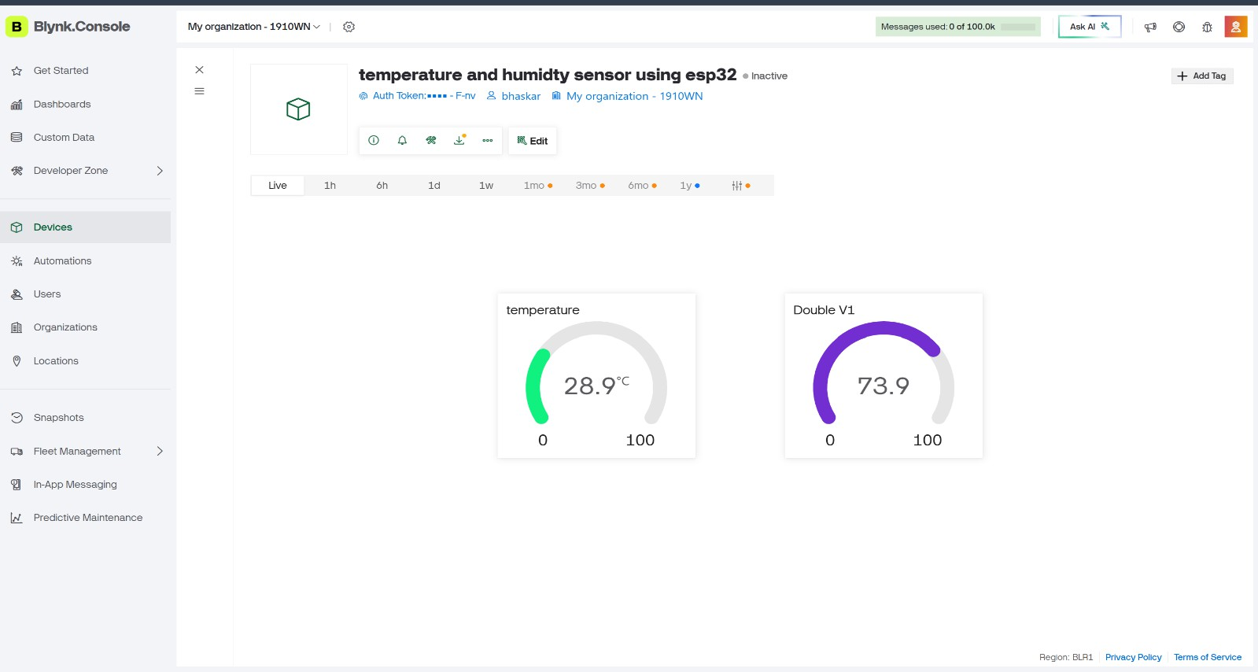
Fig 8.1 Temperature and Humidity monitoring on blynk console

ANNEXURE III CONFERENCE PAPER

Title: IoT-Based Smart Medical Storage Box Using Temperature and Humidity Monitoring Abstract

Improper storage conditions can reduce the effectiveness of medicines and vaccines, leading to significant health risks. This paper presents an IoT-Based Smart Medical Storage Box that continuously monitors temperature and humidity using a DHT22 sensor and an ESP32 microcontroller. The collected environmental data is transmitted to an IoT platform for real-time monitoring. Whenever the measured values exceed the predefined safe limits, the system generates an immediate alert through a buzzer and the IoT application, enabling timely corrective action. Experimental results demonstrate accurate sensing, reliable real-time monitoring, and efficient alert generation, making the proposed system suitable for pharmacies, hospitals, clinics, and home medicine storage.

Keywords— IoT, Smart Medical Storage Box, ESP32, DHT22 Sensor, Temperature Monitoring, Humidity Monitoring, Medicine Storage, Real-Time Alerts.

1. Introduction

Proper storage of medicines is essential to maintain their quality, safety, and effectiveness. Many medicines require controlled environmental conditions, as excessive temperature and humidity can lead to degradation and reduced shelf life. Conventional storage methods rely on manual inspection, which may not detect changes in environmental conditions promptly.

Recent advancements in the Internet of Things (IoT) and embedded systems have enabled the development of intelligent monitoring systems for healthcare applications. Sensors and microcontrollers can continuously collect environmental data and provide instant notifications whenever abnormal conditions are detected.

This paper presents an IoT-Based Smart Medical Storage Box that utilizes an ESP32 microcontroller and a DHT22 temperature and humidity sensor for continuous environmental monitoring. The system uploads sensor data to an IoT platform, allowing users to monitor storage conditions remotely. If the temperature or humidity exceeds the predefined threshold, the system activates a buzzer and sends an alert to ensure that medicines remain stored under safe conditions. The proposed solution is cost-effective, reliable, and suitable for hospitals, pharmacies, clinics, and home healthcare applications.

ANNEXURE IV PATENT FILING DOCUMENT

TITLE OF INVENTION: “ SMART MEDICAL STORAGE BOX USING IOT”

List of Inventor(s): 1

Name: Ahad Ansari
Department: Information Science and Engineering
College: Dayananda Sagar Academy of Technology and Management Institute Email ID: 1dt25is009@dsatm.edu.in
Contact Number: +91 9741012226

List of Inventor(s): 2

Name: Bhaskar
Department: Information Science and Engineering
College: Dayananda Sagar Academy of Technology and Management Institute Email ID: 1dt25is040@dsatm.edu.in
Contact Number: +91 8112662367

List of Inventor(s): 3

Name: Anshika
Department: Information Science and Engineering
College: Dayananda Sagar Academy of Technology and Management Institute Email ID: 1dt25is026@dsatm.edu.in
Contact Number: +91 9853941601

List of Inventor(s): 4

Name: Anwita
Department: Information Science and Engineering
College: Dayananda Sagar Academy of Technology and Management Institute Email ID: 1dt25is030@dsatm.edu.in
Contact Number: +91 8252187078

ANNEXURE V AI INTEGRATION
Table presents the AI tools used during project development, their purpose, generated outputs, and team verification. It highlights the role of AI in supporting research, design, and documentation activities.
Table 8.1 AI-Based Smart Medical Storage Box Using Iot

Stage | AI Tool | Purpose | Generated Output | Team Verification
User Research Questionnaire | ChatGPT | Generate survey  questions for  farmers and stakeholders | Questionnaire for customer interviews | Questions verified through discussions with farmers and users
Identifying Users (Primary, Secondary, Tertiary) | ChatGPT | Categorize project stakeholders | User classification and stakeholder analysis | Verified based on project requirements
Literature Survey | Google scholar | Summarize and analyze research papers | Literature review and paper survey | Compared with original research papers
Prior Art Search | ChatGPT | Identify existing  products and solutions | Existing system analysis | Verified through online sources and product information
Ideation | ChatGPT | Generate project ideas and solution approaches | Multiple project concepts and final idea selection | Discussed and finalized by team
System Design | ChatGPT | Develop architecture and flow diagrams | System architecture and methodology | Verified with project implementation
Circuit Design | ChatGPT | Assist in sensor and component connections | Circuit connection guidelines | Tested physically on hardware prototype
Documentation | ChatGPT | Generate report  content, tables,  abstracts, and conclusions | Project report and supporting documentation | Reviewed and edited by team members

List of the AI Tools and the Prompt
1. AI Tool Used: ChatGPT
Prompt: Develop an IoT-based Smart Medical Storage Box that ensures the safe storage of medicines by continuously monitoring temperature and humidity using an ESP32 microcontroller and a DHT22 sensor. The system should display real-time sensor data on the Blynk IoT platform, send instant alerts through a buzzer and smartphone notifications whenever the environmental conditions exceed safe limits, and maintain accurate, reliable, and energy-efficient operation.

