**KONGU ENGINEERING COLLEGE**

**(Autonomous)**

**PERUNDURAI – 638060**

**Department of Artificial Intelligence**

|  |  |
| --- | --- |
| Roll No: 22ALR090 | Name: K.SHAM SUNDAR |
| Sem:01 | Date: |
| Sub Code:22ADT11(Foundation of Information Technology) | Tutorial: 4  Marks: 25 |

1. Create a given web page with the following styles using Inline CSS style

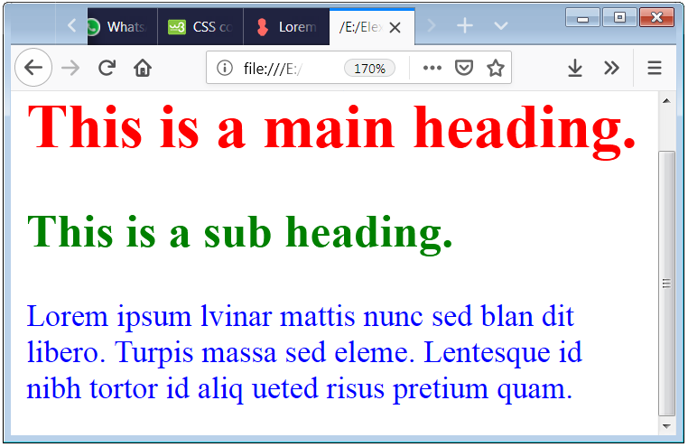

2. Create a given web page with the following styles using internal CSS Style.

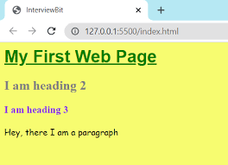

3. Create a given web page with the following styles using External css sheet

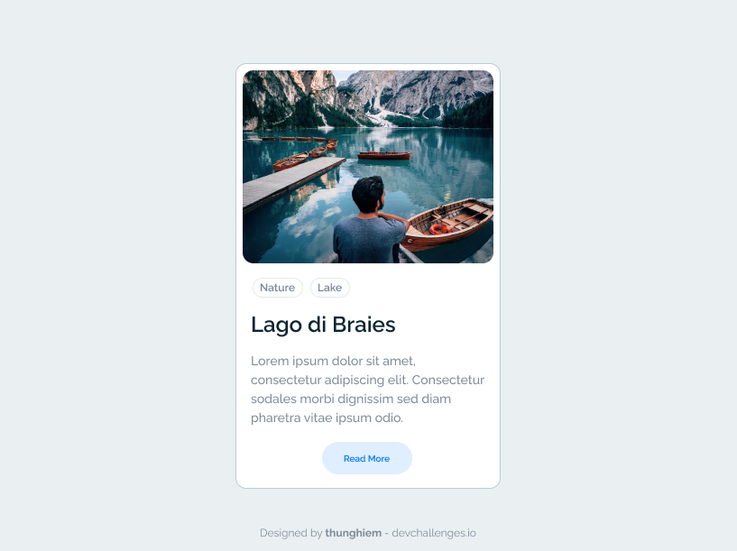

4. Create a given layout of a webpage using external style sheet

