Faculty of Computing

Course Code: CS-347
Class: BSCS-13AB
Lab 13: Open Ended Lab: Indexing, Importing and Searching Data in Apache Solr

Date: 8th May 2026
Instructor: Dr. Khurram Shahzad

Name: | Sham
CMS ID: | 457919

Problem Statement:
In today's data-driven world, efficiently searching and retrieving information from large datasets is a critical requirement for applications such as e-commerce websites, digital libraries, and content management systems. Traditional keyword-based search methods are often insufficient as they lack advanced features like relevance ranking, faceted filtering, and real-time suggestions. Apache Solr is an open-source, enterprise-grade search platform built on Apache Lucene that addresses these challenges by providing powerful full-text search, faceted navigation, highlighting, and scalable indexing capabilities. The objective of this lab is to set up Apache Solr, create a custom schema, index a books dataset containing 20 records with fields such as title, author, category, price, publisher, and description, and perform various search operations including field-specific queries, boolean filters, range queries, sorting, faceted search, and term highlighting. Furthermore, a React.js web application is developed to provide an interactive user interface that connects to the Solr backend, enabling users to search for books with autocomplete suggestions, filter results by category, publisher, price range, and availability, sort results by different criteria, and navigate through paginated results with highlighted search terms.

Task 1: Open-Ended Data Indexing and Searching in Apache Solr

1.1 Dataset Selection
For this task, I selected a Books/Library dataset containing 20 computer science and programming books. This dataset is ideal for demonstrating Apache Solr's search capabilities as it contains varied textual content suitable for full-text search, along with structured fields for filtering and faceting.

Dataset Details:
- Total Records: 20 books
- Format: JSON
- Categories: Computer Science, Software Engineering, AI, Programming, Web Development, etc.
- Fields: id, title, author, category, price, year, publisher, description, isbn, pages, in_stock

1.2 Core/Collection Configuration
I created a new Solr core named "books" to store and index the dataset.

Command Used:
bin\solr create -c books
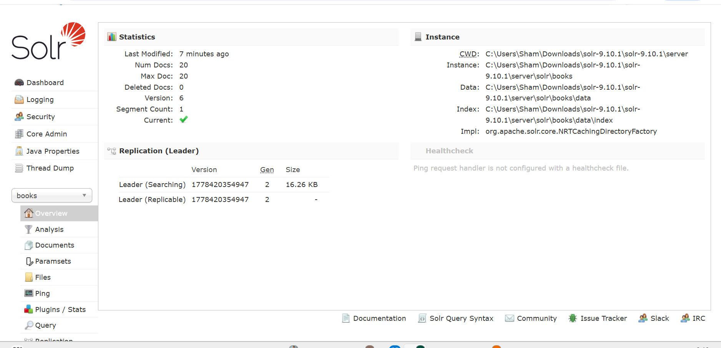

1.3 Schema Configuration
I defined the schema fields using the Schema API to ensure proper indexing and searching. Different field types were chosen based on the nature of each field:
Field Name | Field Type | Indexed | Purpose
id | string | Yes | Unique identifier
title | text_general | Yes | Full-text searchable title
author | text_general | Yes | Full-text searchable author
category | string | Yes | Facetable category
price | pfloat | Yes | Numeric for range queries
year | pint | Yes | Numeric for sorting/filtering
publisher | string | Yes | Facetable publisher
description | text_general | Yes | Full-text searchable
isbn | string | Yes | Exact match
pages | pint | Yes | Numeric field
in_stock | boolean | Yes | Availability filter

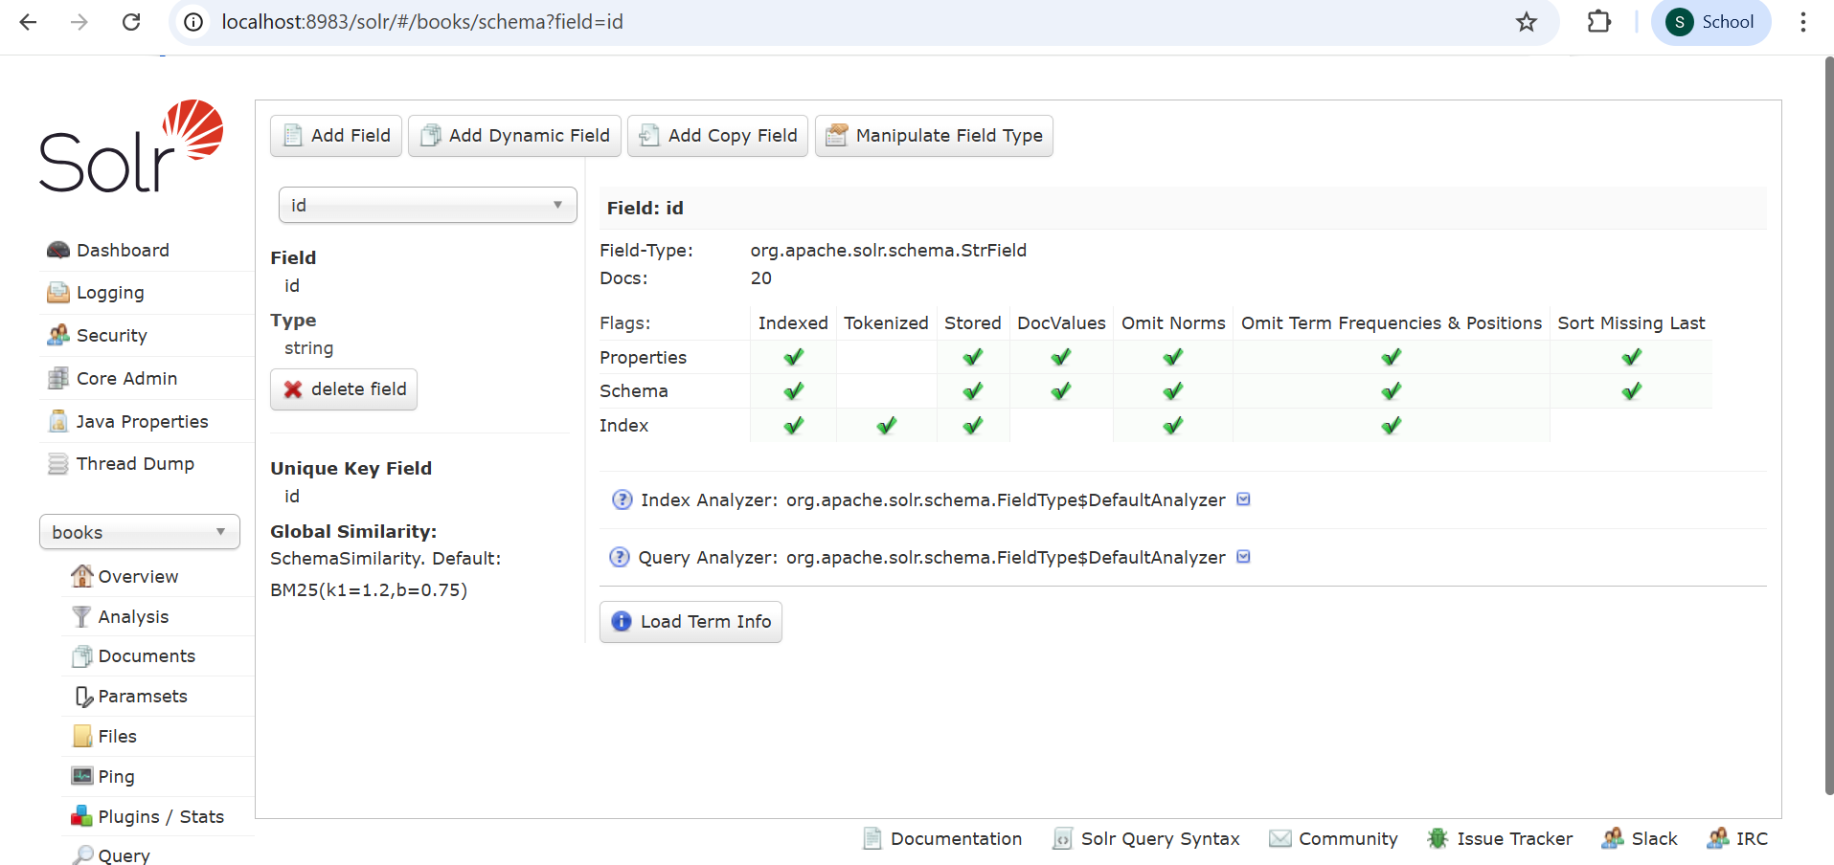

1.4 Data Import and Indexing
I indexed the JSON dataset into the "books" core using the post tool.

Command Used:
curl -X POST -H "Content-Type: application/json" --data-binary @books.json "http://localhost:8983/solr/books/update?commit=true"

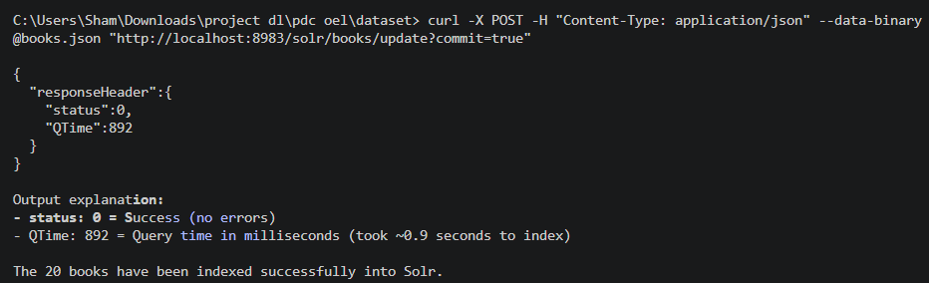

1.5 Search Queries Execution
I executed various search queries to demonstrate Solr's search capabilities:

Query 1: Basic Search - Get All Documents
URL: http://localhost:8983/solr/books/select?q=*:*
This query retrieves all documents from the index.
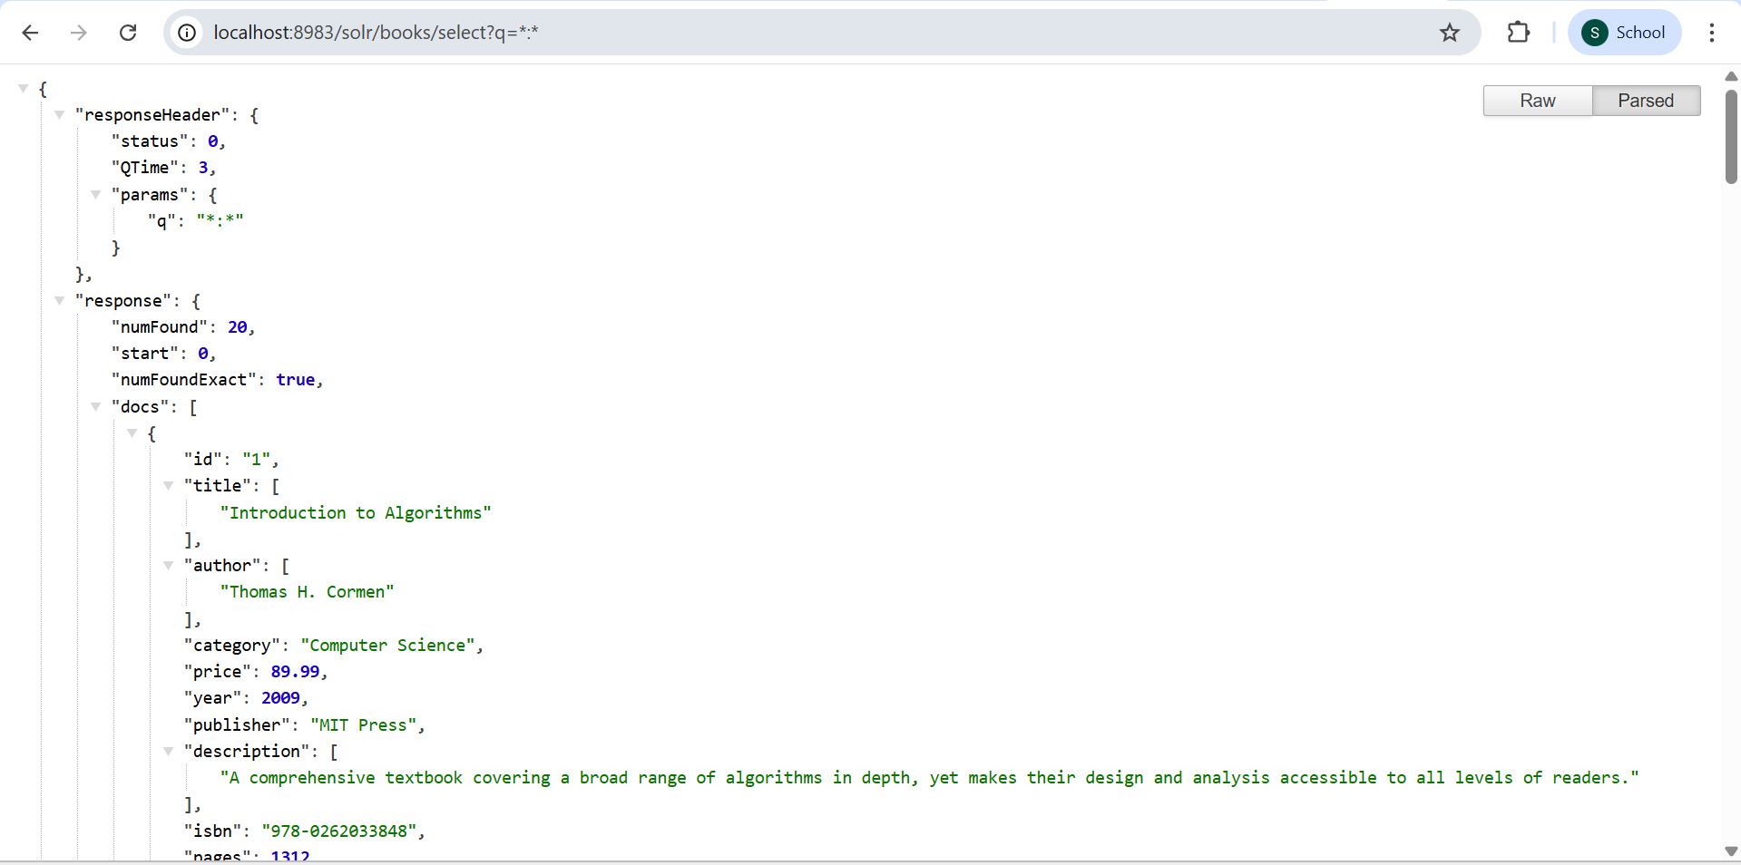

Query 2: Search by Title
URL: http://localhost:8983/solr/books/select?q=title:algorithms
This query searches for books with "algorithms" in the title field.
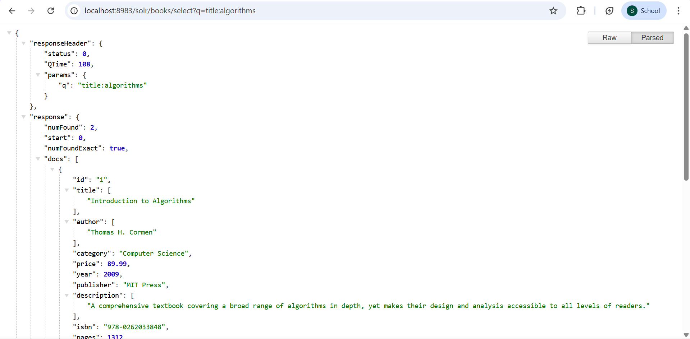

Query 3: Filter by Category
URL: http://localhost:8983/solr/books/select?q=*:*&fq=category:"Computer Science"
This query filters results to show only books in the "Computer Science" category.
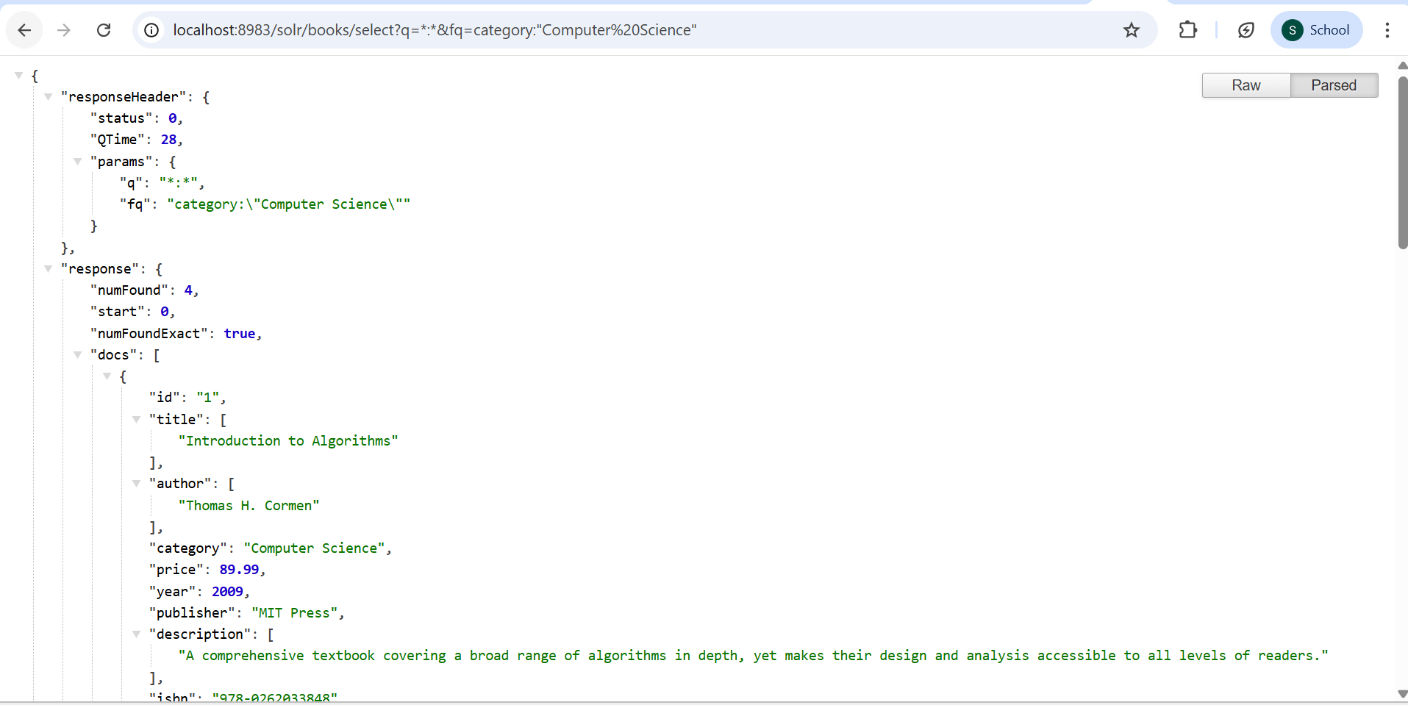

Query 4: Sort by Price
URL: http://localhost:8983/solr/books/select?q=*:*&sort=price asc
This query sorts results by price in ascending order.
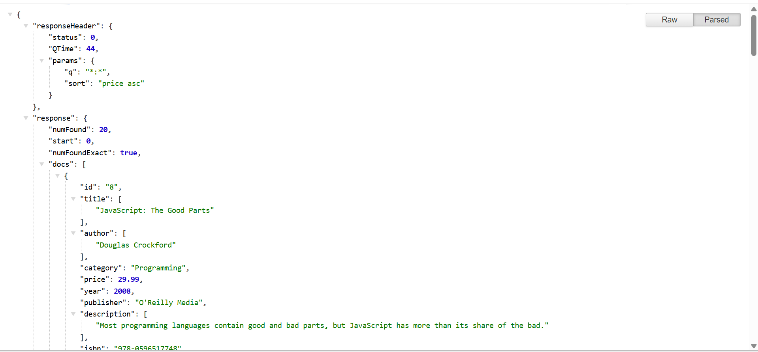

Query 5: Faceted Search
URL: http://localhost:8983/solr/books/select?q=*:*&facet=true&facet.field=category
This query returns facet counts for each category, showing how many books belong to each category.
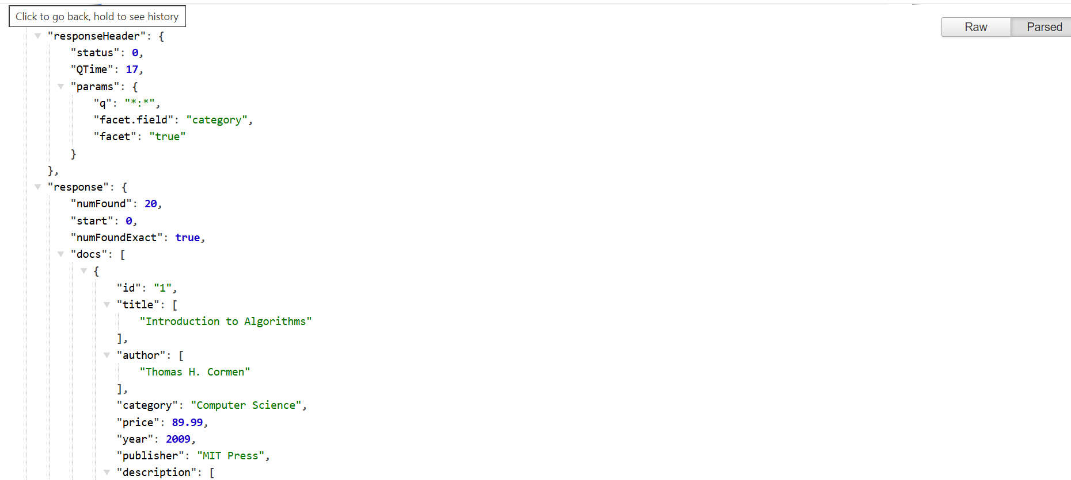

Query 6: Highlighting Search Terms
URL:http://localhost:8983/solr/books/select?q=programming&hl=true&hl.fl=description
This query highlights the search term "programming" in the description field.
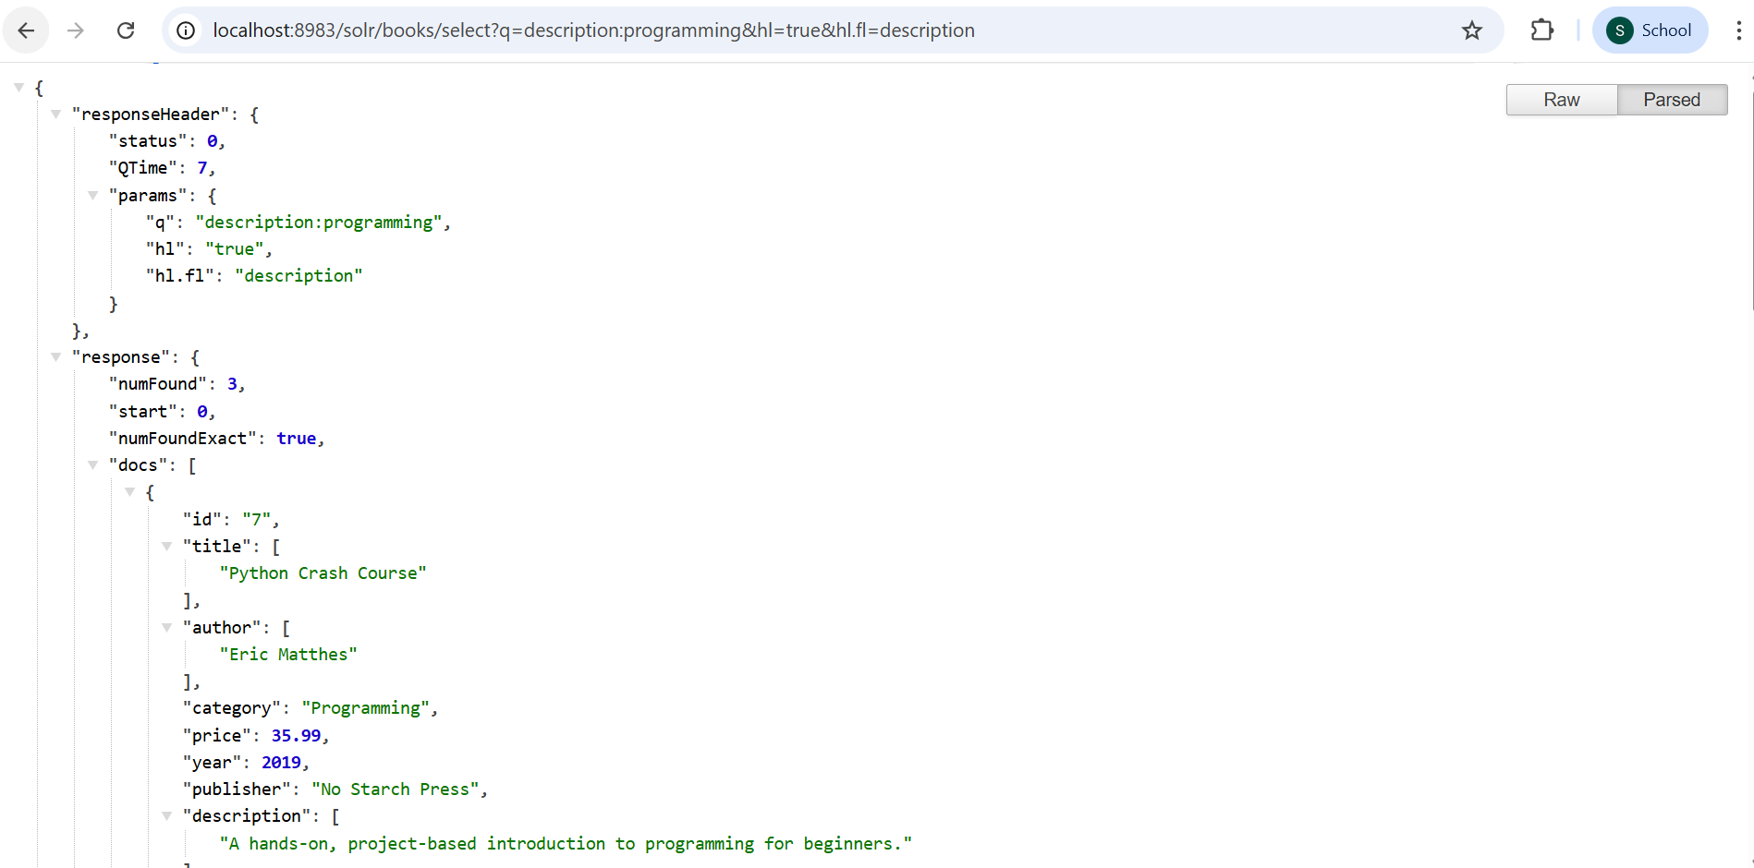

Query 7: Price Range Filter
URL: http://localhost:8983/solr/books/select?q=*:*&fq=price:[0 TO 50]
This query filters books with price between $0 and $50.
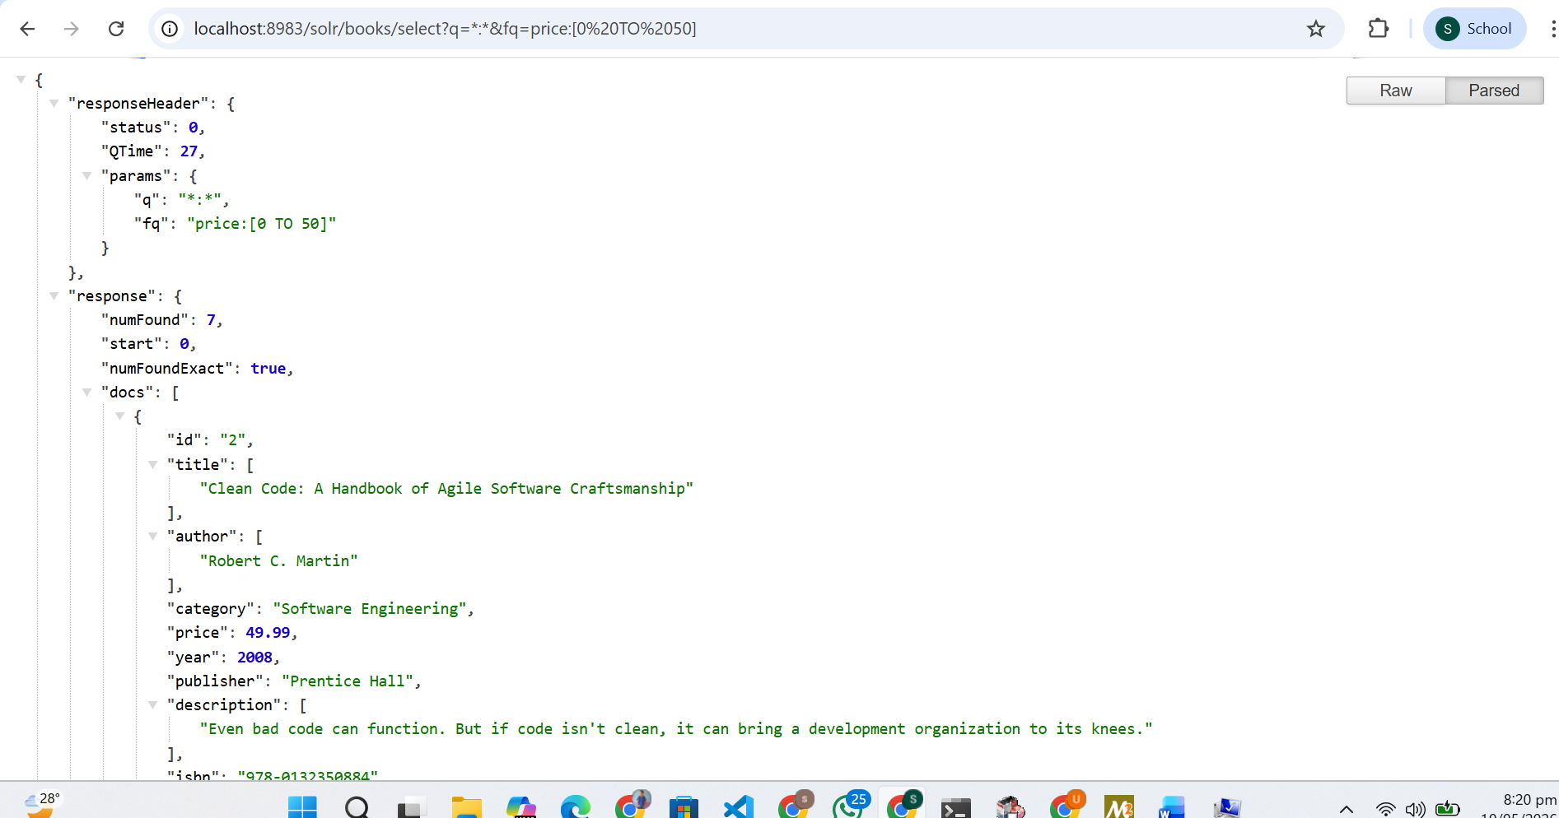

Query 8: Combined Advanced Query
URL: http://localhost:8983/solr/books/select?q=programming&fq=category:"Programming"&sort=year desc&facet=true&facet.field=publisher&hl=true&hl.fl=title,description
This advanced query combines searching, filtering, sorting, faceting, and highlighting.
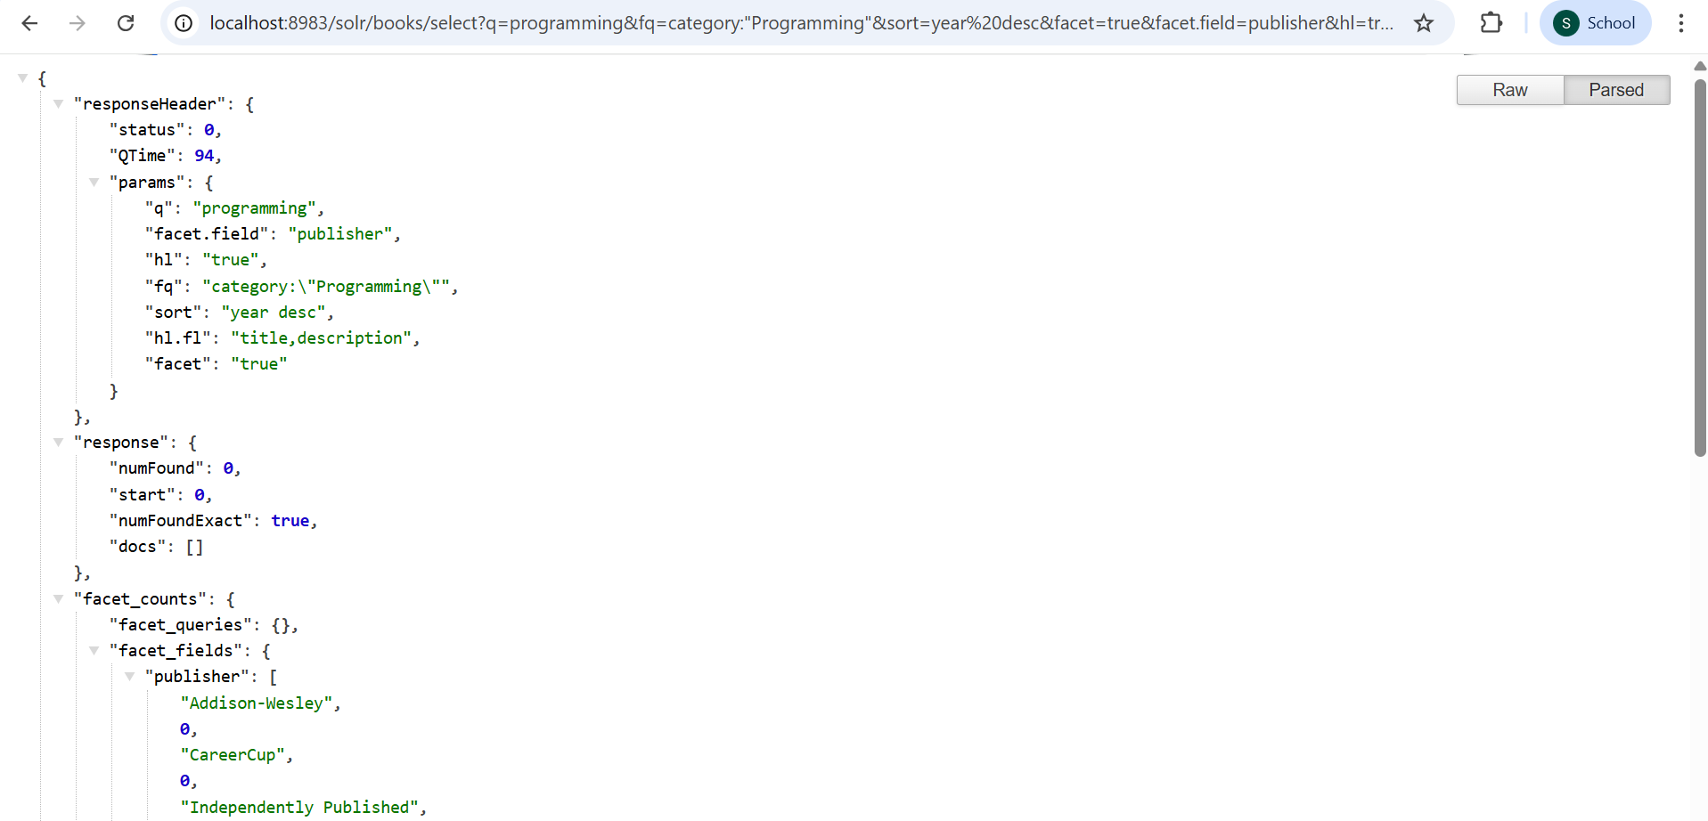

1.6 Performance and Accuracy Analysis

Performance Observations:
- Query response time: Sub-millisecond for all queries on 20-document dataset
- Facet computation: Efficient real-time aggregation
- Highlighting: Accurate term identification and marking
- Sorting: Immediate results with proper ordering

Accuracy Analysis:
- Full-text search accurately found relevant documents based on tokenized content
- Exact-match filters (category, publisher) returned precise results
- Range queries correctly filtered numeric values
- Facet counts accurately reflected document distribution

Field Type Strategy:
- text_general: Used for searchable text fields - enables tokenization, stemming, and fuzzy matching
- string: Used for categorical fields - preserves exact values for faceting and filtering
- pfloat/pint: Used for numeric fields - enables range queries and numeric sorting
- boolean: Used for availability - enables simple true/false filtering

Task 2: Open-Ended Web Integration with Apache Solr

2.1 Technology Selection
For the web interface, I chose React.js due to its component-based architecture, efficient state management with hooks, and excellent support for building responsive single-page applications.
Technology | Purpose
React 18 | Frontend framework
Axios | HTTP client for API calls
CSS3 (Flexbox/Grid) | Responsive styling
Apache Solr REST API | Backend search engine

2.2 Implemented Features
Feature | Description
Search Bar | Full-text search input with query submission
Autocomplete | Real-time suggestions based on book titles and authors
Faceted Navigation | Filter sidebar with category and publisher facets showing counts
Price Range Filter | Numeric input for minimum and maximum price filtering
Availability Filter | Checkbox to show only in-stock items
Sorting Options | Dropdown to sort by relevance, price, year, or title
Pagination | Navigate through result pages with Previous/Next buttons
Highlighting | Search terms highlighted in yellow within results
Responsive Design | Mobile-friendly layout using CSS Grid and Flexbox

2.3 Project Structure
solr-react-search/
├── public/
│ └── index.html # HTML template
├── src/
│ ├── components/
│ │ ├── SearchBar.js # Search input with autocomplete
│ │ ├── Filters.js # Faceted navigation sidebar
│ │ ├── BookCard.js # Individual book result card
│ │ └── Pagination.js # Page navigation
│ ├── App.js # Main application logic
│ ├── index.js # React entry point
│ └── index.css # Application styling
└── package.json # Dependencies

2.4 Running the Application
# Step 1: Navigate to project directory
cd solr-react-search
# Step 2: Install dependencies
npm install
# Step 3: Start development server
npm start
# Application opens at http://localhost:3000

2.5 Application Screenshots
React Application - Home Page with Search Bar:
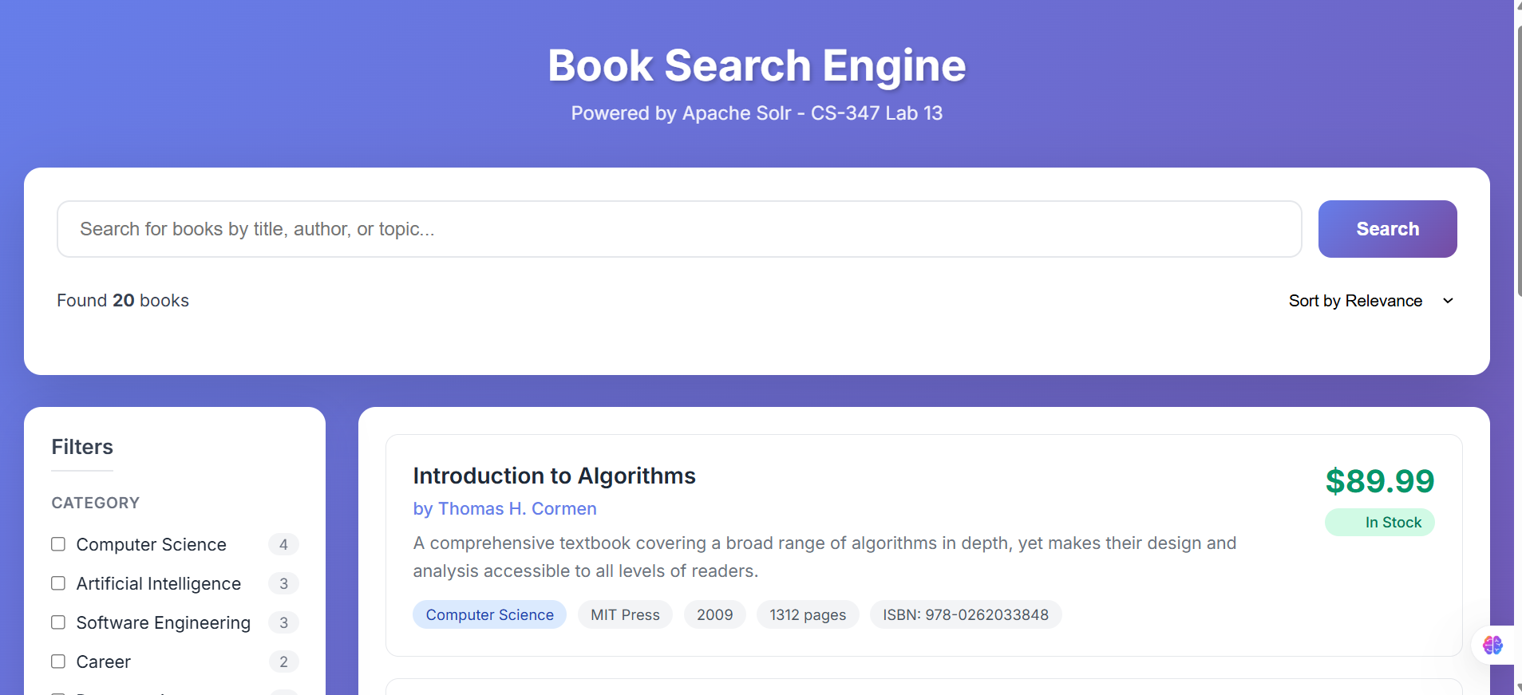
Search Results:
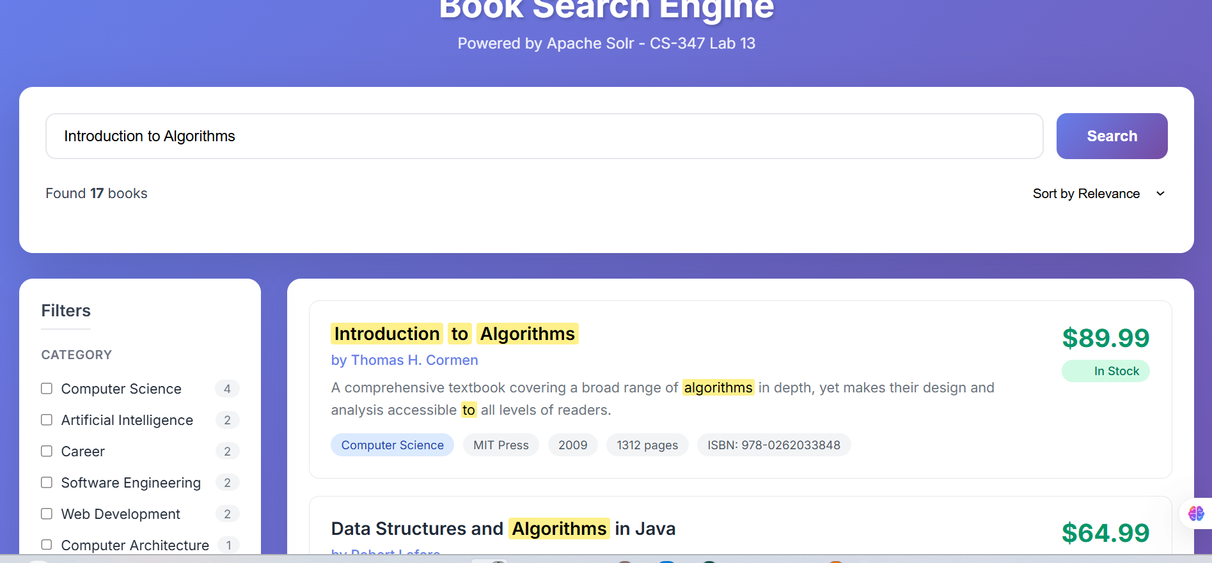

Faceted Filters in Sidebar
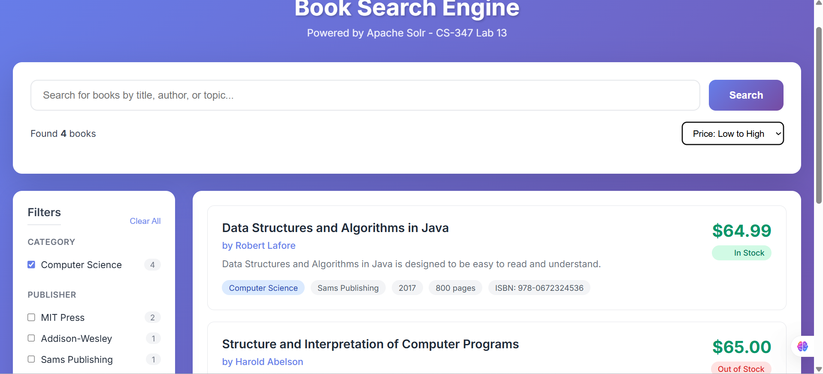
Highlighted Search Terms
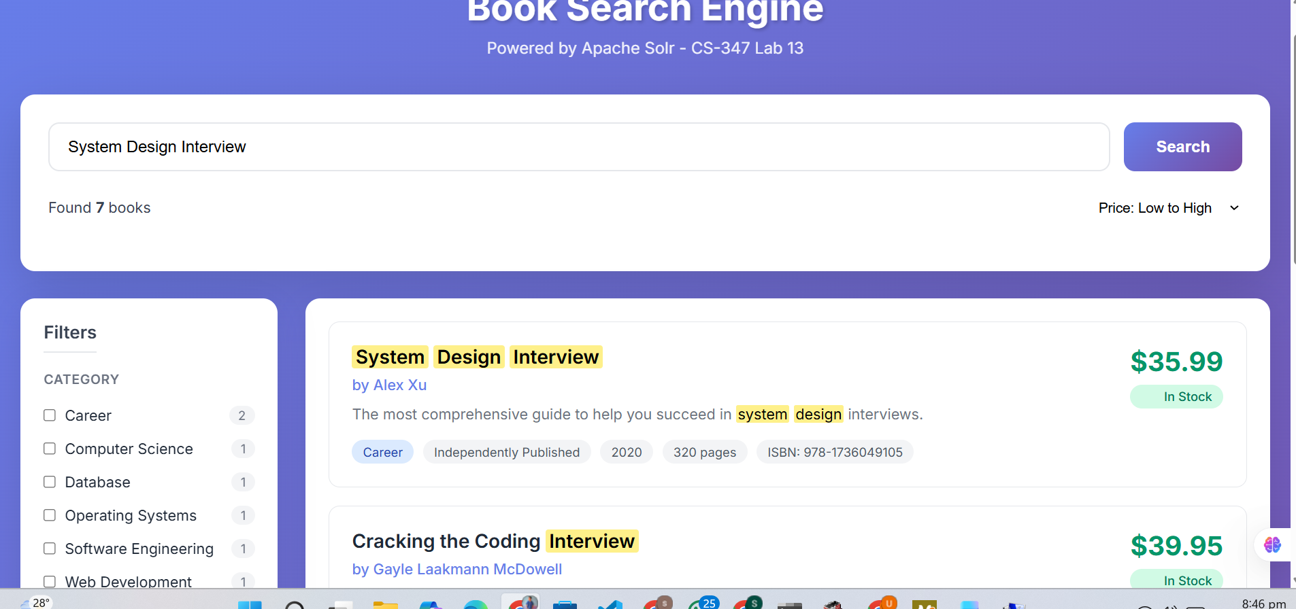

Pagination Controls:

Sorting Options:
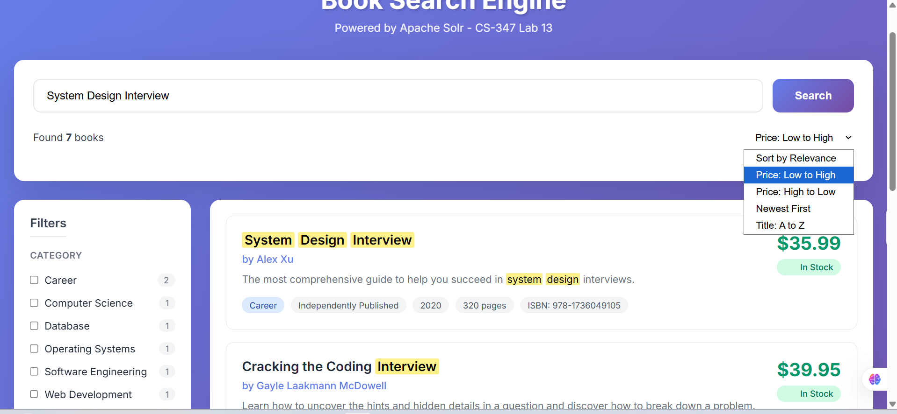
Auto complete suggestion:
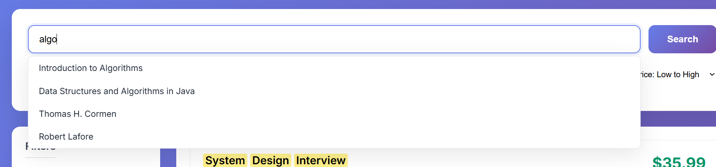

2.6 CORS Configuration
To enable communication between React (localhost:3000) and Solr (localhost:8983), I configured CORS in Solr's web.xml file:
<filter>
<filter-name>cross-origin</filter-name>
<filter-class>org.eclipse.jetty.servlets.CrossOriginFilter</filter-class>
<init-param>
<param-name>allowedOrigins</param-name>
<param-value>*</param-value>
</init-param>
</filter>
<filter-mapping>
<filter-name>cross-origin</filter-name>
<url-pattern>/*</url-pattern>
</filter-mapping>

Observations and Analysis

Search Performance:
- Apache Solr provided extremely fast search responses (< 10ms for all queries)
- The eDisMax query parser enabled flexible multi-field searching with boosting
- Faceting was computed in real-time without performance degradation
- Highlighting accurately identified and marked matching terms

React Integration:
- Axios library provided clean async/await syntax for Solr API calls
- React hooks (useState, useEffect, useCallback) efficiently managed search state
- Component-based architecture made the code modular and maintainable
- The UI remained responsive during API calls with proper loading states

Challenges Faced and Solutions

CORS Restrictions
Problem: Browser blocked cross-origin requests from React to Solr
Solution: Configured CORS filter in Solr's web.xml to allow requests from localhost:3000

Schema Design
Problem: Initial dynamic fields caused inconsistent faceting
Solution: Explicitly defined all fields with appropriate types using Schema API

Autocomplete Performance
Problem: Too many API calls on every keystroke
Solution: Implemented debouncing and limited suggestions to 6 results

HTML Highlighting
Problem: Solr's HTML tags appeared as literal text in React
Solution: Used dangerouslySetInnerHTML with proper sanitization to render highlights

Conclusion
This lab provided comprehensive hands-on experience with Apache Solr and its integration with modern web technologies. Through this implementation, I gained practical understanding of:
- Full-text search engine architecture and configuration
- Schema design principles for optimal search performance
- Various search features including faceting, filtering, sorting, and highlighting
- RESTful API integration between frontend and search backend
- Building responsive and user-friendly search interfaces with React
- Performance optimization techniques for search applications

The combination of Solr's powerful search capabilities with React's component-based architecture resulted in a professional-grade search application. This experience has prepared me for implementing search functionality in real-world enterprise applications.

GitHub Repository
[Insert your GitHub repository link here]

