HACKATHON PROJECT OVERVIEW

PrivacyGate
On device privacy protection for safer image sharing

PrivacyGate examines an outgoing image at the moment of sharing, identifies sensitive information locally and gives the user a practical way to mask it before the image leaves the phone.
Native Android prototype for iQOO 15 and Snapdragon 8 Elite

PROBLEM STATEMENT

The risky moment happens just before send
People routinely share identity documents, payment evidence, invoices and prescriptions through messaging apps. The recipient may need the document, while many visible fields remain unnecessary for the task. A full name, account number, address, card number or vehicle plate can travel farther than the sender expects.
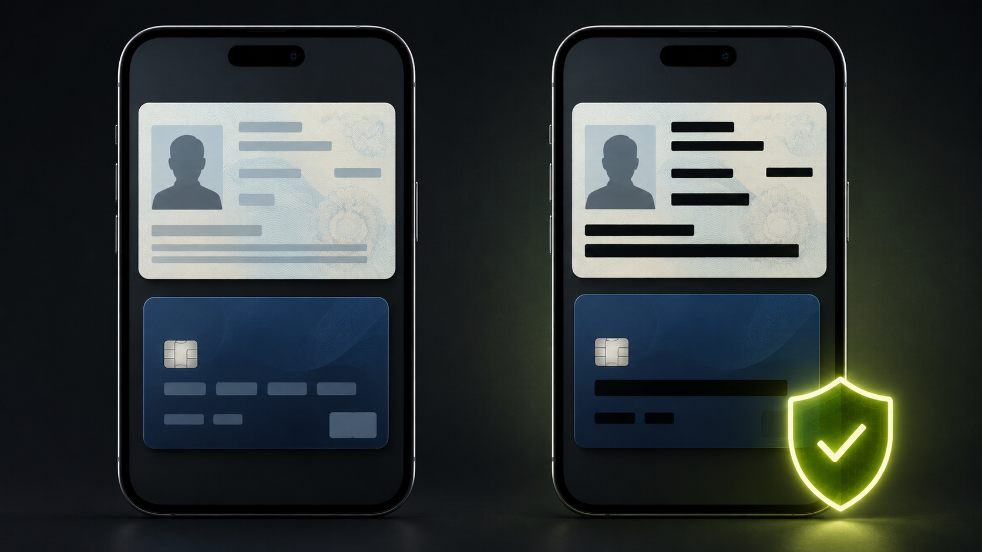
- Awareness arrives too late. Users often notice exposed details only after the message has been sent or forwarded.
- Generic warnings create friction. A warning that only says stop does not help when the document must still be shared.
- Cloud scanning creates another privacy decision. Uploading the image for analysis exposes the same material the product is meant to protect.
Product objective
Add a short, useful privacy checkpoint that helps the sender complete the share safely.

SOLUTION

A privacy assistant inside the sharing flow
PrivacyGate watches supported outgoing image flows and analyzes the selected image on the device. When it finds a meaningful risk, the first send attempt opens a compact privacy warning. The user can mask detected regions, dismiss the warning or continue deliberately.
01 Observe Detect an outgoing image preview or direct share action.
02 Inspect locally Run image labels, face detection and OCR without sending the image to a server.
03 Assess risk Apply category settings, structural rules and checksum validators.
04 Warn at the right moment Pause the first send action and show the reason for the warning.
05 Mask and share Create a protected copy and reopen the Android sharesheet.
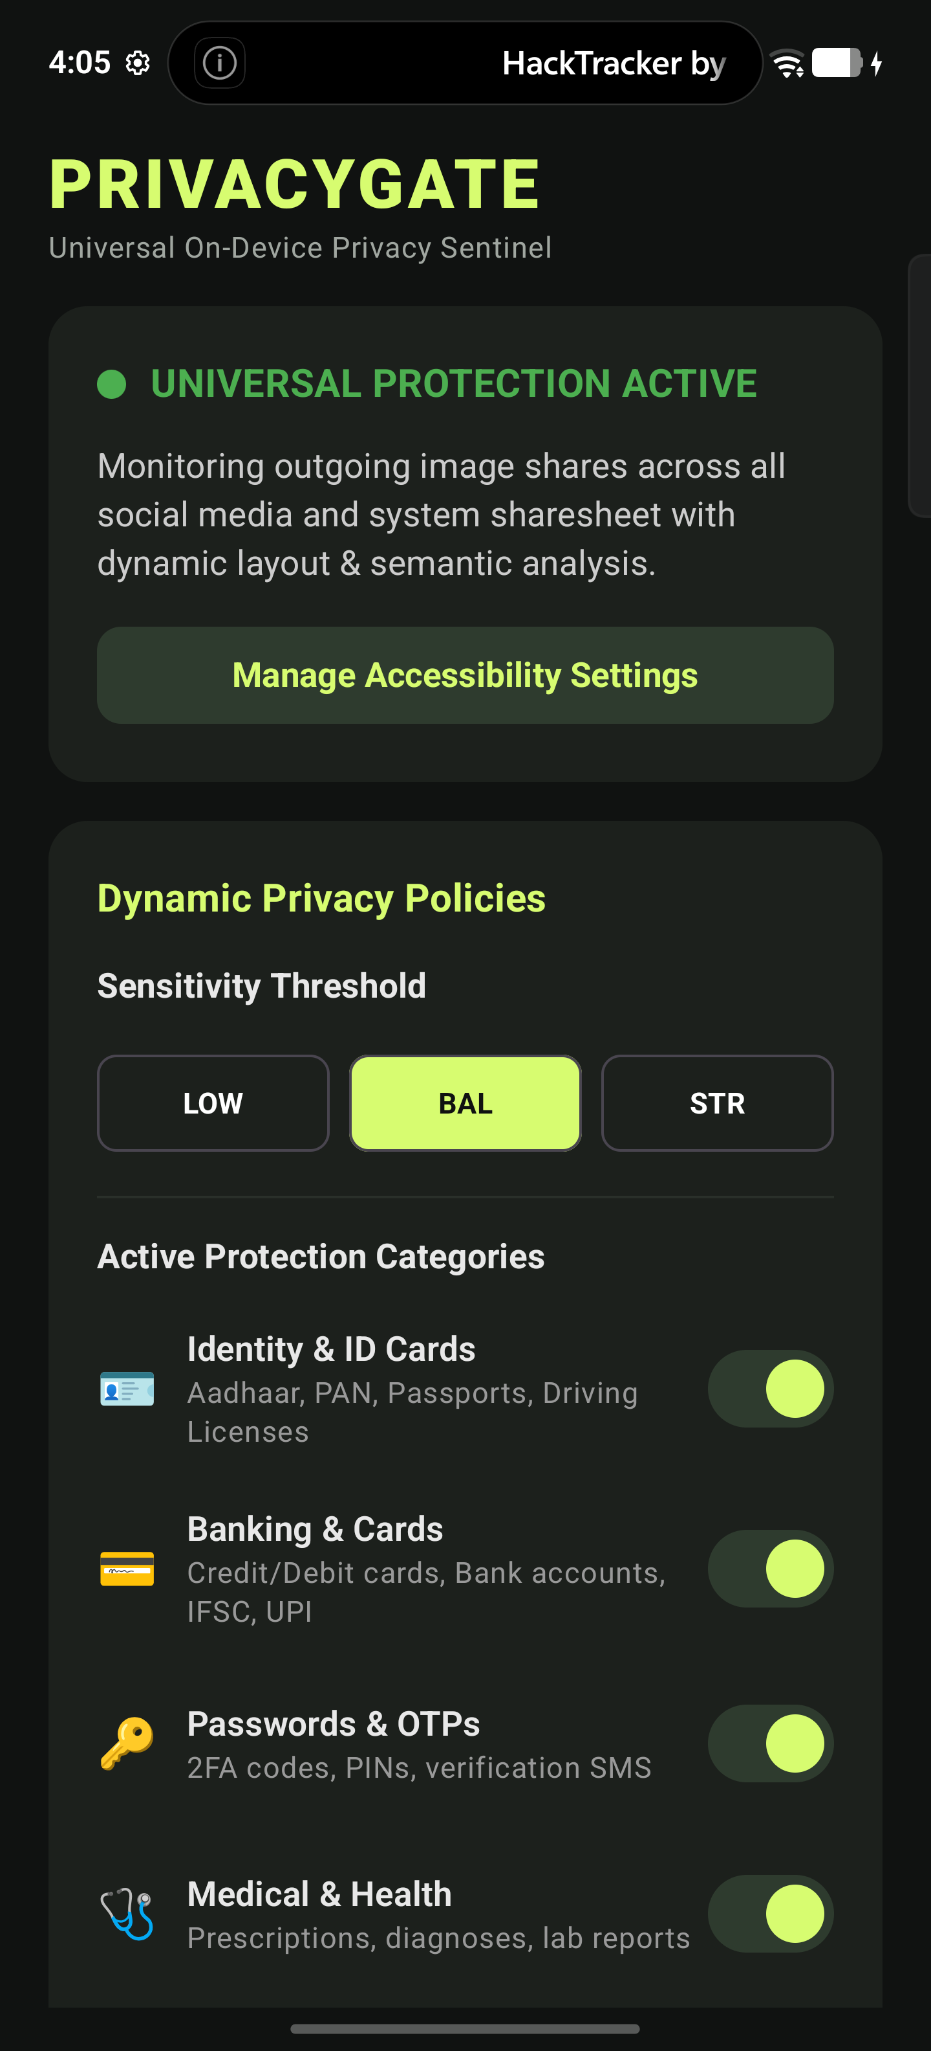
The policy screen lets users choose sensitivity and enable only the categories that matter to them.

HIGH LEVEL ARCHITECTURE

All analysis remains on the phone
The architecture separates capture, understanding, policy and output. Android provides the image. On-device ML Kit extracts visual and text signals. PrivacyGate applies deterministic privacy rules, then generates a protected bitmap for sharing.
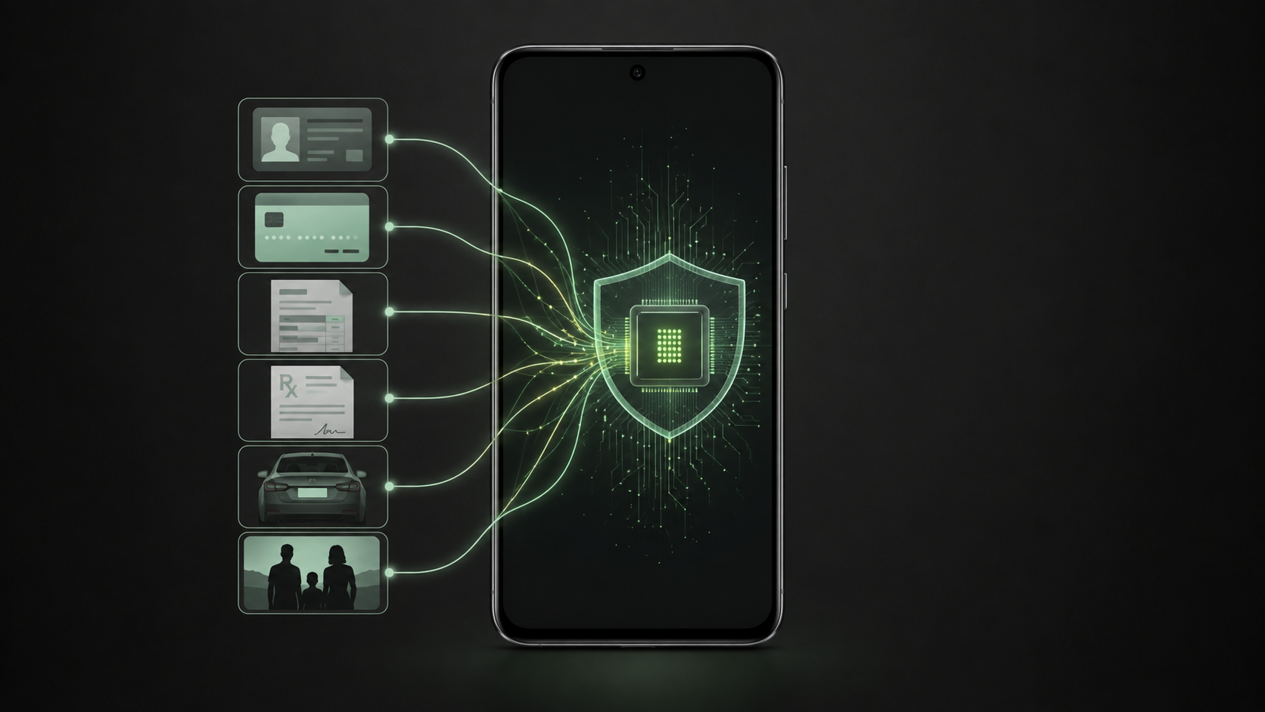
1  Image source  MediaStore or share screen | 2  Local perception  Labels, faces and OCR | 3  Privacy policy  Rules and validators | 4  User decision  Warn, mask or continue | 5  Protected output  FileProvider and sharesheet
Privacy boundary
The manifest removes internet access. The app keeps inference, policy decisions and masking within Android storage and memory.

DETECTION COVERAGE

Privacy categories and their current signals
The first layer combines several small, fast detectors. Each category uses the signal best suited to it.
Category | Detection signal | Protection purpose
Identity and ID cards | OCR, document structure, Verhoeff and patterns | Aadhaar, PAN, passport and licence details
Banking and cards | OCR, Luhn and financial patterns | Card and account information
Passwords and OTPs | OCR with credential keywords | PINs, codes and verification messages
Medical and health | OCR with prescription and medical cues | Patient and prescription information
Bills and invoices | OCR with invoice and GST structure | Customer contact and transaction details
Phone and email | Pattern validators | Personal contact information
Faces and people | Face detection and selfie segmentation | Portrait and people awareness
Vehicles | Image labels | Vehicle gallery grouping
Screenshots | MediaStore context, filename and image labels | Screenshot gallery grouping
Vehicle number plates | Dedicated localization remains in the next milestone | Plate warning and precise masking
Gallery discovery also groups Food and Nature images using ML Kit labels. These groups improve browsing but do not automatically create a privacy warning.

USEFULNESS AND PLAN

Useful protection without blocking legitimate sharing
- Hotel check in and KYC. Share an identity document while hiding fields the recipient does not need.
- Payment disputes. Protect card and account details while keeping the evidence visible.
- Medical coordination. Hide patient contact details while preserving the prescription context.
- Business messaging. Reduce accidental exposure when invoices, receipts and screenshots move through WhatsApp Business.

Delivery plan
Stage | Product result | Acceptance evidence
Current prototype | First send warning, local OCR and classification, full-region masking, gallery index | Physical device demo and offline manifest check
Next milestone | Smart partial masks, cleaner Privacy Island, reliable vehicle plate localization | Aadhaar, card, invoice and plate test set
Product hardening | Background indexing controls, audit history, battery and thermal safeguards | Long-run device tests and privacy review

Hackathon success criteria
A convincing demonstration shows the first send attempt stopping, a clear explanation of the detected risk, a protected copy reaching the Android sharesheet and continued operation with airplane mode enabled.
Recommended direction
Continue with PrivacyGate. The idea addresses a visible everyday problem and the on-device constraint gives the prototype a clear technical identity.

FUTURE SCOPE AND PRODUCT POTENTIAL

A privacy layer for every type of digital sharing
The current prototype focuses on still images and supported Android sharing flows. The same local detection, policy and masking pattern can grow into a broader privacy layer across communication and productivity apps.
Area | Examples | Expansion opportunity
Documents and files | IDs, cards, invoices, prescriptions and PDFs | Detect fields and create purpose-specific protected copies
Messages and screenshots | Chat text, OTP screenshots and account conversations | Warn before sharing secrets, contact details or credentials
Video and screen recordings | Clips, Reels, Status videos and screen captures | Track faces, plates and private regions across frames
Email | Gmail, Outlook, email bodies and attachments | Run a local preflight check before send or upload
Social and messaging | WhatsApp, WhatsApp Business, Instagram, Messenger, Telegram and Signal | Provide consistent protection through share targets and supported send flows
Work and cloud apps | Teams, Slack, Drive, Photos and Files | Apply personal or organization policies before content leaves the device
Audio and voice notes | Voice messages and locally generated transcripts | Detect spoken personal data, passwords and financial details

Long-term opportunity
- Consumer privacy assistant. One protection policy across personal photos, conversations, email and social sharing.
- Business and regulated use. Configurable controls for healthcare, finance, field sales and customer-support teams.
- Platform capability. An Android SDK or system-level share service that other apps can use without uploading private content.
Potential direction
PrivacyGate can evolve from a hackathon image-safety feature into an on-device privacy companion that protects content wherever people communicate.

