PROJECT BOOTSTRAP GUIDE
Image Hardening Factory
Design, delivery flow, implementation milestones, and Day 2 operations
A Confluence-importable introduction for platform engineering, security, product image maintainers, release authorities, and operations
Version 1.0 | 14 August 2026
Starter catalog: UBI 9.8 production lineage, UBI 10.2 canary, Atlassian Data Center LTS images

How to use this guide
This guide is the shared bootstrap narrative for the Image Hardening Factory. It explains why the factory exists, how work crosses trust boundaries, how the ten implementation milestones fit together, and how the service is operated after launch. It complements the executable starter repository; the repository remains authoritative for code, catalog pins, policy, and scripts.
Primary outcome: A repeatable, offline-capable path that converts pinned Repo One sources into internally built, tested, signed, policy-approved OCI images without depending on the Iron Bank platform at runtime.

Confluence compatibility
- The document uses real Word Heading 1-3 styles so Confluence can create a navigable page hierarchy.
- Diagrams are embedded inline as high-resolution PNG files; there is no Mermaid, SmartArt, floating object, or external image dependency.
- Tables are simple fixed-width grids with a single header row and no merged layout cells.
- Hyperlinks are ordinary external links. Command examples use plain preformatted paragraphs.
- After import, replace this page's static contents list with the Confluence Table of Contents macro and verify image alt text.

Contents
- Purpose, scope, and design principles
- Architecture, trust zones, and dependency model
- End-to-end process and release evidence
- Ten implementation milestones and launch sequence
- Roles, controls, and AI operating boundaries
- Day 2 cadence, runbooks, metrics, and support model
- Confluence publishing checklist and source references
Status: The starter repository is deployable and locally validated. Environment binding remains for GitLab, Artifactory, Cosign/Artifactory, protected runners, certificates, U.S.-person approval groups, and production integration tests.

1. Purpose and intended outcomes
The Image Hardening Factory separates source intake, offline build, evidence generation, signing, and promotion into independently controlled stages. It reuses Repo One content as upstream source guidance while replacing Iron Bank platform services with internal Artifactory and GitLab, mirrored community tooling, Artifactory-compatible Cosign signing, and a protected CrowdStrike FCS assessment runner.

What the factory delivers
- Reproducible inputs. Full commit pins, content checksums, OCI digests, RPM snapshot IDs, and toolchain digests are captured in an immutable resource lock.
- Offline builds. Build jobs reach only internal Git, immutable Artifactory repositories, and the GitLab coordinator.
- Evidence-first releases. Every candidate carries SBOM, vulnerability, compliance, test, provenance, gate, and approval evidence tied to the same digest.
- Separated authority. Build, import, sign, and promote credentials are held by different protected jobs and runner classes.
- Digest-preserving promotion. Commercial, Gov1, and Gov2 pull the exact approved digest and its OCI referrer closure; they do not rebuild.
- Guarded automation. AI may summarize evidence or propose a patch, but deterministic tools and humans retain decision and release authority.

Non-goals
- Re-creating the Registry1/Iron Bank platform, VAT workflow, or external Harbor dependency.
- Allowing public internet access from build, offline-scan, test, sign, or promotion jobs. The protected FCS runner is the sole scan-egress exception and may reach only the selected Falcon region.
- Promoting mutable tags as evidence identity; the digest is the release identity.
- Bundling the legacy Helm content from the Repo One source repositories into this image pipeline.
- Allowing an AI agent to approve exceptions, edit policy/VEX, sign, publish, or promote.

Initial product scope
Image | Starter pin | Track | Dependency / intent
ubi9-minimal | 9.8 | Release | Active hardened base for the Atlassian lineage
bitbucket-lts | 10.2.6 | Release | Depends on the approved UBI 9 digest
confluence-lts | 10.2.15 | Release | Depends on the approved UBI 9 digest
jira-lts | 11.3.10 | Release | Depends on the approved UBI 9 digest
ubi10-minimal | 10.2 | Canary | Independent compatibility evidence only

2. Design principles
1. Internal-first dependency resolution
Git, OCI bases, RPMs, offline scanner databases, security feeds, binaries, and source archives resolve from internal Artifactory or internal Git. FCS assesses the local candidate through a protected Podman socket and uses allowlisted Falcon API access.
2. Connected intake is a controlled exception
Only the intake class can reach approved upstream endpoints. It verifies content, records immutable identities, and produces a signed transfer bundle.
3. Build once, promote by digest
The candidate is built in the disconnected factory. Downstream environments copy the exact subject and evidence graph instead of rebuilding it.
4. Policy fails closed
The implemented OPA gate denies missing or invalid SBOM, compliance, product-test, or FCS evidence. FCS tenant image-assessment policy is the sole vulnerability-scanner authority; Grype, Trivy, OSV, KEV correlation, and ClamAV remain informational. Database-age and signed-exception enforcement are roadmap controls.
5. Least privilege by runner class
Intake, build, test, AI, import, signing, remediation broker, and promotion execute on different runner classes with purpose-specific credentials.
6. Human authority is explicit
Protected environment approvals and release roles remain human-controlled, including environment-local .us approval for Gov1/Gov2.

Community tooling baseline
Function | Tool / service | Factory use
OCI build / copy | Buildah, Skopeo | Rootful single-use builders; OCI layouts; registry copy
SBOM | Syft | CycloneDX and SPDX representations
Vulnerability | CrowdStrike FCS; Grype, Trivy, OSV Scanner | FCS is authoritative and connected; community scanners are offline informational evidence
Compliance | OpenSCAP + ComplianceAsCode | RHEL 9 / RHEL 10 tailored container profiles
Policy | OPA | Release decision from SBOM, compliance, tests, and FCS status
Signing | Cosign + Artifactory OCI referrers | Environment-key signatures and signed attestations
OCI evidence | ORAS | Predicate and referrer handling where needed

3. Architecture and trust zones
The architecture is intentionally asymmetric. Connected intake collects and verifies content but cannot release. Internal build, offline scans, compliance, and tests cannot publish or reach public services. A separate protected FCS runner has Falcon-only egress and no Artifactory write, signing, exception, or promotion credentials. Protected release jobs operate on verified digests with narrowly scoped credentials.
Runner hardening: Do not mount a Docker socket. Do not use privileged pods on reusable Kubernetes runners. Prefer a single-use VM for rootful Buildah and destroy it after the job.
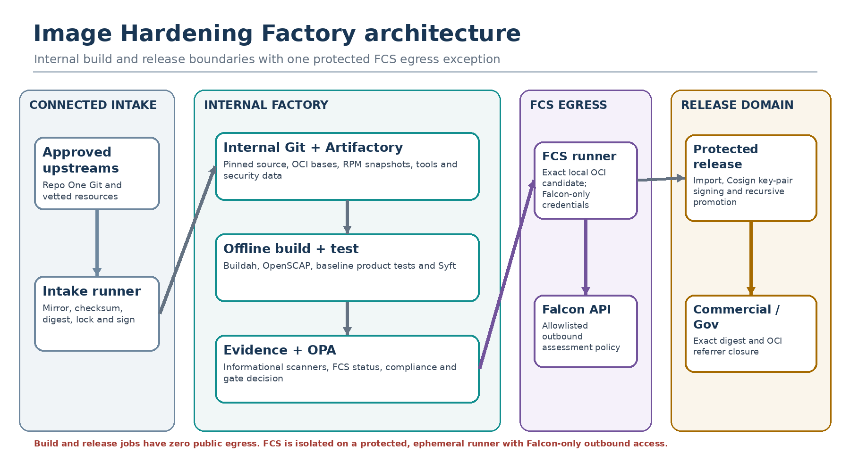
Figure 1. Connected intake, disconnected factory, and release-domain separation.

Runner classes and privileges
Runner tag | Network | Credential scope | Operational rule
factory-connected-intake | Approved upstream + internal | Intake-only writes | Ephemeral VM; cannot write release repositories
factory-offline / factory-buildah-ephemeral | Internal only | Artifact read | Single-use; rootful Buildah with chroot isolation
factory-fips-ephemeral | Internal only | Artifact read | FIPS-enabled host; destroyed after job
factory-test-ephemeral | Internal only | Test registry read | Runs exact candidate digest
factory-fcs-connected | Falcon API + local Podman socket | Falcon image-assessment credentials only | Ephemeral protected runner; sole controlled scan-egress exception
factory-ai-untrusted | AI endpoint + evidence read | No Git/registry write | Proposal and summary only
factory-remediation-broker | Internal GitLab | Branch/MR creation | Protected; validates permitted paths
factory-protected-importer | Quarantine | Quarantine write | Imports passing OCI layout only
factory-protected-signing | Artifactory only | Cosign key + referrer write | Protected job using short-lived Artifactory identity
factory-protected-promotion | Source + target repositories | Release copy | Verifies image signature, recursively copies referrers, and checks digest

4. Image dependency and pipeline selection
The catalog is the control plane for dependency-aware pipeline generation. A UBI 9 change selects the base and all three Atlassian descendants. An application-only change selects only that application. UBI 10 remains isolated until a reviewed catalog change explicitly adds a downstream dependency.
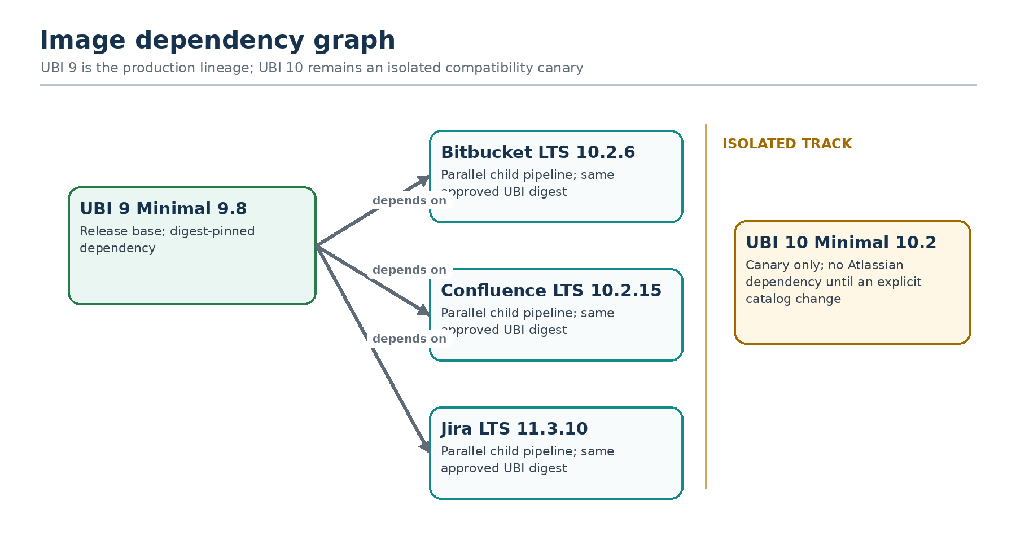
Figure 2. Production and canary image dependency graph.

Selection behavior
Changed catalog item | Rendered child pipelines | Expected behavior
ubi9-minimal | UBI 9 + Bitbucket + Confluence + Jira | Base completes first; applications fan out in parallel
bitbucket-lts | Bitbucket only | No unrelated application rebuild
confluence-lts | Confluence only | Uses currently approved UBI 9 digest
jira-lts | Jira only | Uses currently approved UBI 9 digest
ubi10-minimal | UBI 10 canary only | Cannot alter production Atlassian base lineage

Local pipeline checks
make validate
make test
PYTHONPATH=. python3 -m factory.cli pipeline --catalog catalog/images --changed ubi9-minimal --output generated-child.yml

5. End-to-end process flow
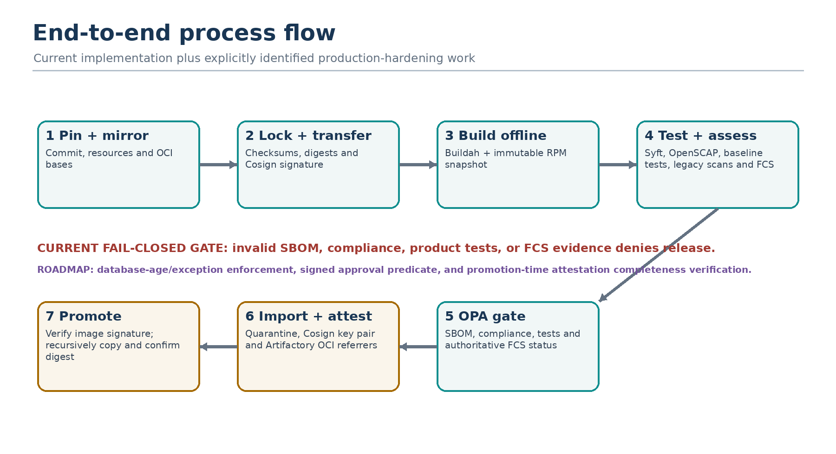
Figure 3. Intake-to-promotion flow with fail-closed gates.

1. Pin and mirror
Mirror the five Repo One repositories into internal Git at full 40-character commits. Resolve manifest resources and OCI bases. Verify declared checksums before upload.

2. Lock and transfer
Produce resource-lock.json with the pinned source, manifest resources, OCI identities, and RPM snapshot metadata, then sign it with the intake Cosign key. The current generatedAt field means byte-for-byte deterministic replay is not yet achieved, and security-data/toolchain digests are not yet embedded in the lock.

3. Prepare and build
Apply the approved overlay to a clean pinned source checkout. Build with Buildah using only internal resources and an immutable RPM snapshot.

4. Test and scan
Run structural, RPM integrity, crypto-policy, OpenSCAP, Syft SBOM, informational vulnerability, and baseline product runtime checks against the exact candidate. A protected FCS job assesses the loaded OCI candidate and supplies the authoritative image-policy status. Licensed PostgreSQL and cluster scenarios remain environment work.

5. Evaluate policy
Normalize informational findings and evaluate OPA. The current gate fails closed for invalid SBOM, compliance, tests, or FCS status, including FCS report/SBOM validation and digest mismatch. Database-age and signed-exception rules are not yet implemented.

6. Import and sign
A protected importer preserves and verifies the scanned digest while writing to quarantine. A separate protected signer uses an environment-specific encrypted Cosign key and short-lived Artifactory identity to attach signatures and attestations as OCI referrers.

7. Promote
The current promotion job verifies the source image signature, recursively copies the exact digest and OCI referrer closure, confirms digest preservation, and verifies the destination image signature. Approval-predicate and promotion-time attestation-completeness verification remain required production hardening.
Identity rule: The image digest is the release identity. Tags are convenience pointers and must never be used as evidence identity.

6. Evidence and policy model
The implemented signer attaches the current evidence set to the imported subject digest as Cosign attestations. FCS status embeds the candidate digest and the OPA gate checks that it matches. Several desired controls—signed approval evidence, policy-bundle digest, universal embedded subject fields, and promotion-time attestation completeness—remain roadmap work and must not be presented as enforced.
Predicate | Producer | Minimum contents
Resource lock | Intake | Source commit, manifest digest, resource checksums/OCI digests, and RPM snapshot metadata
CycloneDX + SPDX SBOM | Syft | OS packages, source-built Git, nested Atlassian JARs
SLSA provenance | Protected metadata job | Source, base, locked resources, builder, RPM metadata, and attached subject
FCS image assessment + CycloneDX SBOM | CrowdStrike FCS | Native report, scanner status, exact digest, tenant-policy result, and FCS component inventory
Informational vulnerability | Grype / Trivy / OSV normalizer | Matches, KEV correlation, fix data, baseline comparison; does not independently deny release
Compliance | OpenSCAP | ARF, profile, fail / not-applicable / error controls
Tests | Product test job | Runtime checks, logs, and pass/fail; attestation binds the result to the subject
Gate | OPA | Allow/deny and reasons; policy-bundle digest is not yet recorded
Approval (roadmap predicate) | Protected GitLab environment | Deployment approval exists operationally; signed approval predicate is not currently emitted

Default deny conditions
- Roadmap only: legacy security-database age exceeds the catalog maximum. The field is present but is not evaluated by the current Rego policy.
- SBOM validation, compliance evaluation, or product integration tests fail.
- FCS tenant image-assessment policy returns a nonzero result for the candidate.
- FCS evidence is missing, malformed, identifies the wrong scanner, or refers to a different digest.
- Roadmap only: an exception is invalid, expired, or incorrectly scoped. The current exception data is not consumed by Rego.

Promotion preconditions
- Current: the image signature verifies and the promotion source digest matches the imported candidate. Roadmap: verify every required attestation and its subject before promotion.
- Image signature verification uses the environment-approved Cosign public key. Recording and verifying a policy-bundle digest remains roadmap work.
- Protected GitLab environment approval must apply to the intended target; emitting that approval as a signed predicate remains deployment work.
- Gov1/Gov2 approvals are environment-local and satisfy the configured U.S.-person rule.
- The destination receives the subject plus its complete OCI referrer closure without mutation.

7. Internal Artifactory model
Artifactory replaces external build-time platform dependencies. Repositories are separated by content type and writer so a connected intake identity cannot write release content and a build identity cannot publish.
Repository | Type | Authorized writer | Purpose
generic-source-local | Generic | Connected intake | Checksum-addressed source archives and resources
oci-upstream-cache-local | OCI | Connected intake | Digest-pinned upstream bases
rpm-ubi9-snapshot-local | RPM | Snapshot job | Immutable UBI 9 repository snapshot
rpm-ubi10-snapshot-local | RPM | Snapshot job | Immutable UBI 10 repository snapshot
security-data-local | Generic / OCI | Security-data intake | Scanner DBs, CSAF/OVAL, KEV, EPSS
oci-toolchain-local | OCI | Toolchain bootstrap | Signed offline factory runner images
oci-base-quarantine-local | OCI | Protected importer | Passing base candidates
oci-app-quarantine-local | OCI | Protected importer | Passing application candidates
oci-release-local | OCI | Promotion broker | Approved production release digests
oci-canary-local | OCI | Canary broker | UBI 10 evaluation track
Immutability: Do not point builds at an RPM remote repository whose metadata changes in place. Snapshot the repository, record the snapshot ID and repomd.xml SHA-256, and include both in provenance.

Credential boundaries
Identity | May read | May write | Must not
Intake | Approved upstream + internal | Source/cache repositories | Quarantine or release
Build / scan | Internal mirrors and snapshots | Job-local evidence | Any registry repository
Importer | Passing OCI layout + gate | Quarantine | Sign or promote
Signer | Quarantine digest + evidence | Signatures / attestations | Rebuild or approve
Promoter | Approved source digest | Target release repository | Mutate subject digest

8. Ten implementation milestones
The ten milestones are deployable work packages. Each leaves a testable capability and an explicit exit condition; infrastructure-specific values are bound during environment implementation.
# | Milestone | Primary output | Exit condition
1 | Intake + immutable locks | Signed resource lock and mirrored sources | Checksums and signatures verify; generatedAt normalization is still needed for byte-identical replay
2 | Harden UBI 9.8 | Released base candidate + evidence | Offline build; base and RPM metadata digests in provenance
3 | Atlassian UBI 9 overlays | Cleanly applying Bitbucket, Confluence, Jira patches | Internal base only; version/resource metadata consistent
4 | Parallel Atlassian builds | Dependency-aware child pipeline | UBI 9 fans out; app-only change stays isolated
5 | SBOM, scanning, policy | FCS assessment, informational findings, and OPA decision | FCS is authoritative; invalid/missing FCS, SBOM, compliance, or tests deny
6 | Product integration tests | Baseline structural/runtime evidence | Startup, HTTP status, shutdown, UID, Java, ports, and RPM integrity; licensed DB/cluster scenarios remain
7 | Signing + pull promotion | Signed subject and implemented attestation set | Digest preservation works; promotion-time attestation completeness and approval predicate remain
8 | Read-only AI summaries | Schema-constrained remediation report | No write credentials; unavailable inputs are blocked, not guessed
9 | AI patch merge requests | Brokered MR from ephemeral overlay | Protected paths blocked; clean rebuild; auto-merge disabled
10 | UBI 10 canary | Independent compatibility report | No production base change without explicit dependency change and approval

Recommended delivery sequence
Sprint | Scope | Exit artifact
1 | Milestone 1 | Signed locks in Artifactory
2 | Milestone 2 | Released UBI 9.8 digest
3 | Milestones 3-4 | Three parallel application candidates
4 | Milestone 5 | Enforced release policy
5 | Milestone 6 | Product integration evidence
6 | Milestone 7 | Signed pull-based release
7 | Milestone 8 | Read-only remediation summaries
8 | Milestone 9 | Guarded patch MRs
Parallel | Milestone 10 | UBI 10 compatibility report

9. Bootstrap, validation, and go-live

Day 0: environment bootstrap
- Create Artifactory repositories and enforce writer separation and immutability.
- Build intake and runner toolchain images from verified source/binaries; generate SBOMs and sign them before use.
- Create internal Git mirrors and protect source, pipeline, policy, and release branches with CODEOWNERS.
- Register ephemeral runner classes and enforce network ACLs that match the trust model.
- Configure GitLab OIDC exchange to Artifactory; create environment-specific encrypted Cosign key pairs, trusted public-key distribution, and FCS environment policies/credentials.
- Populate signed security-data and immutable RPM snapshot repositories.
- Configure Commercial, Gov1, and Gov2 protected environments and approver groups.

Day 1: first production activation
- Run the connected intake pipeline and verify the resource lock signature and canonical replay.
- Transfer the source and security-data bundles into the disconnected enclave and verify every digest.
- Render a child pipeline for ubi9-minimal; confirm that all four production-lineage pipelines are selected.
- Build and evaluate UBI 9.8, then stop at quarantine for independent review of SCAP tailoring, RPM deviation allowlists, and evidence completeness.
- Approve, sign, and promote the UBI 9 digest only after the review is complete.
- Build Bitbucket, Confluence, and Jira in parallel using the same approved UBI digest.
- Run the current baseline runtime tests, add licensed PostgreSQL and product-flow integration suites, and validate OCI 1.1 referrer preservation in the deployed Artifactory version.
- Perform a controlled Commercial promotion and a documented rollback rehearsal before enabling Gov promotion.

Go-live acceptance checklist
- No build job can resolve a public URL or public image reference.
- Build, importer, signer, and promoter identities are technically distinct.
- FCS failures and tenant-policy denials stop release. If a 72-hour legacy database gate is required, implement and test the Rego rule before claiming enforcement.
- Every released digest has the implemented Cosign attestations; production activation additionally requires promotion-time completeness verification and signed approval evidence.
- A tag mutation cannot alter the evidence identity or bypass verification.
- Gov1/Gov2 require local .us approval and local signing.
- Rollback to the last approved UBI 9 and application digests is rehearsed and documented.

10. AI-assisted remediation boundaries
AI is an untrusted analysis and proposal component. It can reduce triage effort, but it never becomes a policy, approval, signing, or publication authority. Retrieval inputs are limited to signed evidence, approved vendor data, source files, and verified internal package candidates.
AI may | AI may not
Summarize signed findings and test evidence | Edit release policy, VEX, or exception records
Propose dependency, Dockerfile, or overlay changes | Choose an unverified version or checksum
Write to an ephemeral overlay working tree | Push directly to protected Git branches
Produce a schema-constrained remediation plan | Approve or auto-merge its own proposal
Label unverifiable guidance as blocked | Sign, import, publish, or promote an image

Guarded patch-MR flow
- The AI runner receives evidence and a disposable overlay worktree with no Git or registry write credentials.
- Deterministic resolvers prove that proposed packages and artifacts exist in internal Artifactory and calculate checksums.
- A trusted broker validates changed paths, creates the branch and merge request, and keeps auto-merge disabled.
- A clean-checkout pipeline applies the patch, rebuilds, rescans, retests, and reports before/after findings and SBOM delta.
- Human reviewers decide whether to merge; normal release gates still apply afterward.
Prompt injection control: Treat advisories, source comments, logs, and package metadata as untrusted data. They can inform a proposal but cannot issue instructions to the agent or broker.

11. Day 2 operating model
Day 2 begins when the factory is a supported service. Operations continually verifies that inputs are fresh, runners remain isolated, evidence is complete, promotion preserves identity, and rollback remains practical.
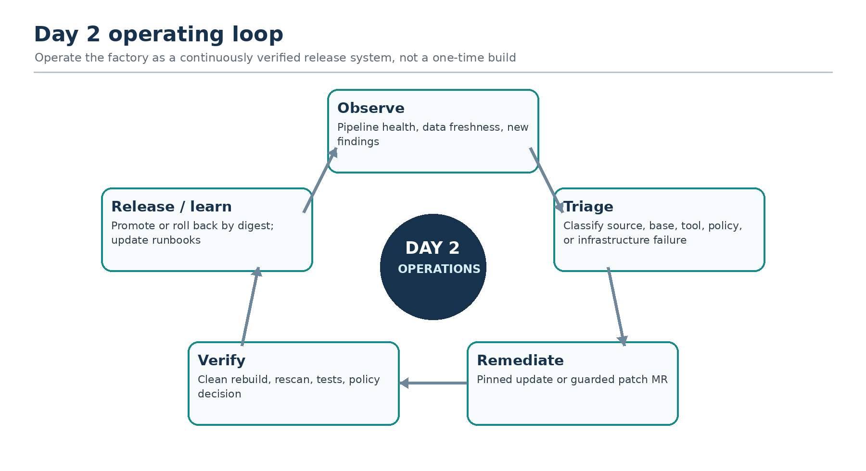
Figure 4. Continuous observe, triage, remediate, verify, and release/learn loop.

Operating cadence
Cadence | Owner | Required actions
Per pipeline | Image maintainer + automation | Verify lock, FCS status, implemented evidence, gate result, image signature, and digest-preserving referrer copy
Daily | Factory operations | Review failed/stuck pipelines, intake freshness, runner health, Artifactory capacity, security-data age
Weekly | Platform + security | Review FCS policy outcomes, informational KEV/Critical/High findings, base updates, and roadmap exceptions
Monthly | Service owner | Restore test, digest rollback drill, credential inventory, capacity trend, runbook corrections
Quarterly | Security + release authority | Key rotation rehearsal, policy review, SCAP tailoring review, access recertification
Per vendor LTS update | Product maintainer | Pin source, update overlay, rebuild, integration test, evidence review, controlled promotion

Support queues
- P1 - release integrity risk. Suspected key compromise, evidence mismatch, digest mutation, unauthorized promotion, or public egress from a protected runner. Freeze promotions and begin incident response.
- P2 - release path unavailable. Factory cannot produce or promote an urgently required security update. Invoke the documented continuity path; do not bypass evidence or signatures.
- P3 - degraded capability. One image, scanner, integration test, or canary path is failing while released images remain supported.
- P4 - maintenance. Backlog, documentation, performance, non-urgent tool or dependency refresh.

12. Day 2 runbooks

Runbook A - new vulnerability or KEV
- Confirm security-data bundle signature and generatedAt timestamp; reject stale or unsigned data.
- Correlate the finding to the exact digest and SBOM component; determine applicability and available internal fix candidates.
- Select the smallest valid update path: source/catalog pin, UBI rebuild, Atlassian overlay change, or guarded patch MR.
- Rebuild from a clean checkout, rescan, rerun compliance and product tests, and compare SBOM/findings delta.
- Promote only after policy allow, approval, signature, and evidence-closure checks. Document residual risk or a signed time-bounded exception.

Runbook B - failed pipeline triage
Failure class | First checks | Escalation / recovery
Intake / lock | Commit pin, checksum, upstream allowlist, canonical lock diff | Quarantine changed content; never update checksum to match unexplained bytes
Build | Overlay apply, internal base digest, RPM snapshot, Buildah logs | Reproduce on fresh ephemeral runner; compare resource lock
Scan / data | FCS status/API policy; legacy DB generatedAt, bundle signature, and scanner/tool digest | FCS failure denies release; refresh legacy bundles for informational evidence
Compliance | Profile applicability, ARF errors, FIPS host state | Security reviews tailoring; build team cannot mark controls N/A
Product test | Baseline service logs, ports, UID, shutdown; PostgreSQL/cluster logs when the licensed suite is added | Product maintainer owns compatibility correction
Sign / promote | OIDC claims, Cosign key, Artifactory identity, subject digest, and referrers | Release authority resolves; never copy unsigned content manually

Runbook C - scanner data stale
- Treat an FCS outage, invalid result, or policy denial as release-blocking. Legacy scanner database age is monitored but does not currently deny release.
- Run connected security-data intake, verify signatures/checksums, and transfer the refreshed bundle.
- Record the bundle digest and generated timestamp; rerun scans and policy evaluation.
- If a legacy feed is unavailable, retain the evidence gap and escalate according to policy. Do not claim automatic freshness denial until the corresponding Rego control is implemented.

Runbook D - planned exception governance
- When signed exception enforcement is implemented, alert at 30, 14, and 7 days before expiry.
- Require the owner to remediate, renew with current evidence and independent approval, or accept release denial.
- Verify scope by correlation key and subject/product constraints; broad wildcard exceptions are not permitted.
- Remove expired records from the active approved bundle and retain an immutable audit copy.

13. Release, rollback, and continuity

Normal promotion
- Resolve the approved source digest; do not resolve only a mutable tag.
- Current: verify the image signature and source digest. Before production activation, add verification of required attestations, gate decision, signed approval evidence, and policy-bundle digest.
- Current: recursively copy the OCI referrer closure. Before production activation, compare it to an explicit required-predicate manifest.
- Pull/copy the subject and closure into the target repository without mutation.
- Re-verify in the target environment and update the approved release tag to the digest.

Rollback by digest
- Identify the last approved digest and its signed evidence closure from the release ledger.
- Verify it remains available and trusted in the target environment.
- Move the deployment or approved tag back to that digest; do not rebuild an old source state.
- Run smoke checks, record the rollback reason and impacted release, and keep the failed digest quarantined for analysis.
- Open remediation work and require the normal gate before any forward fix.
Continuity rule: Urgency changes response time, not evidence requirements. If automation is impaired, a protected manual procedure must still verify the same digest, signatures, approvals, and predicate closure.

Signing key rotation or compromise
- For planned rotation, publish the new verification key and overlap trust before changing the signing reference.
- Sign a test canary and verify it in every target environment before production use.
- For suspected compromise, freeze promotions, disable the affected Artifactory signing identity and Cosign key, preserve audit logs, and invoke incident response.
- Re-signing does not erase history. Record affected signatures/digests and the new trust epoch explicitly.

14. UBI 10 canary operations
UBI 10 is an evidence-producing compatibility track, not a production migration. Its repositories, catalog track, policy profile, tags, and promotion target must make accidental adoption impossible.
- Build UBI 10.2 independently with a validated RHEL 10 SCAP profile and complete vulnerability-data coverage.
- Compare runtime libraries, Java behavior, native dependencies, fonts, crypto/FIPS behavior, and vendor support statements.
- Use optional application compatibility branches only; do not change the production dependency graph.
- Publish canary evidence to oci-canary-local, never the production release repository.
- Maintain UBI 9 rollback digests throughout evaluation.
- Require an explicit catalog dependency change, architecture review, product validation, and human approval before migration.

Canary exit report
Decision area | Evidence required
Vendor support | Atlassian and Red Hat support position for product/JDK/native stack
Security coverage | RHEL 10 OVAL/CSAF, scanner DB completeness, SCAP tailoring validation
Runtime compatibility | Startup, clustering, plugins, Git, Synchrony, JSM, graceful shutdown
Operational readiness | Toolchain, RPM snapshots, runbooks, capacity, rollback and support ownership
Migration decision | Reviewed catalog dependency change with impact and rollback plan

15. Service ownership and RACI
Activity | Responsible | Accountable | Consulted / informed
Source intake + lock | Intake engineering | Factory service owner | Security, image maintainer
Catalog / overlay change | Image maintainer | Product owner | Platform, security
Runner + Artifactory | Platform engineering | Platform owner | Security, operations
SCAP / vulnerability policy | Security engineering | Security authority | Product, release authority
Product integration tests | Product image maintainer | Product owner | Platform, database/service owners
Exception approval | Risk owner + independent approver | Security authority | Image maintainer
Signing / promotion | Release engineering | Release authority | Security, environment owner
Day 2 incident | Factory operations | Service owner | Security / platform / product by fault domain
Gov1/Gov2 approval | Authorized .us approver | Environment release authority | Security and audit

Escalation evidence bundle
- Pipeline URL and job ID; image/catalog name; source commit; candidate digest; target environment.
- Resource-lock digest, RPM snapshot ID, toolchain digest, security-data bundle digest and age.
- Relevant logs, normalized findings, compliance result, test result, OPA decision and signatures.
- Last known good digest and the proposed containment or rollback action.
- Owner, severity, timeline, and decision needed.

16. Metrics and service health
Metrics should prove that the release system is trustworthy and operable. Initial targets below are recommended bootstrap targets; adopt formal SLOs only after measuring the deployed environment.
Measure | Bootstrap target | Why it matters
Security-data age at evaluation | Monitor <= 72 hours (informational today) | Implement a Rego age rule before describing freshness as release-blocking
Evidence completeness | Production hardening: 100% | Current promotion copies referrers but does not verify a required-predicate manifest
Digest preservation | 100% source = target | No rebuild or mutation across environments
External egress from offline runners | 0 connections | Air-gap and supply-chain boundary remains intact
Unauthorized release writes | 0 events | Least privilege and protected workflows hold
Exception hygiene | Roadmap: 0 expired active exceptions | Exception data exists but is not currently evaluated by Rego
Rollback readiness | Monthly verified | Last approved digest can be restored under pressure
Patch MR verification | 100% clean-checkout rebuild | AI proposals cannot bypass deterministic verification

Recommended dashboards and alerts
- Pipeline outcomes by stage, image, runner class, and failure class.
- Security-data and RPM snapshot freshness; next exception expiry; source mirror drift.
- Quarantine-to-release lead time and approval wait time.
- Open KEV/Critical/fixable High/new High findings by digest and owner.
- Cosign signing failures, FCS policy/API failures, Artifactory OIDC failures, and promotion referrer mismatches.
- Artifactory storage/capacity and garbage-collection safety for referenced digests.

17. Contributor onboarding

First-week checklist
- Read this guide, README.md, IMPLEMENTATION_PLAN.md, docs/operations.md, docs/evidence-model.md, and SECURITY.md.
- Understand which runner class and credential owns each stage; never collapse roles for convenience.
- Run catalog validation and unit tests locally with no production credentials.
- Render a child pipeline for an application-only change and a UBI 9 change; compare selected nodes.
- Review one resource lock, one SBOM, one normalized finding set, one OPA decision, and one promotion evidence closure.
- Practice a failed checksum, missing/denied FCS result, failed product test, digest mismatch, and rollback scenario in a non-production environment.
- Submit changes through merge requests with CODEOWNERS review; do not edit generated evidence manually.

Repository orientation
Path | Purpose
catalog/images/ | Pinned sources, dependencies, policy profile, publication target
overlays/ | Reviewed product/base patches applied to clean upstream checkouts
factory/ | Catalog validation, intake, pipeline generation, finding normalization, gate input
scripts/ | Intake, build, scan, compliance, test, sign, import, promote, AI broker helpers
policies/ | OPA release policy and independently governed exceptions
tests/ | Unit tests and image/product test profiles
toolchain/ + tools/ | Offline runner definition and pinned tool versions
docs/ | Operations, evidence model, implementation status

Safe local checks
cd image-hardening-factory
make validate
make test
make pipeline
# Review generated-child.yml; do not commit generated evidence or secrets.

18. Confluence import and publishing
Import this DOCX using the Word import capability provided by your Confluence Data Center version. Import into a staging page or space first so the page hierarchy, links, images, and tables can be reviewed before publication.

Import checklist
- Create or select the target project space and establish page ownership and edit permissions.
- Import the DOCX as a new page hierarchy; keep the original DOCX as a controlled source artifact.
- Replace the static contents section with a Confluence Table of Contents macro.
- Verify all four diagrams render at full width and retain meaningful alt text.
- Check table wrapping, header rows, hyperlinks, and preformatted command examples.
- Convert the Day 2 cadence and runbooks into child pages only if your team needs separate owners or review cycles.
- Add Confluence-native labels, owners, review dates, and status macros after import.
- Do not replace diagrams with Mermaid unless your approved Confluence environment supports and governs that macro.
- Publish only after the factory service owner, platform owner, security authority, product maintainers, and release authority review their sections.

Recommended page hierarchy
- Image Hardening Factory - Project Bootstrap (landing page)
- Architecture and process flow
- Implementation milestones 1-10
- Evidence, policy, and promotion model
- Day 2 operations and runbooks
- Contributor onboarding and references
Maintenance: Assign a named owner and review date to each Confluence page. Code and catalog remain authoritative; update the wiki whenever a trust boundary, runner class, repository name, policy threshold, approval rule, or runbook changes.

19. Source repositories and supporting material
- Bitbucket Data Center LTS - https://repo1.dso.mil/dsop/atlassian/bitbucket-data-center/bitbucket-lts.git
- Confluence Data Center LTS - https://repo1.dso.mil/dsop/atlassian/confluence-data-center/confluence-lts.git
- Jira Data Center LTS - https://repo1.dso.mil/dsop/atlassian/jira-data-center/jira-lts.git
- Red Hat UBI 10 Minimal - https://repo1.dso.mil/dsop/redhat/ubi/10.x/ubi10-minimal.git
- Red Hat UBI 9 Minimal - https://repo1.dso.mil/dsop/redhat/ubi/9.x/ubi9-minimal.git
- Iron Bank pipeline guidance - https://repo1.dso.mil/ironbank-tools/ironbank-pipeline.git

Starter repository authority
The implementation-specific values described in this guide are grounded in the image-hardening-factory starter repository. Before production use, reconcile this guide against the deployed GitLab CI version, Artifactory behavior, Cosign key and Artifactory configuration, certificates, protected environments, and licensed product integration tests.

Glossary
Term | Meaning
Subject digest | Immutable OCI digest that identifies the candidate or release
Referrer closure | Signatures, attestations, SBOMs, and other OCI artifacts that refer to the subject
Resource lock | Signed manifest of source revision, manifest/resource digests, OCI identities, and RPM snapshot metadata
Quarantine | Protected repository for passing candidates before release promotion
Gate | OPA decision over SBOM validity, compliance, tests, and authoritative FCS status
Canary | Evidence-producing compatibility track that cannot become production by tag accident
Day 2 | Ongoing operation, maintenance, support, incident response, and lifecycle management after launch

