

NED UNIVERSITY OF ENGINEERING & TECHNOLOGY
NCCS Department — Internship Program

TASK 02
Process Injection and Memory Forensics
Offensive Simulation and Defensive Memory Analysis

Submitted by: Shane Zehra
To: Sheikh Abdul Basit
NED Internship – nccs department
Date: 10th August, 2026

Objective:
The objective was to understand how user-mode process injection can create unusual memory artifacts and then learn how a forensic analyst can identify those artifacts from a RAM image. Notepad was selected as the benign target process. Cheat Engine was used to allocate and modify memory, while Volatility 3 was used from Kali Linux to inspect the resulting Windows memory image.

Stage | Purpose | Evidence Produced
Phase 1 – Injection | Create a controlled suspicious memory region inside Notepad. | Cheat Engine screenshots, PID 6284, allocation address, NOP/RET payload.
Phase 2 – Acquisition | Capture RAM while the modified process state exists. | VirtualBox dumpvmcore command and 4.4 GB memdump.elf.
Phase 3 – Forensics | Detect and characterize the injected region from memory. | Volatility info, pslist, malfind, vadinfo, vadwalk and vaddump evidence.

Lab environment
The work was performed using a Windows 10 virtual machine as the target and Kali Linux as the analysis environment. The Windows VM was treated as an isolated laboratory system. Because in-guest acquisition drivers were blocked by the Windows security configuration, the submitted report documents hypervisor-level acquisition through VirtualBox instead of WinPmem/FTK.

Phase 1 – Memory Injection (Offensive Perspective)
In Phase 1, a benign Notepad process was used as the target. The purpose was not to deploy a real-world payload, but to create a controlled memory artifact that could later be detected during forensic analysis.

1.1 Launching Notepad and preparing the target
Notepad was launched and used as the target process. A small dummy text file was opened to ensure that the process was active during the experiment.
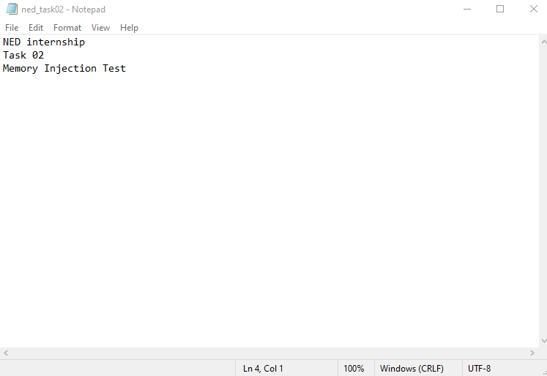

Figure 1.1. Notepad running as the benign target process.

1.2 Identifying the Notepad PID
Task Manager was used to identify the process identifier. The recorded PID was 6284, which later matched the PID recovered from the memory image.
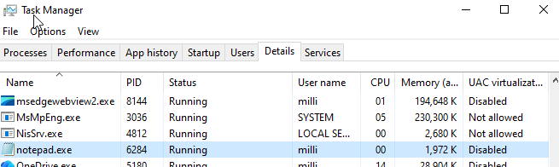

Figure 1.2. Task Manager showing notepad.exe with PID 6284.

1.3 Attaching Cheat Engine
Cheat Engine was attached to the Notepad process so that its memory could be inspected and modified inside the controlled lab.
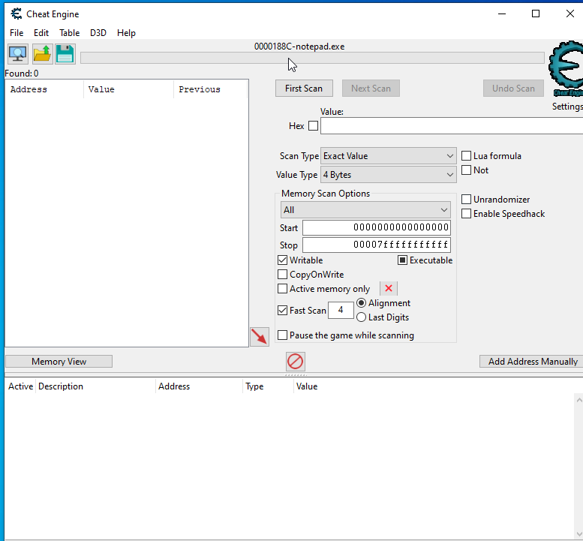

Figure 1.3. Cheat Engine attached to the Notepad process.

1.4 Opened the Memory Viewer
The Cheat Engine Memory Viewer was used to inspect the process memory. The screenshot also records the protection state of a normal Notepad-backed region before the test allocation.
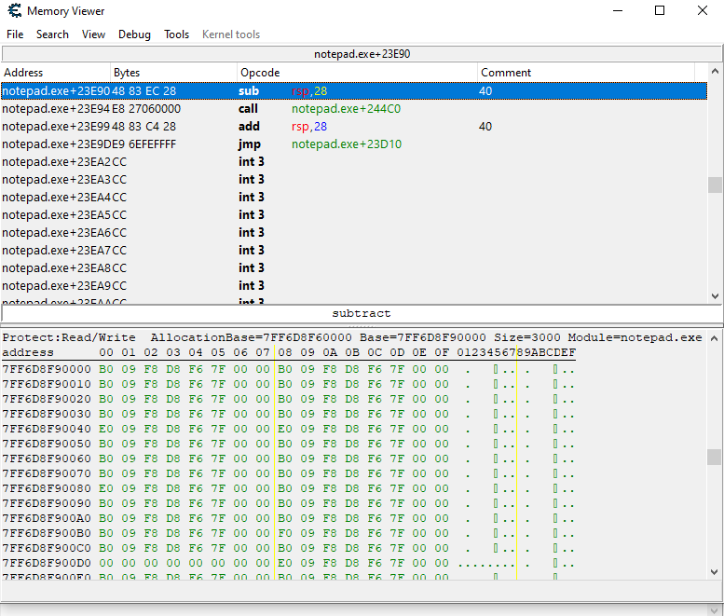
Figure 1.4. Cheat Engine Memory Viewer showing Notepad memory and protection information.

1.5 Allocating memory
A small 4096-byte region was allocated. The evidence shows the allocation at 0x2D635670000. This region became the trampoline area used to redirect execution toward the newly allocated code region.
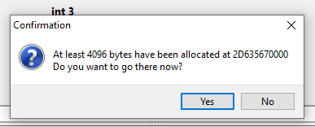

Figure1.5. Cheat Engine confirmation that 4096 bytes were allocated at 0x2D635670000.

1.6 Successful code injection
The Auto Assemble operation reported successful injection and identified the new memory region as 0x2D635680000. This is the primary address of the test code region used in the subsequent forensic analysis.
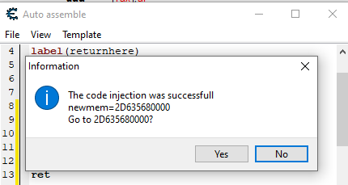

Figure 1.6. Cheat Engine confirmation of successful code injection and the new memory address.

1.7 Verification of the injected payload
The Memory Viewer shows the payload bytes 90 90 90 90 C3 at 0x2D635680000. The first four bytes are NOP instructions and C3 is a RET instruction. The surrounding bytes also show a jump from the 0x2D635670000 region into 0x2D635680000.
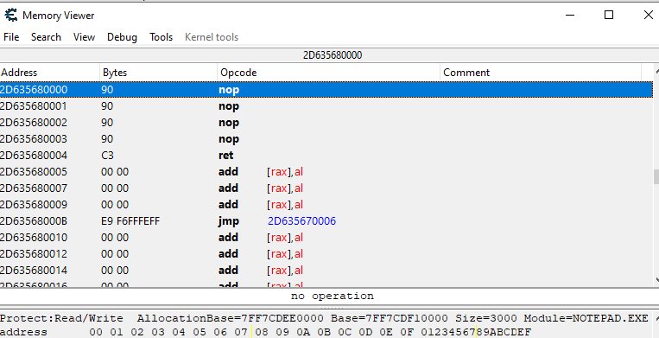

Figure 1.7. Verification of the injected NOP/RET test payload in the allocated executable memory.

Phase 2 – Memory Acquisition
The objective of Phase 2 was to capture the RAM state while the modified Notepad process existed. The submitted evidence documents an alternative acquisition method because Windows security controls prevented the intended in-guest acquisition drivers from loading.

2.1 Acquisition method and limitation
The HVCI/DSE/kernel-driver restrictions prevented WinPmem/FTK from loading inside the Windows 10 Pro VM. Therefore, VirtualBox's hypervisor-level debugvm dumpvmcore mechanism was used to capture the VM's physical memory state. This is a defensible laboratory workaround and should be explicitly stated during presentation rather than implying that WinPmem was successfully used.
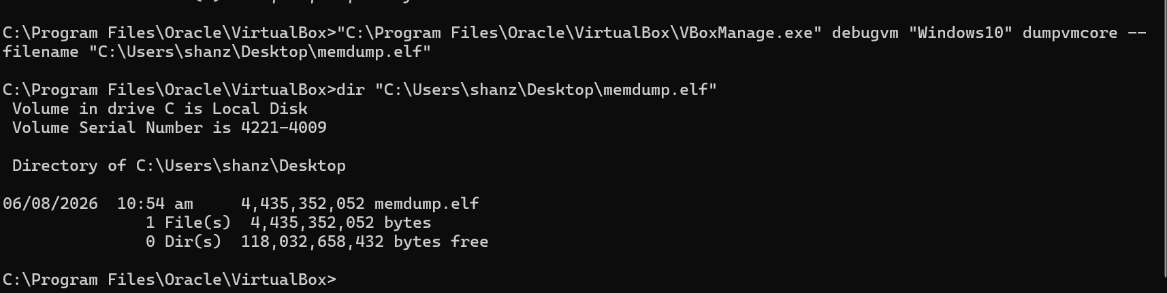

Figure 2.1. VirtualBox dumpvmcore acquisition and verification of the 4,435,352,052-byte memdump.elf file.

Phase 3 – Detection and Analysis (Defensive Perspective)
Phase 3 moved from the offensive simulation to forensic analysis. Kali Linux was used as the analysis machine, and Volatility 3 Framework 2.28.2 was used to examine the Windows memory image.

3.1 Starting the analysis environment
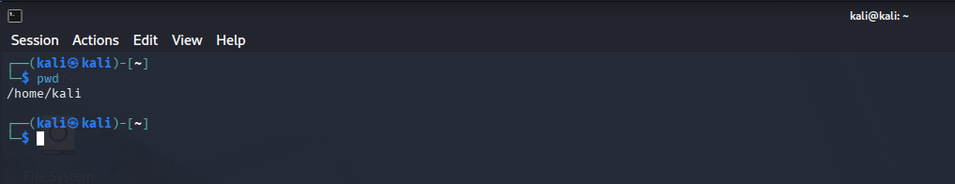
Figure 3.1. Kali Linux terminal opened for memory-forensics work.

3.2 Verifying Python
Python 3 was verified before running Volatility 3.
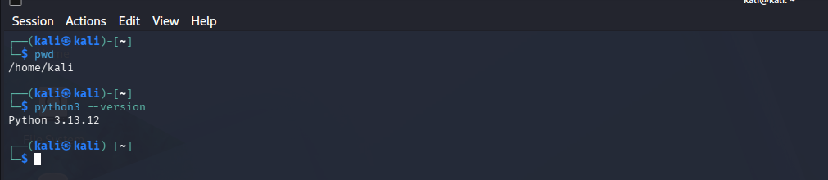

Figure 3.2 Python 3 version verification.

3.3 Installing required packages
Git and Python package-management dependencies were installed or updated so that the Volatility 3 environment could be prepared.
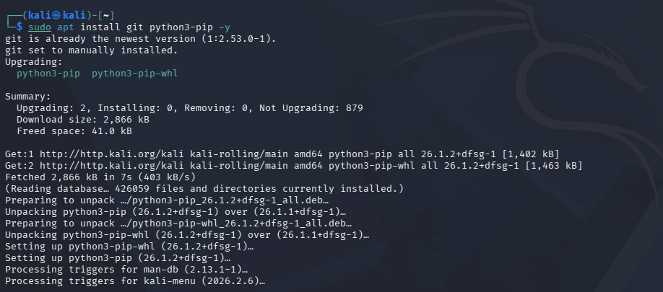
Figure 3.3. Installation of Git and Python pip dependencies.

3.4 Downloading Volatility 3
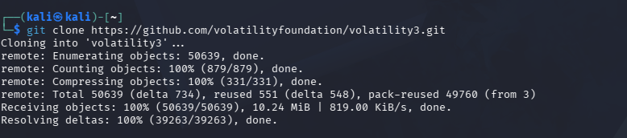
The official Volatility 3 repository was cloned into the Kali home directory.

Figure 3.4. Cloning the official Volatility 3 repository.

3.5 Verifying Volatility 3
The Volatility command-line help was displayed successfully, confirming that the framework was
installed and callable.
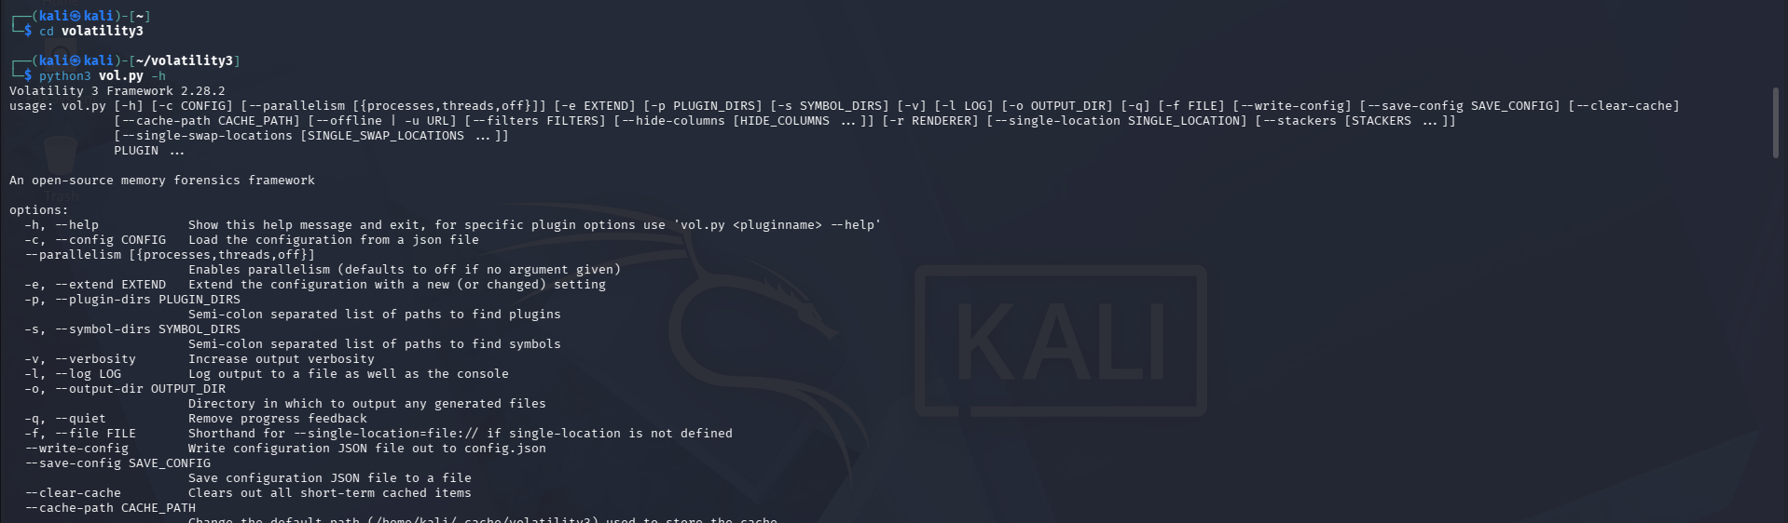

Figure 3.5. Volatility 3 help output confirming the framework is available.

3.6 Validating the memory image
The plugin identifies the Windows kernel and operating-system characteristics. The submitted output identified a 64-bit Windows 10 system (major/minor 10.0; build 19041) and completed PDB scanning.
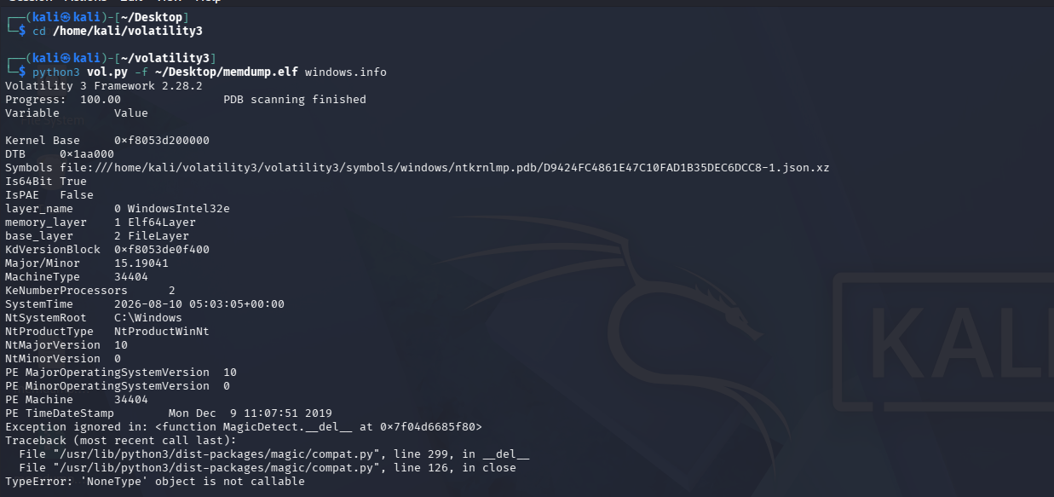

Figure 3.6. Volatility memory-image validation: Windows 10 build 19041 identified successfully.

3.7 Identifying the target process
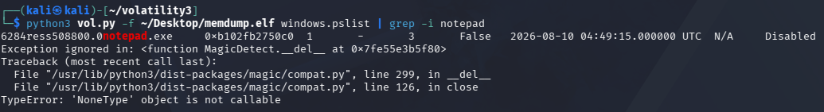
Figure 3.7. windows.pslist identifies notepad.exe with PID 6284, matching the Phase 1 PID.

3.8 Detecting injected memory with malfind
The analysis identified two suspicious VAD regions in notepad.exe:
Region | Protection | Observed evidence
0x2D635680000 – 0x2D635680FFF | PAGE_EXECUTE_READWRITE | 90 90 90 90 C3 NOP/RET pattern.
0x2D635670000 – 0x2D635670FFF | PAGE_EXECUTE_READWRITE | Jump/trampoline region pointing toward 0x2D635680000.
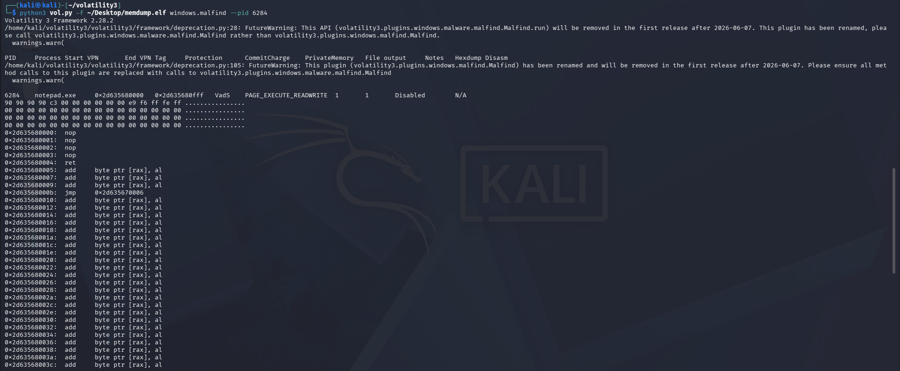

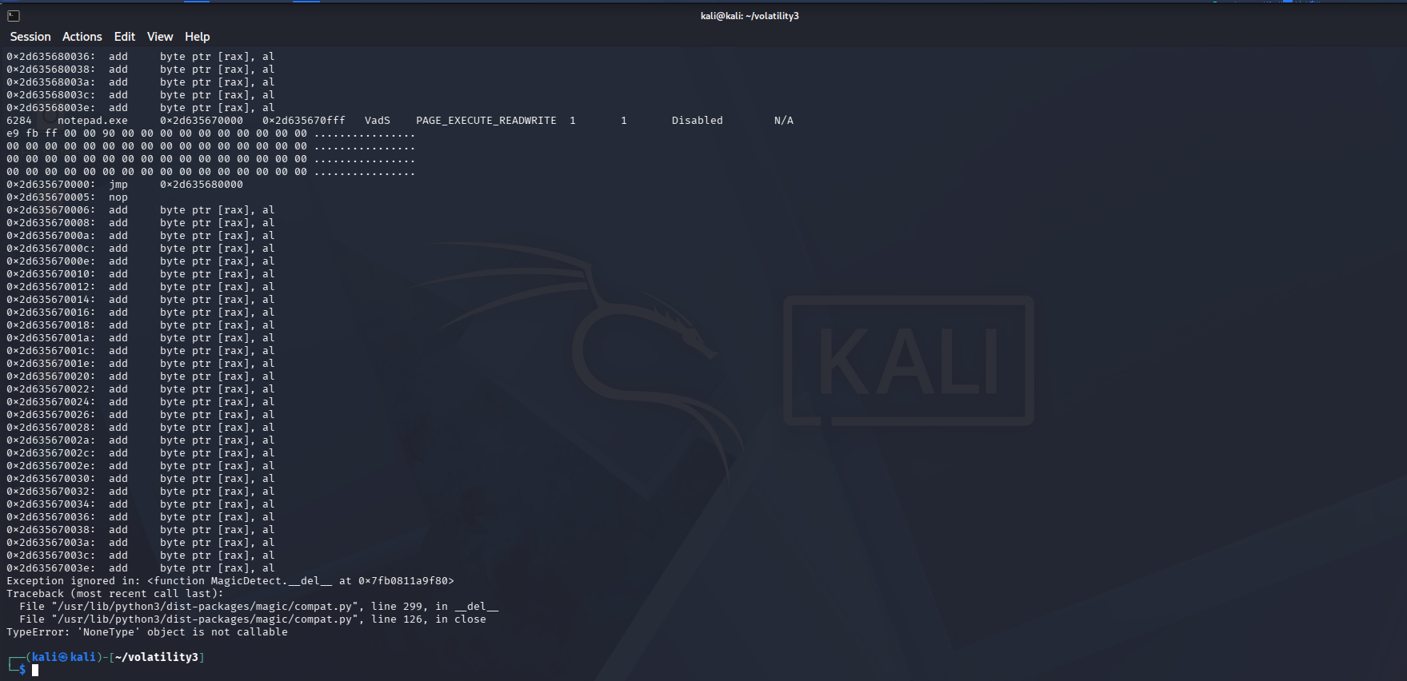

Figure 3.8. malfind disassembly/hexdump showing the injected NOP/RET pattern and jump relationship.

3.9 Examining VAD information
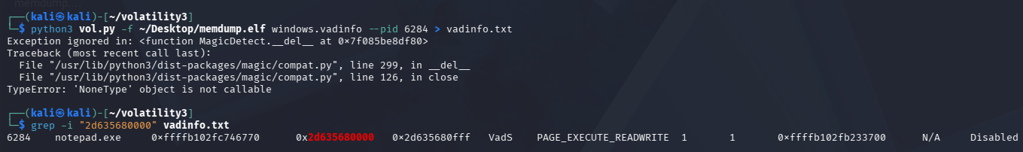
windows.vadinfo enumerates Virtual Address Descriptors (VADs) belonging to the selected process. VADs describe ranges of virtual memory and their protection/allocation characteristics.
Figure 3.9a. VAD information for the Notepad process, including memory-protection fields.

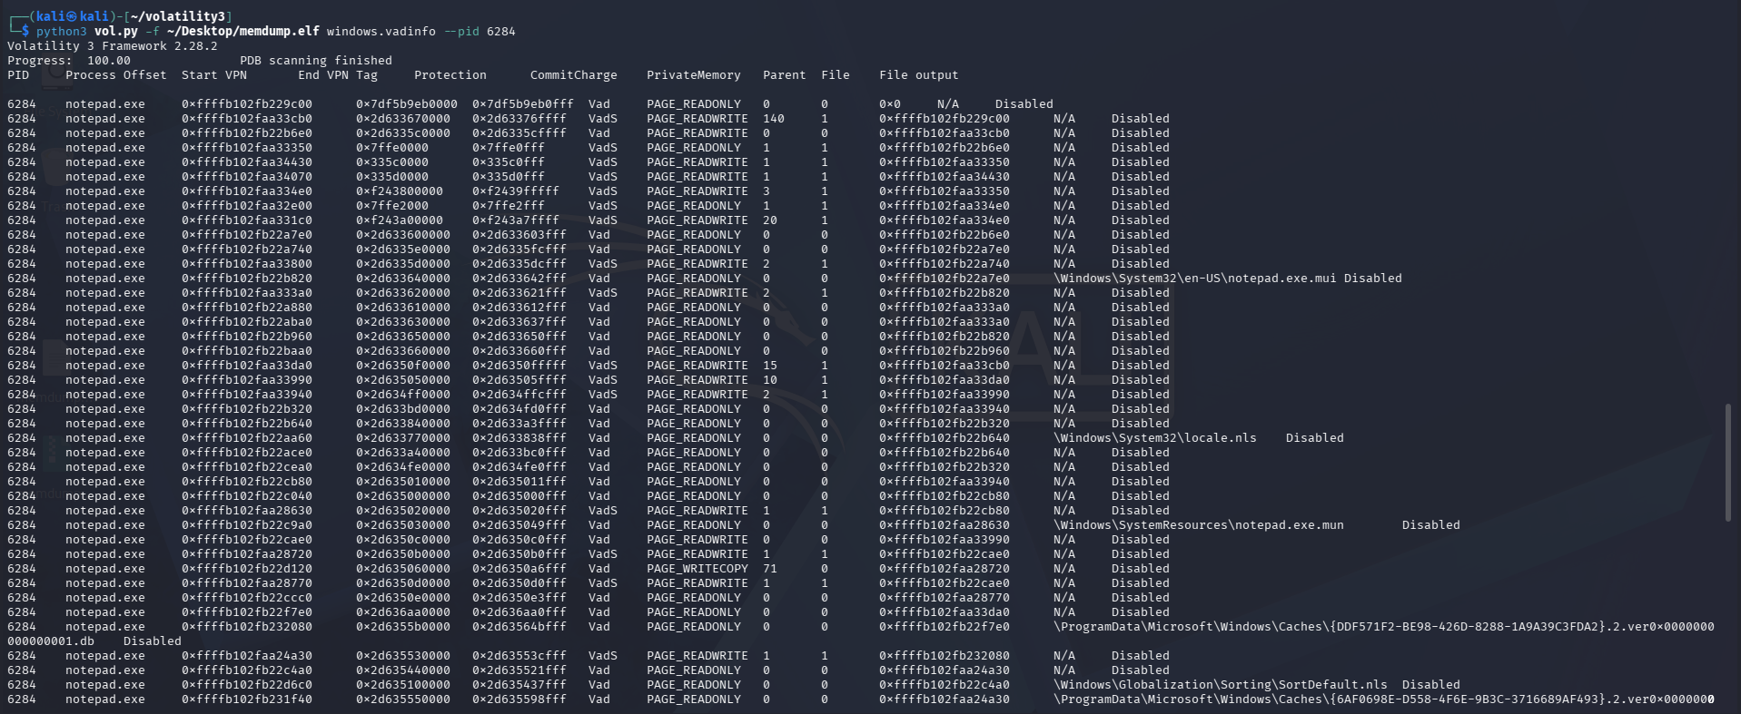
Figure 3.9b. Targeted VAD search confirming the suspicious executable/writable region.

3.10 Reviewing the VAD structure
Windows.vadwalk displays the VAD structure associated with the selected process. It is useful for understanding how the suspicious region sits within the process address space.
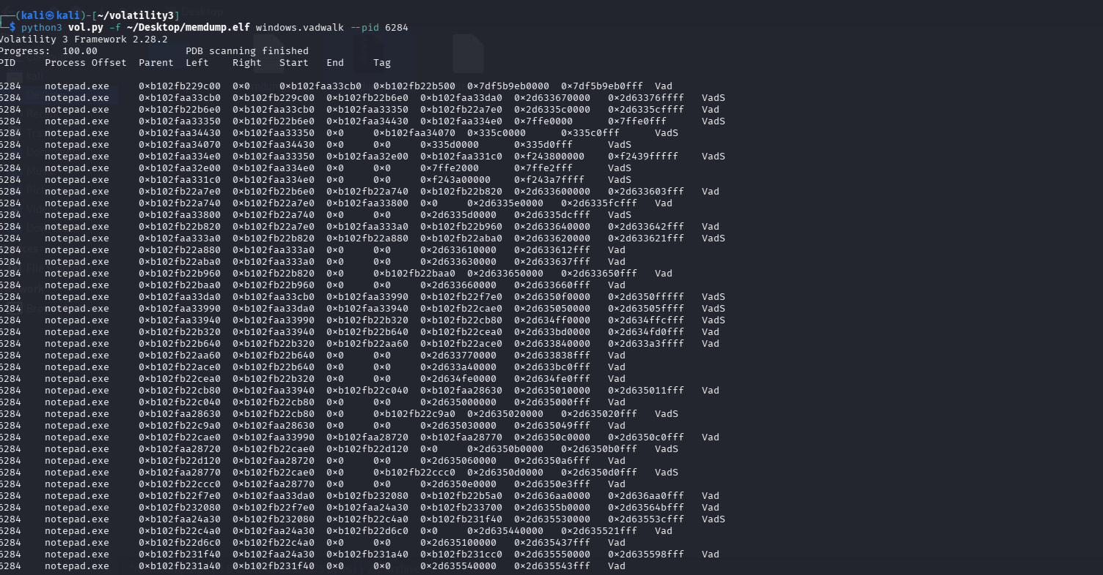
Figure 3.10. VAD structure for notepad.exe.

3.11 Extracting the suspicious VAD
The submitted evidence shows the resulting per-process dump file in the vaddump output directory. The file is named 6284.dmp, linking the extracted memory to the Notepad PID.
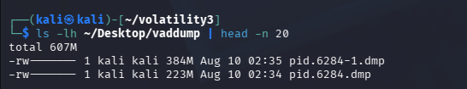
Figure 3.11. Injected-memory dump output showing the generated 6284.dmp artifact.

Key Findings and Interpretation
- Why did malfind flag the region?
The region was RWX (PAGE_EXECUTE_READWRITE) and contained the test payload (90 90 90 90 C3), making it suspicious.
- How is it different from legitimate modules?
Legitimate modules such as ntdll.dll and kernel32.dll are normal loaded modules. The injected region was a private memory allocation with RWX protection.
- What are the two suspicious regions?
0x2D635670000 is the trampoline, which jumps to 0x2D635680000. The second region contains the NOP/RET test payload.
- Evasion consideration
An attacker could change the memory protection after writing the code, such as removing write permission. However, other forensic evidence may still remain.

Conclusion
The exercise successfully showed how process injection can be detected using memory forensics. Volatility identified the injected memory in Notepad, including the same address, RWX protection, and payload bytes seen during the injection.

